Problem Solving and
Decision Making

Student Name: Louise Catherine Franklin

Student ID: 2025915

Module Title: Problem Solving and Decision Making

Module Code: BMSW4004

Lecturer: Sujeewa Herath

Table Of Content

Introduction……………………………………………………………………………p.3

What is Work-Related Stress? ….…………………………………………………p.4

Fishbone Analysis……………………………………………………………………. p.5

Causes of Work-Related Stress………………………………………………………p.6-7

Pestle Analysis…………………………………………………………………………. p.8

Solutions for Work-Related stress……………………………………………………p.9

P.M.I Analysis…………………………………………………………………………...p.10

Action Plan………………………………………………………………………………. p.11

Conclusion………………………………………………………………………………. p.12

Reference List……………………………………………………………………………p.13

Introduction

In the United Kingdom stress is said to affect the population on a day-to-day basis. When stress spirals out of control this could lead to mental health issues even long-term health conditions. The most common stress to affect the population is work related stress. The next most popular stress to hit the British public is financial stress, this could be anything from not getting enough financial support or not earning enough to fulfill your financial needs. After financial stress comes Family stress, health stress and relationship stress. All in all, stress is very bad for the population if it is left to spiral (Statista.com, 2020).

p.3

What is work related stress?

Work-related stress

On a day-to-day basis many of us suffer with work related stress. Work related stress could cause you to not be your effective self when it comes to work sharing your workload and communicating with your co-workers could help to relief some of the pressures coursed from work. Not finding solutions to work related stress could help towards life-long illnesses for workers. When we talk about work related stress, people may consider that to be from not enjoying your job. That is not the case for many people. Work related stress can be caused through language barriers, poor communication, and even Poor leadership. Finding a solution and trying to fix your problem could relief some work related stress. Work Related stress impacts people in many ways, some cases leading to long lasting health conditions which enables people to no longer work (Bhui et al., 2016). When Work-related stress starts to affect an organisation, or a business intervention need to be made and their needs to be an analysis to see how we can reduce stress. Using a Fishbone Analysis can help to find what the course and effects are to work-related stress from the inside of the business or organisation, also when looking at courses and effects to macro-environmental facts to a business organisations and business could use a PESTLE analysis. Making sure you have these extra steps in place may help towards decreasing work related stress.

p.4
Fishbone Analysis

A fishbone analysis is usually used to find the cause and effects before you solve the problem. Using this analysis gives a shared idea amongst workers of a problem. Organisations could benefit from using this analysis. Solving problems finding the root cause of a problem will help solve the problem not putting these measures in place could towards never fixing the problem this could lead to failure throughout a business or organisation.

To use the Fishbone analysis, you should jot down each of the main effects and write down factors that could help contribute to the problem. You should go through each one and seek out what could help cause the problem. Keep continuing to go through every branch until you find every possible cause. We use this to get people thinking and coming up with ideas to contribute to solving problems. Kaora Ishikawa developed the fishbone analysis in the 1960’s (Mindtools,2009).

Causes of Work-related stress

There are many problems that cause work-related stress. problems are barriers that slightly stop or prohibit you from the task at hand most of which with intervention and measurements may be fixed. Having these problems may course the organisation to shut down or be branded as not useful.

Language Barriers
A language barrier is a barrier to communication between people who cannot speak a common language with one another. This could be due to the fact people may not speak the same native language or people may use jargon (Al Shamsi et al., 2020).

Poor Leadership
Poor leadership can cause low morale between co-workers and begin to put a strain on any business or organization. Poor leadership can even cause tension between colleagues and cause bad attitudes towards patients/customers.

Poor Environment
Working in surrounding that not suitable could cause anxiety, mood swings, Bad language and most importantly could cause serious health problems or you could occur injuries from not having the wright equipment.

Heavy Workload
This is where the work is too much for one person and is not achievable. This may occur when a business or organization want to trim costs.

Reaching Targets and Deadlines
This could cause lack of sleep and built-up work. Having deadlines means working quicker if you’re not able to complete the work within the deadline could result in been let go by your employer (Pipedrive,2015).

Lazy Employees
When working within a business or organization employees need to be on the same page when understanding what it is they need to do. When you have an employee that is not understanding their task this could lead to laziness resulting in aggressive words been passed between co-workers causing drifts within the business or organisation.

p.7

PESTEL ANALYSIS

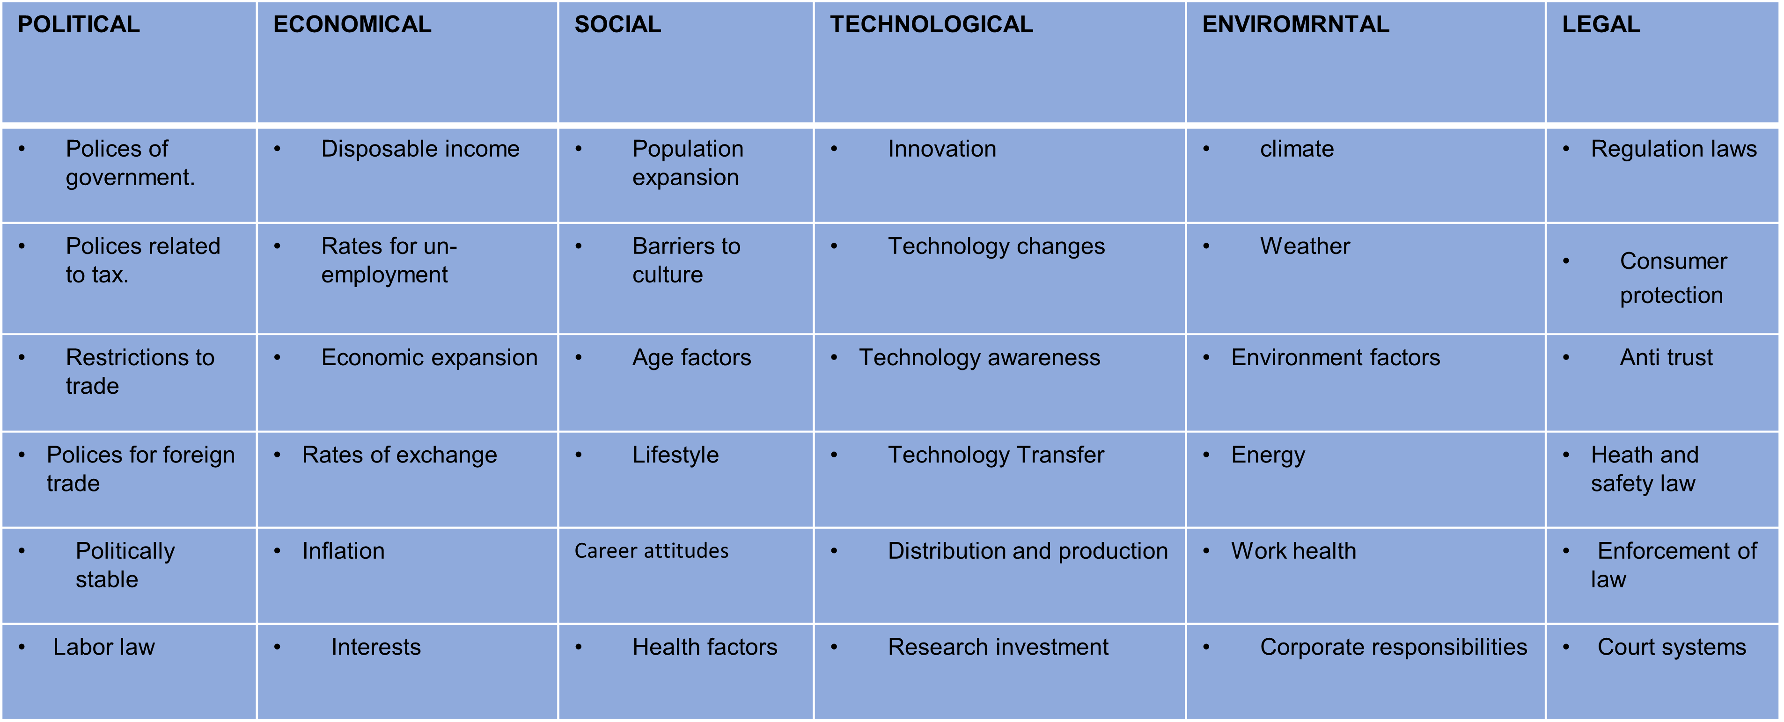

A Pestel analysis is used to identify effects to an organisation from the outside. Pestle is an acronym which stands for, political, Economical, Social, Technological, Environmental, Legal. The earliest sight of this acronym was used by Francis j. Aguilar 1967 he used the tool to scan the business environment. With this tool measuring the problems from all outside factors this could help an organisation or business to thrive and overcome the root course of a complex problem and help to reduce other problems from occurring.

This analysis could be used to identify factors that change, rather the finding a solution for the factors. The PESTLE analysis helps an organization see the bigger picture off what is going on through their environment. This also helps to see market growth, changes to the law and research investment. When a business or organization can use these tools to help reduce problems from occurring this could help the whole company to thrive and grow. There are many other tools which are like the PESTLE tool these are, PESTLIED which means, political, economic, sociological, technological, environmental, legal, international, environmental, demographic. This tool could also be used in the same way the pestle analysis can be used.

p.8

Solutions for the workplace for work-related stress

Skills training
Gaining new skills for a specific job role. This could help gain more experience boosting morale. Making stress less and helping to work harder.
Flexible working Hours
Flexible working hours could help not just with work but also home life releasing more stress. Giving you more time to do other tasks.
Career Change
Changing your career path could bring new and exciting situation to your work life. Also this could be the answer to reducing work-related stress
Staff meetings
Staff meeting could keep all staff members up to date with information that is useful to completing their job.
Effective communication
Effective communication is where co-workers can understand on another for this to work co-workers need to understand and listen carefully to on another (Sandeep Kashyap,2019).
Job role change
Been able to progress in a company can be very gratifying to someone this could help relief work related stress.
Pension scheme
Offering your co-workers, a pension scheme helps to reduce stress when workers know they could help towards their family’s life.
Pay rise Company perks i.e., company car, Free meals, win prizes.
Giving your employees pay rises and having company perks boots employee’s morale and encourages employees to work better this could help boots businesses and organisation reputation on a whole reducing stress as when you’re doing well at work related stress is reduced.

p.9
P.M.I Analysis

A P.M.I analysis is used to identify ways what could be positive or negative or even interesting (Duffy,2021). This could help to also reduce Work-related stress on a personal level for example from your own perspective rather than looking at how to reduce stress for everyone in the business or organization.

Plus | Minus | Interesting
New skill development.  + 7 | Anxiety to not being able to develop new skills.  - 5 | Meet New people.  - 4
New career path.  + 5 | The unknown off what I might face.  - 3 | Pay rise.  + 8
Personal growth.  + 9 | Not liking change of career.  - 2 | The working environment.  + 3
32 – 14 = 18

Training skills

Training skills for me is the most ideal solution for me to help towards my work-related stress. P.10
ACTION PLAN FOR P.M.I

An action plan is used to put your task in to motion. Having an action plan could reduce work-related stress and help you to do better with your work and could reduce long-life health condition and help reduce mental health problems from occurring.

Action | How to achieve goals | When to achieve by
Career change | Apply for new jobs that will increase morale and happiness. | I would like to have made this achieved this goal by 2023.
Develop new skills | Search for new skills to gain and join raining causes. | This would be achieved by 2022.
Personal growth | I will complete this bye achieving my other to tasks. | Once I have made these changes, I would have made personal growth.

p.11

CONCLUSION

Work related stress can cause many problems like I have demonstrated. I have concluded that if you come together with co-workers and find solutions work related stress can be less. Using diagrams like the Fishbone analysis can help an organisation to put solutions in place for the causes and effects that occur in the workplace. PESTEL analysis helps an organisation to identify problems and their effects to the business from the outside perspective. Helping yourself with solutions to help with work related stress could help reduce work related stress. A P.M.I. analysis could help with this stress related problem. This could help determine the best solution for yourself to tackle any work-related stress.

p.12

References

Al Shamsi, H., Almutairi, A.G., Al Mashrafi, S. and Al Kalbani, T. (2020). Implications of Language Barriers for Healthcare: A Systematic Review. Oman Medical Journal, [online] 35(2). Available at: https://www.ncbi.nlm.nih.gov/pmc/articles/PMC7201401/.
Bhui, K., Dinos, S., Galant-Miecznikowska, M., de Jongh, B. and Stansfeld, S. (2016). Perceptions of work stress causes and effective interventions in employees working in public, private and non-governmental organisations: A qualitative study. BJPsych Bulletin, [online] 40(6), pp.318–325. Available at: https://www.ncbi.nlm.nih.gov/pmc/articles/PMC5353523/ [Accessed 16 Nov. 2021].
Duffy, S. (2021). The New Cybersecurity Maturity Model Certification. [online] Learningtree.com. Available at: https://blog.learningtree.com/ [Accessed 2 Nov. 2021].
Harappa (2021). Examples and Types of Language Barriers - Harappa. [online] harappa.education. Available at: https://harappa.education/harappa-diaries/language-barriers-examples-and-types/ [Accessed 18 Oct. 2021].
Mindtools (2009). Cause and Effect AnalysisIdentifying the Likely Causes of Problems. [online] Mindtools.com. Available at: https://www.mindtools.com/pages/article/newTMC_03.htm [Accessed 13 Nov. 2021].
Pipedrive (2015). What to Do When Your Team Is Not Hitting Their Targets? [online] Pipedrive. Available at: https://www.pipedrive.com/en/blog/sales-targets-what-to-do-when-you-are-not-hitting-them [Accessed 6 Dec. 2021].
Sandeep Kashyap (2019). Here’s How Effective Communication is in the Hands of 73% of Professionals. [online] ProofHub. Available at: https://www.proofhub.com/articles/effective-communication [Accessed 3 Dec. 2021].
Statista.com (2020). Statista - The Statistics Portal. [online] Statista. Available at: https://www.statista.com/aboutus/our-research-commitment/1799/conor-stewart [Accessed 22 Nov. 2021].

p.13

