Advanced AI & Machine Learning Assignment
Ren Li 1805212

1. Basic Theory of Influence Map
Influence map is an Artificial Intelligence technique used in computer games to help decision makings. It uses numerical values to represent spatial features and environment conditions of the game [1][2]. In practice, there will be some influence sources in the game map, whose influence will be propagated to other grids of map. There are two approaches to spread influence, one is using convolution filter and the other is using formula, which will be discussed separately in following subsections [3].

1.1 Convolution Filter Updating
Convolutional filtering technique has been applied successfully to many fields like digital signal processing, electrical engineering and image processing. For influence map, convolution filter is used to spread out the influence from sources. A typical convolution filter type is 3x3 Gaussian kernel filter.

For every grid in map, its surrounding influence value will be multiplied by the corresponding values of the filter. Then the products are added together to be the new influence value of central grid. Therefore, with the filter sweeping over the whole map, the influence spreads out from the source. As an example, following is the convolutional computation process for the (4,2) cell of influence map with Gaussian kernel filter:

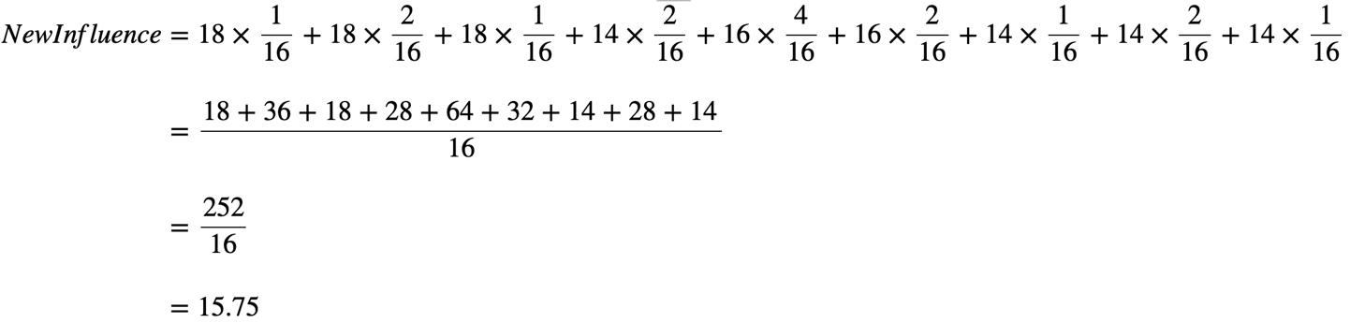

To analyse the space and time complexity of this method, we first write the general algorithm of it.

initialize another influence map2 of the same shape with original influence map
for each row in original influence map:
for each pixel in row:
set sum to zero
for each filter row in filter:
for each element in filter row:
multiply the filter element by the corresponding value of original influence map
add the product result to sum
set the pixel's value of influence map2 to sum
update the original influence map with influence map2

From the above algorithm we can see that there are four for-loops, so the time complexity should be the product of execution times of each loop. Consequently, time complexity is O(map_height * map_width * filter_height * filter_width). The space complexity is O(2 * map_height * map_width) because there is another influence map used to store temporary results.

1.2 formula updating
It is also feasible to update the influence using formula. A typical updating formula is below:

Following is the computation of cell (4,4)’s influence value using this formula, and two influence sources are located at (1,1) and (1,6).

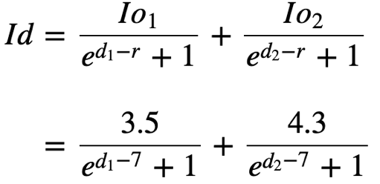

We use two approaches to compute the distance, which are Euclidean Distance and Manhattan Distance. For Euclidean Distance,

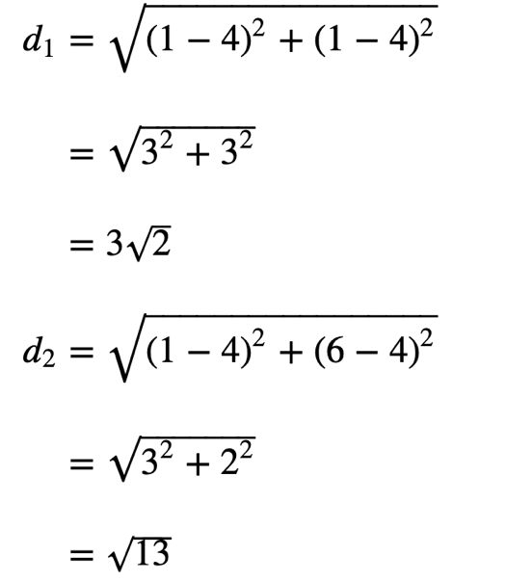
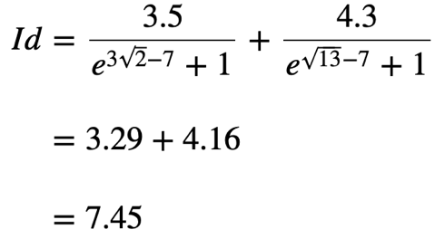

For Manhattan Distance:

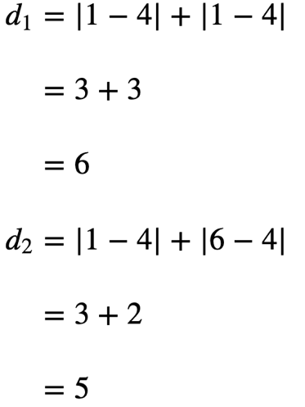

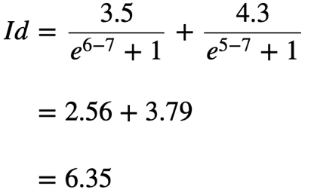

To analyse the time complexity and space complexity, we firstly show the outline algorithm for updating influence map:

initialize another influence map2 of the same shape with original influence map
for each row in original influence map:
for each pixel in row:
set sum to zero
for each influence source:
compute the influence value using spreading formula
add the result to sum
set the value of corresponding pixel in influence map2 to sum
update the original influence map with influence map2

The time complexity of algorithm is O(map_height * map_width * number of influence source) and space complexity is O(2 * map_height * map_width). Because in practice there are usually large amounts of influence sources, the calculation consumption will become huge and unaffordable. Therefore, it is unlikely to directly use this approach to implement influence, and in order to improve the time efficiency, we can use convolution filter updating discussed above, or update with only the highest influence values and ignore others.

2. Influence Map Implementation
In this section, we will introduce the implementation details of the influence map.

2.1 Data structure
The influence map is represented by a 2-D array, where the first axis of array represents rows of map and the second axis represents columns. Except for the array to store influence value, there are two another maps, one is to store temporary calculation results and the other is to store the values of influence sources read from file. Influence Sources are stored in InfluenceSource.txt file as the form of matrix, which is located in the same directory with .cpp file. In InfluenceSource.txt file, influence sources are marked by positive or negative values and other cells are 0.

2.2 Updating Algorithm
The Gaussian convolution filter is also represented by a 3×3 2-D array. While updating influence map, the influence value of cell will be computed with corresponding value of convolution filter. The filter will sweep over the whole map (except the border part), so influence will spread from the influence sources.

3. Influence Map Test
To test the effectiveness of influence map, we implement a robot guiding scenario where the robot needs to navigate its way to destination and avoid enemy positions. Destination is represented by red point and will send out positive influence. Enemy positions are represented by blue points and will send out negative influence. Robot is represented by a white point. When deciding moving direction, the robot will calculate a comprehensive value of positive and negative influence in each direction and choose the highest one. If there are multiple directions with the highest value, robot will randomly choose one to step.

To start the game, press space button to spread the influence and press r button to make robot move. Note that because the initial position of robot is far from positive influence source, if positive influence does not spread out enough, robot will not know where to move and will perform randomly. Therefore, it is better to start to guide robot when you can see the red influence is near it.

Followings are some screen shots of the application.

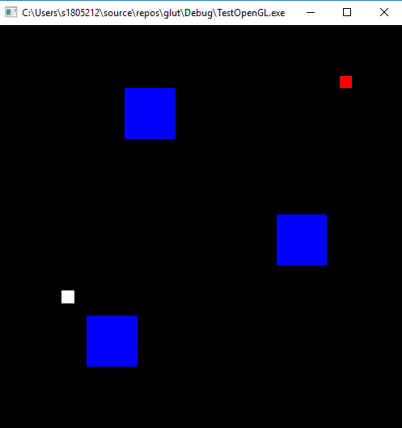
Figure 1: Influence map’s initial status

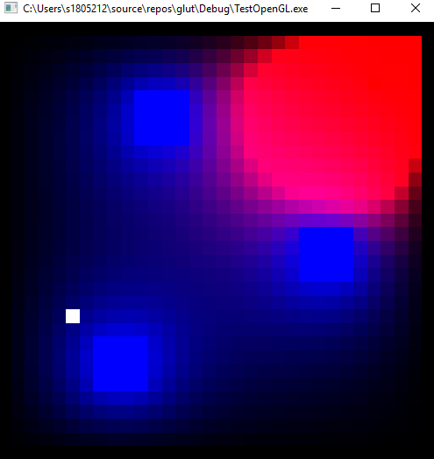
Figure 2: Influence has spread out

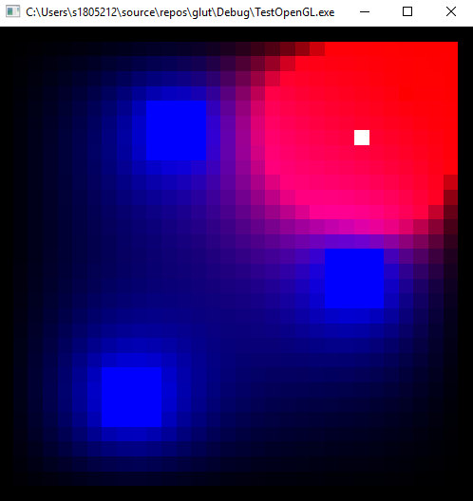
Figure 3: Robot has reached the destination

References
- Wirth, Nathan, and Marcus Gallagher. "An influence map model for playing Ms. Pac-Man." 2008 IEEE Symposium on Computational Intelligence and Games. IEEE, 2008.
- Svensson, Johan, and Stefan J. Johansson. "Influence Map-based controllers for Ms. PacMan and the ghosts." 2012 IEEE Conference on Computational Intelligence and Games (CIG). IEEE, 2012.
- Millington, I and Funge, J; Artificial Intelligence for Games, 2nd Ed; Charles River Media, 2009.
- Krontiris, Athanasios, Kostas E. Bekris, and Mubbasir Kapadia. "ACUMEN: Activity-centric crowd authoring using influence maps." Proceedings of the 29th International Conference on Computer Animation and Social Agents. ACM, 2016.
- Hagelbäck, Johan, and Stefan J. Johansson. "Using multi-agent potential fields in real-time strategy games." Proceedings of the 7th international joint conference on Autonomous agents and multiagent systems-Volume 2. International Foundation for Autonomous Agents and Multiagent Systems, 2008.

Appendix

Source.cpp file
#include <iostream>
#include <stdio.h>
#include <stdlib.h>
#include <cstdlib>
#include <fstream>
#include <string>
#include <sstream>
#include "glut.h"
#define GRIDSIZE 32
using namespace std;

typedef struct rgbtag {
double r;
double g;
double b;
}rgb;

rgb grid[GRIDSIZE][GRIDSIZE]; // influence map
rgb gridtemp[GRIDSIZE][GRIDSIZE]; // store temporary comuting result
rgb gridInfSource[GRIDSIZE][GRIDSIZE]; // store influence source
double convFilter[3][3];
int robotRow;
int robotColumn;
//function prototypes
void init(void);
void display(void);
void drawBox(float w, float h, float l);
void reshape(int w, int h);
void updateTempMapPixel(int row, int column);
void setInfSource();
void robotMove();

void init()
// Initialization function
{
glClearColor(0.0f, 0.0f, 0.0f, 0.0f); // clears colour buffer
glEnable(GL_DEPTH_TEST); // hidden surface removal
glEnable(GL_CULL_FACE); // do not calculate inside of poly's
glFrontFace(GL_CCW); // counter clock-wise polygons are out

for (int i = 0; i < GRIDSIZE; i++) {
for (int j = 0; j < GRIDSIZE; j++) {
gridtemp[i][j].r = 0;
gridtemp[i][j].g = 0;
gridtemp[i][j].b = 0;
}
}

// read influence source from file
string line = "";
ifstream rfile;
rfile.open("InfluenceSource.txt");

if (!rfile.is_open()) {
perror("Error open");
exit(EXIT_FAILURE);
}

int i = 0;
while (getline(rfile, line)) {
int j = 0;
istringstream iss(line);
do
{
//split string by whitespace
string subs;
iss >> subs;
// transform string to double,
// use red to represent positive influence, blue negative
double lol = atof(subs.c_str());
if (lol == 0) {
gridInfSource[i][j].r = 0;
gridInfSource[i][j].g = 0;
gridInfSource[i][j].b = 0;
}
else if (lol > 0) {
gridInfSource[i][j].r = lol;
gridInfSource[i][j].g = 0;
gridInfSource[i][j].b = 0;
}
else if (lol < 0) {
gridInfSource[i][j].r = 0;
gridInfSource[i][j].g = 0;
gridInfSource[i][j].b = -lol;
}
j++;
} while (iss);
i++;
}

robotRow = -1;
robotColumn = -1;

// initialize Gaussian convlution filter
convFilter[0][0] = 0.0625; // 1/16
convFilter[0][1] = 0.125; // 1/8
convFilter[0][2] = 0.0625;
convFilter[1][0] = 0.125;
convFilter[1][1] = 0.25; // 1/4
convFilter[1][2] = 0.125;
convFilter[2][0] = 0.0625;
convFilter[2][1] = 0.125;
convFilter[2][2] = 0.0625;
}

void drawBox(float w, float h, float l)
//drawBox
//***************************************************************************
//This function first translates a further x,y,z units then draws a box of
//width w, height h, length l
{
glPushMatrix(); //save modelview
w = w / 2.0; h = h / 2.0; l = l / 2.0; //adjust values so centre is in middle of box
//draw faces of box
glBegin(GL_POLYGON);
glVertex3f(w, l, h);
glVertex3f(w, l, -h);
glVertex3f(-w, l, -h);
glVertex3f(-w, l, h);
glEnd();
glBegin(GL_POLYGON);
glVertex3f(w, l, h);
glVertex3f(-w, l, h);
glVertex3f(-w, -l, h);
glVertex3f(w, -l, h);
glEnd();
glBegin(GL_POLYGON);
glVertex3f(w, l, h);
glVertex3f(w, -l, h);
glVertex3f(w, -l, -h);
glVertex3f(w, l, -h);
glEnd();
glBegin(GL_POLYGON);
glVertex3f(-w, l, h);
glVertex3f(-w, l, -h);
glVertex3f(-w, -l, -h);
glVertex3f(-w, -l, h);
glEnd();
glBegin(GL_POLYGON);
glVertex3f(-w, -l, h);
glVertex3f(-w, -l, -h);
glVertex3f(w, -l, -h);
glVertex3f(w, -l, h);
glEnd();
glBegin(GL_POLYGON);
glVertex3f(w, -l, -h);
glVertex3f(-w, -l, -h);
glVertex3f(-w, l, -h);
glVertex3f(w, l, -h);
glEnd();
glPopMatrix(); //restore previous modelview matrix so leaving things as you found them
}

// display
//************************************************************************
// desc: handles drawing of scene
void display()
{
glClear(GL_COLOR_BUFFER_BIT | GL_DEPTH_BUFFER_BIT); // clear screen and depth buffer
glLoadIdentity(); // reset modelview matrix

gluLookAt(0.0, 0.0, 1.0, 0.0, 0.0, 0.0, 0.0, 1.0, 0.0); //reset camera position
glColor3f(0, 0, 0); //set colour
glTranslatef(0.5, 0.5, 0.5); //move by x,y and z units
//tests grid by applying greyscale values to each position

for (int i = 0; i < GRIDSIZE; i++) {
for (int j = 0; j < GRIDSIZE; j++) {
glColor3f(grid[i][j].r, 0, grid[i][j].b); //display influence

if (i == robotRow && j == robotColumn) {
glColor3f(1, 1, 1); // display robot
}

glPushMatrix(); //save current position/orientation, etc.
glTranslatef(i, j, 0);
drawBox(1, 1, 1); //draw
glPopMatrix(); //restore previous "current" position/orientation etc.
}
}

glFlush(); //force drawing

glutSwapBuffers(); // bring backbuffer to foreground
//any errors then display error codes
GLenum errCode;
const GLubyte *errString;
if ((errCode = glGetError()) != GL_NO_ERROR)
{
errString = gluErrorString(errCode);
fprintf(stderr, "OpenGL error : %s\n", errString);
}

}

void keyboardread(unsigned char key, int x, int y)
{
switch (key) {
case 'r':
robotMove(); //move robot
glutPostRedisplay();
break;
case ' ':

for (int i = 0; i < GRIDSIZE; i++) {
for (int j = 0; j < GRIDSIZE; j++) {
updateTempMapPixel(i, j);
}
}

//copy calculated array into original
for (int i = 0; i < GRIDSIZE; i++) {
for (int j = 0; j < GRIDSIZE; j++) {
grid[i][j] = gridtemp[i][j];
}
}

setInfSource();

glutPostRedisplay();
break;
}
}

void updateTempMapPixel(int row, int column)
// update the influence value of pixel specified by row and column, using convolution filter
{
// not update edge pixels
if (row == 0 || row == GRIDSIZE - 1)
{
return;
}
else if (column == 0 || column == GRIDSIZE - 1)
{
return;
}
else {
double sumr = 0;
double sumb = 0;
int convCentre = 1;
for (int i = -1; i < 2; i++) {
for (int j = -1; j < 2; j++) {
// convolutional caculation
sumr += grid[row + i][column + j].r * convFilter[convCentre + i][convCentre + j];
sumb += grid[row + i][column + j].b * convFilter[convCentre + i][convCentre + j];
}
}
gridtemp[row][column].r = sumr;
gridtemp[row][column].b = sumb;
}
}

void setInfSource()
{
// only set influence source values
for (int i = 0; i < GRIDSIZE; i++) {
for (int j = 0; j < GRIDSIZE; j++) {
if (gridInfSource[i][j].r != 0 || gridInfSource[i][j].b != 0) {
grid[i][j] = gridInfSource[i][j];
}
}
}
}

void robotMove() {
if (robotRow == -1 || robotColumn == -1)
{
// init robot's position
robotRow = 5;
robotColumn = 10;
return;
}
else
{
// use (weight*redValue-blueValue) as comprehensive influence value to guide robot
double redWeight = 100;
// store comprehensive values in foure directions#
// initialize with very small value (if not being resett means can't go this direction)
// 0-up, 1-down, 2-left, 3-right
double directionInf[4] = { -255, -255, -255, -255 };
if (robotRow == 1 && robotColumn != 1 && robotColumn != GRIDSIZE - 2) {
// can't go left
directionInf[0] = redWeight * grid[robotRow][robotColumn + 1].r - grid[robotRow][robotColumn + 1].b;
directionInf[1] = redWeight * grid[robotRow][robotColumn - 1].r - grid[robotRow][robotColumn - 1].b;
directionInf[3] = redWeight * grid[robotRow + 1][robotColumn].r - grid[robotRow + 1][robotColumn].b;
}
else if (robotRow == GRIDSIZE - 2 && robotColumn != 1 && robotColumn != GRIDSIZE - 2) {
// can't go right
directionInf[0] = redWeight * grid[robotRow][robotColumn + 1].r - grid[robotRow][robotColumn + 1].b;
directionInf[1] = redWeight * grid[robotRow][robotColumn - 1].r - grid[robotRow][robotColumn - 1].b;
directionInf[2] = redWeight * grid[robotRow - 1][robotColumn].r - grid[robotRow - 1][robotColumn].b;

}
else if (robotColumn == 1 && robotRow != 1 && robotRow != GRIDSIZE - 2) {
//can't go down
directionInf[0] = redWeight * grid[robotRow][robotColumn + 1].r - grid[robotRow][robotColumn + 1].b;
directionInf[2] = redWeight * grid[robotRow - 1][robotColumn].r - grid[robotRow - 1][robotColumn].b;
directionInf[3] = redWeight * grid[robotRow + 1][robotColumn].r - grid[robotRow + 1][robotColumn].b;
}
else if (robotColumn == GRIDSIZE - 2 && robotRow != 1 && robotRow != GRIDSIZE - 2) {
// can't go up
directionInf[1] = redWeight * grid[robotRow][robotColumn - 1].r - grid[robotRow][robotColumn - 1].b;
directionInf[2] = redWeight * grid[robotRow - 1][robotColumn].r - grid[robotRow - 1][robotColumn].b;
directionInf[3] = redWeight * grid[robotRow + 1][robotColumn].r - grid[robotRow + 1][robotColumn].b;
}
else if (robotRow == 1 && robotColumn == 1) {
// can't go left and down
directionInf[0] = redWeight * grid[robotRow][robotColumn + 1].r - grid[robotRow][robotColumn + 1].b;
directionInf[3] = redWeight * grid[robotRow + 1][robotColumn].r - grid[robotRow + 1][robotColumn].b;
}
else if (robotRow == 1 && robotColumn == GRIDSIZE - 2) {
// can't go left and up
directionInf[1] = redWeight * grid[robotRow][robotColumn - 1].r - grid[robotRow][robotColumn - 1].b;
directionInf[3] = redWeight * grid[robotRow + 1][robotColumn].r - grid[robotRow + 1][robotColumn].b;
}
else if (robotRow == GRIDSIZE - 2 && robotColumn == 1) {
// can't go right and down
directionInf[0] = redWeight * grid[robotRow][robotColumn + 1].r - grid[robotRow][robotColumn + 1].b;
directionInf[2] = redWeight * grid[robotRow - 1][robotColumn].r - grid[robotRow - 1][robotColumn].b;
//cout << "Inf: " << directionInf[0] << ", " << directionInf[1] << ", " << directionInf[2] << ", " << directionInf[3] << endl;
}
else if (robotRow == GRIDSIZE - 2 && robotColumn == GRIDSIZE - 2) {
// can't go right and up
directionInf[1] = redWeight * grid[robotRow][robotColumn - 1].r - grid[robotRow][robotColumn - 1].b;
directionInf[2] = redWeight * grid[robotRow - 1][robotColumn].r - grid[robotRow - 1][robotColumn].b;
}
else {
//can move to all four directons
directionInf[0] = redWeight * grid[robotRow][robotColumn + 1].r - grid[robotRow][robotColumn + 1].b;
directionInf[1] = redWeight * grid[robotRow][robotColumn - 1].r - grid[robotRow][robotColumn - 1].b;
directionInf[2] = redWeight * grid[robotRow - 1][robotColumn].r - grid[robotRow - 1][robotColumn].b;
directionInf[3] = redWeight * grid[robotRow + 1][robotColumn].r - grid[robotRow + 1][robotColumn].b;
}

// find max value of directionInf array, if values are same, go randomly
int maxDirection = 0;
double maxValue = directionInf[0];
for (int i = 1; i < 4; i++) {
if (directionInf[i] > maxValue)
{
maxDirection = i;
maxValue = directionInf[i];
}
else if (directionInf[i] == maxValue)
{
int randNumber = rand() % 100;
if(randNumber<=50)
{
maxDirection = i;
}
}
}

// move robot
if (maxDirection == 0) {
robotColumn += 1;
}
else if (maxDirection == 1) {
robotColumn -= 1;
}
else if (maxDirection == 2) {
robotRow -= 1;
}
else if (maxDirection == 3) {
robotRow += 1;
}
cout << "row: " << robotRow << ", column: " << robotColumn << endl;
cout << "maxValue: " << maxValue << ", maxDirection: " << maxDirection << endl;
cout << "directionInf: " << directionInf[0] << ", " << directionInf[1] << ", " << directionInf[2] << ", " << directionInf[3] << endl;
cout << "red: " << grid[robotRow][robotColumn].r << endl;
return;
}

}

void reshape(int w, int h)
//reshape
//************************************************************************
//OpenGL reshape callback is called when the window is resized
{
glViewport(0, 0, (GLsizei)w, (GLsizei)h); //respecify size of view port to match new w and h
glMatrixMode(GL_PROJECTION); //go into projection mode
glLoadIdentity(); //reset projection matrix
glOrtho(0.0, GRIDSIZE, 0.0, GRIDSIZE, 0.0, 100.0); //defines orthoganal projection (parrallel
// viewing volume
// window limits of display
// left =0.0, right =2.0,
// bottom = 0.0, top = 2.0
// near =0.0, far = 100.0
//gluPerspective(60.0,(GLfloat)w/(GLfloat)h,1.0,200.0); //redefine projection matrix to match changes in w and h
glMatrixMode(GL_MODELVIEW); //switch back to modelview mode
glLoadIdentity(); //reset modelview matrix
gluLookAt(0.0, 0.0, 1.0, 0.0, 0.0, 0.0, 0.0, 1.0, 0.0); //reset camera position
}

int main(int argc, char** argv)
{
glutInit(&argc, argv);
glutInitDisplayMode(GLUT_DOUBLE | GLUT_RGB | GLUT_DEPTH);
glutInitWindowSize(500, 500);
glutInitWindowPosition(100, 100);
glutCreateWindow(argv[0]);
init();
glutDisplayFunc(display);
glutReshapeFunc(reshape);
glutKeyboardFunc(keyboardread);
glutMainLoop();
return 0;
}

