
APPENDIX GA36a

LEVEL 4 ASSESSMENT SPECIFICATION

Student name: | Jordan James | Student ID number:
Programme: | HNC Mechanical Engineering
Module: | Materials
Module code: | PSDM4003 | Contribution to Overall Module Assessment (%): | 20%
Lecturer: | P R Taylor | Internal Verifier: | L Rutherford
Assignment Title: | Ductile and Brittle Fracture | Word count (or equivalent): | 1500
Submission deadline: | April 29th, 2021. | Return date of provisional marks & written feedback: | May 20th, 2021
Submission method: | All written assessments, where practical and possible, must be submitted via Turnitin unless otherwise instructed by the Lecturer. (Please DO NOT put this assessment specification into Turnitin or it will match many similarities with other students’ submissions.)  Alternative submission method (if applicable):  Late submission of the assessment will result in a late penalty mark. Penalties for late submission: Up to one week late, maximum mark of 40%. Over one week late, 0%. Only the Extenuating Circumstances Panel may approve a change to submission dates.
Academic honesty / referencing: | Academic honesty is required. In the main body of your submission you must give credit to authors on whose research and ideas your work is based. Append to your submission a reference list that indicates the books, articles, etc. that you have used, cited or quoted in order to complete this assessment.

Module Learning Outcomes
(from module syllabus)
Analyse and understand the cause of materials failures.

TASK DESCRIPTION

Introduction.

Fracture is a common cause of failure in metals. Whilst it will occur when a metal is stressed
beyond its tensile strength under certain conditions, it will also occur at stresses below the elastic limit.
Some metals may creep over long periods of time (particularly at high temperatures) until fracture.
occurs, whilst fracture which is the result of repeated cyclic stress is termed fatigue failure. Furthermore,
some metals may fail by a form of brittle fracture (which is influenced by low temperatures) and other will.
fail due to ductile failure.

Object:

To investigate notched bar impact tests on metals over a range of temperatures to determine their susceptibility to brittle fracture.

Impact testing can be used to the investigate fracture characteristics of metals. Typically, samples will
tested through a range of temperatures and the energy absorbed during testing used to determine the
fracture toughness of the material. Using a Hounsfield balanced impact tester, the following data was
gathered.

Temperature of sample during testing ( C ) | Impact value (J)  Aluminium | Impact value (J)  Copper | Impact value (J)  Mild Steel (0.1% C)
-200 | 6.1 | 17.6 | 1.1
-100 |  |  | 4.1
-50 |  |  | 6.8
-20 |  |  | 54.9
0 |  |  | 55.3
21 | 7.1 | 18.0 | 58.3
50 |  |  | 54.2
100 | 6.6 | 15.9 | 54.5

GUIDANCE FOR Students IN THE COMPLETION OF TASKS

Plot a graph of Impact value against temperature for each metal.

Identify with metal(s) that exhibit a ductile/brittle transition temperature. Explain the importance of the
ductile/brittle transition temperature and discuss what factors affect the result at which the temperature
occurs.

Using the graphs estimate the per cent crystalline fracture appearance at each test temperature as well as
the level of plastic deformation.

Discussion of results.
Explain the important differences between ductile and brittle impact failures.
Identify the type of fractures which occur in the metal tested and co-relate that to the testing temperature.
Discuss the significance of your results.
What other factors may influence the transition temperature in the affected metal? Heat treatment and mechanical working?
Illustrate your report with relevant examples.

GUIDANCE FOR Students IN THE COMPLETION OF TASKS

NOTE: The guidance offered below is linked to the five generic assessment criteria overleaf.

- Engagement with Literature Skills
Your work must be informed and supported by scholarly material that is relevant to and focused on the task(s) set. You should provide evidence that you have accessed an appropriate range of sources, which may be academic, governmental and industrial; these sources may include academic journal articles, textbooks, current news articles, organisational documents, and websites. You should consider the credibility of your sources; academic journals are normally highly credible sources while websites require careful consideration/selection and should be used sparingly. Any sources you use should be current and up-to-date, mostly published within the last five years or so, though seminal/important works in the field may be older. You must provide evidence of your research/own reading throughout your work, using a suitable referencing system, including in-text citations in the main body of your work and a reference list at the end of your work.

Guidance specific to this assessment:

- Knowledge and Understanding Skills
At level 4, you should be able to demonstrate knowledge of the underlying concepts and principles associated with your area(s) of study. Knowledge relates to the facts, information and skills you have acquired through your learning. You demonstrate your understanding by interpreting the meaning of the facts and information (knowledge). This means that you need to select and include in your work the concepts, techniques, models, theories, etc. appropriate to the task(s) set. You should be able to explain the theories, concepts, etc. to show your understanding. Your mark/grade will also depend upon the extent to which you demonstrate your knowledge and understanding.

Guidance specific to this assessment:

- Cognitive and Intellectual Skills
You should be able to present, evaluate and interpret qualitative and quantitative data, in order to develop lines of argument and make sound judgements in accordance with basic theories and concepts of your subject(s) of study. You should be able to evaluate the appropriateness of different approaches to solving problems related to your area(s) of study and/or work. Your work must contain evidence of logical, analytical thinking. For example, to examine and break information down into parts, make inferences, compile, compare and contrast information. This means not just describing what! But also justifying: Why? How? When? Who? Where? At what cost? You should provide justification for your arguments and judgements using evidence that you have reflected upon the ideas of others within the subject area and that you are able to make sound judgements and arguments using data and concepts. Where relevant, alternative solutions and recommendations may be proposed.

Guidance specific to this assessment:

- Practical Skills
At level 4, you should be able to apply the basic underlying concepts and principles to evaluate and interpret these within the context of your area of study. You should be able to demonstrate how the subject-related concepts and ideas relate to real world situations and/or a particular context. How do they work in practice? You will deploy models, methods, techniques, and/or theories, in that context, to assess current situations, perhaps to formulate plans or solutions to solve problems, or to create artefacts. This is likely to involve, for instance, the use of real world artefacts, examples and cases, the application of a model within an organisation and/or benchmarking one theory or organisation against others based on stated criteria.

Guidance specific to this assessment:

- Transferable Skills for Life and Professional Practice
Your work must provide evidence of the qualities and transferable skills necessary for employment requiring the exercise of some personal responsibility. This includes demonstrating: that you can communicate the results of your study/work accurately and reliably, and with structured and coherent arguments; that you can initiate and complete tasks and procedures, whether individually and/or collaboratively; fluency of expression; clarity and effectiveness in presentation and organisation. Work should be coherent and well-structured in presentation and organisation.

Guidance specific to this assessment:

Student FEEDBACK FORM

This section details the extent to which the assessment criteria are demonstrated by you, which in turn determines your mark. The marks available for each category of skill are shown. Lecturers will use the space provided to comment on the achievement of the task(s), including those areas in which you have performed well and areas that would benefit from development/improvement.

Generic Assessment Criteria | Marks available | Marks  awarded
1. Engagement with Literature Skills
.
A comprehensive bibliography is included. There is excellent evidence of further reading with clear referencing within the text. |  | 8
 | 10 | 8
2. Knowledge and Understanding Skills

The report shows clear evidence of an excellent understanding of the principles and concepts of impact testing. There is wide discussion within the report. |  | 30
 | 40 | 30
3. Cognitive and Intellectual Skills

Evaluation of the data and results is excellent. The report clearly shos excellent insight and understanding. |  | 15
 | 20 | 15
4. Practical Application Skills

A very good range of skills and techniques has been employed. Some greater use of graphics packages would have been advantageous. |  | 12
 | 20 | 12
5. Transferable Skills for Life and Professional Practice

The work is well written and is presented in a professional manner. The report is well laid out with a fluency evident in the rubric. |  | 6
 | 10 | 6

Assessment Mark (Assessment marks are subject to ratification at the Exam Board. These comments and marks are to give feedback on module work and are for guidance only until they are confirmed. ) | Late Submission Penalties (tick if appropriate) |  | 71%
 | Up to 1 week late (40% Max) |  | 71%
 | Over 1 week late (0%) |  | 71%

GENERIC ASSESSMENT CRITERIA

Level 4
In accordance with the Framework for Higher Education Qualifications, at the end of Level 4 students will be expected to have demonstrated knowledge of the basic underlying concepts and principles of a subject, and an ability to evaluate and interpret these within the context of that area of study. They should be able to present, evaluate and interpret qualitative and quantitative data in order to develop lines of argument and make sound judgements in accordance with basic theories and concepts of their subject(s) of study. They will have learned how to evaluate different approaches to solving problems, and will be able to communicate the results of their study/work accurately and reliably, and with structured and coherent arguments. They will be able to undertake further training and develop new skills within a structured and managed environment and will have the qualities and transferable skills necessary for employment requiring the exercise of some personal responsibility.

Level 4 | FAIL | MARGINAL FAIL | SATISFACTORY  (3rd / Pass) | GOOD  (2.2 / Pass) | VERY GOOD  (2.1 / Merit) | EXCELLENT  (1st / Distinction) | EXCEPTIONAL  (1st / Distinction)
Category | 0-29% | 30-39% | 40-49% | 50-59% | 60-69% | 70-84% | 85-100%
Engagement with literature (including reading, referencing,  academic conventions and  academic honesty) | Little or no evidence of reading and/or reliance on inappropriate sources.  Views and findings mostly unsupported and non-authoritative.  Referencing conventions used incoherently or largely absent. | Poor engagement with essential reading. No evidence of wider reading. Reliance on inappropriate sources, and/or indiscriminate use of sources. Heavily reliant on information gained through class contact. Inconsistent and weak use of referencing. | Engagement with a limited range of mostly relevant and credible sources but with some reliance on information gained through class contact. Some omissions and minor errors.  Referencing conventions evident though not always applied accurately or consistently. | Engagement with an appropriate range of literature, including sources retrieved independently. Some over-reliance on texts rather than other sources. Referencing may show minor inaccuracies or inconsistencies. | Engagement with a wide range of literature, including sources retrieved independently.  Selection of relevant and credible sources. Generally sound referencing, with no/very few inaccuracies or inconsistencies. | Engagement with an extensive range of relevant and credible literature. Consistently accurate application of referencing. | Exceptional engagement with an extensive range of relevant and credible literature. High-level referencing skills consistently applied.
Knowledge and understanding (Knowledge of the basic underlying concepts and principles of a subject.) | Major gaps in knowledge and understanding of the basic underlying concepts and principles of the subject matter. Inclusion of irrelevant material. Substantial inaccuracies. | Gaps in knowledge of the basic underlying concepts and principles, with flawed or superficial understanding. Some significant inaccuracies and/or irrelevant material. | Limited knowledge and understanding of the basic underlying concepts and principles within the subject area. Some elements may be missing. | Knowledge of the basic underlying concepts and principles is accurate with a good understanding of the field of study but lacks depth and/or breadth. | Competent knowledge of the basic underlying concepts and principles. Exhibits very good understanding. | Excellent knowledge and understanding of the basic underlying concepts and principles of the subject. | Exceptional, detailed knowledge and understanding of the basic underlying concepts and principles
Cognitive and intellectual skills  (Evaluate underlying concepts and principles of a subject and interpret qualitative and quantitative data in order to develop lines of argument and make sound judgements.) | Wholly or almost wholly descriptive work. Little or no evaluation of the underlying concepts and principles.  Failure to develop arguments, leading to illogical or invalid judgements. Minimal or no use of  evidence to back up views. | Largely descriptive work, with superficial evaluation of the underlying concepts and principles. Weak interpretation of data, flawed development of arguments and judgements. Information accepted uncritically, uses generalised statements made with scant evidence and unsubstantiated opinions. Ideas sometimes illogical and contradictory. | Limited attempt at evaluation of the underlying concepts and principles, tending towards description.  Can interpret qualitative and quantitative data but with some errors. Some evidence to support emerging arguments and judgements but these may be underdeveloped or with a little inconsistency / mis-interpretation. | Good evaluation of the underlying concepts and principles. Can interpret qualitative and quantitative data, with minor errors.  An emerging ability to use evidence to support the argument.  Mostly valid arguments and logical judgements. | Sound evaluation of the underlying concepts and principles. Can interpret qualitative and quantitative data accurately. Ability to devise arguments using evidence to make mostly appropriate and valid judgements. | Excellent evaluation of the underlying concepts and principles. Can interpret qualitative and quantitative data accurately and with some insight. Excellent ability to devise arguments using evidence and make appropriate and valid judgements. | Exceptional evaluation of the underlying concepts and principles based evidence. Outstanding interpretation of qualitative and quantitative data.  Exceptional ability to devise arguments using evidence and make wholly appropriate and valid judgements.
Practical skills  (Different approaches to solving problems in particular contexts.) | Limited or no use of taught, basic methods, materials, tools and/or techniques.  Little or no appreciation of the context of the application.  Very weak evidence of different approaches to problem-solving in particular contexts. | Rudimentary application of taught, basic methods, materials, tools and/or techniques but without consideration and competence. Flawed appreciation of the context of the application.  Weak evidence of different approaches to problem-solving in particular contexts. | An adequate awareness and mostly appropriate application of basic methods, materials, tools and/or techniques.  Basic appreciation of the context of the application.  Can identify problems in particular contexts and propose basic alternative approaches or solutions though there may be errors. | A good and appropriate application of basic methods, materials, tools and/or techniques.  Clear appreciation of the context of the application.  Good evidence of different approaches to problem-solving in particular contexts and proposes mostly appropriate solutions. | A very good application of a range of basic methods, materials, tools and/or techniques.  Very good consideration of the context of the application. Very good evidence of different approaches to problem-solving in particular contexts and proposes appropriate solutions. | An advanced application of a range of taught, basic methods, materials, tools and/or techniques.  The context of the application is well considered, and insightful.  Excellent evidence of different approaches to problem-solving in particular contexts and proposes appropriate solutions. | Exceptional levels of application and deployment skills in particular practical contexts. Outstanding identification of problems in particular contexts and formulation of wholly appropriate, thoughtful solutions / different approaches.
Transferable skills for life and professional practice  (Communicate the results of their study/work accurately and reliably, and with structured and coherent arguments; the qualities needed for employment requiring the exercise of some personal responsibility within a structured and managed environment.) | Work is poorly structured, disorganised, inaccurate and/or confusingly expressed. Very weak use of language and/or very inappropriate style. Failure to work effectively individual or as part of a group. Little or no evidence of the skills for employment requiring the exercise of some personal responsibility. | Work is poorly presented in a disjointed manner. It is loosely, and at times incoherently, structured, with information and ideas often poorly expressed. Weak use of language and/or inappropriate style. Flawed approach to individual or group work, meeting only partial obligations to others. Limited evidence of the skills for employment requiring the exercise of some personal responsibility. | Mostly ordered presentation and structure in which relevant ideas / concepts are reasonably expressed. Work may lack coherence and/or accuracy in places. Can work as part of a group, meeting most obligations to others but perhaps with limited involvement in group activities.  Demonstrates the basic skills for employment requiring the exercise of some personal responsibility, with some areas of minor weakness. | Mostly coherent, organised and accurate work, in a suitable structure and is for the most part clearly expressed. Can work effectively independently and/or as part of a team, with clear contribution to group activities.  Demonstrates the skills for employment requiring the exercise of some personal responsibility, with some areas of strength and some of minor weakness. | Work is accurate, coherent, fluent, well-structured and organised.  Can work effectively independently and/or as part of a team, with very good contribution to group activities. Demonstrates very good skills for employment requiring the exercise of some personal responsibility, with just occasional minor weakness. | Work is coherent, very fluent and is presented professionally. Can work effectively independently and/or as part of a team, with an excellent contribution to group activities. Demonstrates excellent skills for employment requiring the exercise of some personal responsibility with an appetite for further development. | Work is accurate, exceptionally coherent, very fluent and presented well. Can work effectively independently and/or as part of a team, with an exceptional contribution to group activities. Demonstrates exceptional skills for employment requiring the exercise of some personal responsibility with an appetite for further development.



Student Name: Jordan James
Lecture Name: Peter Taylor
Module: Materials
Module Code: PSDM4003
Assignment Name: Brittle Fracture

Table of Contents
Introduction 15
Ductile and Brittle Fracture 16-19
Results 20-22
References 23
Bibliography 24

Introduction

This assignment will discuss different failure mechanism that material can experience and how they react at different temperatures. A display of data will be shown presenting the relationship between material temperature and applied energy. A discussion of the result will also be shown and how mechanical work process can affect the properties and crystal structure. A description of standard impact test methods will be displayed and how the standard test procedure is carried out.

Ductile and Brittle fracture

Impact testing is used in industry to help determine the toughness of a material. Toughness is defined as the amount of energy required to cause a specimen to fracture. The toughness of a material is measured underneath stress/ strain diagram, but this is when a load is being applied gradually. Impact testing determines the toughness of a material when it is exposed to fast loading conditions. Impact testing also illustrates a materials resistance to ductile or brittle fracture.
Impact testing can be carried out using two main types of tests, Charpy and Izod test. Both determine the same property but in two slightly different methods. The results of these tests can only be compared if the same specimen has undergone a fit for service assessment. Impact testing is a very controlled type of testing and the specimens used by meet required standards The Charpy impact test consists of a pendulum travelling at a set speed into the specimen which has been machined notch in it. The method of this test came from ‘French scientist Georges Charpy’ - Allen, J (2011). The parameters of this notch in the face of the specimen must meet BS EN ISO 148-1:2016, this allows it to be a qualitive test and produce control, reliable results. See Figure 1.

Figure 1
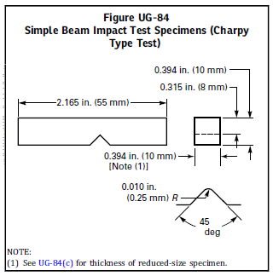

Figure 1 is adapted from Figure UG-84. (Figure 1 is taken from ASME VIII: ASME Boiler and Pressure Vessel Code, p.215, 2017

The machined specimen will be supported, and the pendulum will strike the face of the specimen opposite to the notch. The pendulum will swing through the test piece and the

height of the pendulum after the strike is the measurement of the energy absorbed by the specimen, therefore it can be determined how much energy is required to fracture the specimen. See Figure 2.
Figure 2
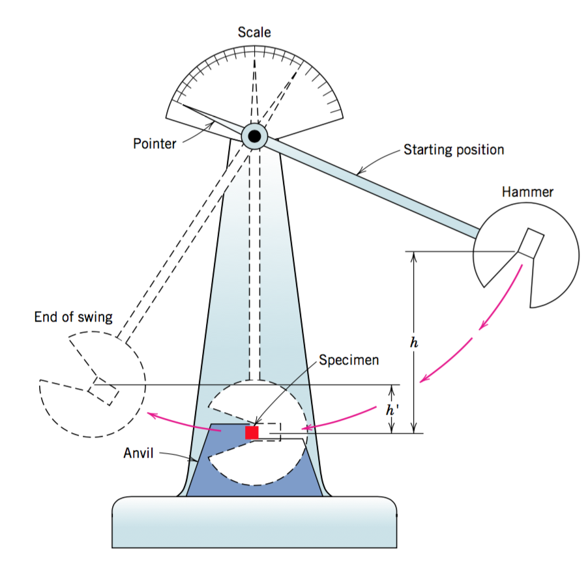

Figure 2 is taken from Jordan, J (2016) Materials Science.
Every specimen should be tested three times at the same temperature and the mean results shall be used, this ensures the results are reliable and can be used in confidence.

Material failures can be devastating occurrences and it is key that they are identified and designed against in the engineering industry. There are three main types of failure mechanisms, fatigue, fracture, and creep. Fatigue failure is when a material will fail when it has experienced repeated stress for extensive periods of time, this type of failure is often found in components that experience cyclic loading, i.e., turbines and engines.
Creep is ‘when a material is subjected to a load for a very long time it may continue to deform until a sudden fracture occurs’ – Engineering Toolbox (2011).
When material fails due to fracturing, the fracture type is either ductile or brittle. Ductile failure is the desired failure type as the material will give indication that failure is imminent, unlike a brittle fracture. Materials that fail in the result of a ductile fracture will indication plastic deformation. Plastic deformation is when a material is no longer able to returns to its original shape, even when the load is removed, permanent strain on the material remains.

A visual aid of this happening is when a material specimen begins to neck, this is when the length of the specimen is increasing but the cross-sectional area is decreasing. See Figure 3.

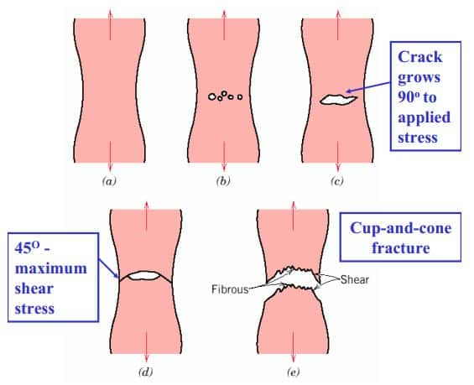
Figure 3

Figure 3 is taken from Paul, A (2014) Ductile Fracture of Metals by Necking.

When a specimen is under load it will begin to neck if it is a ductile material. Eventually after continuous load void nucleation will begin to occur, eventually each minuscule void will grow and link up. The distorted specimen will begin to shear at the surface until the point of fracture.
Brittle fracture on the other hand will show no plastic deformation prior to fracturing, the fracture occurs by rapid crack propagation, unlike a ductile fracture here the crack propagation is gradual. Brittle materials tend to have little toughness and are poor under strain. A brittle fracture of a specimen can be determined by the flat fracture surface and little or no indication of plastic deformation. See figure 4.

Figure 4

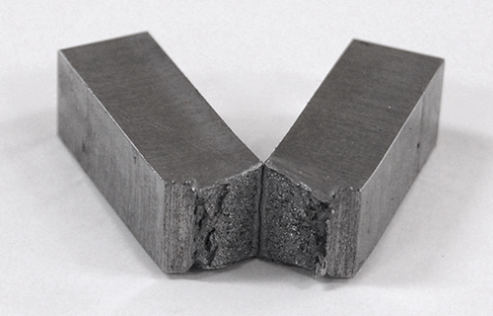

Figure 4 is taken from Astrona, Mechanical Testing

Figure 4 is a steel specimen that has undergone a Charpy v-notch impact test. The fracture is smooth and leaving a shiny surface. There are two types of surfaces with brittle fracture, intergranular fracture and transgranular fracture. Intergranular fracture is when a crack propagates along the grain boundary, whereas transgranular fractures are when the material fractures through the grain boundaries. Transgranular fractures will leave a smoother fracture surface as the crack is within the grain making it difficult to follow the grain boundary and change direction.

Results

Temperature of sample during testing (C) | Impact value (J)  Aluminium | Impact value (J)  Copper | Impact value (J)  Mild Steel (0.1% C)
-200 | 6.1 | 17.6 | 1.1
-100 |  |  | 4.1
-50 |  |  | 6.8
-20 |  |  | 54.9
0 |  |  | 55.3
21 | 7.1 | 18.0 | 58.3
50 |  |  | 54.2
100 | 6.6 | 15.9 | 54.5

Table 1 – Assignment data

Table 1 is test data provided by Pembrokeshire college is the results from an impact test activity carried out by a Hounsfield balances impact tester. Three materials were used, aluminium, copper, and mild steel. Each specimen was tested as a range of temperatures to see how they react with regards to the fracture toughness of the material. Figure 5 shows a graph with the impact values of each metal plotted against the different temperatures. Each metal is displayed to show the comparison in behaviour at each temperature.

Figure 5

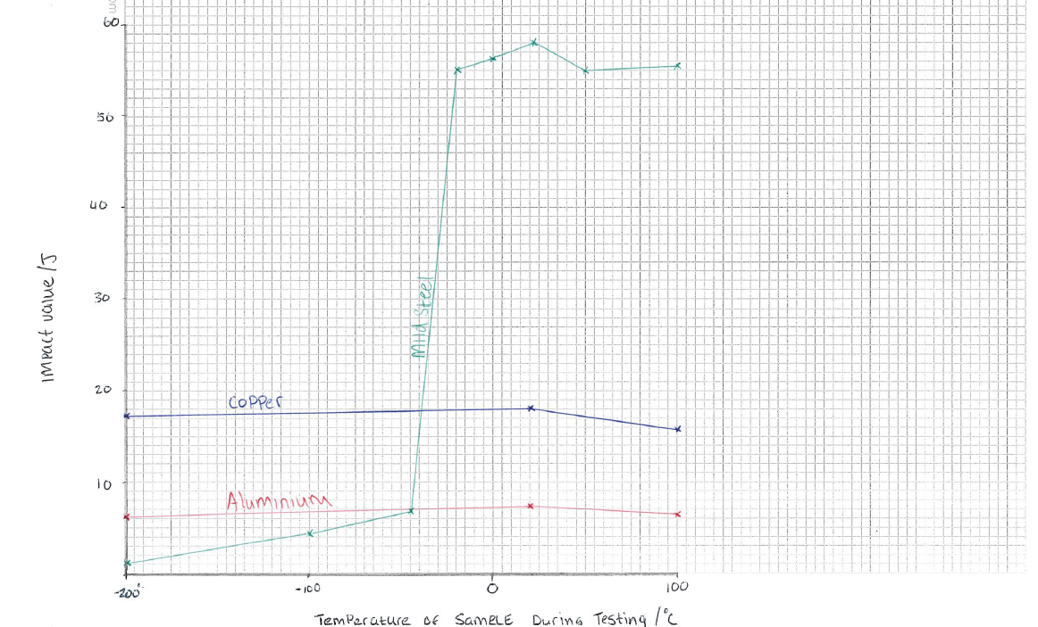

Figure5 – Graph of Impact value against temperature for each metal, Source: Personal Collection

Figure 5 shows the relationship between ductile and brittle behaviour. 0.1% mild steel shows that the material is brittle at low temperatures and becomes more ductile as the temperature increases. From temperature range -200°C to -50°C the mild steel is extremely brittle as it only requires 1.1 -6.8 joules of impact energy to break the specimen. As the temperature of the material begins to increase, so does the impact energy value. This shows that the mild steel is able to absorb more impact energy, thus making it more ductile. The brittle to ductile transition temperature is at -20°C due to the increase of impact energy required to fracture the specimen, 54.9J. As mild steel has a body centred cubic crystal structure it does have DBBT, unlike with copper and aluminium there is no ductile to brittle temperature transition. This is because approximately the same amount of energy is required to fracture the at any temperature range from -200°C to 100°C.
Being able to identify the brittle to ductile temperature is important as it will give an understanding of how a material will react under different temperatures. The WWII liberty ships, is a prime example of this. The steel used in fabrication was exposed to extreme temperatures much below the critical temperature, this significant temperature change, alter the failure mechanism from ductile to brittle, resulting in the ships splitting into two.
Overtime, engineers have identified the significance of the DBTT and use a range of methods to avoid unexpected fracture. Heat treatment and cold working of metal is way of altering the mechanical properties and crystal structure which changes the behaviour of how they react. A main mechanical property that is manipulated is the hardness of a metal, this can be reached by heating a metal to a set temperature and rapidly quenching it to re-configure the crystal structure. The time spent quenching the steel determines the type of steel is formed. If the steel is quenched rapidly, martensite will be formed. martensite is very and hard and strong, however it is brittle and extremely poor ductility, the reason for this is because there are trapped atoms in the distorted crystal structure. Pearlite can be formed as well but the steel must be cooled in air for a longer duration of time, pearlite is a soft steel and usually added to cementite to create harder steel.
As a result, it is clear that heat treatment and mechanical workings to steels can affect how steels behave around the ductile to brittle transition temperature.

References

Jordan, J (2016) Ductile to brittle transitions in materials. Available at: Ductile to brittle transitions in materials. (jeremyjordan.me) (Accessed 12/04/21)

Allen, J (2011) Mechanics of Materials for Dummies. Indiana, Wiley Publishing Inc, p. 219
Engineering Toolbox, (2011). Steels - Endurance Limits and Fatigue Stress. [online] Available at: Steels - Endurance Limits and Fatigue Stress (engineeringtoolbox.com) (Accessed 12.04.21)

Paul, A (2014) Ductile Fracture of Metals by Necking. Available at: Ductile Fracture of Metals by Necking - Cup and Cone Failure | CivilDigital | (Accessed 12/04/21)

Astrona (2020) Mechanical Testing. Available at: Charpy Impact Test - Testing | Charpy V-notch Test Lab | ATRONA Test Labs (Accessed 13/04/21)

Bibliography
Allen, J (2011) Mechanics of Materials for Dummies. Indiana, Wiley Publishing Inc

Huber, M (2013) The Beginners Guide to Engineering: Mechanical Engineering. Pittsburgh, PA, Quantum Scientific Publishing

Marine History (2010) History of the Liberty Ships from World War 2. Available at History of the Liberty Ships from World War 2: The Fatally Flawed Ships - Bright Hub Engineering (Accessed 28/04/2021)

