UNIVERITY OF WALES TRINITY SAINT DAVID

WORKPLACE CULTURE AND ITS IMPACT ON ORGANISATIONAL EFFICIENCY
  - Tesco Plc


STUDENT NAME: MADALINA GEORGIANA SOREANU
ID: 1813590
LECTURER: JANET GREEN

Table of Contents
TABLE OF FIGURES 3
INTRODUCTION 4
WORKPLACE CULTURE OF TESCO PLC 5
BRIEF INTRODUCTION TO TESCO PLC ORGANIZATION 5
ORGANIZATIONAL CULTURE 6
APPLICATION OF MANAGEMENT THEORIES ON TESCO’S ORGANIZATIONAL CULTURE 10
CRITICAL EVALUATION OF MACRO ENVIRONMENT OF THE RETAIL INDUSTRY OF THE UK 13
PESTLE ANALYSIS OF RETAIL INDUSTRY OF THE UK 13
IMPACT ON ORGANIZATIONAL CULTURE AND PERFORMANCE OF TESCO 15
CORPORATE SOCIAL RESPONSIBILITY 17
CONCLUSION 19
REFERENCES 20

TABLE OF FIGURES
Figure 1: General management theory 7
Figure 2: Management by Objectives 9
Figure 3: Contingency theory 9
Figure 4: Organization culture 10
Figure 5: PESTLE framework 13
Figure 6: Governance structure 17

INTRODUCTION
The development of an organization depends upon the establishment of an effective organizational culture. An effective organizational culture has a strong learning system that improves employee performance. The knowledge and awareness of the organizational culture increase employee loyalty. In this assignment, the theoretical review of various aspects of organizational culture is discussed. How organizational culture influences the efficiency of the organization is also discussed. In this assignment, the ethical standards and present organizational culture of Tesco Plc of the UK are analyzed.

WORKPLACE CULTURE OF TESCO PLC

BRIEF INTRODUCTION TO TESCO PLC ORGANIZATION
Tesco Plc is one of the largest foods retailing organization in the world and one of the leading retailers in the UK industry. The first ever Tesco Store was started by Jack Cohen in the year 1919, 100 years ago, in the East end market of Brixton, London. Later in 1924, when the Cohen combined the business to open a flagship Tesco store in North London with T. E. Stockwell, they named it Tes-co from the initials of their name. In 1932, Tesco has become a private limited company (PLC) (Tesco, 2019).
Tesco PLC operates in 12 countries of the world but dependent on the UK market for most of its business. It employs more than 450,000 employees in 6,993 stores around the world. In the fiscal year 2018-19, the company has doubled the number of its stores from 3,751 to 6,993. It has been headquartered at Hertfordshire, England. Tesco Finest is the biggest Food brand of the UK (Tesco, 2019).
The retail sector is the fastest growing sector in the global market. It accounts for $1.14 trillion of the total global economy as of 2017 report. Tesco is dependent on the UK retail market mostly as it has maximum stores present in the UK which accounts for more than 80 percent of sales of Tesco. Tesco has various food and non-food products in its products mix. It has almost all the grocery items in the food products. In non-food items, it has clothing, Petrol, electronics, music downloads, telecommunication tools, consumer insurance, dental insurance, renting and selling DVDs, and software brands. It is generating annual revenue of 52 Billion British pounds as of 2018-2019 fiscal year report (Tesco 2019).

ORGANIZATIONAL CULTURE
Organizational culture term is first identified in the literature article by Pettigrew named as Administrative Science Quarterly. Since then, Organizational culture has been defined in various ways. Organizational culture is the shared rituals of dressing, communicating, behaving, values, beliefs, and all other social phenomena which define the norms and character of the organization. The employees' performance depends on how well they understand and is aware of the organizational culture. The ritual an employee follows at the organization helps him to learn the organizational culture and core values. The power distance, individualism, uncertainty avoidance, and masculinity are the different dimensions of organizational culture. To maintain the organization culture many researchers have developed models of effective leadership and management that have different perspectives (Driskill, 2018).
CLASSICAL MANAGEMENT THEORIES (1900-1930) - The classical management theories emphasize structure, organizational benefit, and practical management. It promotes that an ideal workplace has a hierarchical structure, specialized labor, and incentive system as core principles of its management.
Scientific Management theory by Fredrick Taylor (1913): The Scientific theory of management is based on four principles. The first principle states that the organization must experiment and develop new techniques to make the work easier and effective in a lesser amount of time. The second principle is that the work environment of the organization must be equally favorable for labor and management. The third principle suggests that the mutual involvement of managers in setting standards helps in sharing responsibilities and increases the efficiency of the organization. The fourth and last principle of the theory suggests that the management should incorporate proper training and development programs for increasing the efficiency of each individual since the beginning (Saxena, 2019).
General management theory by Henri Fayol (1925): it is a simple model of interaction of management with the employees. He explained that the activities of an industrial organization can be divided into types; management, accounting, security, technical, commercial, and financial activities. Then he divided the management studies into three parts:
- Managerial qualities and training: According to Fayol, a manager must have six qualities which are Physical, mental, technical, educational, moral, and experience.
- Elements of management: Fayol explained that the management consists of planning, organizing, commanding, coordinating, and controlling the process.
- General principles of management: Fayol developed 14 principles of management which can be applied to any business. He realized the importance of having principles of management to increase the effectiveness of the management process.
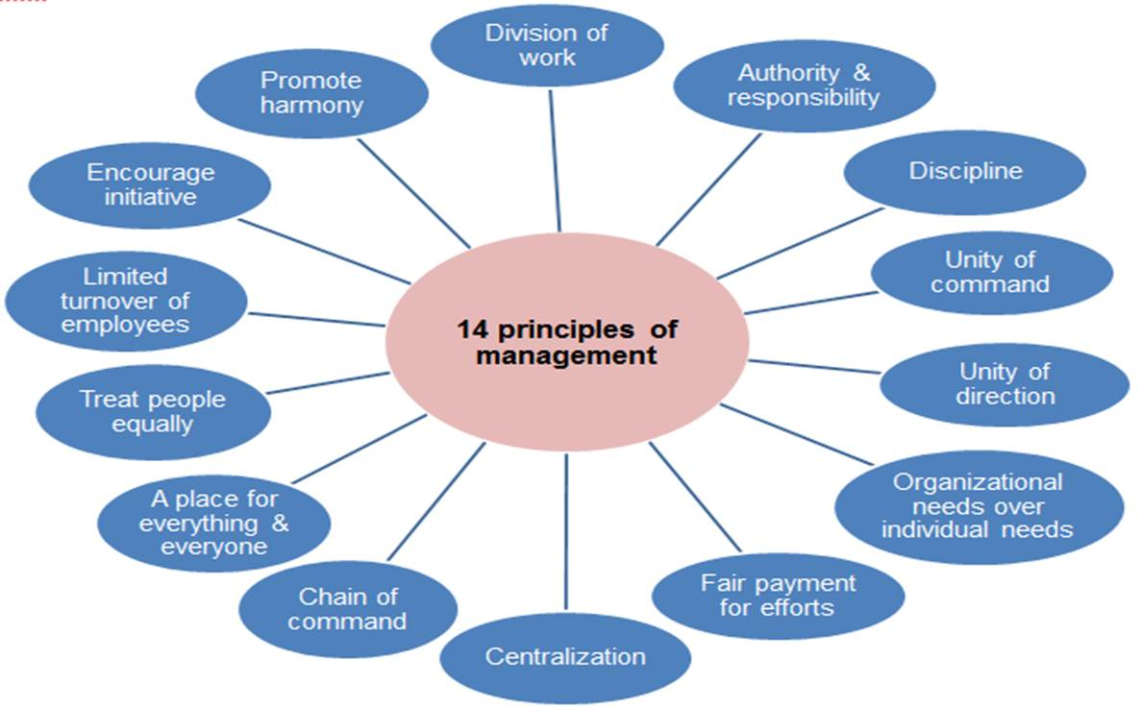
Figure 1: General management theory
(Source - Saxena, 2019)
The Fayol theory has been criticized for its focus on higher-level management and negligence of joint management. This theory has the least focus of individuals and most focus on the universal methods of management.
Max Weber’s bureaucracy theory (1924): This theory is focused on the systematic formation of the organization structure to increase efficiency and effectiveness. The six characteristics of bureaucracy defined by Max Weber are Task specialization to simplify the process, Hierarchy of authority to control the process, formal selection to increase competency, official rules for administration, impersonal relationship to improve employee relation, and career-oriented labor. This theory is beneficial for a large organization to manage and control the process which leads to higher efficiency levels and consistent execution of the work. The restriction of this theory is that it restricts employees to innovate and controls the whole process according to the set policies and regulations (Khorasani and Almasifard, 2017).
Classical management theories are focused on clear management structure, easier division system of labor, clarity in job role definition and incentive motivation. There are some major flaws in classical theories that restrict employers to include this management model. Controlling and predicting human behavior ignores the benefits of human relations and creativity. These theories fail to provide job satisfaction and establish a mechanical culture in the workplace.
Behavioral THEORIES (1940-50) - Behavioral theory suggests that the managers must focus on identifying and analyzing the factors which affect human behavior at the workplace. It suggests that employee behavior can be affected by various other factors that job conditions. The behavioral theories have two main theories; the Human relation theory, and the Behavioural science theory. Human relations theory suggests that managers should focus on how they interact with employees. Employee morale and performance get positively affected when the mangers address their concerns and motivate them. Behavioral science theory is base on identifying the determinants of behavior in a leader to motivate others (de Graaf, 2019).
MANAGEMENT BY OBJECTIVES THEORY (1954) - The modern corporate management is based on the ideas and thoughts of Peter Drucker on management. He argued that effectiveness is more important than the efficiency of an organization. In his theory of Management by objectives (1954), he stated that every level of the managers in the organization needs to participate in the strategic planning process of the organization to achieve the desired effect of the plan. The managers must include performance management systems to improve the functions of the organization (Khorasani and Almasifard, 2017).
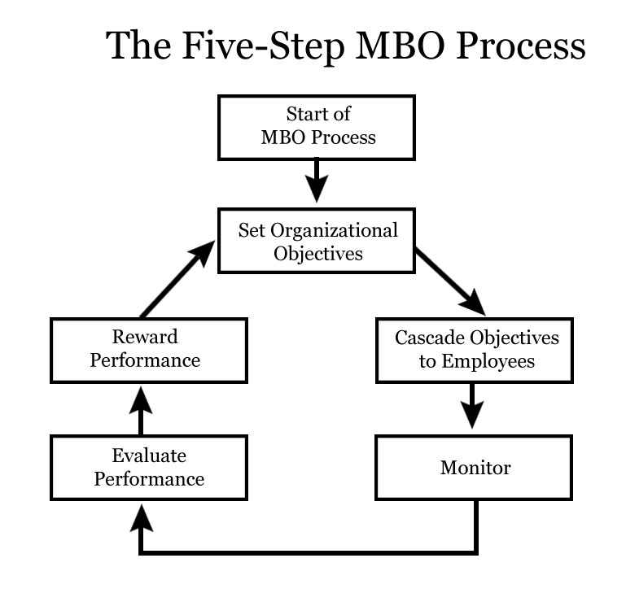
Figure 2: Management by Objectives
(Source - Khorasani and Almasifard, 2017)
CONTINGENCY THEORY BY FRED FIEDLER (1964-1967) - This theory states that there can never be one best way to manage the organization. The leader of the organization must be able to identify the most suitable management style to lead the organization towards the organizational goal. The theory is focused on the leadership orientation of a manager can be measured by the Least Preferred Co-worker. This theory helps in understanding the acceptance of a leader by the employees. It argues that leaders can improve their acceptance level by improving their relationship with the employees (Raju, 2018).
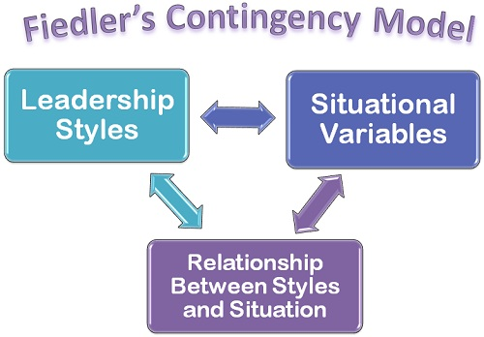
Figure 3: Contingency theory
(Source – Raju, 2018)

APPLICATION OF MANAGEMENT THEORIES ON TESCO’S ORGANIZATIONAL CULTURE
The organizational culture consists of various parts; Customs and norms, Rules and policies, Goals and objectives, Events, physical environment, Organizational structure, Learning and development, reward and recognition, Management, and communications which has their own significance and impact (Driskill, 2018).
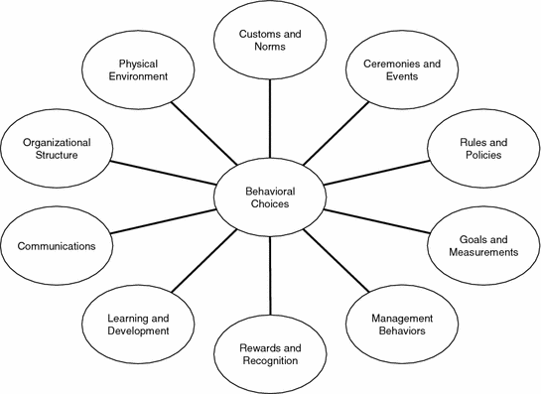
Figure 4: Organization culture
(Source - Driskill, 2018)
Tesco aims at becoming the champion for its customers so that they can enjoy a quality and easier life. The core values of Tesco influences their work practices, as the managers have started incorporating the values a decade ago. It has become the integral part of their work culture. The managers of Tesco monitor and control the employee base of the company to incorporate and follow the code of conduct and HR policies decided by the Leaders of the company. They are focused on training their employees to understand that they must not focus on attracting customers all the time rather treat them as they want. They guide their employees to work efficiently in a way where with little efforts a big difference can be created. The bahaviour of managers and leader towards the employees impacts the organizational culture the most.
The management by objective approach of the managers to make the business help customers with better choices, sustainable products at affordable price, bringing colleagues together, reduces wastage, reduce carbon footprint, and support the community. The organizational culture of Tesco has majorly impact due to the Participative Leadership style of the CEO, Terry Leahy. He has created a healthy, creative, and innovative culture at the organization which has made the employees competent to deal with the challenges of changing trends of retailing (May and Fearne, 2017).
The organizational structure of Tesco has impacted due to the participative leadership in the organization. The structure has become more flat and the employees have the direct communication links to the top management. This helped in reducing conflicts and issues at the workplace and making a healthy environment. The employees are more open to take challenges and create opportunities out of it to solve every day issues of their job role. They are competent of leading their colleagues in time of needs. The employees, especially the service staff are well versed in their skills and experiences to take a strong decision on their own. This helps in easing the business activities of the company. The open communication channel has improved the employee relations and loyalty to the company (Tesco, 2019).
The physical environment, that is, the IT infrastructure is maintained to be hi-tech according to the hanging technological trends of the global environment which has helped in the functioning of the business and improvement of the employee skills. The management at Tesco treats the employees as they want to be treated and do not drive them mechanically but let them creative and innovative in their job roles. This is the biggest reason of retaining the employees for longer duration. The company focuses on training their employees for their individual professional development to become a leader and recognize them with rewards and incentives. This helps in the development of individual and organization as a whole and spread message of Tesco being a responsible employer (Driskill, 2018).
It organizes various events and activities at all its stores to maintain the motivation level of the employees. This helps in making good relationships between employers, manager, and employees. To make the work process healthy and do-able the company has introduced initiatives and strategy which helped it to make a sustainable business growth. The company has started addressing its corporate social responsibility and UN sustainable development goals a decade ago. It has created a corporate responsibility committee to govern its performance in all its stores. Tesco has launched a ‘Little Helps Plan’ in 2017 which focuses on improvement of three areas; People, Products, and Places (Tesco, 2019).
Recommendations
A good leadership practice can help the employees of an organization improve their performance continuously. Tesco offers various food and non-food products to their customers at affordable prices as compare to the competitors. It provides various services like financial services at affordable price which makes it challenging for the employees to maintain the quality of service and service product as effective as the competitor do at higher prices. Management can motivate their skilled professionals to contribute to the process of being better by contributing their ideas and creating something new, by collaborating. The mangers can make teams of different cultures make the product mix stronger and more competitive (Wadhawan and Gupta, 2018).
The service mix of the company can also be improved by using effective management practices like training service staff for improving their interpersonal skills to engage the customers at the restaurants. This will help in making the service staff competent in retaining the customers and making them repeat their visits to the store. Employee performance has a strong impact on the organizational culture as it increases the productivity level. The effective and efficient management of employees can be done only by improving the organizational culture. It increases employee commitment, team efficiency and leads to the sustainability of the Tesco (Bratton and Gold, 2017).

CRITICAL EVALUATION OF MACRO ENVIRONMENT OF THE RETAIL INDUSTRY OF THE UK
To evaluate the macro environment of the retail industry in the UK, the PESTLE analytical tool of environmental scanning is used. PESTLE is the abbreviation of six macro factors: Political, Economic, Social, technological, legal and environmental.

Figure 5: PESTLE framework
(Source - Kilner, 2017)

PESTLE ANALYSIS OF RETAIL INDUSTRY OF THE UK
Political Factors: The political factors in the global business environment influence the business activities of Tesco plc. The political stability of the country in which Tesco is operating its business affects the business decisions. The political climate and attitude towards the business is very effective on the business performance. The effectiveness of the political system of other countries towards economic development and attract foreign investments in the country affects the business growth of Tesco. The Brexit implication on the country has caused many political differences and disputes which has affected the business growth of Tesco and other retailing business in both foreign and domestic countries (Bessière et al., 2019).
Economic Factors: The global economic trends and economy of the country in which Tesco is operating affects the exchange rates, inflation rate, funding accessibility, unemployment rates, and budgets of the business. Increasing exchange rate, inflation rate, etc affects the business income in the country. The accessibility of funding for the business decreases in recession. Recession can cause unemployment which also decreases the disposable income of the customers. All of these economic factors in case of recession in the economy affect the business productivity and profitability. The grocery retail business has a higher average sales rate than the other businesses in the retailing since the consumption of grocery is higher than other household products. Due to this the government in all the developing countries supports the growth of retail business to increase the employment and economic stability in the country (Oraman et al., 2018).
Social Factors: The increasing rate of immigrants has caused diversity in the population which has increased the need of a diverse product and service mix for Tesco. The buying habits of the customers have shifted to the bulk shopping and one-stop shopping. This has increased the growth of supermarkets in the UK. The shift in the attitude towards health has enabled the customers to buy healthy food products and businesses to include organic products in the menu. The customers are choosing those supermarkets to shop which has all or maximum products available all the time so that they can shop and save time from wondering at different places (Bessière et al., 2019).
Technological Factors: The global and national technological advancements in the business environment has changed and improved the business practices. The introduction of online shopping has helped the grocery stores a lot. The Home delivery system has increased the scope of better customer services and opportunity to make happy relationship with the customers. The quality of products and services, communication channels, advertisement process, financial activities, management activities, production, packaging, etc all the sectors of the business have improved. It has helped in reaching out to a greater audience since almost whole population is exposed to using internet (Oraman et al., 2018).
Legal Factors: The legislation applied by the government of the UK and all other country in which the company is operating its business affects the business activities. The management of the business organization needs to include all the necessary rules and regulations in the HR policies, code of conduct, and all other legal requirements of the business. The cost of any failure in adhering to the legislation of the nation can affect the image of the business in front of society and authority. The business must have ability to change, to maintain profitability, to perform, and adapt any changes made by government. The cost to change can also affect the profitability of the business (Bessière et al., 2019).
Environmental Factors: The obligations of business towards environment protection under the Environmental Act affect the business activities and its code of conduct. The sustainability of operations to ethical production, waste management, controlling emissions, and reducing all other harmful effects of the business on the environment is necessary to improve to remain competitive in the market. The increased awareness in the society to use environment friendly products and support environment protection practices has increased the business of those brands which are continuously active in serving the environment. The customers are buying products which have environment friendly packaging (Oraman et al., 2018).

IMPACT ON ORGANIZATIONAL CULTURE AND PERFORMANCE OF TESCO
The macro factors of the external business environment of retail industry have huge impact on the organizational culture and performance of Tesco. The organizational culture includes all the norms, beliefs and attitude of the business which are adhered and followed by its human resources. Tesco aims at becoming the most valued business by the customers, community, colleagues, partners, and shareholders. It has incorporated its vision in its objectives of business and values. It manages to serve the customer in a better way every day. The management and employees focuses on understanding the customers, act responsibly for the community, and improve efficiency to become the first to meet the needs of its customers (Tesco, 2019).
To deal with the increasing competition, Tesco has started focusing on the performance level of the employees by effective her management practices. Team building activities, mutual respect, mutual trust, sharing experiences and knowledge, understanding needs of employees and fulfilling them are the management practices of the HR department of Tesco. Tesco provide an open and transparent environment for the employees. It has flattened the organizational structure by implementing learning management system. It has decreased the number of employees to cut cost of the in 153 metro stores, express branches, and large supermarkets to make the business process effective and efficient so that the customer gets the products and services according to their satisfaction. This reduction will help the company to save cost and make a more sustainable business to lead the market. It has also reduced the express stores opening hours by revising the time of opening of the stores late in the morning and close early in the evening to reduce and simplify the process (Brittany Vonow and Hollie Borland, 2019).
Tesco has improved the training and development processes at the organization to prepare the employees for their growth and success in the future. The company has invested in training and apprenticeships for the employees to improve existing skills and learn new skills which can be in demand in future. New 1,265 apprenticeships were offered to the employees by Tesco in the year 2018. The company culture is supporting and recruiting talented women, training employees to become leaders, creating inclusive work culture. Tesco has refined its policies to reduce discrimination in wages, recruitment, and treatment at workplace over the years (Tesco, 2019).

CORPORATE SOCIAL RESPONSIBILITY
Corporate social responsibilities are the approach of a business to manage the impact of business activities on the society. It creates long-term shareholder value, employee loyalty, customer loyalty and sustainability in the business. The vision, objectives, values and beliefs of Tesco is integrated in its work culture. The company is focused to become the most valued brand in the retail sector of global market. It has started a Little Help Plan which sets out the strategy of the company to make a difference in the environmental and social challenges which affects the society, customers, and colleagues the most (Lins et al., 2017).
Little Help Plan is focusing on fulfilling the UN sustainable goals of the business and corporate social responsibilities of Tesco. It has three pillars; People, Products and Places. There are several targets and actions assigned to each of the three pillars. To deliver the plan and integrate it in the business strategy of Tesco, it has made a Corporate Responsibility Committee. This committee helps the management to monitor and approve changes if required to the plan. It oversees the conduct of the employees, managers, shareholders, partners, and overall business to the society and specifically the consumers. It manages how the Tesco group engages with the stakeholders and interests investors (Tesco, 2019).
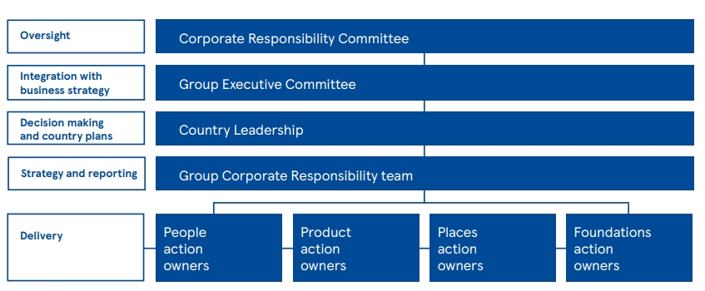
Figure 6: Governance structure
(Source - Tesco, 2019)
The action owners in each country tracks progress on day to day basis against the set KPIs and update to the corporate responsibility committee. Figure shows the governance structure of Corporate Responsibility Committee. Most of their KPIs are based on business performance over a fiscal year. The ratings on achieving the target shows that the level of competency and performance of the different stores of the company to fulfill the target (Tesco, 2019).
Tesco has always incorporated business strategy by analyzing its impact on environment and society. The corporate strategy of Tesco is focused on serving the customers without harming the environment and society. It has integrated the social responsibility of the business in the individual roles of employees and managers to fulfill them effectively. To reduce the energy consumption at the stores and offices, Tesco has made them energy efficient stores in 1996. This has reduced the energy consumption significantly every year. By providing Healthy food for the customers, Tesco has promoted Health consciousness and improved the food choices of its customers around the world (May and Fearne, 2017).
Tesco is actively participating to create employment and promote professional development of workers. Fundraising and charity to promote education in the country and world has also been the part of its corporate strategy. Tesco has trained employees to become responsible leaders to lead the business for the betterment of society and environment. The company has maintained equality and diversity to eliminate discrimination from the work place. It has increased the employment in the areas of low development and high employment in the world (May and Fearne, 2017).
Tesco has considered CSR as its essential philosophy of business. Tesco has focused its corporate strategy to provide quality products and services to the customers rather than increasing the luxurious products. It has increased the socially responsible investment in the past years. Thus it can be said that the organizational culture, ethical standards, values, and beliefs are in accordance with its corporate social responsibilities (Tesco, 2019).

CONCLUSION
Therefore, it can be concluded that the assignment presented here has covered all the given or prescribed points which are relevant for understanding the organizational or workplace culture and the effect that it has on the efficiency of the organization as a whole. This assignment is going to provide a critical assessment of the culture of the workplace in the organization of Tesco. This has also provided with the critical evaluation of a huge surrounding in which the company operates through a popularly known environmental tool known as PESTEL analysis and the effect that it has on the culture and performance of the organization. And lastly, it has also provided with the critical evaluation of the standards in terms of culture and ethics and in-person along with their values and beliefs of being sustainable and aiding in achieving the business goals and community accountability.

REFERENCES
- Bessière, D., Charnley, F., Tiwari, A. and Moreno, M.A., 2019. A vision of re-distributed manufacturing for the UK’s consumer goods industry. Production Planning & Control, 30(7), pp.555-567.
- Bratton, J. and Gold, J., 2017. Human resource management: theory and practice. Palgrave.
- Brittany Vonow and Hollie Borland, 2019. Shorter opening hours for Express stores (Online available at https://www.thesun.co.uk/money/9637975/tesco-staff-redundancies-latest/ last accessed on 31st March 2020).
- de Graaf, F.J., 2019. Ethics and Behavioural Theory: How Do Professionals Assess Their Mental Models?. Journal of Business Ethics, 157(4), pp.933-947.
- Driskill, G.W., 2018. Organizational culture in action: A cultural analysis workbook. Routledge.
- Khorasani, S.T. and Almasifard, M., 2017. Evolution of management theory within 20 century: A systemic overview of paradigm shifts in management. International Review of Management and Marketing, 7(3), pp.134-137.
- Kilner, A., 2017. The Growing Impact of the Macro Environment. Holistic Marketing Management Journal, 7(4), pp.10-19.
- Lins, K.V., Servaes, H. and Tamayo, A., 2017. Social capital, trust, and firm performance: The value of corporate social responsibility during the financial crisis. The Journal of Finance, 72(4), pp.1785-1824.
- May, C. and Fearne, A., 2017. The rise and fall of carbon labelling: a case study of Tesco’s experience and lessons for corporate social responsibility communication.
- Oraman, Y., Unakitan, G., Konyali, S., Basaran, B. and Abdikoglu, D.I., 2018. WHAT EXTERNAL AND INTERNAL FACTORS AFFECT ORGANIC FOOD SECTOR?. New knowledge Journal of science, 7(2), pp.33-44.
- Raju, D.V., 2018. Theory of Lim Law: Leadership Style. Eurasian Journal of Analytical Chemistry, 13(6).
- Saxena, N., 2019. An Overview of Classical Management Theories. BICON-2019, p.173.
- Tesco, 2019. Contributing to the United Nations Sustainable Development Goals (Online available at https://www.tescoplc.com/sustainability/little-helps-plan-overview/ last accessed on 31st March 2020).
- Tesco, 2019. Core Purpose and Values (Online available at https://www.tescoplc.com/about/how-we-do-business/core-purpose-and-values/ last accessed on 31st March 2020).
- Tesco, 2019. Little Helps Plan Progress Report 2019 (Online available at https://www.tescoplc.com/sustainability/little-helps-plan-overview/ last accessed on 31st March 2020).
- Tesco, 2019. Little Plans Help (Online available at https://www.tescoplc.com/sustainability last accessed at 31st March 2020).
- Wadhawan, S. and Gupta, N., 2018. IMPACT OF ORGANIZATIONAL CULTURE ON EMPLOYEE TURNOVER INTENTION IN THE ITES SECTOR. TECNIAJournal of Management Studies, p.20.

