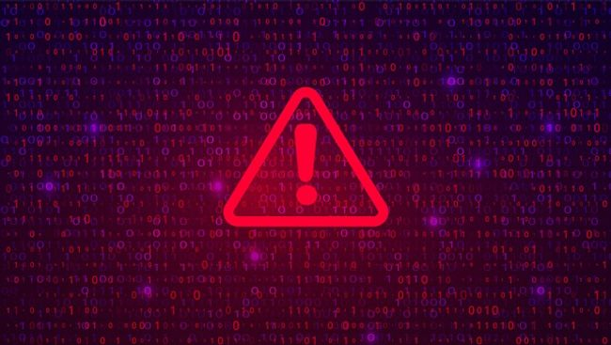

A Researched and Referenced Report on Ransomware

Cover Image Credit, [8]
Contents
Contents 1
Glossary 2
Introduction 3
References 9

Glossary
Words found in bold can be found in the Glossary.
Malware | Malware, short for “malicious software,” refers to any intrusive software developed by cybercriminals (often called “hackers”) to steal data and damage or destroy computers and computer systems [1]
Operating System | An operating system (OS) is the program that, after being initially loaded into the computer by a boot program, manages all of the other application programs in a computer. [2]
Ransomware | Ransomware is malware that employs encryption to hold a victim’s information at ransom. A user or organization’s critical data is encrypted so that they cannot access files, databases, or applications. [3]

Introduction

In this report I will be talking about the ransomware CryptoWall Trojan I will be talking about what this type of malware is and what it can do to your companies data and also how you can protect your company from this kind of ransomware with a backup strategy I will be talking about how you can protect your company with a “3 different place” strategy and I will talk about what would happen if the worst were to happen and your data would be compromised by this ransomware and then I will tell you how your backup strategy would disrupt the attack and what you can do pre-attack to restore your data.

Cryptowall

Cryptowall is a type of ransomware designed to encrypt your data and require you to pay a sum to decrypt your data but that is not all cryptowall will do to your pc it will also try and insert itself into your Operating System it also embeds itself in your PCs start up folder this can be bad news if you are looking to restore data that’s been affected by this ransomware. Once cryptowall has found its way on your system it gets to work by infesting its code into your computers mainframe so whenever you try to reload your PC it will be unable to rid itself of the ransomware as its in your main files so once you load your PC it sends cryptowall the encryption key it will use this to encrypt all of your data. Once cryptowall has done its thing you will get a ransom note usually on your PCs files in the shape of a text document asking you to pay a certain sum of money but there is no guarantee they will decrypt your files after you pay the money.
Cryptowall attack example

2017 WannaCry attack: The world’s first taste of how bad ransomware can get
Let’s start with an attack from several years ago—before “ransomware” was a household name—that shocked the world into taking cybersecurity more seriously. The incident started in May 2017, when hackers infected a computer with the WannaCry ransomware. Within a day, users of over 230,000 computers worldwide found that their files had been encrypted—and that they could only retrieve their data by making a Bitcoin payment to the attackers. [4]
How could WannaCry infect so many computers? The original infection was initially believed to have resulted from a phishing email, but researchers later concluded that the ransomware took hold via a vulnerable SMB port. From there, the infection spread to other computers that had not downloaded a recent Microsoft security update—the hackers used a tool called EternalBlue (developed by the U.S. National Security Agency) to exploit a zero-day vulnerability in Windows. Wannacry caused chaos across multiple sectors in more than 150 countries. The U.K.’s National Health Service (NHS) was particularly badly affected—hospitals even had to cancel operations due to the disarray caused by the attack.The actual ransom payments—between $300-$600 each—added up to a meager $130,634. But estimates of the overall costs associated with the attack range between hundreds of millions and billions of dollars. [4]

1.1 hOW TO DEFEND AGAINST CRYPTOWALL

Here are some ways you can stay protected against cryptowall
Keep your computer patched and up to date
  - Malware uses known vulnerabilities in software to move to new computers. If you leave those vulnerabilities unpatched, you’re effectively leaving an open door for the cybercriminals to enter. If you keep the OS and all of your applications patched to the latest releases, you stand a better chance of avoiding malware infections. [5]
- Use an anti-virus scanner
  - Anti-virus solutions, when updated regularly, can protect you from several kinds of malware attacks. [5]
- Use a firewall
  - A local firewall can protect you from some connections that malware uses, like to the Command and Control server. The CryptoWall ransomware, in particular, depends on a connection to home base to continue the attack. A local firewall may be able to prevent the malware from making that connection and killing the attack. [5]
- Don’t click the links
  - Don’t click links or download files from suspicious emails. If you click a malicious link or download a malicious file, you’re inviting the cybercriminal and their malware into your home. [5]

Backup strategies are also incredibly important for protecting against attacks you should do this by following the “in 3 places” rule this rule dictates that you should store 3 different copies of your data and you should at least have 1 offsite copy of that data. [6]

Backup strategy
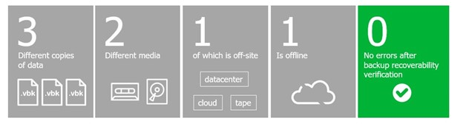
Now you know what cryptowall can do lets talk about what happens if you do get caught out by this nasty malware. following the 3-place method allows your company to ensure data redundancy as shown in the image below.

Figure 1 – this image shows the in 3 place method [9]

Here are some of the biggest data loss threats to a company

Ransomware as we have talked about is one of the biggest threats to companies data your companies data is at a serious risk as the attackers could leak and share sensitive information regarding your company this is why a backup strategy matters when it comes to ransomware having multiple copies of your data allows you to ensure you can keep your data safe and secure and get back on with crucial business swiftly.

User accident is another high cause of data loss this includes anything from computers breaking, lost or stolen having that extra copy of files stored securely can really benefit a company since there’s only a matter of time before someone makes a mistake since we are all human after all.

Heres how the 3-2-1 system works.

A network drive folder Organizational policy requires users to put their data into a network folder to get automatically backed up, often to an on-premises server. This is easy to use, and automated, but not a stand-alone solution as it requires access to the network – usually via VPN. And often, users forget to (or just don’t) put their documents into the correct folder. [7]

An External drive Is a quick and easy solution that offers ready access to your data and can often be automated. Not a stand-alone backup plan, though, because it requires monitoring to ensure the drives are not running out of storage and the drives are still subject to the same user behaviour and location-based risks as the network drive. External Is a quick and easy solution that offers ready access to your data and can often be automated. Not a stand-alone backup plan, though, because it requires monitoring to ensure the drives are not running out of storage and the drives are still subject to the same user behaviour and location-based risks as the network drive. [7]

Cloud-based backup: An automated solution to keep a copy of end-user data in the cloud which can help protect against cybercrimes, human error, and provide critical geographic redundancy. Automatic cloud backups happen continuously in the background and require no user action, which means that data loss can be limited to whenever the last backup was. Because restoring data requires downloading files from the cloud, you must have access to the internet in order to access them. [7]

Conclusion

This report aimed to give a detailed understanding of the risks of ransomware to a company I have given information on the cryptowall ransomware attack including how it operates and targets your data and encrypts your files. I have also provided insights and methods to protect your company against cryptowall through various ways one of the most successful ways to protect against crypto wall is to use the 3-2-1 system this system is a direct countermeasure against ransomware attacks and ensures that your data stays intact and your company

References

[1] | "Cisco," Cisco, 9 11 2022. [Online]. Available: https://www.cisco.com/c/en/us/products/security/advanced-malware-protection/what-is-malware.html. [Accessed 9 11 2022].
[2] | S. J. Bigelow, "TechTarget," TechTarget, 6 2021. [Online]. Available: https://www.techtarget.com/whatis/definition/operating-system-OS. [Accessed 9 11 2022].
[3] | "Trellix," Trellix, 9 11 2022. [Online]. Available: https://www.trellix.com/en-us/security-awareness/ransomware/what-is-ransomware.html. [Accessed 9 11 2022].
[4] | "Tessian," Tessian, 4 3 2022. [Online]. Available: https://www.tessian.com/blog/examples-of-ransomware-attacks/. [Accessed 9 11 2022].
[5] | M. Buckbee, "Varonis," Varonis, 1 6 2018. [Online]. Available: https://www.varonis.com/blog/cryptowall. [Accessed 9 11 2022].
[6] | F. Lloyd-davies, "Acronyms," Acronyms , 16 1 2018. [Online]. Available: https://www.acronyms.co.uk/blog/backup-rule-of-three/#:~:text=The%20backup%20rule%20of%20three%20dictates%20that%20you%20should%3B,one%20of%20those%20copies%20offsite. [Accessed 9 11 2022].
[7] | "CrashPlan," CrashPlan, 9 11 2022. [Online]. Available: https://www.crashplan.com/en-us/business/resources/3-2-1-backup-method/. [Accessed 9 11 2022].
[8] | "https://www.ncsc.gov.uk/guidance/mitigating-malware-and-ransomware-attacks," National Cyber Security Centre, 13 2 2020. [Online]. Available: https://www.ncsc.gov.uk/guidance/mitigating-malware-and-ransomware-attacks. [Accessed 9 11 2022].
[9] | "Data storage and Asean," Data storage and Asean, 28 3 2022. [Online]. Available: https://datastorageasean.com/blogs/more-3-2-1-why-3-2-1-1-0-rule-should-be-golden-rule-ransomware-protection. [Accessed 9 11 2022].

