
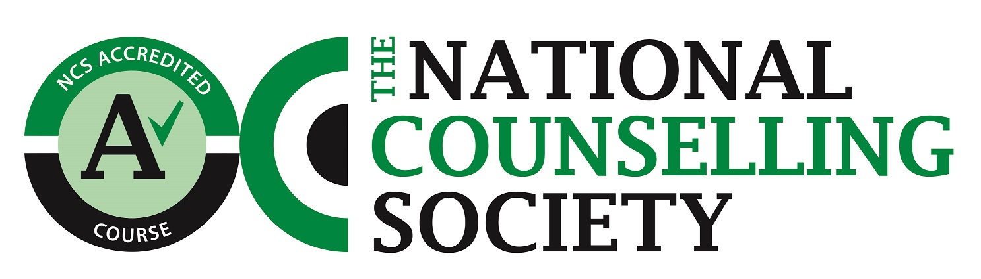

Townhill Rd, Swansea, SA2 0UT Wales, UK
Ffôn: (01792) 481000 Ffacs: (01792) 475037

DATE
Ysgol Cyfiawnder a Chynhwysiant Cymdeithasol
School of Social Justice and Inclusion

To whom it may concern,

Re: ………………..- Confirmation of Readiness to Practice

I am pleased to confirm that ……….has met all of the below and I have no concerns in her beginning to work with clients as a student Counsellor.

The Masters in Psychotherapeutic Practice seeks to ensure that all students have reached a minimum standard of competency before they begin a placement.

Each student is assessed on the following:

Interpersonal skills
Personal beliefs and values
Conceptual ability
Personal ‘soundness’
The ability to form and maintain a therapeutic relationship
Ability to understand and work within social systems
Openness to learning and inquiry
Ability to self-care

Yours sincerely

Carol Hughes
BA, MPhil, FHEA, MBACP(Accred)
Senior Lecturer
Programme Director: MA in Psychotherapeutic Practice
Email carol.hughes@uwtsd.ac.uk
Tel: 01792 482109

