

Student Name: Josephine Taller
Student ID: 2431097
Programme: BSc Health and Social Care
Module Name: Principles of Health and Social Care Practice
Module Code: BMHP5016
Lecturer Name: Mark Kane
Assessment: Component 1: Written Assignment (Reflective Report)
Submission Date: 15th April 2026, 2:00 PM

Table of Contents
Introduction 3
Task 1: Reflection on the Importance of Principles of Health and Social Care 4
Person-Centred Care in Enhancing Individual Outcomes 4
Partnership Working and Collaborative Practice 5
Ethical Practice and Decision-Making in Care Delivery 5
Task 2: Practical Examples of Concepts in Practice 6
Task 3: Self-Reflection as a Health and Social Care Professional 8
Applying Person-Centred Care in Daily Practice 8
The Role of Partnership Working in Professional Practice 9
Ethical Practice and Professional Responsibility 9
Skills, Strengths, and Areas for Improvement 10
Future Professional Development and Application 10
Conclusion 12
References 13

Introduction

The practise of health and social care in the United Kingdom has core principles that take care of safe, effective, and compassionate service delivery. The foundation of high-quality care has been person-centred care, partnership working, and ethical practise. These traits promote individual dignity, shared decision-making and ethical accountability and finally enhance health outcomes and holistic wellbeing within various care environments.

Task 1: Reflection on the Importance of Principles of Health and Social Care

Person-Centred Care in Enhancing Individual Outcomes
Person-centred care is a key concept in the UK health and social care system and aims at addressing individual preferences, values, and autonomy. The strategy is consistent with Maslow’s Hierarchy of Needs in which the provision of care goes beyond the physical needs to psychological and self-fulfilment (Moonie, 2020). The ability to customise care plans according to the circumstances of the individual leads to better satisfaction, dignity, and independence of the service users. As an example, personalised care planning has been demonstrated to improve emotional wellbeing and anxiety in residential care settings. This is strengthened in the Care Act 2014 which emphasises wellbeing and makes sure that individuals are the ones at the centre of decisions (McCormack, 2020). Nevertheless, issues like time and staffing pressure may restrain a complete implementation and it needs an unceasing professional growth and organisational encouragement to maintain quality care.
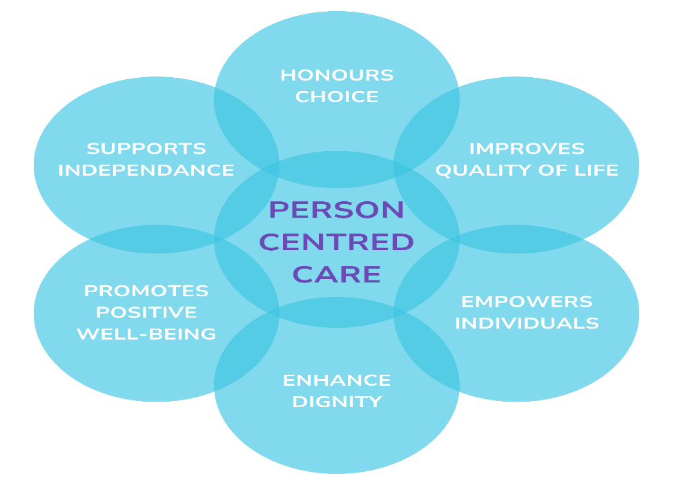
Figure 1: Person-Centred Care
Source: (Moonie, 2020)

Partnership Working and Collaborative Practice
Partnership working empowers partners to deliver holistic and coordinated care, which is facilitated by multidisciplinary teams, service users, and families. Health and Care Act 2022 encourage Integrated Care Systems (ICSs), which ensure effective communication and share of resources of services (Charlton, 2021). Practically, by means of collaboration in discharge planning among social workers and healthcare professionals, there are fewer instances of hospital readmission and easier ways of transferring patients to community care. Although these have these advantages, poor communication, role confusion, and organisational differences are just some of the barriers that could influence the outcomes. To enhance accountability and confidence in service delivery, it is important to strengthen teamwork by having effective communication channels and following professional codes of conduct (Gallagher et al., 2025).

Ethical Practice and Decision-Making in Care Delivery
Ethical practice is fundamental in every area of care and it is regulated by certain fundamental principles that include self-determination, beneficence, non-maleficence and justice. These values make sure that care is being provided in a fair, safe, and respectful way (Edelman, 2022). Ethical decision-making is aided by professional codes of conduct when the situation is tricky as was the case with the refusal of treatment. Corruption of individual autonomy and duty of care is important in such situations. It is through ethical guidelines and legal provisions that practitioners will be able to make informed decisions that safeguard rights, wellbeing and uphold professional integrity.
All these principles contribute to the quality of care by all means of being supportive of individualised care, successful collaboration, and moral responsibility. Their implementation makes them meeting with the legislation and enhances the outcomes (Atwal, 2022). There is need to continue with reflections and adaptations to create high standards in changing environments of health and social care in the UK.

Task 2: Practical Examples of Concepts in Practice
Application of Person-Centred Care in a UK Setting: The UK example is the hospital discharge planning in an integrated care system, which can be considered a relevant UK case (Damant et al., 2025). In one instance, a discharge plan was used to support an elderly person with several health problems and his discharge plan focused on his personal preferences, home setting, and emotional availability. Professionals in healthcare did a more thorough screening, including their own objectives in care plans. The studies show that attentive hearing to patient storeys and the interpretation of personal experiences builds trust and commitment, resulting in positive recovery outcomes (Cribb and Woodcock, 2022). This is a person-centred care provision as it involves customising services instead of standardisation, which fosters dignity and independence as one moves out of hospital to home.
Role of Partnership Working in Coordinated Care: The main concern of this scenario was partnership working whereby the hospital staff, social workers, community nurses, and voluntary organisations worked together (Fridberg, Wallin and Tistad, 2022). The UK case study reveals that the coordinated discharge process in which various stakeholders are involved in reduces hospital admission and offers holistic and wrap-around support to patients and carers. This collaboration makes the care continuity possible, minimises service fragmentation, and enhances intersectoral communication (Entwistle et al., 2022). Nevertheless, to achieve successful collaboration joining, the roles should be identified, and information exchange should be regular because dysfunctional communication may harm patient safety and outcomes.
Ethical Practice in Decision-Making: Ethical requirements were also manifest in the informed consent, privacy, and honouring autonomy during the care process (Richter et al., 2022). As an example, patient autonomy and patient safety risk were weighed in decisions about the timing of discharge. The moral codes of conduct helped professionals to ensure beneficence and reduction of harm are upheld. It was indicated that good patient-professional relationships may help to increase the level of trust, wherein, one may feel safe and respected to make any decision (O’Connor et al., 2024). This shows how person-centred care and partnership working can only be founded on ethical practise to ensure accountability and fairness.
Improving Practice Through Policy and Guidelines: The existing UK policies like the Care Act 2014 and the Health and Care Act 2022 facilitate integrated, person-centred methodologies through encouraging wellbeing and cooperation between services (McCormack, 2020). These systems promote early discharge planning, shared decision -making and multidisciplinary coordination. Structured care pathways, digital information-sharing systems, and continuous professional training are necessary to resolve challenges, including communication gaps, limited resources, etc.

Impact on Patient Care and Outcomes: Person-centred care, partnership working, and ethical practise are all integrated to result in better patient satisfaction, fewer readmissions, and improved life quality (Moonie, 2020). The consistent use of these principles in the UK healthcare facilities promotes responsive, safe and effective care delivery.

Task 3: Self-Reflection as a Health and Social Care Professional

Applying Person-Centred Care in Daily Practice
Person-centred care is a core element of what happens in the day-to-day professional operations whereby people are accorded respect and personalised care. This, in a practical sense, implies active listening to patients, knowing more about individual preferences, and engaging patients in decision-making. The use of this principle is consistent with the Care Act 2014 that focuses on the wellbeing and choice (McCormack, 2020). Indicatively, when planning care, I would give more attention to the emotional, cultural and social requirements of individuals as opposed to concentrating on clinical conditions. The strategy indicates the postulates of Maslow’s Hierarchy of Needs where both the lower and upper levels are met (Gallagher et al., 2025).
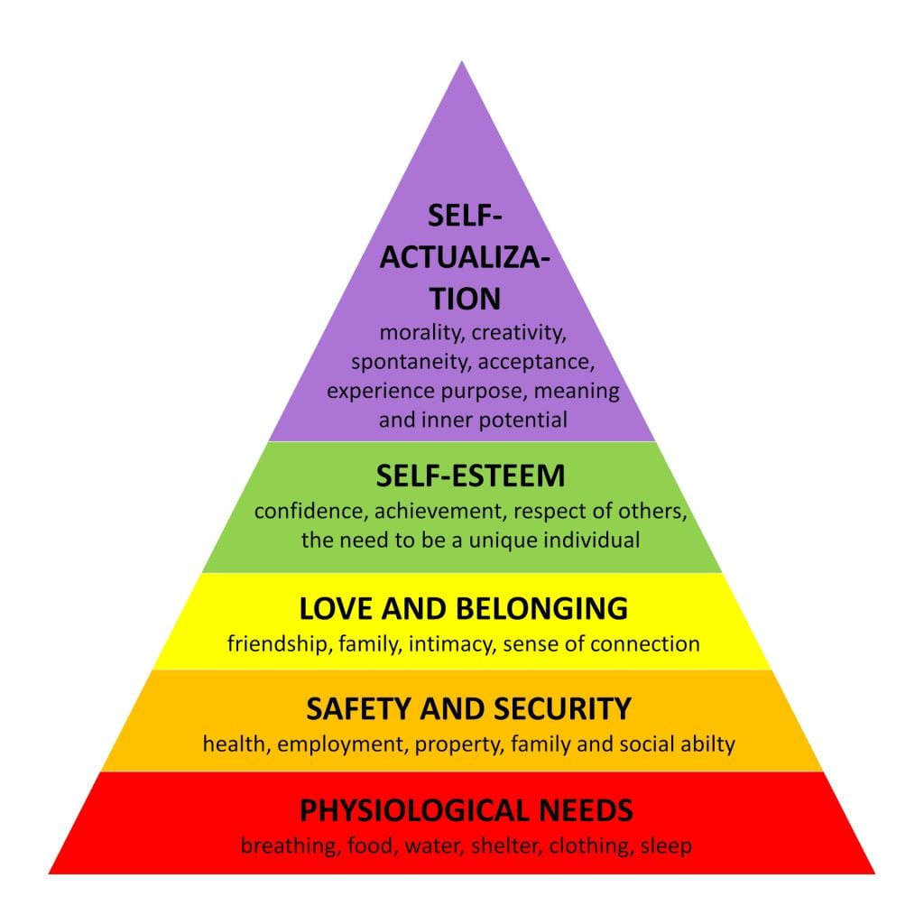
Figure 2: Maslow’s Hierarchy of Needs
Source: (O’Connor et al., 2024)s
But it is noted in reflection that it is difficult to be consistent in person-centred strategies in high pressure settings. Lack of time and overload can restrict the possibility of active communication (Fridberg, Wallin and Tistad, 2022). To do that, I will focus on the aspects of time-management and prioritisation and make every single interaction meaningful and respectful. Reflective practise will also improve adaptability of care approach to different patient needs as continuous practise will be undertaken.

The Role of Partnership Working in Professional Practice
Partnership working is an important factor that has an impact on daily tasks based on the enhancement of collaboration within the multidisciplinary teams. Practically, I often communicate with the representatives of other professional backgrounds, such as nurses, social workers, and support staff, in order to coordinate care delivery (Entwistle et al., 2022). The Health and Care Act 2022 promote this multifunctional approach, which promotes communication and joint accountability between services.
One of the strong points is the ability to communicate effectively, which helps to exchange information and collaborate. As an example, attending team meetings and case discussion can make sure that the decisions made in care are based on various perspectives (Edelman, 2022). Nonetheless, contemplation reveals that the ability and readiness to make difficult decisions or participate in complicated debates need some enhancement. The intensity of assertiveness and critical thinking will help in increasing the contributions in the team environment.
To enhance working with partners, I will participate in interprofessional training and workshops, which will help to comprehend roles and duties in multidisciplinary teams (Damant et al., 2025). Moreover, acquisition of digital literacy skills will help in the successful application of shared care systems, which will enhance continuity and communication of care.

Ethical Practice and Professional Responsibility
The whole professional practise is supported by ethical practise, which determines decision-making and communication with service users. During my daily practise, I make sure that the concepts of confidentiality, dignity, and informed consent are properly maintained (Cribb and Woodcock, 2022). Ethical behaviour has a structure in the form of professional codes of conduct and legislation and serve to hold everyone accountable and protect them.
The ethical dilemma that occurs most frequently is the need to maintain autonomy and respect with the obligation of care. As an illustration, cases of people declining to receive treatment should be approached with a proper sense of legal and ethical obligations (Charlton, 2021). In these situations, I use the ethical frameworks and organisational policies as a reference to make decisions in a manner that does not compromise the interests of an individual, and that their rights are not infringed.
The reflection shows that there is a high understanding of ethics; though more needs to be done to handle complex ethical issues with some confidence. To overcome this, I will attend ethics training and consult professional seniors in case of problematic situations (Atwal, 2022). This will increase the decision-making skills and best practise standards.

Skills, Strengths, and Areas for Improvement
Skills: Existing strengths are excellent communication, compassion, and willingness to be a caring provider of care. These attributes facilitate the building of trustful relations with service users and colleagues (Richter et al., 2022). Also, dynamic responsiveness to changing care requirements through adaptability in dynamic environments.
Strengths: Although these strengths exist, there are a number of strengths that can be identified. These are the development of leadership skills, gaining more confidence in decision-making, and gaining a better knowledge of policies and legislation. A more efficient practise and professional development will be achieved with strengthening these areas (O’Connor et al., 2024).
Areas for Improvement: To do this, I intend to engage in incessant professional growth by participating in formal training, workshops and self-directed learning. The participation in the current research and evidence-based practise will also contribute to the knowledge and skills (Moonie, 2020). Reflective practise will continue to be one of the instruments to define learning needs and assess the progress of learning at a certain period.

Future Professional Development and Application
The dedication to the incorporation of person-centred care, partnership working, and ethics into every sphere of professional activity will influence the future practise. High standards of care will be facilitated by continuous learning and compliance with the laws, including the Care Act 2014 and the Health and Care Act 2022 (McCormack, 2020). Such steps as the desire to continue education in communication, leadership, and ethical decision-making, and the active request of colleagues and supervisors to share their feedback are specific steps. The engagement in multi-disciplinary programmes will also enhance collaboration (Fridberg, Wallin and Tistad, 2022). Overall, the utilisation of these principles will add to the provision of safe, effective, and compassionate care and help in the further professional growth of the UK health and social care sector.

Conclusion
Person-centred care, collaboration, and ethical practise continue to play a fundamental role in providing quality health and social care in the UK. Those values embrace dignity, cooperation and accountability in decision making and this results to better outcomes. Through constant reflection and professional growth, the practitioners will be able to be effective in practise so that they can cope with the ever-changing care needs and at the same time, providing a safe, compassionate, and evidence-based service provision.

References
Atwal, A. (2022). Preparing For Professional Practice In Health And Social Care. S.L.: Wiley-Blackwell.
Charlton, V. (2021). Justice, Transparency and the Guiding Principles of the UK’s National Institute for Health and Care Excellence. Health Care Analysis, 30. doi:https://doi.org/10.1007/s10728-021-00444-y.
s10728-021-00444-y.pdf
Cribb, A. and Woodcock, T. (2022). Measuring with quality: the example of person-centered care. Journal of Health Services Research & Policy, 27(2), p.135581962110542. doi:https://doi.org/10.1177/13558196211054278.
Measuring with quality: the example of person-centred care
Damant, J., Hamashima, Y., Toma, M., Smith, N., Taylor, J., Caprioli, T., Jasim, S., Prato, L., Mcleod, H., Giebel, C., Peters, M., Ferguson Montague, A., Wright, L., Knapp, M. and Towers, A. (2025). Investigating Person‐Centered Care Planning in Care Homes Across England: An Exploratory Study of Practices and Contextual Factors. Journal of Advanced Nursing. doi:https://doi.org/10.1111/jan.16965.
Edelman, N.L. (2022). Trauma and resilience informed research principles and practice: A framework to improve the inclusion and experience of disadvantaged populations in health and social care research. Journal of Health Services Research & Policy, [online] 28(1), pp.66–75. doi:https://doi.org/10.1177/13558196221124740.
Entwistle, V.A., Cribb, A., Mitchell, P. and Walter, S. (2022). Unifying and Universalizing Personalised Care? An Analysis of a National Curriculum With Implications for Policy and Education Relating to Person-centered Care. Patient Education and Counseling, 105(12). doi:https://doi.org/10.1016/j.pec.2022.07.003.
Fridberg, H., Wallin, L. and Tistad, M. (2022). Operationalization of person-centred care in a real-world setting: a case study with six embedded units. BMC Health Services Research, 22(1). doi:https://doi.org/10.1186/s12913-022-08516-y.
Gallagher, A., Davies, N., Mathastein-Bowen, N. and Sicat, S. (2025). Interprofessional Ethics Across the Life Course in Health and Social Care. Taylor & Francis.
McCormack, B. (2020). Fundamentals of person-centered care principles & practice for healthcare students. Hoboken, NJ: Wiley-Blackwell.
Moonie, N. (2020). Advanced health and social care. Oxford: Heinemann Educational.
O’Connor, Wilson, V., Brown, D., Cleland, I. and McCance, T. (2024). Development and optimization of a mobile app (impact) for improving person-centered practice in healthcare settings: A multi-methods evaluation study. Digital Health, 10. Doi: HTTPs://doi.org/10.1177/20552076241271788.
Richter, C., Fleischer, S., Langner, H., Meyer, G., Balzer, K., Köpke, S., Sönnichsen, A., Löscher, S. and Berg, A. (2022). Factors influencing the implementation of person-centred care in nursing homes by practice development champions: a qualitative process evaluation of a cluster-randomized controlled trial (Centacare) using Normalization Process Theory. BMC Nursing, [online] 21(1). doi:https://doi.org/10.1186/s12912-022-00963-6.

