Amjad Ali: 2424832

BScProgramme: BSc Applied Computing
Applie
Module: Network Operating Systems and Services ACCA5023
d
Lecturer: Md Abrar Jahin Almazi Bipon
Date 02/07/2026

Table of Contents
Task 1 2
Research on Hypervisor 2
Research on IP Addressing 2
Research on Routing 4
Research on Network Services 4
Task 2 5
Report: Technical Documentation 5
Reflection 17
Technical Reflection 17
Personal Reflection 19
References 19

Task 1

Research on Hypervisor
Hypervisors are generally classified as Type 1 (bare metal) and Type 2 (hosted) [1]. Type 1 hypervisors run directly on physical hardware and provide high performance scalability and security because virtual machines interact directly with the hypervisor layer. Examples include Microsoft Hyper‑V and VMware ESXi [1]. Type 2 hypervisors operate on top of an existing host operating system where the hypervisor functions as an application [2]. Common examples include Oracle VirtualBox and VMware Workstation [3]. Although Type 2 hypervisors introduce some performance overhead, they are easier to install manage and maintain particularly in educational and testing environments.
For the NOSS London 2026 topology Oracle VirtualBox was selected as the virtualization platform. The topology consists of a Windows Server 2022 domain controller (B-DC) a Debian Server (L-CD) a Windows 10 client and a Debian client. VirtualBox supports both Windows and Linux operating systems and provides configurable virtual network adapters enabling the implementation of separate Birmingham and London networks connected through a WAN link [4].
The choice was influenced by available hardware resources and project requirements. VirtualBox is free lightweight and compatible with standard student hardware making it suitable for hosting multiple virtual machines without requiring enterprise grade infrastructure. While a Type 1 hypervisor could provide greater performance and security the size of the BIRMINGHAM.ACCA domain environment does not require large scale enterprise virtualization. Therefore, Oracle VirtualBox provides a practical balance between functionality compatibility cost efficiency and ease of deployment while successfully supporting both Windows and Debian based services within the proposed network topology [5].

Research on IP Addressing
Based on the group activity, I understand that IP addressing plays a fundamental role in enabling communication across networks and the Internet. When a user sends data it is divided into packets containing source and destination IP addresses. These addresses allow routers to determine the optimal path for forwarding packets towards their destination. Without IP addresses devices would be unable to identify each other or exchange information efficiently across interconnected networks. Routers facilitate communication between networks by examining IP addresses, while switches operate within local area networks (LANs) by forwarding data frames to the correct devices [6].
IPv4 uses a 32-bit addressing structure represented in dotted-decimal notation e.g. 172.16.1.10. However, due to the increasing number of Internet connected devices IPv6 was introduced using a 128-bit hexadecimal format providing a significantly larger address space [7].
Subnetting is the process of dividing a larger network into smaller logical networks to improve performance security and address management. In the NOSS London 2026 topology Birmingham uses subnet 172.16.1.0/24 while London uses 172.16.2.0/24 reducing broadcast traffic and improving network efficiency [8]. CIDR notation allows administrators to allocate addresses based on organisational requirements and avoid wastage [9].

Practical Application
BIRMINGHAM (172.16.1.0/24) B-DC: 172.16.1.1 ClientS1: 172.16.1.10
WAN (10.0.0.0/30) B-DC: 10.0.0.1 L-CD: 10.0.0.2
LONDON (172.16.2.0/24) L-CD: 172.16.2.1 ClientL1: 172.16.2.10
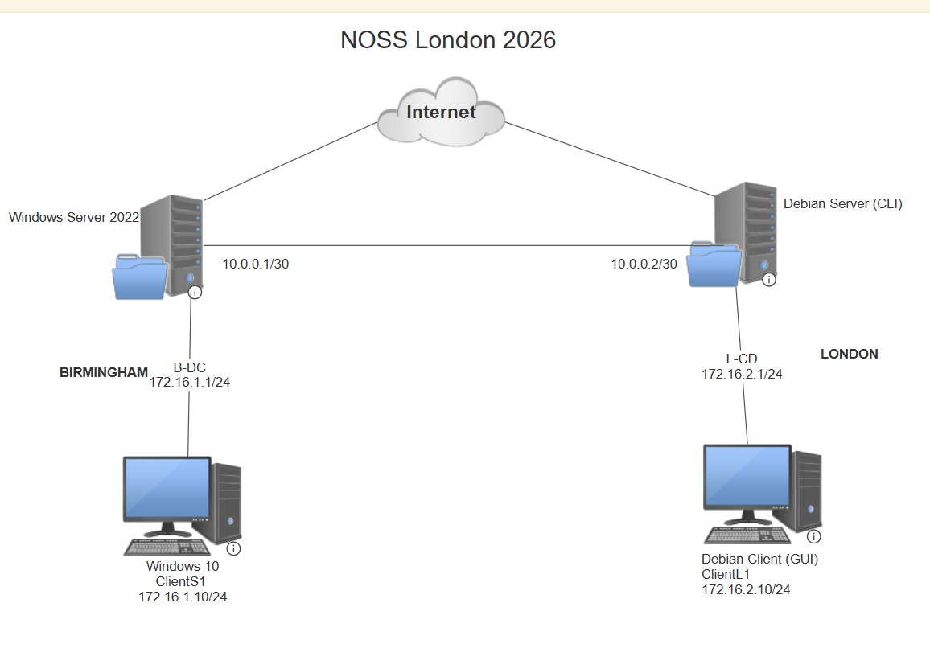
Figure 1 Topology
The 10.0.0.0/30 WAN subnet efficiently uses only two host addresses for communication between servers. Overall, IP addressing enables host identification network segmentation routing and reliable communication making it essential for the functionality and effectiveness of modern enterprise networks [10].

Research on Routing
Routing is a networking function that enables data packets to travel between different networks. Routing protocols are designed to help network devices determine the most efficient path to a destination by maintaining routing tables containing information about reachable networks and next hop addresses. When a packet arrives at a router the device examines the destination IP address and forwards the packet according to the entries in its routing table. This process ensures reliable communication between geographically separated networks and allows organisations to interconnect multiple sites [11].
Routing can be implemented using either static or dynamic methods. Static routing requires network administrators to manually configure routes on each device. This approach is straightforward predictable and consumes minimal system resources because no routing updates are exchanged across the network. However, if the network topology changes routes must be updated manually. Dynamic routing on the other hand uses protocols such as RIP, OSPF and BGP to automatically discover networks exchange routing information and adapt to link failures or topology changes. Although dynamic routing improves scalability and resilience it introduces additional processing overhead and configuration complexity [12].
Static routing is the most appropriate solution for my NOSS London 2026 topology. This network consists of only two LANs Birmingham (172.16.1.0/24) and London (172.16.2.0/24) connected through a point-to-point WAN link (10.0.0.0/30). Debian Server acts as a DHCP Relay for the London subnet while Windows Server 2022 hosts domain services and network connectivity. Given the limited number of networks and routes implementing OSPF or another dynamic protocol would add unnecessary administrative complexity. Static routing provides easier administration lower overhead improved control and reliable communication between both sites [13].

Research on Network Services
Network services are essential for supporting communication security and administration within enterprise environments. In my understanding Virtual Private Networks (VPNs), Dynamic Host Configuration Protocol (DHCP), Active Directory Domain Services (AD DS) and Certificate Authorities (CAs) work together to provide secure and efficient network operations [14].
VPNs enable secure communication across public networks by creating encrypted tunnels between users and organisational resources. They are widely used to support remote access and site-to-site connectivity while protecting data confidentiality. Best practices include implementing strong encryption methods, multi-factor authentication, and certificate-based authentication to reduce security risks [15].
DHCP simplifies network administration by automatically assigning IP addresses and other network configuration settings to client devices. This reduces manual configuration errors, improves scalability, and ensures consistent connectivity across the network. In the proposed topology, DHCP allows Windows and Debian clients to receive valid network settings without administrator intervention [16].
AD DS provides centralised authentication, authorisation, and management of users, computers, and network resources. It supports domain-based administration and enables the enforcement of security policies throughout the organisation. Current security guidance emphasises implementing least-privilege access, regular monitoring, and secure administrative practices to protect Active Directory from cyber threats [17].
Certificate Authorities form the foundation of a Public Key Infrastructure (PKI) by issuing and managing digital certificates used for authentication and encryption. Best practices include protecting CA private keys, using strong cryptographic algorithms, planning certificate lifecycles, and securing certificate templates to prevent misuse.
Within the BIRMINGHAM domain integrating VPN, DHCP, AD DS and Certificate Authority services provide secure communication automated administration centralised identity management and trusted authentication across both the Windows and Debian environment [18].

Task 2

Report: Technical Documentation
I chose Oracle VirtualBox because it is free easy to use and supports both Windows Server 2022 and Debian Linux virtual machines. As a Type 2 hypervisor it allows multiple operating systems to run on a single computer making it ideal for building and testing the NOSS London 2026 network. VirtualBox also provides virtual networking features that helped create the Birmingham and London LANs and the WAN connection between them. It does not require dedicated server hardware making it a practical and cost-effective choice for my assignment. Oracle VirtualBox provided all the functionality needed to implement the domain environment while remaining simple to deploy and manage.
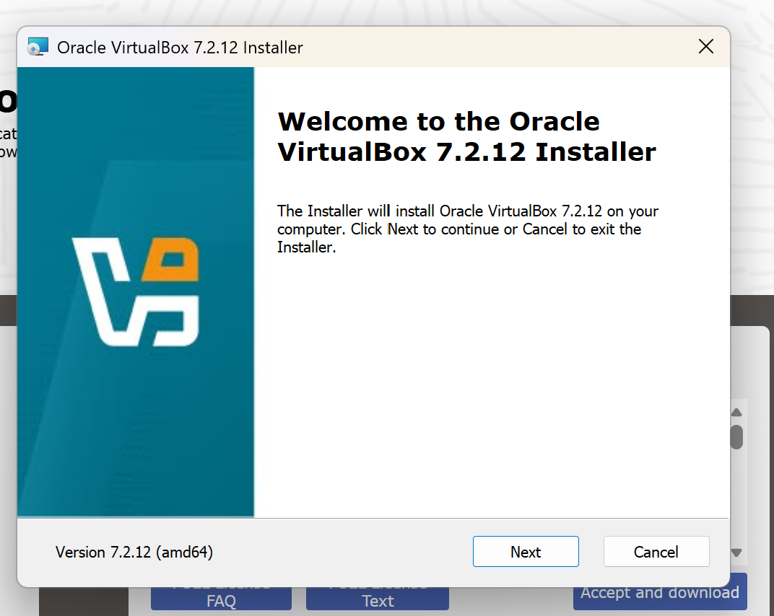
Figure 2 Oracle VirtualBox
After Downloading Oracle VirtualBox I installed windows server and client for BIRMINGHAM and Debian server and Debian Client server using the following links inside the Oracle VirtualBox V
- Windows Server 2022: https://www.microsoft.com/en-us/evalcenter/download-windows-server-2022
- Windows Client: https://www.microsoft.com/en-us/evalcenter/evaluate-windows-11-enterprise
- Debian Server: https://www.debian.org/CD/netinst/
- Debian Client: https://www.debian.org/CD/live/

Once installed the Main Page should look like as follows
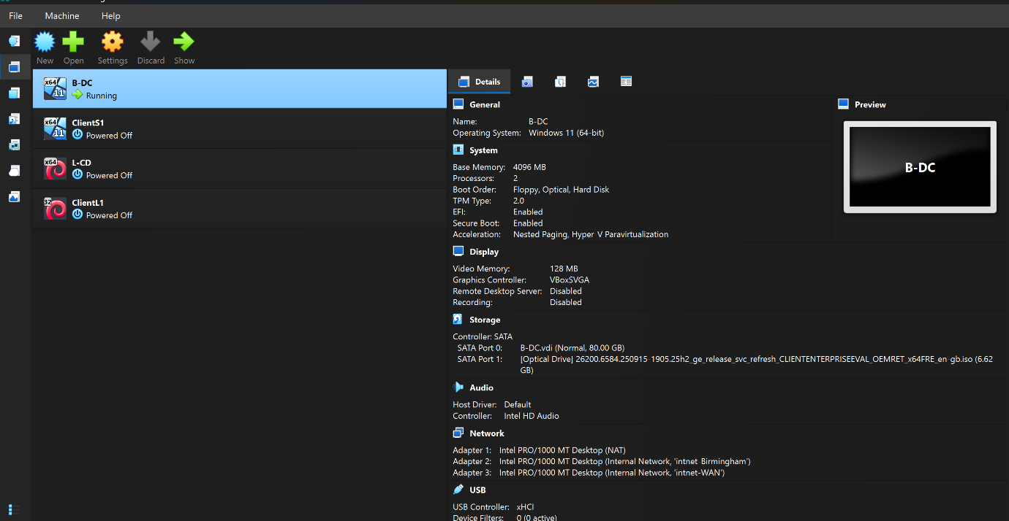
Figure 3 Main and client servers installed
Figure 3 shows the Oracle VM VirtualBox environment that I used to create and manage multiple virtual machines for a networking and system administration lab. The virtual machine B-DC is currently running and is configured with Windows 11 (64-bit), 4 GB of RAM, and 2 virtual processors. The virtual machine also has an 80 GB virtual hard disk and a mounted Windows Enterprise installation ISO. Three network adapters are configured including a NAT connection for internet access and two internal networks for communication with other virtual machines in the lab environment. The additional virtual machines (ClientS1, L-CD, and ClientL1) are currently powered off and are intended to act as client computers connected to the network. This setup allows me to simulate a real-world network infrastructure practice configuring services and gain hands on experience with virtualization operating systems and network management.
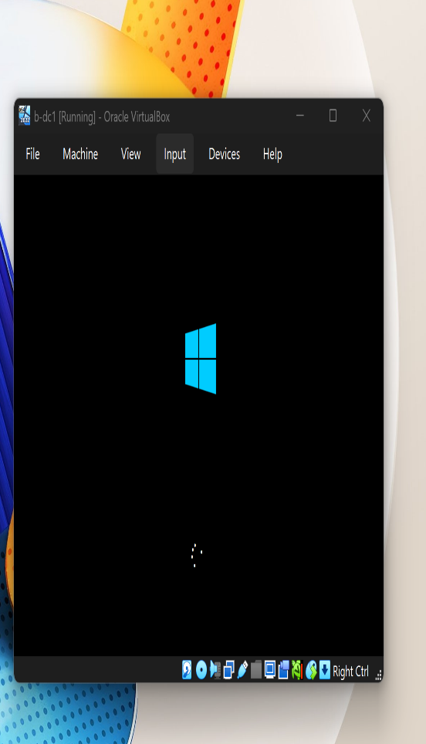
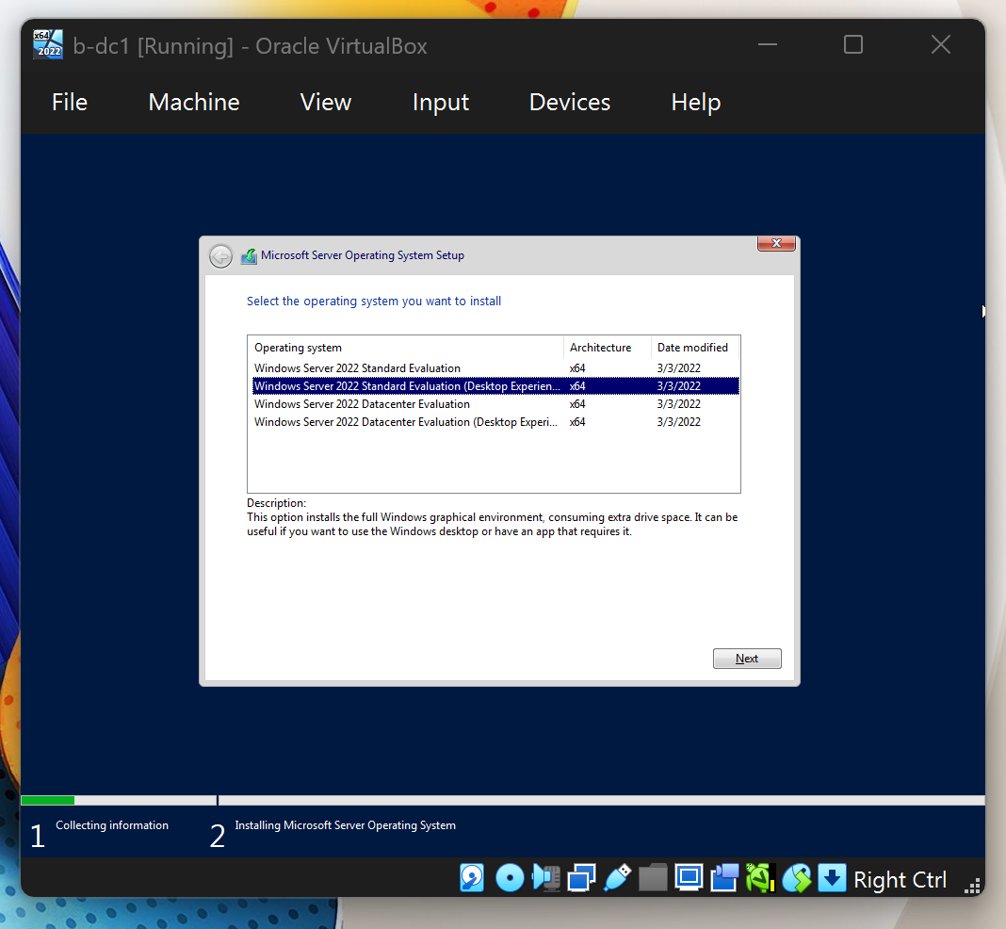U need to open the windows server [B-DC]
Figure 4 Running Windows Server
Figure 4 show the installation of Windows Server 2022 on the B-DC virtual machine in Oracle VirtualBox.
In the first screenshot the Windows Server setup wizard is asking which version of Windows Server should be installed. I selected Windows Server 2022 Standard Evaluation (Desktop Experience) because it includes a graphical user interface (GUI) making it easier to manage and configure the server. After selecting the operating system, I clicked Next to continue the installation.
In the second screenshot the virtual machine is displaying the Windows startup screen. This appears after the installation files have been copied to the virtual hard disk and the system has restarted. The server is loading Windows Server 2022 and completing the installation process.
This step is important because it installs the operating system that will later be configured as a Domain Controller. Once the installation is complete additional services such as Active Directory Domain Services (AD DS) and DNS can be installed to manage user, computers and network resources within the lab environment.
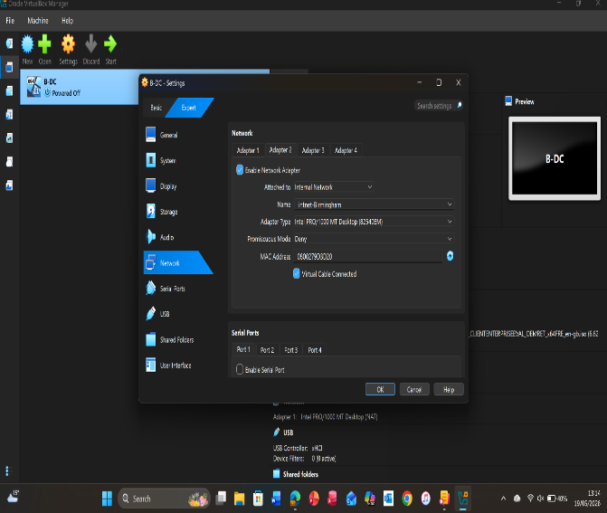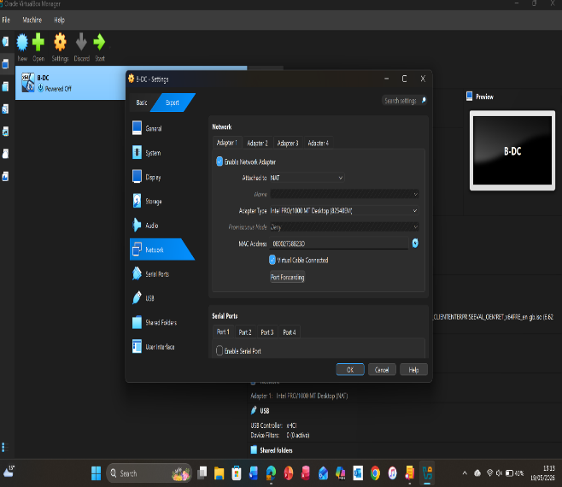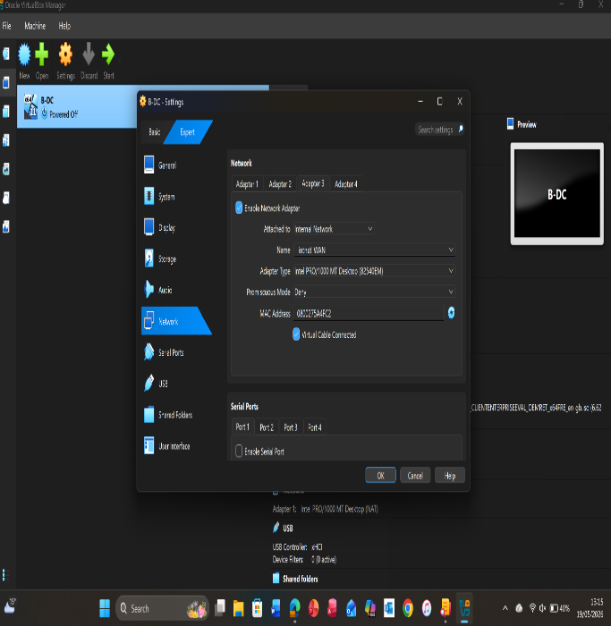
Figure 5 Configured 3 networks
Figure 5 Configured three network adapters in VirtualBox for the B-DC server.
- Adapter 1: Connected to intnet Birmingham (internal network for communication with lab machines).
- Adapter 2: Connected to intnet-WAN (simulates a separate network/WAN connection).
- Adapter 3: Set to NAT (provides internet access through the host computer).
B-DC virtual machine uses three network adapters intnet-Birmingham for lab communication, intnet-WAN to simulate a WAN network and NAT for internet access. After configuring the adapters, I clicked OK to save the settings allowing the server to communicate with other virtual machines and access the internet.
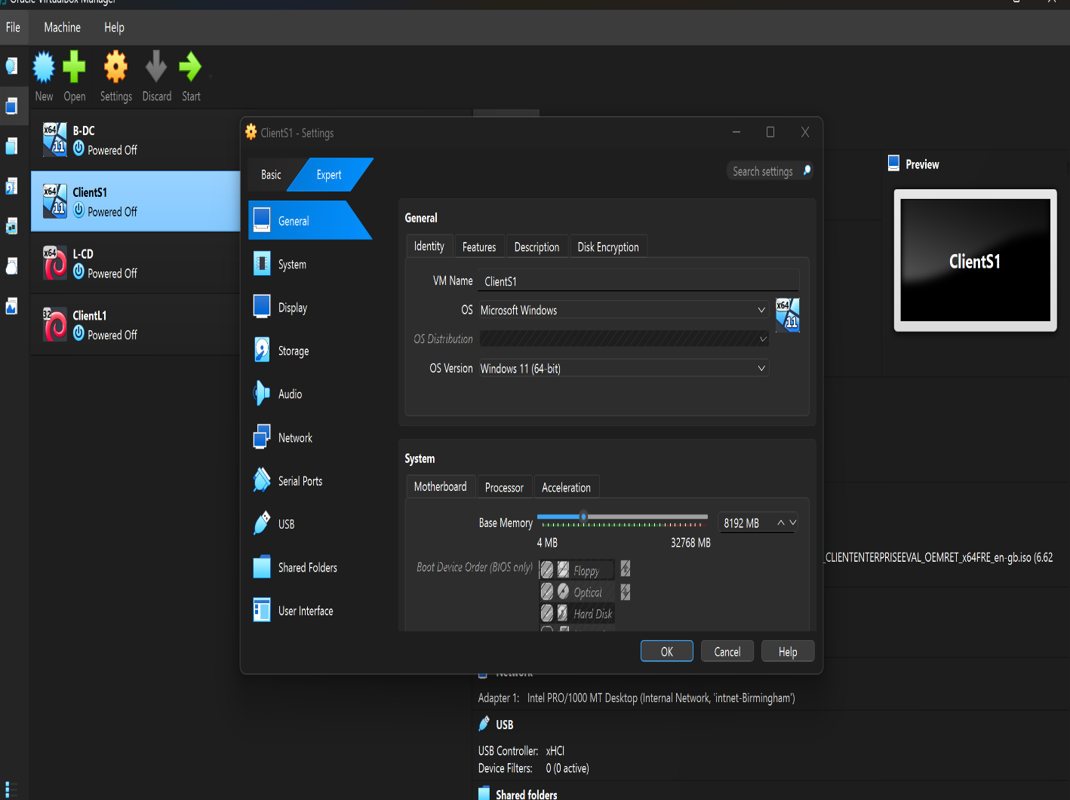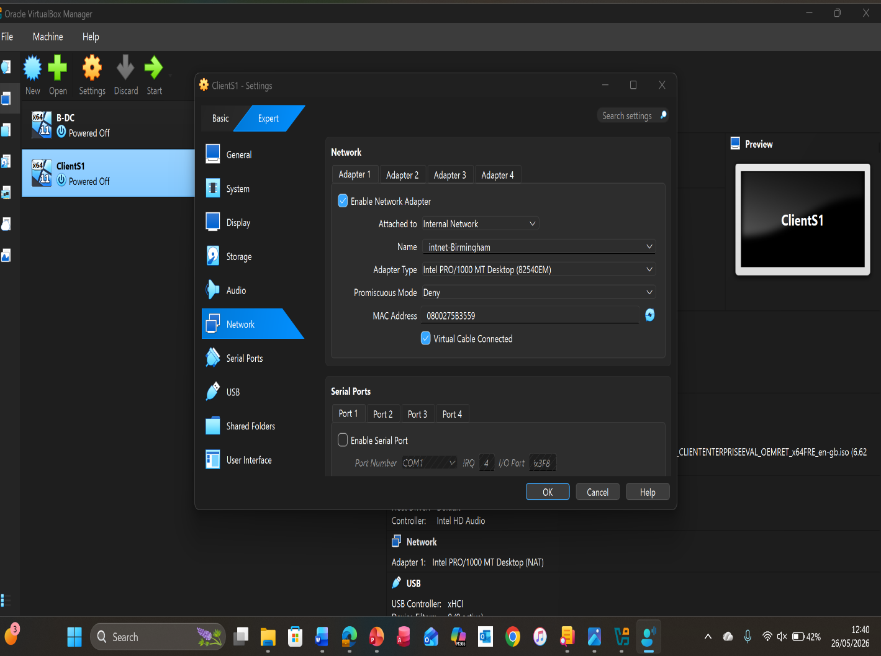Figure 6 Configured client for windows server

Figure 6 shows how I configured the network adapter for the ClientS1 virtual machine so it could communicate with the B-DC server and other devices on the virtual network.

- Open Oracle VM VirtualBox and select ClientS1 from the list of virtual machines.
- Click Settings and then select Network from the left-hand menu.
- Under Adapter 1, tick Enable Network Adapter.
- In the Attached to drop-down menu, select Internal Network.
- In the Name field, enter intnet Birmingham to connect the client to the same network as the domain controller.
- Leave the Adapter Type as Intel PRO/1000 MT Desktop (default setting).
- Ensure Cable Connected is checked.
- Click OK to save the configuration.
- Start the virtual machine and verify that it can communicate with other devices on the intnet Birmingham network.
This configuration allows ClientS1 to join the same internal network as B-DC enabling communication between the client and server for tasks such as domain joining network testing and Active Directory exercises.
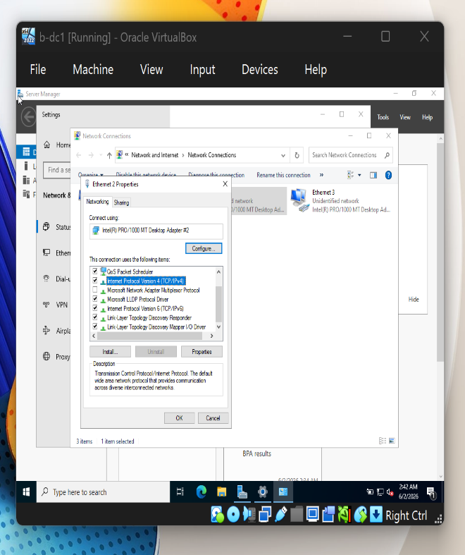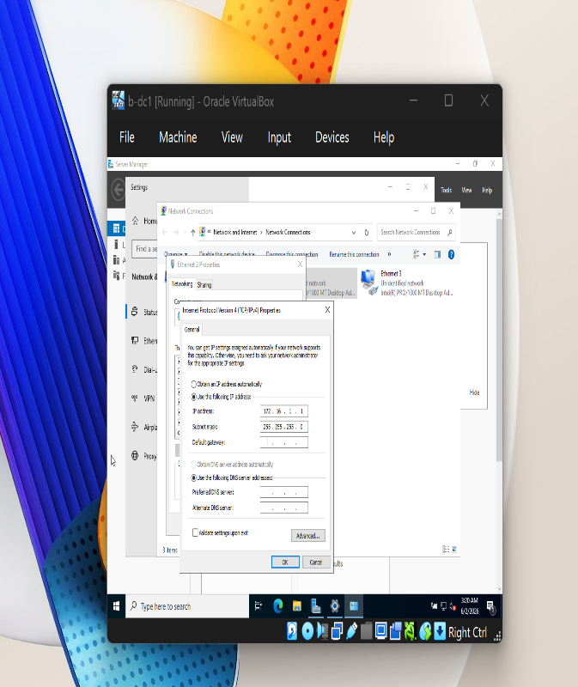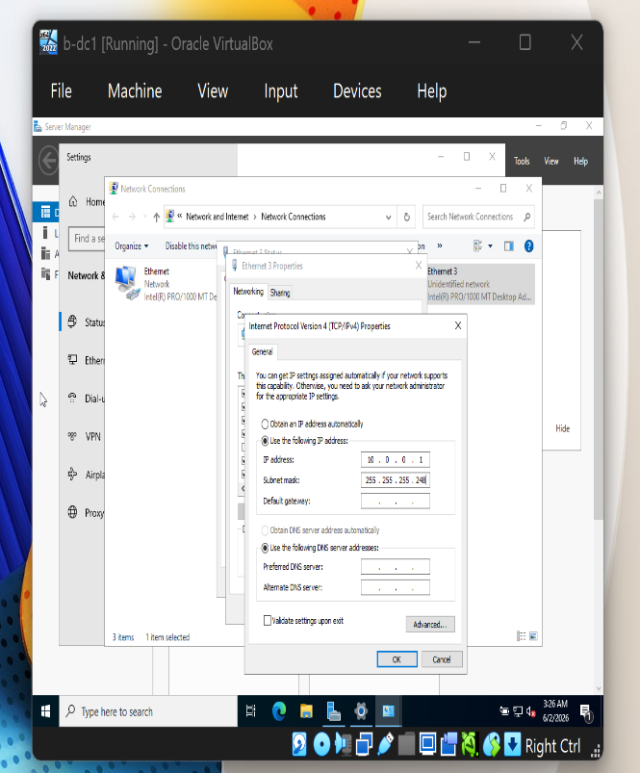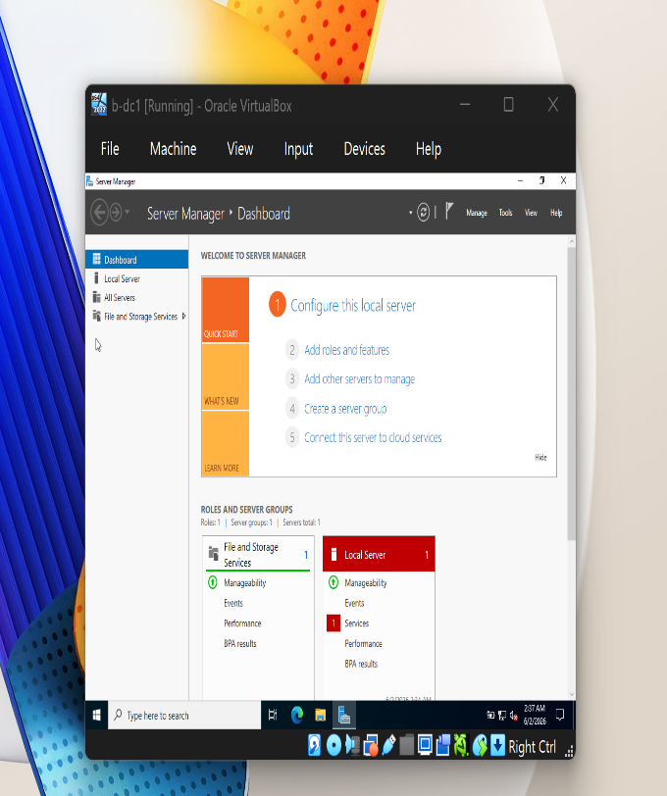Figure 7configuring ip address
Figure 7 show the B-DC server being assigned static IP addresses for its network adapters.
- Open Network Connections.
- Right-click Ethernet and select Properties.
- Open Internet Protocol Version 4 (TCP/IPv4).
- Select Use the following IP address.
- Enter the IP address, subnet mask, and DNS settings.
- Click OK to save the configuration.
This ensures the server always uses the same IP address for reliable network communication.
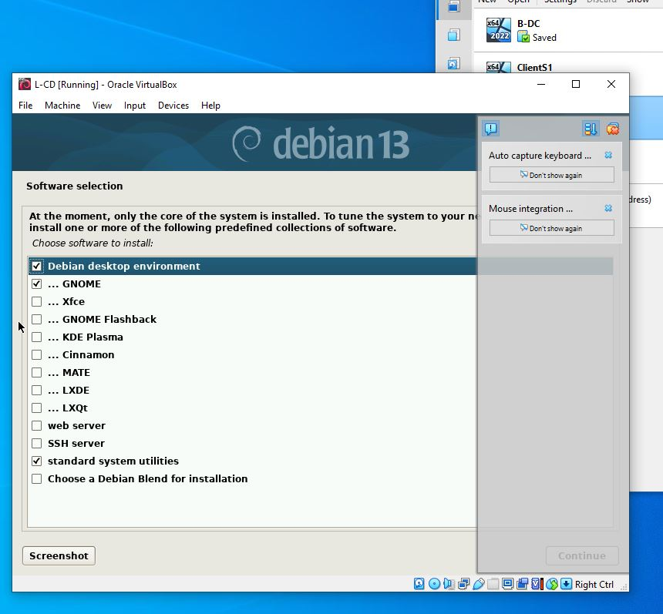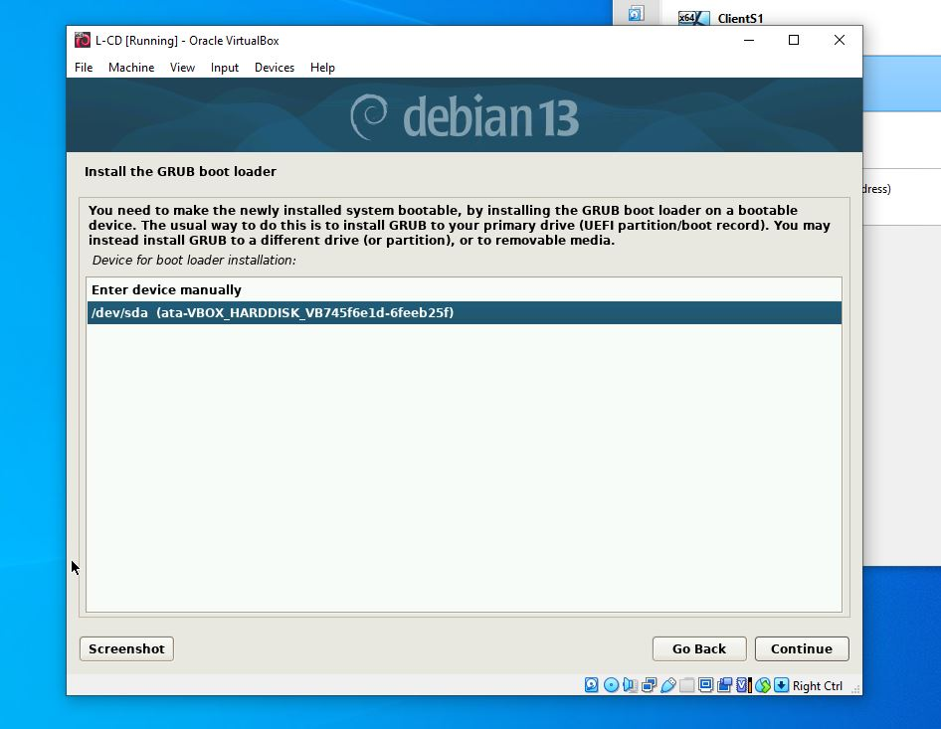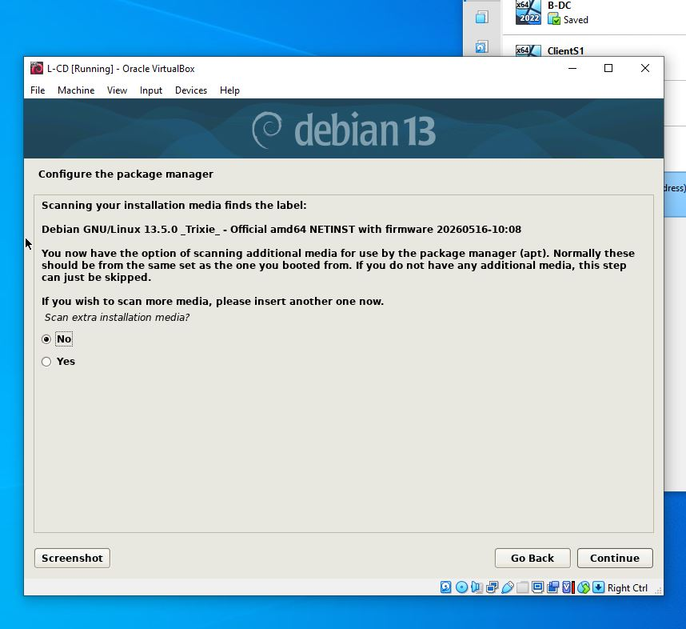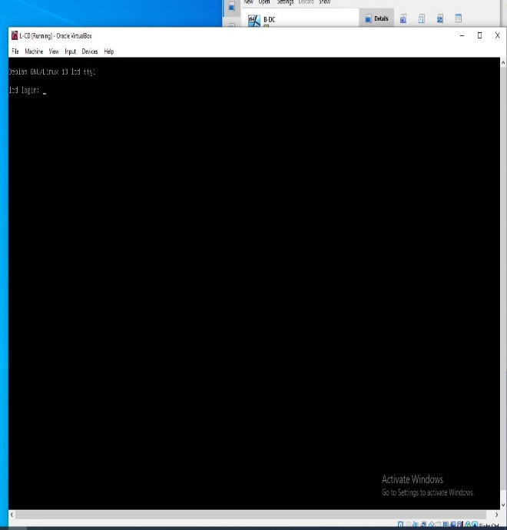Figure 8 Debian Server
Figure 8 show the installation of Debian 13 on the L-CD virtual machine. A desktop environment and system utilities were selected the installation was completed and the system successfully booted to the Debian login screen.
- Start the Debian installer in VirtualBox
- Select Debian Desktop Environment and Standard System Utilities
- Complete the installation steps
- Restart the virtual machine
- Log in to Debian

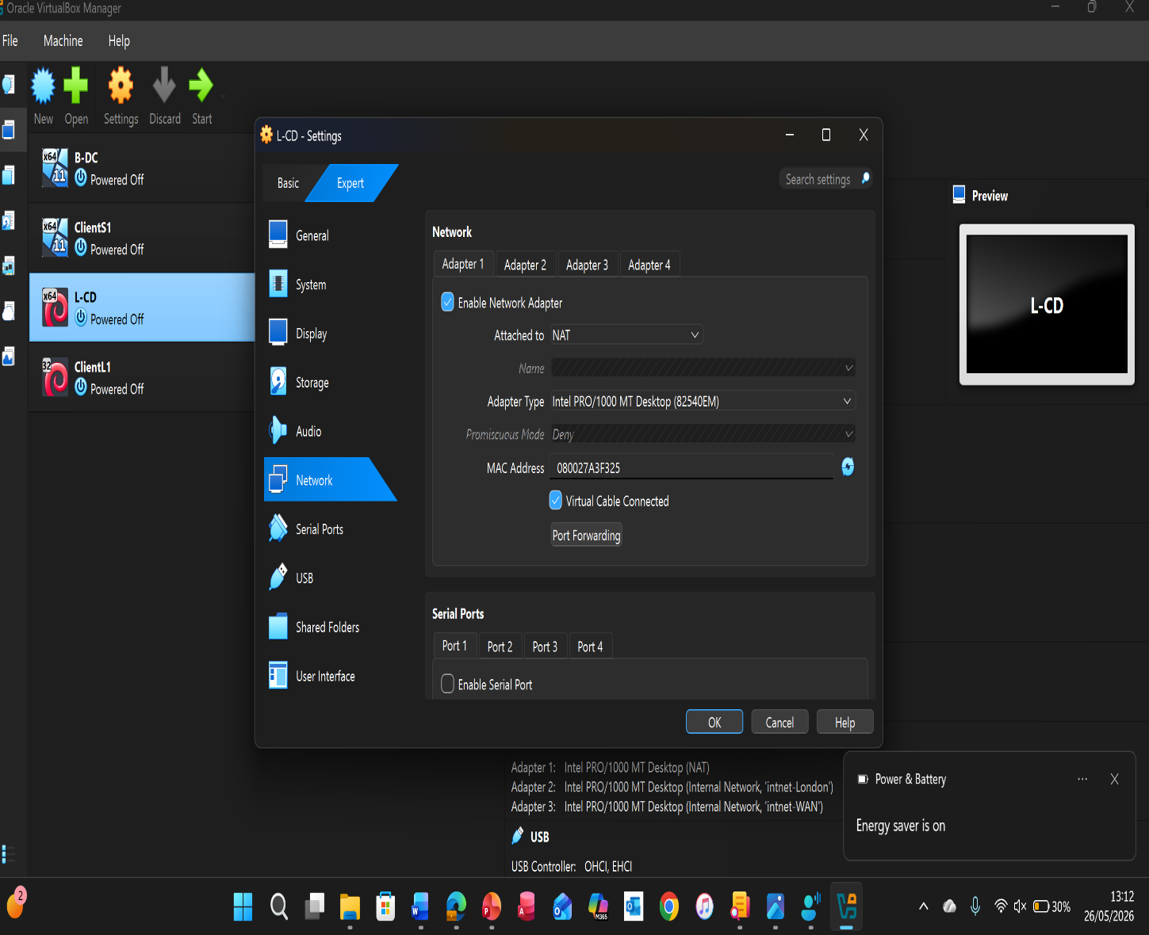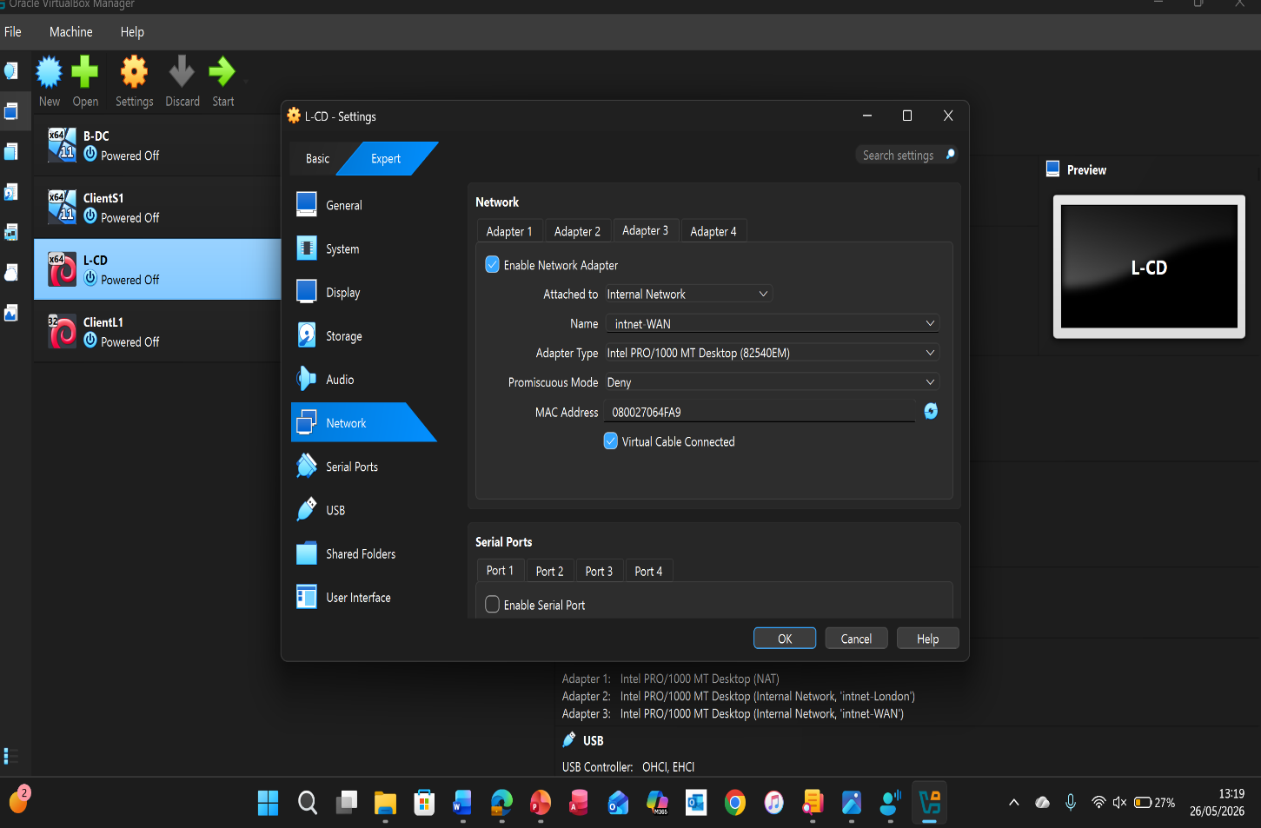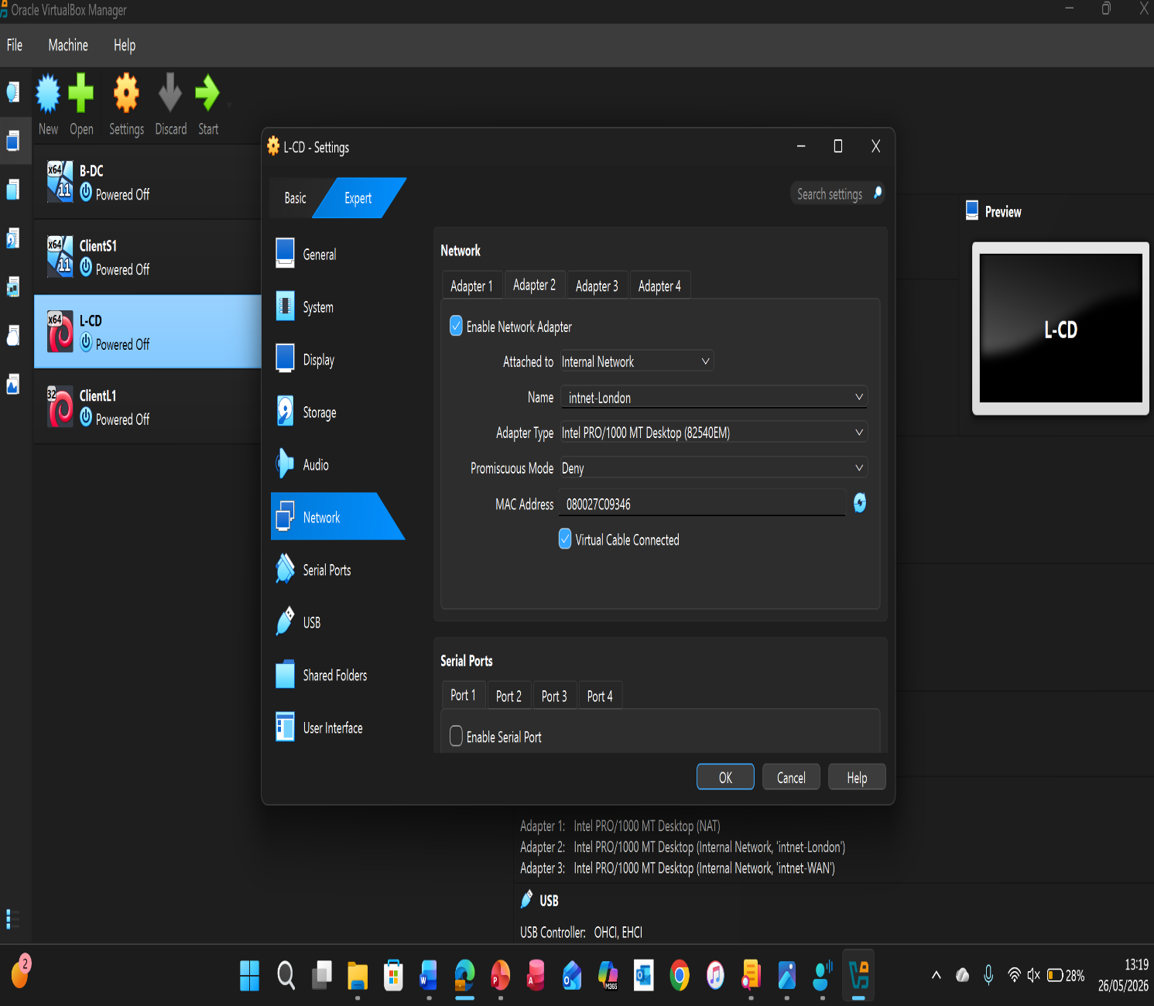
Figure 9 Debian Server network setup
Figure 9 show the network configuration of the L-CD virtual machine in VirtualBox. Three network adapters were configured to allow communication with other lab machines simulate a WAN connection and provide internet access.
- Open VirtualBox and select L-CD
- Go to Settings > Network
- Set Adapter 1 to intnet-London
- Set Adapter 2 to intnet-WAN
- Set Adapter 3 to NAT for internet access
- Ensure Cable Connected is enabled and click OK to save
This setup allows L-CD virtual machine to communicate with the lab network and access the internet when required.
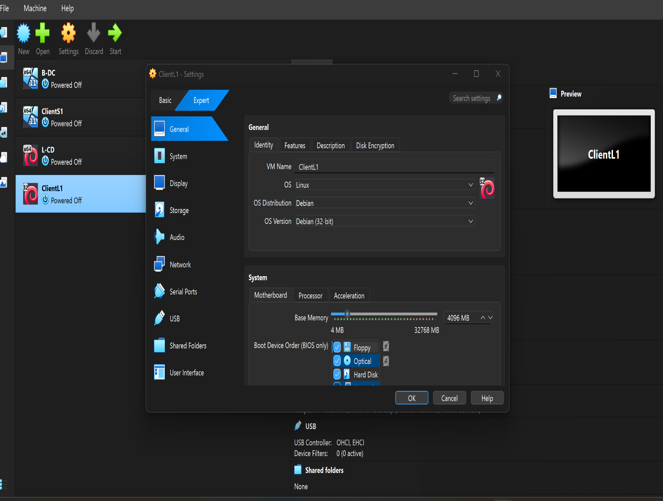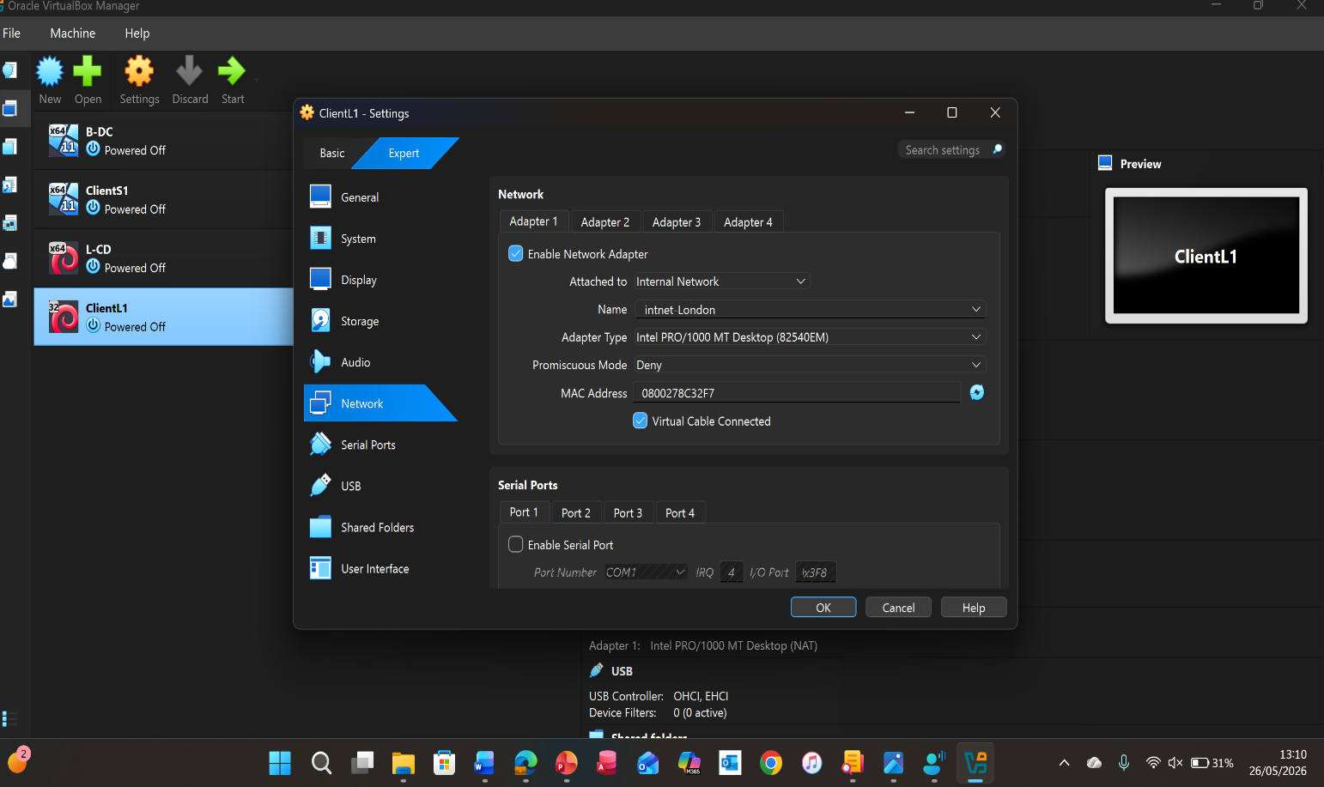
Figure 10 Debian Client Network setup
Figure 10 show the creation and network setup of the ClientL1 virtual machine in VirtualBox.

- Create the ClientL1 virtual machine
- Configure the system settings (memory and storage)
- Open Settings > Network
- Enable Adapter 1 and connect it to intnet-Birmingham
- Click OK to save the settings
This allows ClientL1 to communicate with other devices on the lab network.

Reflection
Technical Reflection
I deployed a virtual network environment using Oracle VirtualBox. The environment included a Windows Server 2022 Domain Controller (B-DC) Windows client machines and Linux virtual machines. The main tasks involved installing operating systems configuring network adapters assigning static IP addresses and setting up Active Directory Domain Services (AD DS).
One of the challenges encountered was configuring the network adapters correctly. The virtual machines required connections to intnet-Birmingham, intnet-WAN and NAT networks. Initially some devices were unable to communicate because they were connected to the wrong virtual network. To diagnose the issue, I reviewed the VirtualBox network settings and confirmed that the adapters were assigned to the correct networks.
Another issue involved network connectivity and DNS configuration. After assigning static IP addresses I used the ping command to test communication between devices. When connectivity failed, I checked the IP addresses, subnet masks and DNS settings. I discovered that some client machines were not using the Domain Controller as their DNS server preventing them from locating the domain correctly. After correcting the DNS configuration, the clients successfully joined the domain.
Throughout deployment and testing I followed a systematic troubleshooting approach by checking configurations testing connectivity and reviewing server settings. This helped resolve issues efficiently and ensured that all systems communicated correctly within the virtual network.

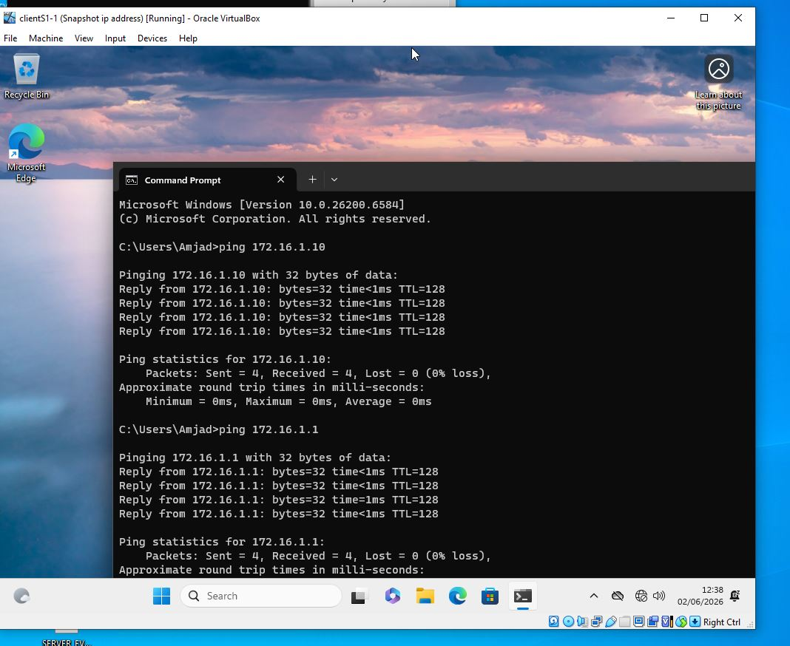 Figure 11Windows Client Ping test

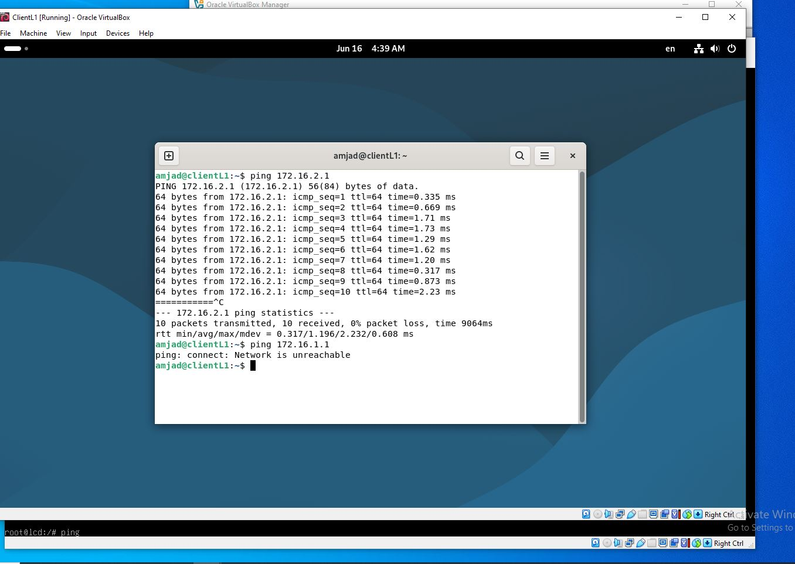 Figure 12 Debian client ping
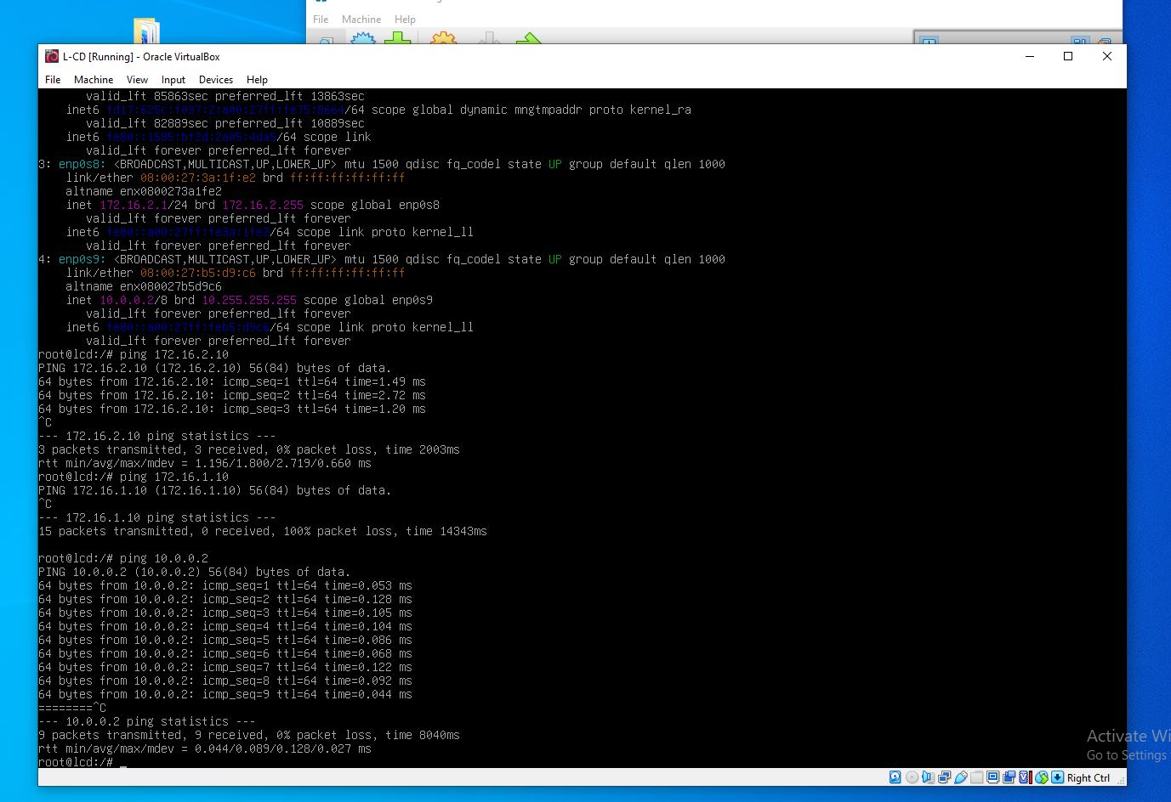Figure 13 Debian Server ping test

Personal Reflection
This project provided valuable hands-on experience in virtualization, networking and server administration. I improved my understanding of IP addressing, DNS, Active Directory and network troubleshooting. Although some configurations were challenging initially, I developed confidence by working through problems methodically. The project enhanced my technical and problem-solving skills and gave me practical experience of managing a small enterprise network environment which will be beneficial for my future studies and career in IT.

References
[1] C. Jiang et al., “Energy efficiency comparison of hypervisors,” Sustainable computing informatics and systems, vol. 22, pp. 311–321, June 2019, doi: 10.1016/j.suscom.2017.09.005.

[2] A. Sequeira, "The phantom menace: Security," Commun. News, vol. 44, (5), pp. 22, 2007. Available: https://www.proquest.com/trade-journals/phantom-menace-security/docview/202803585/se-2.

[3] C. Sturdevant, “VMware Workstation vs. Oracle VM VirtualBox,” eWeek (New York, N.Y.), vol. 27, no. 12. Quinstreet, New York, pp. 22–24, June 21, 2010.

[4] J. Horalek, J. Matyska, and V. Sobeslav, “Performance comparison of selected virtualization platforms,” in 2013 IEEE 14th International Symposium on Computational Intelligence and Informatics (CINTI), IEEE, Nov. 2013, pp. 327–332. doi: 10.1109/CINTI.2013.6705215.

[5] W. Lloyd, S. Pallickara, O. David, J. Lyon, M. Arabi, and K. Rojas, “Performance implications of multi-tier application deployments on Infrastructure-as-a-Service clouds: Towards performance modeling,” Future generation computer systems, vol. 29, no. 5, pp. 1254–1264, July 2013, doi: 10.1016/j.future.2012.12.007.

[6] M. A. Sportack, IP addressing fundamentals. Indianapolis, Ind: Cisco, 2003.

[7] Yuk-Nam Law, Man-Chiu Lai, Wee Lum Tan, and Wing Cheong Lau, “Empirical Performance of IPv6 vs. IPv4 under a Dual-Stack Environment,” in IEEE International Conference on Communications (2003), IEEE, May 2008, pp. 5924–5929. doi: 10.1109/ICC.2008.1107.

[8] K. Wallace and linkedin.com, Carpenteria, CA. Learning Subnetting., (2019). [Online Video]. Available at: https://www.linkedin.com/learning/learning-subnetting-2019?u=77966930&auth=true

[9] “Letters,” IT architect, vol. 18, no. 1, MultiMedia Healthcare Inc, San Francisco, p. 8, January 1, 2003.

[10] S. Troia, F. Sapienza, L. Vare, and G. Maier, “On Deep Reinforcement Learning for Traffic Engineering in SD-WAN,” IEEE journal on selected areas in communications, vol. 39, no. 7, pp. 2198–2212, July 2021, doi: 10.1109/JSAC.2020.3041385.

[11] R. McMillen and linkedin.com, Carpenteria, CA. Introduction to Network Routing., (2021). [Online Video]. Available at: https://www.linkedin.com/learning/introduction-to-network-routing?u=77966930&auth=true

[12] P. Amaral and D. Simoes, “Deep Reinforcement Learning Based Routing in IP Media Broadcast Networks: Feasibility and Performance,” IEEE access, vol. 10, pp. 62459–62470, Jan. 2022, doi: 10.1109/ACCESS.2022.3182009.

[13] Z. Huang et al., “Communication-Topology-preserving Motion Planning: Enabling Static Routing in UAV Networks,” ACM transactions on sensor networks, vol. 20, no. 1, Art. no. 24, Dec. 2023, doi: 10.1145/3631530.

[14] V. Fulber-Garcia, E. P. Duarte, A. Huff, and C. R. P. dos Santos, “Network service topology: Formalization, taxonomy and the CUSTOM specification model,” Computer networks (Amsterdam, Netherlands : 1999), vol. 178, Art. no. 107337, Sept. 2020, doi: 10.1016/j.comnet.2020.107337.

[15] M. Oswalt, C. Adell, S. S. Lowe, and J. Edelman, Network programmability and automation : skills for the next-generation network engineer, Second edition. Sebastopol, CA: O’Reilly Media, Inc., 2023.

[16] H. Abbas et al., “Security Assessment and Evaluation of VPNs: A Comprehensive Survey,” ACM computing surveys, vol. 55, no. 13s, Art. no. 273, Dec. 2023, doi: 10.1145/3579162.

[17] T. Wechsler, Carpenteria, CA. Windows Server 2022: Active Directory Domain Services (AD DS) lokal und in der Cloud bereitstellen und verwalten (AZ-800 Teil 1), (2022).

[18] Z. Li, L. Wang, and F. Li, “Model-and-data-driven robust concurrent optimization for structural topology and device layout integrating load location and non-design domain effects,” Aerospace science and technology, vol. 170, Art. no. 111566, Mar. 2026, doi: 10.1016/j.ast.2025.111566.

