Aron Jones
UWTSD
Dynamics Assignment
Centrifugal Clutch

Task A
  - What is a centrifugal clutch?
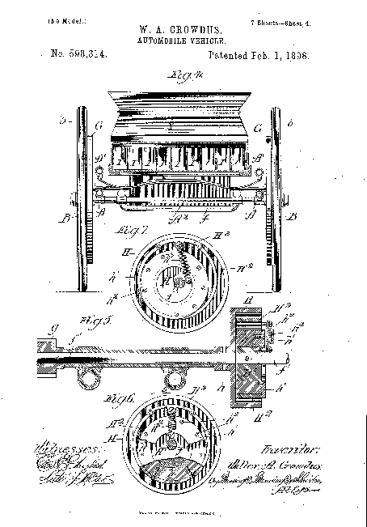
The centrifugal clutch was invented in 1858 for use on locomotives and was then later patented in 1898 by W. A. Crowdus for the automobile vehicle. The image below shows the original design for the automobiles clutch.

(Anon., 2021)
As the name intends a centrifugal clutch uses centrifugal force in order to provide a connection between a driveshaft and the transition shaft. The clutch is engaged according to the speed of the engine which means that there is no need for a clutch peddle. This allows a driver to start and stop the engine without upping/downing the gears. As the clutch relies on centrifugal forces to operate, the higher the speed (RPM) the more effective the clutch is at creating friction between the friction lining and outer drum. This creates higher amounts of torque which is then transmitted to the driven shaft via the drum.
The material used on the clutch determines the amount of friction produced when engaging the outer drum. The most common lining is organic materials such as compounded rubber than has been woven or moulded. There are also heavy-duty organic materials that have a higher heat resistance compared to the alterative organic. Ceramic materials can also be used for their heat resistant properties.
It is considered to be the smoothest type of clutch due to its gradual engagement which in turn allows the engine to reach the optimal torque range prior to the load been applied. This is why it is used for equipment such as chainsaws as when the user releases the throttle the clutch is safely disengaged. (Toulas, 2018)

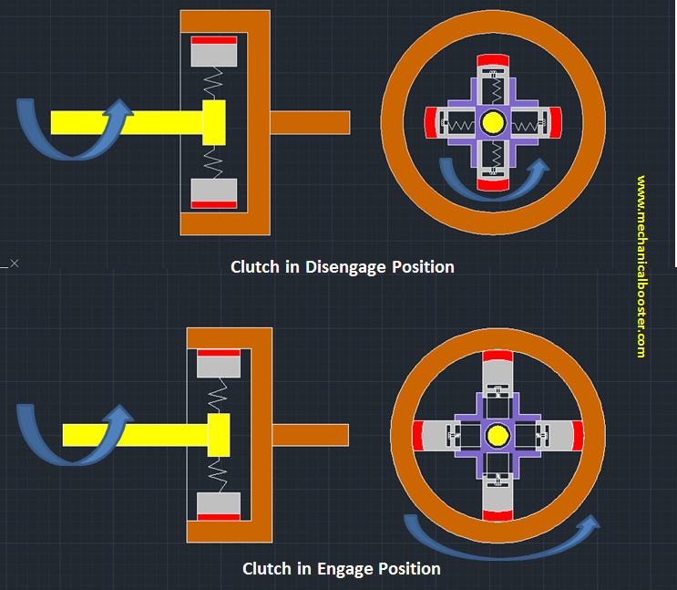 (Mechanicalbooster, 2021)

  - The Parts.
The clutch consists of 5 main parts, these being: the shoes, spring, drum, spider and friction lining.
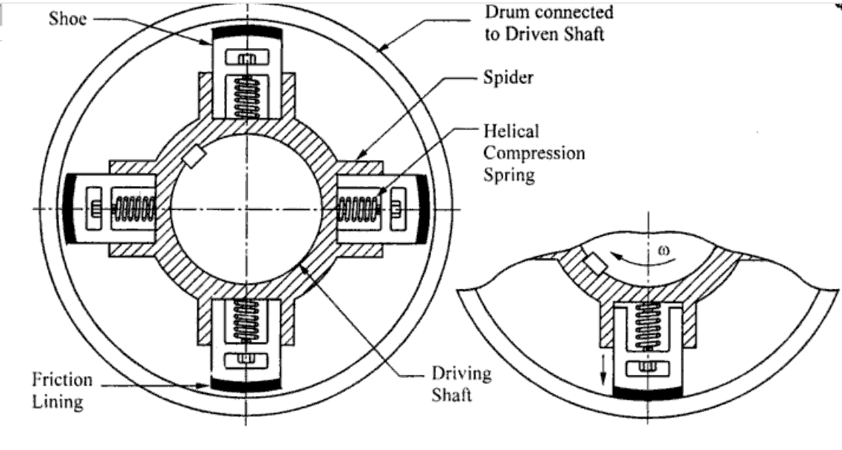 (Mechdiploma, 2021)
The shoes are intended to slide between the spider/ guideways when attached to the spring. The shoe has a friction lining at the surface that comes in contact with the outer drum.
The frictional lining of the shoes transmits the torque of the driveshaft to the outer drum. The lining gives the shoe more grip on the drum as it rotates.
The spring of the clutch is the controlling element as it determines the speed required to engage the clutch. When the RPM is lower enough and the force applied in lesser than that of the spring’s stiffness, the spring will disengage the shoes from the outer drum. To change the engagement speed the springs are switched with ones set to the required stiffness.
The spider is fitted onto the drive shaft from a motor with equal spacings between the guideways. The shoes rest within the guides until the speed required to overcome the springs stiffness is met.
The drum of the clutch acts as both a housing and a means of transferring the torque form the motor to the driven shaft.
  - The applications of centrifugal clutches.
Centrifugal clutches are used in a variety of environments on equipment that requires a high starting inertia. In recent years these clutches have been used on portable and mobile equipment that use a small petrol/ diesel engine to operate. (Lancereal, 2021)
Here are a few examples.
- Lawnmowers, woodchippers, milling cutters and chainsaws
- Go-Karts
- Street cleaners
- Concreate finishers
- Compressors
- Mopeds
- Boats and paramotors
These devices use centrifugal clutches to keep the engine from stalling due to the output shaft being slowed.
  - Advantages of centrifugal clutches
- The centrifugal clutch will automatically engage and disengage removing the need of a control mechanism like a peddle.
- It allows for greater control of the engagement speed as the torque transmitted gradually increase with the speed of the motor. This also gives the clutch a much longer lifespan.
- The clutch provides shock-free acceleration when using a heavy load or an abrupt start or stop, there is less chance of stalling. This makes them safer as there is progressive
- They are a cheaper alternative to most modern types of clutches due to the fewer parts used in its assembly and the lack of additional components being needed.
  - Disadvantages of centrifugal clutches
- When engaged there is a large amount of heat generated due to the friction between the lining of the shoes and the drum. Poor driving habits and use can lead to the heat damaging the clutch completely causing it to fail.
- The clutch needs to be oiled frequently to prevent the build-up of heat and the keep it at a safe temperature.
- Slipping and friction will result in the loss of power even if the clutch is working at peak performance.
- The clutch can be contaminated by sand and dust which will alter the frictional properties leading to uncontrolled behaviour.
- Poor installation can lead to the clutch failing in under an hour and normally they do not have a long-life span, on average they last 5 years.
(Toulas, 2018)

  - Electromagnetic clutches
An electromagnetic clutch is electrically operated however it transmits torque mechanically. The coil shell is used to create a circuit when a magnetic material comes in contact. This pulls the armature to be in contact with the rotors face. The friction and magnetic field begin the rotational motion. The material of the clutch reduces the amount of wear it receives. When a high amount of torque is needed, the material is changed to one with a higher coefficient of friction. (Electric-clutches, 2021)
These clutches are used in high speed and cycle rate equipment that has a long-life span such as packaging machines, printer and mixers. They can be used in an automobile to remove the need of a clutch pedal and instead replacing it will a transfer button. A smaller version of this clutch can be found in air conditioning systems to pressure the compressor. Even though is an expensive device it provides fast and easy operation and can be used for automatic transmission. The speed at which it operates makes it ideal for manufacturing as it can aid in the production process such as a packaging machine being able to finalise products at high speeds. (Kalyani, 2021)

Task B
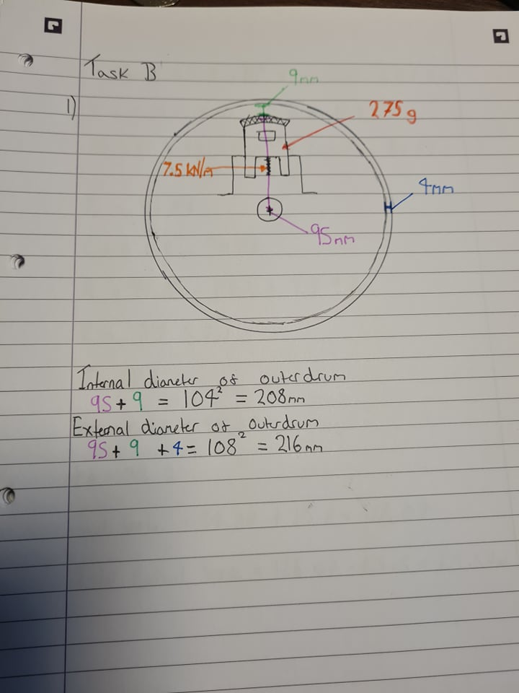
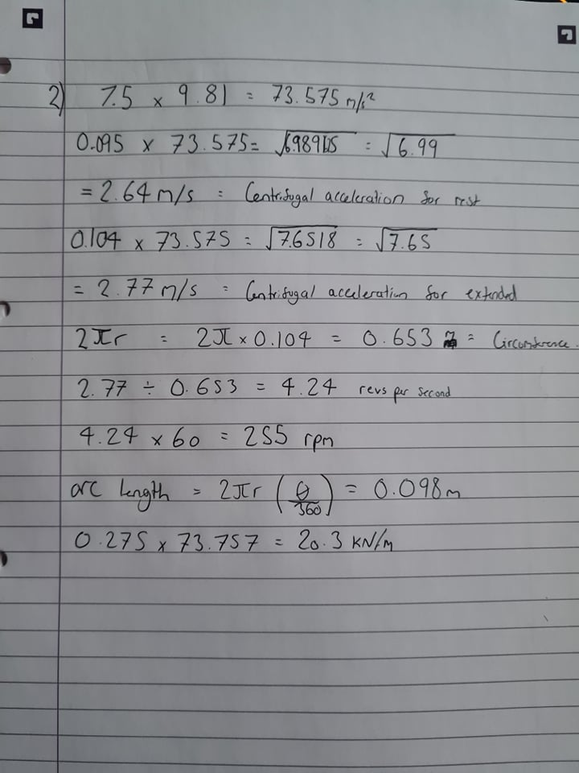
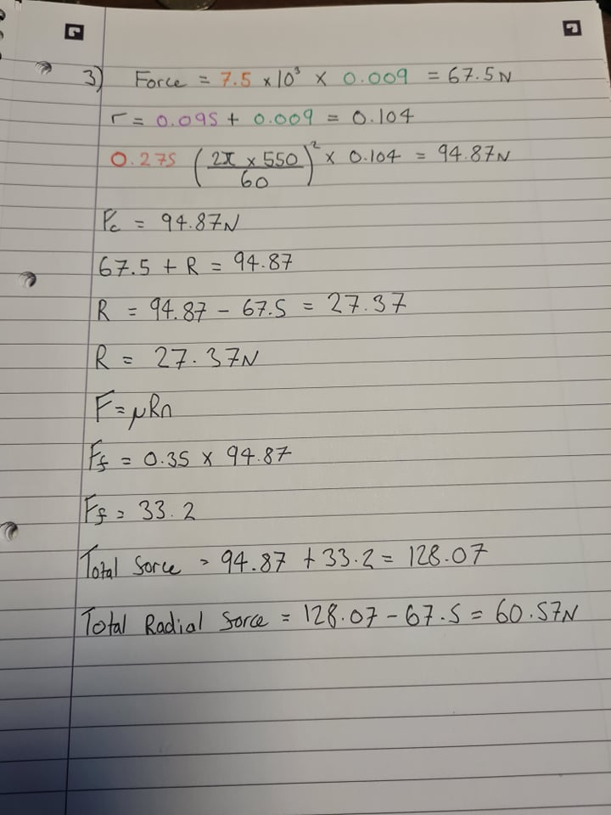

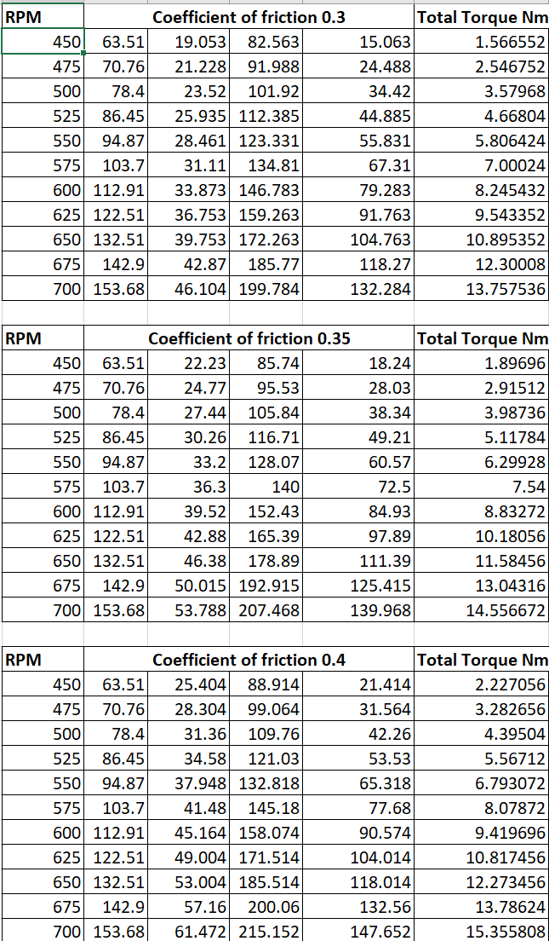

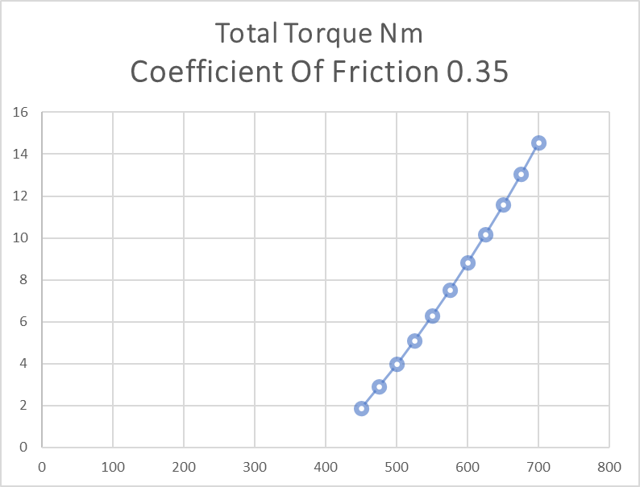

The graph shows that as the RPM increases the amount of torque also increases. A high coefficient of friction results in an increase in torque and a lower coefficient result in a lower amount of torque transmitted.

Bibliography
Anon., 2021. patents.google.com. [Online]
Available at: https://patents.google.com/patent/US598314
[Accessed 10 October 2021].
Electric-clutches, 2021. Electric-clutches.com. [Online]
Available at: https://www.electric-clutches.com/
[Accessed 10 October 2021].
Kalyani, U., 2021. Autoprotips.com. [Online]
Available at: https://www.autoprotips.com/electromagnetic-clutch-applications/#:~:text=%20Applications%20Of%20Electromagnetic%20Clutch%20%201%20Electromagnetic,clutch%20pedal%20via%20way%20of%20means...%20More%20
[Accessed 10 October 2021].
Lancereal, 2021. Lancereal.com. [Online]
Available at: https://www.lancereal.com/centrifugal-clutch-explained/#:~:text=What%20Is%20A%20Centrifugal%20Clutch%3F%20A%20centrifugal%20clutch,giving%20a%20%E2%80%9Csoft%20start%E2%80%9D%20with%20no%20load%20engagement.
[Accessed 10 October 2021].
Mechanicalbooster, 2021. Mechanicalbooster.com. [Online]
Available at: https://www.mechanicalbooster.com/2017/06/centrifugal-clutch.html
[Accessed 10 October 2021].
Mechdiploma, 2021. Mechdiploma. [Online]
[Accessed 10 October 2021].
Toulas, B., 2018. Engineering clicks. [Online]
Available at: https://www.engineeringclicks.com/centrifugal-clutch/
[Accessed 10 October 2021].

