Lucie Jones 2200871
ECAD5008- Leading the learning: what, how and why am I teaching.

A written assignment critically evaluating how Assessment for Learning can be utilised in a series of learning opportunities to aid progression across chosen areas of learning and experience.

In January 2020 Donaldson (2015) created the new Curriculum for Wales Framework specifically for use in schools in Wales. Six Areas of Learning and Experience (AoLEs) will make up the new Welsh curriculum. To improve pupils’ performance in the classroom, teachers have been using assessment for learning. A teaching strategy known as assessment for learning (AfL) provides feedback that students may utilise to raise their performance levels. It is the process of gathering and analysing data so that educators and students may determine where they are in their learning, where they need to go, and the most effective way to get there. Excellent AfL practice is already well established in many schools across Wales. My selected group of learners are year 5, age 9-10. The three AoLEs I have chosen to do is Maths, Welsh, and Expressive arts. The theme we have been concentrating on is Space. In my class there is three different grouped abilities. Each task is differentiated three times to suit the abilities in each group.

Maths links under the mathematics and numeracy AoLE. There are four statements of what matters in this AoLE. Seen in appendix 1, the maths lesson is based on using prior knowledge to draw a bar graph and answer questions on a graph. This lesson plan links to what matters statement four, progression step 3. ‘I can represent information by creating a variety of appropriate charts of increasing complexity,
including tally charts, frequency tables, bar graphs and line graphs. I can use different scales to extract and interpret information from a range of diagrams, tables, and graphs. I am beginning to interpret and analyse simple graphs, charts, and data.’ This lesson also links with other meaningful links across the curriculum. It links with the Numeracy framework and the Digital Competence framework. This lesson includes a starter, a main task and two extensions. As the theme is space, they will be answering questions on a graph based on the Rover that is stuck on Mars. One of the extensions is developing ICT/ digital competence skills by using laptops to create a graph. The tasks have been differentiated three times to suit different abilities and needs in the class (for example some pupils will be using a scale going up in two, fives, eights etc). The tasks also include challenge questions and extensions.

Welsh links under the Language, Literacy and Communication AoLE. There are four statements of what matters in this AoLE. Seen in appendix 2, This Welsh lesson is based on practising Welsh translation skills. This lesson plan links to what matters statement three, Expressing ourselves through language is key to communication. The learning and experience support them to develop an awareness of how they use a range of languages to express themselves for different purposes and audiences. For Welsh or English this includes both speaking and writing. It links to what matters statement 1, I can communicate in a growing range of languages. It also links with what matters statement 2, I am begging to recognise and read high- frequency words that I encounter. This lesson also links with other meaningful links across the curriculum. It links with the Expressive Arts framework. As this is an English medium school, they have low ability Welsh. As the theme is Space they have been learning about Elon Musk. In this lesson pupils are given a Welsh information sheet about Elon Musk, and they have to scan through the text and answer questions on it. Each table have a different work sheet with questions suitable for their ability. There are two different versions of the information sheet based on ability. After they have completed that the extension is to make a poster on all the information, they know about him.

Drama and Art link under the Expressive arts AoLE. There are three statements of what matters in this AoLE. Seen in appendix 3, this lesson is based on playing the role of Elon Musk and answering any questions in front of the class. This lesson plan links to what matters statement three, creating combines skills knowledge, drawing on the sense, inspiration, and imagination. This links with progression step 3, I can perform, produce, design, exhibit and share my creative work in formal and non-formal contexts, considering the impact of my creative work on the audience. This lesson also links with the Literacy framework as pupils will be writing down possible questions on speech bubbles to ask each other as if they were Elon Musk. This lesson is based on hot seating where pupils take it in turn to act out Elon Musk and answering any questions asked.

The idea that student judgements count most in the classroom is a fundamental component of assessment for learning. Students require ongoing information about their learning, information about what they are doing well, information about where to focus their efforts to raise their performance, and information about potential strategies to advance their learning in order to make informed decisions. Students become significant collaborators in their own learning and are able to assume more responsibility for it when they are given well-defined learning objectives to work towards and helpful feedback on how they are doing. Assessment is done to assist learning and is an inherent component of the teaching and learning process. Teachers employ a wide variety of assessment techniques and activities in the assessment for learning classroom to get a complete picture of their students' learning styles. In addition to providing feedback to students, the teachers monitor and modify lessons based on their analysis and interpretation of the data. Pupils actively contribute information. In addition to participating in the teaching and learning activities, they also utilise the results of assessments to define objectives, make decisions about their own personal growth, and get a sense of what constitutes high-quality work.

The purpose of assessment for learning is to encourage students in practicing their understanding of expert performance in several disciplines by first helping them grasp what it looks like. AfL techniques in schools comprise common pedagogical activities such as outlining the goals of the lesson, defining success criteria, obtaining evidence of progress, giving feedback, and assisting students in self- and peer-evaluation (Black and Wiliam, 1998; Klenowski, 2009). In addition to understanding and using collaborative and conceptual language, students must be able to establish connections between various activity levels. As a result, students who struggle with language and/or attentional issues are faced with a challenge. AfL methods can, on the one hand, give access to curriculum that is developmentally appropriate. However, AfL techniques could also create new obstacles to learning.

There are 4 main elements of AfL. The first one is Sharing criteria with learners. This enables learners to know what will make their work good. It also helps learners know where they are, and the next step, according to the criteria. Students' language and focus are crucial to common AfL approaches include revealing success criteria via assessments and having students use them to question examples and provide feedback. Sharing objectives and criteria can have a lot of benefits. It encourages pupils to take more control of their learning. It gives teachers an example for providing feedback. Students will have a defined framework for learning and can demonstrate accomplishment throughout the session due to the sharing of objectives and criteria, which provides comfort. By sharing success criteria with students, you can also assist them learn what constitutes success and how to provide and accept constructive criticism and recommendations that will further their learning. There are, however, a few possible drawbacks to take into account. For example, having too many goals or objectives might make the lesson difficult to manage and lose its intended focus. According to John Hattie, it's critical to let pupils know what the learning objectives and achievement standards are. He says that when it comes to what is happening in the classroom and what the students should be learning as an outcome of doing, the students and the instructor should be in agreement.

The second element of Assessment for Learning is quality of questions/ quality of talk. All learners actively think up answers to good, open questions. Learners explain ideas to each other, reinforcing their learning and understanding. It inspires pupils to interact with one another and their work. It encourages pupils to think aloud. Inspires active learning through dialogue. It gives pupils the confidence to believe that their ideas are valid. Enhances communication and listening abilities. Develops critical thinking abilities and aids pupils in making sense of what they have learned. According to educational studies, classroom conversation may significantly affect students' learning, development, and success. Effect sizes are a useful tool used by Hattie (2009) to assess the impact of various interventions and instructional pedagogies on student success. Effective asking improves learning, as evidenced by Hattie's research, which values the effect size of questioning at 0.82, which is above average. There is no evidence to say that quality of questions and quality of talk is bad. In fact, asking questions is a crucial component of education and has been recognised as a successful strategy for fostering learning.

The third element of Assessment for Learning is use and quality of feedback. It seems that the main focus of AfL was receiving and giving useful feedback (1999). AfL "could do more to improve educational outcomes than almost any other investment in education," according to research that reviewed 250 evaluation articles published over a ten-year period. (Black and others, 2003). Pupils can identify areas for improvement, knowledge gaps, resources for support, and learning techniques to modify or adapt in order to accomplish course objectives with the use of feedback. Feedback can also help students understand, participate in, or create efficient processing methods for the material they are supposed to learn. there are different types of feedback that can be used in a classroom. Written feedback is often provided after a task, whereas oral feedback is typically provided during a lesson. Written feedback must specify the areas in which the student has satisfied the success criteria and/or learning aims and the areas in which they still need to develop. Feedback should ideally occur while students are working on a task and are learning. Alternatively, it might be provided right away following the work to give opportunity for revisions. Two evidence-based models by Hattie and Timperley (2007) and Black and Wiliam (2009) emphasise that every student needs a goal, and that the teacher's feedback should be based on the student's progress towards that objective. Meyer, Bachman, Hempelmann, Ploger, and Spiller (1979) and Meyer (1982) conducted a series of studies related to feedback and praise. These authors showed how older students interpreted praise upon achievement or indifferent comments following a setback as a sign that the instructor thought poorly of them. They felt that the teacher had judged their talent to be high and their effort to be low when they received constructive criticism after failing and neutral comments after succeeding. However, younger pupils did not exhibit the same effects, seeing criticism after failure as a sign of poor ability and praise following success as an indicator of strong ability.

The fourth element of assessment for learning is peer and self-assessment. Peer assessment is a teaching technique that asks students to examine one another's work in a classroom setting in order to help them learn further in the future. A large number of studies indicates that this technique has substantial advantages and effects on student learning, even if a wide variety of circumstances can affect its efficacy (H. Li et al. Citation2020; van Zundert, Sluijsmans, and van Merriënboer Citation2010). Students monitor and assess the quality of their behaviour and thought processes during the learning process through a technique called self-assessment. By assessing their level of knowledge and comprehension, it gives students the ability to take responsibility for their education. Peer evaluations give pupils more self-assurance, promote constructive dialogue, and aid in the improvement of their communication abilities. Utilising peer evaluation enhances learning possibilities since students pick up a lot from their peers. Students are encouraged to take charge of their education and participate more actively in the process as a result. Benefits of Self-Evaluation increases self-awareness. Self-assessment promotes self-awareness by emphasising strengths and areas for development and aids in a deeper knowledge of oneself. Promotes personal development - It serves as a stimulant for personal growth, encouraging people to advance their knowledge and abilities. Limitations of peer assessment include pupils not being kind to each other when writing feedback, especially in the higher years. Must be closely monitored to make sure there are no personality problems or inappropriate remarks. Additional techniques of assessment should be used to supplement it. Peers may hesitate to provide feedback because they are uneasy, unconfident, or worried. Some limitations of self-assessment can be that students think they've accomplished more than they have. Students must understand the evaluation criteria. Students must be clear about their accomplishments and the steps they need to take to fill in any gaps. Some students might not have faith in their own capacity to decide how best to proceed.

For one of my lessons, I decided to teach maths. Maths is very important in the school I’m placed in as it is one of the main focuses alongside Literacy. The topic we recently moved onto was data. In this lesson in particular, we focused on bar graphs. They had been learning about bar graphs in pervious lessons, so they were all familiar with this type of data. One of the main focuses this lesson was to use their prior knowledge to help them answer questions on a graph, turn the graph back into a tally chart and then make their own graph. As the theme this term was space, the graph they answered questions on was about the Mars Rover, and for the extension they had to make their own graph about the size of each planet. As the pupils already learned about this type of data in previous lessons, this was the last lesson they were going to spend learning about graphs. The lesson started off with a starter on the board. The board showed a graph with a series of questions beneath. They answered the questions one question at a time on their white boards. I used an AfL strategy called secret squirrel. This is where the students write down their answers on white boards and hide behind them like a squirrel so no one else sees their answer. When time comes to reveal the answers, they shoot their boards high in the air so only I can see them. The pupils seem to really enjoy using this method of teaching. Mini whiteboards are a quick formative assessment tool that enables teachers to interact with every student's thought process, comprehension, and advancement simultaneously. There's no more effective technique to determine who in the class is clueless and who is knowledgeable. They enable us teachers to ask follow-up questions and provide prompt feedback. All pupils are certain to participate due to mini whiteboards. For those pupils who got the answers wrong, I would ask somebody who got it right to explain to the others how they got their answer. This also encourages pupil discussion. According to research from (Wiliam and Black 1998), using white boards in a classroom is very quick effective way to assess where pupils are.

After the starter, the pupils wrote the learning intention in their books. I then explained the main task. As there is three different abilities in my class, the tasks have been differentiated three times to suit different abilities and needs in the class. For example, some pupils will be using a scale going up in two, fives, eights etc. The tasks also include challenge questions and extensions. Another AfL strategy I used to check pupil understanding was hands up/ hands on head. This is where pupils put their hands on their head if they understand and hands on their head if they don’t understand and wave their hands if they are in the middle. It’s a similar technique to thumbs up/thumbs down. This is a technique the class teacher taught them, so they were familiar with it and do it almost every day. This can be used in almost any point of the lesson. This is because if the pupils find the task difficult throughout the lesson, they put their hands up in their air and us teachers go and check to see if they need extra support. This is also a good technique when pupils are working independently and quietly as the pupils don’t need to get up out of their chairs to ask for help. This technique is a quick and simple approach to make sure pupils are understanding and to maintain their interest in what they are learning. It may be applied as a conversation technique to determine the degree to which an activity is helpful, difficult, or pleasurable for every learner.

Another lesson I did with the pupils was an expressive arts lesson. This included some drama and arts. The children have been learning about Elon Musk and have learnt a lot of information about him. They seem very keen to know as much as they can about him. In this lesson they would have a go at something called hot seating. This is when the students pretend to be Elon Musk and the other pupils have to ask them questions to answer. This is an activity designed to help you understand character better. When asked questions in character, an actor takes the hot seat and responds impromptu to questions they may not have thought of before. In previous lessons, the pupils have been researching about Elon Musk. Given that the hot-seating strategy's structure forces students to acquire and use new vocabulary while also honing their inquiry and questioning skills (which include summary, inference, prediction, and main idea skills), it is an effective tool for improving language and reading comprehension. In addition to requiring students to think and re-reflect on the material included in or implied by the text, it offers several possibilities for the deconstruction and reconstruction of knowledge and helps them to make sense of the range of viewpoints in the class. Each student in the class must project their opinions onto the characters when they respond to interview questions, much like the students in front of the room do when they write up questions in preparation for the interview. From a tactical standpoint, the teacher can use the question-writing process to test the students' current comprehension of the subject or topic and/or to use it as a formal writing exercise. All of this is accomplished by utilising theatre and drama educational activities while making the learning enjoyable. However, hot seating might not be successful if teachers and students aren’t prepared. To avoid this from happening the pupils already had a great amount of knowledge about Elon Musk.

The next lesson I decided to teach was Welsh. It is an English medium school but as its in Wales they still like to encourage as much Welsh as they can. They have been recently learning about Elon Musk and his relation to space through his company SpaceX. The pupils have been wanting to learn everything about Elon Musk. In the previous lesson they had the experience of playing the role of Elon Musk and answering questions as if they were him. To end the topic, I decided to gather information they have learnt about Elon Musk and translate it to Welsh. The pupils then had to work out what the fact file said about him and translate it into English. They completed this task in pairs. As each pair was working, I walked around the classroom providing live feedback. As there are not many confident Welsh speakers in the class, I provided a word mat to each table to help them. By doing live marking, I can more quickly correct any misunderstandings or gaps in the pupils' knowledge. Students would receive clear instructions from their feedback on how to proceed in order to reach their goals. The direction of the lesson or work unit may then be determined by the overall agreement. Teachers can take use of the chance to compliment pupils and provide guidance, pointers, and advise in addition to accepting any misunderstandings that may surface. As I go about the classroom, I can distinguish by posing various questions to various students. However, time is drained by live marking, and managing an entire class throughout a session may be quite difficult.

After they finished translating the Welsh to English, the pupils had to make a poster on everything they know about Elon Musk. This was to end the topic before they moved on to another topic. A mind map is a visual aid that enables pupils to illustrate ideas conceptually. According to Ambrose et al. (2010), mind maps may be used as a diagnostic tool to evaluate students' past learning, as well as a formative tool to gauge how well students have learned a subject. They can also be used to spark debate.
It can assist in determining if pupils have truly internalised a notion, idea, topic, or theory, or have only rote-learned it. Since learning is outwardly represented when students create their idea maps and then explain them to others, it becomes simpler to evaluate the often internalised learning processes. “A window into students’ minds” is what it offers (Shavelson et al, 2005:416). However, mind maps can take up a lot of time and effort, but it is a great way of putting all of your information onto one piece of paper especially for a task like this. I also noticed that a few pupils were more interested in making the mind map look prettier and noticeable which also took up most of their time as they did not have provide a lot of information. However, it was a good way of checking how much the pupils remembered about Elon Musk. I also used this task as a great way to live mark. I walked around the classroom when the pupils were creating their mind maps, providing possible ideas for what the pupils can add to them.

Overall, I think that using AfL in the classroom is a great way to aid pupil progression. All of the AfL strategies I used when teaching showed a great impact on pupils learning and also for me as the teacher to check where pupils were at and if they needed that extra support. My overall favourite AfL strategy was the hands up/ hands on your head. This really enabled me to check if pupils understood what to do and if they needed help. I also found it was a good behaviour management strategy as pupils could carry on with their work quietly and just raise their hands in the air if they needed my support. I will carry on using AfL strategies in every lesson in the future as I can see the great benefits.

References
(No date a) Assessment for learning and the National Literacy and Numeracy Framework. Available at: https://hwb.gov.wales/api/storage/b447d1fe-5463-4382-9726-e68623a05dd2/assessment-for-learning-and-the-national-literacy-and-numeracy-framework.pdf (Accessed: 04 January 2024).
(No date a) Creative teaching in the classroom: A case study using the hot-seating Available at: https://www.austinisd.org/sites/default/files/dresurveys/20.43_Creative%20Teaching%20in%20the%20Classroom%20%20A%20Case%20Study%20Using%20the%20Hot-Seating%20Strategy%20in%20English%20Language%20Arts.pdf (Accessed: 04 January 2024).
(No date a) Full article: Peer Assessment, self-assessment, and resultant feedback ... Available at: https://www.tandfonline.com/doi/full/10.1080/03043797.2023.2185769 (Accessed: 04 January 2024).
(No date) Learning how to learn through AFL strategies - curee.co.uk. Available at: http://curee.co.uk/files/publication/1301578655/Learning%20how%20to%20learn%20through%20AfL%20strategies%20March%202007.pdf (Accessed: 04 January 2024).
Berry, R. (2008). Assessment for Learning. Hong Kong University Press. http://www.jstor.org/stable/j.ctt1xcs68(Accessed: 04 January 2024).
Black, P., and Wiliam, D. (2018). Classroom assessment and pedagogy. Assess. Educ Princ. Policy Pract. 25, 551–575. doi: 10.1080/0969594X.2018.1441807(Accessed: 04 January 2024).
Collier, E. (2023) What is effective questioning?: Techniques for the classroom, The Hub | High Speed Training. Available at: https://www.highspeedtraining.co.uk/hub/what-is-effective-questioning/ (Accessed: 04 January 2024).
Concept mapping (no date) Assessment for Learning at Kings. Available at: https://blogs.kcl.ac.uk/aflkings/students-directing-their-own-learning/concept-mapping/ (Accessed: 04 January 2024). [Original source: https://studycrumb.com/alphabetizer]
Deborah Bullock (no date) Assessment for learning, Teaching English. Available at: https://www.teachingenglish.org.uk/professional-development/teachers/assessing-learning/articles/assessment-learning (Accessed: 04 January 2024).
Descriptions of learning (no date) Hwb. Available at: https://hwb.gov.wales/curriculum-for-wales/science-and-technology/descriptions-of-learning/ (Accessed: 04 January 2024).
Education is changing (no date) GOV.WALES. Available at: https://www.gov.wales/education-changing (Accessed: 04 January 2024).
Hattie, J., & Timperley, H. (2007). The Power of Feedback. Review of Educational Research, 77(1), 81–112. https://doi.org/10.3102/003465430298487
Sharing objectives: Principles of assessment for learning (2008) RSC Education. Available at: https://edu.rsc.org/assessment-for-learning/sharing-objectives-principles-of-assessment-for-learning/4012320.article (Accessed: 04 January 2024).
Types of feedback (2022) Education. Available at: https://education.nsw.gov.au/teaching-and-learning/professional-learning/teacher-quality-and-accreditation/strong-start-great-teachers/refining-practice/feedback-to-students/types-of-feedback (Accessed: 04 January 2024).
What can we learn from Dylan Wiliam and AFL? (2013) Joe Kirby. Available at: https://joe-kirby.com/2013/03/30/afl/ (Accessed: 04 January 2024).

Appendix
1

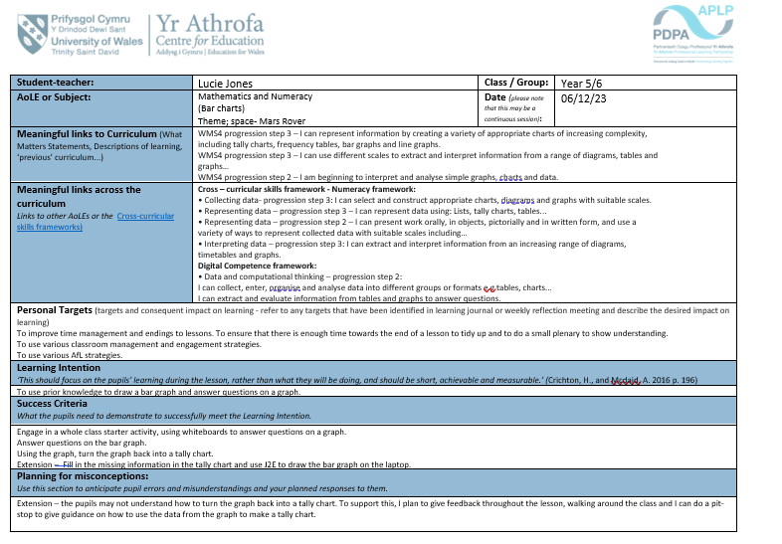

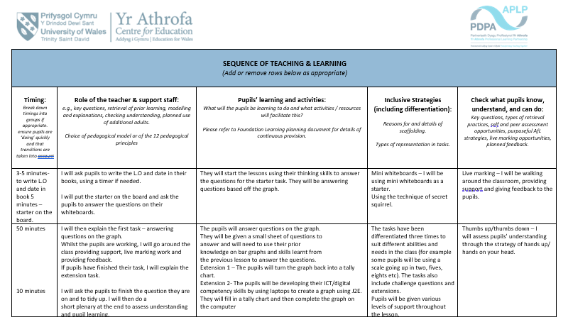

2

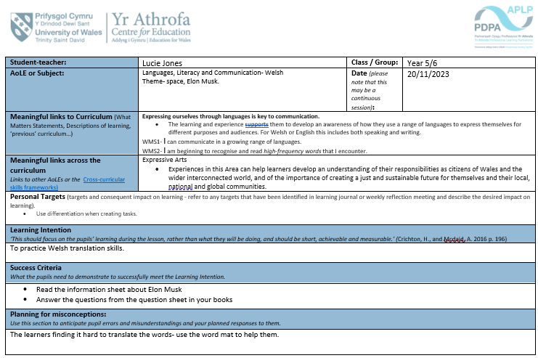

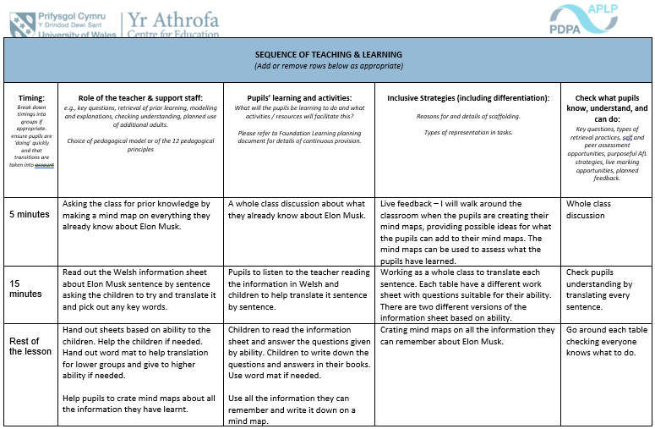

3



