A Critical Evaluation of the role of digital innovation in Professional Practice

Introduction
This assignment will critically consider the role of digital innovation in professional practice in the context of Post Compulsory Education Training (PCET) including workforce education and training.
The first section will consider the ‘Role of Creativity and Digital Innovation.’ This will focus specifically on the use of digital innovation, particularly digital based quizzes, in pedagogy to enhance learner motivation and engagement and assess learning outcomes, giving due attention to the relevance of learning theory. ‘Selection and Justification of appropriate Teaching Tool’ will then explore a chosen tool which is relevant for the teaching session, giving thought to suitability in the context of topic, environment, and learners. ‘Application of the Chosen Learning Tool’ will demonstrate development and use of the tool in action, and finally an ‘Evaluation and Reflection’ on the effectiveness of the learning tool in practice will be undertaken with consideration given to professional development in the use of digital technology for future practice.
With the use of technology in education significantly increasing over past decades; more recently, with the Covid 19 pandemic, the use of virtual spaces in education have taken a necessary precedent (Wang, Weng and Quek, 2022; Celestino and Noronha, 2021; Guardia et al, 2021). However, Beetham and Sharpe (2020) emphasise that despite the growing use of digital technology, the way students learn has not changed, and pedagogy should lead on how technology is used, not the other way around; with technology used to enhance learning (Swanzen, 2018, Hollaway and Guthro, 2020). This viewpoint will be explored further during this assignment.
(255)
The Role of Creativity and Digital innovation
This section will provide an overview of literature which considers the use of digital based quizzes to enhance student motivation, engagement, and assess learning outcomes in PCET with further thought given to work-based training. Any identified gaps in research will be outlined and consideration given to its implication for professional practice.
Assessment is an essential part of measuring students’ learning in higher education (Race, 2020). Race and Pickford (2007 p.77) state ‘most learners are driven by assessment.’ They suggest students are motivated if they know they will be marked on their work. Furthermore, they propose assessment should be linked to learning outcomes. Wang, Weng and Quek (2022) state that assessment encourages students to take their learning more seriously. Reece and Walker (2007) and Ollin, Thompson and Tummins (2019) explain assessments are used to measure student learning and to consider how much students know about a subject, whether prior to the teaching (formative) or at the end (summative).
According to Ryan and Deci (2000), extrinsic motivation is manifested by external factors such as rewards which can be linked to assessment grades or positive feedback. Factors that trigger intrinsic motivation are ‘challenge, curiosity, control and fantasy’ (Gopalan et al, 2017 p. 2). Reece and Walker (2007 p.97) state the models of learning that link to types of motivation include ‘Behaviourist model: Extrinsic motivation (goals prescribed)’ which is connected to theorists such as Thorndike, Skinner and Gagne. Intrinsic motivation is more in line with Cognitivist model of learning such as theories proposed by Piaget, Bruner and Ausubel noting ‘subject matter and stage of development determines goals.’ The Humanist model of learning, which is linked to the thinking of theorists such as Rogers, Maslow, Dewey and Neill, also suggest that individuals are intrinsically motivated as ‘individual sets own goals’ (Reece and Walker, 2007 p.97). According to Fleming (1992), individuals have different learning dimensions including Visual, auditory, read/write and Kinasthetic, and according to Race (2020), educators should aim to meet each of these dimensions in lessons. Raes et al (2020) proposes that the use of quizzes in teaching is positively related to student motivation.
Oh and Hwang (2022) state quizzes are most often used as a form of formative assessment as it enhances motivation, provides immediate feedback and highlights to the learner deficits in their knowledge, thus encouraging more self-directed learning (Knowles, 1984; Serrano et al, 2019). Oh and Hwang’s (2022) study in to 217 first year medical students in Kosin Medical college, South Korea aimed to determine whether using a quiz for formative assessment to identify areas of further learning had an impact on successful learning outcomes which would be monitored by use of a quiz for summative assessment. Their findings highlighted that those who used a quiz for formative assessment met the learning outcomes better in the summative quiz. Motivation derived from the identification of knowledge gaps and therefore led to self-directed learning (Knowles, et al 2020; Ryan and Deci, 2000). Although the outcome of their study was largely in favour of the use of quiz to effectively assess learning, it did not particularly highlight views of students regarding enjoyment levels of the use of quizzes during the session. In contrast to Oh and Hwang (2022), Kirzner, Alter and Hughes (2021) focussed on levels of student enjoyment and engagement as well as effectiveness of learning outcomes during their study in to the use of digital quiz with the tool Kahoot as an exit ticket at the end of each research class during a semester. Their study consisted of seventy-one social work students (aged between 18-60) in a university in the United States. Their aim was to consider whether gamification and digital quizzes were effective in cementing student learning and increasing motivation and retention. Although their paper addresses a research gap by considering Kahoot as an exit ticket in a student social work research class, the demographic is quite specific and niche therefore cannot automatically be applied to different student groups. Nevertheless, their findings are predominately in favour of the use of Kahoot/interactive quiz for assessment as it increased engagement, enjoyment and motivation noting that students felt it was fun and helped with the learning of the session. Likewise, Cameron and Bizo (2019) completed a study in to the effectiveness of Kahoot with Animal Science students. Their research considered seventy-two students in a New Zealand university, and the research method was a qualitative 20 question survey. The findings indicated students found it a fun, enjoyable and competitive way to end a class. They note the use of Kahoot creates ‘an interaction between intrinsic motivation and extrinsic motivation’ (p.2) and students found it more engaging, motivating and fun than paper-based quizzes. Furthermore, they note that from the perspective of the teacher, this type of tool will show how quickly learners answer a question, therefore highlighting any identified areas for further development. Cameron and Bizo (2019) like Gopalan (2017) suggest ‘Challenge, control, immersion, interest and purpose of the game’ are significant aspects when promoting learner engagement and they suggest using Kahoot promotes these elements (Cameron and Bizo, 2019 p.3).
Despite the positive studies in to the use of Kahoot in PCET, an alternative tool for a digital based quiz is Mentimeter. Tarazi and Ortega Martin (2023) note student engagement can be challenging in an online synchronous classroom and following a review of different studies in to the use of the digital tool Mentimeter, they found most students involved in the studies became engaged in the learning as it increased motivation due to the enjoyable aspect. These findings were shared by Madiseh, Al Abri and Sobhanifar (2022), and although their paper has not been widely cited, or peer reviewed, they raise similar points by concluding in their review of research in to the use of Mentimeter, the tool enhanced student motivation, promoted engagement, and the immediate feedback was a positive factor for students (Serrano et al, 2019). Iona (2018 p.153) reviewed that Mentimeter appears more ‘grown up’ than counterparts such as Kahoot and could be more beneficial for older learners.
Despite the differing focus of their respective studies, the combined findings of the aforementioned authors note using a digital quiz in a post compulsory setting increases motivation, engagement, is an effective form of assessment and contributes to a fun classroom environment.
Somewhat contrastingly, however, Wang, Weng and Quek (2022) completed a study in to learner engagement in Synchronised Online Learning (SOL) with of 55 learners across 4 classes and the age of the learners ranging from 17-20 years old in Singapore. Their overall conclusion was the main factors to increase engagement with online learning is the teacher, the content and the learner; technology and the classroom environment is not as significant which reinforces the aforesaid views of Swanzen (2018), Hollaway and Guthro (2020) and Beetham and Sharpe (2020). However, they do also state that learning content does help satisfy learner needs and goals, and e-assessment can motivate and engage learners. Furthermore, they also found feedback, polls and quizzes were engaging. Despite overall positive findings regarding the use of quizzes to enhance motivation, engagement and assess learning outcomes, The Collegion (2023) proposes some disadvantages of using quizzes with students including it can increase stress and anxiety for learners and note some students may guess the answers, which may mean they have not fully grasped the topic. Reece and Walker (2007) and Fowdar (2011) also note disadvantages of digital game-based quizzes include technology not working, and nondetailed feedback.
Some limitations to the research considered thus far in this literature review include that the focus has predominately been on students who are studying in Higher Education Institutes and does not delve deeper in to multi-generational student factors.
Urick (2016) considers the need for educators and trainers to integrate technology in to the work-based learning environment and this should include a consideration of the different learning needs of multi-generations as the workforce consists of multi-generational learners who attend training. His view is that game-based learning should be used in workforce training as it increases fun, however, he found in his study that the younger generations were more used to technology in training compared to the older generation who were not ‘computer savvy’ (Urik 2016 p. 56). Lowell and Morris (2019) state that educators and trainers need to adjust their approach to consider multi-generational learners and their varying needs. Staddon (2020) also highlights the need for educators to design lessons and activities that all learners can access, and it is important to consider the learning needs of all students. However, Staddon (2020) also established in her study that no difference in attitudes were found towards use of technology of mature students compared to younger students. She notes that once mature learners realise the value of technology, it increases motivation, which links with Knowles’ (1984) theory of Andragogy, that learners need to know why they are doing something and its application to their lives. Surana (2018) agrees that using interactive digital quizzes in workforce development will create a fun and competitive environment between colleagues. He notes that employees ‘typically forget 80% of new information within 30 days’ and suggests that online quizzes will help learners retain information. However, this recommendation is not based on specific research, rather a business suggestion and therefore lacks credibility. Furthermore, it is based on e-learning rather than in class face-to face learning. Arguably though, the points made are reinforced by the Ebbinghaus Forgetting Curve (Ebbinghaus, 1885) which suggests the individual’s biggest forgetting curve is immediately after something is first learned. Therefore, revisiting the information at the end of the session will assist with retaining information (Race, 2020).
Limitations of this literature review include a lack of consideration of research in to digital exclusion for varying reasons such as digital poverty (Digital Poverty Alliance, 2021), lack of confidence in using technology or the impact of digital technology and quiz-based learning on students with additional learning needs. Additionally, research was considered from different areas across the world. It would be useful for further research to be undertaken considering the benefits of using digital quizzes in a face-to-face workforce training session, particularly in Wales; especially when considering the Office of National Statistics (ONS, 2019) state ‘In 2018, Wales had the lowest proportion of people with all five basic digital skills (66%) and the highest proportion of those with zero basic digital skills (19%).’ ONS (2019) suggest individuals who are not fully engaged with the ‘digital world are at risk of being left behind’ which leads to inequality and a ‘digital divide.’ The Digital Strategy for Wales (Welsh Government, 2021) aims to reduce digital exclusion in Wales with specific missions including to ‘Equip people with the motivation, access, skills and confidence to engage with an increasingly digital world, based on their needs’ (Mission 2, Welsh Government, 2021). Nevertheless, educators and trainers would benefit from being mindful of potential limitations to the use of digital technology in post compulsory education and training including workforce training and development.
(1824)
Selection and Justification of appropriate Teaching Tool
Based on the above general conclusion that the use of interactive quiz-based activities enhances motivation and engagement in learners and acts as an effective assessment tool in a PCET setting, I have decided to devise a quiz utilising the tool Mentimeter. This will be for a session on ‘Reflective Practice’ with social workers aged between 25-55 years old undertaking their first year in practice (K2, K4, UK Professional Standards Framework- UKPSF hereafter, 2011).
The Mentimeter quiz will be utilised as a ‘short cycle’ summative assessment as it will take place within one session rather than over a series of lessons (Dylan Wiliam Centre, 2017). The aim of using this tool for assessment will be to enhance the learning experience of the attendees (Ollin, Thompson and Tummins, 2019). Furthermore, as a formative assessment of learner’s initial knowledge on the subject, I will set up a slide with a Mentimeter word cloud to use at the beginning of the session to gauge the initial knowledge of the learners on reflective practice. Learners will be able to scan a QR code or access the website on the instruction page and input words to describe their thoughts on reflective practice in the workplace. Iona (2018) notes Mentimeter is a digital tool whereby users can create interactive content such as presentations. Learners can use mobile phones to connect to the programme in order to take part. However, if they do not have mobile phones, they are able to access the programme via the website. An additional advantage to Mentimeter according to Vallely and Gibson (2018) is that students found it easy to use as well as being an effective assessment tool. Anonymous responses which allow for a safe, non-judgemental environment, offer a setting for individuals to comfortably move along Maslow’s hierarchy of needs (Maslow, 1943). However, anonymity can also act as a disadvantage, according to Vallely and Gibson (2018) as it is not possible to see who has replied to a question, it is difficult to identify learner needs from this assessment tool alone. Also, they suggest as submitted answers cannot be edited, some students may feel self-aware or frustrated if they make mistake.
When considering the benefit of the use of this tool for assessment in my session, I reviewed the TPACK model (Mishra and Koehler, 2006). Regarding the Technological Content Knowledge, I have designed a PowerPoint presentation for the session and the interactive quiz at the end of the session will be used to review and assess the retention and learning. I have Content Knowledge of the subject area; however, it is a subject these learners may not consider significant in day-to-day work therefore the use of the word cloud slide will enable me to assess their initial knowledge and compare with results of the quiz to review learning outcomes. Therefore, the aim will be to promote deeper learning which is engaging and fun (Reece and Walker, 2007). Greener (2018) notes the use of digital technology to provide feedback on learning and achievement can help increase learner engagement (Pedagogical knowledge). Furthermore, as part of my job-role I have free access to a Mentimeter account which will enable me to explore the tool without restrictions. I have previously developed a quiz in a separate setting using this programme and it was positively received as a fun, engaging summative assessment. I have considered whether the interactive elements of the session will be a distraction for the learners, or whether it will complement the pedagogy (Beetham and Sharpe, 2020) and I feel it will be a positive addition. Duja (2017 p.103) states technology should be used as a ‘medium for instruction’ rather than the main focus of a lesson or a distraction, and the use of technology in class is purposeful as it mirrors the current societal climate where use of technology is commonplace (V4, UKPSF, 2011).
Before I was aware of Mentimeter as a tool for an interactive quiz, I would have used a quiz in my teaching sessions but it would have been PowerPoint slides which detailed the questions. When considering the SAMR model (Puentdura, 2006), I can identify that a Mentimeter quiz for me would be A- Augmentation as although it is a direct substitution for a PowerPoint slide, the interactive and competitive element of a Mentimeter quiz with emojis and immediate feedback allows students to monitor their progress and exposes the student’s competitive nature which enhances motivation and enjoyment (Knowles, 2020; Gopalan, 2017)
The aim of the session is to support learners to remember the content of the session, have an understanding on what was discussed and to apply the learning in practice (Bloom’s Taxonomy of Needs, 1956). A quiz will allow me to assess their skills in remembering and understanding the topic. Applying the knowledge will be difficult to assess as it will be in practice outside of the teaching session.
I will be ‘designing and planning learning activities’ (A1, UKPSF, 2011) which include delivery of the topic and a quiz for assessing the learning. I have considered that this is an ‘appropriate method for teaching, learning and assessing’ and ‘an appropriate learning technology’ (K2, K4, UKPSF, 2011) at this level as it is a work based one-off training and the assessment is needed of this particular session rather than series of lessons. In my view, it will also be a ‘method for evaluating the effectiveness of teaching’ (K5, UKPSF, 2011) as if the quiz is not successful, or the learners are unable to answer the questions, I will need to review my delivery of the topic.
Some considerations for implementing a Mentimeter quiz in a work-based training session however, would be digital exclusion (UK Parliament, 2023). Specifically, whether individuals have smartphones to scan the QR code or whether there is internet access. Furthermore, some individuals may not feel confident with technology and therefore may not feel comfortable resulting in dis-engagement and demotivation. The concern is there would not be ‘equality of opportunity for learners.’ (V2, UKPSF, 2011). In order to address this, I will be sure to ask them to bring a digital device prior to the session as this will promote participation in the session (V2, UKPSF, 2011).
Therefore, to conclude this section, I have chosen a Mentimeter quiz as my tool. I feel this will be engaging and fun and will be an effective way to assess the learning from the session, which is a vital aspect of pedagogy.
(1071)

Application of the Chosen Learning Tool
This section consists of the lesson plan for the session, highlighting the plan to utilise the Mentimeter quiz and also photographs of my delivering and co-ordinating the quiz.
Lesson Plan:



Lesson Plan

Topic: Reflective Practice in social work |  | Class: First year in Practice Social Workers
Date: 17/3/23 | Length of lesson: 3 hours |  | Number of students: approx. 15
Resources required: Laptop, projector screen, reflective practice cards, phone/laptop.

Aim of Lesson

- To provide newly qualified social workers with the basics of reflective practice and encourage regular use throughout practice with strategies.

Learning Outcomes – The Learners Should Be Able To:

- Explain what is reflective thinking
- Explain the how to be reflective practitioner
- Name some reflective models
- Describe why being a reflective practitioner is important

Previous student knowledge required for the session:

Students have been made aware in advance of the need to bring a digital device.
These students would all be in their first year in practice of social work and would have a social work degree

Anticipated difficulties (if applicable):

Social workers often feel too busy to utilise reflection and do not see the value. Staff may be distracted by work commitments.

Professional Standards (where are these being met within the session)

A1 Design and plan learning activities and/or programmes of study: (I developed the lesson including learning activities)
A2 Teach and/or support learning: (as the sole trainer, I was teaching and supporting learners with the content)
A4 Develop effective learning environments and approaches to student support and guidance: The environment was appropriate in a training room with other social workers at the same stage of qualification.
A5 Engage in continuing professional development in subjects/disciplines and their pedagogy, incorporating research, scholarship and the evaluation of professional practices: This session contributed to learner CPD in an area linked to their professional practice.
Core Knowledge
K1 The subject material: I have good knowledge of the subject area as it is a regular topic that needs to be covered in my role.
K2 Appropriate methods for teaching, learning and assessing in the subject area and at the level of the academic programme: I have utilised a range of teaching methods to try and promote deeper learning.
K4 The use and value of appropriate learning technologies: Digital quiz to enhance motivation, engagement and assess learning
K5 Methods for evaluating the effectiveness of teaching: I have asked learners to fill out feedback sheets for my own knowledge and future teaching.
V3 Use evidence-informed approaches and the outcomes from research, scholarship and continuing professional development: various teaching strategies used to try and meet different learning needs,
V4 Acknowledge the wider context in which higher education operates recognising the implications for professional practice: this session was to enhance knowledge and improve on skills relevant for practising social workers.

Lesson Detail:

Stage | Focus | Strategy | Time
Introduction  Development  Plenary/conclusion | Introduction  Ground rules  Overview of session  Learning outcomes  Ice Breaker  Thinking time  Model of reflections (overview)  Why it’s important  Recap  Discussion  Exercise 1 & 2  Quiz  Questions/comments  Evaluation  Feedback for use of Mentimeter in session | Power point  Question and answer ‘reflect for session.’  Power point/question and answer – reflective thinking to reflective practice  Mentimeter- wordcloud/or just question and answer  Powerpoint  Powerpoint  Videos x 3 reflective practice  Question- what tools can you use?  Break  Case study and own case discussion  Quiz – mentimeter  Handouts What, so what, now what?  Feedback form | 9.00-9.10  9.10-9.25  9.25-9.35  9.35-9.45  9.45-10  10 -10.10  20 min + 30 min (10.10-10.30 &10.30-11)  11.00-11.15  11.15-11.30  11.50-12.00

Assessment Strategies: when and how are they included within the lesson?

Mentimeter word cloud as a formative assessment of student’s awareness of the topic before the session starts and as an ice breaker.
Summative assessment with use of an interactive quiz to assess learning from the session. As this session is a one off, the assessment/quiz will be an interactive, engaging way to end the session to gauge what has been learnt.

Informal reflection (to be completed after the session)

The session went to plan. The learners were engaged and appeared to enjoy aspects of the session. I feel the information could have been deeper for this learning and I will look at developing my training for the future.

I decided not to do the Mentimeter word cloud as I felt that just shouting out answers met the needs of the learners better. The Mentimeter word cloud in this situation would have been using technology for the sake of it. There was no need to keep the comments made by the learners and as I did not ask each individual to feedback, there was no pressure on the learners at this particular time.

The quiz was engaging and fun and I felt that it was a good element. Feedback was positive overall; however, I was concerned about the speed of the response time, especially for those who had informed me they were dyslexic. As I was aware of this, I had adjusted the response time to be longer. I was worried about individuals who did not have a mobile phone or who did not have a suitable connection but all went to plan. However, I should have ensured I had printed out more case study information as it did not work so well in the group work aspect.
Also on hindsight, I could have made the whole presentation more interactive and will do this in the future as people could have logged in at the beginning and it would have saved time.

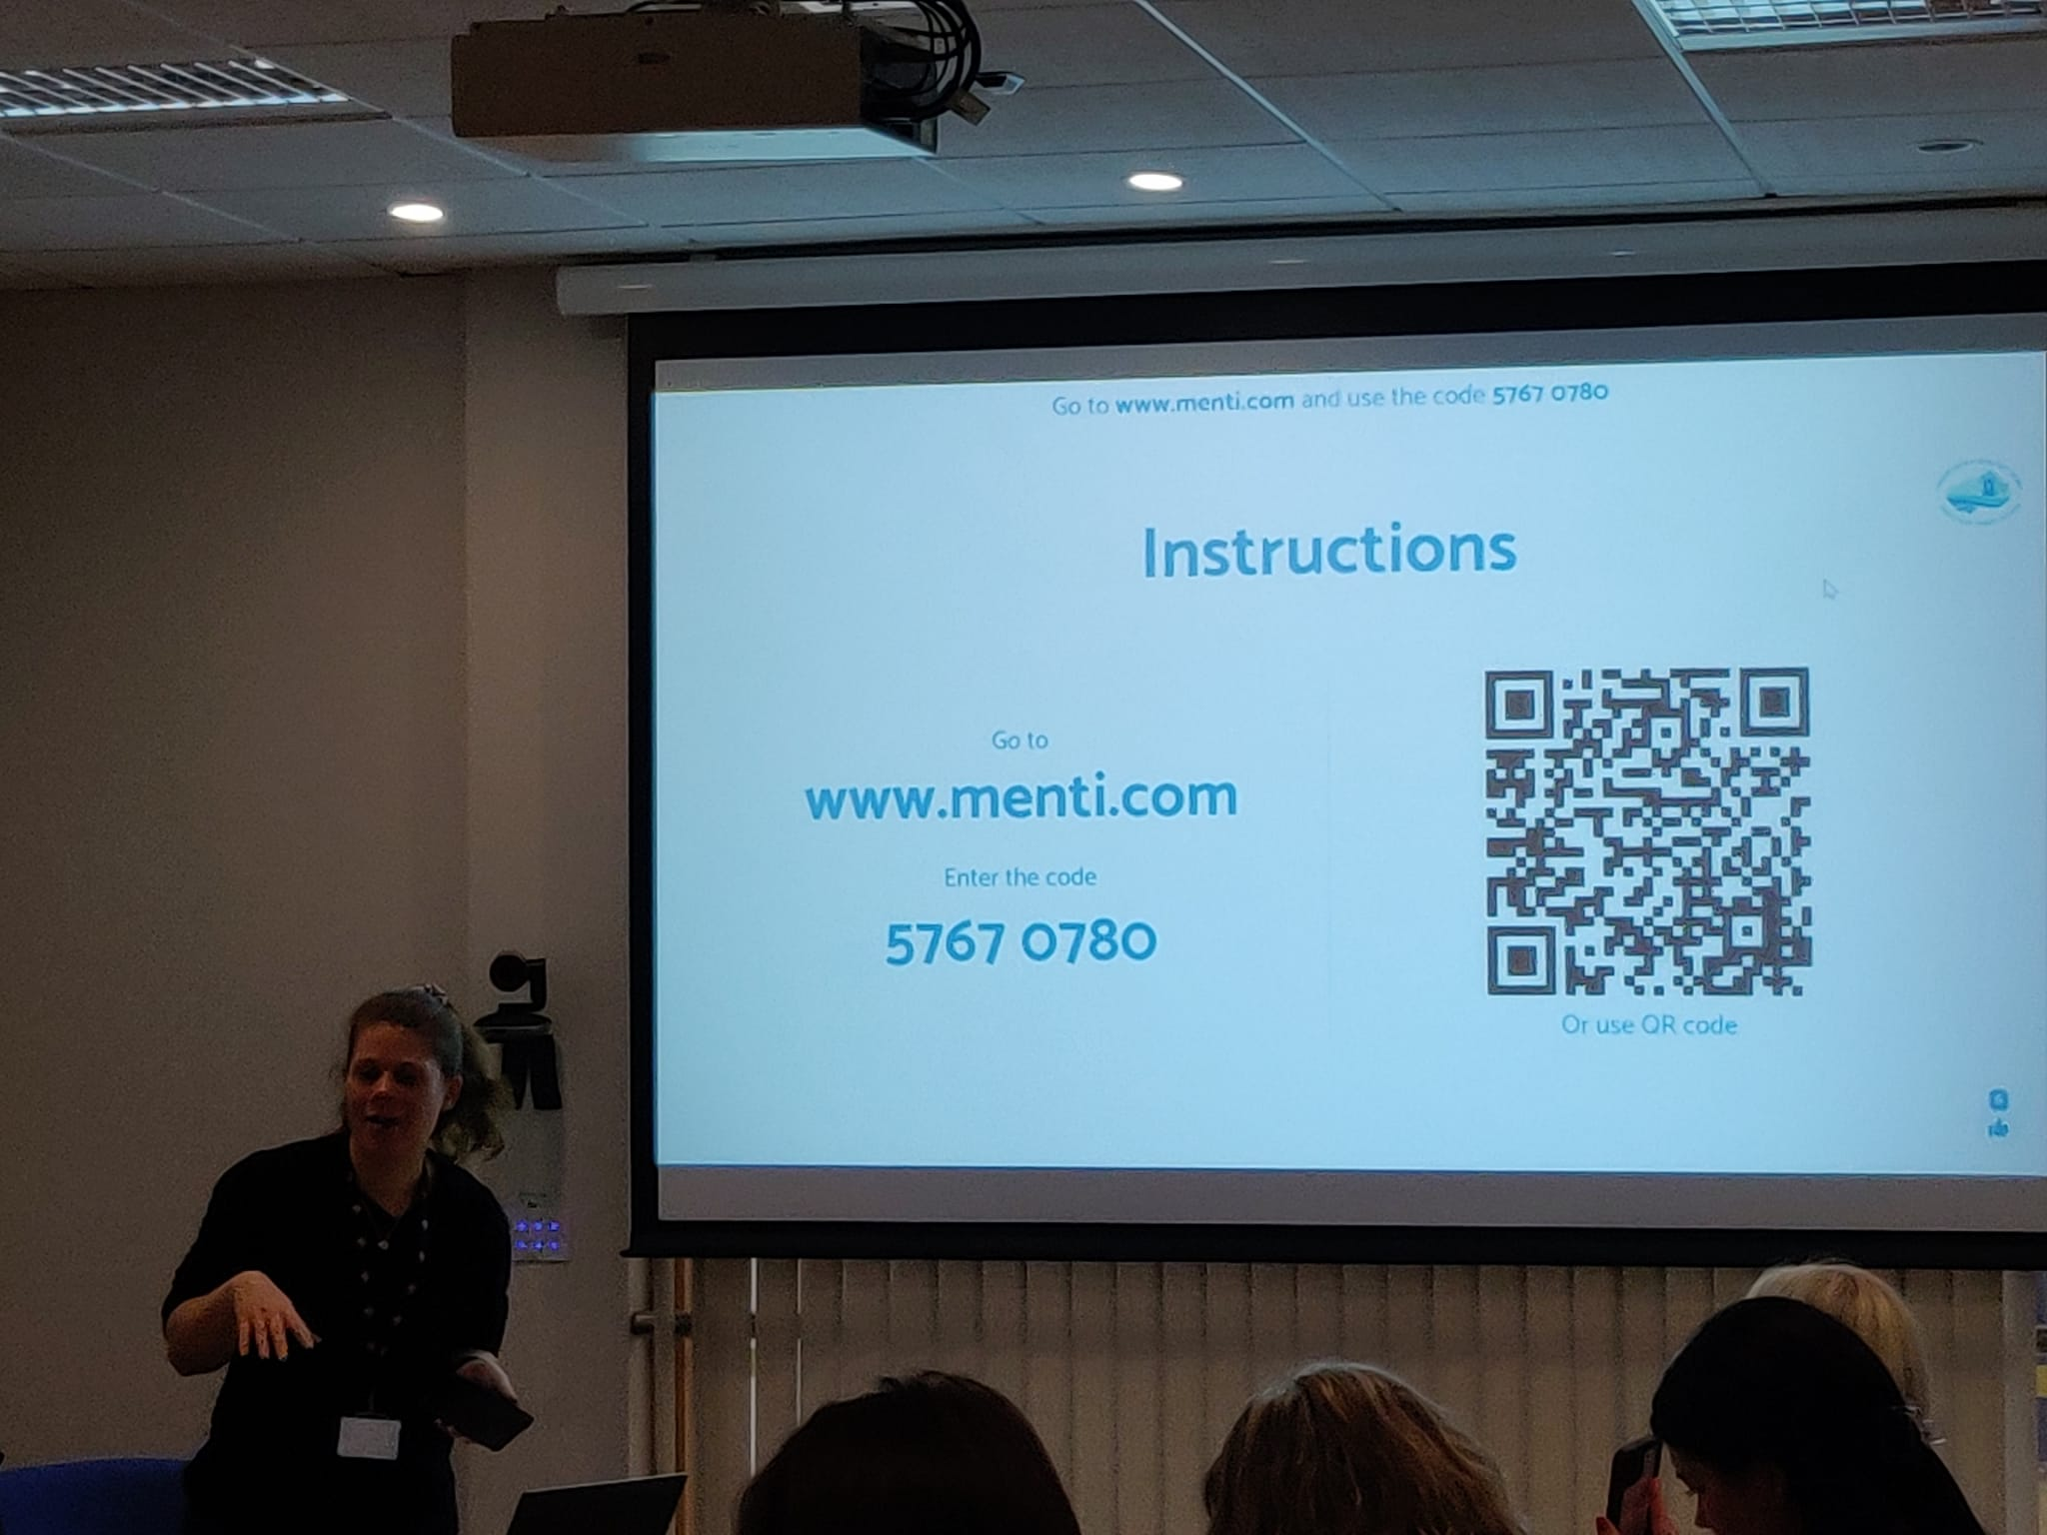
Figure 1

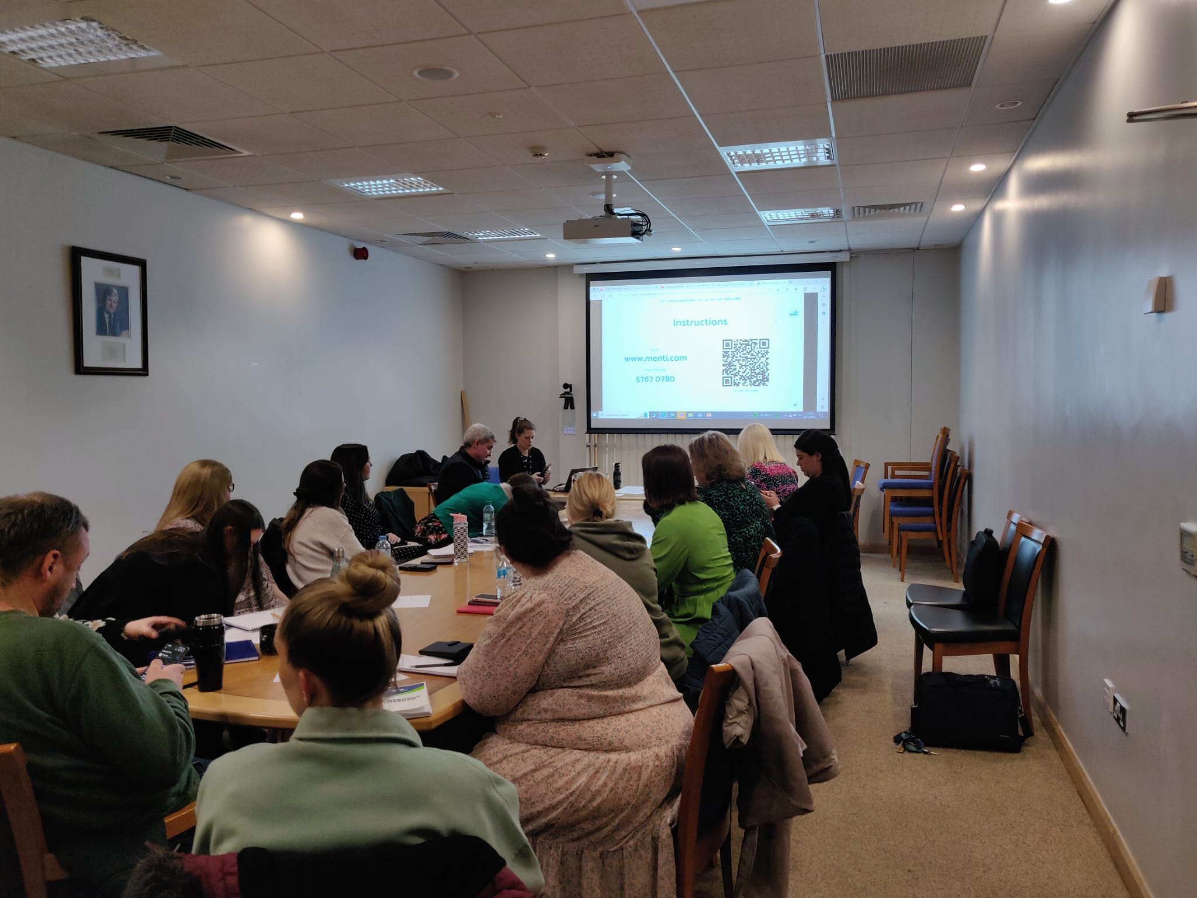
Figure 2
Figures 1 and 2 demonstrate the moment when learners were using their phones to connect to the quiz by scanning the QR code and following the ‘instructions page’. I was controlling the quiz from my laptop at the front.
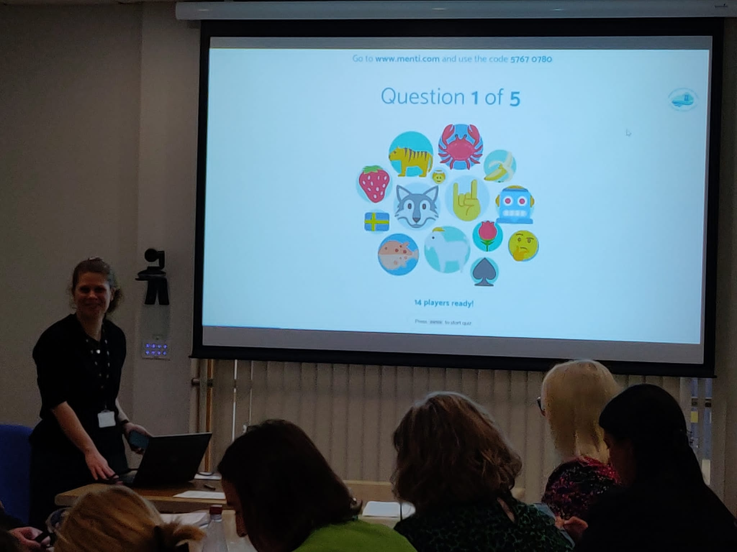
Figure 3

Figure 3 shows the learners in the process of connecting to the quiz. Once learners were connected, they were all allocated an icon which appeared on the screen to represent them. They were able to put a suggested name, or choose a name to represent them.
Below pictures include slides with questions and a countdown whereby the learners needed to respond within a specific time limit.
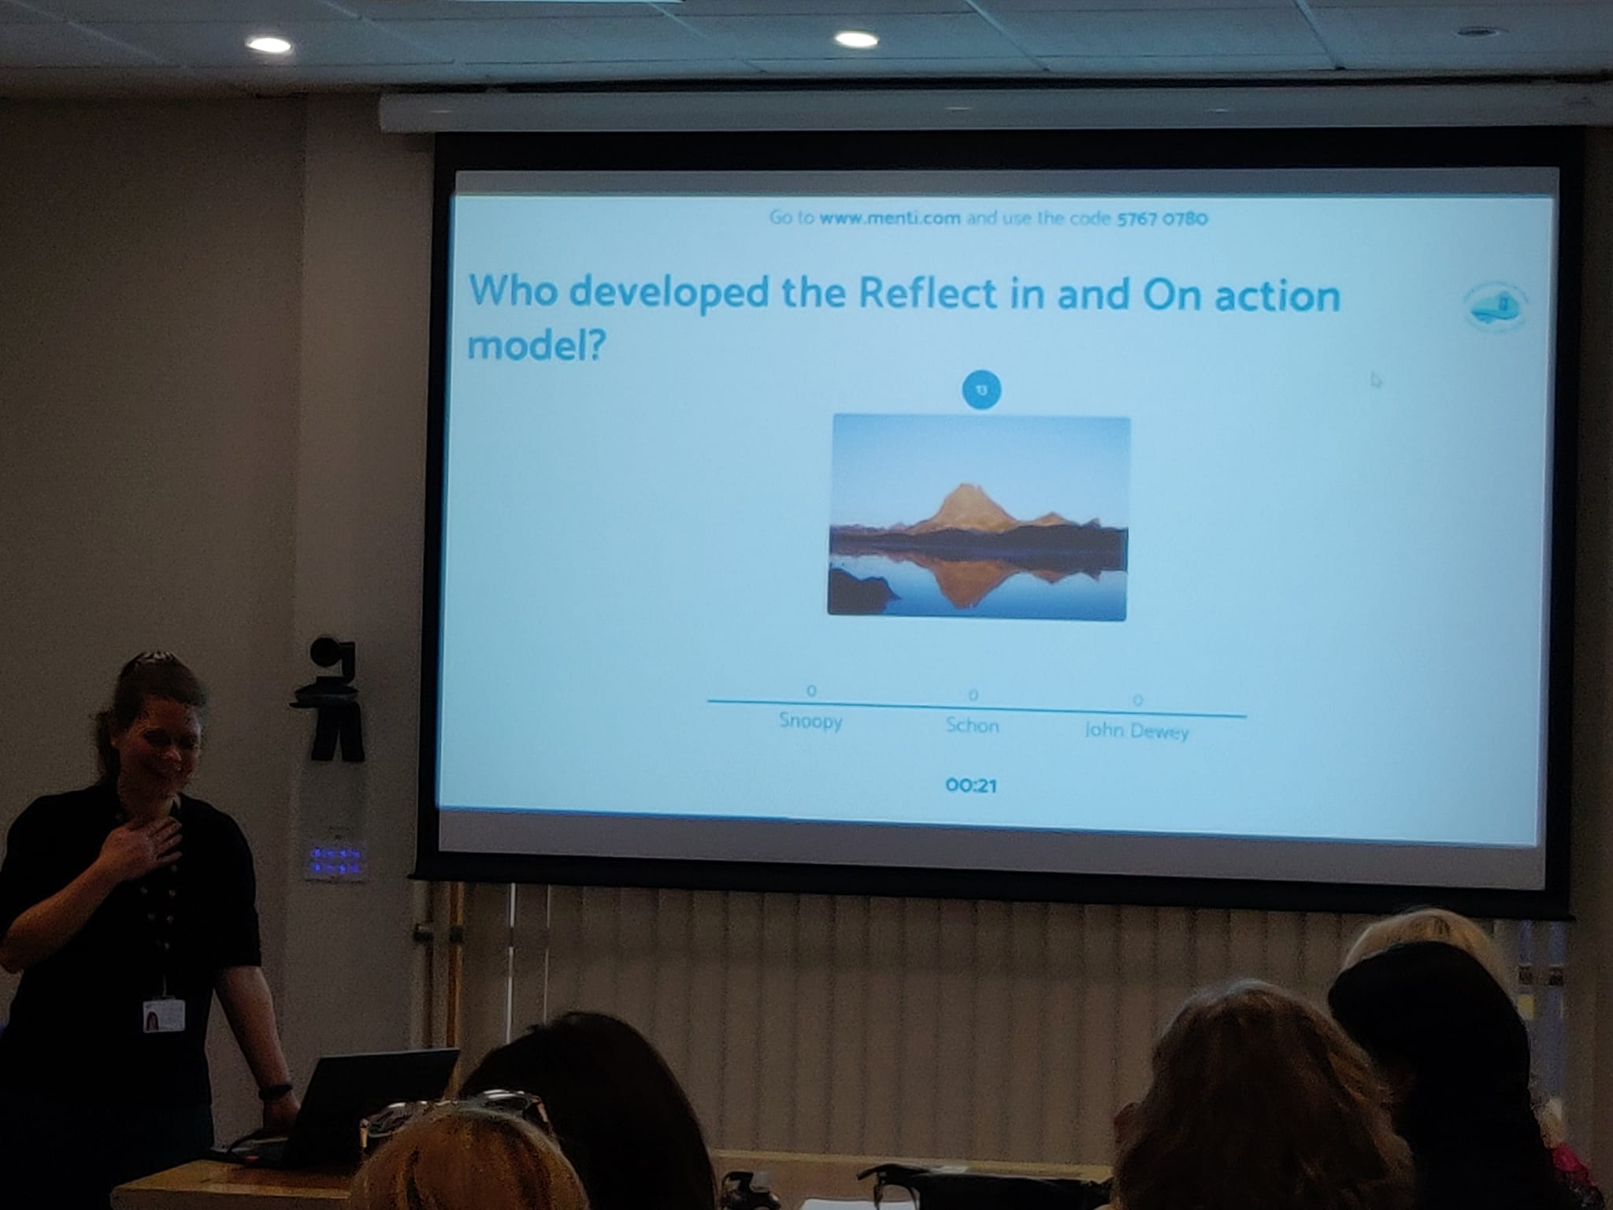
Figure 4

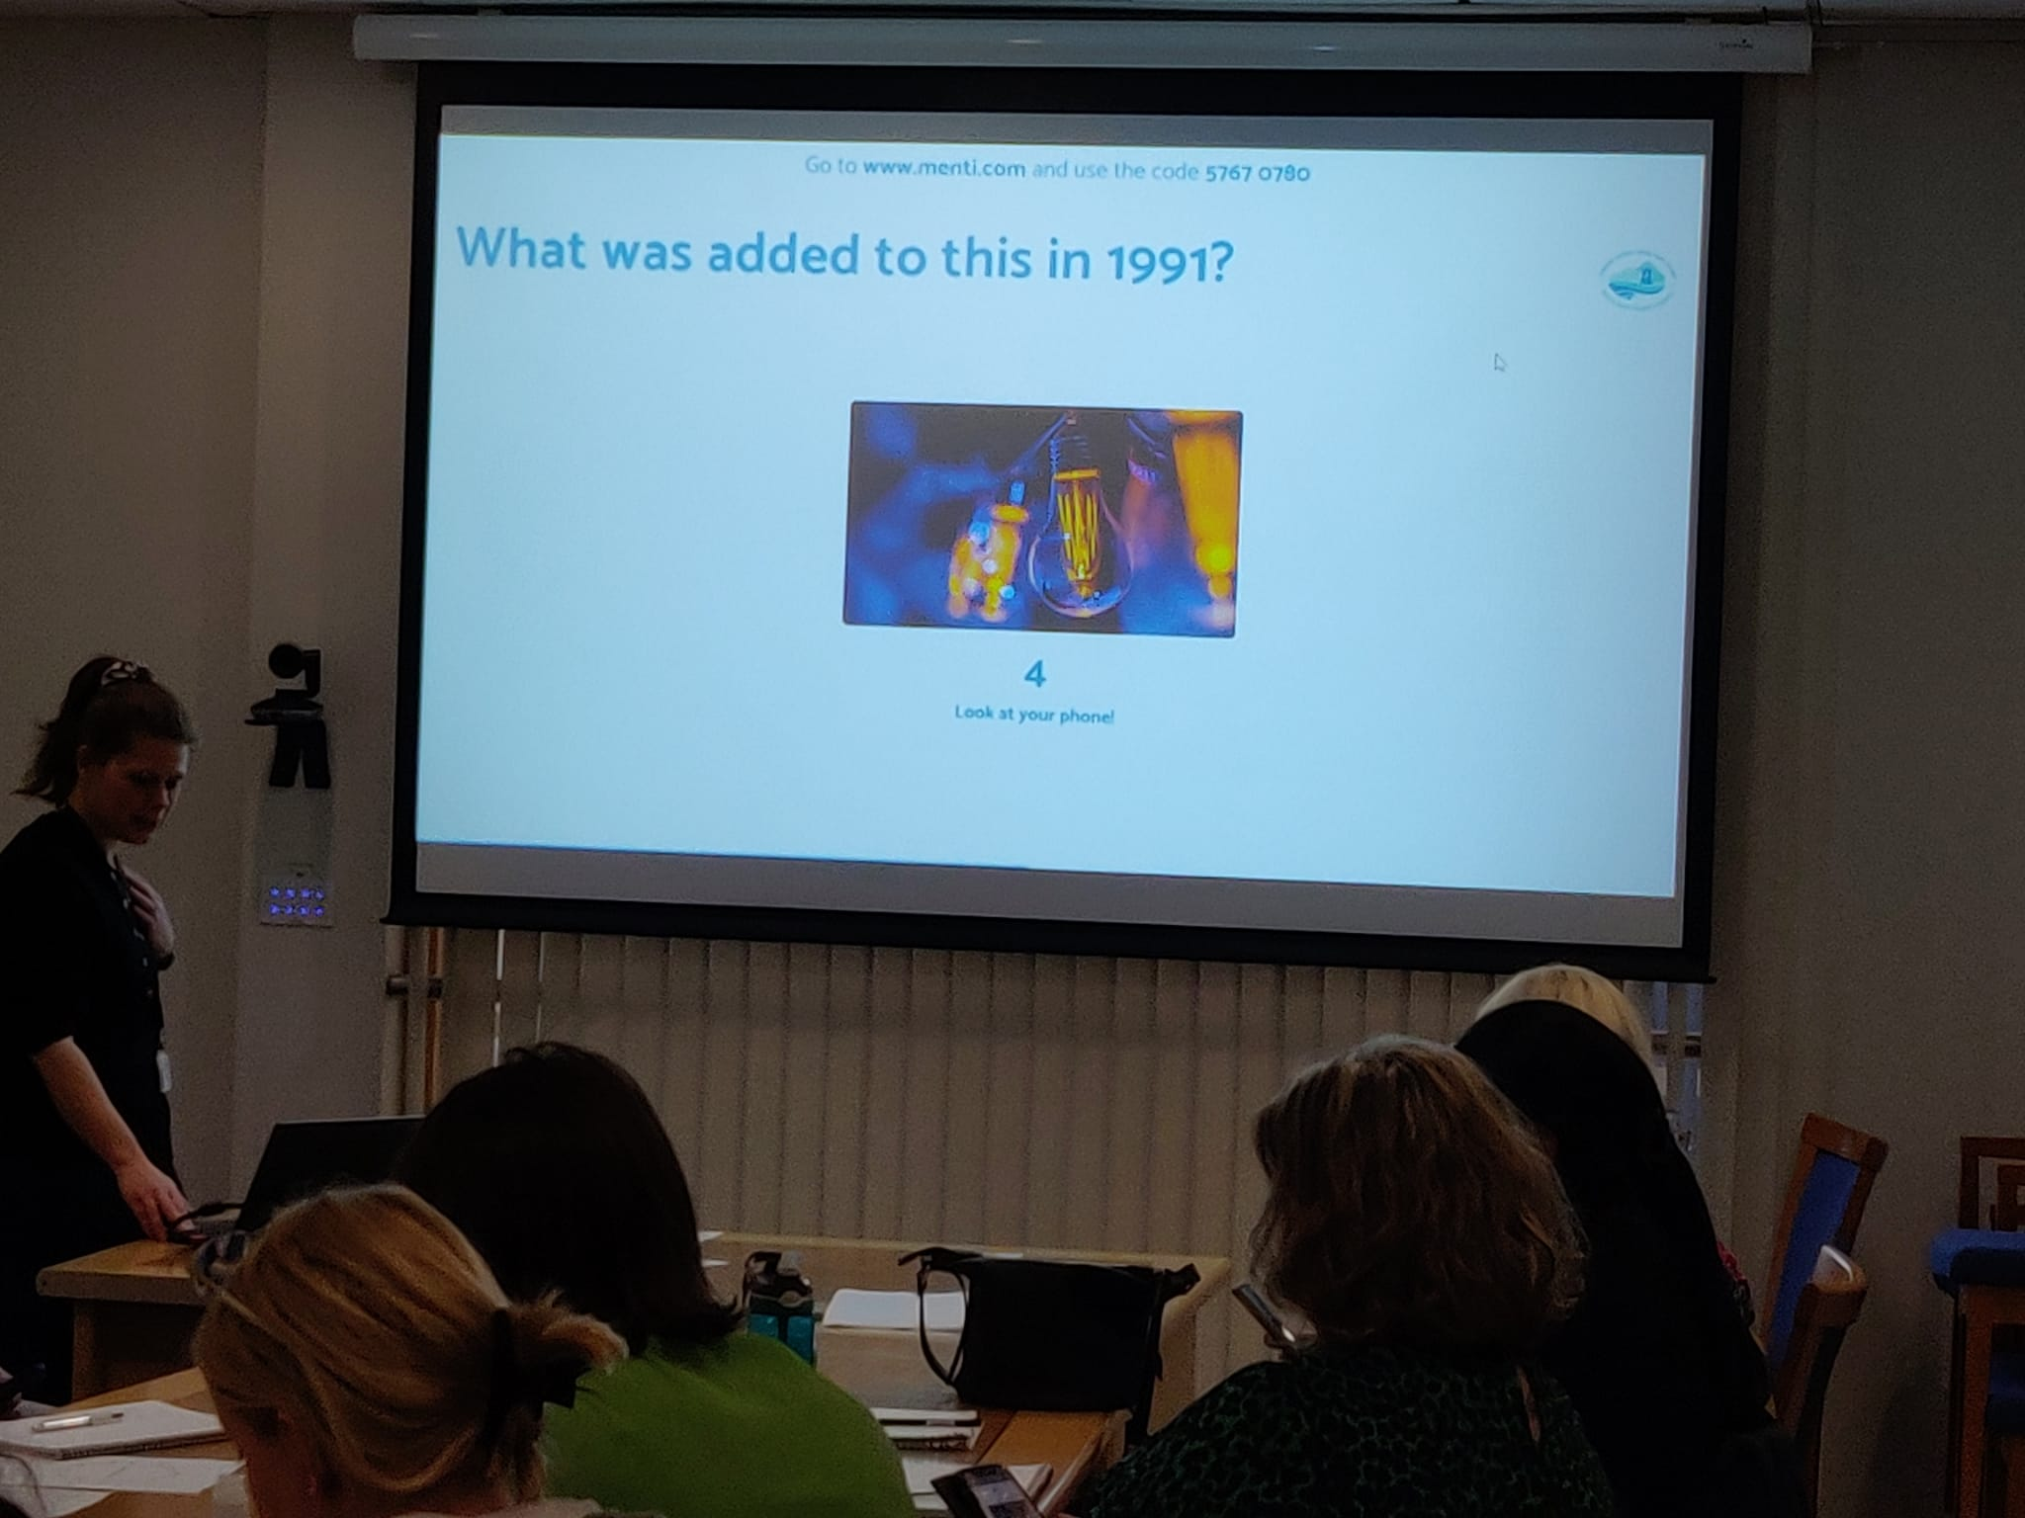
Figure 5
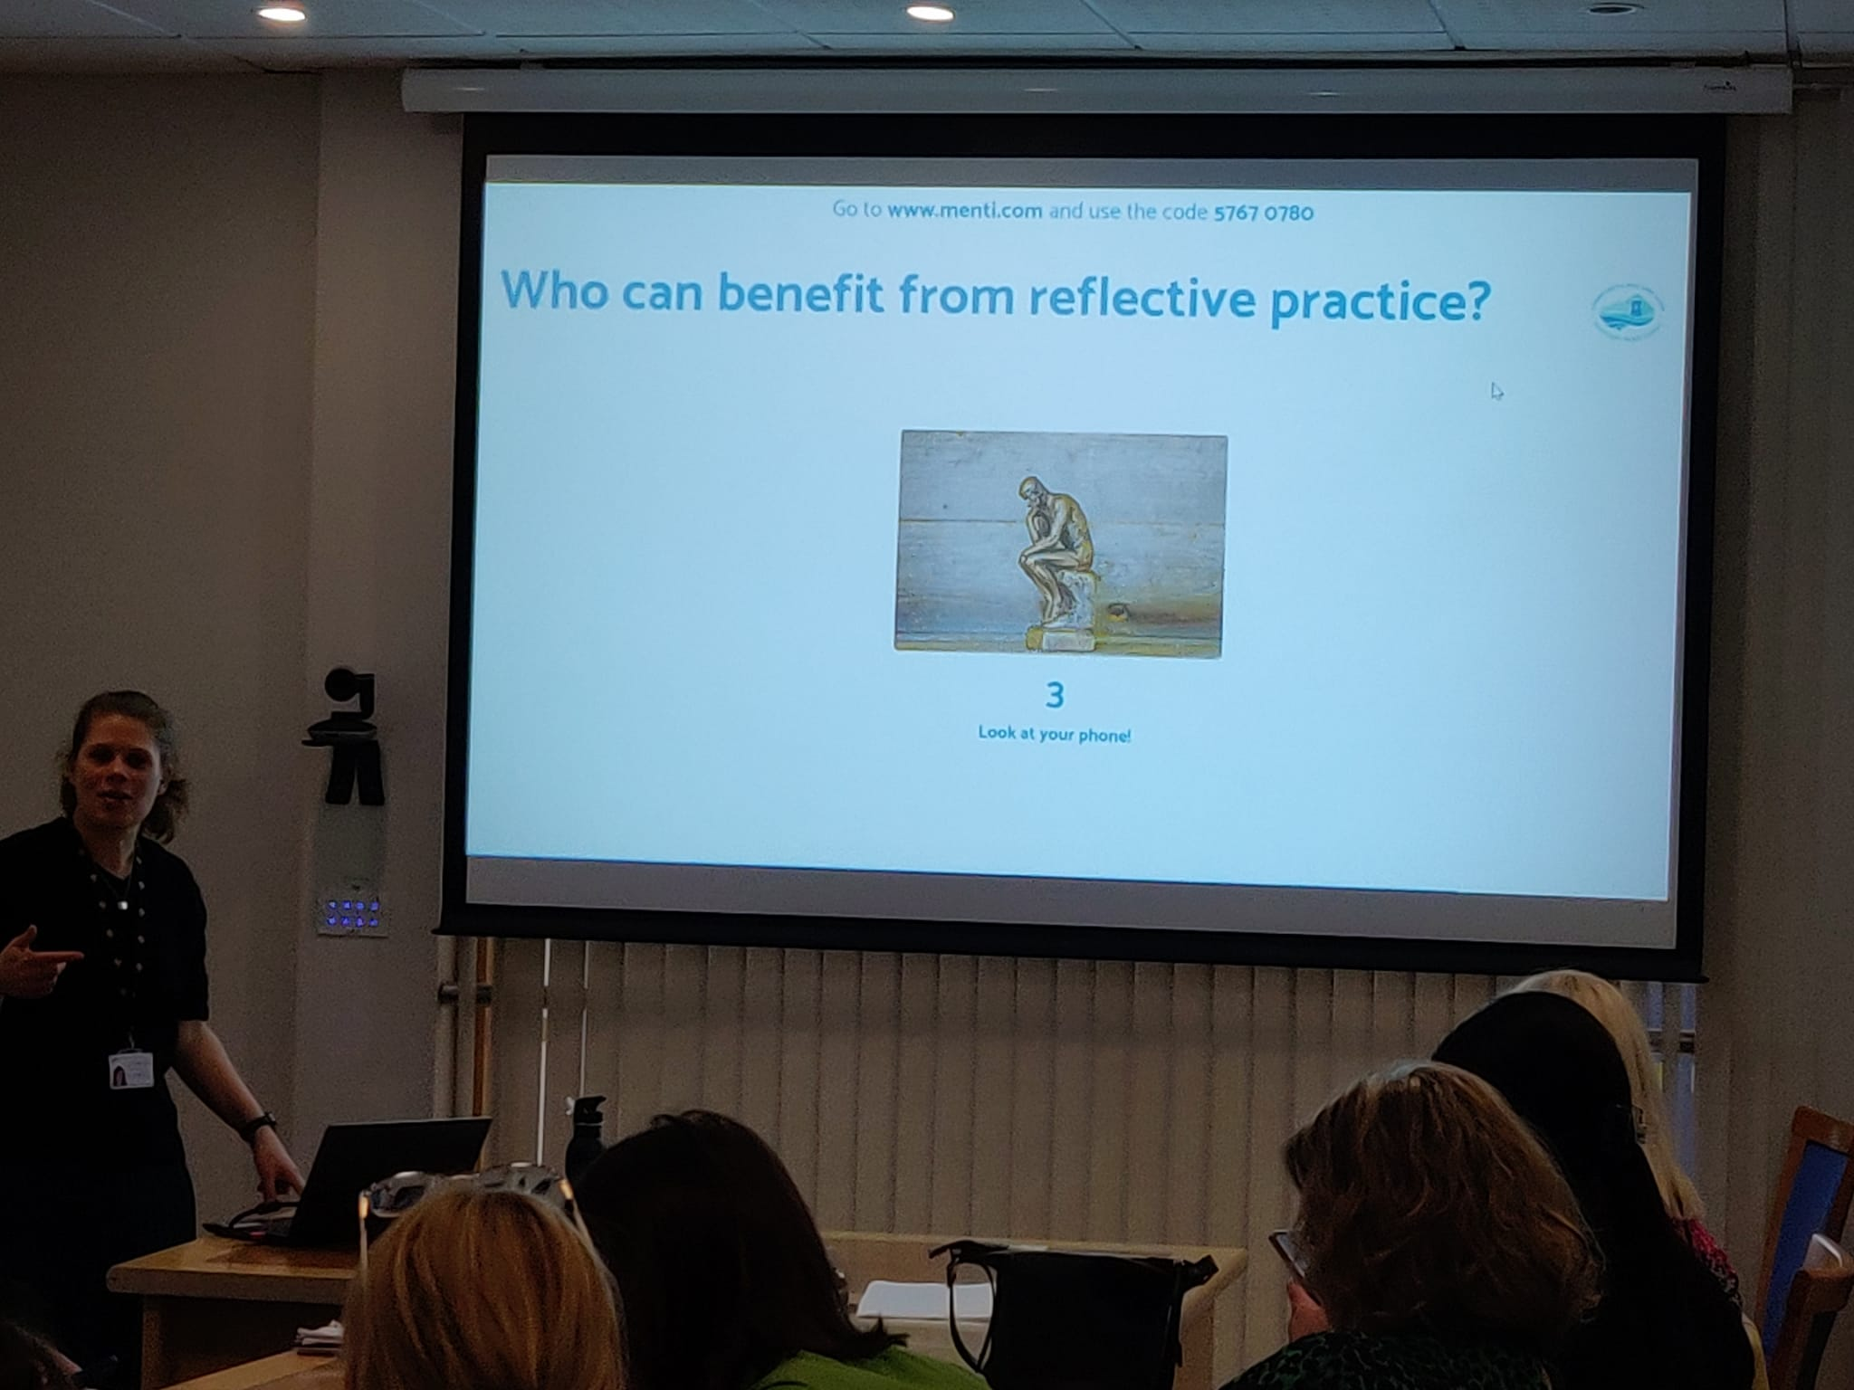
Figure 6

Figures 4-6 demonstrating learners are using mobile phones to respond to the questions

Figure 7

Figure 7 demonstrates question on the slide which aims to assess learning from the session.
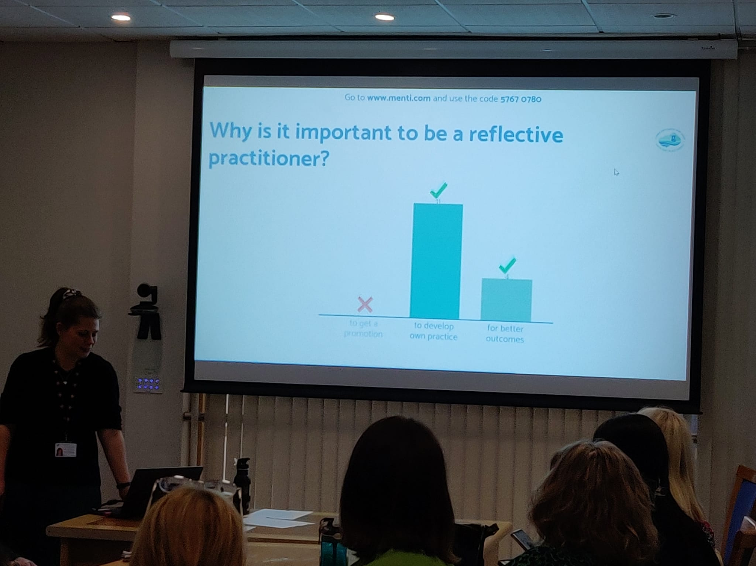
Figure 8

Figure 8 above shows the instant results from a question providing immediate feedback to learners.
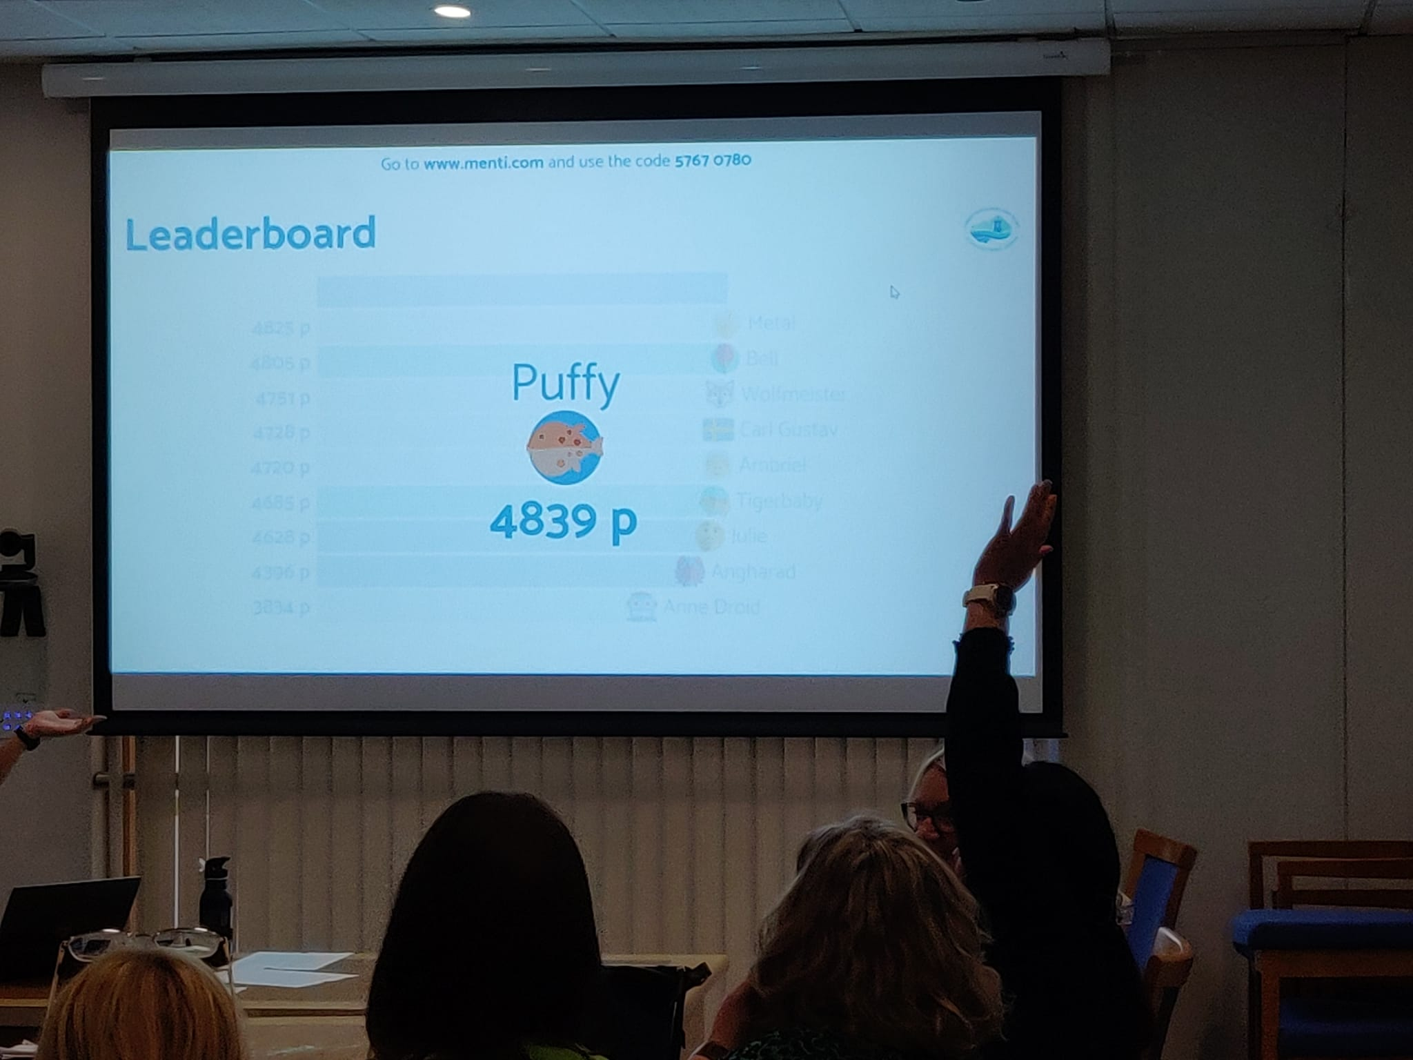
Figure 9

Figure 9- This is the moment that the winner of the quiz was revealed.
Evaluation and Reflection
In order to reflect on and evaluate the use of a Quiz through the digital tool Mentimeter, I will follow Jasper’s (2013) ERA model to consider Experience, Reflection and Action.
Experience: The session took place on the 21st March 2023 with fifteen Newly Qualified Social Workers aged between 25-55 who were attending mandatory training on Reflective Practice. I was ‘supporting learning’ by promoting the importance of reflective practice and utilising reflective models in the workplace (A2, UKPSF, 2011). The Mentimeter quiz included a set of questions which I had devised in order to assess learning (A3, UKPSF, 2011) in a fun and engaging way with a view to increase motivation of learners (Coleman and Money, 2020). In order to achieve this outcome, I had put the questions on individual slides in ‘competition mode’ as it would ensure anonymity of learners, and a competitive time limit to answer the questions.
Reflection: I had planned on using the word cloud element of Mentimeter tool for a formative assessment of knowledge at the beginning of the session but felt that question and answer was more appropriate and quicker in the moment, therefore I omitted the word cloud aspect. This evidenced to me that the pedagogy needs to precede technology (Beetham and Sharpe, 2020) and teachers need reflect in action (Schön, 2984) to determine the needs of the moment. With regards to the use of Mentimeter Quiz as a summative assessment, I felt it was a successful way to assess learners (Vallely and Gibson, 2018; A3, UKPSF, 2011). The Quiz itself was short and engaging.
I had devised Feedback forms and had obtained feedback from fifteen learners. I had asked the following questions and have summarised the answers:
How did you feel about the Quiz? All fifteen learners said they enjoyed it, it was fun, and a good recap of the session. Five learners specified they enjoyed the interactive element and one specifically commented it was interesting and different to use a mobile phone.
What are the benefits and limitations of having a quiz in the session? Eight learners fed-back it was beneficial, easy to use, it broke up the session and consolidated the learning and did not note any limitations. Out of the remaining seven learners, the benefits included it was a good aspect which cemented the learning, makes the session more interactive, relaxes people and the instant results are a benefit, additionally, it is anonymous and does not identify individuals. However, some of the feedback for the limitations included the system was unfamiliar, the need to use technology, the phone signal in the building is not the best, and not everyone has a mobile phone to use.
Would you have preferred to do something else? No
Based on the feedback, I can summarise that overall, the quiz element was a positive addition to the session. Individuals felt that it was interactive and fun and it was a good recap of the session. However, some learners felt that the system was unfamiliar and they did not like the use of technology. Although individuals can access the quiz on their laptops, this may not have worked for them in the moment. This could have led to excluding those who did not have a smart phone or who were not confident in this level of digital technology, which would not have allowed for an ‘equal opportunity for all learners’ to participate (V2, UKPSF, 2011.) This feedback correlates with the disadvantages mentioned by The Collegion (2023), Reece and Walker (2007) and (Fowdar, 2011).
I feel that the quiz was visually pleasing with emojis as characters which I thought enhanced enjoyment and I felt it met ‘the way students learn’ (K3, UKPSF, 2011) based on VARK learning dimensions (Fleming, 1992). However, there was no mandatory expectation to engage with the digital quiz. Learners could have answered the questions personally by writing down the answer if this was more comfortable for them. In future sessions, I will be sure to emphasise that option which will create a more Humanism learning approach (Saunders, 2020). When considering the set learning outcomes, the quiz successfully identified whether they had been met (Race and Pickford, 2007). Overall, I feel that the instant feedback and competition element was good in this session to enhance learner engagement, promote intrinsic and extrinsic motivation (Ryan and Deci, 2000) and to assess learning (A3, UKPSF, 2011; Cagiltay, Ozcelik and Ozcelik, 2015). However, in the future, I will also revisit the learning outcomes following with quiz (Race, 2020). Arguably, the instant rewarding feedback can link to Behaviourist theory (Skinner, 1938).
I had been informed by a learner that she was dyslexic and required information ahead of the session, therefore I sent her the PowerPoint slides in advance as advised by British Dyslexia Association (N/D). However, I did not send the quiz link as my intention was to assess learning at the end of the session. I was initially concerned about the need to read fast and answer the quiz questions quickly, therefore, I increased the response time on the slide to allow more time to read and answer the question to ensure ‘equality of opportunity for all learners’ (V2, UKPSF, 2011). On reflection, I feel that the allocated time to answer the quiz questions was sufficient and furthermore, the individual with dyslexia informed me that she was able to participate as she is used to using her own phone. This demonstrates that the use of technology in lessons is beneficial if it complements how learners use technology daily (V4, UKPSF, 2011; Duja, 2017). Unfortunately, I had made an error on one of the quiz questions in my preparation, and I had omitted one correct answer. Therefore, when some of the learners selected this answer, it came up as incorrect even though it was correct in the context of the session. I felt this was demotivating for the learner concerned. They were frustrated as they had been penalised by my error. As this was at the end of the session, it did not impact on the engagement during the session but I will be mindful of ensuring the quiz answers are all accurate next time.
Additionally, I feel that I had missed an opportunity to make the whole session interactive. Learners could have accessed the whole presentation on their devices as they entered by scanning the QR code/accessing the website and this would have allowed for use of the word cloud slide and greater engagement and collaboration in line with the Technology Integration Matrix (2006). My focus was the Mentimeter quiz at the end, however, there is much more that Mentimeter can offer such as a fully interactive presentation (Iona, 2018).
Action: In advance of future sessions, I will ask learners to bring either a phone or a laptop to ensure they are adequately prepared. As they enter, I will ask learners to scan the QR code/access the website at the beginning to allow full access to the presentation to ensure time efficiency and full involvement when activities take place (K4, V2, UKPSF, 2011). However, I also recognise not everyone wants to be involved with digital content particularly a quiz, so I will emphasise the option of writing answers down (K2, K3, K4, UKPSF, 2011). Furthermore, in each future session, I will align the learning outcomes more to the specific questions of the quiz and recap the learning outcomes at the end of the session (A3, K5, UKPSF, 2011).
(Written assignment total word count: 4390)

References
Advance HE, Guild HE, Universities UK (2011) The UK Professional Standards Framework for teaching and supporting learning in higher education, York: Advance HE: Available at: UK Professional Standards Framework (PSF) | Advance HE (advance-he.ac.uk) (Accessed: 4.4.23)
Ayat Tarazi, Ayat Tarazi, José Luis Ortega-Martín, & José Luis Ortega-Martín (2023). ‘Enhancing EFL students’ engagement in online synchronous classes: The role of the Mentimeter platform.’ Frontiers in Psychology, 14. Pp. 1-11. Available at: https://doi.org/10.3389/fpsyg.2023.1127520 (Accessed: 10.5.23)
Beetham, H. and Sharpe, R. (2020) Rethinking Pedagogy for a Digital Age: Principles and Practices of Design. 3rd edn. London: Routledge
Bloom. B.S. (1956) Taxonomy of Educational Objective Handbook 1. New York: David McKay
British Dyslexia Association (n/)d) Dyslexia Friendly Training. Available at: Dyslexia friendly training - British Dyslexia Association (bdadyslexia.org.uk) (Accessed: 20.5.23)
Cagiltay, Ozcelik, E., & Ozcelik, N. S. (2015). ‘The effect of competition on learning in games.’ Computers and Education. Vol 87 pp 35–41. Available at: https://doi.org/10.1016/j.compedu.2015.04.001 (Accessed: 10.5.23)
Cameron, K and Bizo, L (2019) Available at: Use of the game-based learning platform KAHOOT! to facilitate learner engagement in Animal Science students | Research UNE (Accessed: 20.5.23)
CELESTINO, E.H. and NORONHA, A.B., 2021. Blended learning: a systematic review of advantages and disadvantages in students' perceptions and impacts on higher education institutes. Administração: Ensino e Pesquisa, 22(1), pp. 31-63. Available at : Blended learning: a systematic review of advantages and disadvantages in students' perceptions and impacts on higher education institutes - ProQuest (Accessed: 6.5.23)
Chi Eun Oh, & Hyunyong Hwang. (2022). How does quiz activity affect summative assessment outcomes? An analysis of three consecutive years’ data on self-directed learning. Kosin Medical Journal (Online), 37(3), 228–235. Available at: https://doi.org/10.7180/kmj.22.118 (Accessed: 21.5.23)
Coleman, & Money, A. G. (2020). Student-centred digital game–based learning: a conceptual framework and survey of the state of the art. Higher Education, 79(3), 415–457. Available at: https://doi.org/10.1007/s10734-019-00417-0 (Accessed: 6.5.23)
Digital Poverty Alliance (2021) Howe we define Digital Poverty. Available at: Home - Digital Poverty Alliance (Accessed: 23.5.23)
DUŢĂ, N. (2017). ‘ONLINE INTERACTIVE RESOURCES AND TEACHING TOOLS FOR THE CLASSROOM - THEORETICAL APPROACHES IN EACHING-LEARNING PROCESS.’ Euromentor Journal, 8(3), pp. 103-124. Available at: ONLINE INTERACTIVE RESOURCES AND TEACHING TOOLS FOR THE CLASSROOM - THEORETICAL APPROACHES IN EACHING-LEARNING PROCESS - ProQuest (Accessed: 13.5.23)
Dylan Wiliam Center (2017) Assessment, the bridge between teaching and learning. Available at: 2017-06-30 Baltimore County Public Schools keynote.pptx (live.com) (Accessed 22/5/23)
Ebbinghaus, H. (1885). Memory: A contribution to experimental psychology, New York: Dover. Available at: Classics in the History of Psychology -- Ebbinghaus (1885/1913) Chapter 1 (archive.org) (Accessed: 22.5.23)
Fleming, N. D. and Mills, C. (1992) ‘Not Another Inventory, Rather a Catalyst for Reflection,’ To Improve the Academy, 11 pp. 137-143. Available at: www.vark-learn.com (Accessed: 2.1.23)
Fowdar, S (2011) ‘A Critical Analysis of e-Assessment with Particular Emphasis on the use of Different Types of Online Quizzes’ The International Journal of Learning Volume 18, Number 1. Available at: A Critical Analysis of e-Assessment with Particular Emphasis on the use of ...: EBSCOhost (uwtsd.ac.uk) (Accessed: 21.5.23)
Gopalan, V. et al (2017) ‘A review of the motivation theories in learning’. AIP Conference Proceedings . Volume 1891, Issue 1 pp1-7. Available at: A review of the motivation theories in learning (scitation.org) https://doi.org/10.1063/1.5005376 (Accessed: 10.5.23)
Greener, S. (2018) ‘Student disengagement: is technology the problem or the solution?’ Interactive Learning Environments, Volume 26 issue 6, pp. 716-717. Available at: DOI: 10.1080/10494820.2018.1498235 (Accessed: 18.5.23)
Guardia, L, Cloughter, D, Anderson, T, Maina, M (2021) ‘IDEAS for transforming Higher Education: An Overview of Trends and Challenges.’ International Review of Research in Open and Distance Learning Vol 22 issue 2 pp. 166-184. Available at: DOI10.19173/irrodl.v22i2.5206 (Accessed: 13.5.23)
Iona, J (2018) ‘Mentimeter’. The school Librarian Vol 66, issue 3 p 153 Available at: Mentimeter - ProQuest (Accessed: 13.5.23)
Jasper, M. (2013) Beginning Reflective Practice. 2nd edn. Andover: Cengage Learning.
Kang, X and Zhang, W (2020) ‘An experimental case study on forum-based online teaching to improve student’s engagement and motivation in higher education.’ Interactive Learning Environments. Pages 1029-1040 Available at: https://doi-org.ezproxy.uwtsd.ac.uk/10.1080/10494820.2020.1817758 (Accessed: 18.5.23)
Kirzner, R., Alter, T., &. Hughes, C. (2021) ‘Online Quiz as Exit Ticket: Using Technology to Reinforce Learning in Face to Face Classes,’ Journal of Teaching in Social Work, Vol 41 issue 2, pp. 151-171. Available at: DOI: 10.1080/08841233.2021.1898521 (Accessed 13.5.23)
Knowles, M. S., Holton III, E. F., Swanson, R. A., & Robinson, P. A. (2020) The Adult Learner: The definitive classic in Adult Education and Human Resource Development. 9th edn. London: Routledge
Knowles, M. (1984). The Adult Learner: A Neglected Species. 3rd edn. Houston, TX: Gulf Publishing.
Lowell, V.L. and Morris, J., Jr (2019) ‘Leading Changes to Professional Training in the Multigenerational Office: Generational Attitudes and Preferences toward Learning and Technology.’ Perf Improvement Qrtly, issue 32 pp. 111-135. Available at: https://doi.org/10.1002/piq.21290 (Accessed: 13.5.23)
Madiseh, F., Al Abri, A., and Sobhanifar, H. (2022) ‘Integration of Mentimeter into the Classroom: A Scoping Review’ Research Square Available at: 3bc61484-a68a-44ac-87b8-562008295c5d.pdf (researchsquare.com) (Accessed: 20.5.23)
Mishra, P., & Koehler, M. J. (2006). ‘Technological Pedagogical Content Knowledge: A Framework for Teacher Knowledge.’ Teachers College Record Vol 108, pp. 1017-1054. Available at: http://dx.doi.org/10.1111/j.1467-9620.2006.00684.x (Accessed: 13.5.23)

Morris, J., and Lowell, V. (2018). ‘Multigenerational classrooms in higher education: equity and learning with technology’ Available at: EMERALD_IJILT_IJILT620310 78..93 (googleusercontent.com) (Accessed: 4.5.23)
Ollin, R., Thompson, R., and Tummins, J. (2019) Teaching in Lifelong Learning A Guide to Theory and Practice. Edited by J. Avis, R. Fisher & R. Thompson. London: Open university Press.
Office of National Statistics (2019) Exploring the UK’s digital divide - Office for National Statistics (ons.gov.uk) (Accessed: 21.5.23)
Puentedura, R. R. (2006, November 28). Transformation, technology, and education in the state of Maine [Web log post]. Available at: http://www.hippasus.com/rrpweblog/archives/2006_11.html (Accessed: 25.5.23)
Race, P and Pickford, R (2007) Making Teaching Work. London: Sage Publications.
Race, P. (2020) The lecturer’s toolkit: A practical guide to assessment learning and teaching. 5th edn. Oxon: Routledge
Raes, Vanneste, P., Pieters, M., Windey, I., Van Den Noortgate, W., & Depaepe, F. (2020). ‘Learning and instruction in the hybrid virtual classroom: An investigation of students’ engagement and the effect of quizzes.’ Computers and Education, Vol 143, Available at: 103682–. https://doi.org/10.1016/j.compedu.2019.103682 (Accessed: 21.5.23)
Reece, I. and Walker. S. (2007) Teaching, Training and Learning: A Practical Guide. 6th edn. Tyne and Wear: Business Education Publishers.
Saunders, L. (2020) Learning Theories: Understanding How People Learn. Available at: Learning Theories: Understanding How People Learn – Instruction in Libraries and Information Centers (illinois.edu) (Accessed 23.5.23)
Sayaf, Alamri, M. M., Alqahtani, M. A., & Alrahmi, W. M. (2022). ‘Factors Influencing University Students’ Adoption of Digital Learning Technology in Teaching and Learning. Sustainability (Basel, Switzerland), Vol 14 issue1, pp. 493–. Available at: https://doi.org/10.3390/su14010493 (Accessed: 7.5.23)
Schön, D. (1983) The Reflective Practitioner: How Professionals Think in Action. 1st edn. New York: Basic Book
Serrano, Dea‐Ayuela, M. A., Gonzalez‐Burgos, E., Serrano‐Gil, A., & Lalatsa, A. (2019). ‘Technology‐enhanced learning in higher education: How to enhance student engagement through blended learning.’ European Journal of Education, Vol 54 issue 2, pp. 273–286. Available at: https://doi.org/10.1111/ejed.12330 (Accessed: 13.5.23)
Skinner, B. F. (1938). The Behavior of organisms: An experimental analysis. USA: Appleton-Century
Staddon, R. (2020) ‘Bringing technology to the mature classroom: age differences in use and attitudes’ International Journal of Educational Technology in Higher Education Vol 17: issue 11, pp 1-20. Available at: https://doi.org/10.1186/s41239-020-00184-4 (Accessed: 10.5.23)

Surana, S (2018) Engage Employees and Reinforce Training with Quizzes in Intranet. Available at: Engage Employees and Reinforce Training with Quizzes in Intranet (linkedin.com) (Accessed: 22.5.23)
Swanzen, R (2018) ‘FACING THE GENERATION CHASM: THE PARENTING AND TEACHING OF GENERATIONS Y AND Z’ International Journal of Child, Youth and Family Studies. Volume 9 Issue 2, pp. 125–150. Available at: DOI: 10.18357/ijcyfs92201818216 Available at 18216-Article Text-17318-1-10-20180515.pdf (Accessed: 10.5.23)
The Collegion (2023) Available at: The Benefits and Drawbacks of Using Quizzes in the Teaching Process - The Collegian (kstatecollegian.com) (Accessed: 21.5.23)
The Technology Integration Matrix (2019) Available at: Matrix | TIM (usf.edu) (Accessed 22.5.23)
Urick, M (2016) ‘Adapting training to meet the preferred learning styles of different generations.’ International Journal of Training and Development, (2017) Vol 21 issue 1. Available at: Adapting training to meet the preferred learning styles of different genera...: EBSCOhost (uwtsd.ac.uk) (Accessed: 10.5.23)
Vallely, K., & Gibson, P. (2018). ‘Engaging students on their devices with Mentimeter.’ Compass: Journal of Learning and Teaching, Vol 11 issue 2. Available at: doi:https://doi.org/10.21100/compass.v11i2.843 (Accessed:15.5.23)
Wang, Q., Wen, Y. & Quek, C.L. (2023) ‘Engaging learners in synchronous online learning’. Educ Inf Technol. Issue 28, pp. 4429–4452. Available at: https://doi.org/10.1007/s10639-022-11393-x (Accessed: 5.5.23)
Welsh Government (2021) Digital Strategy for Wales. Available at: Digital strategy for Wales [HTML] | GOV.WALES (Accessed: 21.5.23)

