University of Wales
Trinity Saint David
School of Applied Computing

Title: Installing and Managing Virtual Networked Systems

Module: Computer Systems
Code: M4X 01500
Student: Martin Darzins
Student no.: 1909722
Programme: Foundation Year (Computing and Electronic Pathways)
Lecturer: John Rees
Due Date: 24th April 2020

Acknowledgements
Due to the UK coronavirus situation, the inability to access the SOAC labs within UWTSD Swansea and the subsequent restrictions placed on Applied Computing students, the author acknowledges contributions from Abigail Crimlis and Theresa Darzins.

Table of Contents
1 Acknowledgements 2
3 Introduction 5
3.1 Aims 5
3.2 Objectives 5
4 Practical work 6
5 observational tasks 13
5.1 Benefits of Type 2 Hypervisor virtualisation software 13
5.1.1 Strengths 13
5.1.2 Weaknesses 14
5.2 Significance 14
5.2.1 Active Directory Forest (ADF) 14
5.2.2 Trees 15
5.2.3 Parents and Child Domains 16
5.3 Active Directory Domain Controller 16
5.3.1 Main Role and Responsibilities 17
5.4 Unavailable Domain Controller 17
5.4.1 Actions to take 17
6 References 19
7 Report Planning Methodology 20

Figure 1 - Client 1 6
Figure 2 - Client 0 6
Figure 3 - Server 0 7
Figure 4 - Server IP configuration 7
Figure 5 - Client 0 ping Client 1 7
Figure 6 – Dcpromo 8
Figure 7 - Configure Virtual Network to Domain Controller 8
Figure 8 - Add role 8
Figure 9 - Show Services installed on Active Domain services 9
Figure 10 - Client 0 ping Server 9
Figure 11 - Create Forest 9
Figure 12 - Create Forest 1 10
Figure 13 - Create Forest 2 10
Figure 14 - Create Forest 3 10
Figure 15 - Server Login after installation 11
Figure 16 - Server after initiation 11
Figure 17 - Add Client 1 11
Figure 18 - Connect Client 1 to Domain 12
Figure 19 - Connect Client 1 to Domain 1 12
Figure 20 - Type 2 Hypervisor representation 13
Figure 21 - Type 1 Hypervisor representation 14
Figure 22 - Overview (Forests, Trees, OU's) 14
Figure 23 - Active Directory Forest example 15
Figure 24 – Active Directory Tree example 15
Figure 25 - Parent & Child Domain examples 16
Figure 26 - Active Directory Domain Controller Overview 16

Introduction

Aims
The aim of this report is to show the practical work of creating a network of virtual machines using Oracle VirtualBox and Windows Networking.

Objectives
The purpose is to show the ability to act as a Systems Manager and implement a network system of 3(three) elements; creating virtual PC’s and servers; installing operating systems and interconnecting these via IP addressing.
With the guidance of the worksheet provided, ensure that;
- 4(four) virtual PC’s in VirtualBox are created
- Install Windows Server and Windows 7
- Manually configure static IP addressing
- A primary domain controller and domain name servers (DNS) are established
- A dynamic host configuration protocol (DHCP) is created and automatically reconfigured
This will be completed through the use of various screenshots and brief notes, showing the progress and demonstration of successfully completing each stage of the task development.

Practical work
The following screenshots are intended to demonstrate the successful progress and completion of each of the stages required to meet the task assignment objectives.
However, there have been issues in downloading and running VirtualBox and virtual machines on Home domestic PC’s, which may be the combination of OS's and VirtualBox requiring greater capacity than that offered by a home set up.
Therefore, this screenshot element of the assignment has been limited to the following;
Figure 1 - Client 1
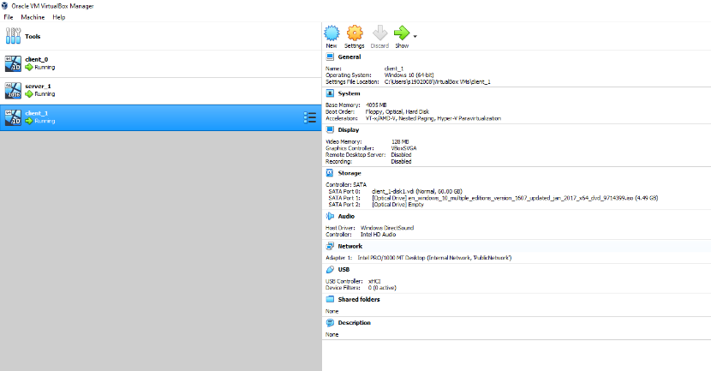
Figure 2 - Client 0
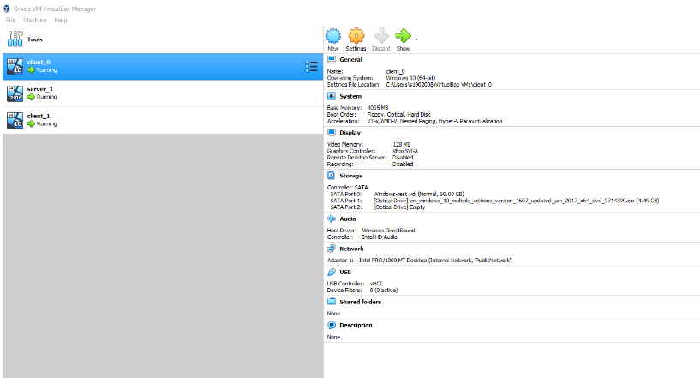
Figure 3 - Server 0
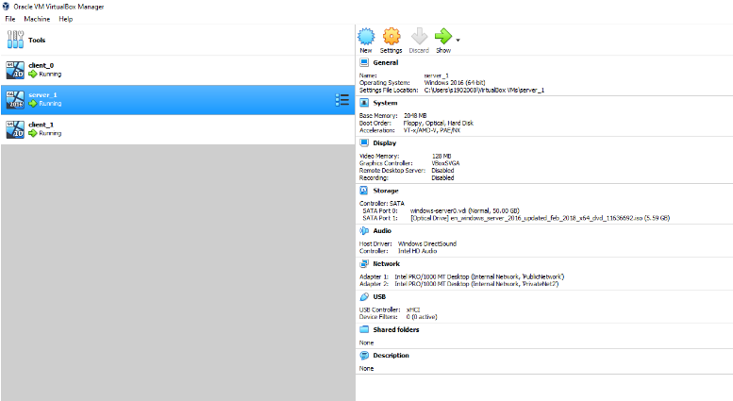
Figure 4 - Server IP configuration
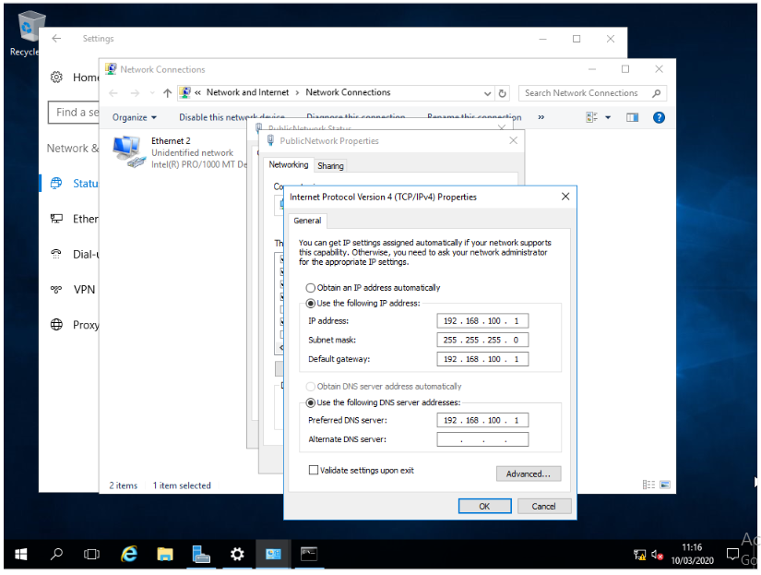
Figure 5 - Client 0 ping Client 1
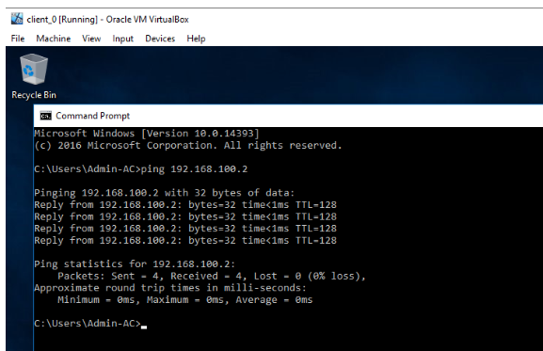
Figure 6 – Dcpromo
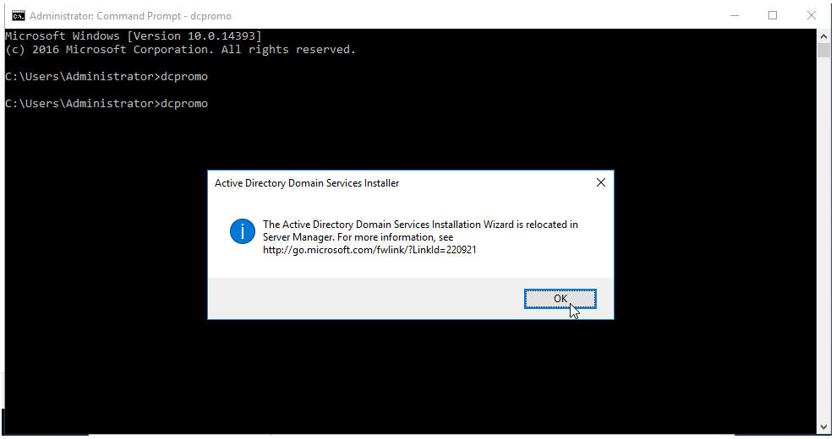
Figure 7 - Configure Virtual Network to Domain Controller
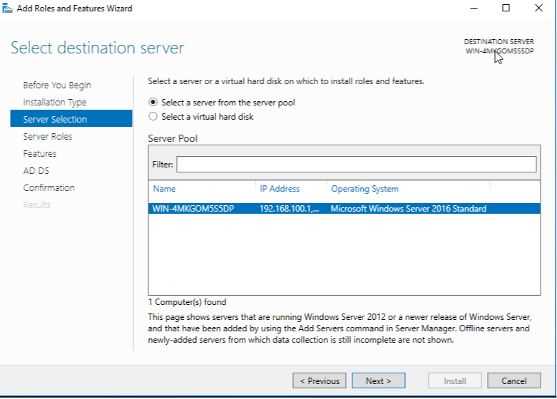
Figure 8 - Add role
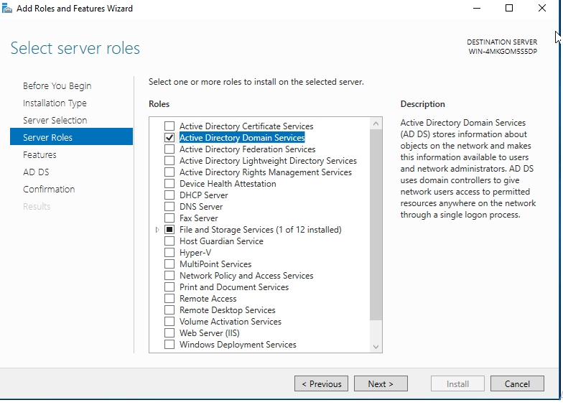
Figure 9 - Show Services installed on Active Domain services
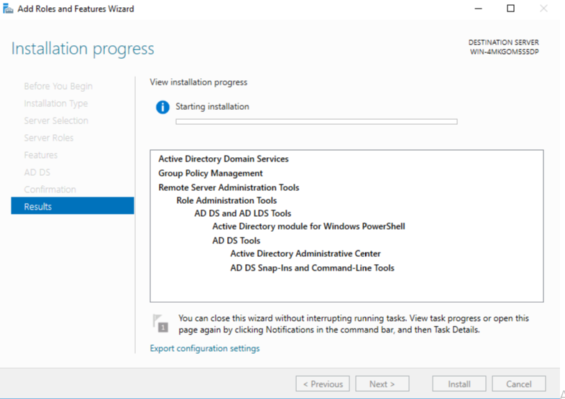
Figure 10 - Client 0 ping Server
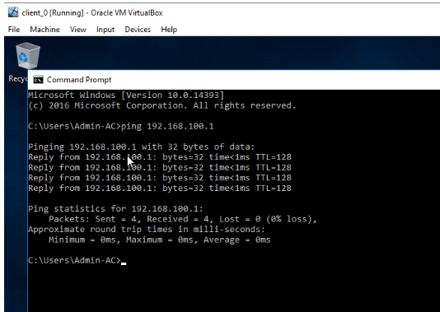
Figure 11 - Create Forest
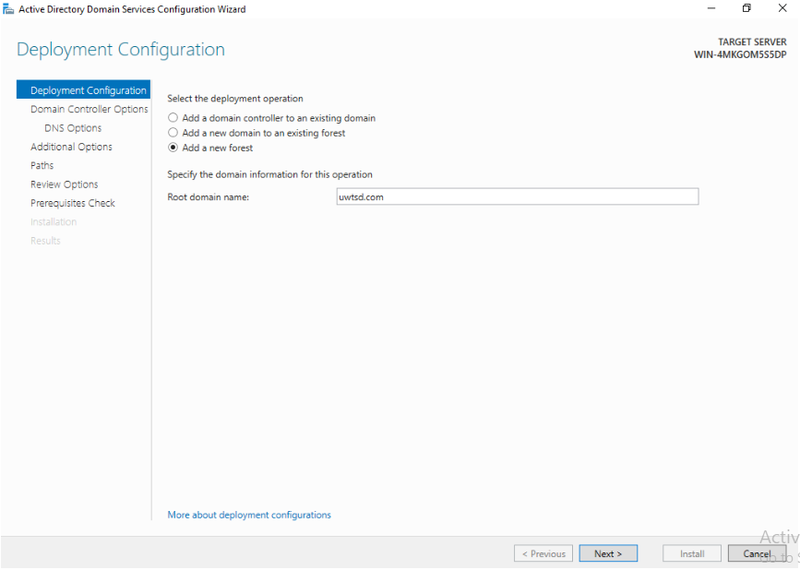
Figure 12 - Create Forest 1
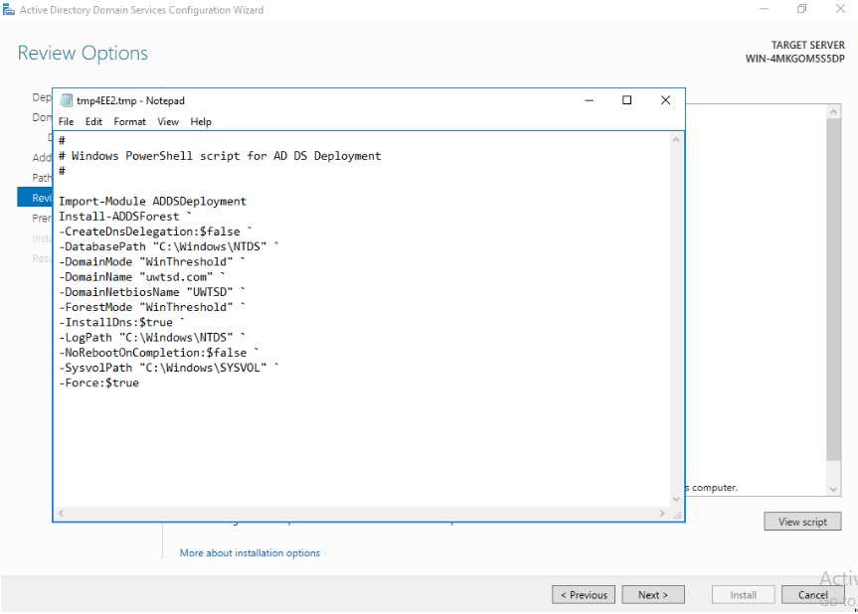
Figure 13 - Create Forest 2
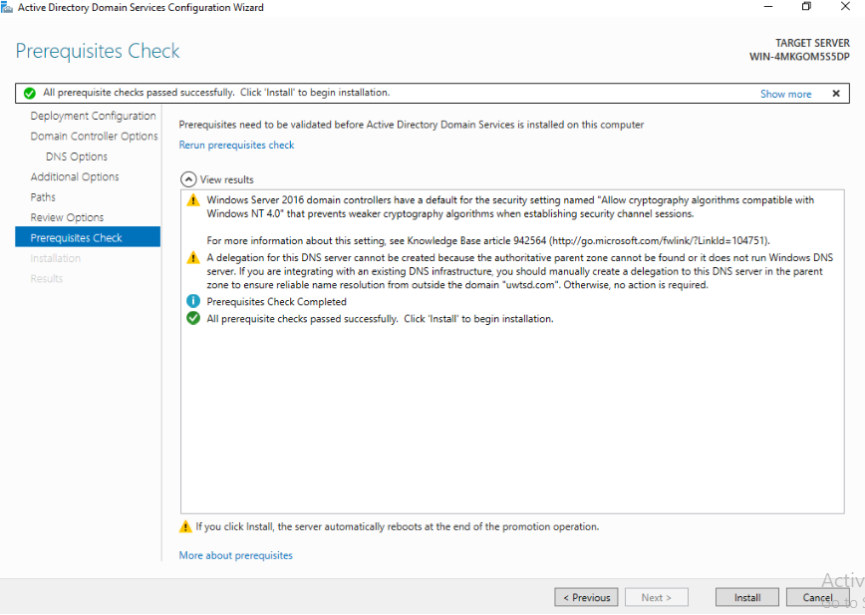
Figure 14 - Create Forest 3
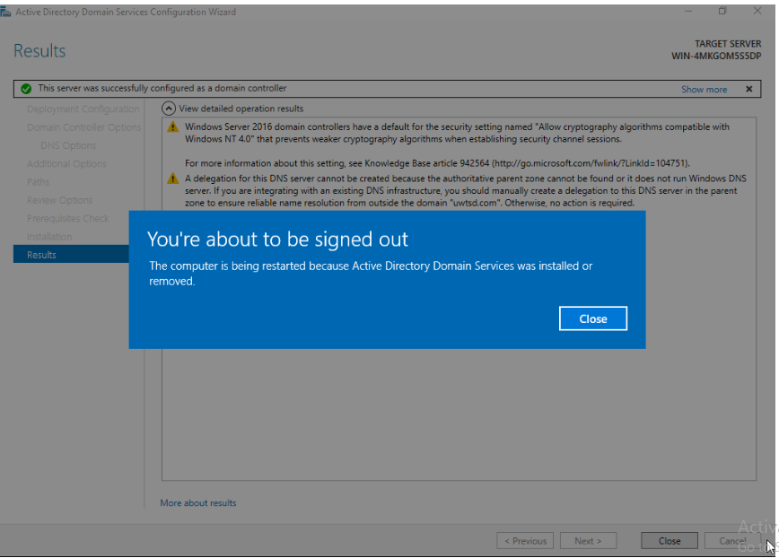
Figure 15 - Server Login after installation
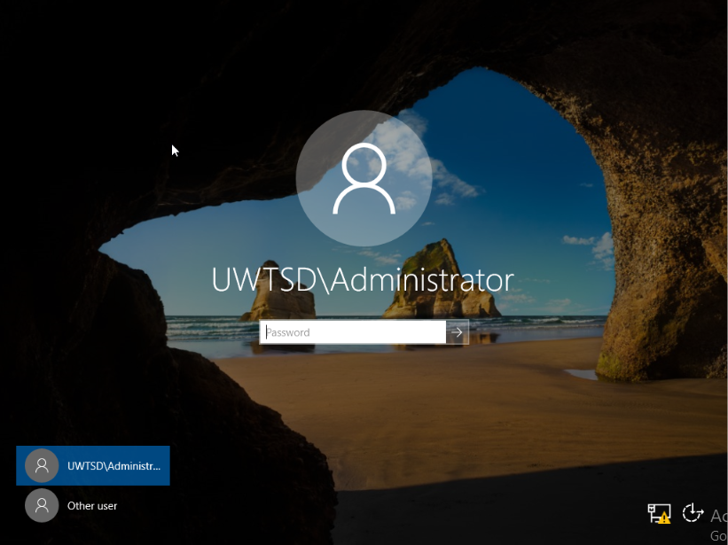
Figure 16 - Server after initiation
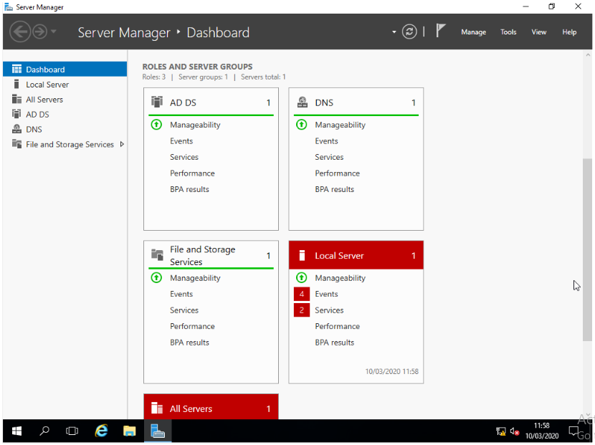
Figure 17 - Add Client 1
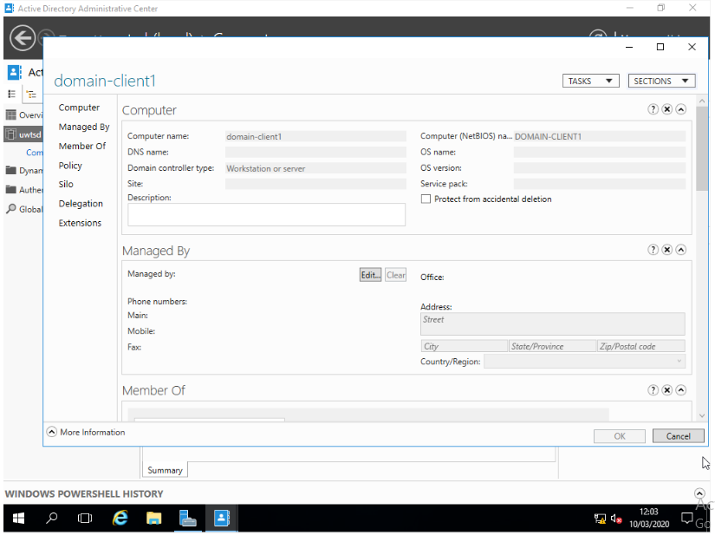
Figure 18 - Connect Client 1 to Domain
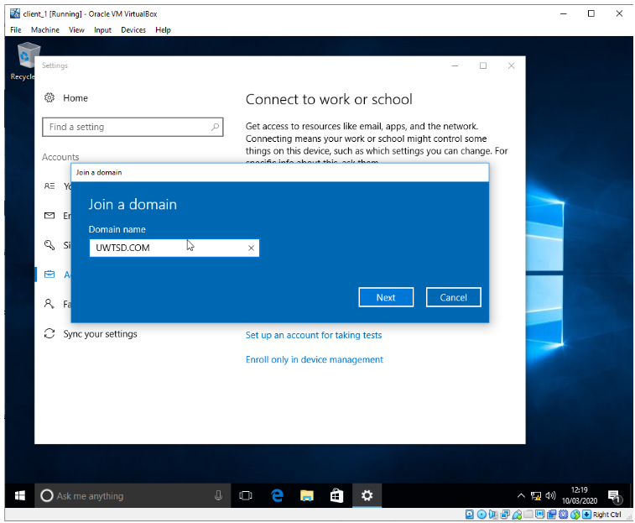
Figure 19 - Connect Client 1 to Domain 1
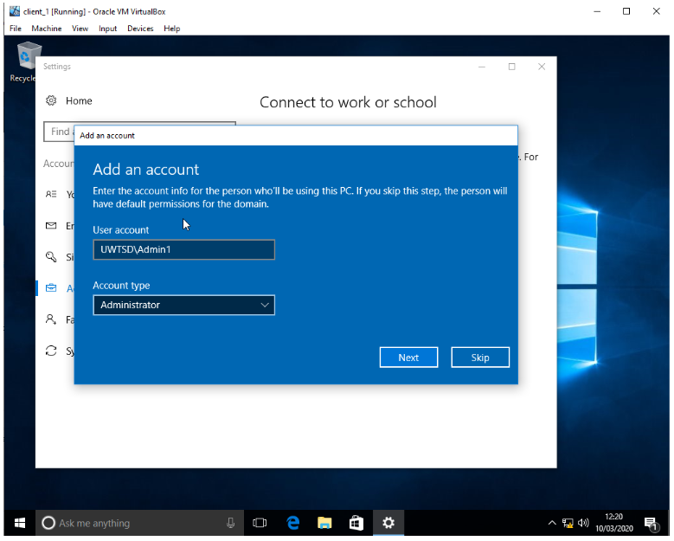

observational tasks

Benefits of Type 2 Hypervisor virtualisation software
This computer software generates and operates virtual machines, which offers the guest Operating Systems (OS) a virtual Operating platform to manage these guest Operating systems [1].
The Strengths [2] and Weaknesses [3] of such software are;

Strengths
- Through the physical host’s OS, type 2 hypervisor co-ordinates calls for CPU, memory, disk, network and other resources making it easier to run a virtual machine on a personal computer.
- More commonly used on devices not dedicated to the Virtual Machine Host role and do not require any special hardware in order to run.
- Widely used in developer environments where access to multiple OS’s and their variants are required, making them convenient for testing new software or research projects scenarios.
- Take up minimal RAM, are relatively fast to reinstall when needed and they are highly optimised for running virtual machine.
- Utilises any hardware that the full OS has drivers for and makes monitoring and back-ups from the host OS easier.
- Separates the OS and applications in a computer from the underlying physical hardware enabling virtualisation and host machine the ability to operate multiple Virtual machines (VM) on the same system and thereby optimises computing resource usage.
- Provides a layer between Hardware/Host OS and VM which handles all transactions between both, (see figure 1) this separation provides a greater degree of privacy and further safeguards from the effects of errors, crash and/or malware attacks.
- VM’s are made more mobile, efficient and scalable through the use of hypervisor.
- Typically utilised within environments of a small number of Servers, where they do not require a separate management console to set-up and manage VM’s, thus making them simple to manage.
Figure 20 - Type 2 Hypervisor representation
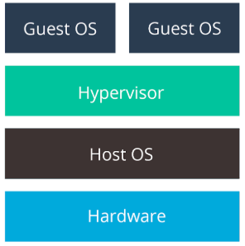

Weaknesses
Figure 21 - Type 1 Hypervisor representation
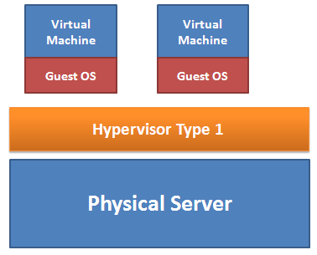
- Type 2 sits on top of OS (see figure 1) and therefore is unable to communicate directly with the hardware making it less efficient than type 1 (see figure 2).
- Type 2 is more susceptible to failure because anything that adversely affects the stability of the base OS can also affect the guest OS and VM, requiring a re-boot of all VM’s.

Significance
An Organisational Unit (OU) is a container used to organise objects within a domain into logical administrative groups. An OU can contain objects such as user accounts, groups, computers, printers, applications, file shares and other OUs [4].
Figure 22 - Overview (Forests, Trees, OU's)
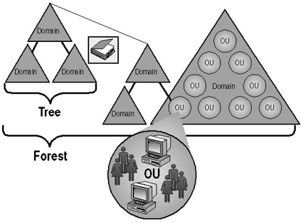

Active Directory Forest (ADF)

ADF’s are the top most logical container in an Active Directory configuration that contains domains, users, computers, and group policies. A single Active Directory configuration can contain more than one domain and under each domain, therefore you can have several trees. A forest is a group of one or more trees however, forests do not have to share the same geographic boundary [5, 6].
Central to the logical structure of an Active Directory is the domain. Grouping objects into one or more domains allows the network to reflect the Company's organisation.
A forest is a grouping or hierarchical arrangement of one or more domain trees that form a disjointed namespace (see Figure 4 below) [4].
Figure 23 - Active Directory Forest example
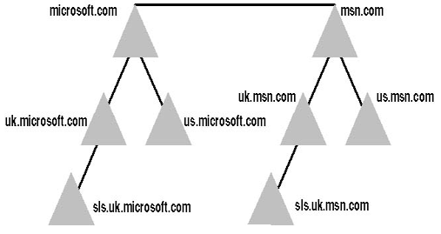

Trees
Trees are a group of one or more domains and domains are a group of shared resources such as computers or users. The domains within a tree share the same namespace as the tree. Each domain has exactly 1(one) parent, leading to a hierarchical tree structure with the group of Active Directory Trees being known as a Forest.
Trees follow the Domain Naming System (DNS) protocols, where the domain name of a child domain is the relative name of that child domain appended with the name of the parent domain. All domains within a single tree share a common representation, which is a formal definition of all object types in an Active Directory deployment. All domains within a single tree share a common catalogue, which is the central repository of information about objects in a tree (see Figure 5 below) [4].
Figure 24 – Active Directory Tree example
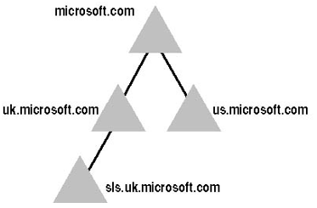

Parents and Child Domains
Parent Domains are domains in a Microsoft Windows Server domain tree whose DNS name forms the basis of subdomains called child domains. A two-way transitive trust exists between a parent domain and its associated child domains.
Whereas a Child Domain is another domain under a Parent in an active directory domain hierarchy and whilst under a parent first root domain will form a Tree, with all trees existing within a Forest [7].
Figure 25 - Parent & Child Domain examples
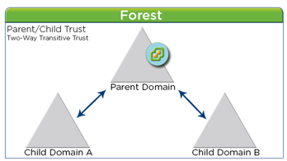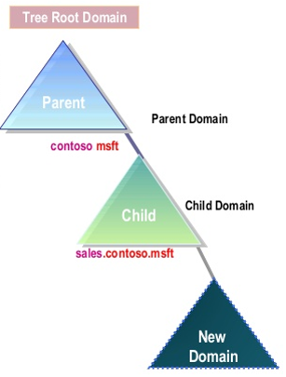

Active Directory Domain Controller
A Domain Controller (DC) server responds to security authentication requests within a Windows Server domain and is responsible for allowing host access to Windows domain resources. The DC is at the centre of the Windows Active Directory service and authenticates users, stores user account information and enforces security policy for a Windows domain. It allows access to another domain in a trust relationship and should the server performing the domain controller role be lost, the domain can still function [8].
Figure 26 - Active Directory Domain Controller Overview
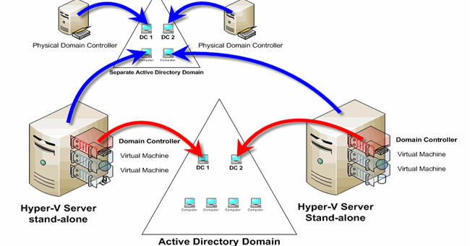

Main Role and Responsibilities
The main roles and responsibilities of Active Directory Domain Controllers are to:
- Maintain the master copy of the schema, where schema refers to the organisation of data as a blueprint of how the database is constructed and a set of formulas (sentences) called integrity constraints imposed on a database.
- Emulate a primary domain controller for backward compatibility with Windows NT, where the Primary Domain Controller Emulator role is the authoritative DC in the domain. The PDC Emulator responds to authentication requests, changes passwords, and manages Group Policy Objects.
- Tracks object names throughout a forest to ensure that they’re unique and track cross-references to objects in other directories, thereby maintaining a Domain naming master.
- Monitor object references among domains and maintain a list of deleted child objects as an infrastructure master.
- Through the Relative Identifier (RID) master, track the assignment of Security Identifiers (SID’s)) throughout the domain. The RID is a variable length number that is assigned to objects at creation and becomes part of the object's SID, which uniquely identifies an account or group within a domain.
Typically, the first domain controller created in the first domain assumes the operations master roles, thereafter these roles can be assigned to other domain controllers in the domain or forest, but only one domain controller at a time can hold each operation’s master role [9].

Unavailable Domain Controller
For Windows Servers, there are several potential resolutions to take in the event of a Domain Controller (DC) becoming unavailable and the following actions should be undertaken until the problem is resolved.
As the client and server do not initially share an encryption key, this new encryption key is called a session key and the Kerberos ticket is used to distribute it to the verifier. The Kerberos ticket is a certificate issued by an authentication server, encrypted using the server key [10].

Actions to take
- Fix Domain Name System (DNS) errors.
- Synchronize the time between computers.
- Verify IP address.
- Check that Client can ping the DC.
- Check cable and other hardware connections.
- Check the Access this computer from the network user rights.
- Verify that the domain controller's user AccountControl attribute is 532480.
- Fix the Kerberos realm (confirming the PolAcDmN and the PolPrDmN registry keys match).
- Reset the machine account password and then obtain a new Kerberos ticket.
Word count: 1,592 (excluding Title page and sections 1,2, 6 & 7)

References
[1] Wikipedia.org (2020) Hypervisor. Available at:
https://en.wikipedia.org/wiki/Hypervisor (Accessed: 04 April 2020)

[2] Medium.com (2019) Type 1 and Type 2 Hypervisors: What Makes Them Different. Available at:
https://medium.com/teamresellerclub/type-1-and-type-2-hypervisors-what-makes-them-different-6a1755d6ae2c (Accessed: 04 April 2020)

[3] SecurityWing.com (2020) Types of Virtualization Technology-Advantages vs. Disadvantages. Available at:
https://securitywing.com/types-virtualization-technology/ (Accessed: 04 April 2020)

[4] eTutorials.org (2020) Lesson 5: Understanding Active Directory Structure and Replication. Available at:
http://etutorials.org/Microsoft+Products/microsoft+windows+xp+professional+training+kit/Chapter+5+-+Using+the+DNS+Service+and+Active+Directory+Service/Lesson+5nbspUnderstanding+Active+Directory+Structure+and+Replication/ (Accessed: 04 April 2020)

[5] Petters, J. (2020) What is an Active Directory Forest? Available at:
https://www.varonis.com/blog/active-directory-forest/ (Accessed: 04 April 2020)

[6] Study.com (2020) Forests in Windows Server Active Directory: Definition & Purpose. Available at:
https://study.com/academy/lesson/forests-in-windows-server-active-directory-definition-purpose.html
(accessed: 04 April 2020)

[7] Networkencyclopedia.com (2020) Parent Domain. Available at:
https://networkencyclopedia.com/parent-domain/ (accessed: 04 April 2020)

[8] Petters, J. (2018) What is a Domain Controller, When is it Needed + Set Up. Available at:
https://www.varonis.com/blog/domain-controller/ (Accessed: 04 April 2020)

[9] Clines, S., Loughry, M. (2008) Roles of the Active Directory Domain Controllers. Available at:
https://www.dummies.com/programming/networking/roles-of-the-active-directory-domain-controllers/
(Accessed: 04 April 2020)

[10] Microsoft.com (2019) Domain controller is not functioning correctly. Available at:
https://support.microsoft.com/en-gb/help/837513/domain-controller-is-not-functioning-correctly
(Accessed: 04 April 2020)

Report Planning Methodology
This Computer Systems report assignment was completed by adhering to the following the activities;
- Read and understand the report brief and Task Summary
- Make use of University SOAC lab PC’s.
- Make plan (Gantt chart) including time management – planning/research most time consuming, cater for other exams.
- Create report format and style – use Moodle template example.
- Follow structure
  - Abstract
  - Introduction
  - Main Body
  - Conclusion
  - Reference
- Define the problem and purpose of the report – decide assignment title, aims & objectives.
- Define audience – Lecturer/Tutor (John Rees/David Williams).
- Brainstorm (Mindmaps) and Determine ideas to include.
- Research and gather information (Task Worksheet, library, internet etc).
- Collect, sort, evaluate organise material.
- Complete references (as you go) during all researching phases
- Analysing my research/material.
- Prepare outline drafts.
- Write the report, check spelling and grammar.
- Peer Review – (Terri, David Williams/John Rees)
- Incorporate peer comments into final redraft.
- Submit final report via Turnitin.

