Target 1 | Present the ideas of others in your own words.
Target 2 | Proof-read before submitting your assignment to ensure avoidable errors are not made.
Critically reflect on your pedagogical progress demonstrated through required elements of the Professional Learning Passport, identifying a specific area for professional development and justifying next steps for improvement.
Contents Page

Part 1 - Professional Learning Passport

Reflection on Subject Knowledge Development (Tab 5)

Pages 2-3 Mathematics

Pages 3-4 Digital Competency Framework

Pages 4-5 Literacy

Reflection on Planning for Progression (Tab 7)

Pages 6-8 Mathematics

Pages 9-11 Health and Well-being

Reflection on Planning for The Four Purposes (Tab 7)

Pages 12- 13 Ethically Informed Citizens

Pages 14-15 Ambitious Capable Learners

Part 2- Critical Reflection

Pages 16-21 – Critical Reflection

Pages 22-23 – References

Reflection on Subject Knowledge Development (Tab 5)

Mathematics- Numicon
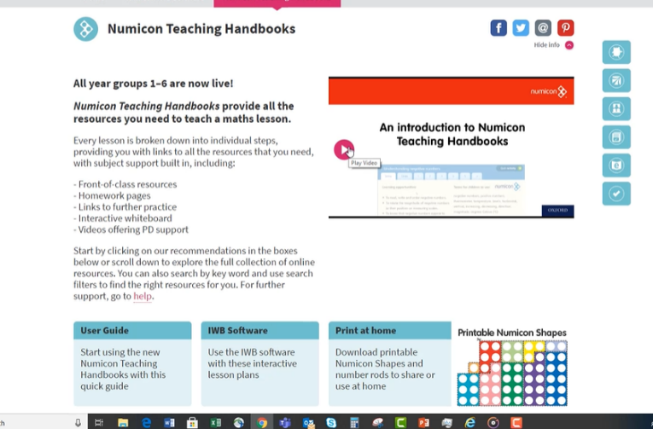
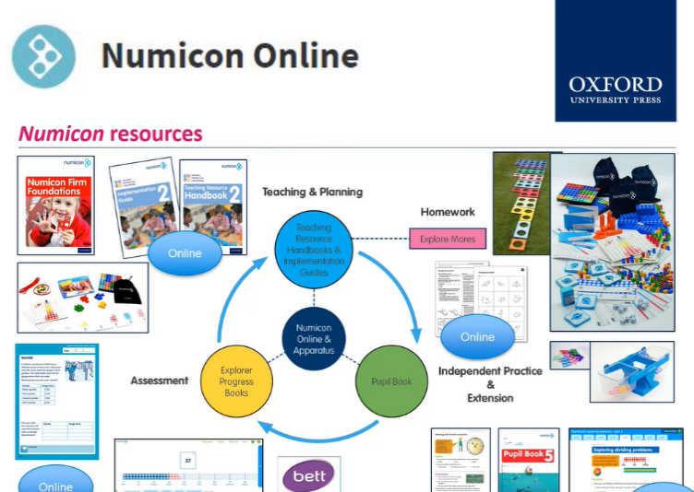
Whilst completing my final teaching experience in a reception class, I was told upon arrival that all maths lessons and activities were based and centred around using Numicon. This made me feel quite apprehensive, due to not having acquired previous experiences. In order to be confident and fluent in delivering it effectively, I decided that I needed to do further research in order to boost my mathematic subject knowledge which would then have a positive impact on my enthusiasm to deliver effective pedagogy. After doing some online research, I came across a live webinar that focused on an introduction to Numicon. The aims of the session were to help support both children’s and teachers’ confidence and enjoyment towards mathematics (Oxford Owl, 2021).

The webinar was a pre-recorded session which allowed me to work at my own pace ensuring that I was learning at a steadiness that suited myself. The webinar focused on different aspects of using this tool to scaffold many aspects of mathematics including; how to implement Numicon, different areas it can be used effectively in, raising attainment and how it supports the child throughout their school progression. The session was very valuable for my own continuous and professional development and allowed me to try new activities in the classroom. I was able to integrate new ideas and new initiatives into my lesson which was brilliant for my own self-esteem. On reflection, it was also surprising at how the children’s confidence increased over the series of lessons and furthermore, their progression whilst using this resource was exceptional. The children use Numicon to help scaffold and support their learning and are assertive with how to use it correctly. Attending a webinar is definitely something I will do again in the future. It allowed me to develop my own pedagogy to ensure it was refined and close to practice.

Reflection on Subject Knowledge Development (Tab 5)
Digital Competency Framework
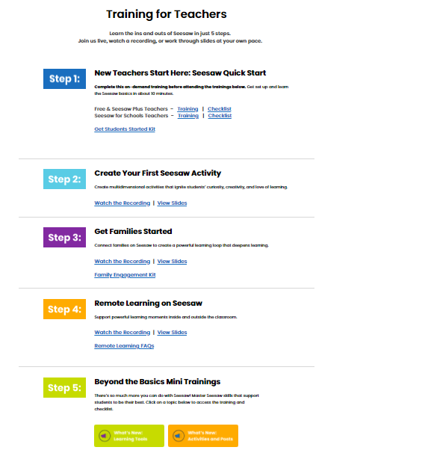
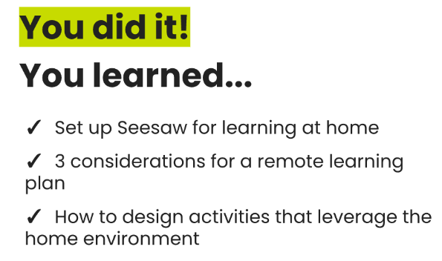

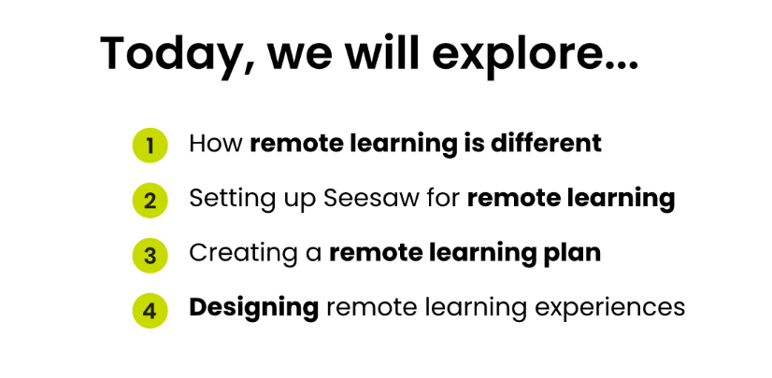

When starting my final placement, it very quickly became apparent that the majority of the teaching would be done through online learning, with two days a week teaching in the Foundation Phase Hub. At first, this made me quite nervous as my digital competency skills were good, but not outstanding. When I discovered that the platform being used in the reception classroom was ‘Seesaw’, I wanted to do all I could to become familiar with this application in order to enhance my digital competency development. Prior to starting my online teaching experience, I thought it would be beneficial for my own continuous and professional development, to do some training prior to the teaching in order to become familiar with how the app works.

The seesaw training was decomposed into five sections, which can be seen above, where the training gradually increased in digital knowledge in order to be able to confidently locate different tools within the app; which enables the lessons to be more effective. From the training, I was able to develop a wide variety of different skills. I learnt how to effectively provide parents/carers with feedback; this also allowed me as the class teacher to collect formative assessments on the pupils. On the return to school, I was then able to utilize the app by creating tasks for the children to complete independently. I was able to make lessons more engaging by integrating the use of the app with many different aspects of learning; child- led mind maps, independently recording themselves, links to topic and demonstrating their understanding through animation.

Reflection on Subject Knowledge Development (Tab 5)

Literacy
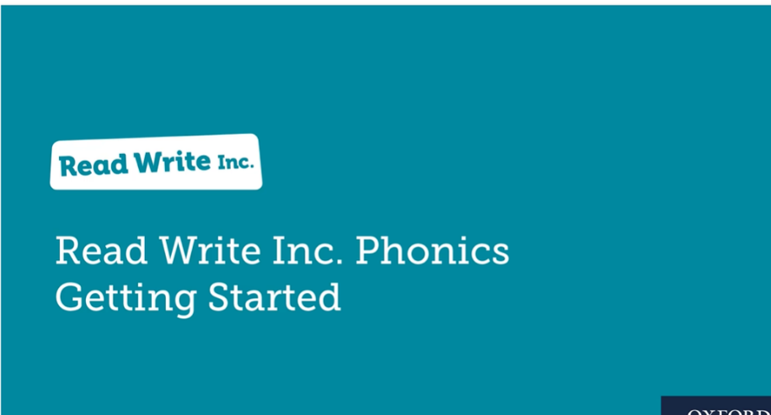
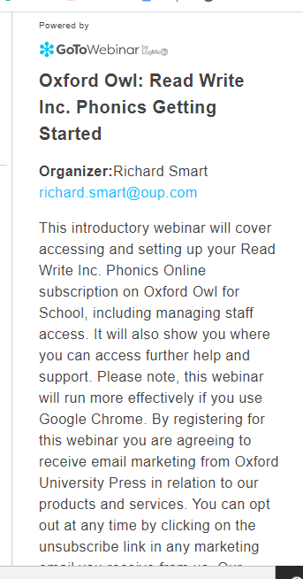

When entering my reception class on my final professional teaching experience, it became apparent that they follow the Read, Write, Inc (RWI) literacy scheme. This was a scheme that I was unfamiliar with and therefore I decided to up-skill myself in this area through self-study, collaborating with professionals and developing my practice. I was able to engage with a webinar that allowed me to understand the key components that ensure RWI is being delivered effectively along with key resources that can help to support learning. After different recommendations, I purchased a variety of my own resources which included two sets of phonic cards. This allowed me to familiarise myself with the rhymes and slogans that the children knew in order to remember the sounds. By having the resources with me at home, I was able to practice until I was confident, especially in order to deliver effective literacy sessions on the return to school from online learning. In order to plan effectively, I needed to be able to see how the scheme worked conclusively within the class and furthermore, I also had an informal meeting with my class teacher who explained how it worked with different ability groups and provided me an outline of the different activities that are usually carried out.

It was interesting to see the difference between RWII sessions online, rather than captivating this scheme with the children face to face in class. When teaching online, I thought the best approach to motivate and engage with the children completing Fred talk and blended sounds would be to model an efficacious way of doing it. I uploaded videos of myself sounding out the key phonic words, giving a different concentration to each group’s differentiated ability. The parents provided me with commendatory feedback and stated that this was a great way to engage the children, especially as they were able to repeat the clip and copy the sound exactly as it was said.

To support the RWI phonic clips, I created different activities that the children could complete to activate their prior knowledge. This also helped to stimulate the children and enabled me to provide them with both verbal and written feedback. The feedback given would be immediate as I distinguished that this would help to drive the children to submit work regularly and worked as an incentive to keep up to date with set activities.

Reflection on Planning for Progression (Tab 7)

‘AOLE- Mathematics’

Link to assets- https://v3.pebblepad.co.uk/spa/#/public/kwhG4ZxyhjhyzzW4wWtnqMZMdM

What did you do and why?
When starting the topic of telling the time within my maths lessons, I realised that my lessons needed to be far more simplistic than I had first anticipated. The first lesson plan consisted of a simple differentiated task where the child needed to draw the correct hands on the clock. Originally, I thought this would be perfect as I knew that they had previously looked at the topic of time and should grasp the activity with ease. When it came to the lesson itself, the children really struggled. I alternatively, had to change the lesson drastically on the spot, and decided to keep it simple and therefore just handed each group a clock instead. The lesson objective then changed to just focusing on the numbers and went through different ' o clock' times, but collaboratively as a group. On reflection, I was expecting far too much from my reception children far too soon. When planning my next sequence of lessons, I needed to make sure that the lessons were in a progressive order which enabled small scare progress for each pupil. I wanted the next sequence of lessons to be hands on and involved the children physically doing the activity to help activate their previous knowledge on the topic. Piaget (2000) supports the use physical experiences and emphasises that children learn the most effectively when they are ‘hands on’ and are familiar with the environment around them.

When making adaptations to my previously planned sequence of lessons, I put them into a chronological order where I would be able to assess the progression effectively. In order to monitor the progression, I also completed whole class introductions where I was able to carry out a number of different Assessment for Learning (AfL) techniques in order to see if progression was taking place with the topic of 'telling the time'. Black and William (2006) strongly believe in the use of AfL and state that assessment within the classroom should prioritise serving the purpose of supporting learning. By using the 'no hands up' strategy it allowed me to target different children and test their knowledge on the spot. I also used the technique of asking four individuals from different focus groups in order to see what progression is being made within the different ability groups. I was able to see within each ability group who was able to effectively complete the work with ease and thus, I actually changed my ability groups throughout the topic to ensure that every child was being challenged to their full potential.

What have you learnt?
On reflection, I was able to recognise that there was an issue with my initial lesson, and I was then able to make practical changes in terms of my own practice and pedagogy. I was pleased with my ability to think on the spot and adapt the lessons and thus, no learning time was misspent. The progression the children made was clear to see and was very well reflected within their maths books. They were also using their knowledge on time outside of the lesson and would tell me what significant times happen throughout the day, for example lunch time and home time. By ensuring that the children physically complete the activity, it allowed them to seek enjoyment and thus turned out to be very advantageous. Another technique that seemed to be powerful for engagement was to learn telling the time songs as a whole class. This ensured that we were using repetition which can be seen to be a is a potent pedagogical tool. Bruner (2000,p.1) supports the effectiveness of this principle and states that ‘repetition is the first principle of all learning’. You could suggest that from Bruner’s viewpoint, repetition supports the enhancement of the learning rather than focusing on the teaching. After progressing onto the topic of one more and one less, I was still incorporating time into my whole class introductions to stimulate previous memories. This proved to be very successful, and it was surprising how the children's knowledge and understanding of time was still continuing to develop, even with the inception of a new maths topic. Further success in relation to progression in learning can be seen in three out of the four differentiated ability groups where the children understand both o clock and half past. The Literacy and Numeracy Framework states that reception aged children should understand o clock and as a result, the progression the children made can be seen to be excellent (LNF, 2008).

What next?
As a result of this reflective learning experience, I feel that my future practice will be very much benefited and enhanced. From reflection, my planning will now be more refined with the concentration on effectually sequencing a series of lessons which will tried to be planned in advance. This will allow me to be able to monitor how the progression will take place, which is thus concentrating on the assessment as well as the pedagogy and lesson itself. I was very pleased with the success of the children's knowledge of the topic and the level of development that happened tangentially was very impressive for the children's age. When teaching mathematics in the future, I will always try to incorporate hands on activities. I would also love to develop my pedagogy and do some further research into the benefits of integrating the subject of mathematics into the outdoors. This would not only enhance my knowledge on different learning environments but may enrich the children’s opportunities within the subject of mathematics.

Reflection on Planning for Progression (Tab 7)

AOLE - ‘Health and Well-being’

Link to asset- https://v3.pebblepad.co.uk/spa/#/public/kwhG4ZxyhjhysGpHMhbZstz76M

What did you do and why?
After the children had been at home engaging with remote learning for many weeks, my focus on their first three day return to school was all centred around their health and well-being. I wanted to slowly introduce the children back into their school routines whilst integrating aspects of mindfulness into their well-being sessions. My initial thoughts concluded that the best way to approach the well-being sessions were to focus on emotional development which would then lead to social development. After the children spending a significant amount of time at home, with some children having very little interaction with others, I wanted to create exciting activities that would involve playing with others to not only help to build confidence, but to learn to play and share with others again.

An example of something different activities that were carried out was creating gratitude jars, mindfulness colouring, breathing buddies, friendship bracelets and yoga. These activities all helped the children to relax and to concentrate on the way the activities made them feel. I wanted to ensure that the activities slowly progress so that the children were able to build back their confidence and self-esteem in order to enhance their social skills. For example, progressing from cosmic yoga and mindfulness colouring to a group scavenger hunt on the final three days of well-being.

Another key focus was looking at emotions and this activity was completed as a whole class. I used the book 'the colour monster' to enhance the children's learning and based the activities centred around this book. The children enjoyed looking at how different things affect our emotions, and every person can feel different. We then expressed our emotions through dance, which the children thoroughly enjoyed. The sequence of lessons seemed to flow very effectively and the progression the children made was worthwhile and successful. After a discussion with the class teacher, it was interesting to notice that some of the most confident children prior to remote learning struggled with a lack of confidence on the return to school. On reflection, all activities were meaningful and provided an inclusive approach to targeting positive health and well-being within the classroom.

What have you learnt?
The experiences that the children had when returning to school helped to create a holistic approach with the focus not only being on mental health, but social and emotional development too. It was interesting to see that some children did not want to participate in some activities on day one, but by day three were carefree and contented. All the intended outcomes were met, and the learning developed incrementally throughout the three days. The children were able to act on previous knowledge and needed to have a structured routine in order to activate this knowledge again. The biggest barrier that needed to be overcome by a majority of the class was learning to share with others. As a class, we sat down and discussed some friendship rules. The children came up with excellent ideas which we then cultivated and displayed on our class wall. As previously discussed, we created friendship bracelets and each child gave one to a friend who had been kind. This was a brilliant activity for the children to express their reasoning and boosted other children’s self-esteem when handed a bracelet with a specific reason why they had received it.

What next?
By having three targeted days to concentrate on mental health in school, it made me realise just how important these types of activities are within the school day. On reflection, I then made a thirty-minute slot where we concentrated on these different aspects in our daily school routine. As an example, during the first full week back in school, we continued to concentrate on our breathing, how we can be kind rules and caried out more mindfulness yoga. All children participated and were excited for this session each day. The significance of this impact on future practice has been fundamental to me ensuring that each child's development is being met holistically. I want to continue to use the online platform 'seesaw' to upload activities to so that the children can work on whilst at home. This will also be a great opportunity to involve parents in their learning and they can help to support both emotional and social development.

Reflection on Planning for The Four Purposes (Tab 7)

‘Ethical, Informed Citizens’

Link to asset- https://v3.pebblepad.co.uk/spa/#/public/kwhG4Zxyhjhyscbmjh5cz4n4hc

What did you do and why?
During my final professional teaching experience, I was placed in a reception class. As it was the start of the new term, the children had already chosen 'arctic regions' for their topic. After having a look at penguins, polar bears and arctic foxes, the children wanted to focus on whales. I thought this would be a great opportunity to integrate aspects of the Four Purposes into a series of lesson; the focus being on 'ethical, informed citizens who show their commitment to the sustainability of the planet' (WG, 2020).

I wanted to integrate the mantle of the expert approach within the introduction of my lesson. I walked into the classroom at the start of my first lesson throwing rubbish all over the floor. Without using any verbal communication, I wanted the children to discuss between themselves what it was that I was doing wrong without giving them any explanation. Once this had then been discussed, I showed a video of a whale who was trapped within a sea of litter and we considered all the different aspects of why it is important to put our rubbish in the bin.

I then planned a variety of different activities that would help to explore the topic of littering and keeping the planet clean. The children created whale art using recyclable materials, explored describing words for whales and also created a save the whale poster where they incorporated and planned for key features of poster writing. During our breaktimes, we also looked for litter on the playground and the children were shocked at how much litter they had accumulated.

What have you learnt?
The children were engaged with the topic from the start and really enjoyed looking at how much our choices can affect so many different things around us. They never realised that it upset, injured, and killed animals and by learning this knowledge, it really impacted their perspective on the topic. By carrying out different assessment for learning techniques, it was clear to see that they had been well engaged and had gained a wide variety of knowledge on the subject.

I was very pleased with their final draft of their 'save the whale' poster. With participating in two planning sessions, prior to the final write, the children were able to know what to include and had engaged with the information which needed to be included. The task was differentiated, and it suited each ability groups needs which was very pleasing. I felt that due to the task being well explained and with creating a success criterion, the task was well accomplished and was completed with no complications. A cross-curricular approach was used within numerous sessions, which was mostly with the combination of both topic and literacy.

What next?
I hope to be able to consistently integrate the Four Purposes into all of my lessons, especially with the curriculum reform becoming closer. On reflection, I did not realise the topic of sustainability would be so engaging, especially in a reception class. Next time, I would love to be able to amalgamate mathematical development to create another cross-curricular link to sustainability and I would also like to have planned more outdoor activities, especially with the subject being linked to the environment.

Reflection on Planning for The Four Purposes (Tab 7)

‘Ambitious Capable Learners’

Link to asset- https://v3.pebblepad.co.uk/spa/#/public/kwhG4Zxyhjhyzynkyzwtqhs7mh

What did you do and why?
In my reception class, I wanted to bring something new to the classroom that would not only benefit the teachers but would have a positive and significant effect on the children's learning and development. The topic for the term was focused around ‘growing things’, and here the chosen focus was on 'frogs'. The children carried out many cross-curricular activities that covered habitats, appearance, facts, and breeds. The children grasped the topic really well and I wanted to do something that would show off just how much they had learnt. I thought that it would be lovely to put a QR code in their books, which would show a video of them telling me just how much they knew. This worked incredibly well, and the children really enjoyed explaining how much they had learnt. This linked very well to The Four Purposes, meeting the criteria of 'ambitious, capable learners who can explain the ideas and concepts that they are learning about' (WG, 2020).

What have you learnt?
Due to the children being such a young age, the use of a QR code worked very effectively. As their writing skills are slowly starting to progress, they would not be expected to independently tell me how much they had learnt about the topic of 'frogs'. It was lovely to see that they did not need support and this task was suitable for the whole class. The focus was not on differentiation as everyone in the class was able to explain the concepts of what they had learnt. The children found the task very engaging and as well as using QR codes in the books. Another positive outcome was that parents were able to engage with the videos as they were uploaded to seesaw. The parents were very pleased with the progress made throughout the topic and thought it was a brilliant idea that was brought to the classroom, especially with the digital world becoming more prominent in day-to-day life. You could also see the children's love for the topic come through during the video which could be seen with facial expressions and especially their enthusiasm whilst talking. The children also had the opportunity to illustrate their knowledge which could then be supported with the recorded evidence. From a teacher's point of view, it was also an excellent way to assess what had been learnt and was very informative evidence when looking into summative assessment at the end of the term. It is also a great indicator to see what lessons worked well, which can be seen through the video by concentrating on what knowledge has been well remembered. On reflection, the children were able to explain the frog life cycle in great detail. This may be due to them being able to see the life cycle process in class with real frog spawn and therefore the real-life experience has helped them to store that knowledge away successfully.

What next?
After seeing how successful the QR code task was for the end of term, this will definitely be something that will be repeated again. It helps to promote confidence, especially with those individuals in the class who do not like to be recorded talking out loud. It also allows the learners to be capable of telling me what they know, without actually receiving any support which is an excellent initiative for building independence within the classroom. If an aspect of this lesson were to be changed, I would have set a camera up in a quiet and calm area which involved the children talking into the camera independently. Even though I was not providing any oral feedback or assistance during the task, my presence may have been off putting and thus by doing it independently, it may have allowed the learners to talk more freely.

Part 2- Critical Reflection

I am going to critically reflect on my pedagogical progress in order to identify a specific area for my continuous professional development. This will be accompanied with a justification of the the next steps which will thus enhance and improve my future practice. For the purpose of this essay, the chosen focus explores the importance of learning mathematics in an outdoor environment. This focus has been devised due to wanting to promote a practical method to learning maths with real life experiences being evident. From experience, I have found the best way to captivate the children’s thinking and engagement is to provide them with an experience where they can apply their skills practically and thus, integrating the outdoor environment is something that could support this.

One of Donaldson’s (2015,p.69) pedagogical principles states that, as teachers, we need to ‘‘create authentic contexts for learning’. In order to support learner progression, the outdoors can provide a learning environment that is stimulating, motivating and provides an excitement to engage with the topic. From experience, you could suggest that the rationale behind negative perceptions about mathematics seems to be the belief of maths being ‘difficult’ which thus, may cause an anxiety towards the topic. Mutodi and Ngirande (2014) have a similar belief and state that the perception of mathematics can be evoked as a mental representation; as a result of social experiences, interactions at school, or the influence of those within the school community. Sam (2002) echoes this thinking and states that many individuals are fearful of mathematics and feel powerless when presenting mathematical ideas. He suggested that mathematics can be viewed as "fixed, immutable, external, intractable and uncreative" (Sam, 2002,p.115). You could suggest that by taking mathematics into an outdoor environment, these perceptions could change due to the vast experiences available with creativity being a key component.

By carrying out further research to develop my knowledge and understanding, additional pedagogical techniques will be gained. This is then able to enhance both future development and teaching practice which Westwood (2005) describes as key for student teachers.

Knight (2011) suggests that mathematics in the outdoors allows children to become more creative when given the freedom to be flexible, innovative, and adaptable. You could suggest that when children are in this environment, it stimulates creative mathematical thinking without the children even realising that they are participating in a maths lesson. Further reading highlights the effectiveness of the implementation of mathematics in an outdoor environment by showing the success in results after a twelve week programme. Research found that individuals gained an average of two months general maths and six months of mental arithmetic, compared to regular maths indoor learning (OEAP, 2018).

Natural Resources Wales discuss how outdoor learning can improve childhood academic attainment and state that ‘being in nature fosters wider, real life learning outside of the classroom, through engaging, fun and stimulating experiences’ (NRW,2021,p.1). Taylor (2013) believes that different outdoor locations appeal to children’s interests and can may be useful to promote and motivate different mathematical ways. Wien (2004) also promotes the use of outdoors and believes that by taking a variety of maths tools outdoors, this helps to promote real-life tasks. This then liberates both children and teachers to act spontaneously, therefore resulting in richer interactions and a calmer learning environment is created. Estyn (2011) highlights the significance of the outdoors and states that it allows children to persevere with activities for an extended period of time and also allows them to attempt new activities more readily. It gives them the opportunities to co-operate with others and furthermore can apply their thinking skills to real problems. The CCEA (2006) believe that a child’s independence, positive self-image, and self-assertion are all central qualities to children viewing themselves as mathematical learners.

Pratt (2011) highlights that in order for children to become efficacious mathematicians a ‘mathematical disposition’ should be developed. This disposition can be developed by the active maths outdoor sessions which empowers individuals to develop an awareness that maths is not just completed indoors, but actually allows them to make connections in their learning and experiences of natural materials. However, Dillon et al (2006) states that you may be narrowminded by trying to heighten the amount of time spent in the outdoor classroom without seeking to enhance the extent to which integrated learning is promoted. Vars (2001) states that the primary goal of an integrated curriculum is to have a child-centred curriculum that allows children to be engaged, interested, and aims to improve student outcomes. Drake (2018) echoes this thinking and believes that it is an effective way to develop generic abilities and critical thinking. One could suggest that a limitation that may arise from an integrated curriculum is that the spontaneity of the different curricular areas may lack structure, which may make it difficult to effectively monitor pupil progression.

An important factor to consider when looking at the outdoors is the impact it has on a child’s mental health and well-being. If an individual is enjoying the lesson, they are more likely to engage with the task that has been set which therefore leads to better engagement and a higher success rate. Fiskum & Jacobsen (2012) highlights the effectiveness of outdoor education and believe that it can have a positive impact on an individual’s verbal and motor agitation. In terms of well-being, they also state that it can cause an increase in variability of emotions, physical activity, and effective collaboration with other students. Travlou (2006) also discusses the effects this environment can have on young people’s wellbeing and states that the outdoors has the potential to confer a profusion of benefits which include emotional, physical, and societal development. These benefits which occur from a natural setting have long lasting effects, especially in the form of emotional stability. Although, it is important to take into consideration that learning in an outdoor setting is not every child’s preferred learning environment. You could suggest that this could be a limitation and thus may lead to a child feeling nervous and apprehensive to learn. This may then have a reverse effect on an individual’s mental health which counteracts the perceived outcome of it boosting a child’s well-being.

When evaluating this type of learning environment, you could suggest that there are some factors that could become a barrier to a successful outdoor maths lesson. Maynard and Waters (2007) carried out a study on four schools in the region of South Wales to find out the use and potential of the outdoor environment. The study highlighted limitations which included lack of resources, weather, complaints from parents and the ratio of children to adults to carry out the outdoor lessons. The study acknowledged the schools having missed opportunities to support the children’s learning in an outdoor environment and how this relates to the current education policy in Wales. The teachers felt that whilst there is a desire to introduce play-based approaches to learning, their understanding highlighted the priority needed to be given to content-based learning which concentrates on factual knowledge and basic skills. The approach that the class teachers took due to curriculum understanding can be supported with Soler and Miller (2003,p.59) representing and defining this as an ‘instrumental view’. You could suggest that from this study, the teacher’s may have lacked in confidence with promoting outdoor education due to not having specific outcomes to follow and thus did not promote the use of an ‘outdoor classroom’ due to lack of understanding and guidance. Ouvry (2000) also highlights this concern and believes that teachers anxieties associated with weather, risk and lack of provision for outdoor learning may be related to a lack of understanding from the role of the teacher. Conversely, Sedwick (2012,p.3) states that ‘teaching children outside a classroom, almost regardless of what we are teaching, increases the vitality of learning’. Here, the emphasis is on children gaining new learning experiences, rather than the focus being on what is being explicitly taught.

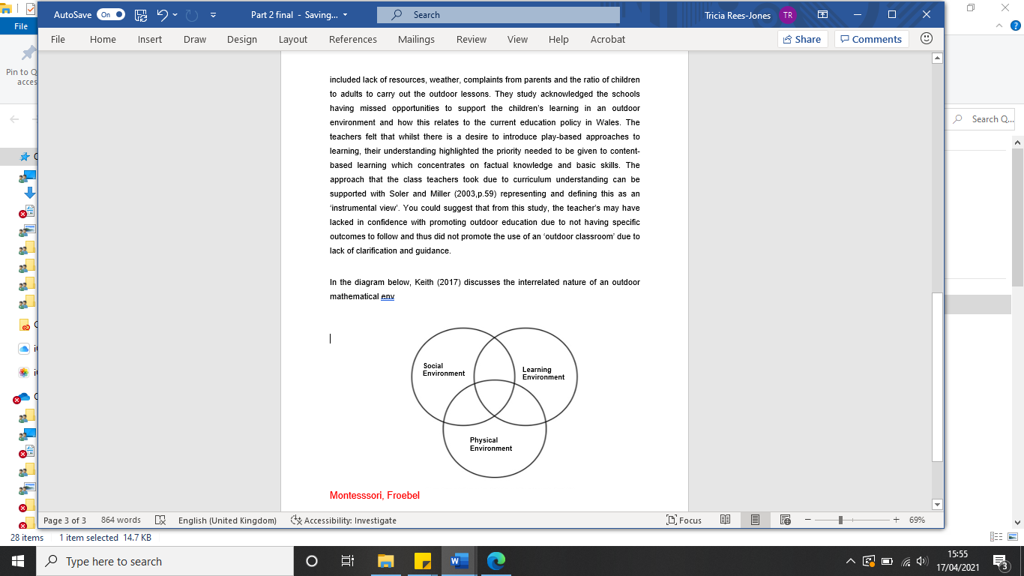
In the diagram below, Keith (2017) discusses the interrelated nature of an outdoor mathematical environment.

(Keith, 2017)

In the social environment, each child’s collaborative input is valued and taken into consideration. The environment focuses on developing a growth mindset towards mathematics which ensures that they are encouraged at all times. Positive attitudes
should be nurtured within the environment with an emphasis on developing curiosity and creativity (Keith, 2017).

The physical environment should be an area where all children feel welcomed and can play freely across all of the outdoor areas, not just dominated to one area. A ‘zone’ should be accessible to all learners which will allow children who need time to reflect on their experiences. Some children may find the outdoor environment too loud and busy and therefore at times, can become overwhelming (Keith, 2017).

The learning environment should be an opportunity for children to link different aspects of mathematics to play. Quality experiences should be available for children to take their learning forward and an abundance of resources should be accessible to allow deeper thinking and for choice to be apparent at all times (Keith, 2017). Although, Estyn (2011) state in an evaluation of learning in the outdoors that there is less evidence to suggest that the outdoors enables children to achieve better standards in different areas of learning. Under half of respondents that participated in a questionnaire identified that there were improvements to children’s mathematical development and skills.

One could argue that a critique of this theory would be that if a child’s desire is not fulfilled in the physical and social environment then the learning environment may not be successful. Nevertheless, you could also suggest that learning should effectively take place within all three environments and thus how can this theory specifically locate learning as one individual environment.

Thinking ahead to my future professional practice, I would ensure that my outdoor learning knowledge is utmost current and effective to allow the best experience for the children. Estyn (2019,p.1) promotes the use of continuous proffessional development and shared in a ‘taking teaching outdoors’ good practice report that ‘continued proffessional development has resulted in increasing teacher confidence. Consequently, more varied pedagogy and practice have evolved and, by now, the whole of the curriculum has been adapted to be taught outdoors.’ This will ensure that progression can be effectively monitored. In terms of progression, it is important to realise the different opportunities needed in order to reach their outcomes. You could suggest that an environment that could help promote progression would be for the children to feel safe, confident and enthusiastic to learn. There should be an abudance of rescources to help support their learning, along with desired outcomes where both the child and the teacher knows where they need to go in order to have meanginful learning.

In order to help deal with and minimise the limitations discussed around outdoor learning; it is vital that teachers feel confident in what they are delivering. Ofsted (2004,p.9) state that by teachers having this lack of confidence, it did not fully exploit outdoor learning opportunities or seek to develop them further’. This links very well to Bandura (1986) concept of perceived self-efficacy and how an individual’s thoughts and feelings affect the way they behave. One could suggest that a person’s own abilities and self-belief could affect their drive and performance.

To conclude, the research carried out will be taken into consideration in order to enhance and develop my future practice. The methods discussed will be considered and incorporated into my current practice which will help to evolve my pedagogical prosperity. Bancroft et al (2013) states that integrating mathematics into an outdoor environment may activate a contrasting conceptual system. This may stimulate pupils to amalgamate both new, enriched, or deeper concepts to enhance mathematical understanding. Rivkin (1998) discusses how meaningful and real-life contexts can be seen to be a core feature in Dewey’s education philosophy. “When the child lives in a varied but concrete and active relationship to this common world, his studies are naturally unified” (Dewey, 1990, p. 91). Dewey may be suggesting that it is through a wide range of experience and active relationships that a child is then able to have meaningful learning. McMillan (1919,p.29) realised the potential of outdoor learning over a century ago and states that “the best classroom and the richest cupboard is roofed only by the sky”. This statement sums up a perspective of an early year’s pioneer who emphasises to the extent of how outdoor learning can enrich a child’s education.

References
- Bancroft et al., 2009. S. Bancroft, M. Fawcett, P. Hay. Researching children researching the world. Trenthem: Stoke-on-trent
- Bandura, A. 1986. Social foundations of thought and action: A social cognitive theory. Englewood Cliffs, NJ: Prentice-Hall.
- Black P. and Wiliam D. (1990). Inside the Black Box Raising Standards Through Classroom Assessment. King’s College London School of Education. Department of Education and Professional Studies.
- Council for the Curriculum, Examinations and Assessment (CCEA) (2006) Understanding the Foundation Phase. Belfast. Early Years Interboard Group.
- Dillon, J., Rickinson, M., Teamey, K., Morris, M., Choi, M.Y., Sanders, D. and Benefield, P., 2006. The value of outdoor learning: evidence from research in the UK and elsewhere. School science review, 87(320), p.107.
- Donaldson, G. (2015) Successful Futures. Crown Copyright. Cardiff. Available at: http://gov.wales/docs/dcells/publications/150317successful-futures-en.pdf
- Drake, S.M. (2018) Integrated curriculum as an effective way to teach 21st century capabilities. Asia Pacific Journal of Educational Research, 1(1), pp.31-50.
- Estyn (2011) Outdoor learning – an evaluation of learning in the outdoors for children under five in the Foundation Phase. Cardiff: Estyn.
- Estyn (2019) Taking teaching outdoors. Effective practice. Available at: Taking teaching outdoors | Estyn (gov.wales)
- Fiskum, T. A., & Jacobsen, K. (2012). Outdoor education gives fewer demands for action regulation and an increased variability of affordances. Journal of Adventure Education & Outdoor Learning, 1-24.
- Keith, L., 2017. Developing young children’s mathematical learning outdoors: Linking pedagogy and practice. Routledge.
- Knight, S., 2011. Risk & adventure in early years outdoor play: learning from forest schools. Sage Publications.
- LNF. 2008. Literacy and Numeracy Framework. Curriculum for Wales Available at: https://hwb.gov.wales/curriculum-for-wales-2008/national-literacy-and-numeracy-framework-curriculum-for-wales-2008-version/
- McMillan, M., 1919. The nursery school. JM Dent & sons, Limited. P.29
- Mutodi, P. and Ngirande, H., 2014. The influence of studentsperceptions on Mathematics performance. A case of a selected high school in South Africa. Mediterranean Journal of Social Sciences, 5(3), p.431.
- NRW (2021) Natural Resources Wales- Mathematics and Numeracy outdoors. Available at: https://naturalresources.wales/guidance-and-advice/business-sectors/education-learning-and-skills/looking-for-learning-resources/learning-resources-search-by-topic/mathematics-and-numeracy-outdoors/?lang=en
- OEAP (2018) High Quality Outdoor Learning for Wales. Welsh council for outdoor learning. Available at:https://evolve.edufocus.co.uk/evco/assets/conwy/high_quality_outdoor_learning_welshenglish.pdf
- Ofsted (2004)Office for Standards in Education. Outdoor education: Aspects of good practice. London: HMSO.p.9
- Ouvry, M., 2000. Exercising Muscles and Minds. Outdoor play and the Early Years Curriculum. London: The National Early Years Network.
- OxfordOwl. 2021 About Numicon Online. Available at: https://www.oxfordowl.co.uk/pages/about-numicon-online
- Piaget, J. (2000) The Psychology of the Child. [Originally 1966, in French]. London: Basic Books.
- Pratt, N. (2011). How young people respond to learning spaces outside school: A sociocultural perspective. Journal. Learning Environments Research, 14, 11–24
- Sam, L. C. (2002). Public images of mathematics. Philosophy of Mathematics Education Journal, 15:15.
- Soler, J. and Miller, L. 2003. The struggle for early childhood curricula: a comparison of the Welsh Foundation Stage Curriculum, Te Whäriki and Reggio Emilia. International Journal of Early years Education, 11(1): 57–67.
- Taylor, A. (2013). Reconfiguring the natures of childhood. London/New York: Routledge.
- Travlou. P (2006). Wild adventure space for young people. Literature review–Survey of findings, pp.1-30.
- Westwood, P., 2005. Approaches to teaching and assessment. Aust Council for Ed Research.
- WG (2020) Curriculum for Wales. Welsh Government. Available at: https://hwb.gov.wales/curriculum-for-wales/

