

Master of Business Administration in International Business

Module: International Business Concepts

Module code: LCMB7034

Assignment Title: International Business Consultancy Report of IKEA

Lecturer’s Name: Dr Hoang Dang Nguyen

Student Name: Sahil Thakarshibhai Lakhani

Student ID.: 2433103

Word count: 5729

Submission Date: 15th December, 2025
Table of Contents
1. Introduction to the report 2
2. Benefits and challenges of international operations 3
a. IKEA is an MNC 3
b. IKEA’s global operations focus on the different important aspects of the value chain such as research and development, sourcing, production, sales, financing etc 3
c. Different entry modes used by the companies in entering the different international markets in which it has a presence 5
d. Explain the key benefits obtained by the company from its international operations. 7
3. Impact of OLI factors (Ownership, Location and Internalisation) on the international market entry mode for IKEA 9
a. Ownership-Specific Advantages 9
b. Location-Specific Advantages 10
c. Internalisation Benefits 12
d. Market Entry Decisions OLI Factors 13
4. Critical Evaluation of Cultural Differences and Their Impact on IKEA’s Market Entry Strategy and Success in Emerging Economies 14
5. Critical Discussion and Recommended SOP Adjustments for IKEA in Emerging Economies of India and China 17
6. Conclusion to the report 22
References 24

1. Introduction to the report
The case study of IKEA internationalizing to India and China is indicative of the company's bigger idea of reinforcing its global presence in emerging markets. IKEA is a Swedish multinational home-furnishing company, which was established in 1943 and has since expanded to become one of the largest furniture multinationals in the world, with its cheap, flat-pack furniture and sustainable business model (IKEA, 2025). As of 31 August 2024, 12 franchisees operate more than 700 IKEA customer meeting points, including traditional stores, small stores, and pick-up points, plus several test formats. Franchisees implement the IKEA Concept by marketing and selling the IKEA product range (IKEA Annual Report, 2024). Regardless of its international success, its entry and operations in various markets like India and China have posed exceptional strategic, operational, and cultural difficulties. This report will discuss the history of IKEA as a multinational company, the advantages and limitations of its global business, apply the OLI model of Dunning to its entry modes, and discuss cultural forces using the dimensions of Hofstede to make improvements that can be implemented. This assignment focuses on IKEA because its expansion into India and China represents one of the most widely analysed examples of globalisation, cultural adaptation and strategic localisation in modern retail research. Examining IKEA enables this assignment to meet its requirements by providing a real-world case where international business theories such as Dunning’s OLI framework and Hofstede’s cultural dimensions can be applied directly to evaluate entry modes, strategic decisions and cross-cultural challenges.
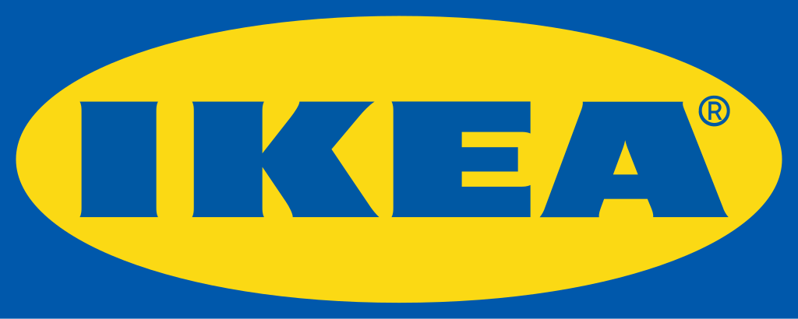
Figure 1: Logo of IKEA
(Source: IKEA, 2025)

2. Benefits and challenges of international operations

a. IKEA is an MNC
IKEA is a multinational corporation (MNC) because it has extensive global presence, cross-border and centralised strategic control based in Sweden. The total asset value of the combined Baltic business was EUR 205 million on 31 August 2023. The revenue was EUR 314 million during FY23. The combined companies employed approximately 1,450 co-workers during FY23 (IKEA Annual Report, 2024). Due to its two-fold structure: Inter IKEA Group (franchising and product development) and Ingka Group (retail operations), it guarantees coordination on a global scale and local adaptation. Having made significant investments into retail and e-commerce expansion in India, ₹10,500 crore (EUR1.1 billion), and with a huge presence in China, IKEA can be characterised as transnational. IKEA has good cross-border integration that makes sure that its operational standards and strategic vision remain the same in every market. Meanwhile, the company localizes its products and services to suit the cultural, social, and consumer preferences of every country it conducts its business.
In 2013, the government approved a Rs 10,500 crore FDI proposal by Ikea to set up 10 stores with allied infrastructure in 10 years. Subsequently, it had plans to open 15 more stores (Times of India, 2024). The company has more than 231,000 employees of 130 nationalities, making it a transnational organisation that combines global talent, global capital and global innovation and becomes a real transnational organisation that would balance global effectiveness and local sensitivity. These attributes indicate the capability of IKEA to be both global and local, meeting the major requirements of a TNC.

b. IKEA’s global operations focus on the different important aspects of the value chain such as research and development, sourcing, production, sales, financing etc
IKEA's global business is anchored on a value chain of global integration but local responsiveness that includes all processes of research and design, production, logistics, retail and sustainability. A value chain is a complete scope of actions that a firm performs to produce a product or service, starting with its conception all the way to the end-consumer's delivery as well as ensuring optimum efficiency, cost-effectiveness and customer satisfaction. The strategy creates the possibility to dominate costs, brand uniformity, and local resonance in various markets. The visualisation of IKEA value chain reveals a consistent chain of events, starting at the R&D, moving to retail and connected with sustainability and digital innovations, which will ensure consistency worldwide and local responsiveness at the same time.
Research and Development (R&D): IKEA has a decentralised R&D based in Almhult, Sweden, that incorporates engineers, designers and sustainability experts to design cost-effective and eco-friendly furniture. China and India have regional teams modifying designs of small living quarters that are multifunctional.
Sourcing and Procurement: The majority of IKEA products (approximately 90%) are sourced from external suppliers across the globe (IKEA Annual Report, 2024). Local sourcing saves tariffs, cuts costs and helps to support communities, and as an example is the Next Generation programme in India that employs 1,400+ artisans.
Production and manufacturing: IKEA integrates both in-house production and local ventures. The main production is handled by IKEA industry, and more than 300 partner producers are located in China. These hybrid models will also ensure cost efficiency, flexibility and regulatory adherence, and ensure that the key markets are developed into centres of production and consumers without compromising quality.
Logistics and Distribution: The global standardisation and regional adaptation are a blend of the IKEA logistics. The packaging of flat packs lowers the transportation costs of retailing firms. IKEA is not becoming green because it is considered to be sustainable, which is one of the principles of their Democratic Design strategy. This design-first mindset shapes everything from supplier relationships to manufacturing materials. Their innovative Buy Back & Resell program, launched in 2022, now operates in most U.S. stores and accepts nearly 3,000 products for resale (Forbes, 2025). Shanghai, Mumbai and Singapore distribution centres enhance responsiveness. Solar warehouses and electric trucks are considered renewable energy investments, which have generated carbon emission reductions by 15% since 2020.
Retail and Marketing: The retail strategy of IKEA integrates large-format stores with smaller city-based IKEA Compact stores and e-commerce. In India, delivery partnerships and stores located in the centre of the cities increase the coverage to Tier-2 cities (Kumar and Chidambara, 2023). The omnichannel strategy of China contributes to 30% of sales online, which is flexible in changing retail and marketing to the local consumer behaviour.
Sustainability and Financing: IKEA is committed to sustainability, which has the goal of becoming climate-positive by 2030 and is using renewable or recycled materials (Ferrer Bauza et al., 2022). It has a financial model of franchising of its business that puts back profit into further growth and environment-focused projects, making it independent of capital markets.
In conclusion, the global operations of IKEA are based on the value chain, which balances between standardisation and localization, which guarantees the efficiency of operations, their relevance to the market, and sustainability. Through the integration of R&D, sourcing, production, logistics, retail and financial strategies across the borders, IKEA gains competitive edge and delivers the special needs of various global customers.

c. Different entry modes used by the companies in entering the different international markets in which it has a presence
The entry strategies of IKEA differ depending on the regulations of the host country, market structure, and culture. Joint ventures, wholly-owned subsidiaries, and franchising have become the major entry modes of the company.
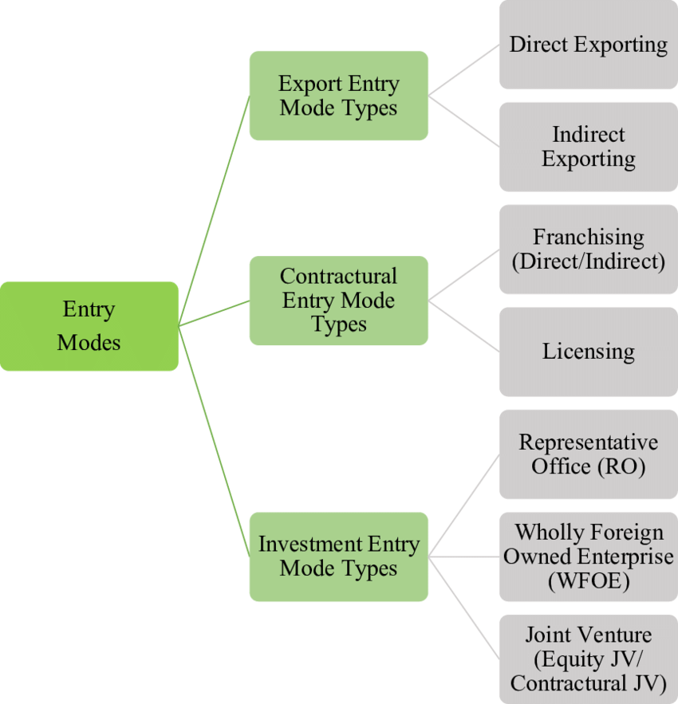
Figure 2: Market Entry Modes
(Source: ResearchGate, 2025)
- Wholly-Owned Subsidiaries (WOS): In regions where laws allow it, IKEA will retain strategic control by having wholly-owned subsidiaries. In China, IKEA first ventured in the 1990s by conducting joint ventures since foreign retailers were not allowed. In 2013, it moved to wholly-owned subsidiaries once the retail sector had been liberalised, which made the operations tighter and allowed the company to make decisions much faster (Tse et al., 2024). For IKEA, this is the dominant market entry mode as it prefers full ownership wherever host-country regulations permit, as this allows the company to maintain control over brand identity, proprietary designs, supply chains, and operational processes.
- Joint Ventures (JV): In India, IKEA did not enter on time because of the severe rules of Foreign Direct Investment (FDI) that demanded 30 percent sourcing locally. At the beginning, it collaborated with the local companies based on the 51% ownership model. In 2012, after the government amended its policy to permit 100 percent FDI in single-brand retail, IKEA took complete control and invested ₹10,500 crore (EUR1.1 billion) to construct stores and develop online branches (Times of India, 2024). The first JV facilitated regulatory compliance and acquiring local knowledge, which was necessary in order to overcome the Indian bureaucracy.
- Franchising: IKEA has been able to expand at high rates in smaller markets or those politically sensitive like the Middle East and Southeast Asia through its franchising model worldwide (Khan and Shafiq, 2021). According to this model, the franchisees have stores with a rigid design, sustainability, and pricing parameters of IKEA. IKEA, however, in its strategic growth markets such as India and China, opts to go direct in ownership to ensure brand uniformity and strategic fit.
Dominant market entry mode
Wholly-owned subsidiaries is the most widespread mode as it would enable IKEA to protect its proprietary designs and intellectual property entirely (Lucas, 2024). It also provides a stable supply chain management and a homogenous customer experience in all markets.

d. Explain the key benefits obtained by the company from its international operations.
- Revenue Diversification and Growth: The presence of operations in the various regions enables IKEA to diversify risk and capitalize on high growth opportunities. The IKEA FY2024 Annual Report shows that the Asian markets recorded annual revenue growth of 11% mainly because of China and India. China is currently contributing about 10 percent of the overall sales of IKEA in the world (EUR4.7 billion), making it the largest market of the company outside Europe (Times of India, 2024). Smaller in size, India has registered growth rates of double-digit since 2018 as it is experiencing high demand for cheap furnishings in the middle-class that is looking at growth.
- The Economies of Cost and Scale: The size of IKEA allows achieving great cost benefits. Its huge quantity of purchases reduces the cost of inputs, whereas the standardisation of design diminishes the cost of developing the products. The presence of local manufacturing in China and India also eliminates high-importation tariffs, reduces the lead time, and lowers the cost of logistics and all this helps improve the overall efficiency of operations (Sass and Kheyirkhabarli, 2025).
- Innovation and Transference of Knowledge: Organisational learning is triggered by international diversification. The availability of exposure to different markets helps IKEA to embrace local innovations across the world. As an example, IKEA's 3D virtual shopping tools were inspired by digital solutions that were developed by the developed e-commerce market in China (Yani et al., 2025). On the same note, the modular furniture that has been compact and designed in India, to fit their small homes, has also affected the European product lines.
- Risk Resilience and Market Resilience: IKEA has diversified geographically, and this minimizes their exposure to local economic recessions (Bourny et al., 2023). The e-commerce in China is strong and resilient, particularly during COVID-19, which was compensating for decreasing sales in Europe.
- Sustainability and Community Development: The sustainability agenda is enhanced by the global presence of IKEA. The Next Generation project in India and the collaboration with the small-scale producers in China are an example that international expansion can support both environmental and social sustainability targets (Hajam et al., 2025). The application of subsidiaries, joint ventures, and gradual entry to China and India by IKEA indicates that regulatory, cultural, and economic factors have been adjusted to.
Brief Challenges: IKEA faces issues like cultural adjustment, dealing with new regulatory complexities and dealing with unstable market niches all of which require specific and closely considered localized approaches to preserve efficiency of operations, brand stability and sustainable development.

3. Impact of OLI factors (Ownership, Location and Internalisation) on the international market entry mode for IKEA
One of the fundamental theories of internationalisation that is of great importance to the study of internationalisation strategies is the OLI (Ownership, Location, Internalisation) framework developed by Dunning. The ownership-specific advantages are those firm-specific capabilities, resources and competences that provide a firm with a competitive advantage in the overseas country (Minbaeva et al., 2025). Location-specific benefits are associated with the features of the host country that render it favourable to invest in, which are market size, labour force, infrastructure, and economic incentives. Internalisation benefits refer to the benefits of managing business operations within an organisation as opposed to subcontracting and these include quality assurance, intellectual property protection and efficiency of supply chain. These aspects are significant since they all contribute to the reason as to why companies such as IKEA chose particular modes of entry, as opposed to others in the new markets.

a. Ownership-Specific Advantages
The internationally recognized, cost-effective, functional, and sustainable brand IKEA is drawing consumers to new markets. Its worldwide brand brought EUR47.6 billion in revenues in 2024 (IKEA Annual Report, 2024). Modular, scalable, and eco-friendly furniture designed at Almhult, Sweden, is adjusted to local markets as Property Product Designs. In India, IKEA launched small-scale multi-purpose apartment furniture with amenities of about 500-700 square feet. The dual organisational structure of the company that consists of the Inter IKEA Group and Ingka Group provides centralised strategic control and at the same time, it provides the local responsibility. This setup gives IKEA the ability to achieve uniformity in all markets and at the same time bring its products to suit regional demands.
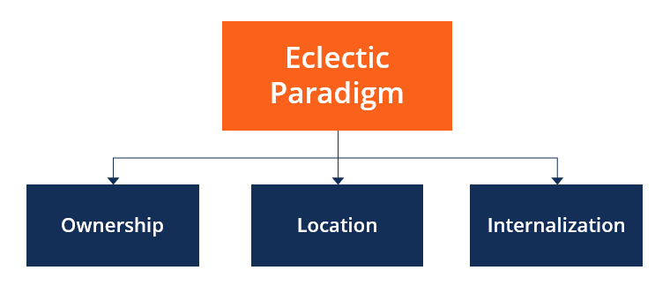
Figure 3: OLI factors (Ownership, Location and Internalisation)
(Source: CFI, 2022)
There is a dual organisational structure (Inter IKEA Group and Ingka Group), which enables centralised control and local responsiveness. Innovation in logistics, such as flat-pack packaging, lowers the cost and streamlines the supply chain in new markets. Nevertheless, unlike standardisation of global operations, IKEA sometimes needs to trade off implementation speed in order to make local adaptations (Mansouri and Zheng, 2025). At the same time, Strong ownership benefits favor the use of wholly-owned subsidiaries (as it allows safeguarding brand and proprietary operations). In China, IKEA moved to fully-owned subsidiaries after the relaxation of regulations in 2013. In India, full ownership came in phase after the liberalisation of FDI. Conversely, joint ventures are required in markets where there are strict regulations, a minor limitation to the ownership control of IKEA but they offer knowledge of the local markets.

b. Location-Specific Advantages
The market size and growth potential in China and India, exemplified by a population of over 1.4 billion each, is extensive with a high rate of urbanisation (Kumar and Ayodeji, 2021). In 2024, IKEA recorded EUR4.7 billion of its annual global sales in China (10% of total sales). Since the first store was launched in 2018, India has been recording a continued double-digit growth, which is an indication of the increasing middle-class demand. The Group consists of three core businesses: Retail Concept, Range and Supply. Core businesses work together with franchisees and suppliers to co-create an even better IKEA offer and franchise system. IKEA sources most of its raw materials in Asia, which includes China, Vietnam, and India (Lan, 2023). The supply centres in the region are located in Shanghai and Mumbai to maximise the manufacturing, reduce lead times, and reduce the cost of logistics.
The two nations are available in skilled labour force, favourable government regulations and urban logistics. India and China have the presence of industrial clusters, transport and FDI incentives which boost performance. IKEA has been leveraging these strengths to establish regional warehouses, streamline supply chains and employ trained employees to ensure an excellent delivery of quality and services. Quite to the contrary, China presents a fast-tracked process of urbanisation, but the local disparity implies that IKEA has to tailor the store format greatly to meet the local preferences (El Baasiri, 2024). For example, through capacity building initiatives on ethical and responsible recruitment and employment practices, the IOM will support IKEA Supply AG to improve the working and living conditions of migrant workers across the IKEA supply chain (IKEA Annual Report, 2024). Therefore, the IKEA forever parts (vision, business idea, culture & values, concept), direction and strategies are the foundation. The Group Code of Conduct and Policy House define Group-wide business requirements. The Chinese customers had a preference for ready-made furniture, which led to integrated assembly services. Smaller urban apartments in India demanded multifunction furniture designs that were compact. Offering products and services that matched the local lifestyles enhanced market acceptance, and this shows that IKEA has managed to balance both global and local responsiveness. Nevertheless, this localisation occasionally raises the complexity and cost of operation that IKEA controls by merging its internal socio-economic abilities effectively (Yu, 2023). Lastly, IKEA offers combined delivery services in China and multi-purpose mini furniture in India to make the products fit the local consumer lifestyle. These changes show that IKEA strikes a balance between globalisation and local responsiveness.

c. Internalisation Benefits
IKEA retains proprietary designs and sustainable production processes in-house, which would help keep its innovations out of the reach of imitation to maintain a similar brand presence in each market. This could be a very important control in the emerging economies, such as China and India, where the risk of intellectual property is more likely, and the company can continue to enjoy the benefit of a competitive advantage and quality standards. Internalisation of operations allows IKEA to manage logistics, sourcing and production directly. The company in India has established the Next Generation programme to work with more than 1,400 local artisans to guarantee ethical sourcing, quality output and consistency with global sustainability requirements, which enhances the reliability of operations and social responsibility in emerging markets (IKEA Annual Report, 2024). The e-commerce operations internalisation in China will enable IKEA to use superior digital tools, including 3D room visualisation, and not lose its brand. This strategy promotes smooth internet customer experiences, online purchases and helps the company to adjust international digital innovations to domestic customer desires in an efficient and effective way. IKEA employs joint ventures in cases where regulatory regimes do not permit total internalisation. India, as an example, before 2012, its FDI laws had a 51% local ownership requirement. This internalisation strategy enables IKEA to meet the legal requirements and retain the primary competencies. Internalisation also is strategic in the sense that it grants IKEA with strategic flexibility as it is able to operate within the regulatory restrictions when joint ventures are initially demanded (Khan and Shafiq, 2021). This approach will allow the firm to keep its main competencies and adhere to the laws in the host country. Internalisation on the other hand demands high investment and operation control which can slow down growth in highly regulated or capital intensive markets. Joint ventures are used by IKEA where total internalisation is prohibited by law such as India prior to liberalization of FDI. Nevertheless, even given these limitations, internalisation enables IKEA to preserve core competencies and effective digital innovations.
Dominant Factor
The OLI factors are predominantly that of ownership in relation to IKEA since its brand, design expertise, and operational experience are the core issues in maintaining the competitive edge and consistency in international markets (Burt et al., 2021). However, location-specific advantages and internalisation are complementary factors, without tapping into local suppliers, infrastructure, and digital platform, IKEA would have been unable to implement its global strategy. Unlike pure ownership, these aspects bring the subtle distinction between regulation and evolution in the new economies.

d. Market Entry Decisions OLI Factors
- China entry strategy: IKEA utilised high ownership benefits of the company, such as brand reputation, research and development, and expertise in operations, as well as location benefits of a large consumer market, large supplier networks and skilled labour. The logistics, retail activities, and digital innovations could fully be controlled with the help of internalisation, facilitating the stable customer experience and the ability to adapt to the market effectively.
- Entry Strategy in India: Regulatory barriers first demanded a joint venture entry. The ownership resources of IKEA, such as brand, design skills and operating knowledge, along with the benefits of location, such as the expanding middle-class market and local suppliers, allowed it to proceed to full ownership.
- Strategic Flexibility: The OLI framework explains the adaptive entry strategy of IKEA (CFI, 2022). In the event of a regulation limiting internalisation, joint ventures or hybrid models are adopted. Wholly owned subsidiaries, on the other hand, are promoted by strong ownership benefits and favourable location conditions.
- Testimony of the Success: The Group operates in an international environment where practices vary in different local settings, and, therefore, it is important to conduct business in an ethical manner in accordance with our code of conduct. Subsidiaries in China owned wholly allowed quick integration into the digital environment, and the share of online sales reached more than 30% of the total income. In India, internalisation has enabled the coordination of over 1,400 local artisans, which ensured high-quality sustainable sourcing, in addition to community development, empowerment and creating brand credibility of IKEA in emerging markets.

4. Critical Evaluation of Cultural Differences and Their Impact on IKEA’s Market Entry Strategy and Success in Emerging Economies
The internationalisation of IKEA (Sweden) to India and China proves that the cultural differences (greater power distance, collectivism, and less indulgence) influence the entry into the market, operations, products, and customer relationships and need to be addressed strategically to achieve a long-term and sustainable success.
Cultural differences between the home country of IKEA (Sweden) and the chosen emerging economies (India and China)
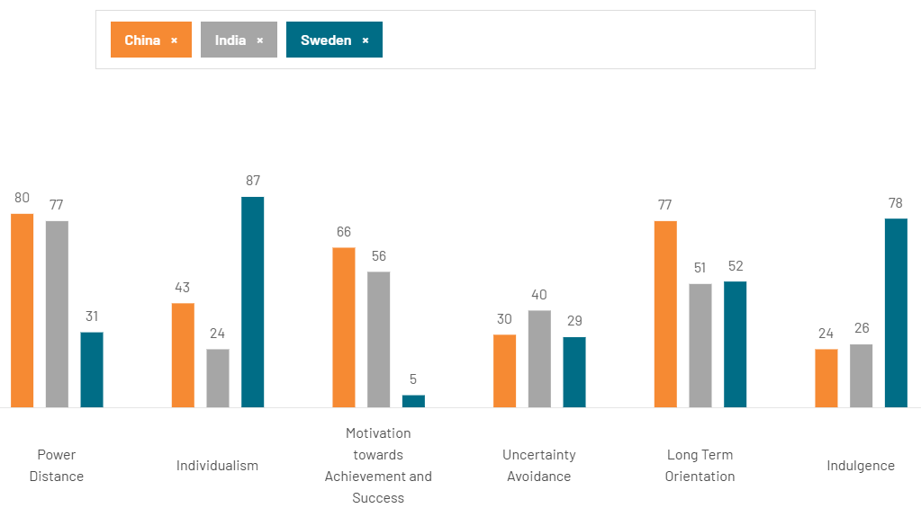
Figure 4: Hofstede's Country Comparison
(Source: Theculturefactor.com, 2025)
Power Distance
Sweden, with a low power distance (31), is the opposite of India (77) and China (80), where everyone is expected to be subordinated and guided in an orderly manner. The self-service model used by IKEA had to change, and IKEA needed to make adaptations such as increasing the number of floor staff, professional assemblies, and improving customer service. High power distance also determined the entry modes: total ownership in China and full ownership in India after the liberation of FDI guaranteed control over training, culture, and quality, which proved the necessity of operational changes in the hierarchical markets (da Silva-Oliveira et al., 2021).
Individualism
The individualism of Sweden (87) is opposite to the family, community, and social approval of consumption in China (20s) and India (40s). IKEA made adjustments by designing multigenerational room sales in China and larger and joint family furniture in India (Gabellini, 2023). The marketing had to become more family-oriented, more focused on festivals than on personal liberty and minimalism. Product-campaign congruency to the collectivist values increased participation, market recognition, and brand acceptance in these emerging markets that possessed culturally different values.
Motivation towards Achievement and Success
The low motivation towards Achievement and Success of Sweden (5) is as opposed to India (56) and China (66), where achievement, status, and material success are appreciated. Minimalist designs at IKEA were rebranded as aspirational, trendy, and fashionable. Products were localized, lighter, and tougher furniture in India and high-end, multi-purpose living sets in China (Sharda et al., 2025). These modifications were able to satisfy quality, longevity, and positioning demands, which showed that the masculinity factor affects product strategy and contributes to perceived value in emerging cultural markets with diversity.
Uncertainty Avoidance
Sweden (29), China (30), and India (40) are low-to-moderate uncertain avoidance, but the Indian consumer likes to be clear and guaranteed. The DIY model of IKEA was uncomfortable at the beginning, so the company increased post-purchase services, long-term warranties, step-by-step instructions, and multilingual instructions in India (Kabir and Simon, 2025). In China, uncertainty was minimized by the use of digital solutions such as augmented-reality planners. These adaptations reflect on how cultural perceptions of risk influence the intensity of their services, operational practices, and customer confidence in their engagement in the market.
Long-Term Orientation
China (77) and India (51) are more long-term oriented than Sweden (52), with their consumers being future-oriented and having a preference towards durability. This conforms to IKEA's sustainability and products of long-life strategies. Partnerships with local craftsmen and the local Indian state contribute to cultural resonance, whereas China appreciates long-lasting and practical solutions (Schreiber and Bota Moisin, 2021). It is the tapping on these compatibilities that enhances the brand authenticity, customer loyalty, and differentiation in the market, which transforms the possible cultural differences into strategic advantages instead of hindrances.
Indulgence
The high indulgence (78) in Sweden has been contrasted with restraint-oriented China (24) and India (26), whereby practicality, family utility, and long-term value prevail. IKEA localised the marketing and product messages: the Chinese campaigns were oriented on space optimization, durability, and intelligent living; the Indian campaigns were oriented on affordability, family value, and the festival promotions. Branding in cultural terms towards restraint made sure that they were relevant to these emerging markets, encouraged the functional value instead of decadence, and enhanced consumer engagement and loyalty in the new markets (Temitope, 2024).
Synthesis and Implications for Market Entry and Success
Implications for Market Entry and Success: Sweden (Home Country Context)
The cultural profile of Sweden is the basis of the IKEA corporate identity and model of operation. Egalitarianism, cooperation, flat hierarchies, and consensus-driven decisions are encouraged by low power distance (31) and very low masculinity (5). Customer autonomy, DIY assembly, and self-service are supported by high individualism (87), whereas innovation and flexible governance are favored by low uncertainty avoidance (29). The branding is motivated by high indulgence (78). This defines the model of IKEA: big self-service shops, Scandinavian minimalism, the involvement of the customer in the process of the assembly and the product, economy, and the loose employee-manager interface. Nevertheless, in new markets such as India and China, market success will require a great adaptation instead of direct transfer due to cultural distance (Li, 2023).
Implications for Market Entry and Success: India and China
The operations of IKEA in India and China have necessitated a lot of adjustments in the power distance, collectivism, masculinity, and long-term orientation. The entry modes were based on good local relationships, governmental involvement, and, in China, joint ventures to legitimize market entry. The classic DIY model was modified to address the needs of service-oriented expectations with higher staff, in-store assembly, and improved showrooms (Holmqvist and Johansson, 2021). Product and marketing strategies were localised: India was focused on aspirational, family-centred designs, and China focused on durability, space, and value in the long term. The lack of indulgence in both markets saw the message shifted to practicality and family coercion to ensure resonance in the market.
Impact on its potential for success in that market
The ability of IKEA to adjust to market cultural, social, and consumer dynamics in India and China is what will determine its success in these markets. The power distance, collectivism, and aspirational culture in India dictated the need to alter the DIY model, improving the customer service, professional assembly, and product customization to suit family focused homes, improving the brand credibility (Lim, 2025). In China, power distance, collectivism, and long-term orientation were high, which meant that the government had to form partnerships, urban stores, guide the staff, and make products that are lightweight and multi-purpose. These culturally sensitive adaptations make IKEA more attractive, competitive, and a sustainable growth opportunity as well as balancing Swedish branding with local demands.

5. Critical Discussion and Recommended SOP Adjustments for IKEA in Emerging Economies of India and China
The high-power distance, collectivism, and aspirational, status-oriented consumer behaviour in emerging markets like India and China are hurting IKEA operations and the market. Three key SOP adaptations are suggested, based on the OLI framework: customer service and in-store support, product localisation and assembly service and culturally aligned marketing and after-sales support.
Adjustment 1: Customer Service and In-Store Assistance Procedures
The Swedish system of operations of IKEA is premised on egalitarianism, minimal hierarchies, and minimal managerial control, which promote the concept of self-psychological shopping and customer freedom (Mansouri and Zheng, 2025). The stores are built to be easily navigated, which is in consideration of the low power distance and high individualism of Sweden (in terms of store design, clear signage, showroom layout and DIY assembly space). The workers are facilitators without necessarily being guides. High power distance (77) and collectivism (24) in India and even higher power distance (80) and collectivism (20-25) in China demand visible power, formal guidance, and family involvement and staff-directed guidance, strict hierarchy and supervision, and organised shopping, respectively. The two countries have families and groups that usually make decisions together, which creates the demand for individualised help, management, and aggressive services.
To overcome these, SOPs ought to institutionalise systematic customer service procedures, adding more staff on the floor, tasking of specialised assistants and proactive interaction whereby the employees advise and demonstrate and give assistance to customers, and supervisors have to exercise visible supervision. Cultural sensitivity and service etiquette, as well as communication protocols, should also be included within the SOPs to maintain uniformity. These changes minimise any cultural friction, foster trust and increase customer satisfaction. Culturally suitable and commercially feasible service provision is guaranteed by ownership benefits in global training, internalisation to exercise operational control, and location benefits such as urban middle-class consumers of India and high-density urbanism in China.
Adjustment 2: Localisation and Assembly Services of Products
The prototype of IKEA is based on monochrome Scandinavian design, utilitarian designs, customer assembly, low pricing and product line standardisation. Its products are modular, they are easy to transport, and they can be flat-packed logistically, but the stores consist of restaurants, showrooms and interactive spaces. Moreover, in India, larger joint-family, aspirational consumption, moderate masculinity (56) requires professional assembly, durable and status-oriented goods and in colour, size and localisation of material. The culture of China (high in urban housing density demand, 66), very high in long-term orientation (77), average to high masculinity (66), multifunctional space maximising products, assembly services which are multifunctional, reliable, urban store designs. Consumers consider long-lasting and long-term value, as well as smaller designs to fit in the apartments, as more important.
The SOPs must instil product localisation like larger seating arrangements in India, foldable table and space saving furniture in China. They should standardise and document procedures of delivery at home, set up and instruction to the home. The material specifications should include robust material and be locally sourced and at the same time, need to be international standards. Formalisation of the sourcing, inventory management as well as quality checks should also be undertaken by the SOPs (Ahmad et al., 2025). Such modifications would contribute towards a higher customer satisfaction, reduction in returns and brand image. The design and operational expertise, internalisation to have control processes, and the location advantage of the urban middle-class consumers in India and China, and local suppliers with skills, scale to culturally consistent offerings.
Adjustment 3: Marketing, Communication and After-Sales Engagement
Marketing in Sweden has been concentrated on pleasure in lifestyles, self-expression, and gluttony (high indulgence 78). In India (low indulgence 26, moderate long-term orientation 51), and China (low indulgence 24, high long-term orientation 77), the consumers are concerned with being practical, long-lasting, family utility and formal instructions with after-sales service. It may not be appealing to the normal Western-based SOPs of marketing, promotions, and after-sales contacts.
As a solution to these variations, SOPs need to standardise culturally relevant marketing and touch-points, such as family-oriented communication, event-centred marketing, and value-based promotions that attract aspirational, collectivist consumers. The marketing that was culturally relevant to India, which includes family-based marketing, festival-based marketing, value-based marketing, and aspirational marketing, should be institutionalised by the SOPs. In China, the message ought to be about durability, multifunctionality, use of space and value to the utmost in the long term. The two markets are standardisation of after-sales procedures to engage in warranties, returns, multilingual instructions, customer care, post-delivery after-sales follow-ups and feedback. Showrooms are expected to be a source of social and experience space founded on local standards, presenting the community and brand interaction.
Such SOPs integration assists in the establishment of confidence, loyalty, and long-term retention because service delivery and communication approach will be geared towards the cultural requirements of the locals. The advantages of ownership in global marketing experience can help to create a campaign, the element of internalisation ensures the control of operations, and the aspect of place benefits, like festival-driven consumption in India and collective urban norms in China, can enhance commercial performance and cultural relevance, which can be applied to enhance the competitive positioning of IKEA.
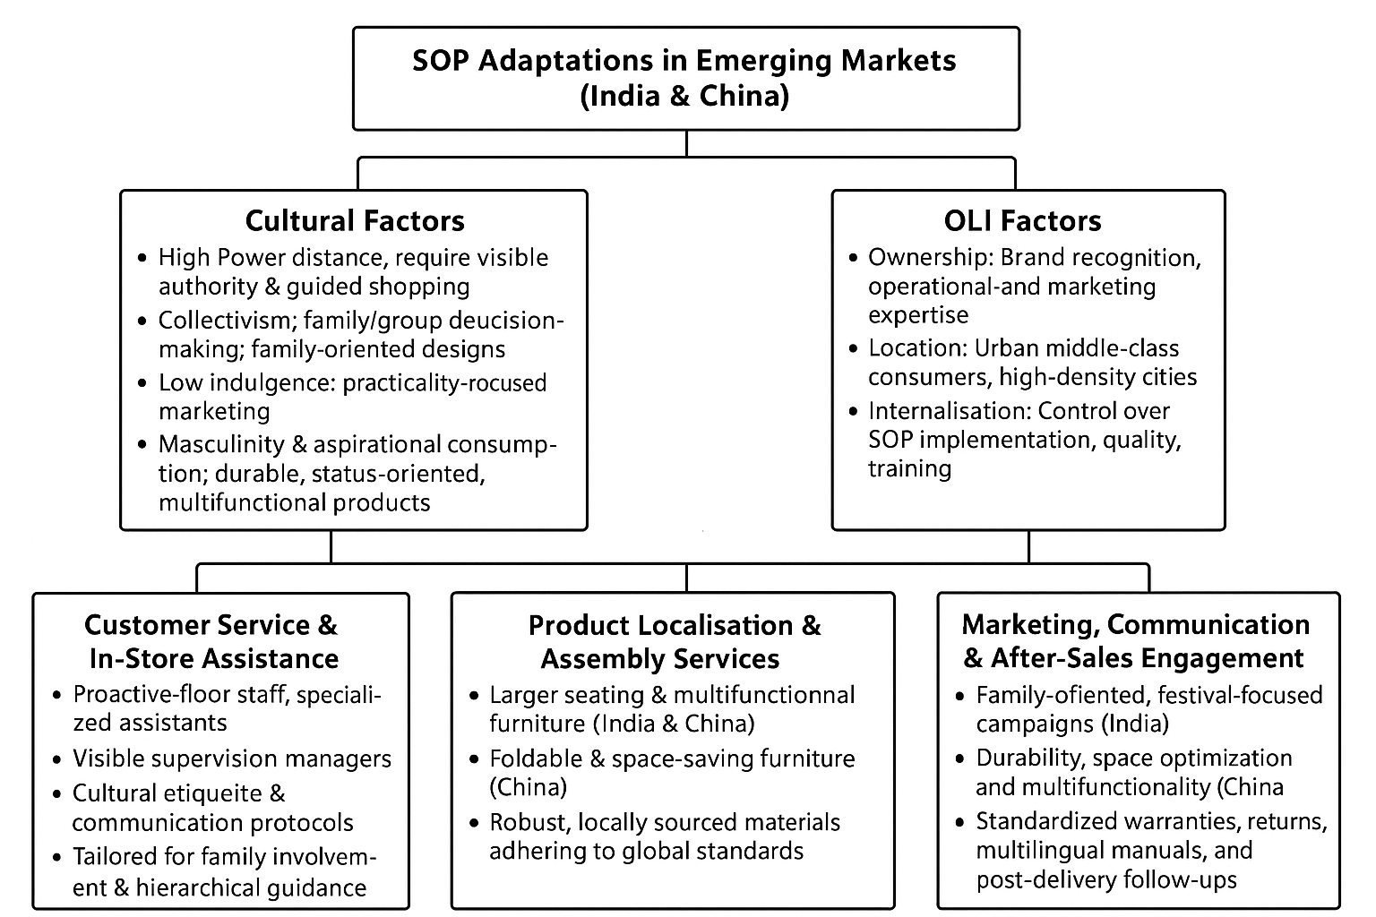
Figure 5: SOP Adaptations in EMerging Marts (India and China)
(Source: Self-created)
Synthesis: The Relationship between OLI and Cultural Factors and SOP Adjustments
OLI Framework
The suggested SOP changes are closely correlated with the OLI framework of IKEA, giving an image of how the benefits of ownership, location and internalisation are utilised to make the strategic decision regarding the operations in the emerging markets such as India and China. The ownership advantage, such as IKEA's worldwide brand name, overall experience in its operations, sophisticated design and marketing facilities, can help to ensure that uniform SOPs are executed in various stores with the material delivery of standard service and brand experience. The benefits of location explain market-specific adaptations, which consider urbanised, family-oriented consumers, a family of three, high density of cities and purchasing behaviour based on festivals. Such situational influences guide a change in the customer service, product localisation, assembly services, and marketing strategies, as they become culturally pertinent and business-wise lucrative. Internalisation provides direct control of the SOP implementation, training of employees, quality assurance and brand management, which prevents risks caused by relying on local partners and disintegrated practices. Combined, the OLI dimensions integration has enabled IKEA to integrate global operational standards and local market specifics to maximise customer satisfaction, operational effectiveness, and sustainable competitive advantage both in India and China.
Cultural Factors
The cultural dimensions are important in determining the adjustments of SOP in India and China by IKEA. Proactive customer service, observable management and participation in family or group decision-making are required to maintain the shopping experiences in consistency with local expectations, as a result of high power distance and collectivist values. The medium-high masculinity and aspirational consumer behaviour contribute to the high demand for durable and high-quality, and multifunctional goods that indicate social status. Low indulgence demands marketing to focus on utility, value and use by the family instead of lifestyle and self-expression, and long-term orientation facilitates the product to be durable, reliable and space-efficient design to fit in the urban living environment. With such elements of culture being incorporated in SOPs, i.e. customer service, product offered, assembly services, marketing and after sales engagement, IKEA can assure stability in service delivery, decrease operational tension, and establish consumer trust. Matching SOPs to these cultural realities will increase the effectiveness of operations, build brand credibility, and gain market acceptance and eventually provide a sustainable competitive advantage and long-term success in India and China.

6. Conclusion to the report
In conclusion, this report has critically discussed the internationalisation strategy of IKEA of Sweden to the emerging economies of India and China and specifically how cultural differences and the OLI (Ownership, Location, Internalisation) framework interact to determine operational success. The review has shown that the standardised Swedish model of operations with low power distance, high individualism, low masculinity, high indulgence, and DIY self-service of IKEA could not be directly applied to culturally different markets such as India and China without modification.
The most significant cultural differences, including high power distance, collectivism, aspirational consumer behaviour, moderate-to-high masculinity, low indulgence, and long-term orientation, required three large-scale changes to Standard Operating Procedures (SOPs). These are: improved customer service and store support to fulfil hierarchical and family-oriented demand; customization of products design and professional assembling services to the principle of meeting urban housing limitations, multifunctionality, and status conscious consumption; and culturally sensitive marketing and subsequent follow-up to focus on practicality, durability, value and family-oriented communication.
A combination of OLI factors makes sure that IKEA has leveraged its ownership in brand, operational and design skills, exploited location-specific prospects in urban, middle-class and festival-driven markets, and retained internalised control over quality, training and service delivery. Achieving a balance between SOPs and cultural realities, as well as OLI-driven strategies, can help IKEA to reduce the friction in its operations, improve consumer trust, create a stronger brand perception, and earn the sustainability of its competitive advantage. All in all, this report highlights that effective internationalisation requires a delicate balance between international level of operation standards and local cultural appropriateness.

References
Ahmad, D.M., Gáspár, L., Shaheen, H.M., Al-Shihabi, T.A., Maya, R.A. and Pinto, F.S. (2025). Improving Material Tracking for Sustainable Construction: A Standard Operating Procedure (SOP) Framework for Resource Efficiency. Buildings, 15(11), p.1941. https://www.mdpi.com/2075-5309/15/11/1941
Bourny, D., Mirza, D. and Turcu, C. (2023). The culture-promotion effect of multinationals on trade: the IKEA case. Journal of Economic Geography, 23(4), pp.771-800. https://cepii.fr/PDF_PUB/wp/2022/wp2022-06.pdf
Burt, S., Dawson, J., Johansson, U. and Hultman, J. (2021). The changing marketing orientation within the business model of an international retailer–IKEA in China over 10 years. The International Review of Retail, Distribution and Consumer Research, 31(2), pp.229-255. https://www.tandfonline.com/doi/pdf/10.1080/09593969.2020.1857294
CFI (2022). Eclectic Paradigm. [online] Corporate Finance Institute. Available at: https://corporatefinanceinstitute.com/resources/management/eclectic-paradigm/.
da Silva-Oliveira, K.D., de Miranda Kubo, E.K., Morley, M.J. and Cândido, R.M. (2021). Emerging economy inward and outward foreign direct investment: A bibliometric and thematic content analysis. Management International Review, 61(5), pp.643-679. https://link.springer.com/content/pdf/10.1007/s11575-021-00448-9.pdf
El Baasiri, G. (2024). Augmented, virtual and extended reality in cultural heritage: transforming preservation, tourism, and economic growth. https://www.politesi.polimi.it/bitstream/10589/230751/1/2024_12_ElBaasiri.pdf
Ferrer Bauza, L., Jiménez Estévez, P., Blázquez Resino, J.J. and Gutiérrez Broncano, S. (2022). The circular economy and its effects on reducing the Carbon Footprint in Ikea Company. https://ruidera.uclm.es/server/api/core/bitstreams/69fbb4e3-d9bb-435f-bcd2-2f89f57eb040/content
Forbes (2025). IKEA’s Circular Economy: Redefining Sustainability In The Furniture Industry. Forbes. [online] 14 Jan. Available at: https://www.forbes.com/sites/christophermarquis/2025/01/14/ikeas-circular-economy-redefining-sustainability-in-the-furniture-industry/.
Gabellini, G. (2023). The choice of brand names for home furniture companies entering the Chinese market and its relation to marketing policy. https://unitesi.unive.it/bitstream/20.500.14247/14153/1/866890-1268480.pdf
Hajam, M.A., Kaur, H., Manzoor, J. and Nisar, A. (2025). Integrating Sustainability in Small Scale Industries: From Environmental Degradation to Cleaner Practices. Environmental Claims Journal, pp.1-42. https://www.researchgate.net/profile/Harwinder-Kaur-3/publication/392809698_Integrating_Sustainability_in_Small_Scale_Industries_From_Environmental_Degradation_to_Cleaner_Practices/links/6868be6f92697d42903d3f84/Integrating-Sustainability-in-Small-Scale-Industries-From-Environmental-Degradation-to-Cleaner-Practices.pdf
Holmqvist, M. and Johansson, L. (2021). A self-service design concept for last mile delivery: The solution for retail stores in urban environments. https://lup.lub.lu.se/luur/download?func=downloadFile&recordOId=9057577&fileOId=9057588
IKEA (2025). Affordable, Quality Furniture & Home Furnishings. [online] Ikea.com. Available at: https://www.ikea.com/in/en/.
IKEA Annual Report (2024). Inter IKEA Holding B.V. Annual Report FY24. [online] Available at: https://www.inter.ikea.com/-/media/interikea/igi/financial-reports/fy24-financial-reports/inter-ikea-holding-bv-annual-report-fy24.pdf?rev=2212fa15a98048f7b08b0c6a6be79421&sc_lang=en.
Kabir, M.M. and Simon, M.R. (2025). Assessing the impact of product customization on improving customers experience of IKEA in Finland. https://www.theseus.fi/bitstream/handle/10024/895171/Kabir_Simon.pdf?sequence=2
Khan, A. and Shafiq, A.A. (2021). Internationalization challenges for retail firms in emerging Asian markets: a case study of IKEA. https://www.diva-portal.org/smash/get/diva2:1563364/FULLTEXT01.pdf
Kumar, I. and Chidambara (2023). Freight patterns and spatial planning requirements of third generation E-commerce in Indian cities. Urban, Planning and Transport Research, 11(1), p.2256817. https://www.tandfonline.com/doi/pdf/10.1080/21650020.2023.2256817
Kumar, V. and Ayodeji, O.G. (2021). Determinants of the success of online retail in India. International Journal of Business Information Systems, 37(2), pp.246-262. https://www.researchgate.net/profile/Vikas-Kumar-122/publication/352080406_Determinants_of_the_success_of_online_retail_in_India/links/60c5925592851ca6f8e57238/Determinants-of-the-success-of-online-retail-in-India.pdf
Lan, S. (2023). Assessing textile raw materials and exploring sustainable sources for future renewable textile materials for IKEA of Sweden. https://stud.epsilon.slu.se/19551/1/Lan-S-20231010.pdf
Li, C. (2023). Cultural friction in international joint ventures: Whose cultural distance affects market reactions?. Journal of Management, 49(7), pp.2288-2317. https://journals.sagepub.com/doi/pdf/10.1177/01492063221104030
Lim, Q. (2025). The Dynamic Integration of National Culture in Organizational Structure for Entrepreneurial Success. https://digitalcommons.liberty.edu/cgi/viewcontent.cgi?article=2616&context=honors
Lucas, J. (2024). Strategy in Action: The Creation of the Codex. https://scholarsarchive.byu.edu/cgi/viewcontent.cgi?article=1391&context=studentpub_uht
Mansouri, N. and Zheng, Z. (2025). Balancing Global Consistency and Cultural Adaptation: A Comparative Study of IKEA’s Brand Communication in China and Sweden: Cultural Dimensions-Based Content and Interview Study. https://www.diva-portal.org/smash/get/diva2:1987697/FULLTEXT01.pdf
Minbaeva, D., Narula, R., Phene, A. and Fitzsimmons, S. (2025). Beyond global mobility: how human capital shapes the MNE in the 21st century. Journal of International Business Studies, 56(2), pp.136-150. https://link.springer.com/content/pdf/10.1057/s41267-024-00755-x.pdf
ResearchGate (2025). Figure 3. Overview of Foreign Companies’ Market Entry Modes and Market. [online] Available at: https://www.researchgate.net/figure/Overview-of-Foreign-Companies-Market-Entry-Modes-and-Market-Entry-Mode-Types_fig1_324964189.
Sass, M. and Kheyirkhabarli, C.M. (2025). The Role of Aid for Trade in Global Value Chains in Emerging Economies. https://doktori.bibl.u-szeged.hu/id/eprint/12590/1/Final_Dissertation_Mahammad_Kheyirkhabarli.pdf
Schreiber, R. and Bota Moisin, M. (2021). Rebranding “Made in India” through Cultural Sustainability: Exploring and Expanding Indian Perspectives. https://www.diva-portal.org/smash/get/diva2:1553045/FULLTEXT01.pdf
Sharda, M., Kumar, A. and Samb, N. (2025). Global Economic Trends and Challenges. https://www.researchgate.net/profile/Pankaj-Sharma-164/publication/390582794_Artificial_intelligence_and_machine_learning_in_drug_research_A_new_era/links/67f4fc1695231d5ba5bc43bd/Artificial-intelligence-and-machine-learning-in-drug-research-A-new-era.pdf
Temitope, A. (2024). Exploring the Interplay of Hedonic, Functional, and Symbolic Brand Attributes in Building Brand Loyalty. https://www.researchgate.net/profile/Abass-Temitope-2/publication/385812561_Exploring_the_Interplay_of_Hedonic_Functional_and_Symbolic_Brand_Attributes_in_Building_Brand_Loyalty/links/6736108c37496239b2bf068e/Exploring-the-Interplay-of-Hedonic-Functional-and-Symbolic-Brand-Attributes-in-Building-Brand-Loyalty.pdf
Theculturefactor.com. (2025). Country comparison tool. [online] Available at: https://www.theculturefactor.com/country-comparison-tool?countries=china%2Cindia%2Csweden.
Times of India (2024). The Times of India. [online] 4 Feb. Available at: https://timesofindia.indiatimes.com/business/india-business/ikea-looks-at-next-round-of-investment-in-india-after-fulfilling-rs-10500-crore-promise/articleshow/107400812.cms.
Tse, C.H., Meyer, K.E., Pan, Y. and Chi, T. (2024). Evolution of MNE strategies amid China’s changing institutions: a thematic review. Journal of International Business Studies, 55(6), pp.657-675. https://link.springer.com/content/pdf/10.1057/s41267-024-00715-5.pdf
Yani, M.F., Muhdiantini, C., Firdaus, F.A. and Muhammad, H.A. (2025). IKEA: Enhancing Customer Experience through Digital Transformation. JIPI (Jurnal Ilmiah Penelitian dan Pembelajaran Informatika), 10(2), pp.1771-1779. https://jurnal.stkippgritulungagung.ac.id/index.php/jipi/article/download/5814/2745?__cf_chl_tk=4fsVXvJuQ42ioVC2BqcmDewCEQjFYA2eqN3ol8Ez58I-1764941508-1.0.1.1-IN25abUR9ogTlTlS9.D_7M9Wmv7G.vmLyhYDDfUr9Wg
Yu, Z. (2023). How will services change MNC’s business models under a circular economic background?. https://gupea.ub.gu.se/bitstream/handle/2077/77859/IBT%202023-23.pdf?sequence=1

‌

