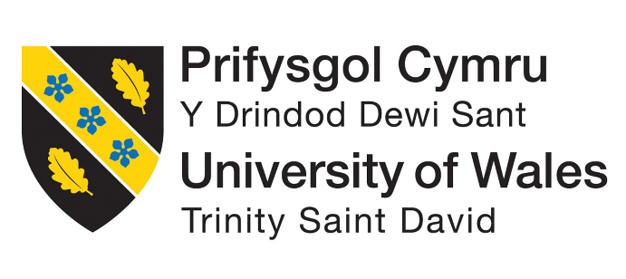

BMIH5007
Financial Management for the Hotel Industry

Business Report
Comparison of Two Hospitality Organizations

Student Name: Alina Grigore
Student ID: 2127560

Lecturer: Tristan Hawkins

Table of Contents
Introduction 2
Total Revenue 3
Market Position 6
Growth Potential 8
Financial Commitment to CSR 9
Recommendation 13
Conclusion 14
References 15

Introduction
Mandarin Oriental Hotel Group and Premier Inn are the biggest hotel chains in the world and they have most of the market shares in the tourism industry this business report focuses on the comparison of Mandarin Oriental Hotel Group and Premier Inn. The main purpose of the report is to evaluate financial management by considering the impacts of financial performance and sustainability. The report focuses on total revenue, market position, growth potential and financial commitment to CSR of both companies. Also, the proper recommendations for both companies are provided in the report.

Total Revenue
Mandarin Oriental Hotel Group
In the year 2022, Mandarin Oriental Hotel Group's total revenue was around £360M, in 2021 it was around £250M, and in 2020 the revenue was around £140M (Companies Marketcap, 2023).
Mandarin Oriental Hotel Group
Year | Revenue
2020 | 140
2021 | 250
2022 | 360

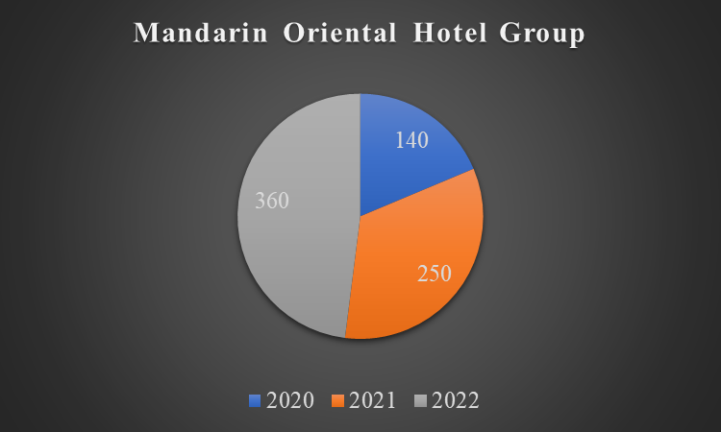
Figure 1: Total revenue of the group from the year 2020 to 2022 (Self-made)
Revenue Trends: Over this period, Mandarin Oriental's revenue rose steadily, from over £140 million in 2020 to almost £360 million in 2022. The worldwide travel and tourist industry has been on the upswing since COVID-19 restrictions were lifted, and this expansion parallels that trend.
Sources of Revenue: Revenue for Mandarin Oriental comes mostly from its five-star hotels, acclaimed restaurants, and luxurious spa. They rely significantly on wealthy tourists and luxury goods enthusiasts as a source of income (Mchugh, 2015).
Factors Driving Growth: Rising demand for high-end vacations, the company's foray into new global markets, and the quality of service and amenities it provides have all contributed to the firm's rising profits (Pasqualino and Jones, 2020).
Premier Inn
The total revenue of Premier Inn was around £2625.2 M in 2022, in 2021 it was around £1703.4 M, and in 2020 the revenue was around £589.4 M (Statista, 2023).
Premier Inn
Year | Revenue
2022 | 2625.2
2021 | 1703.4
2020 | 589.4

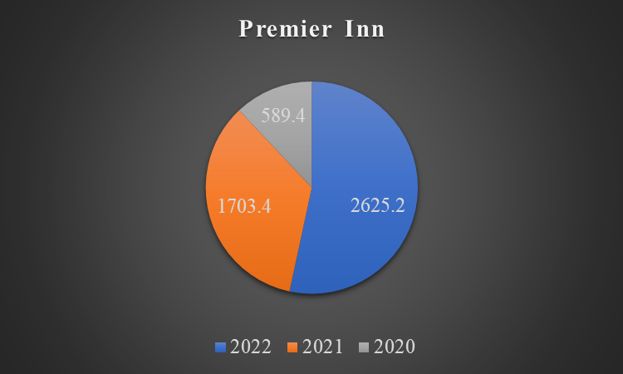
Figure 2: Total revenue of the hotel from the year 2020 to 2022 (Self-made)
Revenue Trends: During this period, Premier Inn's revenues skyrocketed from 589.4 million GBP in 2020 to an estimated 2625.2 million GBP in 2022. This staggering growth further establishes their industry-leading position among inexpensive hotels.
Sources of Revenue: Bookings of guest rooms, meals at the hotel's restaurants, and additional fees all contribute to Premier Inn's bottom line. Their competitive advantage is the ease and low cost with which they can accommodate a large number of guests.
Factors Driving Growth: Premier Inn's success as a budget hotel chain, aimed at frugal vacationers, has contributed to the company's growth in recent years. They saw a significant increase in revenue because of the pandemic-related shift in tourists' preferences towards local and cost-effective solutions (Holloway and Humphreys, 2020).

Market Position
Mandarin Oriental Hotel Group
Customer Demographics: Mandarin Oriental markets itself as a high-end hotel chain that caters to wealthy businesspeople and vacationers. Customers tend to be well-heeled people on vacation or on business who demand only the best in luxury amenities and service. The target demographic is sophisticated individuals interested in unique activities. The customer demography of the hotel is around 44.8% male and 55.2% female, and the age range of the customers is between 25 to 34 years old (Corporate Site, 2023).
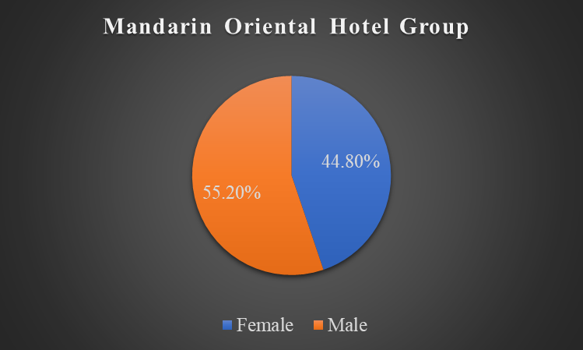
Figure 3: The customer demography of Mandarin Oriental Hotel Group (Self-made)
Brand Perception: Mandarin Oriental is a luxury hotel chain known for its exceptional service, high-end facilities, and convenient locations in affluent cities around the world. It's well-known for its attentive service and luxurious amenities (Goeldner and Ritchie, 2019). The Mandarin Oriental brand is synonymous in the minds of consumers with richness and refinement.
Market Share: The likes of Four Seasons, Ritz-Carlton, and St. Regis are among Mandarin Oriental's competitors in the posh hotel market. Although it does not own the largest portion of the luxury hospitality market in terms of property count, it does hold a prominent place in the industry. The group has around 44 hotels which contains around 11,000 rooms in almost 24 countries. It has around 20 hotels in Asia, 10 hotels in the UK and USA, And 14 hotels in Europe, the Middle East and North Africa (Corporate Site, 2023).
Premier Inn
Customer Demographics: Premier Inn markets itself as a budget-friendly hotel brand, appealing to thrifty vacationers, families, business travellers, and visitors on a tight budget. The company serves customers from all walks of life and economic backgrounds. The target customers of the hotel are mostly business travelers typically male people between the ages of 25 to 54 and females between the age of 25 to 44. About 52.85% of members are male customers and 47.15 are female customers (Dhaliwal, 2020).
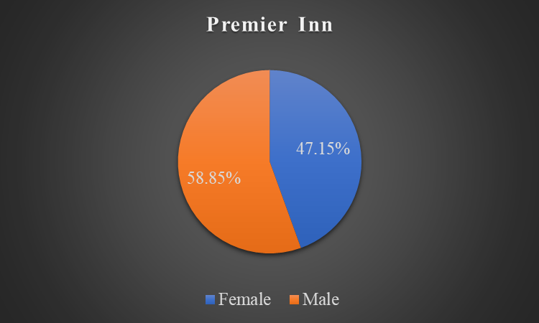
Figure 4: The customer demography of Premier Inn (Self-made)
Brand Perception: The Premier Inn brand is well-liked because of the consistency in the quality of its rooms at reasonable rates. Customers view it as a reliable and convenient hotel option. The brand promotes the value it provides, which includes nice accommodations and easy accessibility.
Market Share: Premier Inn has developed abroad and now dominates the budget hotel market in the UK. It's in the same price category as Travelodge and less expensive than Holiday Inn Express. Premier Inn's large proportion of the market is due in part to the breadth of its property portfolio. It is one of the biggest hotels in the UK and it contains around 12% market share in the tourism and hotel industry in the UK. It has around 800 hotels across the UK which contains around 72,000 rooms in total (Premier Inn, 2023).

Growth Potential
Mandarin Oriental Hotel Group
Expansion Strategies: Throughout its history, Mandarin Oriental has expanded selectively and strategically, prioritising the most desirable locations around the world. The company has room to build its portfolio of high-end hotels in developing countries like China, India, and the Middle East because of the rising middle classes in these regions (Blokdyk, 2019).
Market Opportunities: High-net-worth individuals and affluent tourists are driving the continued increase in demand for high-end vacations. Mandarin Oriental may gain a larger share of this market by investing in the upkeep of its current properties, creating brand-new ones, and expanding the range of services it provides (Bai and Zhang, 2017).
Potential Barriers to Growth: The high initial investment and ongoing upkeep costs associated with luxury real estate could be a problem. In addition to the general economic climate, interruptions in the travel business can affect earnings (Pius, Alharahsheh and Adesanmi, 2020).
Premier Inn
Expansion Strategies: Both locally and abroad, Premier Inn has undertaken an aggressive expansion plan. The company can keep going in this direction by expanding into other geographical areas, particularly Europe, where low-cost lodging is in high demand. Occupancy rates can be increased by smart alliances with internet travel agents and business clientele.
Market Opportunities: Premier Inn is well positioned in the budget and midrange hotel market because of its focus on quality and value. Capitalising on the rising demand from both leisure and business travellers for reasonably priced, high-quality hotel accommodations is possible through the rollout of its "Hub by Premier Inn" brand in major urban areas (Bogueva, 2019).
Potential Barriers to Growth: There is a problem with the rising number of discount hotels both locally and abroad. It might be difficult to keep a large portfolio of properties up to par. Occupancy levels may be affected by economic downturns and changes in consumer preferences.

Financial Commitment to CSR
Mandarin Oriental Hotel Group
Sustainability Practises: By adopting eco-friendly policies and procedures, Mandarin Oriental has proven its dedication to the environment. Efforts to conserve resources like energy and water cut down on waste, and encourage the use of renewable materials all fall under this category. Some of the sustainability programs of the group are mentioned below.
Sustainability in action
Carbon Sequestration | Helping nurture wetlands and mangroves with their coffees
Water cooling wonder | “A little less chilled, a lot of saving”
Green energy | Using solar heating and heat pumps
Electric cars | Use electric Porsche Taycans
Green Liner program | Using upcycling linen napkins
The company has a target of reducing up to 50% carbon intensity from the environment, using up to 15% renewable energy, reducing up to 40% water intensity, and reducing up to 50% water intensity in their kitchen uses by the year 2030 (Sustainability Report, 2022).
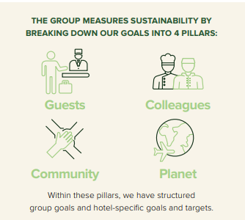
Figure 5: 4 pillars of sustainability of Mandarin Oriental Hotel Group (Sustainability Report, 2022).
Community Engagement: The group has participated in numerous volunteer efforts. This could take the form of financial contributions to local charities and nonprofits, the implementation of community engagement initiatives, or the creation of employment and educational possibilities for locals in the areas where their assets are located. The company helps the community by participating in charities and giving opportunities to people who want to work (McWilliams et al., 2019).
Ethical Business Practises: When conducting business, Mandarin Oriental always sticks to strict moral guidelines. Expenditures on things like staff training and development, upholding ethical labour practises, and sound corporate governance all fall under the umbrella of "ethical practises" that require financial commitments (Collins and Kanashiro, 2021).
Premier Inn
Sustainability Practises: Premier Inn's parent business, Whitbread, is dedicated to environmental preservation. They have established goals for cutting down on greenhouse gas emissions, water use, and trash generation throughout their facilities. Investments in renewable energy, energy-efficient building designs, and waste reduction activities are all examples of possible targets for pledged funds. The sustainability programs used by the hotel are mentioned below.
Sustainability Programmes
Reducing waste | Using recyclable materials
Going net zero | Using 100 per cent renewable energy to power the hotels
All electric Premier Inn | Using natural gas supply for powering around 195 rooms of the hotel
“Stop Food Waste Day” programme | Donating over 140 tons of food And ensuring zero waste.
However, the company has a target to reduce 50 of its carbon emission intensity by the year 2025 and “Going net zero” by the year 2040 (Premier Inn, 2023).
Community Engagement: Premier Inn has supported local charities and community-oriented programmes as part of its community engagement efforts. Donations, sponsorships, and employee-led service projects are all examples of ways that businesses might invest financially (Buttle et al., 2016). The company is involved in community services through their programs like serving up tonnes of food, caring about the customers, providing opportunities to people who want to work, investing in people, and providing responsible sourcing to people.
Ethical Business Practises: Premier Inn has always been committed to doing the right thing for its employees and the communities in which it operates. Spending dedications might cover things like ethical supplier chain standards and employee training programmes. The company follows the Rules and regulations provided by the British Standards Institution (BSI) to serve their customers and they have a BSI score of 88.7 which is higher than most of the hotel chains in the world (Premier Inn, 2023).
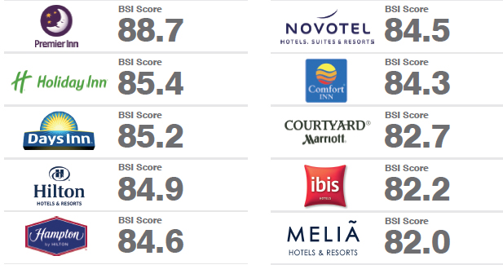
Figure 6: BSI score of Premier Inn (Asia, 2017)

Recommendation
Mandarin Oriental Hotel Group
The research indicates that Mandarin Oriental should expand its operations into the growing premium markets in Asia. The increasing wealth in the region and the desire for high-end vacations are perfect for the luxury brand that is Mandarin Oriental (Dixit, 2017). Investment in new properties and partnerships in major Asian cities will allow the business to take advantage of this development. There is mounting evidence that Asia is a lucrative market for high-end hotels, and it stands to reason that Mandarin Oriental's impeccable service and eco-friendly initiatives will appeal to the region's most discerning guests (Uysal, Schwartz and Sirakaya-Turk, 2021).
Premier Inn
The recommendation for ongoing worldwide expansion, particularly in European countries, is supported by Premier Inn's success in the cheap hotel sector and its aggressive expansion plan. There appears to be a sizable market in European countries where there is a growing need for cheap but secure lodgings (Balboni and Balboni, 2019). Premier Inn can continue its dedication to sustainability and community participation while expanding its reach because of the brand's excellent reputation for quality and affordability.

Conclusion
Premier Inn and Mandarin Oriental Hotel Group are competing global hotel brands. Premier Inn thrives in the budget segment by prioritising quality and pricing, whereas Mandarin Oriental dominates the luxury market with its sustainability and high-end clients. Premier Inn wants to expand across Europe, whereas Mandarin Oriental wants to develop in Asia. Their CSR spending shows they have a financial stake in environmental and community causes. These proposals capitalise on their strengths and market positioning to succeed in the evolving tourism industry.

References
Asia, T.T.G. (2017). Hilton named world’s most valuable hotel brand, Premier Inn most powerful | TTG Asia. [online] www.ttgasia.com. Available at: https://www.ttgasia.com/2017/04/03/hilton-named-worlds-most-valuable-hotel-brand-premier-inn-most-powerful/ [Accessed 17 Oct. 2023].
Bai, C. and Zhang, Q. (2017). A Research on China’s Economic Growth Potential. Routledge.
‌Balboni, M.J. and Balboni, T.A. (2019). Hostility to Hospitality: spirituality and professional socialization within medicine. New York, Ny, United States Of America: Oxford University Press.
‌Blokdyk, G. (2019). Expansion Strategies A Complete Guide - 2019 Edition. 5starcooks.
‌Bogueva, D. (2019). Environmental, health, and business opportunities in the new meat alternatives market. Hershey, PA: Business Science Reference.
‌Buttle, F., Bowie, D., Brookes, M. and Mariussen, A. (2016). Hospitality Marketing. Taylor & Francis.
‌Collins, D. and Kanashiro, P. (2021). Business Ethics. SAGE Publications.
Companies Marketcap. (2023). Mandarin Oriental (M04.SI) - Revenue. [online] Available at: https://companiesmarketcap.com/mandarin-oriental/revenue/ [Accessed: 17 October 2023].
‌Corporate Site. (2023). Luxury 5-Star Hotels & Resorts Worldwide | Mandarin Oriental Hotel Group. [online] Available at: https://www.mandarinoriental.com/en/?src=ps.brand.mohg.ggl&gclid=Cj0KCQjw4bipBhCyARIsAFsieCwro6Apr0YbQ8cSrr_428d7V2v87czFb-MTQenomFmQblLtovbFAqoaAlwiEALw_wcB&gclsrc=aw.ds [Accessed 17 Oct. 2023].
‌Dhaliwal, N.S. (2020). Tourism. London: Vintage Digital.
‌Dixit, S.K. (2017). The Routledge Handbook of Consumer Behaviour in Hospitality and Tourism. Taylor & Francis.
‌Goeldner, C.R. and Ritchie, B. (2019). Tourism: principles, practices, philosophies. Hoboken, NJ: Wiley.
‌Holloway, J.C. and Humphreys, C. (2020). The business of tourism. Upper Saddle River: Pearson.
Mchugh, F. (2015). Mandarin Oriental: hotel group. Cooper-Hewitt Museum.
McWilliams, A., Rupp, D.E., Siegel, D.S., Stahl, G.K. and Waldman, D.A. (2019). The Oxford Handbook of Corporate Social Responsibility. Oxford University Press.
‌Pasqualino, R. and Jones, A.W. (2020). Resources, Financial Risk and the Dynamics of Growth. Routledge.
‌Pius, A., Alharahsheh, H.H. and Adesanmi, A.A. (2020). Contemporary Management Approaches to the Global Hospitality and Tourism Industry. Hershey: IGI Global.
‌Premier Inn (2023). Force For Good. [online] Premier Inn. Available at: https://www.premierinn.com/gb/en/why/force-for-good.html [Accessed: 17 October 2023].
Statista. (2023). Whitbread: total revenue 2011-2019 statistic. [online] Available at: https://www.statista.com/statistics/511372/total-revenue-whitbread-united-kingdom-uk/ [Accessed: 17 October 2023].
Sustainability Report. (2022). Corporate Site. Available at: https://photos.mandarinoriental.com/is/content/MandarinOriental/_Corporate/PDFs/mandarin-oriental-sustainability-report-2022.pdf [Accessed: 17 October 2023].
Uysal, M., Schwartz, Z. and Sirakaya-Turk, E. (2021). Management Science in Hospitality and Tourism. Apple Academic Press.

