

Student Name: - Vraj A Pandya
Student ID: - 2244599
Programme: - MBA General Management
Module: - Marketing Management
Code: - LCMB7001
Lecture: - Tushara Balendran



(Source: Logo.com, 2023)
Optimizing Zara's Customer Journey:
A Total Engagement Approach

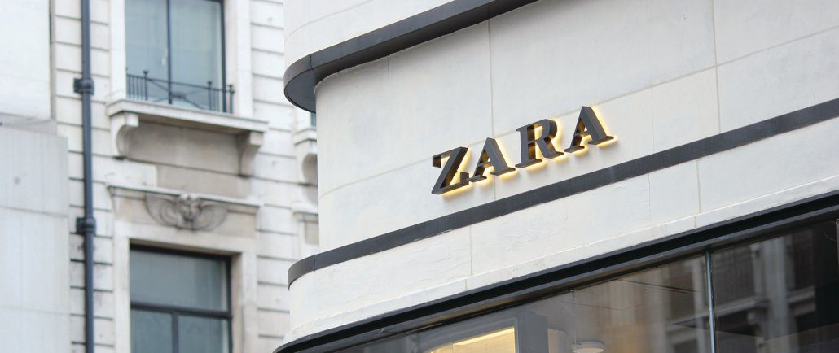

Table of Contents
1. Introduction 3
2. Communication 3
2.1 Shannon Weaver Model 3
3. Integrated Market Communication 5
4. New Promotional Strategies for Zara 6
4.1 Online Promotion 6
4.2 Offline Promotion 6
5. Branding and Brand Equity 7
5.1 Branding 7
5.2 Brand Equity 9
6. Keller's Brand Equity Model 10
6.1 Advantages of Keller's Model 10
6.2 Disadvantages of Keller's Model 11
7. Customer Journey 12
8. Customer Touchpoints 12
8.1Pre-purchase 12
8.2 Purchase 13
8.3 Post Purchase 13
9. The Persona of a Zara Customer 14
9.1 Customer Journey Map 16
9.2 Critical Analysis of Zara's Customer Journey Map 16
9.3 Strengths 17
9.4Weakness 17
10. The Total Engagement Model 17
11. Recommendations 19
12. Conclusion 19
References 21

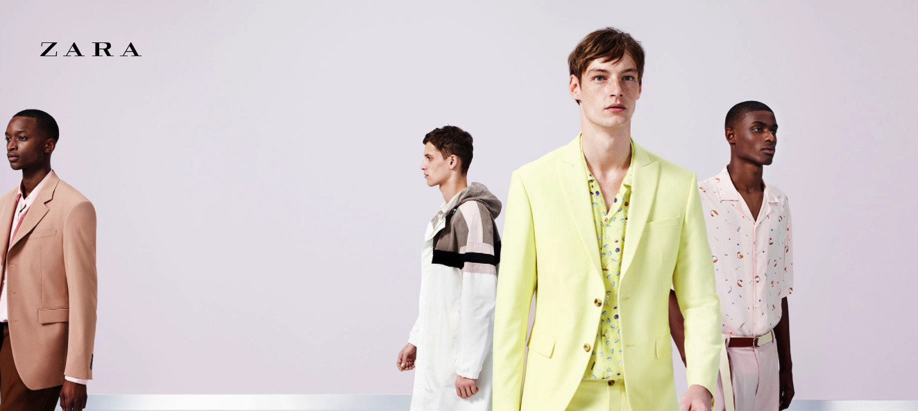
(Source: metropolitanmodels.com)

Introduction
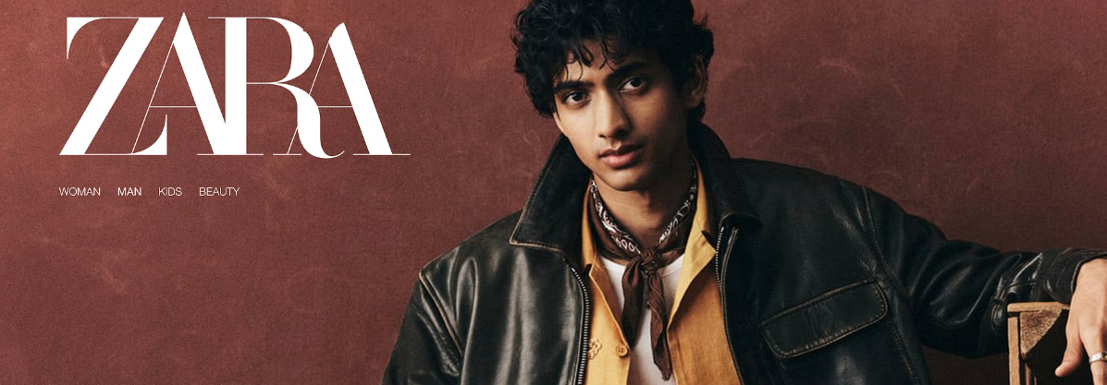
In the present dynamic as well as competitive situation of business, certain companies face some sort of challenges, from mitigating the issues regarding globalisation to embracing the transforming digital environment. One such organisation that goes through these complexities is Zara, which is a renowned chain of business in the sector of fashion. As markets get divided, efficient strategies of marketing become very pivotal in order to ensure proper survival along with growth (El-Barkouky et al., 2023). This assignment will critically evaluate how the company of Zara can innovate its marketing strategies in order to improve brand awareness and meticulously manage and appraise the overall customer journey around certain diversified channels of communication. By merging relevant practical examples with suitable marketing theories, this assessment will aim to illuminate certain pathways for the business of Zara to be able to meet and exceed the level of expectations of current and upcoming stakeholders in a progressively demanding environment of business.
(Source: metropolitanmodels.com)
Mission Statement
- Zara has specifically committed to redefining the fashion landscape primarily by offering trendsetting styles at accessible prices.
- Their mission is to practically empower individuals to express their unique identities through dynamic and affordable fashion choices.
- They specifically strive to provide a seamless and enjoyable shopping experience, specifically both online and in-store, therefore ensuring their customers feel inspired and confident in their style journey.
Vision Statement
- Zara envisions a world where fashion is therefore an inclusive and empowering force.
- Their vision is to be the global leader primarily in fast fashion, particularly celebrated for their commitment specifically to innovation, sustainability, and customer-centricity.
- Aims to continuously elevate the customer journey, therefore fostering lasting connections and becoming synonymous with style, accessibility, and authenticity.

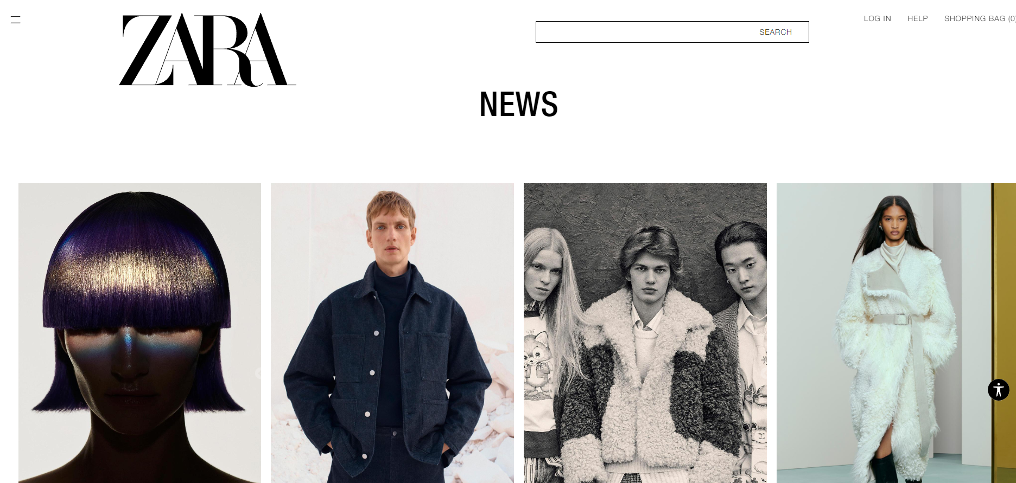
2. Communication
(Source: zara.com/uk)

2.1 Shannon Weaver Model
Communication is considered to be fundamental for any successful marketing strategy, and here the “Shannon-Weaver Model” basically offers a subsequent framework for understanding the intricacies of this particular process (socialsci.libretexts.org, 2022). In the precise context of Zara's marketing ventures, efficient communication is very crucial for conveying brand messages properly, creating good connections with consumers, and meeting stakeholder expectations.
The “Shannon-Weaver Model” technically delineates the concept of communication as a linear process that is consisting of a specific a channel, a sender, a message, a receiver, and lastly feedback. Zara, being the sender, should deliver attractive messages that resonate with its precise target audience. These sorts of messages roam across various channels, like advertising, social media, along with in-store displays, that are acting as mediums for data transmission. The main challenge lies in certifying that the intended message is decoded by the diverse receivers following an accurate way, who might interpret data in a different manner as per social, cultural, or even individual factors.

(Source: communicationtheory.org, 2022)
The strategy of marketing communication made by Zara must be adaptive and effectual, according to the multichannel category of contemporary interactions. Through this discussed model, the organization of Zara can analyse the efficiency of its communication channels, enhance messaging for proper clarity as well as impact, and further incorporate feedback loops to constantly develop its communication methods. Thus, the “Shannon-Weaver Model” basically serves as a very useful tool for Zara to streamline its efforts regarding communication, encouraging a resonant and coherent dialogue with its audience throughout the entire customer journey.

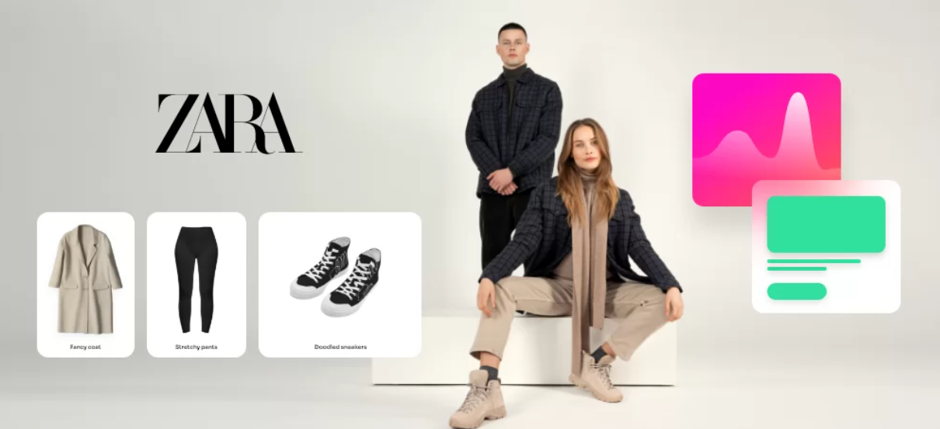
3. Integrated Market Communication
(Source: start.io/blog)
“Integrated Marketing Communication” also known as IMC is practically a strategic approach that aligns as well as coordinates with several channels of communication to convey a stable and unified message to the fixed target audience (Smartinsight.com, 2022). In the business of Zara, IMC plays a very significant role in fostering an immaculate and impactful consumer experience around diversified platforms.
Zara, being an international fashion retailer, can grasp IMC to make sure that its promotional efforts resound cohesively across the platforms of social media, direct marketing, advertising, public relations, and other channels of communication. By synchronizing correct messages and imagery, Zara can seamlessly establish a robust and unified brand identity, strengthening key brand values and further positioning in the minds of customers.
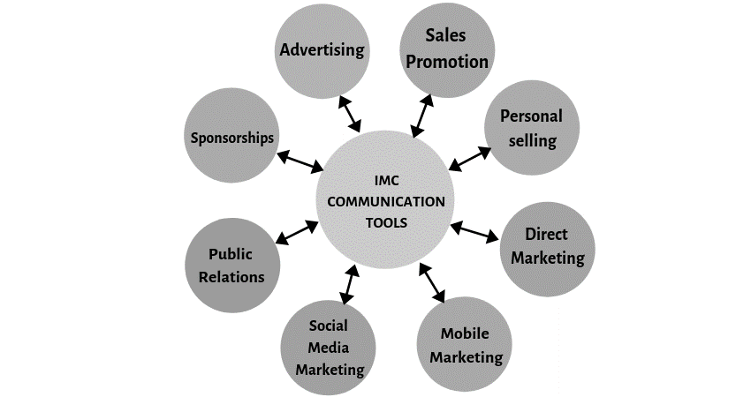
(Source: media.com, 2022)
IMC promotes synergy among several communication elements, escalating the overall effect of the marketing efforts made by Zara. For instance, a well-made campaign around certain online and offline channels can practically improve brand recall along with the engagement of the consumers. Consistency in messaging assists in building trust and helps to manage as well as exceed customer expectations throughout their whole journey with the mentioned brand. Moreover, IMC permits Zara to embrace its communication strategies that are based on relevant consumer insights and current trends of the market, ensuring proper resonance and applicability in an ever-evolving situation. By applying an integrated approach, the company Zara can resolve the challenges that are posed by digitalization, globalization, and rising consumer expectations, creating a holistic as well as useful marketing ecosystem that drives the brand forward.


4. New Promotional Strategies for Zara
(Source: manilaonsale.com)

4.1 Online Promotion
- In the current landscape of fast fashion, Zara can transform its promotional strategies by adapting creative ways of online approaches.
- One promising avenue is the incorporation of augmented reality or AR experiences, by allowing online shoppers to try on the updated fashionable wears before making a final purchase through virtual ways (Time.com, 2022).
- The sort of immersive element smooths the interaction with the consumers through their online shopping experience, and it also bridges the gap between the digital and physical retail situations.
- Strategic collaborations with renowned fashion influencers as well as attractive content creators on the platforms of social media can practically intensify the online presence made by Zara, by tapping into the huge level of reach of digital communities.
- Live streaming events that display undercover looks or exclusive previews, can seamlessly generate certain excitement, and foster a mere sense of immediacy, through amplifying customer engagement.
- Personalized sort of online promotions that are driven by data analytics and insights regarding customer behaviour can generally tailor valuable recommendations as well as discounts, fostering a more individualized experience of shopping.

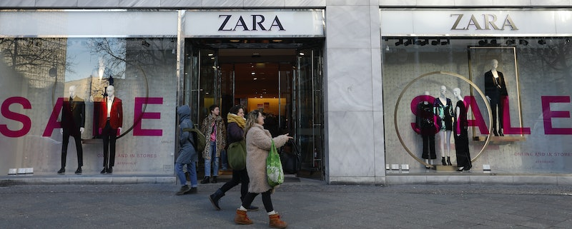
4.2 Offline Promotion
(Source: bustle.com)
- Zara, specifically a trailblazer in the fashion industry, therefore, unveils innovative offline promotional strategies to captivate its particular audience and elevate brand visibility.
- Adopting experiential marketing, Zara, therefore, introduces "Fashion Soirées" at select flagship stores, thereby inviting local influencers, fashionistas, and loyal customers to exclusive evenings of style exploration.
- The events blend fashion showcases, personalized styling sessions, and interactive workshops, specifically fostering a sense of community and brand engagement (sproutsocial.com, 2023).
- Zara revolutionizes in-store experiences primarily with the implementation of augmented reality (AR) mirrors.
- Customers can therefore virtually try on different outfits, facilitating a seamless and enjoyable shopping journey.
- To practically amplify customer loyalty, Zara has launched a membership program that offers exclusive benefits, early access to collections, and personalized recommendations that are based on individual style preferences.
- Recognizing the importance of sustainability, Zara therefore initiates a clothing recycling program. Customers who primarily bring in old garments receive discounts on new purchases, thereby emphasizing Zara's commitment to environmental responsibility (martinroll.com, 2023). In collaboration with local artists, Zara primarily transforms selected store facades into vibrant murals, creating visually specifically appealing spaces that attract passersby and reinforce the brand's connection to art and culture.
- Zara's offline promotional strategies not only practically showcase its commitment to innovation and sustainability but also aim to specifically create memorable and immersive experiences for its diverse customer base.

5. Branding and Brand Equity
(Source: citymagazine.si)

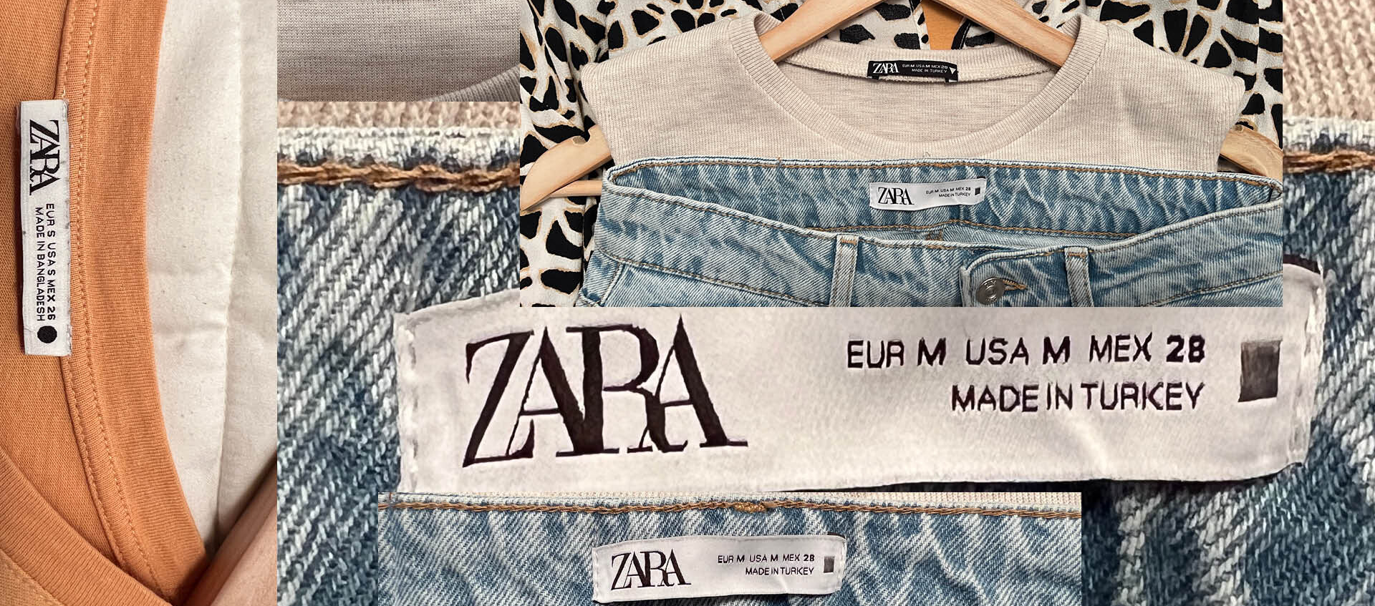
5.1 Branding
- Branding is known as the main essence of a recognition made by the company, which encapsulates its total values, and personality, along with a promise to its loyal customers (Forbes, 2021).
- For the business of Zara, an international fashion powerhouse, efficient branding goes beyond a mere sort of identity; it shapes an emotional connection with its diversified base of consumers. The brand strategy made by Zara technically revolves around a final commitment to bring fast fashion, merging the latest trend responsiveness with affordability as well as proper quality.
- The distinctive approach of the brand to production, design, and distribution fortifies its vast image as a base trendsetter.
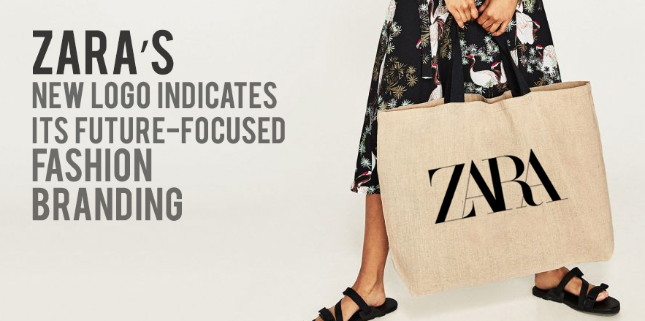
ZARA as a Brand
(Source: Logo.com, 2023)
- Consistency in branding is considered to be very critical for building an appropriate level of trust and loyalty.
- The sleek and minimalist logo of Zara, which is coupled with its modern style of store designs, seamlessly cultivates a coherent experience of the brand around several touchpoints.
- The emphasis made by Zara on the concept of sustainability contributes to an optimistic brand image, aligning with transforming customer values (Salem and Alanadoly, 2023).
- In the powerful industry of fashion, the branding of the organization predominantly goes beyond the transactional, seeking to resonate with consumers on a deeper personal level.
- The success rate of the business lies in its capability to constantly change while staying honest to its core values, creating a brand recognition that helps to endure market challenges and to set different trends in the ever-evolving market of fashion.

5.2 Brand Equity
- Brand equity is the progressive value that a business adds to a particular product or service, which extends beyond certain tangible attributes to emphasize customers’ perceptions, and maintenance of loyalty, along with proper associations (Marketevolution.com, 2022).
- Zara, being an international company of fashion, has made some substantial brand equity through some combination of factors.
- The commitment made by Zara to deliver fast fashion that is trendy as well as affordable has built positive associations with the latest style along with accessibility.
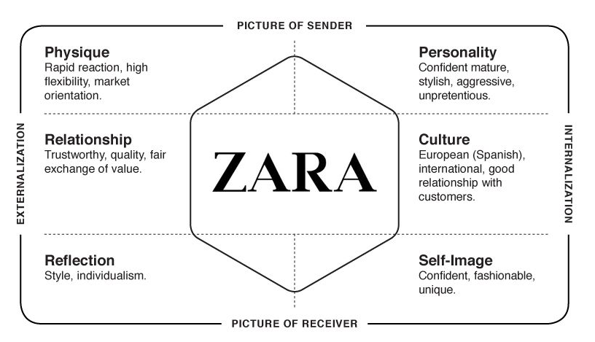
(Source: Pinterest.com, 2023)
- The stable and distinctive approach of Zara towards better design, which is characterized by quick turnaround times as well as restricted production runs, has finally contributed to a nature of urgency along with exclusivity among the customers, further refining brand equity.
- Customer loyalty is technically made through a flawless experience of shopping, creative layouts of the store, and a robust online presence.
- In the competitive nature of fashion organizations, the brand equity held by Zara acts as a useful intangible asset, which inspires the consumers to choose and solidify its suitable position as a leader in the industry of fast fashion.

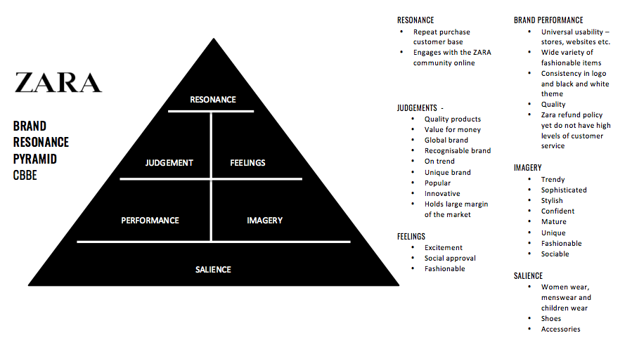
6. Keller's Brand Equity Model
(Source: Myra364.wordpress.com, 2017)

6.1 Advantages of Keller's Model
“Kevin Lane Keller's Brand Equity Model” is broadly well-known in the field of marketing, and within this specific framework, Keller's Model particularly introduces various distinct advantages. Fundamentally, Keller's Model places a very powerful emphasis on brand knowledge, which concentrates on the awareness as well as the image of the brand. This sort of dual focus permits a subsequent understanding of how customers perceive and further identify the brand.
Moreover, Keller's Model precisely acknowledges the adaptive nature of brand equity by integrating brand resonance and consumer engagement. By encompassing the creation of a deep, emotional bond with the customers, it offers a certain pathway for brands to move beyond mere identification to creating loyalty along with advocacy (Dang, 2022).
In addition, Keller's Model is very dynamic towards different sectors and market conditions, as it makes the theory applicable to a broader range of brands. Its particular consumer-centric approach matches well with the current marketing strategies, as it establishes the significance of consumer experiences along with suitable relationships in fostering and sustaining proper brand equity (Han, 2022).

6.2 Disadvantages of Keller's Model
While “Keller's Brand Equity Model” is vastly acclaimed, it carries some limitations as well. One notable disadvantage specifically lies in its mere complexity. The model includes a multi-dimensional approach, which has established the associations, awareness, resonance, loyalty, and image of the brand. This intricacy can practically pose certain challenges for companies that have limited resources or those aiming for a more direct framework.
Another disadvantage is the emphasis of the model on customer perceptions. Keller's model precisely focuses on how customers view and further interpret a particular brand, possibly avoiding the influence of exterior factors or dynamics of the market. In the fast-changing markets, this could restrict the adaptability of the model (Iliadi, 2023).
Furthermore, Keller's Model might not fully take account of any types of cultural nuances along with regional variations. Businesses that are operating in diversified international markets might find it very challenging to employ a standardized approach across several cultures as well as customer behaviours.
Lastly, the reliance of the model on quantitative data for measurement might not capture the entirety of a brand's equity, especially the precise aspects that are related to emotional or experiential connections, which are progressively crucial in the modern style of marketing. Despite these limitations, the “Brand Equity Model” of Keller remains a very useful tool, but users must consider these mentioned factors when trying it out for their specific contexts.

7. Customer Journey
The customer journey mainly refers to the entire experience a customer holds with a precise brand, from the stage of initial awareness through the process of purchasing, and post-purchase interactions, along with possible loyalty and advocacy. It is a nonlinear and adaptive method that is shaped by several touchpoints around both online as well as offline channels.
The journey typically starts with awareness, where consumers get to discover a product or service. Comprehensively, they move to the stage of consideration, conducting proper research, comparing several options, and analysing the total offerings of the brand. The decision stage goes behind, where the consumers make a final purchase as per their assessments.
Post-purchase, the customer journey extends into the overall experience along with the phase of satisfaction. Optimistic experiences can lead to a certain sense of loyalty, repetitive business, and advocacy, inspiring others in their journey (Iftikhar, 2023).
Therefore, understanding and mapping the customer journey is pivotal for several businesses. It permits the identification of pain points and further opportunities for development, enabling various companies to tailor their strategies of marketing, communication, and service to better meet customer expectations at every potential stage of the journey, finally building long-term relationships as well as loyalty to the brand.

8. Customer Touchpoints
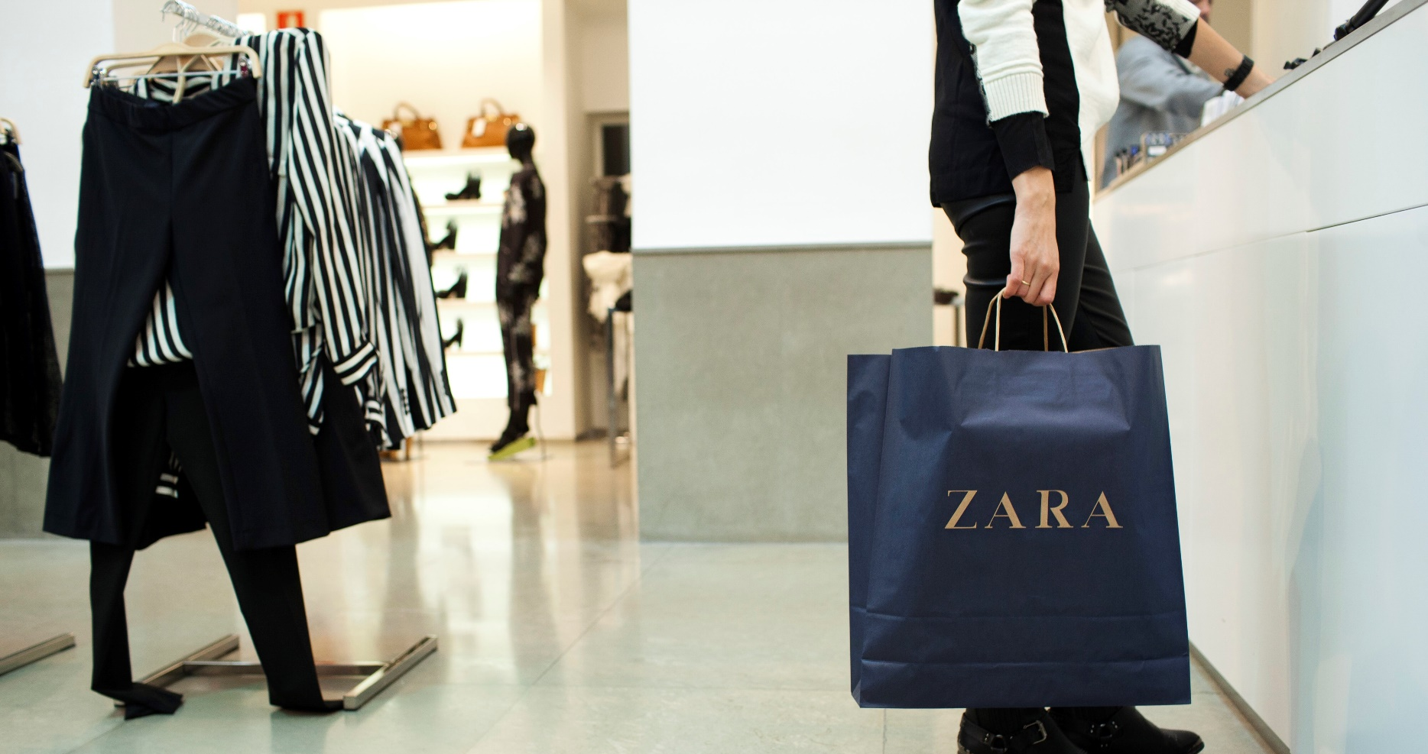
(Source: evamurphyryan.com)

8.1 Pre-purchase
- In the particular pre-purchase stage of consumer touchpoints, certain interactions occur before the actual decision of buying.
- The specific sort of phase generally encompasses several channels like reviews, advertisements, and recommendations through word-of-mouth and social media.
- Prospective consumers form their initial impressions and further collect data, inspiring their perception regarding the brand (Alexander and Kent, 2022).
- Efficient pre-purchase touchpoints concentrate on fostering awareness, offering relatable information, and building a positive brand image, which will guide consumers toward considering and selecting a product or service.

8.2 Purchase
- During the stage of purchase of customer touchpoints, the interaction technically culminates in the actual transaction which can practically occur online, in-store, or through numerous channels of sales.
- Clear and concise product data, user-friendly interfaces, along flawless payment methods are critical in ensuring an easy experience of the purchase.
- Customer service at this exact stage has a very significant role, in addressing different queries and concerns promptly (Alexander and Kent, 2022).
- Well-made purchase touchpoints contribute to the enhancement of customer satisfaction and further motivate their decision to complete the overall transaction, encompassing an optimistic association with the brand.

8.3 Post Purchase
- In this post-purchase stage of customer touchpoints, the total concentration shifts to maintaining as well as developing the consumer relationship after the main transaction.
- The post-purchase stage involves order confirmation, tracking of delivery, and constant follow-up communication.
- Customer support, mechanisms of feedback, and loyalty programs play pivotal roles in this precise phase.
- Positive kinds of post-purchase touchpoints generally contribute to consumer satisfaction, and loyalty, along with appropriate advocacy.
- Companies that practically prioritize these discussed touchpoints continue to have a proper engagement with their consumers, motivate feedback, and resolve any issues promptly.
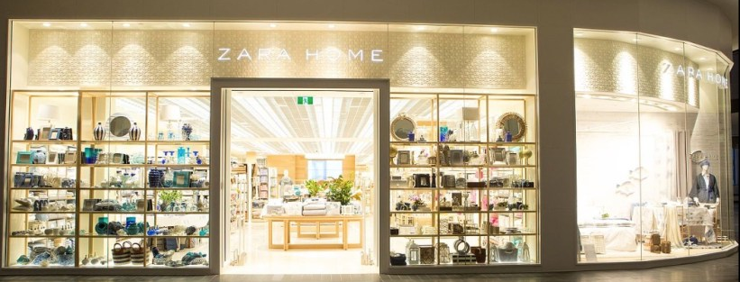

9. The Persona of a Zara Customer
(Source: blog.contactpigeon.com)
The specific persona of a Zara customer in the particular “customer journey map” is known to be fashion-forward, that seeks trendsetting styles at minimum affordable prices. Hugely engaged in online and in-store experiences, they practically value convenience, a swift style of decision-making, and customized recommendations. From the initial level of awareness to the stage of post-purchase, this customer appreciates smooth transitions, diversified offerings of product, and a right sense of exclusivity, which could contribute to a dynamic as well as enjoyable journey with the discussed brand.

Values:
  - Innovation: Zara is committed to staying at the forefront of fashion trends, constantly seeking new and creative ways to design and deliver stylish clothing.
  - Accessibility: Making fashion accessible to a wide audience, Zara believes that everyone should have the opportunity to express their unique style.
Personality Traits:
  - Trendsetting: Zara is seen as a trendsetter in the fashion industry, always anticipating and adapting to the latest styles and preferences.
  - Agile: Like the fast-paced world of fashion, Zara is known for its agility in responding quickly to changing market demands and consumer tastes.
Communication Style:
  - Chic and Contemporary: Zara's communication style is sophisticated, yet approachable, reflecting the modern and urban lifestyle it caters to.
  - Informative: Zara keeps its customers informed about the latest trends, promotions, and collections through various channels, maintaining a strong online and in-store presence.
Visual Identity:
  - Clean and Minimalist: Zara's visual identity is characterized by clean lines and a minimalist design approach, reflecting the simplicity and elegance of its clothing.
  - Earthy Tones: The brand often uses neutral and earthy tones in its branding, creating a sense of timelessness and versatility.
Customer Experience:
  - Personalized Shopping: Zara provides a personalized shopping experience, with frequent updates to its collections and a diverse range of styles to suit various tastes.
  - Fast Fashion: Zara offers a unique and exciting shopping experience by constantly refreshing its inventory, encouraging customers to visit frequently to discover new arrivals.
Brand Promise:
  - Affordable Luxury: Zara promises to deliver affordable yet stylish and high-quality fashion, allowing customers to express their individuality without breaking the bank. Sustainable Fashion: As part of its commitment to responsibility, Zara also emphasizes sustainable practices in its production processes.

9.1 Customer Journey Map
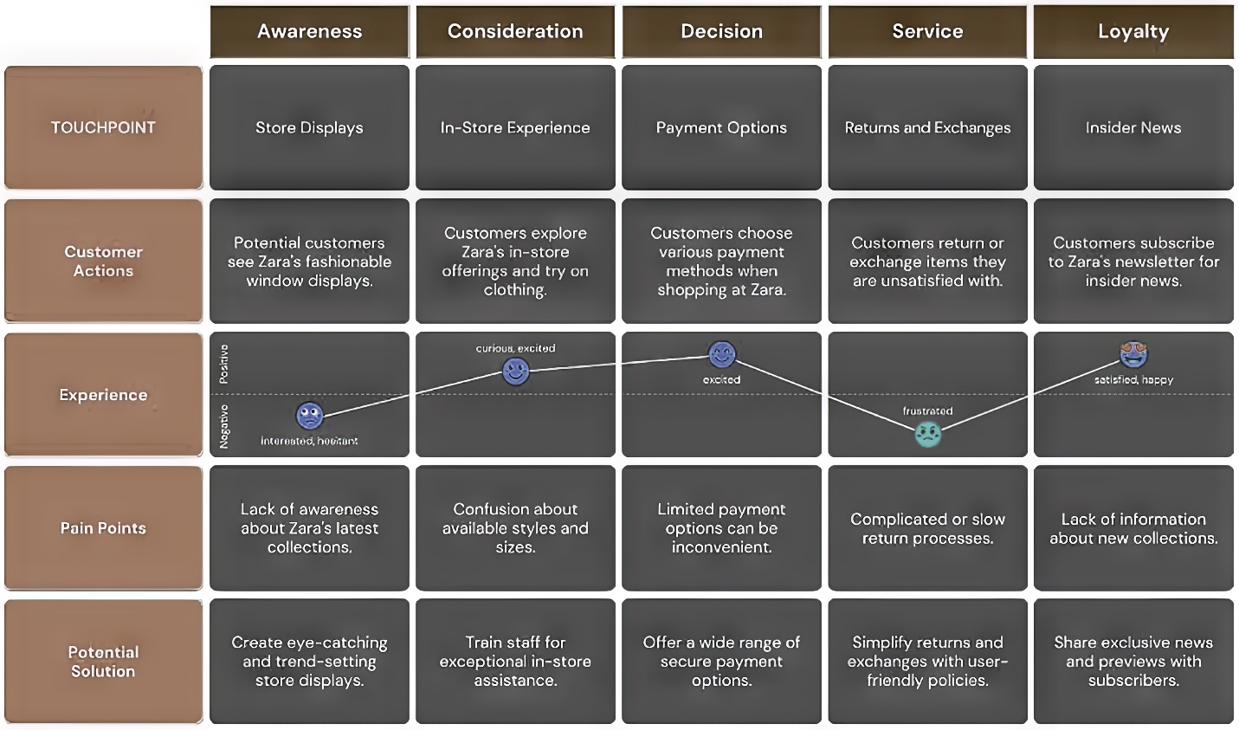(Source: Created by Self)

9.2 Critical Analysis of Zara's Customer Journey Map
The “customer journey map” of Zara shows the efficient incorporation of online and offline touchpoints, establishing the responsiveness of speed along with trends. However, possible areas for development involve improving post-purchase engagement as well as customization. The map could practically benefit from a more powerful loyalty program and further advanced data analytics to tailor experiences in the future. Balancing exclusivity and proper accessibility throughout the base journey remain very important for sustained consumer satisfaction and loyalty.

9.3 Strengths
- The “customer journey map” predominantly excels in the smooth incorporation of online along offline experiences, which caters to the dynamic preferences of such customers who are known to be fashion-forward in styling.
- The strengths lie in the fast adoption of trends, offering a user-friendly website, and effective in-store experiences (Kondo and Vicente, et al., 2023).
- The capability of the brand to build a sense of exclusivity, combined with affordability, ultimately contributes to the loyalty toward customers.
- The strengths of the organization in these areas dominantly solidify its position as a leader in the sector of fast fashion.

9.4Weaknesses
- The “customer journey map” has adequate room for enhancement in post-purchase engagement as well as customization.
- The brand can refine its customer loyalty by applying a stronger loyalty program and leveraging the advanced stage of data analytics.
- Excelling in the specific trend responsiveness helped to bring a better level of nuanced approach regarding personalized experiences, which could further strengthen the relationships among consumers.
- Balancing the proper level of accessibility and exclusivity at last remains a challenge, which necessitates careful consideration for maintaining sustained consumer loyalty and satisfaction (Palazón et al., 2022).

10. The Total Engagement Model
The “Total Engagement Model” practically represents a subsequent framework that helps to extend beyond the traditional journey of the customers, establishing constant and immersive interactions among a brand and its fixed audience. Unlike a precise linear approach, this model identifies that engagement is an ongoing process that includes multiple touchpoints throughout the lifecycle of an individual consumer.
At its core, the “Total Engagement Model” actually emphasizes the stages of pre-purchase, purchase, and post-purchase, which helped to integrate them easily into a holistic as well as circular continuum. It encompasses the importance of constant, two-way communication, addressing the reciprocal nature of brand-customer relationships.
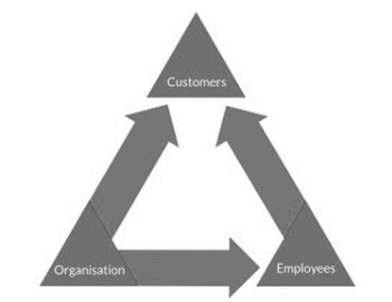
(Source: Engagedstrategy.com.au, 2020)
In this exact model, customer engagement generally goes beyond certain transactions as it includes emotional connections, fostering community, and individualized experiences. Brands that are applying the “Total Engagement Model” basically prioritize the concept of customer satisfaction, and feedback, along with the maintenance of loyalty, identifying that each of these interactions ultimately contributes to the whole perception of the brand (Engagedstrategy.com.au, 2020).
Organization: To be in the market preferences Zara uses the advertising process which consist of both online and offline process. Currently, the use of digital marketing has increased so considering Zara advertises its brand through different online stores and its website. The use of these digital technologies requires new and fresh talents which helps them to perform culturally well (Engagedstrategy.com.au, 2020).
Employees: Employees are entitled to provide the best experience to the customers. Being digitally superior Zara uses its website to connect to its customers. Frequent surveys are conducted to know what exactly the customers want and perform according to it. On the other hand, customers can speak to the company directly through the online aspect and let the company know what went wrong.
Customers: The purchasing power of the customers has mostly shifted digitally, and they have found ways to compare between two companies and find out the best product. Comparison allows the company to find out which other competitor is taking up the preferences of the customers. Customers are the people who provide the company with the best opportunities to succeed in the market by preferring them to other people.

11. Recommendations
- For the company Zara to develop its “customer journey map” and secure its position in the market of fast fashion, various recommendations can be considered that are going to be discussed.
- The brand must focus on enhancing its post-purchase touchpoints by employing a subsequent and customized loyalty program.
- The association finally involves certain exclusive offers, early access to new kinds of collections, and customized recommendations that are based on the history of the purchase.
- Investing in the field of “advanced data analytics” can crucially enhance the facilities of personalization throughout the overall customer journey.
- The business of Zara can easily leverage customer data to provide tailored online experiences, recommend suitable products, and anticipate individual levels of preferences, therefore building a better connection with the consumers.
- In order to address the challenge of balancing both exclusivity as well as accessibility, Zara must continue developing its restricted production runs, through maintaining an aura of exclusivity without ultimately compromising its core commitment to the concept of affordability.
- Incorporating emerging technologies like augmented reality for virtual try-on along with interactive visiting-store experiences can basically elevate consumer engagement and can further make the entire journey much more memorable.
- Zara can further smoothly refine its “customer journey map,” by employing these mentioned recommendations and fostering a more customized, engaging, as well as flawless experience that gets to resonate with its adaptive and fashion-conscious customer base.

12. Conclusion
The main “customer journey map” created by the organisation of Zara, while exhibiting remarkable strengths in trend responsiveness and smooth incorporation of online along with offline touchpoints, presents various opportunities for enhancement. Refinements in “post-purchase engagement,” individualisation or personalization, and a better nuanced approach towards balancing accessibility and exclusivity can easily further raise the position of standing of the brand in the sector of fast fashion. Applying a strong loyalty program, utilising “advanced data analytics,” and adapting strategic collaborations will assist to contribute to sustained consumer satisfaction along with loyalty. The “Total Engagement Model” ultimately serves as a guiding philosophy that encompasses the dynamic, constant nature of consumer-brand interactions. Zara, by able to embrace and employing these exact recommendations, has the potential and possibilities to meet as well as surpass several consumer expectations, maintaining appropriate enduring relationships and solidifying its final position as a practical leader in the ever-changing world of fashion retail.

References
Alexander, B., & Kent, A. (2022). Change in technology-enabled omnichannel customer experiences in-store. Journal of Retailing and Consumer Services, 65, 102338.

Communicationtheory.org. (2022). Shannon-Weaver Model of Communication [Online] Available at: [https://www.communicationtheory.org/shannon-and-weaver-model-of-communication/ ] Accessed on: 17.11.23.

Dang, Y. (2022). Key factors in designing successful retail omnichannel.

El-Barkouky, H.E.E.M. (2023). The customer journey: the ongoing cycle of customer experience, value co-creation, and customer engagement.

Engagedstrategy.com.au. (2020). Total engagement model round [Online] Available at: [https://www.engagedstrategy.com.au/home/total-engagement-model-round/] Accessed on: 21.11.23.

Forbes. (2021). The Importance Of Branding In Business [Online] Available at: [https://www.forbes.com/sites/forbesagencycouncil/2021/03/24/the-importance-of-branding-in-business/?sh=4bb5b41e67f7] Accessed on: 17.11.23.

Logo.com. (2023). The Zara Logo And Brand: Modernity In A Timeless Logo Design [Online] Available at: [https://logo.com/blog/zara-logo] Accessed on: 20.11.23.

Marketevolution.com. (2022). Brand Equity: What it Is & Why It's Key to Your Business [Online] Available at: [https://www.marketingevolution.com/marketing-essentials/what-is-brand-equity-marketing-evolution] Accessed on: 17.11.23.

Martinroll.com. (2023). The Secret of Zara’s Success: A Culture of Customer Co-creation [Online] Available at: [https://martinroll.com/resources/articles/strategy/the-secret-of-zaras-success-a-culture-of-customer-co-creation/] Accessed on: 17.11.23.

Smartinsight.com. (2022). Examples and definitions of integrated marketing today. Find out why integrated omnichannel marketing is essential to the success of your business [Online] Available at:[https://www.smartinsights.com/traffic-building-strategy/integrated-marketing-communications/what-is-integrated-marketing/] Accessed on: 17.11.23.

Media.com. (2022). Integrate Marketing Communication[Online] Available at: [https://media.licdn.com/dms/image/C5612AQGRfv33RI_mkA/article-inline_image-shrink_1000_1488/0/1639052747695?e=1704326400&v=beta&t=ejY5YOtTtJx_Gz1fvvxvJ0J2swcMZYZjvrcHxqEipHM] Accessed on: 17.11.23.

Myra364.wordpress.com. (2017). H&M V Zara [Online] Available at: [https://myra364.wordpress.com/2017/03/20/first-blog-post/] Accessed on: 17.11.23.

Pinterest.com. (2023). BRAND IDENTITY PRISM [Online] Available at: [https://www.pinterest.com/pin/573997914985650242/] Accessed on: 20.11.23.

Salem, S.F., & Alanadoly, A.B. (2023). Driving customer engagement and citizenship behaviour in omnichannel retailing: evidence from the fashion sector. Spanish Journal of Marketing-ESIC.

Socialsci.libretexts.org. (2022). Models of Interpersonal Communication [Online] Available at: [https://socialsci.libretexts.org/Bookshelves/Communication/Interpersonal_Communication/Interpersonal_Communication_-_A_Mindful_Approach_to_Relationships_(Wrench_et_al.)/02%3A_Overview_of_Interpersonal_Communication/2.04%3A_Models_of_Interpersonal_Communication] Accessed on: 17.11.23.

Sproutsocial.com. (2023). Social media marketing: What it is and how to build your strategy [Online] Available at: [https://sproutsocial.com/insights/social-media-marketing-strategy/] Accessed on: 17.11.23.

Time.com. (2022). Augmented Reality is the Future of Online Shopping [Online] Available at: [https://time.com/6138147/augmented-reality-shopping/] Accessed on: 17.11.23.

Han, D.I.D., Bergs, Y., & Moorhouse, N. (2022). Virtual reality consumer experience escapes: preparing for the metaverse. Virtual Reality, 26(4), 1443-1458.

Iftikhar, R., 2023. Design of Technology-Enabled Interactions for Flow Experience in an Omnichannel Customer Journey (Doctoral dissertation, National University of Ireland Maynooth).

Iliadi, M.M., 2023. Unlocking Customer Insights Through Service Analytics to Improve Customer Experience and Drive Business Success (Bachelor's thesis, University of Twente).

Kondo, K., and Vicente, Â.J.B., 2023. The Coordination Imperative: A Comprehensive Approach to Align Customer Demand and Inventory Management for Superior Customer Experience in Retail (Doctoral dissertation, Massachusetts Institute of Technology).

Palazón, M., López, M., Sicilia, M. and López, I., 2022. The customer journey: a proposal of indicators to evaluate integration and customer orientation. Journal of Marketing Communications, 28(5), pp.528-559.

