THE IMPACT OF NEWS MEDIA ON THE ROLES OF MIGRANTS IN CONTEMPORARY FILM AND ANIMATION

Conor Haslem

December 2018

Contents
1..Introduction
2. Literature Review
2.1 Coverage of Migrants and migrant issues in news media
2.1.1 Illegal Immigration Last Month Hit Highest Level in Over a Decade - Breitbart
2.1.2 Migrant crisis: Migration to Europe explained in seven charts - BBC News
2.1.3 The Representation of the Illegal Migrant in Contemporary Cinema: Border Scenarios and Effects - Fabrice Schurmans
3. OTHER INFORMATION
3.1 Figures, photographs, videos and tables
3.1.1 Statistics on Migration from the BBC
3.1.2 BME Representation in 2014’s Top 100 Films
4. Results and Discussion
4.1 Results of Questionnaire
4.2 Analysis of Results and Discussion
5. Conclusion
6. Bibliography

Introduction

Throughout many years, various disenfranchised minority groups have faced prejudice and discrimination in relation to their acceptance and rights within modern society, such as that of women, the LGBT+ community, BME groups, and migrants. While these prejudices may persist today to an extent, there has been the commonality of these groups coming together, forming movements and campaigns and fighting against the issues that affect them, usually to success. However this is not to say the attitudes that enable these issues in the first place disappear following the successful social justices victories, only held in dormant with them now considered socially unacceptable. With that it is not far fetched to assume the ideologies that these attitudes perpetrate could grow once again given the right support and outlet for validation.

In the current political and social climates, immigration has become much more common in the public's vocabulary. In the US 2016 presidential election immigration, and so called ‘illegal’ migrants, became a major driver of the political climate and this followed through to the UK with the EU referendum with migrants frequently targeted by far-right ‘Brexiteers’ who promote a fortress Britain with hard, closed borders to stop migration to the country. This was also seen in the 2016 presidential elections in America, with the then republican nominee Donald Trump advocating a similar concept. However the views expressed here were never a result of the alt-right campaigns, instead these campaigns acted as an outlet for the prejudices that people previously held to themselves, now finding validation

The development of the media has had a huge impact on how these issues unfold. With the narrative of migrants during the aforementioned example, the media played a major role in portraying and projecting the issue to the general public. This role, in recent years, has become even more important when considering the reflection of real world attitude simply due to quantity. In the past the number of media outlets available was limited and with that so were the views surrounding any social justice topic, however now not only do we have more mainstream outlets, with thousands of networks and channels available, but we also have a more accessible internet that has allowed more people to enter the industry independently to produce whatever they wish and share it with a worldwide audience, this includes news media, which takes a more direct approach, and filmmaking, giving creatives the ability to produce whatever is in their capability.

With these developments there a huge increase surge of information available to the public which continues to grow, offering every view and narrative surrounding any topic. It is very difficult to determine the ultimate effect on the issues surrounding migrants in society, although it is clear this massive development of media can offer every possible viewpoint an outlet for validation.

2. Literature Review

2.1 Coverage of Migrants and migrant issues in news media

2.1.1 Illegal Immigration Last Month Hit Highest Level in Over a Decade - Breitbart

This article from Breitbart, an alt-right American news and opinion website, reports on the recent increase of immigration into America via it’s southern border with Mexico, stating that there were close to 52,000 border crossings in November 2018 alone, being the highest since April 2015 and highest for the month since 2006. The article continues the focus on the scale of immigration, highlighting figures from previous months and years, specifically when these were highest. Although the reporter of the article, John Binder, uses this information to bring Donald Trump’s southern border wall to attention;

“Spiraling illegal immigration to the country is set behind a backdrop of a White House and Department of Homeland Security (DHS) Secretary, Kirstjen Nielsen, that have yet to convince House and Senate Republicans — who only have control of Congress for about a month — to fund Trump’s central campaign promise: A southern border wall.”

Suggesting the correlation between the two to push for more support for this wall, then further suggesting the mass immigration would serve to reward the Democratic party through ‘importing’ voters.

The article from Breitbart has very clear bias towards immigration, although initially this bias may be overlooked as the initial focus is on the facts and figures of migration rather than directly referring to the individual migrants themselves. From this it may be easy for the reader to look at the high figures as a potential issue without looking into the case further, although the article uses this to its advantage later in the article;

“The mass immigration scheme is a boon to real estate developers, who thrive on the booming populations in major cities, and employers who benefit from a flooded labor market with stagnant U.S. wages and displaced American workers.”

From this statement, the straightforward reporting on migration figures becomes a tool for scaremongering for the American readers who may or may not have a neutral stance on immigration or migrants themselves although through targeting their interests and common patriotism, this stance can easily be pushed to being against the subject in fear of repercussions.

Another major element used in the article to further the obvious goal of portraying an anti-migrant narrative is the repeated use of a single term: ‘Illegal Alien’. This term having two main implications which aid in the article’s narrative, referring to the migrants as illegal, it establishes them as not only criminals in their actions but also in their existence, making it easier for the reader to disassociate themselves from the migrants. Pairing this with the term Alien, not only does the author criminalise the migrants, but completely dehumanises them, further dissociating the reader from the migrants and making it easier for the reader to see this as a collective invasion intent on causing harm rather than as individuals attempting to better their lives.

2.1.2 Migrant crisis: Migration to Europe explained in seven charts - BBC News

The article from the BBC once again reports on the increase of immigration into Europe, in this case from Northern Africa and the Middle East between 2014 and 2016 although without comparing this to another time. Like the Breitbart article, the BBC have focused on the figures surround this immigration, looking at a number of associated areas, from the numbers from each country, their distribution, routes, asylum applications, which countries are most affect and EU quotas and, interestingly, the dangers faced by migrants in their journeys. However notably introducing the first section of the article, which countries are migrants from, is a look, albeit short, on the reasoning of the mass migration;

“The conflict in Syria continues to be by far the biggest driver of migration. But the ongoing violence in Afghanistan and Iraq, abuses in Eritrea, as well as poverty in Kosovo, are also leading people to look for new lives elsewhere.”

The article immediately links to the reasoning behind the mass migration from these countries, rather that ignoring this to vilify migrants.

The overall articles presents a much less biased approach to the subject than the previous article from breitbart, looking at it from both the need of the migrants to move from their countries while also acknowledging the issues faced in accommodating the influx of migrants, which it makes from the beginning of the article;

“...a crisis as countries struggled to cope with the influx, and creating division in the EU over how best to deal with resettling people.”

Reflecting on the common criticisms of migration that tend to not be necessarily anti-migrant; that there is an issue with immigration that is not being accounted for, the article offers an understanding to those views without passing the blame onto the migrants individually, which was found regularly in Breitbart’s article through their repeated dehumanising language, while also addressing the issues faced through the migration in the ‘How dangerous is the journey’ section where BBC details the fatalities faced by migrants in their move to their respective destinations.

An interesting piece of information offered from this article which details the countries most affected from the migration, displaying this information not only in the raw quantities of migrants to each country but as the number of migrants per local population. In this section it charts the asylum applications per 100,000 local population and reveals this in comparison with the EU average. Notably some of these countries, such as Hungary and Germany had a significantly higher impact that the average, however these countries were also mentioned in another Breitbart article regarding a study on the support for increased immigration by the countries citizens. However in the breitbart article, despite having this information available, used this to suggest a significant lack of support for immigration (Binder, 2018), without addressing this disproportion that already existed.

Another notable difference from the previous breitbart article, despite addressing the illegal entry to the UK, is the absence of the criminalising language of referring to the the migrants themselves as illegal, highlighting once again the lack of bias of agenda in the reporting of this migrant crisis.

2.1.3 The Representation of the Illegal Migrant in Contemporary Cinema: Border Scenarios and Effects - Fabrice Schurmans

The report by Fabrice Schurmans analysis the roles and representation of migrants, namely those who have migrated illegally, through analysis of these characters in a number of films and by a number of different authors, considering the various viewpoints that exist in these scenarios. The report focuses on the main concept that decides the status of these characters and their real-world counterparts: the border. Looking at how the existence of the border in these films is interpreted and their effects on the migrant characters.

Breaking this down into two primary representations of characters impacted by the border: the illegal migrant as a subject of the border, and the ‘indispensable border intermediary of the middle-ages western man in crisis.

Before addressing separate roles that exist in the analysed film, Schurmans offers an analysis of the border itself, providing context to their later points. In this Schurmans observes the existence of the border in two primary forms: the official border touted by governments based on their geographical location and their separation from neighboring countries, and the more metaphorical border that more regularly impacts on those who are subject to the physical border, those in areas intentionally made impoverished, prisons, detention centers and other areas in society that emphasis the person's status as a migrant.

Looking at the border, Schurman observes this as being much more complex than the line separating countries and enforced through border agencies, military powers, etc. and which goes beyond this as for the migrant, the impact of the border does not end once they have crossed, they remain detained by the metaphorical border of the respective country as they continue their journey, whether or not this is through legal or illegal immigration, through the likes of fenced in camps and other transit zones. On the topic of transit zones, the report considers this to be a natural element of the border itself, on a wider scale this is due to the modernisation of the world were borders have little to no major impact on the lives of most with movement between bordered countries becoming ever easier, although in terms of cultural and economic elements, regardless of how the border is enforced whether it is a hard or soft border, these elements seem to blend in the areas of the borders, further reflecting their status as transit zones rather than barriers.

As a subject of the border, as addressed in the analysis of the select films of the report, those who experience it are subject to two different, almost opposing aspects the border; the first as a source of tension and violence between those crossing and those enforcing, and as a place of opportunity, opposing the barriers set but the authority of the state and incentivising it as an areal of alternative economic opportunity. Looking at this from a real world perspective, this can relates to a number of criminal enterprises such as the drug trade and human trafficking, both dealing with what they consider a ‘merchandise’ made more valuable as a result of the borders existence. Although it is not only these illegal trades that benefit from the border, but also in the legal economic industries of the respective countries, incentivising employers to hire undocumented migrants as a source of cheap labor and taking advantage of their inability to seek legal assistance in this (a point also raised to an extent in the previous Breitbart article in regard to Mexican migrants).

These instances of migrants subject to human trafficking and labor exploitation are explored in the films ‘Promised Land’ (2006) and ‘Fast Food Nation’ (2006), as addressed in Schurman’s report in which the migrants in these films, through the subjectation of the border find themselves in a commodity status. In Promised Land, the several characters are subject to human trafficking after being kidnapped and taken to Israel, the director, Teresa Villaverde, explores this journey as being almost effortless for the traffickers when moving across the Israeli border despite suggesting it’s strong enforcement and heavy military presence. In Fast Food Nation, while the commodification is significantly different to what is explored in Promised Land, it still displays them in anonymity as the factory where they work is inspected, the inspector in question taking no notice of them as though they are a natural part of the factory setting and disregarding their individuality.

In both cases the migrants as border subjects are examined in the respective films as being a normal, or even necessary, part of the society they are exploited in despite the enforcement of the physical borders, the border itself instead serving as tool to commodify their bodys for the benefit of the country in some form, whether this for legal or criminal activity.

3. OTHER INFORMATION

3.1 Figures, photographs, videos and tables

3.1.1 Statistics on Migration from the BBC

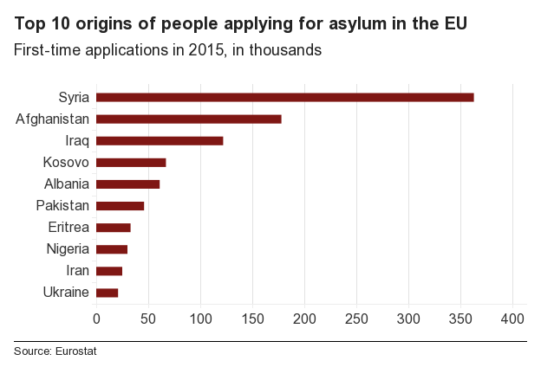
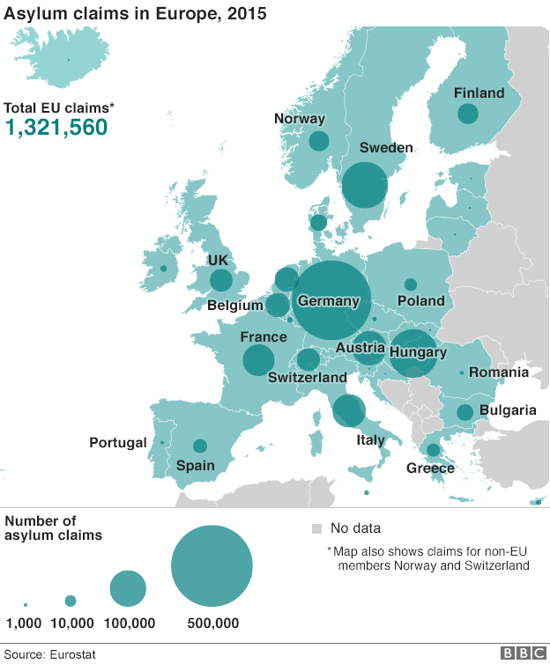

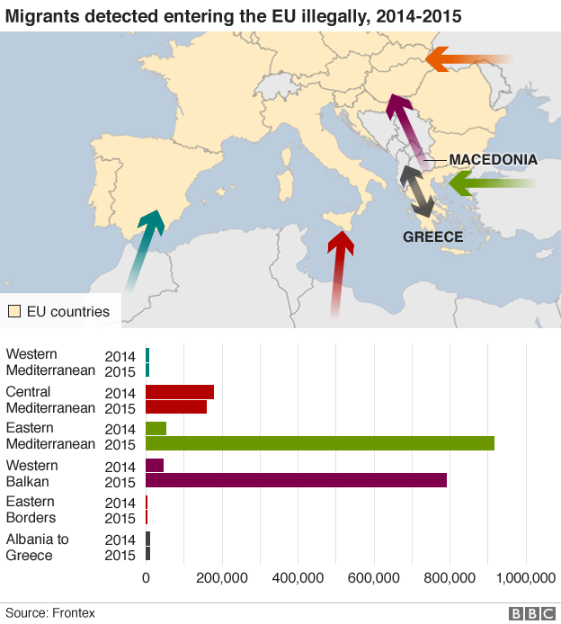

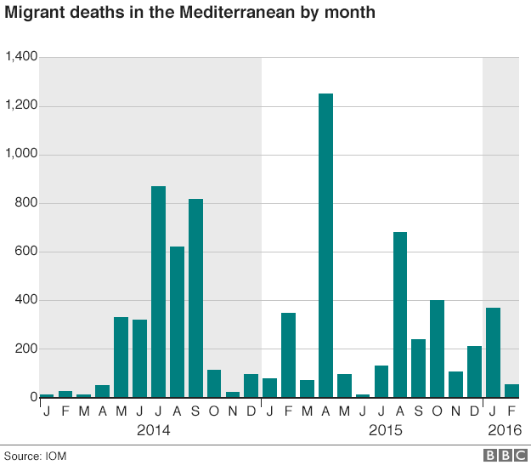
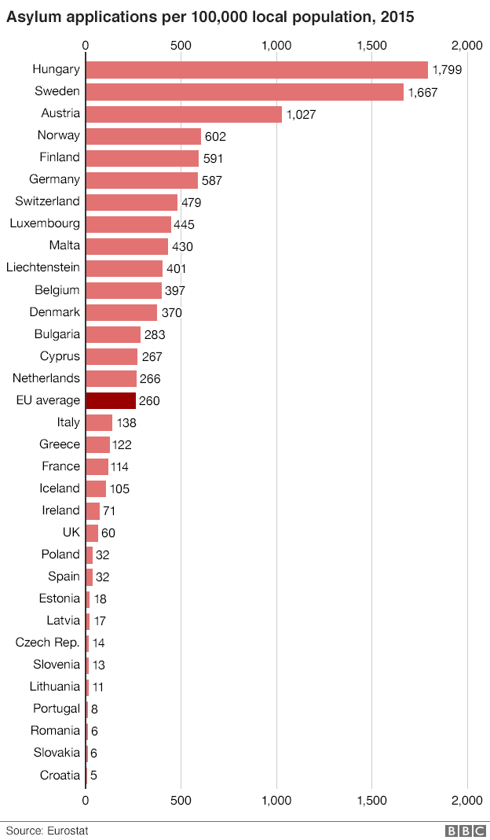

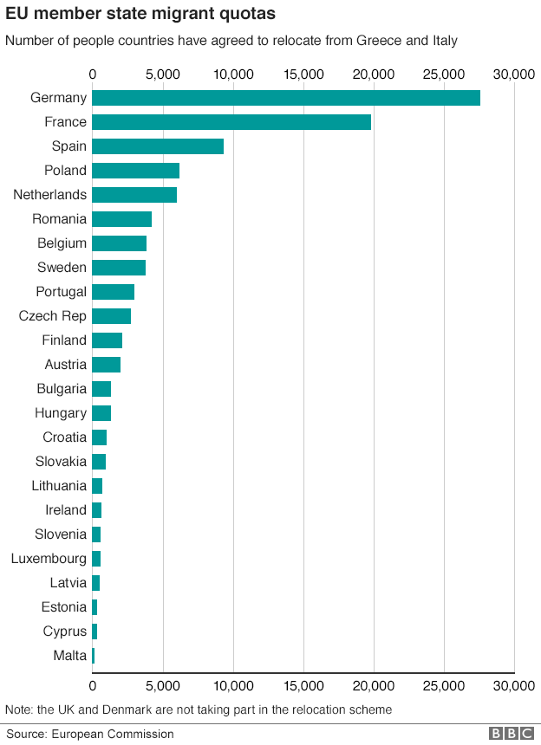

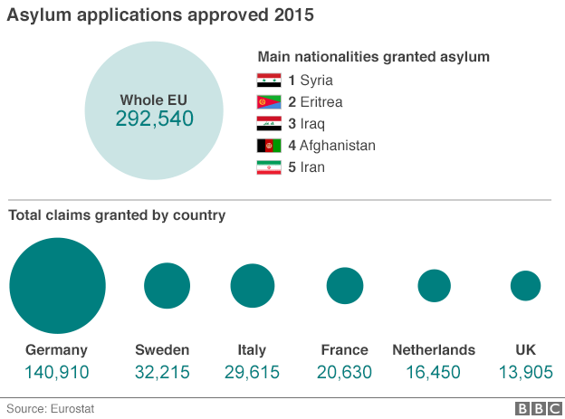

3.1.2 BME Representation in 2014’s top 100 films

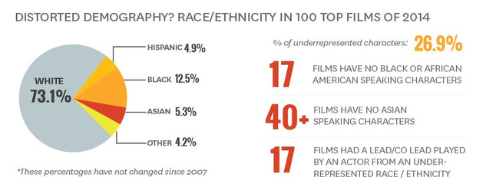

4. Results and Discussion

4.1 Results of Questionnaire

Q1 How would you be politically aligned?

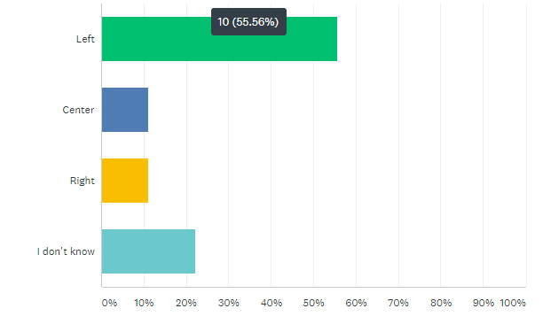

With the topic focusing on migration and the roles and representation of migrants in the media, political alignment plays a large role in determining the likely views each participant would have on migrants initially. Notably, majority of the 17 participants considered themselves left wing in their political views, suggesting a more positive view on migrants and immigrants from the responses although it will be worth considering their views on news media, comparing to that of migrant representation in film.

Q2 Do you feel the media can be influential to its audience?

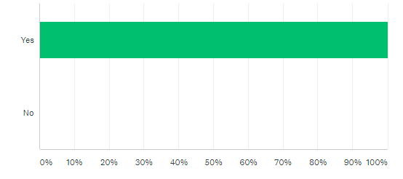

Out of all the participants of the questionnaire, 100% of them agreed on the influence of the media, this would suggest the media having a huge role in public perception and development of issues facing migrants although how this may translate to the role of migrants in contemporary film remains to be seen. With this it may be worth comparing the styles of reporting from news media, such as that of Breitbart, with the representation of migrants in films such as those addressed in the Fabrice Schurmans report as while these were fictional films, ‘Fast Food Nation’ was original based on a non-fiction book of the same name, and therefore would offer an alternative perspective on a topic also addressed in the Breitbart article.

Q3 Are you likely to accept the views of pages or public figures you follow on social media?

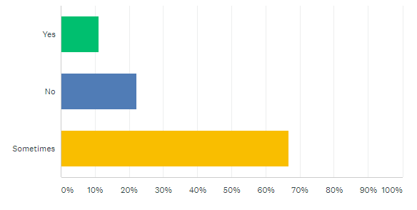

Despite the previous question having a 100% agreement that the media can be influential to its, the majority of responses,almost 70% participants (with 11% respondent suggesting they would and the rest denying), to this question suggested they may still accept the views of pages or public figures they followed. While not related to the same degree as news media, many pages and public figures, especially in recent years, would focus heavily on politics and social issues, some often considering themselves independent journalists. While this was not directly addressed on the questionnaire, this may have a link with the participants’ affinity for news media and views on representation of migrants, relating to their overall views on migrants and potentially comparing and/or contrasting with the role of migrants in film.

Q4 Are you likely to accept the stories of news media?

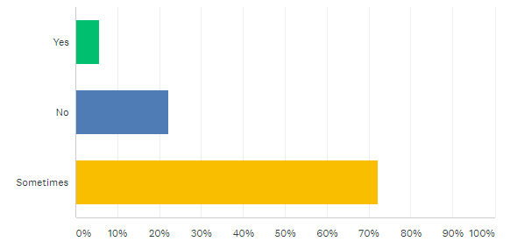

Similarly to the responses of the previous questions, majority of the responses, in this case over 70% of the respondents, suggesting they would sometimes accept stories from news media, although notably the yes responses here have reduced. This is still despite the agreement that the media can be influential which remains surprising given the general distrust in the media, particularly with mainstream media, however none of the participants elaborated on their answer and so the cause of this is up for speculation although research could be done here through social media attitudes to the stories coming from news media which may reveal the potential factors contributing to this.

Q5 Are you more or less likely to accept stories from independent news media versus mainstream?

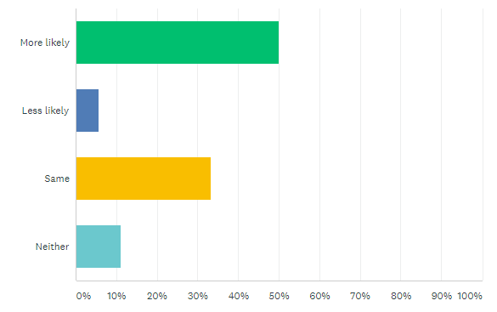

Linking with the previous question in the favoured sources of news media, the responses here were much more diverse, with 50% of the responses saying they would be more likely to accept stories from independent news sources over those from mainstream sources, suggesting a greater trust in independent news. The differences how these sources report on the same issues may be a contributing factor to this as it could offer very different perspectives on the same issue. How this is reflected on the roles and representation of migrants in film remains to be seen, although it may be worth considering the responses to films and other forms of entertainment media in how they represent migrants and migrant issues through social media and other forum platforms.

Q6 Do you feel migrants are fairly represented in news media? (mainstream or independent)

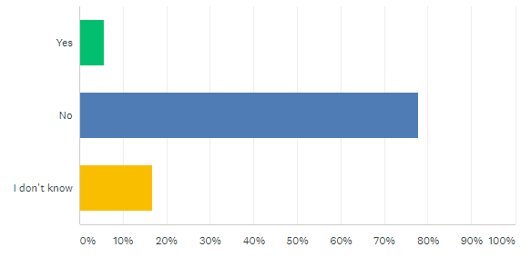

Immediately it is clear from the responses of this question that most feel migrants are not fairly represented in news media, while not elaborated on further, this may link to how migrants and migrant issues are perceived by the public and perhaps impacted on by news media through this lack of fair representation which may reinforce a negative perception where these issues are not explored enough and potentially leaving the audience misinformed on these issues, such as the focus on the negative impacts on Americans as result of the immigration from Mexico without considering the reasons for the immigration, as reported by Breitbart.

Interestingly one of the participants offered some elaboration on their answer, suggesting left leaning media is ‘scared’ to address any negative stories that involve migrants whereas the issue with right leaning meaning misrepresenting through clickbait focused headlines. It will be useful to look further into the reporting from left versus right leaning media in cases such as this to discover the validity of this statement.

Q7 Do you feel migrants are fairly represented in contemporary film/animation?

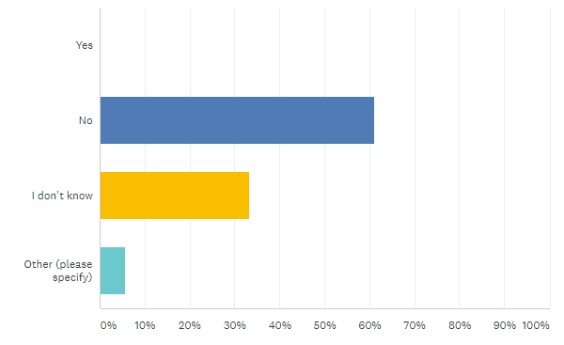

While the distribution of the responses for this question has shifted slightly from the previous question, the majority of participant still feel that in contemporary film, migrants are still not fairly represented, although this is notably to a lesser degree than the question for news media, having more responses saying they didn’t know which may link to how the public are influenced by the media and the possible misinformation considered above as a possible cause to the representation of migrants in entertainment media.

Once again, the participant who elaborated on their previous response suggested that migrants are romanticized in these forms of media and never criticised, this is a particularly interesting response considering the majority feeling an unfair representation is more common, whether or not this response is valid, it is worth considering this participants responses to the other questions, particularly their political alignment and views on news media, and whether there is a correlation between this view point and the role of migrants in these forms of media considered in the Schumers report and other areas of representation.

Q8 Do you feel the film industry has a responsibility to represent minority groups such as migrants?

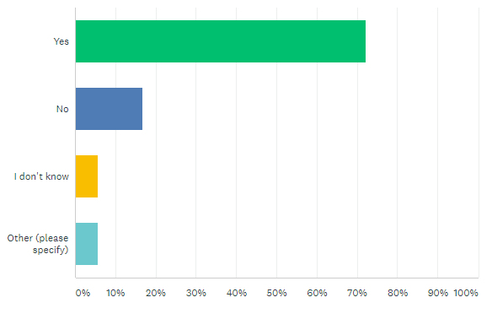

Considering the responses to the previous question, it is unsurprising to see the majority of responses to this questions agreeing that the film industry does have a responsibility to represent migrants (and other minority groups). Once again this may link to the current representation and roles of migrants in entertainment media and the potential impact that news media may have on this. As mentioned before, analysing the response to migrants in entertainment media through social media and online forums and also considering the correlation between the responses from the participants.

Although while there is a majority that agree that there is a responsibility with the film industry to represent migrants, there remains a number of participants suggesting this is not the case which again may link to potential trend between the negative or misinformed reporting/discussion on other sources of media.

4.2 Analysis of Results and Discussion

Analysing the responses from the participants of the questionnaire, there are a number of notable elements that link to how the issues facing migrants and surrounding immigration may impact public perception on this, and from this to the views on the roles of migrants in the film industry. Easily found in the results is the trends between political alignment and the responsibility of the film industry to represent migrants, with those on the left having a majority yes response and those on the right responding with no here. With those on the left, the responses to migrant representation were generally more positive, most feeling both news media and the film industry do not fairly represent migrants.
As with the no response from those on the right, the same was true in their responses to the fair representation of migrants, all with a no response here also, although it is worth noting that a very small minority of the participants considered themselves on the right, most being left or center, with this there is the possibility these responses are coincidence and not reflective of the the whole right, however it does reveal a trend in considering the response from those with right wing affiliation on issues affecting other minority groups (Haslem, 2017).

Additionally, a notable trend between all the participants regardless of their political alignment is their seemingly distrust in mainstream news media, most suggesting they would be more likely to agree with an independent source. This may be attributed to a number of factors, although a common difference between mainstream and independent news is the regulation of each as independent news outlets often make use of the internet to broadcast where there outlets are not subject to the same regulations and television broadcasts. Another factor that may exist here is the perception of greater bias in mainstream news media towards specific political views or parties although where or not this is the case, in the research of the articles from the BBC and Breitbart, Breitbart, being the independent online source appeared to present much greater bias to the immigration of Mexican people into America, playing on the view that it would result in a loss of jobs and welfare for the American people and simply did not report on the reasons for the mass immigration including their heavy use of criminalising language in regard to the migrants which was not the case with the BBC article who addressed migration in Europe in a much more neutral tone, along with explaining the terminology they used in the article.

This appears to be common trend between independent and mainstream reporting in that independent sources often present their information with their personal views made fairly clear, while not explicitly stating this, they're more ready to show their support or disapproval for the topic being reported on which is not always the case with mainstream sources although with these their views on the subject matter of the topic are often apparent in the style of reporting rather than the content. For example in a report from Fox News on a lawsuit against a transgender girl in which the defendant was accused of harassing other girls in their schools locker rooms, Fox News repeated denied the defendants status as a girl, repeatedly referring to them as ‘he’. While not explicitly agreeing or disagreeing with either side of the lawsuit, their misuse of the girls pronouns re-enforces the idea that they are a male in the female changing rooms, feeding a negative narrative around transgender people.
This use of damaging language is a factor that is common in right leaning media regarding migration and more so with independent right wing media, for example in the reporting of the migration of people from Mexico, a number of news sites repeated referred to the event in either negative terms of in a way to describe them in as an aggressive force, such as referring their migration as ‘storming the US’ or calling it an invasion.

The distrust in mainstream media in favour of these independent sources is something that has came about quite recently, particularly in 2016 with the presidential election in the US and Brexit in the UK, when many of the right wing parties and particularly with the then candidate Donald Trump and their repeated referral of fake news in regard to mainstream media, resulting in a lot of distrust in this, although there has been notable backlash in this perception, such as the aforementioned reporting on migration and other issues affecting minorities, in that these unregulated sources have the greater capability to push a specific agenda to impact the public perception of the reported topics.

So looking at how this may impact the film industry, this industry as a whole is one that appears to suffer from a lack of representation of a number of minority groups, from migrants to BME groups and the LGBT society. For example, in a study from USC Annenberg School for Communication and Journalism found that in 2014, non-white actors made up only 26.9% of character in that years top 100 films, massively underrepresenting them in comparison to the 73.1% of white characters. This also extended to workers in this industry, with less than 6% of crew members in film and television comprising of BME workers, linking this underrepresentation in the media itself to the lack of employment of BME people in this sector.

Although looking at the role of migrant characters in film, it appears these roles fall into a number of specific character roles such as that addressed in the the Schurmens report of the migrant as a border subject, someone whos identity as a migrant is determined by their interaction with the physical and metaphorical borders of countries often being commodified as was the case in the Fast Food Nation film where the migrants were made into a object of labour. Although while this appears to be very much a study on the role and treatment of migrants, this is obviously not the only role of migrants, also noting their use as the comedic relief side character, exotic love interest, or, in a much worse tone, in the role of the villains. The later being a common element along with whitewashing in films, a trend that appears to exist in Hollywood in the casting of white actors in roles that either culturally or through source material would be of a different ethnicity, such as the adoption of Japanese anime Ghost in the Shell (being a major example as the main character here was of Japanese descent but played by Scarlett Johansson) or in the films Gods of Egypt or Exodus, which cast caucasian actors to play characters that are traditionally non-caucasian.

5. Conclusion

Observing both how news media and the film industry perceive and and represent migrants, including other minority groups, there is major trend revealing how the former may impact on the later. This trend is in the resulting public perception of these minority groups, creating a negative narrative surrounding migrants encourages opposition to their fair representation in these industries and to a positive development of the issues faced by them. As seen in the analysis of the questionnaire responses, those of a particular political affiliation are more likely to consume their information from sources that seem to cater for their views, while it may be unclear where the original bias begins, it is clear that the misinformation found with the likes of Breitbart and also from publics figures expressing similar views creates an environment in simply circulates the same misinformed opinions.

As such the roles of migrants in the film industry struggle to develop, both in the statistics of the representation and in the narrative roles they take in mainstream film as developments in these are often subject to opposition, particularly from those with right wing affiliation who push back against the so called ‘political correctness’ of the media, as is often the case when topics surrounding the likes of migrant issues are addressed in popular media, for example in the ‘Rosa’ episode of Doctor Who’s eleventh series (the series itself faced backlash at the introduction of the first female Doctor due the a similar reason), the heavy reflection of real world racism faced backlash for being ‘too pc’ as was the response from Jeremy Clarkson's report on the episode for the Sun newspaper.

This paints a very clear image on how media is consumed by individuals, while some may actively seek out information that suits they preconceived views, it is very likely that many views are more susceptible to the influence of the media sources of choice, particularly considering the overall preference for independent media who are more open in the style and content of their reporting. This in turn can lead to the a stronger supportive or antagonistic attitudes to bettering the portrayal of migrants in contemporary film and animation.

6. Bibliography

4rfv. (2007). Event Highlights BME Under-representation In Film & Television. Available: https://www.4rfv.co.uk/industrynews/62670/event_highlights_bme_under_representation_in_film_television. Last accessed 12/12/2018.
BBC News. (2016). Migrant crisis: Migration to Europe explained in seven charts. Available: https://www.bbc.co.uk/news/world-europe-34131911. Last accessed 12/12/2018.
Estefania Medina. (2015). Las mujeres en Hollywood, en un segundo plano (image). Available: http://estaticos.elperiodico.com/resources/jpg/4/2/hollywood-prefiere-representar-personajes-raza-blanca-1438853669224.jpg. Last accessed 12/12/2018.
Fabrice Schurmans. (2015). The Representation of the Illegal Migrant in Contemporary Cinema: Border Scenarios and Effects. RCCS Annual Review. 7 (7), 132-143.
Greg Reese. (2018). BREAKING: MIGRANT CARAVAN SET TO STORM US BORDER SATURDAY DUE TO MEXICO EVICTION. Available: https://www.infowars.com/breaking-tomorrow-migrant-caravan-set-to-storm-us-border-due-to-mexico-eviction/. Last accessed 12/12/2018.
John Binder. (2018). Illegal Immigration Last Month Hit Highest Level in Over a Decade. Available: https://www.breitbart.com/politics/2018/12/10/iillegal-immigration-last-month-hit-highest-level-in-over-a-decade/. Last accessed 12/12/2018.
John Binder. (2018). Pew: No Majority of Citizens in the World Support Increasing Immigration. Available: https://www.breitbart.com/politics/2018/12/10/pew-no-majority-of-citizens-in-the-world-support-increasing-immigration/. Last accessed 12/12/2018.
Mark Lawson. (2015). Has British comedy learned how to portray foreigners?. Available: https://www.theguardian.com/tv-and-radio/2015/feb/10/has-british-comedy-learned-how-to-portray-foreigners. Last accessed 12/12/2018.
Samuel Parker. (2014). ‘Unwanted invaders’: The representation of refugees and asylum seekers in the UK and Australian print media. eSharp. 23 (2), p1-2.

