BSc Software Engineering

Introduction to Web Development (ACCA4003)
HTML & CSS WEB DEVELOPMENT
Specification Report
Austin Hooper
1700481

13/01/2018

Table of Contents
1. Introduction 1
2. Requirements 2
2.1. Introduction to Website 2
2.2. Site Map 2
2.3. Homepage Diagram 3
3. Implementation 4
3.1. Completed Website 4
3.2. Validation 10
3.2.1. HTML Validation 10
3.2.2. CSS Validation 10
4. Evaluation 11
4.1. Accessibility Evaluation 11
4.2. Possible Future Improvement 15
4.3. Overall Site Evaluation and Conclusion 15
5. Bibliography 16

Abstract
The report follows the design and implementation of a photography website.

Included are the planning, design and implementation diagrams. Screenshots illustrate the final design for each site page.

An evaluation analyses the accessibility and general functionality of the site. Future recommendations for the design of the site are considered.

HTML & CSS Web Development

Introduction
This report details the creation of a website promoting a personal interest, in this case photography.

The requirements section details planning and designing of the site, including idea discussion, a site map and home page diagram.

Implementation consists of the development of the site using HTML (Hypertext Markup Language), CSS (Cascading Style Sheets) and code validation.

The accessibility of the site will be evaluated, with future improvements discussed. The accessibility evaluation will be conducted using both standard computer software together with browser extensions.

The website will be compatible with most devices; however, responsive design will not be considered within the scope of this project.

Throughout the project validation online tools will be used to support the development, these sources will be referenced along with any other research.

Requirements

Introduction to Website
The purpose of this website is to promote the author's photography work. The subject was chosen because it was identified as an option which would offer flexibility in appropriate layout, allowing for the possibility of choice of a variety of design styles. If the site were to be hosted for online access, it would be intended as a way of promoting the author's work to potential clients who would have the option of requesting photo shoots.

Site Map
All pages on the site link to each other, with the exception of the contact details page. This page is only accessible from the contact page when submitting data. See a site map illustrating this below:
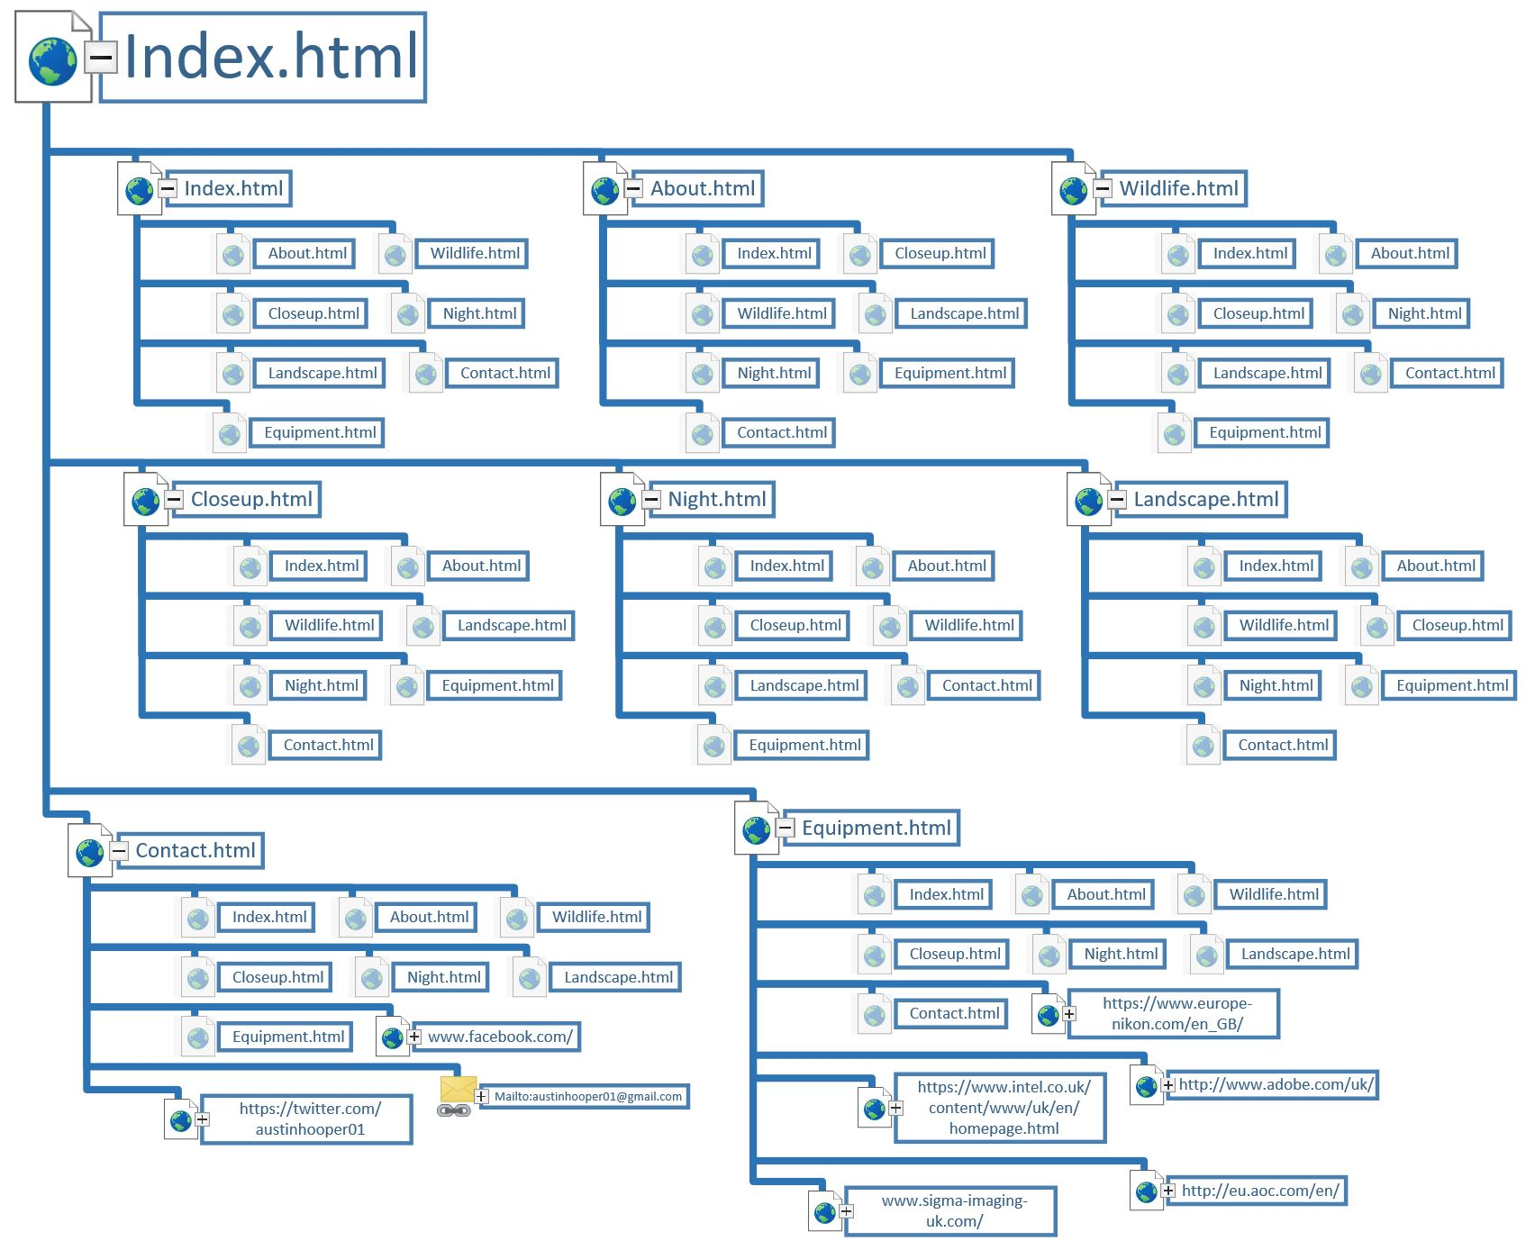
Figure 1 - Site map

Homepage Diagram
See below the wire frame diagram for the homepage of the website:
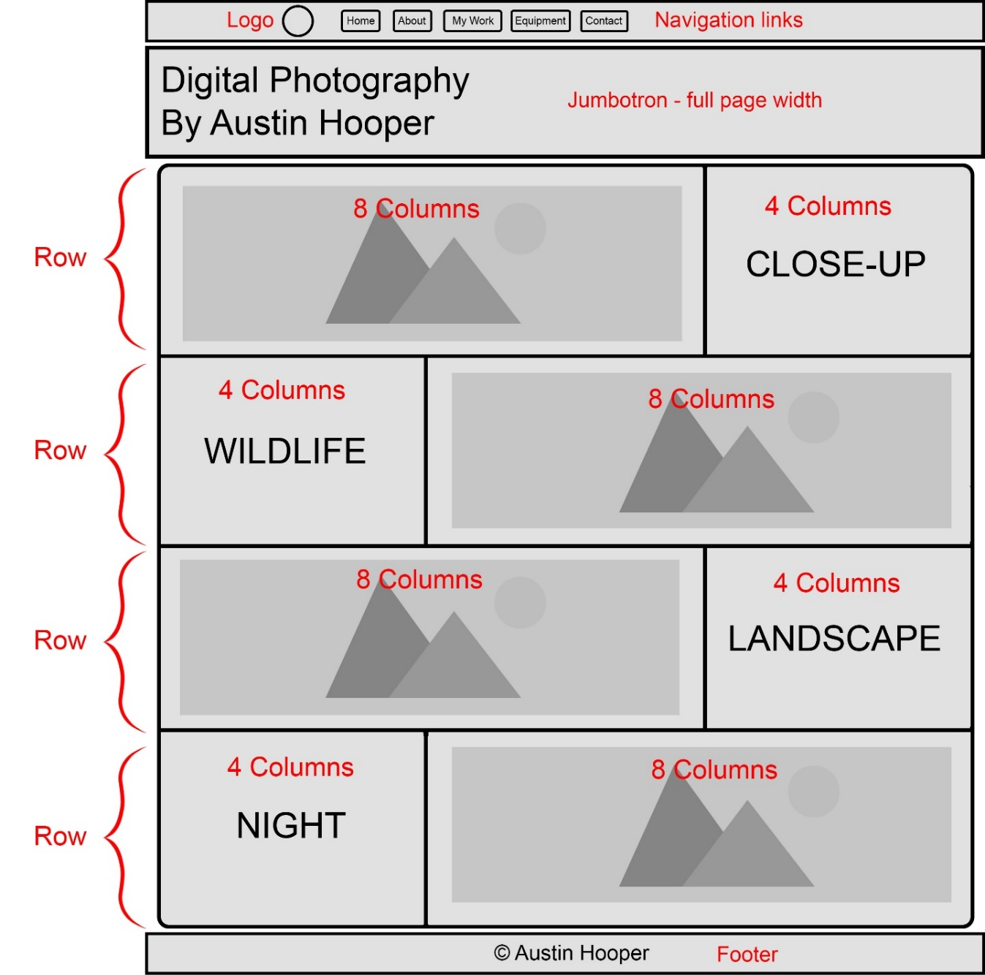
Figure 2 - Homepage diagram

The homepage consists of a navigation bar and footer, a banner and the main content section. The main content section is comprised of four rows, each with two columns. The column proportions were set to be 2:1 per row, with the image and text alternating position in each row. This was done for visual effect and to make the rows less similar and repetitive.
The home page renders well on most displays, however it is displayed incorrectly at certain aspect ratios as it is not responsive. This results in content being cut off, which would preferably be resolved by implementing responsive design in the future

Implementation

Completed Website
All pages in the site contain a fixed navigation bar and footer which are overlaid above the content. The site uses Bootstrap 3 to organise its content. The following are images of each completed page of the site, in full and without cropping to the 16:9 aspect ratio. On a display, the user would scroll to view the entire page.

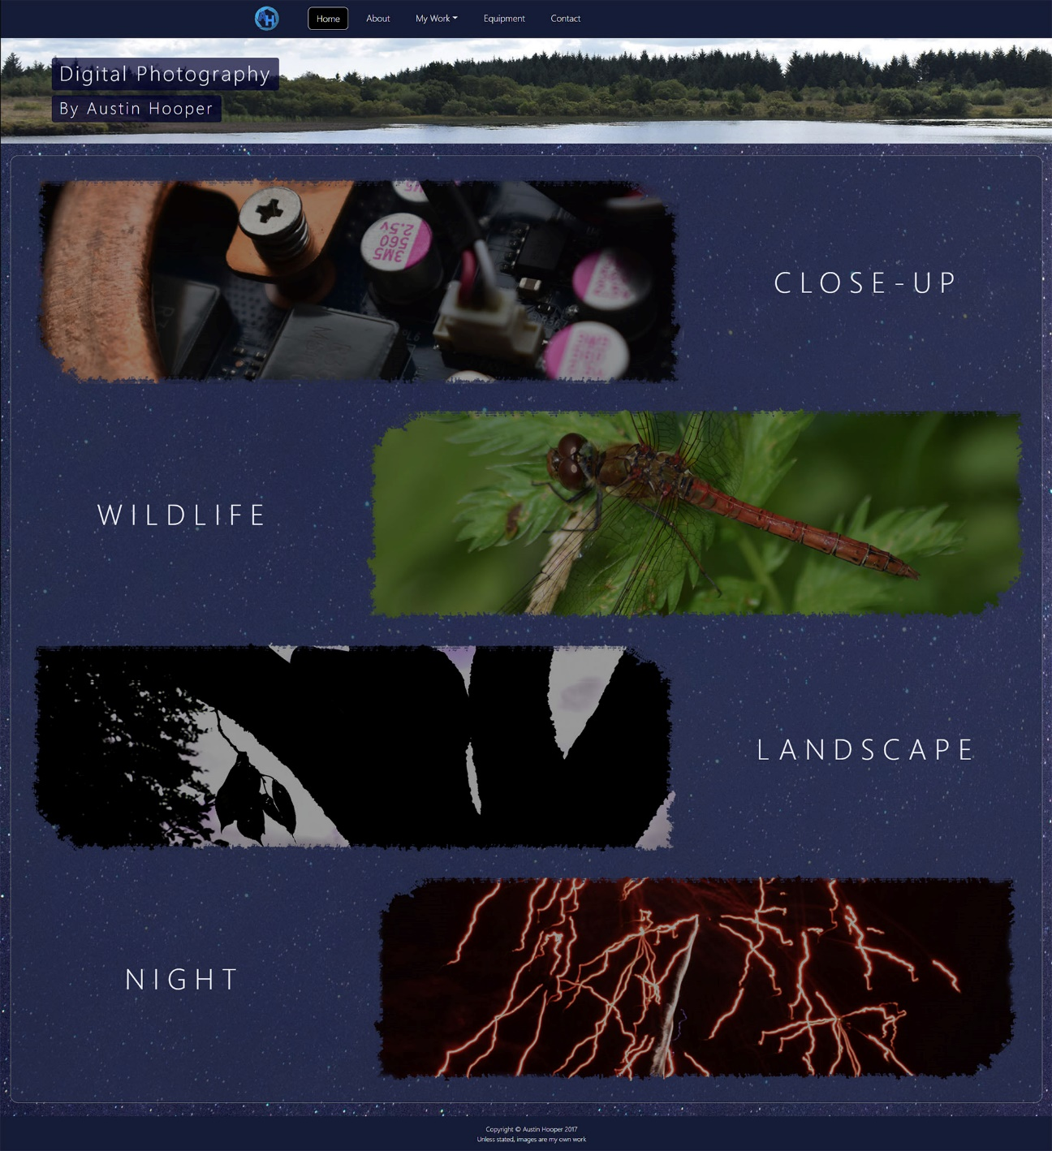
Home Page
Figure 3 - Home page
The home page contains a banner at the top, and a main section with links to the four gallery pages. These are arranged to align to opposite sides per row for visual appeal.
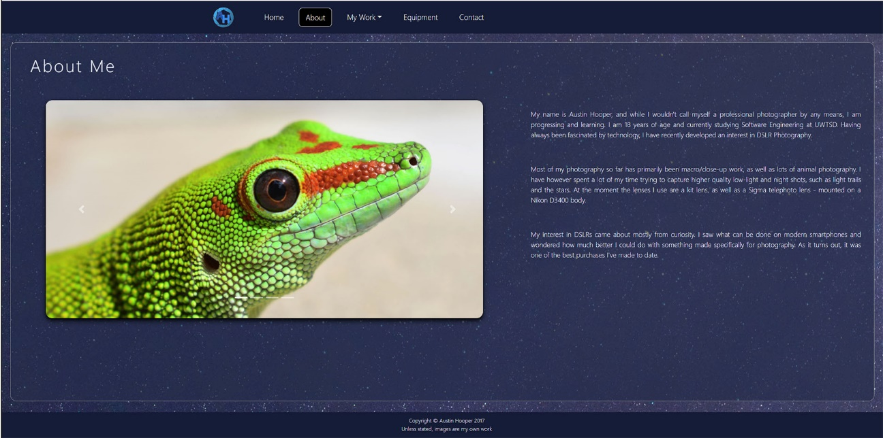
About Page
Figure 4 - About page

The about page contains some background information about the author separated into three paragraphs on the right-hand side, along with an image slider on the left-hand side of the page.

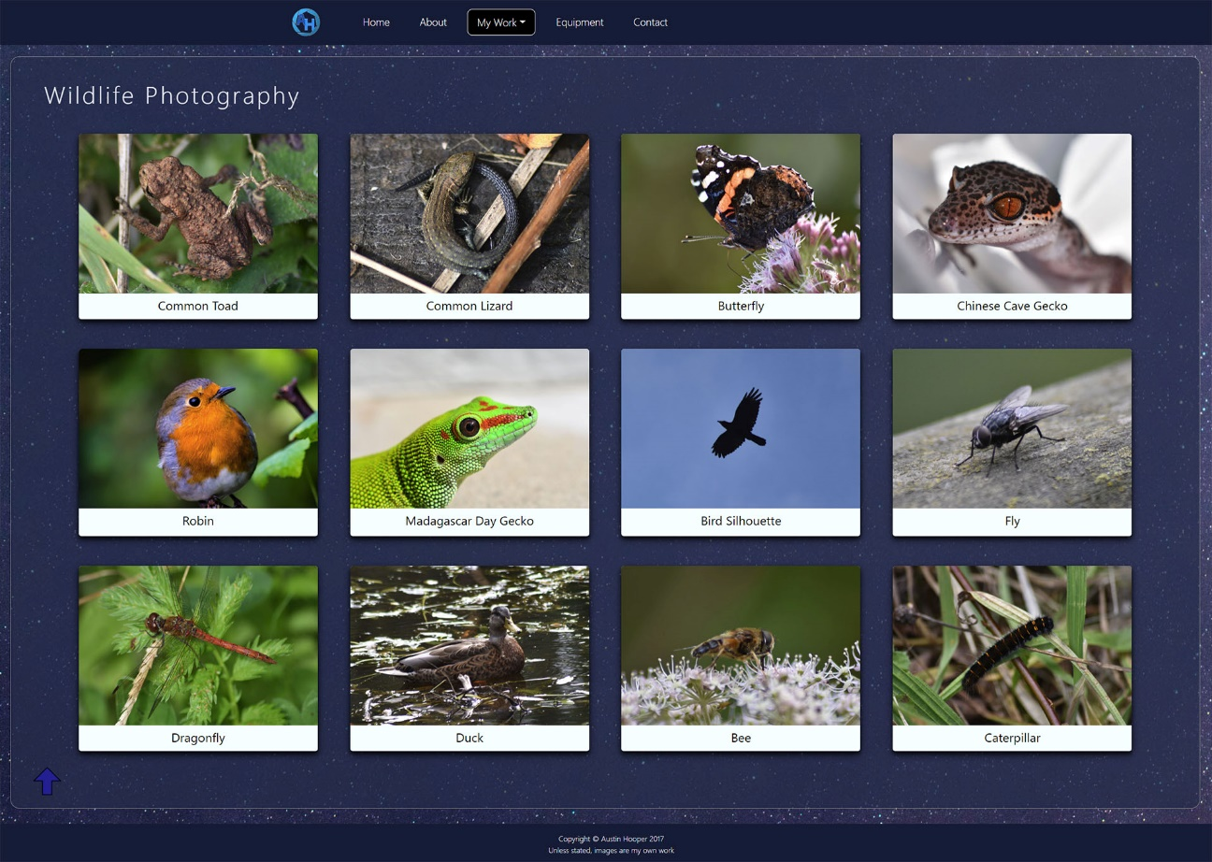
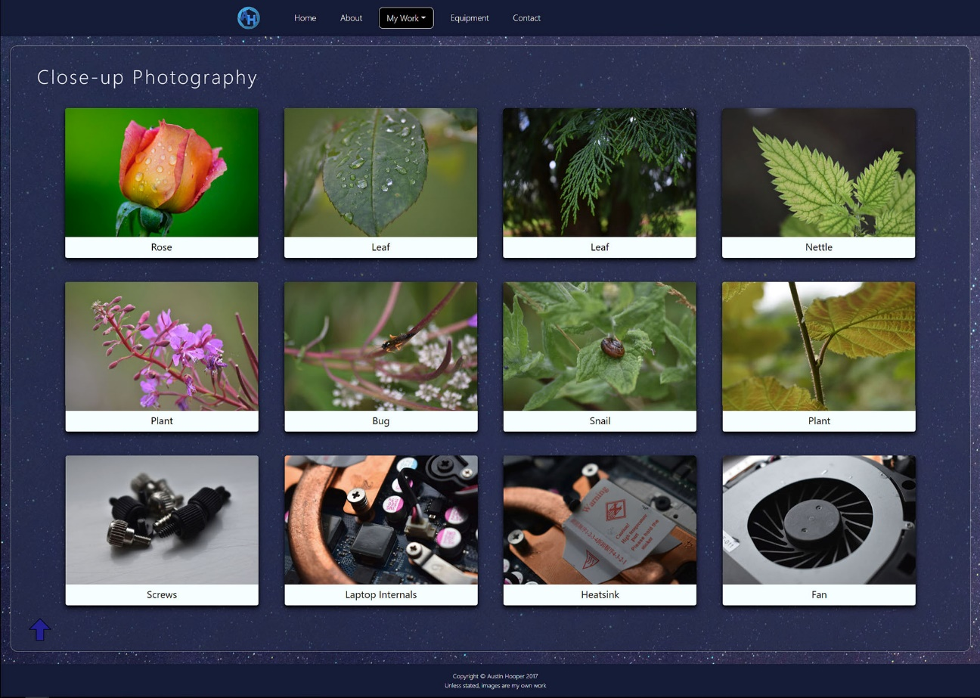
Gallery Pages
Figure 6 - Wildlife gallery page
Figure 5 - Close-up gallery page

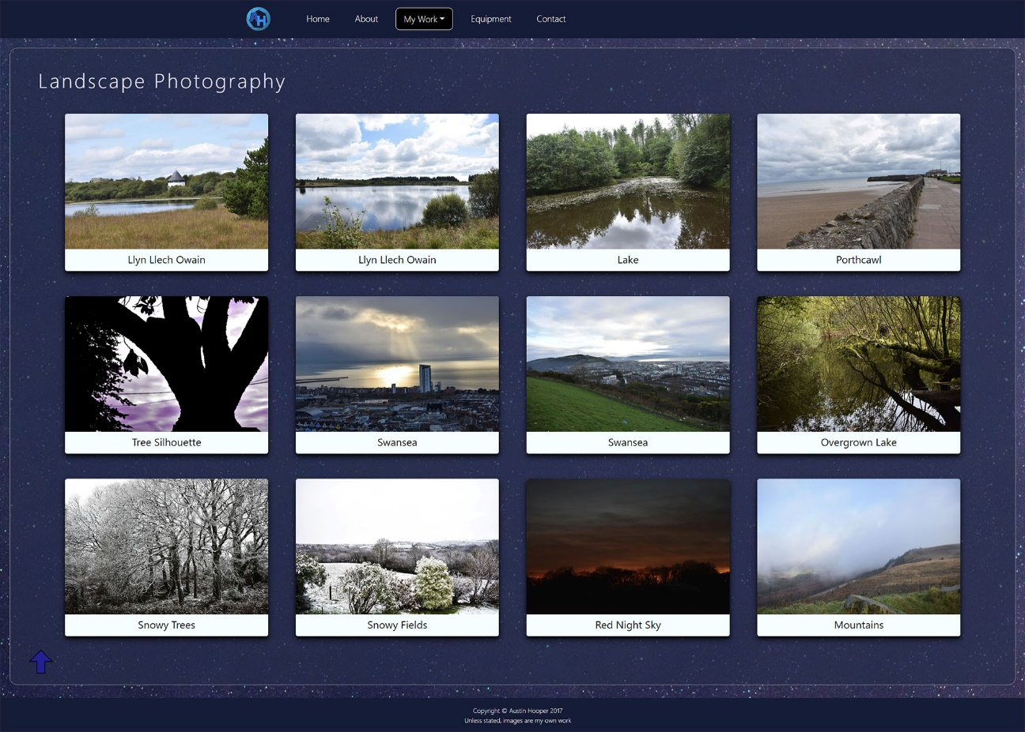
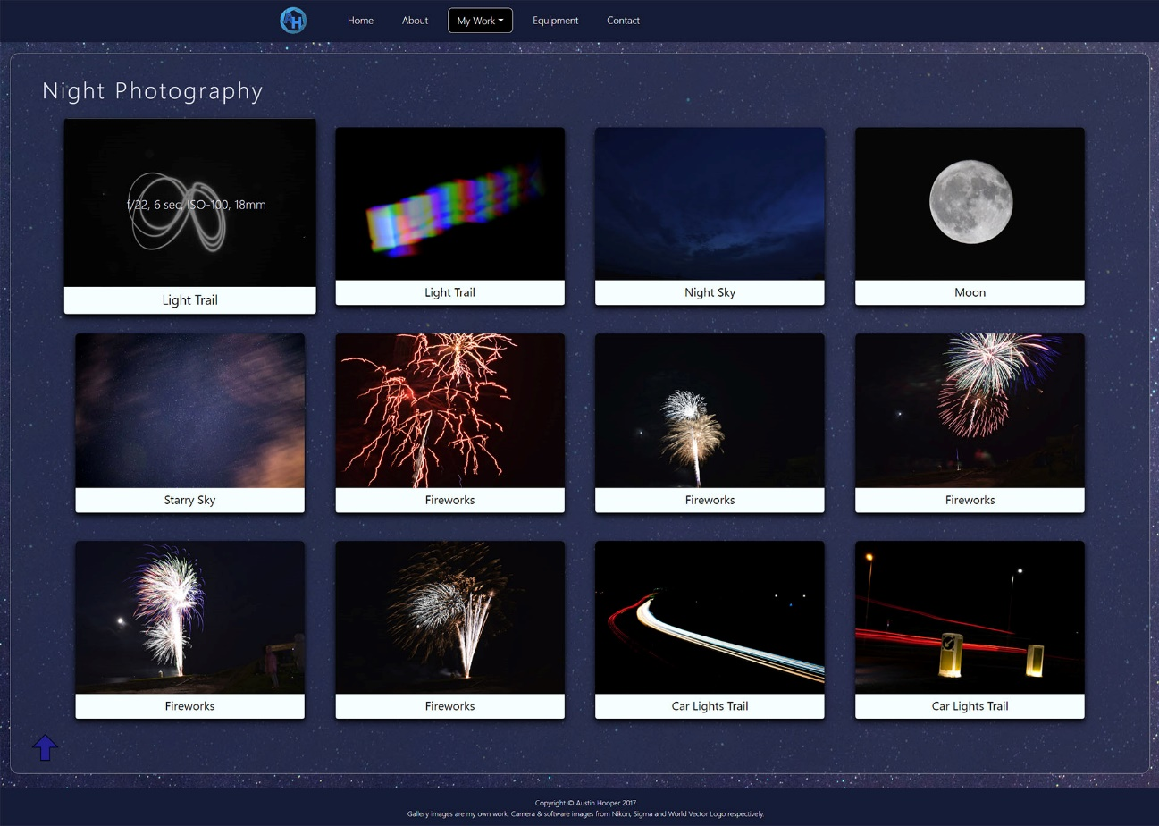
The gallery pages contain a grid of images and a back to top button at the bottom. When an image is hovered over, it greys out, enlarges slightly, and displays the camera settings used to capture the image. This can be seen in the final screenshot.
Figure 8 - Night gallery page
Figure 7 - Landscape gallery page
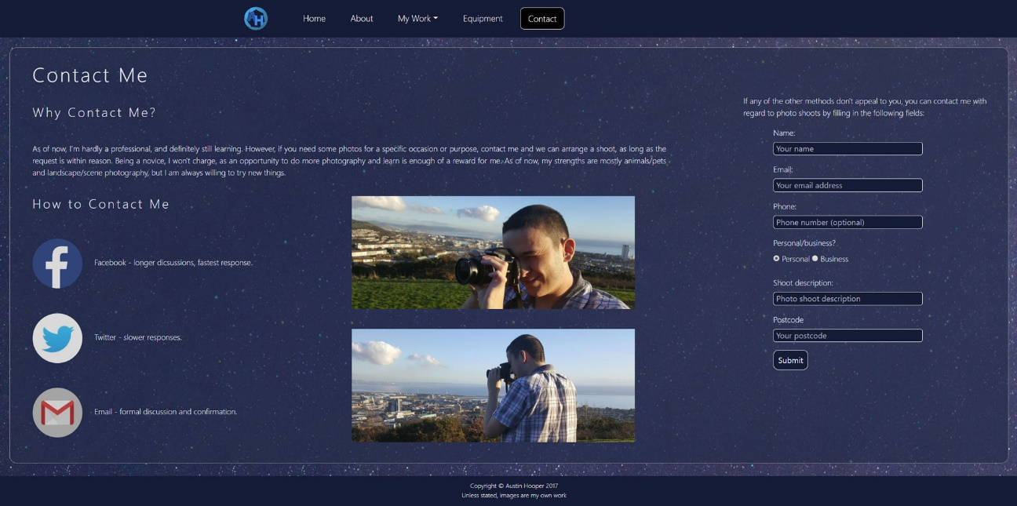
Contact Page
Figure 9 - Contact page
The contact page shows ways of contacting the author along with relevant images and links. A form is used to submit personal contact details.

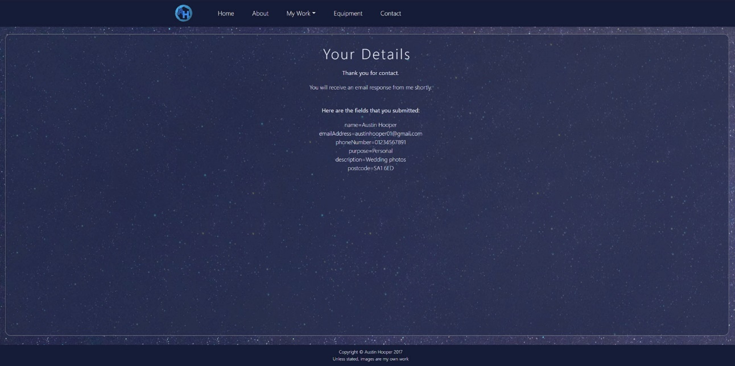
Contact Details Page
Figure 10 - Contact details page
The contact details page displays the user’s input information as confirmation. If the site were to be hosted, this would ideally be saved to a database.

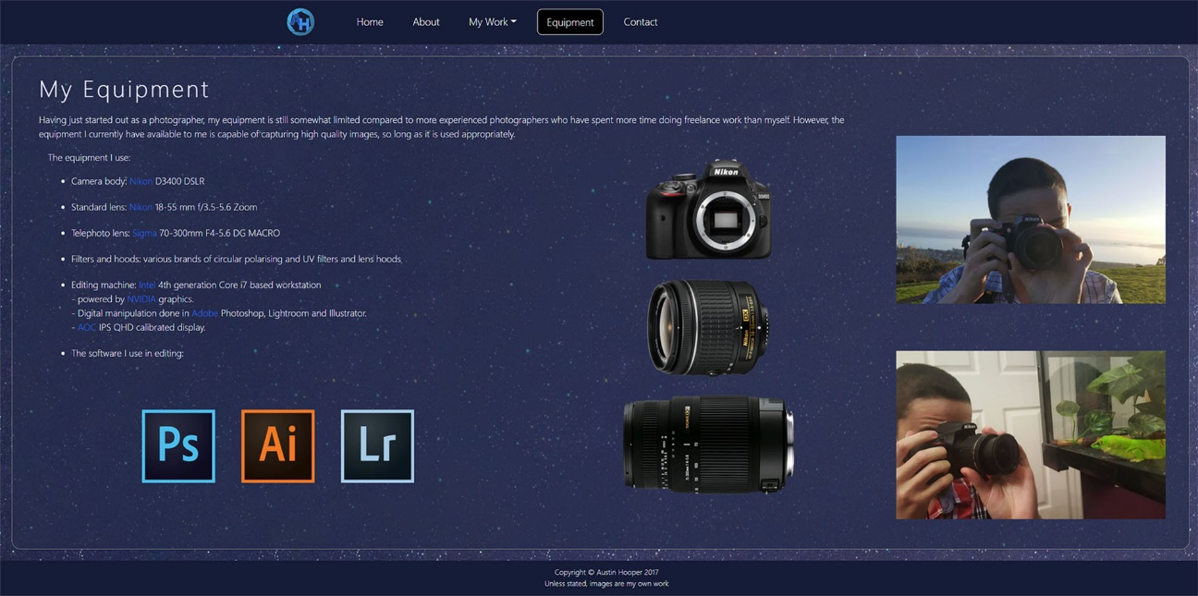
Equipment Page
Figure 11 - Equipment page
The equipment page contains listings of the equipment used by the author, along with appropriate images.

Images of software icons, as well as social media, were obtained from the World Vector Logo site. [1]

Camera equipment images were obtained from the Nikon [2] and Sigma [3] sites.

Images included in the gallery pages, along with images of the author, are the author’s own work.

Validation

HTML Validation
The following were the errors found during validation of the site:
- Lack of "alt" attribute for logo and category images. This was fixed by adding one with a description of either "logo" or of the image category (e.g. "Wildlife").
- The <main> element had been used twice unintentionally, one within another. This was fixed by removing the outer <main> element entirely as there was no additional content inside it other than the second <main>.
- Duplicate IDs within some rows. This was fixed by changing the "id" attributes to "class" attributes.
The W3C Markup Validation Service [4] as well as Microsoft Visual Studio were used to validate the site's HTML code. No other errors were identified.

CSS Validation
Within the site's CSS file there were no errors, but there were two warnings which appeared repeatedly. The first was that measurements of 0 should not have units attached to them, for example 0% and 0px. The second was that RGBA background colour values had been assigned for transparency, but no RGB value was assigned as a fall back. Both warnings were taken into consideration, the units were removed from values of 0 and background colours without transparency were added to fall back on in the event that transparencies were not supported.

The W3C CSS Validation service [5] as well as Microsoft Visual Studio were used to validate the site's CSS.

Evaluation

Accessibility Evaluation

Colour and Contrast

For colour evaluation, Acart Communication's WCAG Contrast Checker [6] was used to check site compliance with WCAG 2.0 colour standards. The initial background and foreground colour combination was found to be insufficient to meet colour difference standards, despite meeting all other standards. To ensure that the main background and foreground combination met this standard, the background colour was changed. This can be seen below:

Background | Foreground
Initial colour  rgb(0, 80, 100) | rgb(240, 240, 255)
New colour  rgb(44,52,87)* | rgb(240, 240, 255)

After modifying the initial background colour, all background and foreground colour combinations that can be tested for are WCAG 2.0 compliant. See below a chart of colour combinations used throughout the site:

Background colour | Foreground colour
rgb(20, 30, 60) | rgb(180, 180, 200)
rgb(20, 30, 60) | rgb(255, 255, 255)
rgb(0, 0, 0) | rgb(240, 240, 255)
rgb(0, 0, 40); | rgb(240, 240, 255)
rgb(44, 52, 87)* | rgb(240, 240, 255)
rgb(245, 255, 255); | rgb(0, 0, 0)

*The background consisted of an image and a translucent colour overlay, meaning it was not one solid colour. The colour value used here is an average colour from the entire page background.

Gallery images could not be tested for colour compatibility as there were many different images, with many colours making up each image. However throughout the accessibility evaluation process, it was noted by peers that the white text was often difficult to read over the images. To correct this, the CSS saturation filter was set to 100% on images and set to decrease to 50% upon cursor hover (when text displays). This greatly increased the readability of text over the images.

Headings

The text on the site is styled using CSS. This includes navigation items, headings, main bodies of text, lists and image captions. Styles are used to differentiate the purpose of each text item.

Heading elements are larger to indicate that they are page or content titles. The site meets WCAG 2.0 guideline 2.4.6 as it correctly describes section content with headings.

As per WCAG 2.0 guideline 2.4.10, the site uses titles to organise content, and uses <h1> and <h2> elements appropriately to differentiate between headings and sub-headings.

Navigation

The main content of the site is grouped together and begins immediately after the navigation bar. The gallery pages have a back to top button to scroll to the top of the page in the case that the user is on a mobile device and scrolling back to the top would be repetitive. As a result, the site meets WCAG 2.0 guideline 2.4.1.

Each page has a title which matches its topic or purpose, as per guideline 2.4.2.
The focus order is appropriate and allows most of the content to retain its meaning. However, gallery images are excluded and cannot be focused on using a keyboard and thus guideline 2.4.3 is only partially met.

The purpose of link text (such as navigation bar items and external links) can be determined from the link text alone, meting guideline 2.4.4.

Images

As per WCAG 2.0 guideline 1.1, text alternatives are provided for any still or moving images on the site in order to allow screen readers and similar assistive technology to tell the user what they are.

Information and Relationships

The site does not meet guideline 1.3.1 for information and relationships. However, it meets many of the points making up this guideline:
- Sections of the page and headings are clearly identified with the "role" attribute
- Semantic elements are properly used to identify components of the site
- The grouping role "radio" was included on the form radio button section
- Heading elements are used as headings, and not for font effects.

Scalable Text Content

The site does not meet WCAG 2.0 standards for text scalability as it has no text resizing functionality. This would ideally be implemented in a later version of the site.

Using tools to check accessibility

Several other tools were used to test all elements of WCAG 2.0 accessibility. Find below the results of each test:

The aXe extension for Google Chrome was used to validate the accessibility of each page of the website. The extension found no flaws with the site in regard to accessibility. This is likely because some accessibility issues were fixed previously.

The Wave Accessibility Extension for Firefox was also used in-browser to check accessibility. No errors were present, however some warnings were displayed. See below the warnings and actions taken to resolve them:

- Justified text was identified, and a warning label was attached. In this case the justified text is intentional.
- A warning was attached to the form on the contact page, pointing out that the radio buttons were not enclosed in a <fieldset> element. To fix this, they were placed inside one.
- Some "alt" attributes were flagged as being too similar to each other. In some cases, they were changed to be more appropriate, but in others they were intentionally the same and so were not modified.
- Two links on the equipment page led to the same place. However, this was intended, so no action was taken.

As well as browser extensions, Visual Studio's inbuilt WCAG accessibility checker was used to test accessibility. Upon testing, there were no errors, however there were many warnings per page. See below the complete list of warning and actions taken to fix any potential issues:
Accessibility warning | Pass/  fail? | Notes/action taken
Use header elements to convey document structure, for example <h2> is a subsection of <h1>.  Do not use header elements for font effects. |  | The HTML was checked to ensure heading elements were used appropriately.
If you are using style sheets, verify that this document can be read with style sheets turned off. |  | The site was tested without style sheets. All content was displayed in an organised fashion.
Consider using <noscript> to provide an alternative description of <script> content. |  | Added a <noscript> element to the contact details page informing the user if JavaScript is not supported.
Verify that any element with its own user interface is device-independent. |  | A keyboard and mouse are supported by the site and while other input methods cannot be tested for, the site should be compatible with input methods such as voice input and other future technologies.
Avoid moving content or allow users to control the movement. |  | Warning referred to external scripts. There is little to no movement on the site.
Verify that programmatic elements are accessible using assistive technology. |  | The website consists of text items and images. All content should be accessible as the images all have an "alt" attribute attached for compatibility with screen readers or similar software. Navigation elements are labelled so should be accessible.
Be sure this page is usable when programmatic objects are turned off or not supported. If not, provide alternative text that describes the information that the element conveys. |  | This warning referred to external script content. With the scripts disabled, the site remained functional with the exception of the drop-down navigation bar. This would ideally be improved upon in a later version of the site.
Large blocks of information should be grouped so they are more manageable. If this form is large consider breaking it up using <legend> and <fieldset>. |  | Form was relatively short and so does not need to be broken up into pieces.

Possible Future Improvement
The following are the potential future improvements, if more time was allocated to the website:
- The site would be responsive, to be more suitable for a wide range of devices
- The contact form data would be saved to a text file or preferably a database instead of being sent to another page
- There would be a JavaScript enabled option to change font size and background/text colour, for better accessibility.
- The gallery pages would have a lightbox to better show the images, as opposed to them remaining small on the display
- Form data would be saved to a text file or preferably a database

Overall Site Evaluation and Conclusion
Overall, it has been found that the website is a success. Exceeding original expectations, the structure provided pleasing aesthetics, and the site is easily navigated and accessible. The site was also found to be intuitive for the user. The main drawback discovered is a lack of responsiveness, more responsiveness would further increase accessibility. The content on the site is appropriate, fitting the brief and is appropriately presented.

Bibliography
[1] World Vector Logo, [Online]. Available: https://worldvectorlogo.com/. [Accessed 16 12 2017].
[2] Nikon, Nikon Corporation, 2017. [Online]. Available: https://www.europe-nikon.com/en_GB/?. [Accessed 14 12 2017].
[3] Sigma, "APO 70-300mm F4-5.6 DG MACRO," Sigma Imaging, 2017. [Online]. Available: https://www.sigma-imaging-uk.com/index.php?route=product/product&product_id=103. [Accessed 14 12 2017].
[4] World Wide Web Consortium, "The W3C Markup Validation Service," World Wide Web Consortium, 2013. [Online]. Available: https://validator.w3.org/. [Accessed 20 12 2017].
[5] Word Wide Web Consortium, "The W3C CSS Validation Service," World Wide Web Consortium, 2009. [Online]. Available: http://jigsaw.w3.org/css-validator/. [Accessed 20 12 2017].
[6] Acart Communications, "WCAG - Contrast Checker," Acart Communications, 2017. [Online]. Available: https://contrastchecker.com/. [Accessed 18 12 2017].
[7] J. Duckett, HTML & CSS: Design and Build Websites, Indianapolis: Wiley, 2011.
[8] Refsnes Data, "W3Schools," Refsnes Data, 2017. [Online]. Available: https://www.w3schools.com/. [Accessed 12 12 2017].

