

University of Wales Trinity Saint David
School of Engineering
Evaluation of Concept Designs and Final Selection
Claudia Andre, Duke Asamoah, Alex Baldwin and Jeffrey Elliss
1704218,1706143,1801714,1802644
Motorsport Engineering Beng
8th February 2019
Engineering Design, M4X01160

Contents

Table of Contents
Contents 1
Duke Asamoah 3
Introduction 3
Comparison on Electrical motors 4
Alex Baldwin 7
1 Introduction 7
2 Results 8
3 Discussion 9
4 Conclusion 11
5 References 11
Jeffrey Elliss 12
Introduction 12
1.0 Initial Concepts 13
1.0.1 Categories 13
1.0.2 Chassis Categories 13
1.1 Chassis material and Construction 14
2.0 Final Design Selection 14
Conclusion 15
Evaluation 16
Appendix A 18

Claudia Andre
Claudia has had computer issues and having sent a draft to me has asked that I not include the work in this report. As such I am adding this note also to her wishes to inform you of the situation.

Duke Asamoah

Introduction
The group came together again during the first week of the 2nd semester to discuss what the next step on the pipe climber project. Each person on the group was responsible for a role. The people in the group were Jeffery who was responsible for Team leadership and system integration, Duke (Me) who’s duty was to gather info and research on the what power generation and storage to use for the pipe climber, Alex who was responsible for the control, robustness and Reliability and payload and Claudia who was responsible for mechanical drive and propulsion. The team leader spoke out on when the group should come together and do work on this pipe climber project which were on Mondays and Thursdays.

Comparison on Electrical motors
Electric motor selection |  | Rating A |  | Rating B |  | Rating C |  | Rating D |  | Rating  E
Description (product) | RS Pro DC motor (A) |  | RS Pro DC motor (B) |  | RS Pro DC motor (C) |  | RS Pro DC motor (D) |  | RS Pro DC motor (E) |  |  | Priority
Weight | 20 | 5 | 44 | 2 | 51 | 1 | 20 | 5 | 20 | 5 |  | 4
RPM | 8200-14000 | 2 | 7800 | 5 | 10668 | 1 | 9000 | 4 | 9869 | 3 |  | 10
Brand | RS PRO |  | RS PRO |  | RS PRO |  | RS PRO |  | RS PRO
Power rating w | 1.21 | 1 | 1.6 | 1 | 5.75 | 4 | 19.68 | 2 | 7.98 | 4 |  | 7
Length mm | 38 | 3 | 30.5 | 5 | 32.5 | 4 | 38 | 3 | 38 | 3 |  | 2
Maximum Output Torque | 10.4 | 1 | 20 | 2 | 58.8 | 3 | 375 | 5 | 78.4 | 3 |  | 10
Current rating mA | 960 | 5 | 850 | 5 | 770 | 5 | 4.41 (Amps) | 4 | 990 | 5 |  | 10
Dimensions mm | 21 (Dia) x 38 | 2 | 23.8 (Dia) x 30.5 | 2 | 27.63 (Dia) x 32.5 | 4 | 27.7 (Dia) x 38 | 5 | 27.7 (Dia) x 39 | 5 |  | 1
Shaft diameter mm | 2 |  | 2 |  | 2.31 |  | 2.3 |  | 2.31 |  |  | 1
Supply Voltage V dc | 1.5to 3 | 2 | 1.5 to 3 | 2 | 6 to 15 |  | 3 to 7.2 | 4 | 6 to 15 | 5 |  | 3
Core Construction | iron core |  | iron core |  | iron core |  | iron core |  | iron core |  |  | 1
Category | DC |  | DC |  | DC |  | DC |  | DC |  |  | 5
Availability | Yes |  | Yes |  | Yes |  | Yes |  | Yes |  |  | 7
Cost (£) | £1.75 | 2 | £2.25 | 2 | £4.48 | 5 | £4.55 | 5 | £5.14 | 3 |  | 10
website | rs components |  | rs components |  | rs components |  | rs components |  | rs components
Total (Worst to Best Motor) |  | 23 |  | 26 |  | 27 |  | 37 |  | 36
The table below is the comparison of what electrical motors were selected with the lowest price cost that was found doing research. The group leader insisted that we get motors below the cost of £5.00 since a save in money could benefit the group for spare component. The rating numbers by the motors indicates what aspect of that motor is good for (1 is poor to 5 is excellent). The ratings of each motor are totalled up resulting in Motor D being the best option and motor A being the worst. Motor D was picked because it had incredible torque and the RPM comes at an adequate speed. The torque needs to outperform the RPM because when the motor is climbing up the pipe it needs to be able to have a strong traction while carrying the components and chain on it. With the cost at a low price of £4.55 and the weight at only 20g. This is the best choice.
Here (below) is another comparison on what battery holder will be wired to the motor D. Discussing with the group what holder for the energy storage to use really benefited on having a verdict. The holder picked out was the keystone 2478 4 x AA (first column) (Keystone 2478 Battery holder for 4 x AA - and Flying Leads | Rapid Online, 2019) because the weight is reasonably light and the cost is cheap as they both mark in at 1st priority. This battery holder has some positive advantages such as
- Economical design, available with PC terminals or wire leads
- Batteries securely held in place to assure a positive connection and maintain a low contact resistance
- Contact springs self-adjust to variations in battery length
- Withstands shock and vibration
- Available with solder lugs or male/female snap fasteners
- For easy removal, available with ribbon
Energy storage
Description (product) | keystone 2478 4 x AA |  | keystone 2465 3 x AA |  | Enclosed 3 xAAA |  | 12V 8 x AA Battery clip |  | Priority
weight (g) | 15 |  | 15 |  | 15 |  | 20 |  | 10
Brand | keystone |  | keystone |  | Pro Power |  | Arduino
Type | battery holder |  | battery holder |  | battery holder |  | battery holder
Battery size | AA |  | AA |  | AAA |  | AA |  | 7
Number of Cells | 4 |  | 3 |  | 3 |  | 8 |  | 9
Terminal Type | wire lead |  | wire lead |  | wire lead |  | wire lead
Length mm | 58 |  | 58 |  | 53 |  | 58 |  | 7
Width mm | 63 |  | 48.3 |  | 37 |  | 61 |  | 7
Height mm | 16 |  | 17 |  | 15 |  | 30 |  | 7
Body Material | polyproplene |  | polyproplene |  | polyproplene |  | polyproplene
Website | Rapid |  | Rapid |  | CPC |  | Bang good
Cost (£) | £1.68 |  | £1.64 |  | £0.72 |  | £1.90 |  | 10

Batteries
Description (product) | Industrial |  | Super Alkaline |  | Alkaline Power |  | Long life batteries
Brand | Duracell |  | JCB |  | Energizer |  | Philips
Weight (g) | 23 |  | 24 |  | 322 |  | 30
Volts | 1.5 |  | 1.5 |  | 1.5 |  | 1.5
Chemistry | Alkaline |  | Alkaline |  | Alkaline |  | carbon chloride
Size | AA |  | AA |  | AA |  | AA
Websites | Battery station |  | Battery Force |  | ebay |  | ebay
cost | £2.99 for box pack |  | £2.89 for 4 cells |  | £3.49 for 8 cells |  | £1.69 for 4 cells

And finally, a comparison for the batteries picked that will be used for the motor and battery holder. The best choice out of the 4 above was the Duracell industrial. It was picked because the weight was lighter than most batteries available on the internet, the cost is low, and the volts will be adequate to power Motor D. A bit of calculation was done to work out the resistance necessary, so the motor works fine, and it doesn’t overflow or underflow the current to power it:
1.5v x 4 cells = 6v, I have my amps of 4.47 in the motor and the volts of 6V. The formula to work out the resistance is: V / I = R, 6 / 4.47 = 1.34. The resistance is 1.34 which is ok to power the motor without it overloading to much current.

Alex Baldwin

1 Introduction
Control, robustness, reliability, payload attachment and effect of weight on the system were researched for the pipe climber. Control systems allow any input to have a specified output, and in the case of this system, a switch in a circuit. Robustness shows how well systems can withstand given forces, for example being dropped from a height and remaining intact. Reliability ensures all parts of the system will last and all components run efficiently for the specified duration and number of runs. The payload attachment indicates where the chain will be mounted on the pipe climber and the effect of weight on the system shows how well the different parts of the climber can handle the weight of the system itself and the applied force by the chain. The aims were to research the concept designs further and achieve a final design for the pipe climber. The parameters set were weight of the system had to be less than 0.3kg and cost less than £20 initially to allow for any errors.

2 Results
Table 1 - Table showing the design feature ratings for materials.
Material | Elastic Deformation | Rigidity | Cost | Weight | Total
Acrylic | 5 | 7 | 7 | 7 | 25
After Priority | 35 | 56 | 48 | 56 | 195
Aluminium | 6 | 4 | 7 | 8 | 28
After Priority | 49 | 48 | 56 | 64 | 217
Steel | 8 | 8 | 8 | 3 | 27
After Priority | 56 | 64 | 64 | 24 | 208
Priority | 7 | 8 | 8 | 8
The material which was best suited for rigidity and elastic deformation was steel but as steel is heavy, its total score was lowered, therefore aluminium was found to be the best material to use.
Table 2 - Table showing the design feature ratings for the type of mounting.
Mounting Type | Simplicity | Ease of Construction | Repairability | Reliability | Cost | Weight | Total
String | 8 | 6 | 9 | 6 | 8 | 9 | 46
After Priority | 64 | 36 | 45 | 48 | 64 | 72 | 329
Metal Rod | 6 | 4 | 5 | 9 | 4 | 5 | 33
After Priority | 48 | 24 | 25 | 72 | 32 | 40 | 241
Mounted directly to Chassis | 9 | 7 | 8 | 7 | 9 | 6 | 46
After Priority | 72 | 42 | 40 | 56 | 72 | 48 | 330
Priority | 8 | 6 | 5 | 8 | 8 | 8
As both string and directly mounting to the chassis mounting types had a very similar score, both methods seemed appropriate but as the string allows the chain to be mounted as low as possible, the string mounting system was chosen.
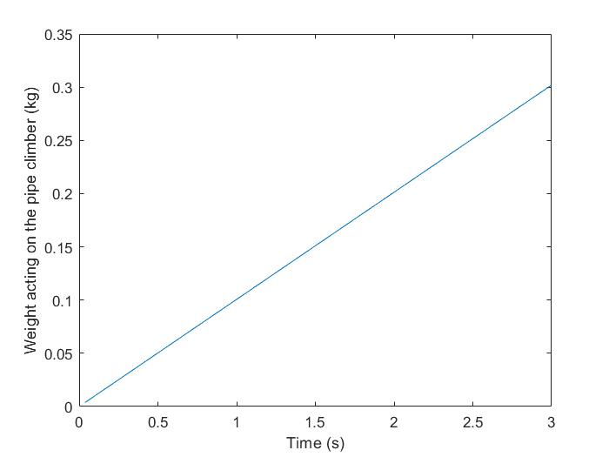
Figure 1 - Graph showing how the weight would increase as the pipe climber ascends the copper pipe.
If the pipe climber ascends at a constant velocity the weight acting on it will increase linearly. The target time for the system to reach the top was decided to be 3 seconds.

3 Discussion
The control system was finalised to be only one switch to turn on the pipe climber and to turn it off when it gets to the top of the pipe. This was to keep the design as simple as possible and as light as possible. This could also cause an issue when turning the pipe climber on as the switch will be located at the top and therefore pressing it may cause a downwards force on the pipe climber as it tries to ascend and therefore potentially increasing the time for it to rise the copper pipe and fall. The switch selected was a push button switch by NKK Switches.
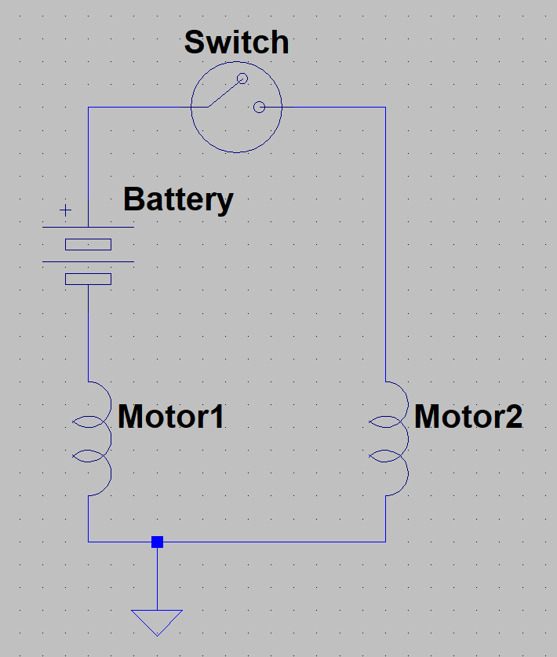
Figure 2 - Picture showing the circuit diagram of the switch circuit being used.
As the pipe climber will go into free fall after it reaches the top, it needs to be robust to not break when it lands back down. Table 1 shows that the material best suited for this was measured to be aluminium as it does not plastically deform easily, it is rigid, it is light and does not cost much to purchase. Aluminium can also be manufactured easily therefore will speed up the manufacturing process which time is limited on. The impact of hitting the ground will be too high for the chassis which was calculated to be around 2.94N using the equation $F=ma$ where $F$ is force, $m$ is mass of the pipe climber (0.3kg) and $a$ is acceleration (9.81$ms^{-1}$) (Zammit, 1987). To decrease impact force acting on the pipe climber when it hits the ground, the time of impact to from $v_{max}$ to $v=0ms^{-1}$ has to increase.
The pipe climber will be run a minimum of 6 times which means that components should not overheat during each run to ensure there is no unwanted wear. These runs should be done at 100% efficiency. Components should also be easily accessible, therefore if a problem does arise it can be easily fixed. Materials selected should not allow parts to plastically deform under torque loads which aluminium will not do.
Table 2 indicates that the 0.302kg chain will be mounted by a string onto the chassis of the pipe climber. This is to ensure the chain is mounted as low as possible which makes climbing the pipe easier as less mass will be acting on the system initially and during the climb. String will be used compared to a metal rod as as it is lighter and less expensive.
As the pipe climber ascends the pipe, more chain will be lifted off the ground therefore increasing the mass acting on the system, which is shown in Figure 1. This means that the torque at the beginning of the run could cause the wheels to spin if there is not enough grip and too much torque, or the torque later on in the run will not be enough to keep the pipe climber ascending. In an ideal situation, the pipe climber will ascend with a constant velocity therefore the weight acting on the system will have a constant increase as well.

4 Conclusion
The mounting system and the material selected for robustness were picked to best suit the criteria of the design. This ensures that the pipe climber created will have a high chance of making it to the top of the copper pipe in the best time possible. Allowing the system to free fall is the simplest design and the fastest way to make the pipe climber get from the top of the copper pipe back down to the ground.

5 References
Zammit, S. J. (1987) Motor Vehicle Engineering Science for Technicians : S.J. Zammit, Pearson Education Limited.

Jeffrey Elliss

Introduction

This report details the selection and reasoning behind the choices made for the overall design of the vehicle and the type and material of the chassis. The aims of the vehicle are detailed in the previous document containing the specification.

Initial Concepts
Once the specification was completed work began sketching and describing some basic concepts for how the chassis might be constructed and overall design ideas as to how the vehicle would operate. These initial concepts are evaluated according to the categories in appendix A. The table takes the score for each category then applies a priority modifier. This ensures that more important categories such as the ease of manufacture are properly reflected by the final score.

During the design process, beginning with sketching as many concepts as possible then evaluating each concept using a system which was consistent between all the ideas.

Categories

The following list of categories are what were used to make preliminary evaluations of concept designs. For the purpose of expediency many of them are such that they can be given a score without needing to model or accurately draw each design.

Simplicity – This category rates each concept based on the number of necessary components and the intricacy of each one.
Weight – Based on the amount of material that each idea will require as well as number of motors etc.
Ease of Construction – Simply how difficult the material of the concept is to work with and the difficulty of the manufacturing processes to make each component will be.
Cost – Primarily based on number of motors and power sources required as this is by far the greatest expenditure requirement.
Speed – An approximation of how quickly each design may climb based on the weight and ability to create power and torque.
Reparability – How easy each component is to replace etc.
Reliability – Will the vehicle last through the event and are there likely to be components which wear too quickly.
Need for Maintenance – Lubrication requirements and any parts that may need regular replacement.
Rigidity – How much may the vehicle flex potentially causing wheels to become misaligned damaging mountings of motors etc.
Adjustability – The ability of each design to change according to small differences in pipe diameter or stretching belts etc.

Chassis Categories

Density score – Based on each materials density converted to a score out of ten by the following formula.
$Score=\left(\frac{1}{\frac{Ro}{1000}}\right)*10$
Equation 1$– Converting the density\left(Ro\right)from\frac{kg}{m^{3} } to a score out of ten.$
Stiffness – Based on each material and construction.
Toughness/impact resistance – How likely each material is to break or significantly deform under the force of an accidental drop etc.
Cost – Expense for unit mass of each material.
Acquirable – How quickly and easily each material can be obtained.
Ease of manufacture – The time and effort required to work with each material. E.g. ease of hole drilling etc.

Chassis material and Construction
There are several ways of constructing the chassis for this vehicle, in appendix A is a table showing the categories used to evaluate whole designs and chassis materials. When evaluating the chassis materials there are two key areas, ability to withstand landing impacts and the ease with which you can manufacture parts. The prior being important so as not to shatter or deform past the materials elastic limit on landing. The latter being important for producing the vehicle and creating replacement parts if anything is damaged. It is imperative that the design can be quickly built and that all parts are of low cost and wide availability.

From the five construction methods that were considered the most practical construction will be to use 90-degree aluminium girder for the uprights which will support the wheels and connect them to the track adjustment screw at the top of the vehicle. The angle in the material allows for easy mounting of motor and battery to each leg in any design and provides significant rigidity to the frame.

Final Design Selection

The model in figure 1 shows the final chassis design that was selected. This design was selected primarily because of its simplicity and flexibility. Its chassis allows for the track of the wheels to be adjusted quickly and easily to ensure that the drive wheel will always be in sufficient contact with the pipe for generating traction. As well as this since the chassis is effectively symmetrical a second motor can be added for more drive if cost allowed. The two holes at the top are slightly oversized relative to the size of the bolt allowing for some angle to be created without seizing, a bracket for the switch will be attached here such that it protrudes from the top of the vehicle. The slot on the left leg is to allow for a motor mount bracket to be attached here with some adjustability for belt tensioning. The bar crossing the center is attached by two bolts through the main chassis members and the two retainer brackets allowing it to pivot when the adjustment screw is tightened or loosened. The brackets will be connected by a smooth shafted bolt, the purpose of this is to ensure that the vehicle cannot fall off the pipe due to uneven loading.
This design can be constructed with simple processes and from widely available material. For example, the two brackets in the center ad simply a single piece of flat aluminium bar with two holes drilled into it then bent in a vice.

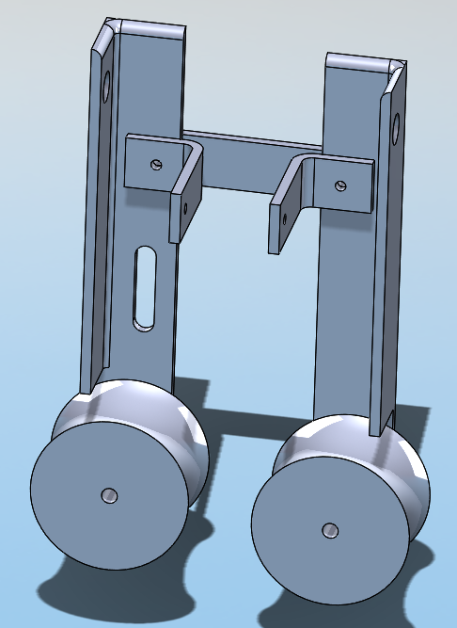

Figure 3-Chassis Model before motor mounts.

Conclusion

When considering which design to use the primary concerns were to ensure that the power system would provide sufficient torque, the chassis could withstand the forces of normal use and that the vehicle could be constructed quickly and efficiently such that if any revisions are required, they can also be made quickly.

Evaluation

During the design process it would have been prudent to spend more time gathering basic concepts and evaluating them as only 5 were evaluated. As well as this rather than only developing one concept it would have been useful to develop two or three further to get a better understanding of the problem.

Appendix A



