Andrew Hart
1803514
Software Development
ACCA4017
Assignment Section A&B

Table of contents
Part A1…………………………………………………………………………..…….Page 3
A2……………………………………………………………………………..…..Page 3
A3…………………………………………………………………………...…….Page 4
Exercise 1……………………………………………………………….…………….Page 4
Exercise 2……………………………………………………………………..………Page 6
Exercise 3……………………………………………………………………………..Page 7
Exercise 4…………………………………………………………………..…………Page 9
References ………………………………………………………………………….Page 12
Appendices ………………………………………………………………………….Page 12
Appendix A Exercise 1 code …………………………………………..….Page 12
Appendix B Exercise 2 code……………………………………….………Page 12
Appendix C Exercise 3 code ………………………………………………Page 13
Appendix D Exercise4 code ……………………………………………….Page 13

A1.
In a C program data is stored in containers that is in turn stored within the memory of the computer, these containers are know as variables. Variables can be named or labelled anything that the programmer desires and stored data can be referenced to using the variable name. In C data is categized into four basic types as shown below: [1]
Data type | Description | Example
char | Used to store single characters | ‘C’ (Must have single quotes)
Int | Used to store whole numbers | 22
Float | Used to store decimal numbers up to 6 dp | 4.651
double | Used for decimal numbers up to 10 dp | 0.0123456789

Programmers frequently use variables as it allows them to produce flexible programs, whilst allowing them to represent and process different types of data. Once a program is executed real data from the program replaces the variables. Constant is the direct opposite of the variable, as the name applies the data stored in a constant container can’t change. Because of the constants permanent state programmers tend to stay away from using them.

A2
A loop is a function that automatically repeats a desired section of code within the program. The most common loop used within C programming is the ‘for’ loop, for this loop to function a start value and an end value needs to be declared, as well as an instruction as can be shown below
For (Initialize; test expression; incrementor)
Start value End value instruction
For loops are used if the programmer knows exactly how many times the desired section of the code is repeated. Below is an example of how the for loops can used as a counter:
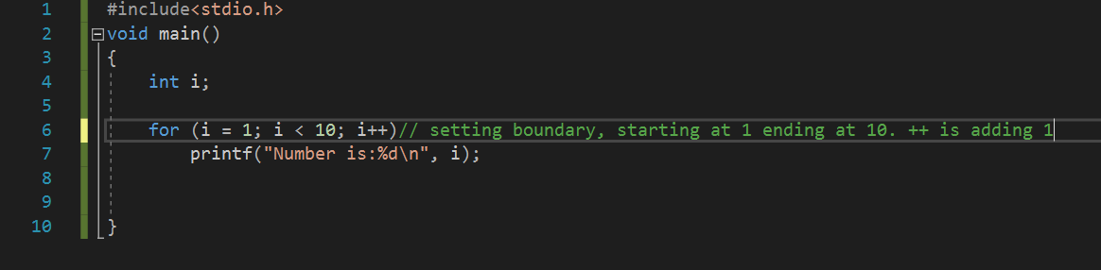
Figure 1 For loop counter code

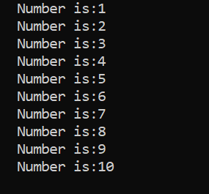

Figure 2 For loop program
The start of the counter is set at +1, this is shown in the code in figure 1 as ++ which is adding on to the next number. Declaring i=1 is the start value and the counter is being starting at 1, also as we can see i<10 this is the end value of the loop and tells the counter to stop repeated when the value has reached 10. [1]

A3
An array is an arrangement within the C language that allows the programmer to store the same type of elements within it. This is beneficial to the programmer as they don’t have to declare each individual variable separately, they can simply declare an array. The programmer must remember that only the same type of variable can be entered into one array. The number of elements that can be stored within one array is determined by the programmer. An example of an array can be seen below.
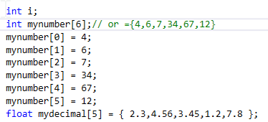
Figure 3 Example of an array

As shown in figure 3 there are two arrays. One has been declared to store integers and the other has been declared to store float values, the amount of values that can be stored in each array is by the value with the square brackets. The two arrays above also show there are 2 different ways which values can be entered into the array [2].

Exercise 1
1.1Identify the problem
- User inputs 3 different values
- Char string for name
- Int for the age
- Float for height
- Store 3 different types of values
- Display the user inputs on screen

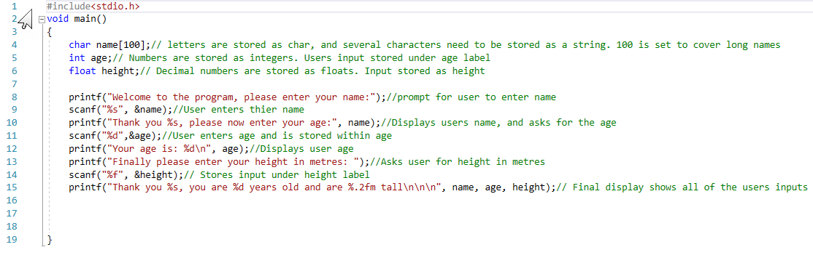
1.2 Annotated code

1.3 Testing
1.3.1 Normal valves
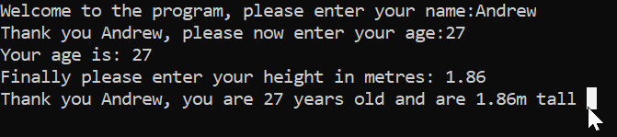

Result: Program ran as expected when correct types are valves are entered and displayed as expected

1.3.2 All integer values entered
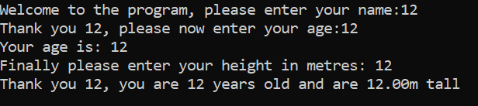

Result: Program failed, program displayed the integers in all the output stages even though the incorrect format of valves has been entered.

1.3.3 All character values entered
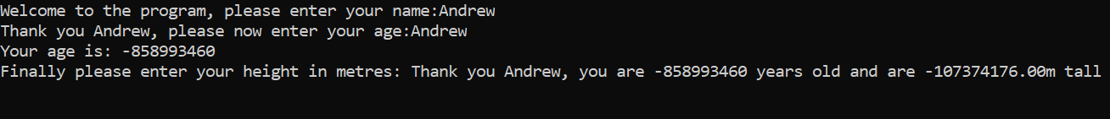

Result: Program failed, random numbers are displayed instead of the entered values.

Exercise 2
2.1 Identify the problem
- User inputs 3(circle radius, triangle height and base width) dimensions, float or int?
- Calculate area of a circle $A=πr^{2}$
- Calculate are of triangle $A=\frac{\left(bxh\right)}{2}$
- Subtract area of triangle from area of circle
- Display total area of shaded area
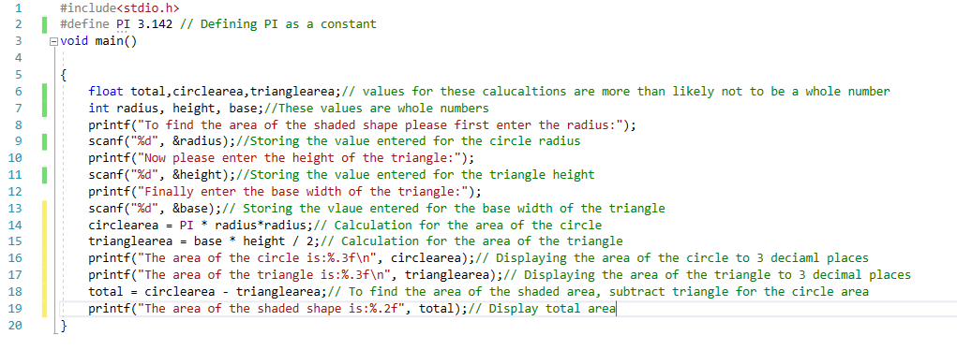
2.2 Annotated code
2.3 Testing
2.3.1 Correct values entered by the user
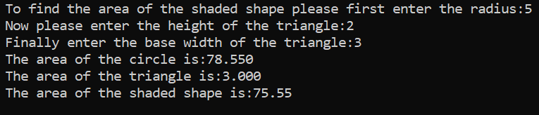

Result: Program ran as expected, calculated area of triangle, circle and shaded area correctly.
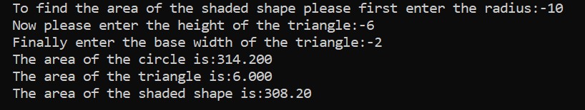
2.3.2 Negative numbers entered

Result: Program failed as not expecting a negative number to be entered by the user
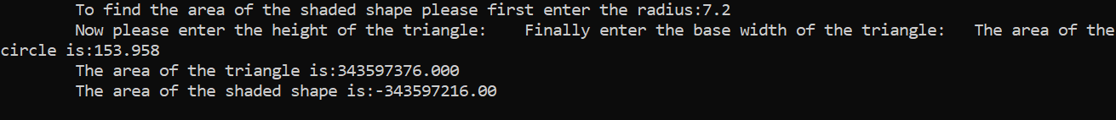
2.3.3 Decimals entered
Result: Program failed. Decimal number entered and program fails to do anything then else. User inputs not programmed stored decimal numbers.

Exercise 3
3.1 Identify the problem
- User enters 5 prices(float)
- Use for loop as a counter
- Use an Array
- Add the 5 values together
- Plus 20% to the total of the 5 values
- Total*0.20 then add result to the total
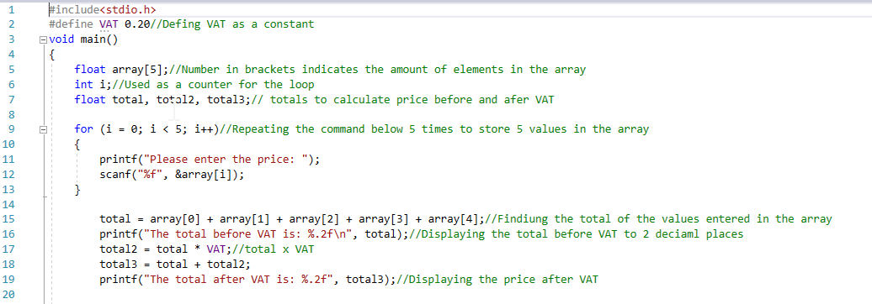
3.2 Annotated code

3.3 Testing
3.3.1 Normal values
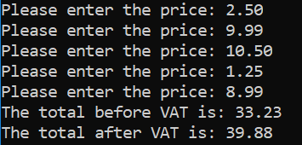

Result: Program ran as expected, totals are correct

3.3.2 Negative values entered
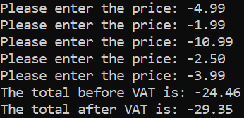

Result: Program ran as expected and continued to calculate the totals
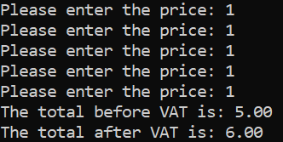
3.3.3 Same values entered

Result: Program ran as expected, program calculated totals correctly
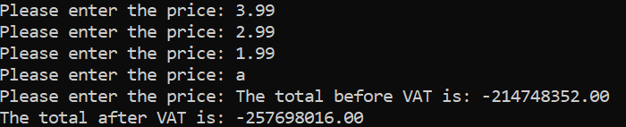
3.3.4 Character entered

Result: Program ran okay until a character is entered then the program crashed out. Program not expecting a character to entered and has not been instructed to store a character value
Exercise 4
4.1 Identify the problem
- Generate 3 random numbers
- Include addition library for ran and sran
- Include addition library for time
- Formula to generate a random number x3
- If statement for jackpot
- Else if statement for other prizes
- Else to end the program if no prize has been won
- Make random range between 1-5 x3
- Int for rand1,rand2,rand3
- Int =1 & 5 for the highest and lowest value of the random number
- While loop to loop program

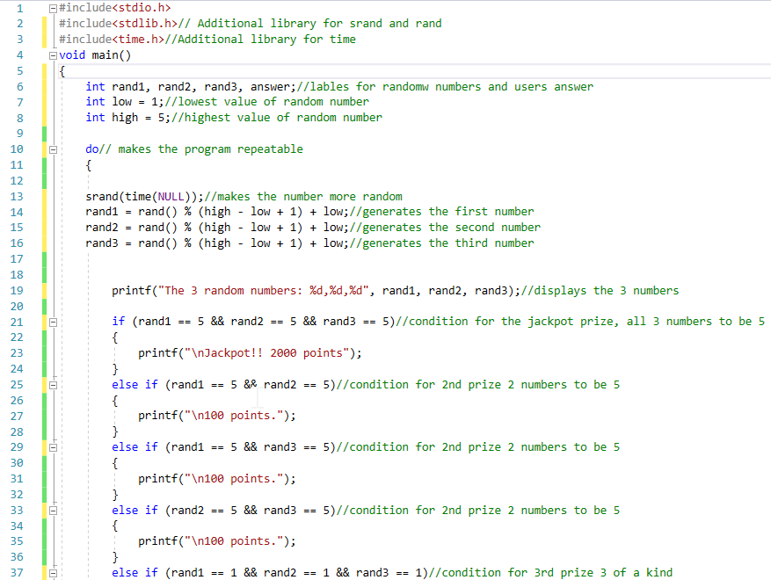
4.2 Annotated code
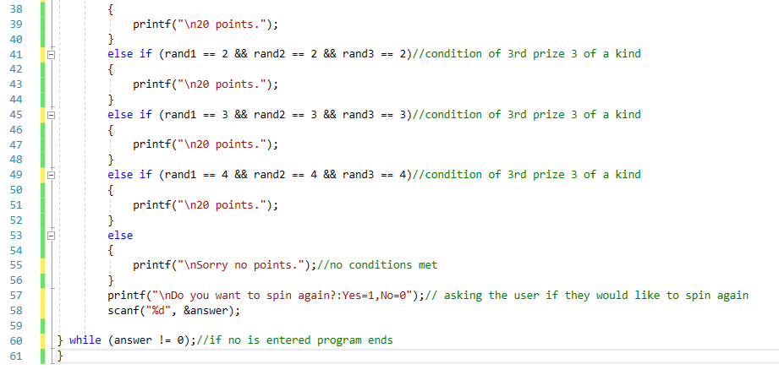
4.3 Testing
4.3.1 No prize draw
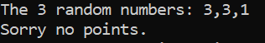

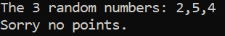

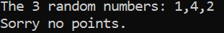

Result: Program ran as expected random generated numbers do not march criteria for any prize. Displayed no prize message.
4.3.2 Three of the same number
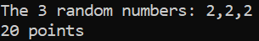
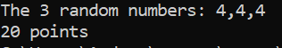

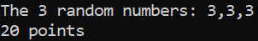

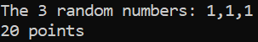

Result: Program ran as expected, random numbers generated are 3 of the same value meets prize criteria and message is displayed.
4.3.3 Two 5s generated
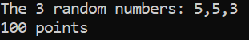

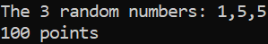

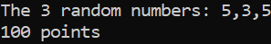

Result: Two of the three random generated numbers are 5s. Meets criteria for a prize, correct prize message displayed.

4.3.4 Three 5s generated
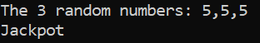

Result: Program ran as expected, the three random numbers generated are 5s, displaying the jackpot message
4.3.5 Spin again
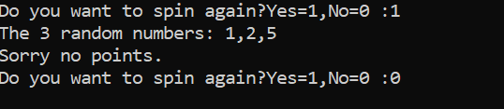

Result: Program allows the user to spin again or end the program when they want

References

[1] | M. McGrath, "Creating program variables," in C Programming, UK, In easy steps, 2014, pp. 20-21.
[2] | "C- Arrays," [Online]. Available: https://www.tutorialspoint.com/cprogramming/c_arrays.htm. [Accessed 10 February 2019].

Appendices

Appendix A (Exercise 1 Code)
#include<stdio.h>
void main()
{
char name[100];// letters are stored as char, and several characters need to be stored as a string. 100 is set to cover long names
int age;// Numbers are stored as integers. Users input stored under age label
float height;// Decimal numbers are stored as floats. Input stored as height

printf("Welcome to the program, please enter your name:");//prompt for user to enter name
scanf("%s", &name);//User enters thier name
printf("Thank you %s, please now enter your age:", name);//Displays users name, and asks for the age
scanf("%d",&age);//User enters age and is stored within age
printf("Your age is: %d\n", age);//Displays user age
printf("Finally please enter your height in metres: ");//Asks user for height in metres
scanf("%f", &height);// Stores input under height label
printf("Thank you %s, you are %d years old and are %.2fm tall\n\n\n", name, age, height);// Final display shows all of the users inputs

}

Appendix B(Exercise 2 Code)
#include<stdio.h>
#define PI 3.142 // Defining PI as a constant
void main()

{
float total,circlearea,trianglearea;// values for these calucaltions are more than likely not to be a whole number
int radius, height, base;//These values are whole numbers
printf("\tTo find the area of the shaded shape please first enter the radius:");
scanf("%d", &radius);//Storing the value entered for the circle radius
printf("\tNow please enter the height of the triangle:");
scanf("%d", &height);//Storing the value entered for the triangle height
printf("\tFinally enter the base width of the triangle:");
scanf("%d", &base);// Storing the vlaue entered for the base width of the triangle
circlearea = PI * radius*radius;// Calculation for the area of the circle
trianglearea = base * height / 2;// Calculation for the area of the triangle
printf("\tThe area of the circle is:%.3f\n", circlearea);// Displaying the area of the circle to 3 deciaml places
printf("\tThe area of the triangle is:%.3f\n", trianglearea);// Displaying the area of the triangle to 3 decimal places
total = circlearea - trianglearea;// To find the area of the shaded area, subtract triangle for the circle area
printf("\tThe area of the shaded shape is:%.2f\n\n", total);// Display total area
}

Appendix C (Exercise 3 Code)
#include<stdio.h>
#define VAT 0.20//Defing VAT as a constant
void main()
{
float array[5];//Number in brackets indicates the amount of elements in the array
int i;//Used as a counter for the loop
float total, total2, total3;// totals to calculate price before and afer VAT

for (i = 0; i < 5; i++)//Repeating the command below 5 times to store 5 values in the array
{
printf("\tPlease enter the price:£ ");
scanf("\t%f", &array[i]);
}

total = array[0] + array[1] + array[2] + array[3] + array[4];//Findiung the total of the values entered in the array
printf("\tThe total before VAT is: %.2f\n", total);//Displaying the total before VAT to 2 deciaml places
total2 = total * VAT;//total x VAT
total3 = total + total2;
printf("\tThe total after VAT is: %.2f\n\n", total3);//Displaying the price after VAT

}

Appendix 4 (Exercise 4 code)
#include<stdio.h>
#include<stdlib.h>// Additional library for srand and rand
#include<time.h>//Additional library for time
void main()
{
int rand1, rand2, rand3, answer;//lables for randomw numbers and users answer
int low = 1;//lowest value of random number
int high = 5;//highest value of random number

do// makes the program repeatable
{

srand(time(NULL));//makes the number more random
rand1 = rand() % (high - low + 1) + low;//generates the first number
rand2 = rand() % (high - low + 1) + low;//generates the second number
rand3 = rand() % (high - low + 1) + low;//generates the third number

printf("The 3 random numbers: %d,%d,%d", rand1, rand2, rand3);//displays the 3 numbers

if (rand1 == 5 && rand2 == 5 && rand3 == 5)//condition for the jackpot prize, all 3 numbers to be 5
{
printf("\nJackpot!! 2000 points");
}
else if (rand1 == 5 && rand2 == 5)//condition for 2nd prize 2 numbers to be 5
{
printf("\n100 points.");
}
else if (rand1 == 5 && rand3 == 5)//condition for 2nd prize 2 numbers to be 5
{
printf("\n100 points.");
}
else if (rand2 == 5 && rand3 == 5)//condition for 2nd prize 2 numbers to be 5
{
printf("\n100 points.");
}
else if (rand1 == 1 && rand2 == 1 && rand3 == 1)//condition for 3rd prize 3 of a kind
{
printf("\n20 points.");
}
else if (rand1 == 2 && rand2 == 2 && rand3 == 2)//condition of 3rd prize 3 of a kind
{
printf("\n20 points.");
}
else if (rand1 == 3 && rand2 == 3 && rand3 == 3)//condition of 3rd prize 3 of a kind
{
printf("\n20 points.");
}
else if (rand1 == 4 && rand2 == 4 && rand3 == 4)//condition of 3rd prize 3 of a kind
{
printf("\n20 points.");
}
else
{
printf("\nSorry no points.");//no conditions met
}
printf("\nDo you want to spin again?Yes=1,No=0 :");// asking the user if they would like to spin again
scanf("%d", &answer);

} while (answer != 0);//if no is entered program ends
}

