
Academy Report writing for workplace culture and its impact on organisational efficiency

Students Name: Nwakaego peace Elumese
Students number: 2114106
Module: Workplace Culture and its impact on Organisational Efficiency
Module code: BMSW5105
Lecturer Name : Olusoyi Ashaye
Date: 14/08/2023
Report writing

Table of Contents
Executive Summary …….. ………………………………………..​3
Introduction: Easy Jet​………………………………………………………………3
Relationship between Organisational Culture and Structure​ ………4
2.1 The Definition and Conceptualisation of Organisational Culture​…..4
2.2 Review of EasyJet's organisational culture​………………………………….4
2.3 Effects of Organisational Culture on Financial and Non-Financial​…4
2.4 The Effects of Organisational Structure on Performance​………………..4
2.5 Criticisms and Ideas to Improve Culture-Structure Fit​…………………..5
3. Taking a Look at EasyJet's Broader Environment​…………………….5
3.1 PESTEL Analysis of the Airline Industry​……………………………………5
3.2 Porter's Five Forces Analysis of EasyJet​ ……………………………………6
3.3 Key Drivers of Change in EasyJet's Workplace Practices​…………7
3.4 Additional methods and instruments for organisational analysis​…….8
4. How Different Ethical Models Affect Company Culture​…………..10
4.1 Ethical Framework​………………………………………………………………….10
4.2 Analysis of Ethical Approaches in EasyJet Plc​……………………………11
4.3 Benefits of Practising Ethical Approaches…………………………​12
5. Environmental Challenges in the Airline Industry​…………………..12
5.1 Environmental Challenges​……………………………………………………….12
5.2 Ethical Challenges and Stakeholder Expectations………………….,​13
5.3 Impact of Challenges on Organisational Performance​………………….14
6. Enhancement of Practices………………………………………….​14
6.1 Addressing Environmental Challenges…………………………….​14
6.2 Enhancing Ethical Practises and Stakeholder Engagement……​16
6.3 Developing Sustainable Strategies and Initiatives​………………………..16
6.4 Improving Diversity and Inclusion Efforts​…………………………………17
6.5 Justification of Recommended Actions​………………………………………17
7. Conclusion​……………………………………………………………………………..18
7.1 Summary of Findings​……………………………………………………………..18
7.2 Implications for EasyJet Plc​…………………………………………………….19
7.3 Final Remarks​……………………………………………………………………….19
Reference List​………………………,………,.,,..,……………………………………..20
List of Illustration​………………………………………………………………………22

Executive Summary
This report analyses EasyJet's culture and its effects on efficiency. The report uses academic management models, methods, and theories to examine the relationship between organisational culture and structure, EasyJet Plc's broader environment using PESTEL and Porter's Five Forces Model, the company's ethical practises, and recommendations for improving performance in light of environmental and ethical issues. According to the findings, EasyJet's decentralisation, innovation, and supplier relationships boost its efficiency. The report recommends improving diversity and inclusion and implementing sustainable practises to boost performance and address new challenges.
Introduction: Easy Jet
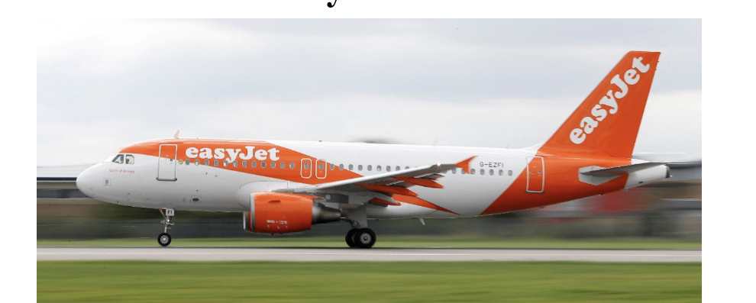
EasyJet Plc, founded in 1995, is a well-known low-cost airline with a fleet of 308. They fly 927 routes in 34 countries. EasyJet Plc has become "the web's favourite airline" thanks to its novel approaches to passenger safety and organisational performance, as evidenced by the popularity of its slogan, "Come on, let's fly!" The company has a culture that values decentralisation, adaptability, and constant improvement in order to increase operational efficiencies and motivate employees to work hard.
Figure 1. EasyJet cuts more flights to try to manage disruption. (2022)
Relationship between Organisational Culture and Structure
2.1 The Definition and Conceptualisation of Organisational Culture
By "organisational culture," we mean the set of shared values, beliefs, assumptions, and norms that influence employees' actions and decisions. It includes the shared beliefs, practises, and symbols that give a group its identity and sense of direction(Balmer and Gary, 2000). EasyJet is a company whose culture values experimentation, distributed authority, and flexibility.
2.2 Review of EasyJet's organisational culture
Organisationally, EasyJet places a premium on the well-being of its customers, the success of its operations, and the pursuit of constant advancement. Employees are expected to take responsibility for their work and contribute thoughtfully to company-wide deliberations. EasyJet Plc ensures its employees can effectively respond to changing circumstances, like those experienced in the airline industry, by encouraging a culture of flexibility and adaptability.
2.3 Effects of Organisational Culture on Financial and Non-Financial
EasyJet's organisational culture has a major effect on the company's bottom line and other metrics of success. The company can save money, make better use of its resources, and increase customer satisfaction by putting an emphasis on creativity and effectiveness. Increased motivation, productivity, and customer service are all results of the decentralised culture that allows for speedy decision making and gives employees significant agency.

2.4 The Effects of Organisational Structure on Performance
EasyJet Plc's organisational structure supports the company's ethos by providing a foundation for effective management. The organisational structure of the company encourages open lines of communication and cooperation between its various divisions. This organisational setup allows EasyJet Plc to swiftly adjust to new requirements from customers and shifting market conditions. Employees are given more agency and pride in their work as a result of decentralising decision-making, leading to higher productivity and satisfaction.
2.5 Criticisms and Ideas to Improve Culture-Structure Fit
Even though EasyJet's values and organisational structure are congruent with its goals, the company could do more(Trzebiatowska , 2010). One piece of advice is to make progress on diversity and inclusion initiatives so that the organisation can benefit from a wider range of thought. Moreover, encouraging a culture of learning and development can help staff members Pick up new abilities and adjust to shifting business norms. Improve culture-structure fit and overall organisational efficiency by fostering open lines of communication and encouraging cross-departmental teamwork.

Taking a Look at EasyJet's Broader Environment
3.1 PESTEL Analysis of the Airline Industry
PESTEL analysis helps assess an organisation's external factors. The airline industry analysis considers these dimensions(Rahman, 2023):
Political: Aviation policy, taxation, and bilateral agreements can impact EasyJet's business. Stable politics and government aviation investment are vital to the airline industry.
Economic: GDP growth, inflation, exchange rates, and consumer spending affect air travel demand. Economic downturns or changes in fuel prices can have an impact on EasyJet's performance.
Social: Sociocultural shifts affect consumer behaviour and preferences. EasyJet Plc must consider passenger demographics, travel patterns, and customers' desire for a more personalised and convenient experience (Rahman, 2012).
Technological: Tech changes the airline industry. EasyJet Plc must adopt and use new technologies to improve operational efficiency, passenger experiences, and competitiveness. Data analytics, digital platforms, and aircraft technology innovations are included.
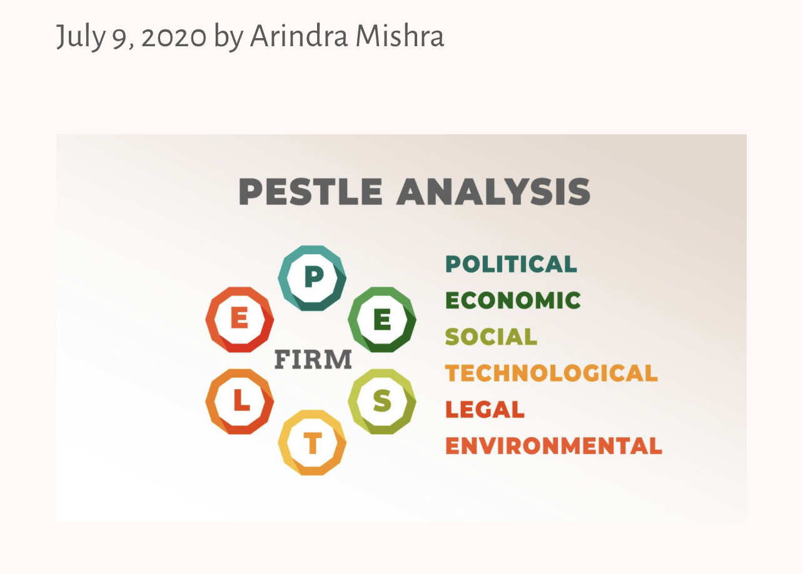

Management weekly- July 9, 2020 by Arindra Mishra

Environmental Factors: Airlines are increasingly concerned about climate change and sustainability. EasyJet Plc must reduce carbon emissions, adopt sustainable practises, and investigate alternative fuels to reduce its environmental impact.

Factors: EasyJet Plc must follow safety, labour, and consumer protection laws. To avoid fines and brand damage, the airline must comply with industry regulations.
Figure 2. Colin-Petit, E. (1648394568000) Strategic Tool Box Serie (#3) The PESTEL Analysis : determine your environment.
3.2 Porter's Five Forces Analysis of EasyJet
Porter's Five Forces analysis provides insights into the competitive dynamics of an industry. For EasyJet Plc, the analysis reveals the following factors (Porter, 2008):
• Threat of New Entrants: Capital, regulations, and brand loyalty make the airline industry difficult to enter. New entrants—particularly low-cost carriers—remain a threat.
• Bargaining Power of Suppliers: EasyJet relies on aircraft and fuel suppliers. Supplier bargaining power affects airline costs and profitability. Strong supplier relationships and alternative sourcing can reduce this risk.
• Bargaining Power of Buyers: Airline customers are influential. EasyJet Plc must always meet customer service, price, and convenience expectations. Due to the availability of alternative airlines and price sensitivity among passengers, buyers have high bargaining power.
• Threat of Substitutes: EasyJet Plc competes with other airlines, trains, and buses. EasyJet Plc must differentiate to stay competitive as substitutes affect air travel demand.
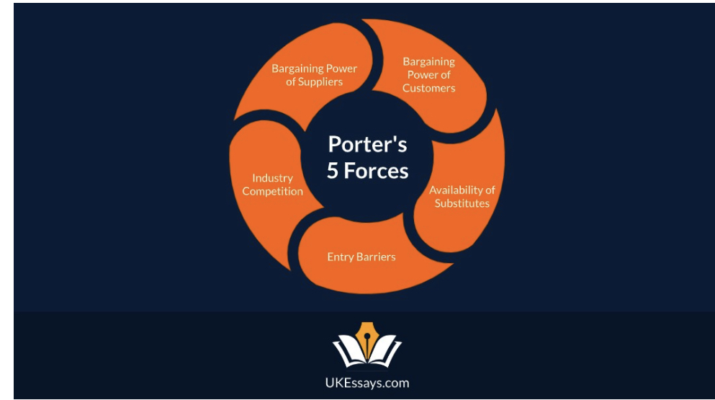
Industry Rivalry: Airlines compete fiercely. EasyJet competes with low-cost and traditional airlines. Price competition forces service quality, efficiency, and innovation to improve.
Figure 3. Porter’s 5 forces analysis guide. (2023)
3.3 Key Drivers of Change in EasyJet's Workplace Practices
Various factors are causing significant changes in the airline industry, which include:
• Technological Advancements: Technology is changing airline operations quickly. EasyJet Plc uses self-service check-in kiosks, mobile apps, and automated processes to boost efficiency and passenger satisfaction.
• Changing Customer Expectations: Passengers want seamless, personalised, and affordable travel. EasyJet must adapt its operations to meet these changing demands and provide a great customer experience.
• Market Volatility: Fuel price volatility, economic downturns, and geopolitical events affect the airline industry. EasyJet must be flexible to reduce risks and seize opportunities.
• Regulatory and Environmental Pressures: Airline regulations and environmental pressures are rising. To meet industry standards, EasyJet must reduce carbon emissions, follow safety rules, and practise sustainability.
• Industry Competition: Working practises must improve due to intense airline competition. To compete, EasyJet Plc must excel in operations, cost, and innovation.
3.4 Additional methods and instruments for organisational-analysis
Other organisational analytical methods and tools can illuminate EasyJet's environment beyond PESTEL and Porter's Five Forces. These are:
3.4.1 SWOT Analysis:
SWOT analysis—"strengths, weaknesses, opportunities, and threats"—is a common way to assess a business's internal and external factors. It shows EasyJet's market opportunities and threats, as well as its strengths and weaknesses compared to competitors. SWOT analysis helps understand the airline's current situation and inform strategic decisions.
3.4.2 Stakeholder Analysis:
Finding and comprehending important stakeholders is made easier with the aid of stakeholder analysis. Using this method, EasyJet Plc can put faces to the names of their customers, workers, suppliers, government agencies, and communities. Stakeholder engagement and relationship management are enhanced by a thorough examination of the stakeholders' interests, influence, and expectations.
3.4.3 Value Chain Analysis:
Value chain analysis helps determine how a company creates customer value. EasyJet's value chain includes operations, marketing, and customer service (e.g., procurement, technology, and human resources). This analysis improves value delivery, lowers costs, and uncovers new opportunities.
3.4.4 Balanced Scorecard:
The balanced scorecard is a useful tool for monitoring an organisation's progress across multiple dimensions. Some examples of these are customer satisfaction, the efficiency of internal operations, and the rate of development and improvement. The balanced scorecard can help EasyJet Plc link their long-term goals with measurable indicators of success.
3.4.5 Benchmarking:
Benchmarking compares a company's practises, results, and competitors. EasyJet Plc can identify areas for improvement by comparing itself to market leaders. Best practises and improvements can improve operational efficiency, customer satisfaction, and overall performance for the airline.
3.4.6 Scenario Planning:
Using scenarios, businesses can better plan for the future. Using this method, EasyJet Plc can gauge the results of various scenarios. The company can get ready for the unknown by thinking through potential outcomes, analysing risks and opportunities, and making calculated choices.
These organisational analytical tools help EasyJet Plc understand its internal and external environment (David, 2017). These analyses show the company's strengths, weaknesses, opportunities, threats, and stakeholders' expectations. This knowledge helps EasyJet Plc make strategic decisions, optimise operations, and compete in the dynamic airline industry.
4. How Different Ethical Models Affect Company Culture
4.1 Ethical Framework
Ethical frameworks help organisations make ethical decisions. They give businesses a moral compass for dealing with stakeholders, employees, and society. Organisational ethics include:
Utilitarianism: Utilitarianism is an ethical theory that prioritises-doing the most good for the most people possible. This framework may help EasyJet prioritise the happiness and contentment of its customers, employees, and other stakeholders in making decisions.
Deontology: Deontological ethics stresses the importance of doing the right thing and acting morally. By being open, honest, and fair in its dealings and always following the letter of the law, EasyJet Plc can embrace deontological principles (Van Stave ten, 2007).
Virtue Ethics: The focus of virtue ethics is on the cultivation of admirable qualities of character. With the help of EasyJet's leadership, the company can develop a culture that encourages its employees to uphold ethical standards in everything they do.
Social Contract Theory: According to proponents of social contract theory, people's moral obligations stem from an unspoken understanding among society's participants. By embracing its responsibilities to its customers, employees, suppliers, and the community at large, EasyJet Plc can take advantage of this framework (Huhtala et al., 2016).

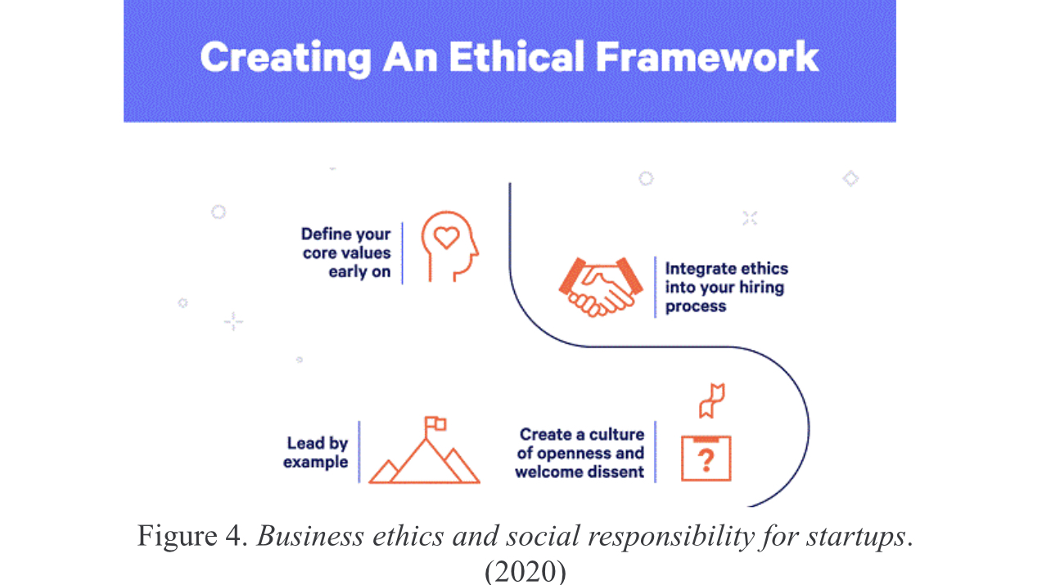
4.2 Analysis of Ethical Approaches in EasyJet Plc
EasyJet Plc values ethics. The company values safety, ethics, and regulation. Passengers are safe, and the aviation industry is well regulated.
EasyJet Plc also prioritises employee equality and fairness. By celebrating employees' differences, the company promotes diversity and inclusion. This includes encouraging employee well-being, work-life balance, professional development, and gender and ethnic diversity in the workplace.
EasyJet Plc also uses eco-friendly business practises. EasyJet recognises that airlines are a major source of carbon emissions and must reduce them. The company has reduced its fossil fuel use by researching alternative aviation fuels, buying more fuel-efficient planes, and improving fleet efficiency.

4.3 Benefits of Practising Ethical Approaches
Praying ethical approaches within its organisational culture offers several benefits for EasyJet Plc:
• Enhanced Reputation: EasyJet benefits from ethical behaviour. Ethical companies gain trust and a competitive advantage from customers and stakeholders.
• Stakeholder Engagement: Ethical practises build trust with customers, employees, suppliers, and the community. EasyJet Plc can gain trust and engagement by prioritising their well-being and interests, improving collaboration, customer satisfaction, and supplier relationships.
• Inspiration and Retention of Workers: Ethical workplaces engage and retain employees. Employees are more engaged, committed, and motivated to work hard when they think their company is ethical.
• Risk Mitigation: EasyJet Plc reduces legal, regulatory, and repetitional risks with ethical practises. The company avoids legal and compliance issues and protects its brand and reputation by adhering to ethical frameworks and high ethical standards.
By embracing ethical approaches, EasyJet Plc not only upholds its responsibilities to stakeholders but also gains tangible benefits that contribute to its long-term success and sustainability (Grant, 2016).

5. Environmental Challenges in the Airline Industry
5.1 Environmental Challenges
Carbon Emissions: Aviation emits greenhouse gases, especially carbon dioxide. EasyJet is under pressure to reduce its carbon footprint and mitigate air travel's climate change impact. The airline faces stricter emissions regulations, environmental targets, and public awareness of flying's environmental impact(How the industry approaches sustainability, s.d.).
Noise Pollution: Airport noise can harm nearby communities and the environment. As EasyJet Plc expands and increases flight frequencies, it must address noise pollution concerns and minimise local community impact.
Waste Management: Airline cabin, packaging, and catering waste are significant. To reduce its environmental impact, EasyJet Plc must implement recycling, waste reduction, and responsible disposal programmes.
Fuel Efficiency: EasyJet Plc must maximise fuel efficiency to reduce its financial and environmental impact. The company needs fuel-efficient planes, cutting-edge technology and operations, and alternative fuels to reduce emissions and save money.
5.2 Ethical Challenges and Stakeholder Expectations
Safety and Security:
EasyJet prioritises passenger security. To satisfy passengers and regulators, the company must invest in strong safety measures, follow regulations, and maintain high safety and security standards (Johnson, Whittington and Scholes, 2019).
Fair Pricing and Transparency:
EasyJet Plc must ethically offer fair and transparent pricing. Customers expect fare transparency, ancillary charges, and other travel costs. The airline must clearly communicate pricing and treat customers fairly (Cattaneo et al., 2018).
Employee Well-Being:
EasyJet Plc must prioritise employee well-being and fairness. This includes competitive wages, work-life balance, a safe and inclusive workplace, and career development and advancement.
Customer Privacy and Data Protection:
EasyJet Plc handles sensitive customer data as a travel provider. The company must ethically protect customer privacy, data security, and data protection laws.

5.3 Impact of Challenges on Organisational Performance
Repetitional Risk:
Environmental and ethical neglect can damage a reputation. Environmental, safety, and ethical scandals can damage the airline's brand image and market share.
Regulatory Compliance:
EasyJet Plc may be fined for violating environmental and ethical standards. Emissions and safety violations can cost the company money and slow operations (Gillan and Lall, 2004).
Customer Loyalty and Satisfaction:
Environmental and ethical practises can boost customer loyalty. Stakeholder expectations, such as safe and environmentally responsible travel, can boost the airline's reputation, attract more customers, and increase customer loyalty (Harvey and Turnbull, 2020).
Cost Efficiency:
EasyJet Plc can save money by reducing fuel consumption and improving operational efficiency. Fuel-efficient technologies and sustainable practises improve financial performance and mitigate rising fuel prices and environmental regulations(Cattaneo et al., 2016).
Sustainable practises, stakeholder engagement, innovation, and regulatory compliance help EasyJet Plc address environmental and ethical issues. The airline can improve its performance and contribute to a more responsible aviation industry by incorporating environmental and ethical considerations into its business strategy.

6. Enhancement of Practices
6.1 Addressing Environmental Challenges
Using Sustainable Fuels: EasyJet Plc should keep funding sustainable aviation fuel (SAF) R&D and looking into biofuel businesses to work with. The aviation sector can cut its carbon emissions and become more sustainable if it increases the percentage of SAFs in its fuel mix.
The replacement of older, less fuel-efficient planes with newer, more environmentally friendly versions should be a top priority for the airline as part of its fleet modernisation strategy. Fuel consumption and emissions can be reduced by investing in fuel-efficient aircraft, such as those with modern engine technology and aerodynamic designs.
EasyJet Airline may reduce its carbon footprint by implementing energy-efficient measures, including revamping its ground operations, retrofitting airports and buildings with LED lighting, and researching alternative energy sources. These changes can help the organisation reach its sustainability targets by decreasing energy use (Whitehall, 1997).
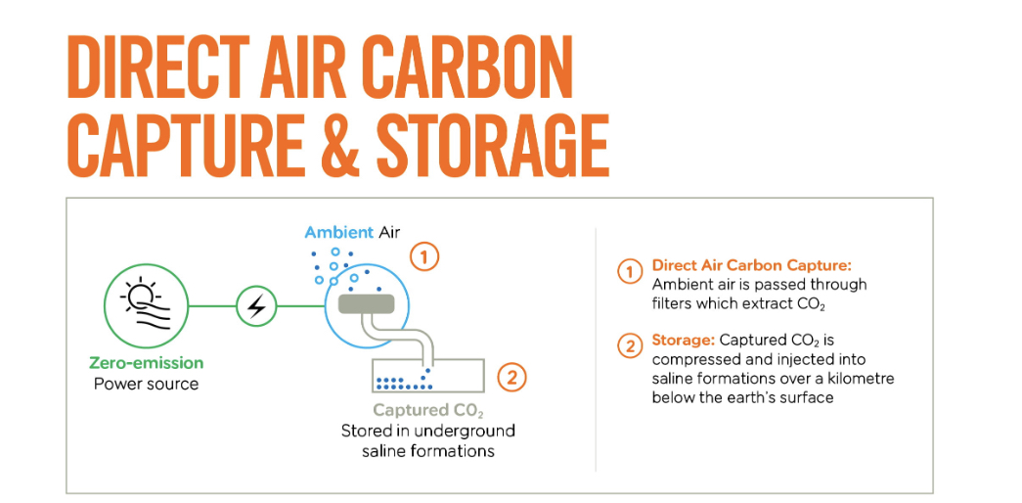
Carbon Offsetting: With our established relationships with reputable carbon offset suppliers, EasyJet Plc is able to give consumers the option to offset their carbon emissions. The airline enables passengers to shoulder some of the burden of reducing greenhouse gas emissions by arranging carbon offset programmes.
Figure 5. Sustainability. (s.d.)
6.2 Enhancing Ethical Practises and Stakeholder Engagement
Creating a Comprehensive Code of Conduct Outlining Ethical Guidelines and Expectations for All Employees is a Necessary Step for EasyJet's Image. To further ensure that workers are familiar with and abiding by the company's ethical standards, it is important to provide them with ongoing training on ethical behaviour and decision-making (Owen et al., 2001).
The airline must be forthright about all of its pricing methods, including rate structures, ancillary charges, and extra levies. Customers' trust and loyalty can be increased through straightforward communication.
Customers, staff, vendors, and communities are all examples of stakeholders that EasyJet Plc should interact with often. This can be accomplished through consistent communication, feedback mechanisms, and factoring in stakeholder input during decision-making. The airline can better handle the problems and expectations of its customers if it actively involves its various stakeholder groups (Bouncer et al., 2020).
In order to practice ethical supply chain management, EasyJet needs to examine and improve its supplier selection procedures. This will guarantee that the company's principles and ethics are upheld by its suppliers. In order to promote sustainable and ethical practises all throughout the supply chain, the airline can give preference to forming agreements with suppliers who show social and environmental responsibility.
6.3 Developing Sustainable Strategies and Initiatives
To monitor its progress towards sustainability, EasyJet Plc needs to set up key performance indicators (KPIs) and reporting methods. The airline may show its dedication to sustainable practices by measuring and reporting on environmental and social performance (Greenwood, 2007).
The airline should work closely with other organisations, such as government agencies, NGOs, and academic institutions, to propel sustainability efforts forward. By collaborating, EasyJet Plc is able to pool resources, learn from one another, and advance mutual sustainability objectives.
EasyJet Plc has the resources to execute extensive waste management methods such as garbage reduction, recycling programmes, and ethical disposal procedures. The airline may make substantial progress towards its sustainability goals by encouraging waste reduction and recycling among its staff and customers.
6.4 Improving Diversity and Inclusion Efforts
In order to attract a more varied pool of personnel, EasyJet Plc-implemented diversity recruitment tactics. The business can review its hiring policies and procedures and provide equitable opportunities for underrepresented groups by forming partnerships with organisations that are dedicated to diversity and inclusion. Long-term success also requires retention programmes that value and promote diversity and inclusion in the workplace (Cowper-Smith and de Grosbois, 2011).
Employees at all levels of EasyJet should have access to diversity and inclusion training programmes. This education has the potential to increase consciousness, broaden comprehension, and encourage welcoming actions and policies. A more diverse and inclusive workforce can also be the result of investments in employee training, mentorship programmes, and positions of leadership.
6.5 Justification of Recommended Actions
Competitive Advantage: EasyJet Plc may gain an edge in the market by leading the way in sustainable practises, boosting ethical approaches, and fostering diversity and inclusion. Taking these measures helps the airline stand out from the competition and appeal to customers who value sustainability and social responsibility.
Regulatory Compliance: It is consistent with legislative regulations and industry norms to address environmental concerns, practise ethical methods, and encourage diversity. EasyJet may minimise legal and repetitional concerns by proactively adopting these steps and remaining in compliance with ever-changing legislation (Altus, 2009).
Stakeholder Expectations: There is a growing expectation among customers, employees, and other stakeholders that businesses will operate ethically and solve environmental and social issues. By taking the advised measures, EasyJet Plc will show that it values its stakeholders and is dedicated to doing what it takes to make them happy and satisfied.
Long-Term Sustainability: The proposed changes improve EasyJet Plc's long-term viability by decreasing its negative effects on the environment, increasing the prevalence of an ethical culture, and broadening its reach to more people. These steps are crucial for the airline's continued viability in today's competitive market (Balmer and Grey, 2000).
These proposals can help EasyJet Plc enhance its performance, strengthen its reputation as a responsible airline, and meet rising environmental, ethical, and social standards.

7. Conclusion
7.1 Summary of Findings
This paper evaluated how EasyJet's working culture affects efficiency. Academic management theories and environmental studies yielded numerous major findings:
EasyJet's culture emphasised innovation, decentralisation, and adaptability. Its culture supported organisational goals, improving financial and non-financial performance. Decentralised decision-making empowered employees, increasing motivation and productivity.
PESTEL and Porter's Five Forces highlighted major reasons for EasyJet's workplace reform. Technology, consumer expectations, and legal and environmental challenges required continual improvement and adaptability in the organisation.
EasyJet's culture prioritised safety, fairness, and corporate citizenship. These ethical practises showed the company's commitment to stakeholders and provided benefits like reputation, stakeholder engagement, and risk mitigation.
EasyJet Plc faced environmental issues including carbon emissions, noise pollution, trash management, and fuel economy. To satisfy stakeholders and regulators, ethical issues like safety, fair pricing, employee well-being, and data privacy needed attention.
The detected issues affected EasyJet's performance. To increase performance and assure long-term sustainability, effective environmental, ethical, diversity, and sustainability measures were advocated.
7.2 Implications for EasyJet Plc
This report impacts EasyJet. To improve efficiency and performance, the organisation must harmonise its culture and structure. Diversity and inclusion, ethics, and stakeholder engagement boost corporate image and customer loyalty. EasyJet must address environmental issues. Sustainable fuel, fleet modernisation, energy efficiency, waste management, and carbon offset programmes will reduce the airline's environmental impact. These approaches increase cost efficiency and consumer perception.
Maintaining stakeholder trust and loyalty requires ethical problem-solving. EasyJet Plc's ethical practises and industry standards will be strengthened by implementing a strong code of conduct, improving pricing and communication transparency, and ensuring data protection and security.
7.3 Final Remarks
The low-cost airline EasyJet faces challenging conditions. The company adapts to changing business situations through innovation, improvement, and adaptability. Ethical practises, environmental sustainability, and stakeholder expectations will make EasyJet Plc trustworthy. This research helps EasyJet Plcimprjove performance, mitigate risk, and find new possibilities. These proposals can improve organisational efficiency, competitiveness, and the sustainability of a socially responsible aircraft firm.
Growing EasyJet Pix must continually assess its external environment, industry trends, and plans. In a competitive market, EasyJet Plc may prosper by promoting learning, adaptation, and innovation.

Reference List
• Altus, S. (2009) 'Effective flight plans can help airlines economise In: Boeing Aero
• Balmer, J. M. T. and Gary, E. R. (2000) 'Corporate identity and corporate communications: creating a competitive advantage' In: Industrial and commercial training 32 (7) pp.256–262. At: http://dx.doi.org/10.1108/00197850010379811
• Bouncer, F., Genera, D., Russo, M. and Salvatore, D. (2020) 'Cognitive job crafting: A possible response to increasing job insecurity and declining professional prestige' In: Human resource management journal 30 (2) pp.244–259. At: http://dx.doi.org/10.1111/1748-8583.12270
• Cattaneo, M., Malighetti, P., Morality, C. and Redondo, R. (2016) 'Quantity price discrimination in the air transport industry: The easyJet case' In: Journal of air transport management 54 pp.1–8. At: http://dx.doi.org/10.1016/j.jairtraman.2016.03.008
• Cattaneo, M., Mali ghetto, P., Redondo, R. and Salani, A. (2018) 'Changes in frequencies and price variations on point-to-point routes: The case of easyJet' In: Transportation research. Part A, Policy and practice 112 pp.60–70. At: http://dx.doi.org/10.1016/j.tra.2018.01.007
• Cowper-Smith, A. and de Grosbois, D. (2011) 'The adoption of corporate social responsibility practices in the airline industry' In: Journal of sustainable tourism 19 (1) pp.59–77. At: http://dx.doi.org/10.1080/09669582.2010.498918
• David, R. *. (2017) 'EasyJet: a case of entrepreneurial management?' In: Strategic Management in Aviation. (s.l.): Rutledge. pp.87–98.
• Feebly, D. F. and Ives, B. (1990) 'In search of sustainability: Reaping long-term advantage from investments in information technology' In: Journal of management information systems : JMIS 7 (1) pp.27–46. At: http://dx.doi.org/10.1080/07421222.1990.11517879
• Gillian, D. and Lall, A. (2004) 'Competitive advantage of low-cost carriers: some implications for airports' In: Journal of air transport management 10 (1) pp.41–50. At: http://dx.doi.org/10.1016/j.jairtraman.2003.10.009
• Grant, R. M. (2016) Contemporary strategy analysis: Text and cases edition. (s.l.): John Wiley & Sons.
• Greenwood, M. (2007) 'Stakeholder engagement: Beyond the myth of corporate responsibility' In: Journal of business ethics 74 (4) pp.315–327. At: http://dx.doi.org/10.1007/s10551-007-9509-y
• Harvey, G. and Turnbull, P. (2020) 'Ricardo flies Ryanair: Strategic human resource management and competitive advantage in a Single European Aviation Market' In: Human resource management journal 30 (4) pp.553–565. At: http://dx.doi.org/10.1111/1748-8583.12315
• How the industry approaches sustainability (s.d.) At: https://www.iata.org/en/policy/environment/ (Accessed 17/07/2023).
• Hug tala, M., Captain, M. and Felt, T. (2016) 'How perceived changes in the ethical culture of organisations influence the well-being of managers: a two-year longitudinal study' In: European journal of work and organisational psychology 25 (3) pp.335–352. At: http://dx.doi.org/10.1080/1359432x.2015.1068761
• Johnson, G., Whittington, R. and Scholes, K. (2019) Exploring Strategy: Text and Cases. (s.l.): Pearson.
• Kassel, R., Salami, A. and Ganepola, C. N. (2023) 'CSR, credibility, employees’ rights and legitimacy during a crisis: a critical analysis of British Airways, WizAir and EasyJet cases' In: Employee relations 45 (1) pp.1–20. At: http://dx.doi.org/10.1108/er-11-2021-0517
• Koenigsberg, O., Muller, E. and Volcanism, N. J. (2008) 'easyJet® pricing strategy: Should low-fare airlines offer last-minute deals?' In: Quantitative marketing and economics 6 (3) pp.279–297. At: http://dx.doi.org/10.1007/s11129-007-9036-2
• Malighetti, P., Paleari, S. and Redondo, R. (2015) 'EasyJet pricing strategy: determinants and developments' In: Transport metrics A Transport Science 11 (8) pp.686–701. At: http://dx.doi.org/10.1080/23249935.2015.1063021
• Morality I, C., Cattaneo, M., y, P. and Redondo, R. (2017) 'Multi-dimensional price elasticity for leisure and business destinations in the low-cost air transport market: Evidence from easyJet' In: Tourism management 61 pp.23–34. At: http://dx.doi.org/10.1016/j.tourman.2017.01.009
• Owen, D. L., Swift, T. and Hunt, K. (2001) 'Questioning the role of stakeholder engagement in social and ethical accounting, auditing and reporting' In: Accounting forum 25 (3) pp.264–282. At: http://dx.doi.org/10.1111/1467-6303.00066
• Porter, M. E. (2008) Competitive strategy: Techniques for analysing industries and competitors. (s.l.): Simon and Schussed.
• Rahman, M. (2012) 'Developing a multi-criteria decision making model for PESTEL analysis' In: International Journal of Business and Management 7 (24)
• Rahman, M. (2023) PESTEL Analysis of the aviation (airline) industry. At: https://www.howandwhat.net/pestel-analysis-aviation-airline-industry/

Trzebiatowska, M. (2010) 'The advent of the ‘EasyJet priest’: Dilemmas of Polish Catholic integration in the UK' In: Sociology 44 (6) pp.1055–1072. At: http://dx.doi.org/10.1177/0038038510381618
• Van Stave ten, I. (2007) 'Beyond utilitarianism and deontology: Ethics in economics' In: Review of political economy 19 (1) pp.21–35. At: http://dx.doi.org/10.1080/09538250601080776
• Whitehall, M. (1997) 'Knowledge-based strategy to deliver sustained competitive advantage' In: Long range planning 30 (4) pp.621–627. At: http://dx.doi.org/10.1016/s0024-6301(97)00046-0
• (S.d.) At: https://aviationstrategy.aero/airlines/easyjet/(Accessed 22/07/2023
• (S.d.) At: https://www.theguardian.com/business/2021/jul/08/easyjet-orders-12-new-aircraft-as-covid-crisis-hits-rivals (Accessed 22/07/2023b).
• (S.d.) At: https://www.e-unwto.org/doi/pdf/10.18111/9789284421944 (Accessed 11/08/2023
List of Illustration
1. Business ethics and social responsibility for startups (2020) At: https://gethppy.com/hr-infographics/business-ethics-and-social-responsibility-for-startups (Accessed 12/08//2023).
2. Colin-Petit, E. (1648394568000) Strategic Tool Box Serie (#3) The PESTEL Analysis : determine your environment. At: https://www.linkedin.com/pulse/strategic-tool-box-serie-3-pestel-analysis-determine-your-elodie/ (Accessed 12/08/2023).
3. EasyJet cuts more flights to try to manage disruption (2022) In: Reuters 20/06/2022 At: https://www.reuters.com/business/aerospace-defense/easyjet-cuts-more-flights-try-manage-disruption-2022-06-20/(Accessed 17/07/2023).
4. Porter’s 5 forces analysis guide (2023) At: https://www.ukessays.com/guides/marketing/porters-5-forces-analysis-2498.php (Accessed 11/08/2023).
5. Sustainability (s.d.) At: https://www.easyjet.com/en/sustainability (Accessed 17/07/2023).

