Why was there an anime boom recently and what could the implications of this be for society?

Intro
Animation has always been popular as a children’s genre, with companies like Disney creating household films such as Cinderella (1950), which made around 264 million dollars worldwide, about 91 times its initial production budget (“Cinderella (1950)”).
However, with the rise of series like the Simpsons (1989), Rick and Morty (2013) and Bojack Horseman (2014), all of which focus on entertainment for adults, the focus of animation has shifted from making productions exclusively for children but is now heavily catering to adults as well. This effect can also be seen in more current films like Coco (2017) and Encanto (2021), both of which handle more mature content like the concept of death and the afterlife, and the complicated relationships between family members.
With this change within the industry, another sub-genre of animation has since become more popular: Anime. Outside of Japan, anime typically refers to animated series and films made in Japan. This literature review will be investigating the potential reasons why anime has become so popular over the years in contemporary society. It’s important to research phenomenon such as this due to the potential implications it may have on areas of life such as mental health and education, to further understand how the film and TV industry can adapt to these changes.

Viewership
Animated productions have been growing in popularity over the last few years, with Netflix (2020) reporting a 50% increase in the number of households across the globe who had watched at least one anime on their platform from September 2019 to October 2020. Another source shows a similar increase, with only 24% of viewers being anime fans in 2018, to that figure increasing to 36% in 2021 (Gooderick, 2021). This source also points out that Crunchyroll, an anime streaming service platform, had a subscriber boom in the 5 years prior to August 2021. Additionally, a 2020 survey found that 44% of adults viewed animated films somewhat favourably while 25% viewed them very favourably (MorningConsult, n.d.). Curiously, in Japan, 33% of the population actively watches anime whilst in America this number is closer to 18% (Stojcheva, 2023). Globally, the findings are very similar, with the global animation market having grown from $250 billion in 2018 to $270 billion by 2021. However, by the end of 2021, the animation market value grew to $372.5 billion (Katatikarn, 2023).

Research
These findings seem to suggest that the COVID pandemic played a significant role in the growing of the animation market, although the reason may not be as straight-forward as people simply just having more time. During the pandemic, studies have found that some people experienced more anxiety and depressive symptoms but also that reports of their emotional state tended to be quite negative (Herbert, Bolock & Abdennadher, 2021). However, other studies have found that not everyone’s mental health deteriorated and this seems to have been thanks to them maintaining certain hobbies and routines to cope with the changes around them (Wright et al., 2022). Additionally, it was found that people did spend more time watching TV during lockdown, especially for those with higher levels of anxiety and stress, and it also suggested that watching TV during the Pandemic was used as a “recovery strategy” by a lot of different people from different backgrounds (Boursier et al., 2021). These findings suggest that in times of stress and uncertainty, people tend to turn to certain activities like television or maybe even games for the purposes of escapism and the release of anxiety.
And while the pandemic definitely seems to have facilitated the way for animes’ increased popularity, it’s also worth mentioning that, compared to the early 2000’s, anime websites and sources are more readily available now. This change came around the 2010’s when streaming platforms started to include more anime in their platform, allowing for a wider audience to enjoy it (Kishikawa, 2022).
Another factor that played into animes popularity is its variety compared to western content. Anime as in, Japanese animations seem to have showed up in 1917, but the anime style that has become popular nowadays has been around since the 1960s (Wonderopolis, n.d.). But for a long time, anime was typically thought of as being something made for children, and therefore deemed as “childish”. Anime has always been an extremely diverse category, and while some shows are made for children, there are many different ones that are catered towards teenagers and adults (Hood, 2019). To give a few examples, Death Note (2006) is about a boy who finds a notebook with the power to kill anyone, Elfen Lied (2004) is a gruesome anime where a mutant girl created by the government escapes her facility and murders her handlers, and even the popular Attack on Titan (2013) anime features a lot of graphic deaths at the hand of the titans in the world. Like these examples, many other animes feature the topics of murder, gruesome deaths, psychological horror and sometimes more adult content that simply aren’t suitable for children, but due to the more mainstream examples like Naruto (2002), Yu-Gi-Oh! Duel Monsters (2000) and Dragon Ball Z (1989), this might’ve given the general public the idea that most Japanese animation is like this, and therefore is made with children’s entertainment in mind. Nowadays though, with the rising success of animes like My Hero Academia (2016) and Jujutsu Kaisen (2020), more people are being pulled into the genre and experience its diversity and complexity.
As mentioned before, during the pandemic there seemed to have been a rise in anime watchers, and while this means that more people get to experience the complexity of the genre through the variety of content it offers, what benefits could this bring to those watching it?

Benefits and disadvantages of watching anime
When it comes to the potential disadvantages of anime, it’s important to clarify that anime as a whole includes series geared to different age groups, therefore making it important for children to be monitored while they’re too young to find their own content.
Nevertheless, watching anime brings a number of benefits for those watching it, like language learning. Anime can become a gateway to facilitate language learning, specifically Japanese. As with any language someone is learning from scratch, any additional material used to immerse oneself into the language and culture can be greatly beneficial in facilitating their journey (Marc, 2022).
Another benefit would be the fact that because anime is japanese animation content, made and typically set in Japan, it can teach many around the world about the country and their culture. It is not uncommon in their series to see cultural events being depicted like festivals, New Year’s festivities, and customs that we might’ve otherwise never known of (Chrissie, 2023). Of course, each series might depict it differently depending on which historical era they are depicting or even which region it’s set in, but it’s a country that takes great pride in their history and customs and are not afraid to show it through their art.
However, as with any activity, some people may be prone to becoming troubled in a way. As mentioned above, mental health decreased during the lockdown, which may have led a number of people engage in “escapism”, a behaviour where one looks for a distraction from an unpleasant situation. Studies have shown that watching television and video games are frequently used methods of escapism with an effective effect on those using it (Hastall, 2017). And anime provides the movements, colours and narratives many find appealing in such situations. The problem with this, is that this escapism behaviour takes people away from the “real world”, and it can lead to avoidance of important tasks as well (Kalia, 2021).

Conclusion
In this review it became apparent that with lockdown, anime viewership went significantly up and the overall mental health of the population worsened. From this investigation, further questions arise in which studies could be performed on such as, could there be a correlation between declining mental health in an individual and their TV viewing habits, even outside of anime. Further academic studies on the effects of anime in adolescents could also lead to a better understanding of any correlations that might’ve been missed in this review, such as whether bullying or students at-home situation affects whether they’re more likely to resort to anime as a means of escapism.

Biography
Boursier, V., Musetti, A., Gioia, F., Flayelle, M., Billieux, J. and Schimmenti, A., 2021. Is watching TV series an adaptive coping strategy during the COVID-19 pandemic? Insights from an Italian community sample. Frontiers in psychiatry, 12, p.599859.
Chrissie (2023) The power of anime: Why everyone should watch it, Medium. Available at: https://medium.com/@chrissteven743/the-power-of-anime-why-everyone-should-watch-it-f4c1523c2991 (Accessed: 15 December 2023).
Cinderella (1950) - financial information (no date) The Numbers. Available at: https://www.the-numbers.com/movie/Cinderella-(1950) (Accessed: 15 December 2023).
Gooderick, R. (2021) Sony acquires anime streaming service Crunchyroll for $1.175bn, Ampere Analysis Home. Available at: https://www.ampereanalysis.com/insight/sony-acquires-anime-streaming-service-crunchyroll-for-1175bn (Accessed: 15 December 2023).
Hastall, M.R., 2017. Escapism. The international encyclopedia of media effects, pp.1-8.

Herbert, C., El Bolock, A. and Abdennadher, S., 2021. How do you feel during the COVID-19 pandemic? A survey using psychological and linguistic self-report measures, and machine learning to investigate mental health, subjective experience, personality, and behaviour during the COVID-19 pandemic among university students. BMC psychology, 9(1), pp.1-23.
Hood, C. (2019) Why anime is definitely not just for kids, ScreenRant. Available at: https://screenrant.com/anime-mature-not-kids-children/ (Accessed: 15 December 2023).
Kalia, S. (2021) Escapism is a way to cope under stress. but it can also become a tool for self-deception, The Swaddle. Available at: https://www.theswaddle.com/escapism-is-a-way-to-cope-under-stress-but-it-can-also-become-a-tool-for-self-deception (Accessed: 15 December 2023).
Katatikarn, J. (2023) Animation market statistics: The ultimate list in 2023, Academy of Animated Art. Available at: https://academyofanimatedart.com/animation-market-statistics/ (Accessed: 15 December 2023).
Kishikawa, M. (2022) Why is anime so popular after years of being ignored?, CBR. Available at: https://www.cbr.com/anime-why-popular-after-being-ignored/ (Accessed: 15 December 2023).
Marc (2022) Does watching anime help learn a language?, Learn From The Best / ILoveLanguages. Available at: https://www.ilovelanguages.com/does-watching-anime-help-learn-a-language-2/ (Accessed: 15 December 2023).
Nationaltrackingpoll#200158 January23-24,2020 ... - morning consult (no date) Morning Consult. Available at: https://morningconsult.com/wp-content/uploads/2020/01/200158_crosstabs_FOREIGN_FILMS_Adults_v2.pdf (Accessed: 15 December 2023).
NETFLIX BETS BIG ON ASPIRATIONAL AND DIVERSE ANIME ADDING FIVE MAJOR PROJECTS (2020) Netflix. Available at: https://about.netflix.com/en/news/netflix-animeslate (Accessed: 15 December 2023).
Stojcheva, L. (2023) How many people watch anime? [2023], CyberCrew. Available at: https://cybercrew.uk/blog/how-many-people-watch-anime/ (Accessed: 15 December 2023).
When did anime begin? (no date) Wonderopolis. Available at: https://wonderopolis.org/wonder/when-did-anime-begin (Accessed: 15 December 2023).
Wright, L., Fluharty, M., Steptoe, A. and Fancourt, D., 2021. How did people cope during the COVID-19 pandemic? A structural topic modelling analysis of free-text data from 11,000 UK adults. MedRxiv, pp.2021-08.

How do the series of My Hero Academia and Avatar: The Last Airbender compare to each other, and what do these similarities mean for Eastern and Western animation?

Introduction
The Film and TV industry is a worldwide profitable industry that brings in around 12.6 billions of pounds to UK’s economy alone in 2019 (Social Films, 2023) and having brought 11.4 million USD in 2019 to North America (Daniel Loria, 2020). And within this worldwide industry, another section of it has been growing over the last few years: Animation.
Attempts at recreating the illusion of Animation have been happening for hundreds of years, with a good example of this being chronophotography and Eadweard Muybridge’s zoopraxiscope (“Eadweard Muybridge,” n.d.). Globally, this industry was said to be worth around 259 billion USD in 2022 (Monique Solomons, 2023), and while COVID did impact the industry as a whole, the effect it had on the Animation industry was relatively less than within the live-action section of film and TV due to being able to quickly adapt to a more online environment, with some companies seemingly allowing their workers to take equipment home to keep working (Cartoon Brew Op-Ed, 2020).
However, the animation styles between the East and the West have been relatively distinct for quite some time, and it’s almost as if this difference divides the animation industry into two separate entities. But it is also important to recognise that over the years, both of these entities have affected each other. Avatar: The Last Airbender (2005) is not the typical American series, as this popular series was heavily influenced by anime from Japan, basically having been heavily influenced by Studio Ghibli and other anime styles while also being influenced by American culture (Lukas Shayo, 2023). In this review, we’ll be comparing the Japanese anime My Hero Academia (2016) and the American series Avatar: The Last Airbender (2005) and how both of these series compare to each other in style and narrative.

Quick synopsis on both series
Avatar: The Last Airbender – In this world, there are 4 nations, each defined by which “bending” they can perform (water bending, fire bending, earth bending and air bending). In this world, there’s one person who can perform all four of these abilities, the Avatar. In The Last Airbender, Aang is the Avatar, who has reawakened after 100 years of being frozen. He is then encountered with a world where the Aid Nomads are gone, and an ongoing war that he is tasked with ending, in order to return the world to a peaceful time.
My Hero Academia – In this world, most of the population have developed “quirks”, which are basically special powers. Some people within this world become Heroes and use their quirks to uphold peace and deal with criminals. Izuku Midoriya is part of the small percentage of the population without a quirk. Despite this, he is determined to become a hero and save people from criminals. In this series, he is able to acquire a quirk and is thrown in the middle of the biggest battle between good and evil.

Similarities
Superhero stories and how they can be inspiring.
Both of these series share a big focus on superpowers, going as far as each series having a main character who has an even more astonishing superpower than other people within their universe. In The Last Airbender, Aang is the Avatar who can control all 4 forms of bending, something nothing else can do. In My Hero Academia, Midoriya Deku is given a “transferrable” quirk that gives him the ability to increase his physical attributes such as strength.
The fascination with superheroes has been around for a long time, in the form of comics or children’s cartoons. Superheroes can act as a connection between someone and their childhood, and nostalgia has been said to help soothe and fight anxiety (Sydney Baker, 2021). It’s known that rewatching series can bring up the feelings of happiness from watching that show the first time but it’s also known that it can help with anxiety due to the predictability of already knowing what will happen (Lina Mafi, 2021). When it comes to superheroes, it’s typically known that the superhero will inevitably prevail and win against evil, eliminating some of the anxiety of unpredictability.
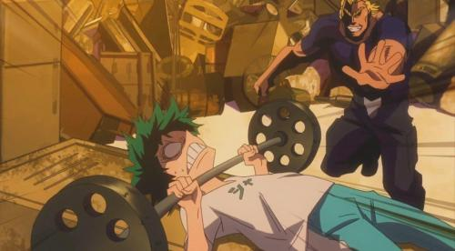
Figure 1 and 2. Stills from My Hero Academia where the main character is training to become physically stronger.
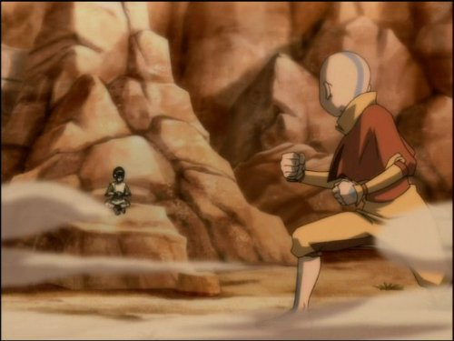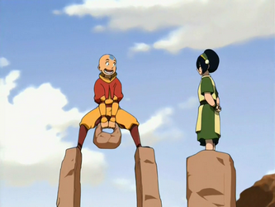
Figure 3 and 4. Stills from Avatar: The Last Airbender when the main character is learning to “Earthbend”.
This is to say, that stories with super-hero like powers can bring out an inspiration within people to do better (Zohvib, 2023). While superpowers like flying and invisibility are impossible for us to achieve, these stories can often inspire people to do better for themselves and those around them. Some people go as far as to admit that anime has inspired them to workout because for one, watching anime can feel exciting and exercise allows for this excitement to be put to use, and secondly, some people want to achieve a physique close to the characters they like to watch (Marx. D., 2021).
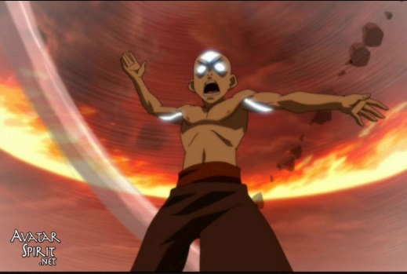
Figure 5. Avatar: The Last Airbender character Aang’s physique.

Figure 6. My Hero Academia’s character Deku’s physique.
For example, within My Hero Academia, the main character goes through some intensive training sessions when he is given his power, as shown in figures 1 and 2. This type of motivation shown by some viewers isn’t completely unfounded, seeing as in figure 5 and 6 we can see that the characters physique can be quite realistic.

Coming-of-age stories
Another similarity is that both of these stories could be considered to be “coming-of-age” stories. Coming-of-age stories typically mean accompanying the characters through their change in emotions, and usually this translates into a young character’s growth into a more mature mindset and adulthood. However, in its essence, these stories can be boiled down to a significant change in a person’s emotions, meaning that this can happen at any stage in life. Emilie-Noelle (2023) states that these types of stories are universal, since a lot of the themes that younger adults struggle with are also themes adults are or have struggled with in the past. It can allow people to better understand their events they may have gone through when growing up, come to terms with their childhood, or even empathise with the characters due to going through similar experiences as adults. Another article states that coming of age stories can be quite nostalgic for the older audiences (Public Libraries Singapore, 2022). At times, older audiences may use coming of age stories as a small escape from the current world into their simple times in the past. A lot of the time, these coming-of-age stories are written at quite an innocent point in most people’s lives, when they are only starting to understand the nuances of relationship and the world around them, so adults typically like to vicariously relive this stage of their life through series or books that cover these stories.
And for younger people, coming-of-age stories can help them understand themselves and their feelings when they feel alone in the world. At times when young adults are starting to mould their personalities and beliefs, coming-of-age stories can give them a place to explore different ideologies and complicated topics that they might need help working through (Bianca Schulze, n.d.).
This phenomenon extends to animated productions and even other tv series. A lot of coming-of-age productions like the two this essay is about can help young people understand the topics of love, friendship and hardship. It can help young people learn different ways to navigate complicated feelings and relationships at a time when they might not feel like they can talk to anyone else. For example, in The Last Airbender, Aang has to deal with the grief of having lost his loved ones. He also has to deal with his friends oftentimes fighting and being expected to stay composed due to his position. In My Hero Academia, Deku was bullied by a childhood friend for not having a power, but later on the dynamic between them slowly starts to change. For young teenagers, these dynamics can feel relatable, and help them navigate these situations.

Visual aesthetics
Lastly, there are some aesthetic similarities between these series as well. My Hero Academia is a Japanese animated series, and Avatar: The Last Airbender, while not a Japanese animated series, it took a lot of inspiration from anime in the way it was written but also in its art style (Dububoi, 2019). Both of these series share the more distinct features that characterise anime, with the exaggerated features and typically a colourful and vivid colour palette.
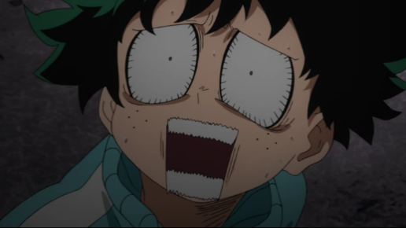 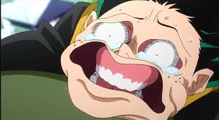
Figure 7 and 8. Stills from My Hero Academia’s exaggerated features.
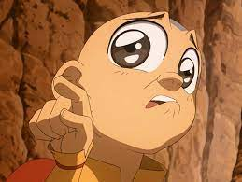 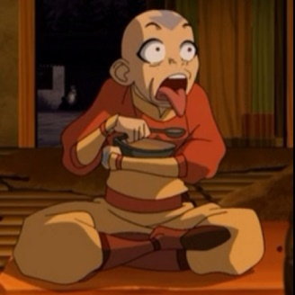
Figure 9 and 10. Stills from Avatar: The Last Airbender’s exaggerated features.
They also both use these vivid colour and exaggerated features to create beautifully dynamic and engaging action scenes shown below.
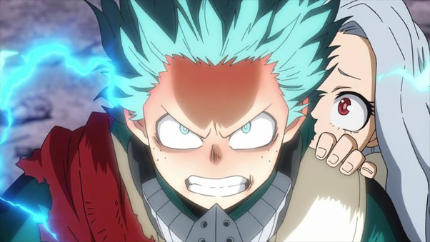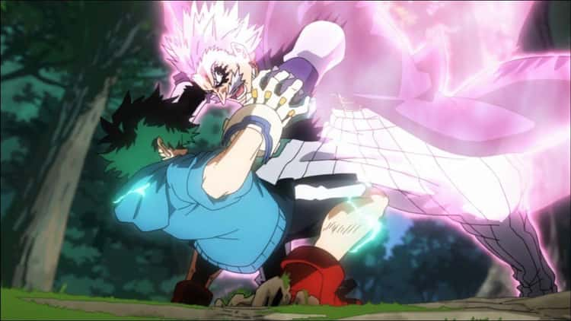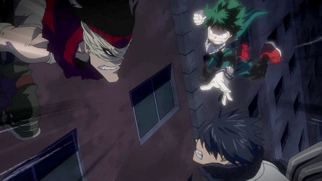
Figures 11, 12 and 13. Depictions of fighting scenes in My Hero Academia.
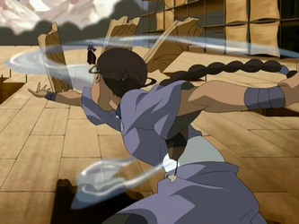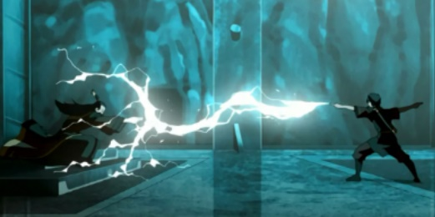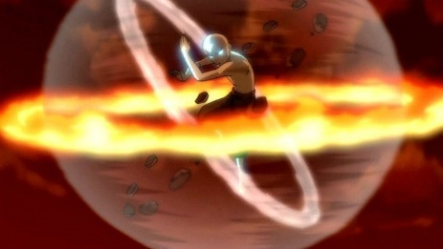
Figures 14, 15 and 16. Depictions of fighting scenes in Avatar: The Last Airbender.
With the added movement within these scenes, the colours and tension from the narrative, it’s easy to see how animated series can be so visually appealing. Animated series allow for the use of ample effects and angles that might be hard to achieve in live action with the technology at the time, making some of the animated fighting scenes absolutely astounding thanks to their dynamic shots.

What can these mean for the future of animation?
The effect that the West and the East are having on each other’s story telling techniques can be a quite positive change for the overall market. The reality is that anime and Japanese culture has been an influence on the West for a good while, with anime being present in American television since the 1960’s, whereas it took an additional 10-20 years for it to become more present in British television (Ryan Lambie, 2015). Shows like Marine Boy, ThunderCats and Akira marked the start of a generation that was exposed to a different type of media and animation that has since grown and evolved. Honourable mentions of popular Japanese shows that were brought into Western TV and became hits would include Dragon Ball Z, Naruto, Pokémon and Yu-Gi-Oh! Duel Monsters. These shows came around in the 1990’s and early 2000’s, and are still widely popular to this day, with Pokémon continuing to release video-games to this day, and Yu-Gi-Oh! Duel Monsters having a successful trading card game.
ThunderCats is actually an American franchise, but it has a more anime-style animation due to having been entirely animated in Japan (“ThunderCats,” n.d.). While instances like this where different countries worked together in creating a series happened even back then, nowadays we can also see instances of Western culture affecting Eastern animation and vice-versa.
For example, the My Hero Academia anime has a somewhat more American friendly plot, with the start of the series presenting a character “All Might” as the epicentre of the hero society, the strongest. An article claims that All Might in this series almost resembles the image that Superman has in the Marvel Universe, whereas the main character Deku, being depicted as a hero nerd who was bullied growing up may resemble Spider-Man’s story (Emily Spector, 2017). This article also points out the individualistic idea of wanting to be the “best hero” within their society and sometimes having to fight against their peers to achieve this more individualistic goal. Eastern countries tend to be more collectivist, so this slight change into including more individualistic features in their characters can be just what is needed for a newer audience first experiencing anime.
In Avatar: The Last Airbender, there are a number of similarities between each of the 4 nations and different indigenous tribes and eastern countries. Jessica Nguyen and Brian Pham (2020) list some of these inspirations that each nation drew from:
- The Water nation seems to have been inspired by the Inuit and Yupik culture in their dressing and dietary habits, by aboriginal Australians and Native Americans in their weapons and war paints, but also drew inspiration from Chinese martial art tai chi for this nation’s form of bending.
- The Earth nation took a lot of inspiration from Chinese history in its landscaping and architecture, it’s cooking and clothing, and even its authoritarian period during the Ming Dynasty. This nation also takes some clothing inspiration from Korea with the hanbok and has some groups within it that draw inspiration from Japan and from the Tuareg people from Africa.
- The Fire nation seems to have been heavily influenced by imperial Japan in its military doings and propaganda used on their people. Some of the architecture here seems to have been influenced by Chinese and Ancient Egyptian architecture, and their form of bending seems to come from the Northern Shaolin system.
- The Air nation is heavily influenced by Buddhism in their clothing and practices with some Hindu influences within their diet. Their architecture resembles Chinese Buddhist Pagodas, and their clothing resembles Shaolin monks’ robes.
By taking inspiration from one another, these Western and Eastern series were able to find great success worldwide. The way in which these series took inspiration from one another to create something formulaic but with new nuances that are interesting and engaging is inspiring. An article briefly mentions how the way in which Avatar: The Last Airbender focuses on historical events and works around those rather than by utilising stereotypes for their advantage is one of its overall good points (Julia Shiota, 2020). The way in which the animation industry is growing by learning from each other to enhance the viewers experience is astonishing and will provide the market with many new and original stories.
Another phenomenon that seems to be happening is almost the blur of genre boundaries in some series. With headlines like “Is Cells at Work shonen?” (Ollie, 2023) and “Is My Happy Marriage a supernatural or a slice-of-life anime? Genre explained” (Anupam Barua, 2023), both articles go into the nuances of why these animes are one genre or the other, however, typically this wouldn’t need to be questioned or analysed so much, since there are basic tropes that almost give away a production’s genre. But with the rise of demand for anime, there is a bigger market to experiment with different genre combinations and narrative tropes. My Hero Academia genres include Shonen (genre aimed at younger male audience and is generally full of action), Comedy, Action, Superhero, and Science fantasy, whereas Avatar: The Last Airbender genres include Action, Comedy, Adventure, Drama, Mystery, Superhero and Fantasy. Anime and current animated films have become so complex that they oftentimes take on the task of addressing numerous sub-plots within the main plot, to the point that they engage with a variety of genres that will appeal differently to different people.
Another interesting question to pose at this point would be whether this continuous change in the industry will mean more diversity within Japanese anime and possibly within their society. Unfortunately, it isn’t all that uncommon to see people complaining about some aspects of Japanese culture when trying to move there. An article by Yoshitaka Lawrence Shimoji (2023) states that a survey report from 2017 showed that almost 40% of correspondents stated that they had been denied from properties simply due to their foreign background, and the same has been said about employment, with 25% of correspondents stating they have been denied employment due to their foreign background. The article states that Japan seems to overlook their racism towards foreigners, which can become increasingly problematic as time goes on. With the worlds growing interest in anime and Japanese culture, it only makes sense that even more people would be curious and interested in making a trip to Japan, to experience the rich culture they are now experiencing through their screens. A graph from Statista titled “Number of international visitor arrivals to Japan” that covers the years of 2005-2022, shows that from while from 2005-2012 the number remained mostly stable, from 2013-2019 the number of visitors increased dramatically from 10.36 million visitors in 2013 to a whopping 31.88 million in 2019, meaning that in 6 years, the number of visitors has tripled (Alexandru Arba, 2023). The impact of this sudden change, however, can be seen in some of the new rules and taxes Japan has been implementing recently. An article states that Japan received 2 million international visitors for 4 consecutive months in September of 2023, stating that the number of visitors is returning to be on par with the pre-pandemic numbers mentioned before (Hughes, 2023). However, this influx of international visitors has had a negative impact on the locals living in the more touristy spots, with many complaining about the public transport infrastructure being overcrowded and being worried about tourists behaviour such as “littering or eating while walking” (Vogt and Qin, 2023). This would explain the measures being taken by the government to expanding their infrastructures with more buses and taxis, increasing bus fares and tourist tax and also by encouraging tourists to explore areas outside of the popular hotspots such as Tokyo and Kyoto (Hughes, 2023).

Conclusion
My Hero Academia and Avatar: The Last Airbender are similar stories at their core: a hero with an amazing power has to undergo training to become strong enough to stop a big threat from continuing its era of terror. They are both inspirational and relatable in their own right and have both succeeded at tackling a number of heavy issues in a light-hearted manner that everyone can relate to and understand. From friendships, to struggling with learning, to dealing with feelings of anger and sadness, both of these animated series strive to teach their audience that both individual growth and being able to rely on the community around you is important. The impact that the West and the East have on each other is becoming more apparent as the industry continues to grow, with current animes such as Demon Slayer (2019) and Jujutsu Kaisen (2020) becoming worldwide sensations in their own right and continuing to move the industry along. If the animation industry continues to focus on a non-judgemental type of narrative, and potentially exploring each other’s rich culture and history, there is an opportunity to continue to create ground-breaking work that will prevail for generations to come. The more we explore within each genre and culture, we are bound to create more innovative storylines and universes that others can build upon as well. The cultural exchange and understanding we can achieve this way could bring about a change in the way we learn and consume information, and it could bring people together in communities like any other engaging hobby. This exchange of ideas between Western and Eastern animation will bring a whole new section of animation that will be engaging for an even wider audience but also educational, with potential to aid young adults and children in their emotional growth. Further studies should be performed on the potential of animation for education and what effects this merge between West and East values could to our current society.

Biography
Arba, A. (2023) Number of international visitor arrivals to Japan from 2005 to 2022, Statista. Available at: https://www.statista.com/statistics/654263/japan-number-foreign-visitors/ (Accessed: 15 December 2023).
Baker, S. (2021) Nostalgia Isn’t Always a Good Thing, Good Housekeeping. Available at: https://www.goodhousekeeping.com/life/a38137325/nostalgia-pros-cons/ (Accessed: 15 December 2023).
Barua, A. (2023) Is my happy marriage a supernatural or a slice-of-life anime? genre explained, Sportskeeda. Available at: https://www.sportskeeda.com/anime/is-my-happy-marriage-supernatural-slice-of-life-anime-genre-explained (Accessed: 15 December 2023).
Brianpham (2020) Cultures represented in Avatar: The last airbender, Baron News. Available at: https://www.baronnews.com/2020/07/22/cultures-represented-in-avatar-the-last-airbender/ (Accessed: 15 December 2023).
D., M. (2021) Anime motivates me to work out, Medium. Available at: https://medium.com/in-fitness-and-in-health/watching-anime-gives-me-motivation-to-workout-fccc65fb9e92 (Accessed: 15 December 2023).
Dububoi (2020) ‘avatar the last airbender’ is not an anime; here’s why, The Boba Culture. Available at: https://www.thebobaculture.com/anime/avatar-the-last-airbender-is-not-an-anime (Accessed: 15 December 2023).
Eadweard Muybridge (2023) Wikipedia. Available at: https://en.wikipedia.org/wiki/Eadweard_Muybridge (Accessed: 15 December 2023).
Hughes, R.A. (2023) New tourist tax and higher transport costs: How Japan is planning to combat overtourism, euronews. Available at: https://www.euronews.com/travel/2023/10/20/new-tourist-tax-and-higher-transport-costs-how-japan-is-planning-to-combat-overtourism (Accessed: 15 December 2023).
Lambie, R. (2015) The shows & films that made Britain fall in love with anime, Den of Geek. Available at: https://www.denofgeek.com/tv/the-shows-films-that-made-britain-fall-in-love-with-anime/ (Accessed: 15 December 2023).
Loria, D. (2020) MPA: 2019 global box office and Home Entertainment surpasses $100 billion, Boxoffice. Available at: https://www.boxofficepro.com/mpa-2019-global-box-office-and-home-entertainment-surpasses-100-billion/ (Accessed: 15 December 2023).
Mafi, L. (2021) How rewatching shows can help ease your anxiety, Intuitive Healing. Available at: https://www.intuitivehealingnyc.com/blog/2021/12/27/how-rewatching-shows-can-help-ease-your-anxiety (Accessed: 15 December 2023).
Ollie (2023) Is Cells at Work Shonen?. Available at: https://moetron.net/is-cells-at-work-shonen/ (Accessed: 15 December 2023)
Op-Ed, C.B. (2020) For the animation industry, the coronavirus crisis has created a big opportunity, Cartoon Brew. Available at: https://www.cartoonbrew.com/ideas-commentary/for-the-animation-industry-the-coronavirus-crisis-has-created-a-big-opportunity-189911.html (Accessed: 15 December 2023).
Provost, E.-N. (2023) Growing pains: Why coming of age stories are for everyone, Writer Unboxed. Available at: https://writerunboxed.com/2023/08/23/growing-pains-why-coming-of-age-stories-are-for-everyone/ (Accessed: 15 December 2023).
Schulze, B. (2018) Why coming-of-age books are important to read, The Children’s Book Review. Available at: https://www.thechildrensbookreview.com/why-coming-of-age-books-are-important-to-read/ (Accessed: 15 December 2023).
Shayo, L. (2023) Avatar: The last Airbender’s similarity to anime addressed by creator, ScreenRant. Available at: https://screenrant.com/avatar-last-airbender-anime-comparison-similarities-response/ (Accessed: 15 December 2023).
Shimoji, Y.L. (2023) Why does japanese society overlook racism?, Public Books. Available at: https://www.publicbooks.org/why-does-japanese-society-overlook-racism/ (Accessed: 15 December 2023).
Shiota, J. (2020) Avatar: The last Airbender’s world never felt tokenizing because it drew from Asian history, SYFY Official Site. Available at: https://www.syfy.com/syfy-wire/avatar-the-last-airbender-pan-asian-history (Accessed: 15 December 2023).
Singapore, P.L. (2023) Why we love coming-of-age stories, Medium. Available at: https://medium.com/publiclibrarysg/why-we-love-coming-of-age-stories-533b24247b7 (Accessed: 15 December 2023).
Solomons, M. (2023) 150 animation statistics and industry trends, Linearity blog. Available at: https://www.linearity.io/blog/animation-statistics/ (Accessed: 15 December 2023).
Spector, E. (2017) The american appeal of anime show ‘my hero academia’ - student life, Student Life - The independent newspaper of Washington University in St. Louis. Available at: https://www.studlife.com/special-issues/freshman-press/2017/08/24/the-american-appeal-of-anime-show-my-hero-academia (Accessed: 15 December 2023).
ThunderCats (2023) Wikipedia. Available at: https://en.wikipedia.org/wiki/ThunderCats (Accessed: 15 December 2023).
UK film industry statistics 2023 (2023) Social Films. Available at: https://www.socialfilms.co.uk/blog/uk-film-industry-statistics (Accessed: 15 December 2023).
Vogt, G. and Qin, S. (2023) Does japan dread or desire its influx of international tourists?, East Asia Forum. Available at: https://www.eastasiaforum.org/2023/12/04/does-japan-dread-or-desire-its-influx-of-international-tourists/ (Accessed: 15 December 2023).
Zohvib (2023) Why we love superheroes psychology, Medium. Available at: https://medium.com/age-of-awareness/why-we-love-superhero-psychology-a3e446083aa5 (Accessed: 15 December 2023).

