BA International Hotel Management
Management and organisational behaviour
Code: BMIH5004
Lecturer Name: Giulia Chifari
Student Name: Sadia Odud
Student ID: 2130037

Table of Contents
Introduction 3
Background of the company 4
Decoding IHG 5
Organizational Structure, Culture and Goal 5
Recent Change Initiatives 5
Strategic Direction & Current Business Performance 6
Linking the Pieces: Structure, Culture, and Performance 7
Managerial Work & Leadership 8
Behavioural Approach 10
Critical Analysis 11
Recommendations 12
Conclusion 13
References 14

Introduction
IHG is a big player in a market with lots of other companies. Guests have different needs. It is successful because it has a lot of brands, can reach people all over the world, and has a loyal customer base. There are, however, things that could go wrong below the surface, such as inconsistent brand experiences, variations in how well different regions do, and a complicated structure that could cause people to think in different ways. It talks in great depth about IHG's complicated organisational structure and how its people, culture, and structure all work together. We make it possible for IHG to reach its full potential by showing it what it does well and what it could do better. Hold on tight as we look into how this huge hospitality company is always changing in order to find ways to improve performance and make sure long-term success.
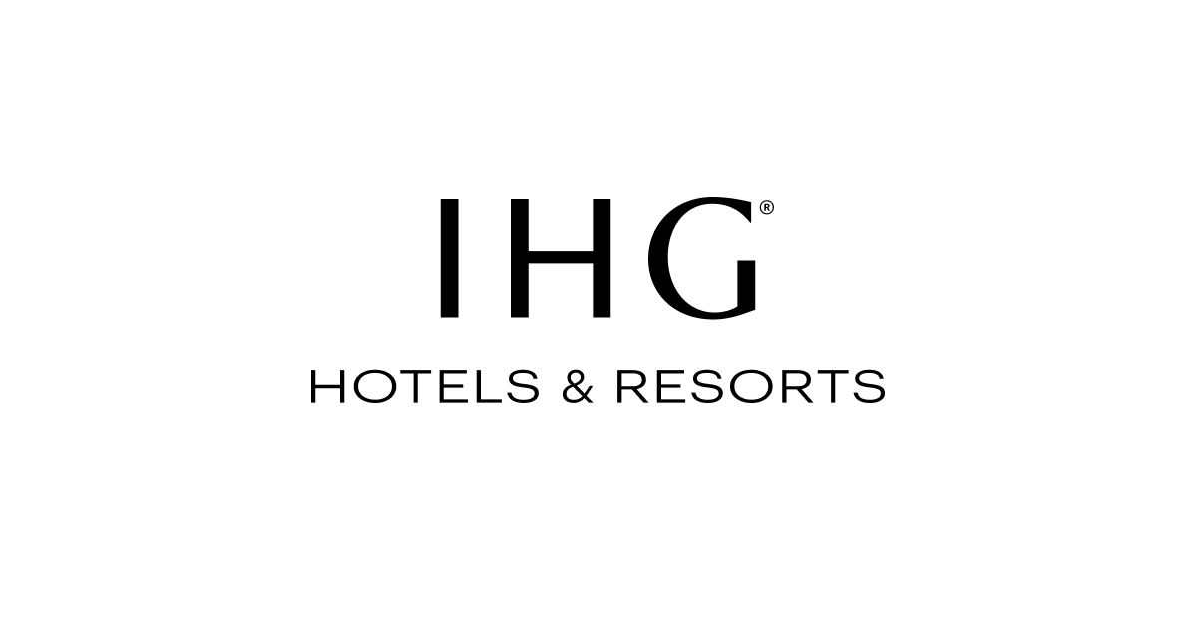
Figure: IHG logo
IHG website address: https://www.ihg.com

Background of the company
IHG's long history began in 1777 with the small Bass Brewery in England. The business was first known for its beers. After buying a few tied public houses, it eventually got into the hotel business and opened the first Crest Hotel in 1969. It changed a lot when it bought Holiday Inn International in 1988 (Mullins, L and Dosser, P. 2013). That move made it stronger in the hotel business. This is where "Bass Leisure Group" got its start (Widani et al., 2019). In 2003, it changed its name to "The InterContinental Hotels Group." IHG stopped making beer in 2005 and only ran hotels after that. It had grown into the huge hotel chain we know today. Always adapting to new styles and guest feedback, IHG stays true to its core value of "True Hospitality for Good." It now has more than 6,000 hotels under 16 different brands.
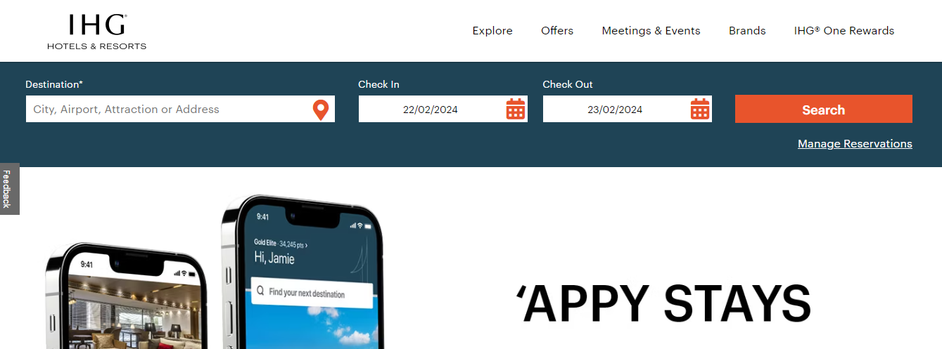
Figure: IHG home page
Source: (Mullins, L and Dosser, P. 2013).

Decoding IHG

Organizational Structure, Culture and Goal
People from all over the world can reach IHG because it has a complex structure that is built around its brand (Mullins, L 2020). The idea behind this design, which is divided by region and focuses on various hotel experiences, is to make things run more smoothly. But thinking in silos and putting things into action in different ways in different parts of the world could be problems. IHG tries to find a line between giving employees a lot of freedom and making sure guests are happy. This makes people more loyal, but it might be hard to get regional priorities to work together. Some of their many goals are to keep making money, grow luxury and lifestyle brands, and make sure that brands work the same way across all segments (Jacobs and Crockett, 2021). Overall performance is getting better, but there are still concerns about how consistent the brand is and how different regions are. It is important to know whether the structure supports or undermines the cultural values (Schein and Schein, 2019). Is the gap between regions good for competition or does it create different points of view? Can teams that are focused on the brand also help reach bigger goals? By looking at how these things interact, IHG can change its structure to better support the culture it wants and reach its lofty goals.

Recent Change Initiatives
To stay relevant, IHG has embraced change by taking the lead on projects like making changes to its brands and loyalty programmes. At first, brand makeovers that tried to update designs, add technology, and make service better got good reviews (Mullins, L. 2016). It caused worry, though, when different hotels in the same chain didn't follow the same rules. In the same way, changes to loyalty programmes made people more likely to join and redeem their points at first, but people didn't like how the points were valued or how complicated the programme became. While both projects tried to adapt to changing needs, they could have been more useful if they had been better explained, carried out, and responded to more quickly (Socha, 2018). It's clear that IHG wants to change, but in a big, complicated company like theirs, it takes careful management to make changes work.

Strategic Direction & Current Business Performance
IHG focuses on growth by expanding its lifestyle and luxury brands to keep up with changes in the market. This fits with how guests' tastes are changing, but it means making sure that every group makes money (Boddy, D. 2014). There are still concerns about brand consistency and performance gaps between regions, even though overall performance is getting better. Its strengths are the variety of brands it sells and the way its business is aligned with luxury trends. It's not always the same for guests with the same brand, though, and performance varies by region, which makes things less clear. The company could do better in the market if it used its range of brands more and fixed problems with consistency. Threats include changes in the economy and competition (Jacobsen, 2021). This makes it more important for brands to offer consistent experiences and for the region's growth to be even. IHG needs to find a steady state between these things if it wants to grow and succeed over time.

Linking the Pieces: Structure, Culture, and Performance
IHG needs to really think about how its complicated structure affects its culture and how that, in turn, affects its work. The brand-focused, regionalized structure makes things run smoothly, but it could cause people to think and experience brands in different ways (Arevuo, 2023). There is a balance between making sure guests are happy and giving employees the freedom to do their jobs. This could make it harder to align regional priorities and get people from different brands to work together. It is important to look at this meeting. Is the way the region is set up good for competition or does it keep different points of view apart? Does someone give brand teams the power to help someone reach bigger goals? Do different ways of communicating help cultural values or keep information separate? If someone look at these questions, he might be able to figure out what changed. To fill in the gaps, someone could get people from different brands to work together through regional task forces or by creating rules for how all brands should be implemented (Andersen, Torp and Linder, 2019). To get the most out of structure and culture, a person need to know how they change how workers act, how decisions are made, and how everyone in the company talks to each other. It's not enough for this analysis to just list IHG's pros and cons; it's also meant to help the company reach its full potential (Binda, 2013). To reach its big goals and deal with the competition easily and consistently, IHG needs to change its structure to support the culture it wants to build and get people from different brands and regions to work together.
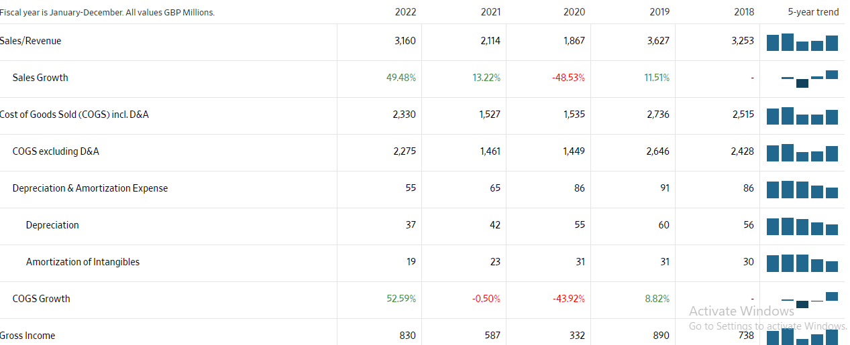
Figure: IHG income statement
Source: (www.wsj.com, n.d.)

Managerial Work & Leadership
It's up to IHG's managers to figure out how to deal with regional priorities, different brand needs, and global strategic directions. Top-down instructions and localised execution need to be able to talk to each other clearly (Lee, 2017). It's important for regional and brand teams to work together to make sure that everything is carried out the same way and to build a sense of shared purpose. Managers need to do more than just talk to people; they need to get people from every background to work together. It's important to know what each person is good at and change how someone lead based on how people work. Give teams within the structure the tools they need and make sure they are all working towards the same big goals. This will strike a balance between freedom and centralised control (Snee, 2020). Knowing the "human equation" of change management is also important. It is possible to learn a great deal from how employees respond to changes, how they work together, and how they see rewards. Finding possible points of resistance and changing how someone talk to people about them can help with implementation and get more people on board (Pietrykowski, 2019). At the end of the day, good managers bring structure, culture, and people together to get work done. In the fast-paced world of hospitality, IHG managers can get the most out of their staff and be successful by learning how to communicate, work with others, and understand how people work.

Behavioural Approach
IHG wants to know how the actions of individuals impact the performance of the company as a whole. The behavioural approach helps us figure out how teams work together, what motivates employees, and how they think (Wheldall, 2017). Do employees think there are ways for them to advance in the company? Are reward systems in line with what someone want people to do? How does the way a team works together and share information affect working together across brands and regions? By answering these questions, IHG can make the workplace a good place to work that encourages the behaviour they want to see (Anderson, Hagler and Business, 2014). Training programmes can be made to fit the needs of each person, high-performance incentives can be set up, and people can change their behaviour for the better if they know what is expected of them (Saurabh Kumar Dixit, 2017). In the end, IHG can make its structure, culture, and management better by knowing "why" employees do the things they do. In this way, the business can get its strategic goals done and make the most of its employees.

Critical Analysis
IHG has many brands, operates all over the world, and has a strong customer base. Its brands don't always match up, and its performance in different regions isn't always the same. Its structure could also be split up into separate areas. When someone deal with these issues, it's important to play to its strengths (Legrand, Henri Kuokkanen and Day, 2023). It would be great if IHG streamlined its structure to encourage collaboration across brands and regions. This would also help make sure that guests have consistent experiences, get more buy-in for change, and learn more about how each employee works so that they can be better trained and given better incentives (Huang and Hands, 2022). As long as IHG aligns its structure, culture, and people in a strategic way, it can deal with competition in a way that is both adaptable and steady.

Recommendations
- To get the most out of a diverse portfolio, encourage brands to work together and market each other.
- To break down barriers and boost teamwork, structure and ways of talking to each other should be streamlined.
- Change can be easier to handle if everyone is on the same page and agrees with the plan.
- Always pay attention to how guest tastes and market trends change, and make changes when someone need to.

Conclusion
The tour of IHG's world shows a business that is full of chances. It has a strong base with many products, customers all over the world, and a large customer base that sticks with it. But it's important to find solutions to issues like inconsistent branding, poor performance in some areas, and a structure that can be split into separate areas. IHG can start a journey that will change everything if they do what we say. It needs to get to know its employees, make sure that its brand stays the same, and simplify its structure in order to reach its full potential. Someone can change it to fit your needs as long as he keep up with changing market trends and guest tastes. Remember that IHG's story of success is still being written. IHG can become a leader in giving travellers all over the world consistent, high-quality experiences if it brings its structure, culture, and people together.

References
Andersen, T.J., Torp, S. and Linder, S. (2019). Strategic responsiveness and adaptive organisations : new research frontiers in international strategic management. Bingley, UK: Emerald Publishing Limited.
Anderson, M., Hagler, B. and Business, N. (2014). Leadership in business education. Reston, Va: National Business Education Association.
Arevuo, D. (2023). STRATEGY : theory, practice, implementation. S.L.: Oxford Univ Press.
Binda, V. (2013). The Dynamics of Big Business. Routledge.
Boddy, D. (2014) Management: An Introduction (6th Ed), Harlow, Pearson
Huang, Y. and Hands, D. (2022). Design thinking for new business contexts : a critical analysis through theory and practice. Basingstoke: Palgrave Macmillan.
Jacobs, J.L. and Crockett, H. (2021). Designing exceptional organizational cultures : how to develop companies where employees thrive. London: Kogan Page.
Jacobsen, D.I. (2021). Organizational Change and Change Management. Vigmostad & Bjørke.
Lee, N.R. (2017). The Practice of Managerial Leadership. Xlibris Corporation.
Legrand, W., Henri Kuokkanen and Day, J. (2023). Critical Questions in Sustainability and Hospitality. Taylor & Francis.
Mullins, L (2020) Organisational Behaviour in the Workplace (12th edition) Harlow:Pearson
Mullins, L and Dosser, P. (2013) Hospitality Management and Organisational Behaviour (5th Ed) Harlow, Pearson.
Mullins, L. (2016) Management and Organisational Behaviour (11th edition) Harlow: Pearson
Pietrykowski, B. (2019). Work. Cambridge, Uk ; Medford, Ma: Polity Press.
Saurabh Kumar Dixit (2017). The Routledge Handbook of Consumer Behaviour in Hospitality and Tourism. Taylor & Francis.
Schein, E.H. and Schein, P.A. (2019). The Corporate Culture Survival Guide. John Wiley & Sons.
Snee, R.W. (2020). STATISTICAL THINKING : improving business performance,. S.L.: John Wiley & Sons.
Socha, G. (2018). Goal-Setting Theory and its Application in Organizations. GRIN Verlag.
Wheldall, K. (2017). POSITIVE TEACHING : the behavioural approach. S.L.: Routledge.
Widani, N.M., Abiyasa, A.P., Sri Darma, G. and Fredy Maradona, A. (2019). Menguji Ketajaman Implementasi E-Commerce Dalam Penjualan Kamar Hotel di Bali. Jurnal Manajemen Bisnis, 16(2), p.79. doi:https://doi.org/10.38043/jmb.v16i2.2042.
www.wsj.com. (n.d.). IHG | InterContinental Hotels Group PLC ADR Annual Income Statement - WSJ. [online] Available at: https://www.wsj.com/market-data/quotes/IHG/financials/annual/income-statement [Accessed 20 Feb. 2024].

