Shader Development
Rose Plumley
2218443
GPU Programming
ACCB6014
Nathan Morgan

Table of Contents
- Introduction………………………………………………………………………………………………………………3
- Task 1………………………………………………………………………………………………………………………..3
- Task 2………………………………………………………………………………………………………………………..4
  - Effect Research and Practical Applications……………………………………………………..4
  - Application Analysis………………………………………………………………………………………5
  - Testing and Validation………………………………………………………………………………….10
- References………………………………………………………………………………..…………………………….15
- Appendix…………………………………………………………………………………………………………………17

- Introduction
This report covers the development of an image loader, allowing for the application of two shader effects to be applied to different regions of a rendered image. Additionally, the two effects will be researched, investigating their practical applications. The two shader effects chosen are a bloom effect, and a greyscale conversion, split between a centre-area and periphery respectively.
- Task 1
Unmodified texture image:
[1]
Final output:
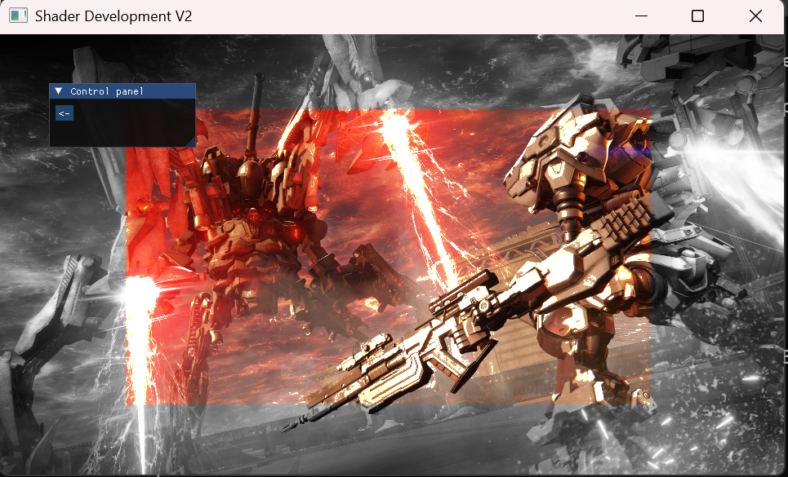
A link to a video viva of the practical work can be found in the appendix.
- Task 2
Task 2 follows research into the chosen effects, their practical applications, some brief analysis of the created application, and the testing and validation performed throughout.
  - Effect Research and Practical Applications
To begin with, bloom in reality is caused by the scattering of light through a lens (such as a camera lens or parts of the human eye), which creates a glowing effect around the light source, additionally dimming the contrast elsewhere in the scene [2]. In applications, bloom is used to convey brightness, simulating this glow effect which bleeds from the light source [3]. This mimics an overexposure effect in bright areas, commonly achieved through a bright-pass filter; a technique that extracts the brightest pixels in an image or texture (filtered through a chosen threshold) by finding the dot product of an image’s RGB values and a constant – essentially transforming the image to greyscale and extracting its relative luminance, where the final result value is in the range between 0 and 1 [3][4]. This specific constant (vec3(0.2126, 0.7152, 0.0722)) is used to determine relative luminance in standard red-green-blue (sRGB) spaces, i.e., those used with monitors and printers [5][6]. Once luminance is determined and extracted, if it exceeds the given threshold, brightness is enhanced by simulating it.
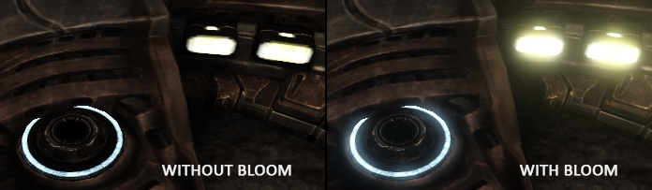An example of the bloom effect [3]
Conversely, the bloom effect is best achieved in combination with other effects, such as the application of a blur – typically Gaussian [7]. By combining bloom with blur, this creates a smoother transition between the brighter glowing areas and the surrounding area, creating a blending effect, resulting in a final product that is less stark and sharp.
Next, the greyscale effect. This was briefly touched on above, but the effect is achieved by sampling the texture colour and then finding the dot product of the colour’s RGB values and another constant to extract the grey from the image. This constant (vec3(0.299, 0.587, 0.114)) is used similarly to bloom’s sRGB values, but instead corresponds to YCbCr spaces (where Y is luma and Cb/Cr is blue-difference and red-difference chroma [8]), which are more suited to digital video, streaming, and broadcasting systems [9][10].
On its own, the greyscale effect is not particularly useful as a final post-processing output, but is instead used in combination with other shader effects, like through bloom above.
  - Application Analysis
The image loader and shader effects application created for Task 1 was made using the OpenGL graphics API, in combination with GLSL (OpenGL Shading Language) and some additional vendor code (stb_image.h) [11].
As background, OpenGL is a widely used cross-platform 2D and 3D vector graphics rendering API. Its flexibility and extensibility, when combined with its ease of use, make it widely accepted and implemented by hardware vendors worldwide, with use in CAD, content creation, game development, manufacturing, and so on [12]. It is especially relevant due to its use of a programmable graphics pipeline, allowing developers to control various stages of rendering.
GLSL is a C-like shader language used in combination with OpenGL to allow for the aforementioned control of the graphics pipeline, specifically in the implementation of separate vertex and fragment shaders [13]. Unfortunately, Visual Studio 2022 does not innately recognise GLSL, and thus requires the use of C++’s <filesystem> library, creating a backend to allow for both access and debugging (see Appendix Shader.h and Shader.cpp).
As for stb_image.h, this is public domain vendor code that allows for image loading and decoding from file/memory, with support for JPG, PNG, TGA, BMP, PSD, GIF, HDR and PIC files [14]. The only way this is potentially modified in the application is with the inclusion of the stb_image_impl.cpp file, which contains:
#define STB_IMAGE_IMPLEMENTATION
#include "stb_image.h"

Which simply creates the implementation. This could be done in the main as well (hence the commenting out in the includes), just as long as the lines are included in a single C/C++ file.
For a brief rundown of the functioning of the shader file, this is split into two halves – the vertex shader, and the fragment shader. The vertex shader takes in four input vertex attributes of varying sizes – aPosition, aNormal, aColour, and aTexCoord – with input received from the effectBloomGreyscale.cpp file:
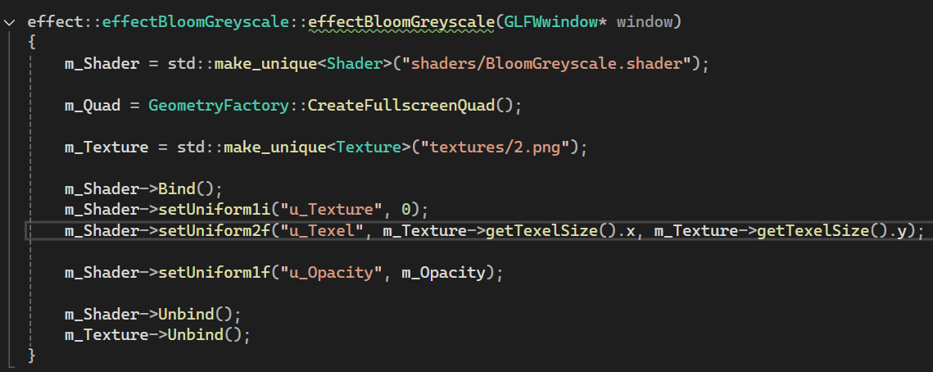
The vertex shader also specifies output to the fragment shader with v_TexCoords.
Otherwise, all that the vertex shader does is assign the data held in aTexCoord to v_TexCoords, and stores aPosition data in gl_position, which itself is used in primitive assembly after vertex processing occurs [15].
Following this, the fragment shader receives v_TexCoords from the vertex shader, and outputs FragColor. Additionally, the fragment shader defines three uniforms (attributes with global scope); u_Texture, u_Texel, and u_Opacity. Otherwise, it contains the functions for applying the bloom effect, applying the greyscale effect, and the main.
The bloom effect is achieved by obtaining the texture colour from the uniform and vertex shader (in RGBA format, note the vec4), then finding the brightness attribute through the dot product of the colour’s RGB values and the relative luminance, returning a value between 0 and 1. If the value exceeds a chosen threshold (in this case 0.7), then colour is returned at an enhanced brightness (multiplied by 1.5, with 1.0 Alpha). Otherwise, colour is returned as normal.
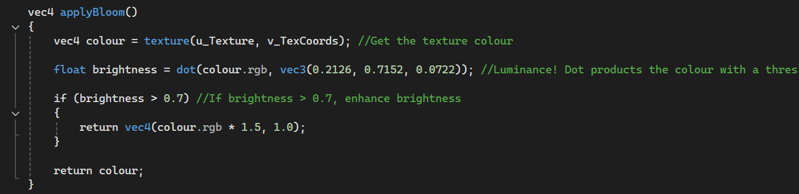
The greyscale effect is achieved in a similar fashion, using the dot product of the texture colour with the values for grey, similarly returning a value between 0 and 1. This resulting grey is returned at 1.0 Alpha.
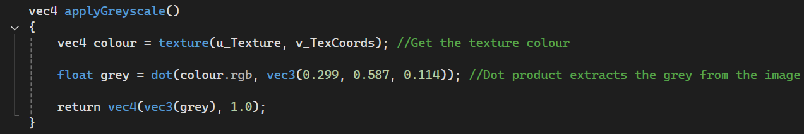
Finally, the main function of the fragment shader takes a base colour value (again, gets texture colour), and sets another vec4 to be the result, first taking from the baseColour attribute. A base colour is maintained for future usage. Following this, the function finds a box area through the vertex shader texture coordinates, and sets result to the output of applyBloom(). Otherwise, anywhere not within the given coordinates has the result set to applyGreyscale()’s output. Finally, FragColor mixes the base, result, and opacity.
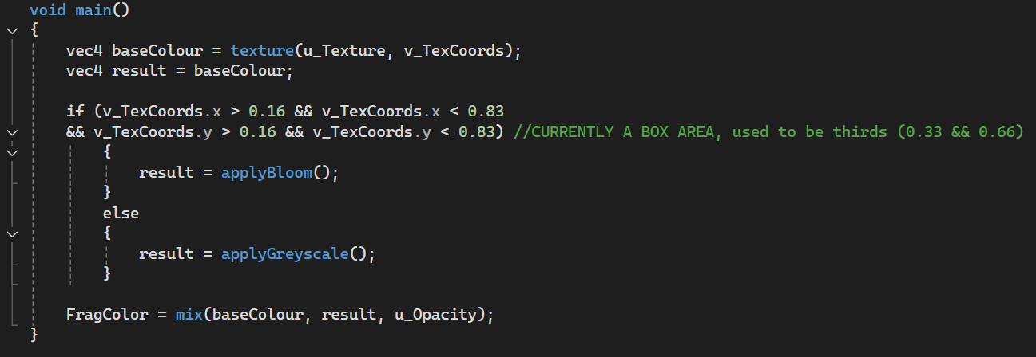
Note however, the lack of usage for u_Texel. This results in the uniform being undefined:
Going step-by-step in the debugger reveals location = -1 (i.e., warning above), and is thus an issue with the setUniform2f function. Stepping through the debugger further, the following data is output during the function:
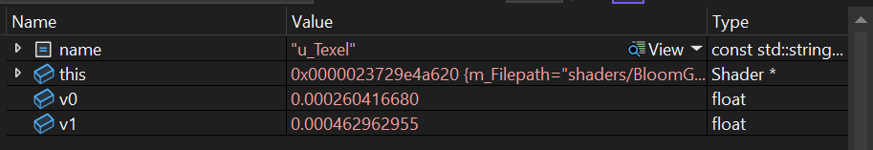
And, next, when glLogCall is performed, location goes from -858993460…
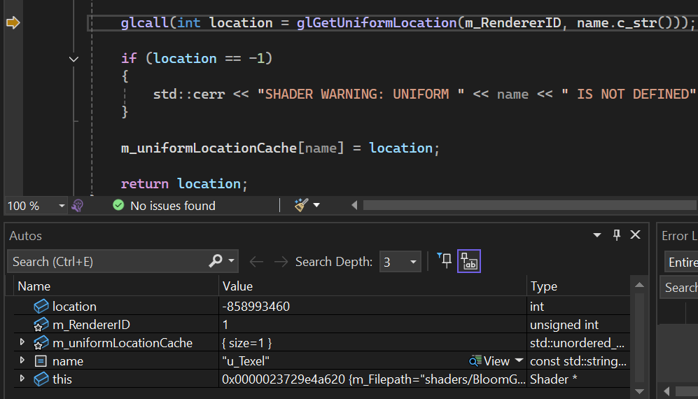
…To -1. While this currently isn’t an issue for the final output, as u_Texel is not used in any of the fragment shader methods, this could potentially be an issue in future implementations which rely on different filtering methods (e.g. nearest neighbour, bilinear, trilinear) using mipmaps [16].
In the final output, the greyscale works as expected. However, because the bloom effect is applied on its own without a blur, this results in a sharp, almost aliased look to the “bright” areas; Note especially the fuel stream of the robot, and the shoulder of the mech:
A closeup of the bright fuel stream
A closeup of the mech’s shoulder
Attempting to use a lower brightness threshold (0.4) results in the following:
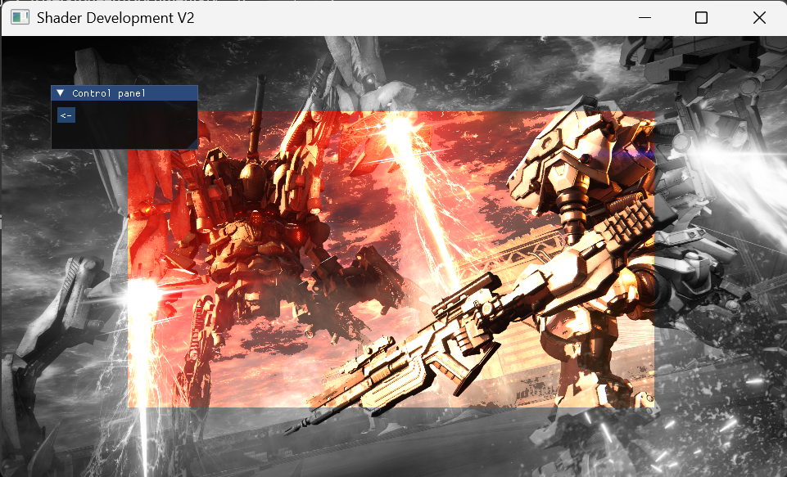if brightness > 0.4
A lower threshold results in a more “overexposed” output, but this output also becomes somewhat egregious, taking away from the more desired subtle highlighting of bright lights. Thus, a more advanced implementation would be improved with a blur to blend the sharp edges – effectively resulting in an anti-aliasing-like effect.
As for the greyscale effect, this works as intended. However, this function uses the vec3 constant from YCbCr. Using the sRGB vec3 constant instead results in the following:
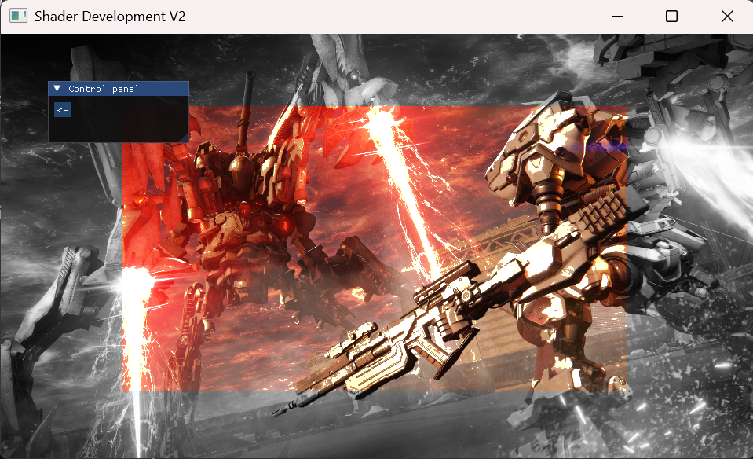applyGreyscale() output with sRGB vec3 constant
Which look nigh identical. Thus, comparison between the two constants would require mathematical precision.
  - Testing and Validation
Below are various tests used during development for different aspects of the program.
Initialise GLFW – if initialisation fails, print to console and close:
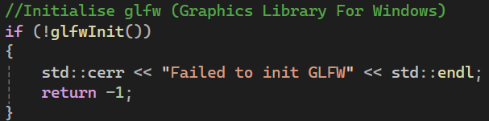
Create new window object – If GLFW window fails to create, print to console, terminate GLFW, close:
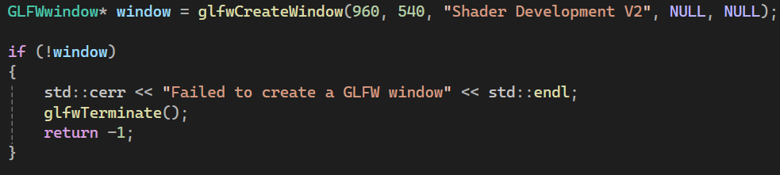
Initialise GLEW – if GLEW fails to initialise, print specific error to console, destroy window, terminate GLFW, close:
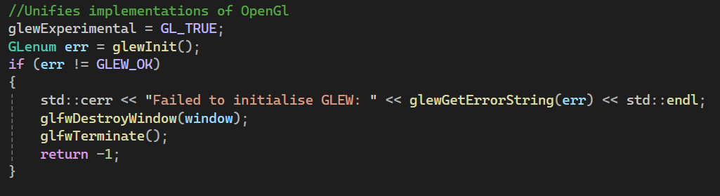
Initialise ImGui OpenGL implementation – if initialisation fails, print to console:
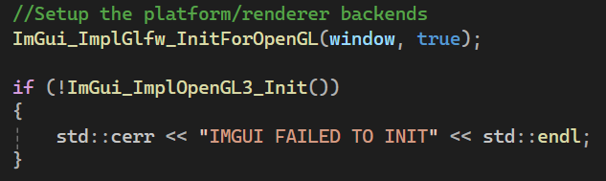
General OpenGL error logging – if glGetError() returns an error, loop through error, printing function, filepath, and line to console, then return glLogCall() as false:
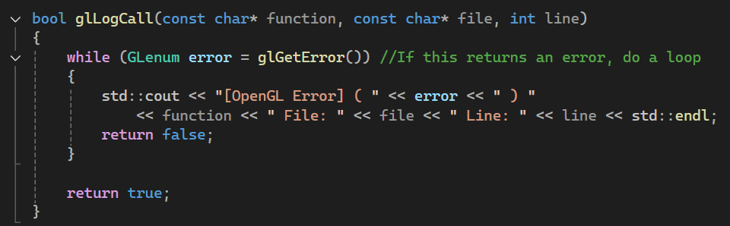
Paired with glLogCall above – Multi-line macro for clearing the error and executing a passed function. If false, calls a break at the exact point, and logs the call command to print out the errors in the function, the file, and the line:
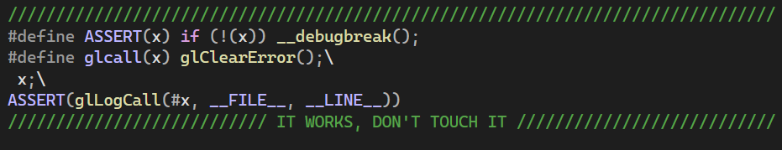
Print Shader ID to console when compiling shader – useful for debugging:
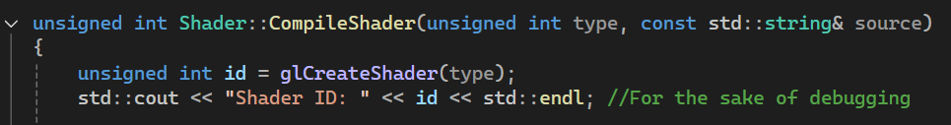
If CompileShader() fails, print failure to compile message, note specific shader – Additionally, malloca isn’t the best form of memory allocation, as it can potentially cause a stack overflow if too much memory is allocated:
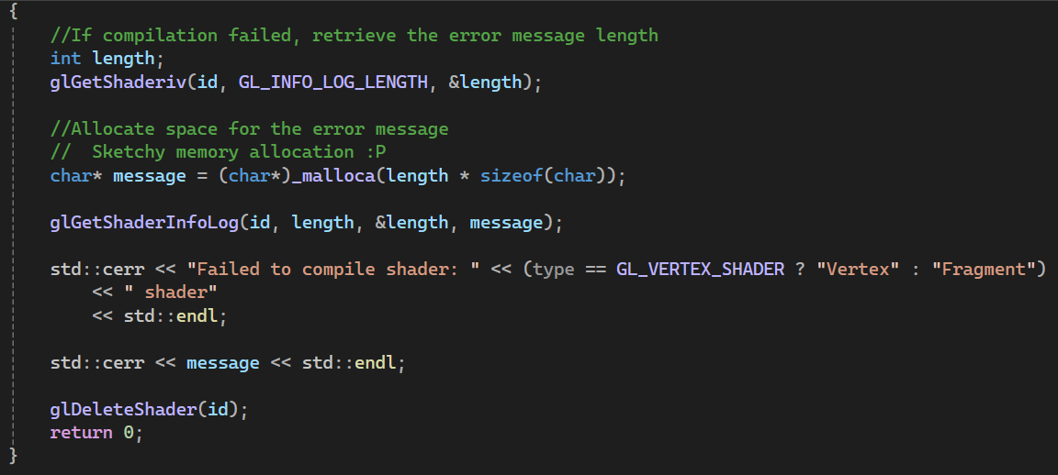
Check if a given file exists – If file through given file path does not exist, print to console:
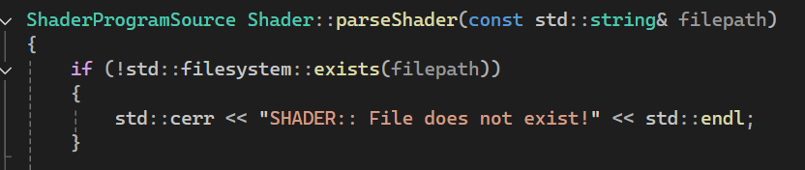
Get uniform location – Prints a warning to the console if a shader uniform is not defined:
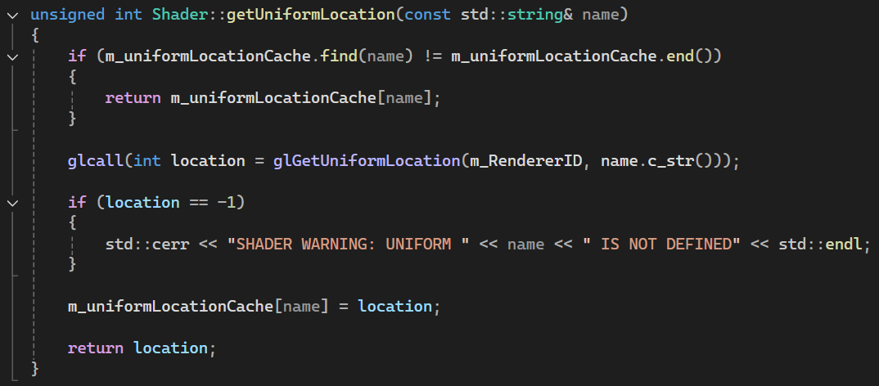
Check size of type in vertex buffer layout – fails if not a float, unsigned int or unsigned byte. Prints runtime error to console:
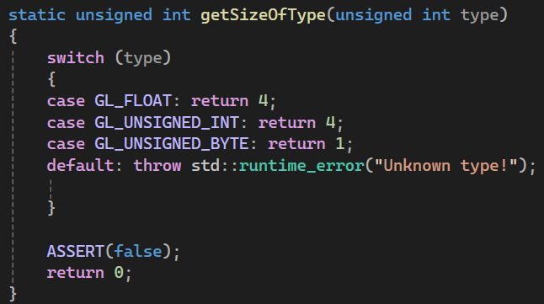
Check if vertex/index array is filled before setting up mesh – fails if either are empty. Could be expanded to check for and specifically print vertex or index array:
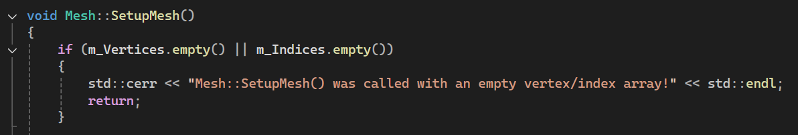
Check if Mesh has been set up before drawing – fails if VAO or IBO is not set up:
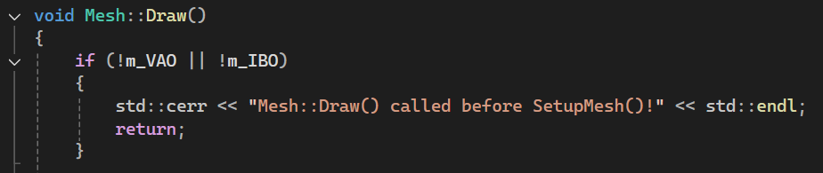
Check asset importer – if no scene, scene flags are incomplete, or scene has no root node, print importer error string to console, and throw runtime error including model and file path. Not used in application creation but left over from boilerplate. Still useful for future expansion of application:
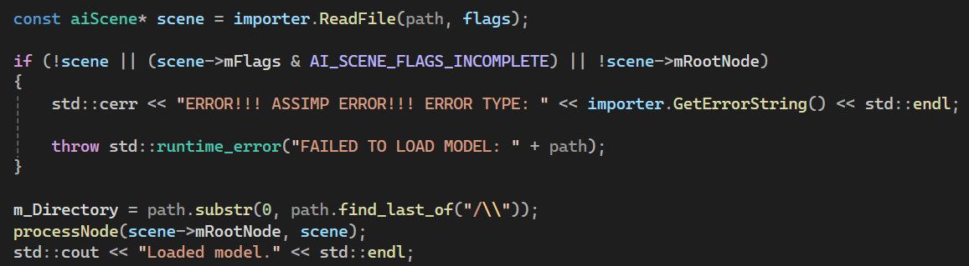
Check Model mesh draw – Fails if model mesh setup not performed first (i.e., no VAO/IBO). Like above, left over from boilerplate, but still potentially useful:
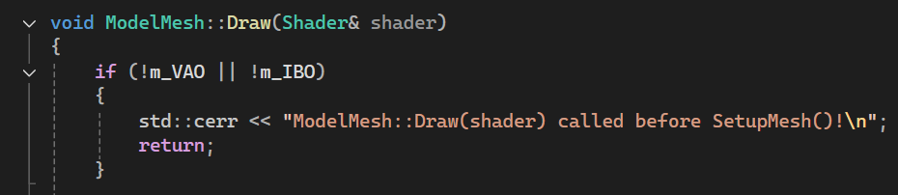

- References
[1] Armored Core VI: Fires of Rubicon. [Software], Japan: FromSoftware, 2023.
[2] T. Möller and T. Moller, Real-time rendering., Fourth edition / Tomas Akenine-Moller [and five others]. Boca Raton: CRC Press, 2019. [Online]. Available at: https://ezproxy.uwtsd.ac.uk/login?url=https://www.vlebooks.com/product/openreader?id=TrinityStD&accId=8886856&isbn=9781351816151&uid=^u
[3] “LearnOpenGL - Bloom,” Learnopengl.com. [Online]. Available: https://learnopengl.com/Advanced-Lighting/Bloom. [Accessed: 09-Apr-2026].
[4] International Commission on Illumination, “Luminance - 17-21-050,” Cie.co.at. [Online]. Available: https://cie.co.at/eilvterm/17-21-050. [Accessed: 09-Apr-2026].
[5] M. Anderson, R. Motta, S. Chandrasekar, and M. Stokes, “Proposal for a Standard Default Color Space for the Internet - sRGB,” in Color and Imaging Conference, 1996, pp. 238–245.
[6] International Electrotechnical Commission, “IEC 61966-2-1,” Oct. 1999.
[7] J. Jimenez, “Next Generation Post Processing in Call of Duty Advanced Warfare,” Aug-2014.
[8] “Understanding the color decoder,” Portrait Displays, 04-Aug-2020. [Online]. Available: https://www.portrait.com/resource-center/understanding-the-color-decoder/. [Accessed: 09-Apr-2026].
[9] International Telecommunication Union, “ITU-R BT.601-5,” Oct. 1995.
[10] International Telecommunication Union, “ITU-R BT.709-5,” Apr. 2002.
[11] S. Barrett, “stb_image.h,” GitHub, 31-May-2024. [Online]. Available: https://github.com/nothings/stb/blob/master/stb_image.h. [Accessed: 09-Apr-2026].
[12] “OpenGL - the Industry’s Foundation for High Performance Graphics,” The Khronos Group, 19-July-2011. [Online]. Available: https://www.khronos.org/opengl/. [Accessed: 09-Apr-2026].
[13] “LearnOpenGL - Shaders,” Learnopengl.com. [Online]. Available: https://learnopengl.com/Getting-started/Shaders. [Accessed: 09-Apr-2026].
[14] S. Barrett, “stb: stb single-file public domain libraries for C/C++,” GitHub. [Online]. Available: https://github.com/nothings/stb. [Accessed: 09-Apr-2026].
[15] “gl_Position - OpenGL 4 Reference Pages,” Khronos.org. [Online]. Available: https://registry.khronos.org/OpenGL-Refpages/gl4/html/gl_Position.xhtml. [Accessed: 09-Apr-2026].
[16] “LearnOpenGL - Textures,” Learnopengl.com. [Online]. Available: https://learnopengl.com/Getting-started/Textures. [Accessed: 09-Apr-2026].

- Appendix
Video viva link:
https://youtu.be/CptUiBuWL_A
Alternative link: https://www.youtube.com/watch?v=CptUiBuWL_A

Source code:
ShaderDevV2.cpp
//Main!

#include <GL/glew.h>
#include <GLFW/glfw3.h>
#include <glm/glm.hpp>
#include <glm/gtc/matrix_transform.hpp>
#include <glm/gtc/type_ptr.hpp>
#include <iostream>
#include "Renderer.h"

/*
#define STB_IMAGE_IMPLEMENTATION
#include <stb_image.h>
*/

#include <imgui.h>
#include <imgui_impl_glfw.h>
#include <imgui_impl_opengl3.h>

#include "effects/effectBloomGreyscale.h"

#define IMGUI_IMPL_OPENGL_LOADER_GLEW

int main()
{
//Initialise glfw (Graphics Library For Windows)
if (!glfwInit())
{
std::cerr << "Failed to init GLFW" << std::endl;
return -1;
}

//Choose OpenGL context versions - Not strictly necessary, but a good place to look if errors are abound
glfwWindowHint(GLFW_CONTEXT_VERSION_MAJOR, 3); //Can update to 4.3 for fancy compute shader things, but beyond scope of assignment
glfwWindowHint(GLFW_CONTEXT_VERSION_MINOR, 3);
glfwWindowHint(GLFW_OPENGL_PROFILE, GLFW_OPENGL_CORE_PROFILE);

GLFWwindow* window = glfwCreateWindow(960, 540, "Shader Development V2", NULL, NULL);

if (!window)
{
std::cerr << "Failed to create a GLFW window" << std::endl;
glfwTerminate();
return -1;
}

glfwMakeContextCurrent(window);

//Unifies implementations of OpenGl
glewExperimental = GL_TRUE;
GLenum err = glewInit();
if (err != GLEW_OK)
{
std::cerr << "Failed to initialise GLEW: " << glewGetErrorString(err) << std::endl;
glfwDestroyWindow(window);
glfwTerminate();
return -1;
}

std::cout << "OpenGL Version: " << glGetString(GL_VERSION) << std::endl;
std::cout << "Graphics Card: " << glGetString(GL_RENDERER) << std::endl;

//Flags
glfwSwapInterval(1);//Enables Vsync
glEnable(GL_DEPTH_TEST); //Enables depth testing
glDepthFunc(GL_LESS); //Set the depth function (setting to default, so this is just for fun)

ImGui::CreateContext();

ImGui::StyleColorsDark();

//Setup the platform/renderer backends
ImGui_ImplGlfw_InitForOpenGL(window, true);

if (!ImGui_ImplOpenGL3_Init())
{
std::cerr << "IMGUI FAILED TO INIT" << std::endl;
}

Renderer renderer;

effect::Effects* currentEffect = nullptr;
effect::EffectMenu* effectMenu = new effect::EffectMenu(currentEffect);

currentEffect = effectMenu;

effectMenu->RegisterEffect<effect::effectBloomGreyscale>("Bloom and Greyscale", window);

float lastTimeFrame = 0.0f;
float deltaTime = 0.0f;

//Rendering Loop
while (!glfwWindowShouldClose(window))
{
float currentFrameTime = static_cast<float>(glfwGetTime());
deltaTime = currentFrameTime - lastTimeFrame;
lastTimeFrame = currentFrameTime;

renderer.clear();

ImGui_ImplOpenGL3_NewFrame();
ImGui_ImplGlfw_NewFrame();
ImGui::NewFrame();

if (currentEffect)
{
currentEffect->Update(deltaTime);
currentEffect->Render();

ImGui::Begin("Control panel");
if (currentEffect != effectMenu && ImGui::Button("<-"))
{
delete currentEffect;
currentEffect = effectMenu;
}

currentEffect->RenderGUI();
ImGui::End();
}

ImGui::Render();

ImGui_ImplOpenGL3_RenderDrawData(ImGui::GetDrawData());

glfwSwapBuffers(window);
glfwPollEvents();
}

delete currentEffect;
if (currentEffect != effectMenu)
{
delete effectMenu;
}

ImGui_ImplGlfw_Shutdown();

glfwDestroyWindow(window);
glfwTerminate();

return 0;
}

Effects.h
#pragma once

#include <vector>
#include <functional>
#include <string>

namespace effect
{
class Effects
{
public:
Effects() {}
virtual ~Effects() {}

virtual void Update(float deltaTime) {}
virtual void Render() {}
virtual void RenderGUI() {}
};

class EffectMenu : public Effects
{
private:
Effects*& m_CurrentEffect;
std::vector<std::pair<std::string, std::function<Effects* ()>>> m_Effects;
public:
EffectMenu(Effects*& currentEffectPointer);

void RenderGUI() override;

template<typename T>
void RegisterEffect(const std::string& name)
{
//Adds a pair to the m_Effects vector, the name and a lambda function that inits
m_Effects.push_back(std::make_pair(name, []() -> Effects* {return new T(); }));
}

template<typename T, typename... Args> //Begins a variadic template definition.
//This will support classes T with various constructor arguments.
void RegisterEffect(const std::string& name, Args&&... args)
{
//This adds the effect to the vector.
//It captures the provided arguments inside the lambda for later use.
m_Effects.push_back(
std::make_pair(name,
[args = std::make_tuple(std::forward<Args>(args)...)]() -> Effects*
{
//This unpacks the tuple elements and passes them to the constructor of T.
return std::apply([](auto&&... unpackedArgs)
{
return new T(std::forward<decltype(unpackedArgs)>(unpackedArgs)...);
}, args);
}));
}

};
}

Effects.cpp
#include "Effects.h"
#include <imgui.h>

namespace effect
{
EffectMenu::EffectMenu(Effects*& currentEffectPointer) : m_CurrentEffect(currentEffectPointer)
{

}

void EffectMenu::RenderGUI()
{
for (auto& effect : m_Effects)
{
if (ImGui::Button(effect.first.c_str()))
m_CurrentEffect = effect.second();
}
}
}

effectBloomGreyscale.h
#pragma once

#include "Effects.h"
#include "../Shader.h"
#include "../Texture.h"
#include "../Mesh/GeometryFactory.h"
#include "GL/glew.h"
#include "GLFW/glfw3.h"
#include "glm/glm.hpp"
#include <memory>
#include <imgui.h>

namespace effect
{
class effectBloomGreyscale : public Effects
{
public:
effectBloomGreyscale(GLFWwindow* window);

void Update(float deltaTime);
void Render();

private:
GLFWwindow* m_Window;

std::unique_ptr<Mesh> m_Quad;

std::unique_ptr<Shader> m_Shader;

std::unique_ptr<Texture> m_Texture;

float m_Opacity = 1.0f;
};
}

effectBloomGreyscale.cpp
#include "effectBloomGreyscale.h"

effect::effectBloomGreyscale::effectBloomGreyscale(GLFWwindow* window)
{
m_Shader = std::make_unique<Shader>("shaders/BloomGreyscale.shader");

m_Quad = GeometryFactory::CreateFullscreenQuad();

m_Texture = std::make_unique<Texture>("textures/1.jpg");

m_Shader->Bind();
m_Shader->setUniform1i("u_Texture", 0);
m_Shader->setUniform2f("u_Texel", m_Texture->getTexelSize().x, m_Texture->getTexelSize().y);

m_Shader->setUniform1f("u_Opacity", m_Opacity);

m_Shader->Unbind();
m_Texture->Unbind();
}

void effect::effectBloomGreyscale::Update(float deltaTime)
{

}

void effect::effectBloomGreyscale::Render()
{
Renderer renderer;
renderer.clear();

m_Shader->Bind();
m_Texture->Bind();

m_Shader->setUniform1f("u_Opacity", m_Opacity);

m_Quad->Draw();

m_Shader->Unbind();
m_Texture->Unbind();
}

BloomGreyscale.shader
#shader vertex // Specifies the vertex shader section
#version 330 core // Using GLSL version 3.30, compatible with OpenGL 3.3

layout(location = 0) in vec3 aPosition;
layout(location = 1) in vec3 aNormal;
layout(location = 2) in vec3 aColour;
layout(location = 3) in vec2 aTexCoord;

out vec2 v_TexCoords;

void main()
{
v_TexCoords = aTexCoord;
gl_Position = vec4(aPosition, 1);
}

#shader fragment
#version 330

in vec2 v_TexCoords;
out vec4 FragColor;

uniform sampler2D u_Texture;
uniform vec2 u_Texel;
uniform float u_Opacity;

vec4 applyBloom()
{
vec4 colour = texture(u_Texture, v_TexCoords); //Get the texture colour

float brightness = dot(colour.rgb, vec3(0.2126, 0.7152, 0.0722)); //Luminance! Dot products the colour with a threshold.

if (brightness > 0.7) //If brightness > 0.7, enhance brightness
{
return vec4(colour.rgb * 1.5, 1.0);
}

return colour;
}

vec4 applyGreyscale()
{
vec4 colour = texture(u_Texture, v_TexCoords); //Get the texture colour

float grey = dot(colour.rgb, vec3(0.299, 0.587, 0.114)); //Dot product extracts the grey from the image

return vec4(vec3(grey), 1.0);
}

void main()
{
vec4 baseColour = texture(u_Texture, v_TexCoords);
vec4 result = baseColour;

if (v_TexCoords.x > 0.16 && v_TexCoords.x < 0.83
&& v_TexCoords.y > 0.16 && v_TexCoords.y < 0.83) //CURRENTLY A BOX AREA, used to be thirds (0.33 && 0.66)
{
result = applyBloom();
}
else
{
result = applyGreyscale();
}

FragColor = mix(baseColour, result, u_Opacity);
}

IndexBuffer.cpp
#include "IndexBuffer.h"
#include "Renderer.h"

IndexBuffer::IndexBuffer(const unsigned int* data, unsigned int count) : m_Count(count)
{
//Confirm if they're the same size
ASSERT(sizeof(unsigned int) == sizeof(GLuint));

glcall(glGenBuffers(1, &m_RendererID));
glcall(glBindBuffer(GL_ELEMENT_ARRAY_BUFFER, m_RendererID));
glcall(glBufferData(
GL_ELEMENT_ARRAY_BUFFER,
count * sizeof(unsigned int),
data,
GL_STATIC_DRAW));
}

IndexBuffer::~IndexBuffer()
{
glcall(glDeleteBuffers(1, &m_RendererID));
}

void IndexBuffer::Bind() const
{
glcall(glBindBuffer(GL_ELEMENT_ARRAY_BUFFER, m_RendererID));
}

void IndexBuffer::Unbind() const
{
glcall(glBindBuffer(GL_ELEMENT_ARRAY_BUFFER, 0));
}

IndexBuffer.h
#pragma once
class IndexBuffer
{
private:
unsigned int m_RendererID;
unsigned int m_Count;

public:
IndexBuffer(const unsigned int* data, unsigned int count);
~IndexBuffer();

void Bind() const;
void Unbind() const;

inline unsigned int getCount() const { return m_Count; }
};

Renderer.cpp
#include "Renderer.h"
#include <iostream>

void glClearError()
{
while (glGetError() != GL_NO_ERROR);
}

bool glLogCall(const char* function, const char* file, int line)
{
while (GLenum error = glGetError()) //If this returns an error, do a loop
{
std::cout << "[OpenGL Error] ( " << error << " ) "
<< function << " File: " << file << " Line: " << line << std::endl;
return false;
}

return true;
}

void Renderer::draw(const VertexArray& va, const IndexBuffer& ib, const Shader& shader) const
{
shader.Bind();
va.Bind();
ib.Bind();

glcall(glDrawElements(GL_TRIANGLES, ib.getCount(), GL_UNSIGNED_INT, nullptr));
}

void Renderer::draw(const VertexArray& va, const IndexBuffer& ib) const
{
va.Bind();
ib.Bind();

glcall(glDrawElements(GL_TRIANGLES, ib.getCount(), GL_UNSIGNED_INT, nullptr));
}

void Renderer::clear() const
{
glClear(GL_COLOR_BUFFER_BIT | GL_DEPTH_BUFFER_BIT);
}

void Renderer::ClearColour() const
{
glcall(glClearColor(0, 0, 0, 1));
}

Renderer.h
#pragma once

#include <GL/glew.h>
#include "VertexArray.h"
#include "IndexBuffer.h"
#include "Shader.h"

//Useful for debugging:
//Multi-line macro for clearing the erorr and executing a passed function.
//If false, call a break at the exact point and log the call command to print out...
//...the errors in the function, file, and line.

////////////////////////////////////////////////////////////////////////////////
#define ASSERT(x) if (!(x)) __debugbreak();
#define glcall(x) glClearError();\
x;\
ASSERT(glLogCall(#x, __FILE__, __LINE__))
/////////////////////////// IT WORKS, DON'T TOUCH IT ///////////////////////////

void glClearError();
bool glLogCall(const char* function, const char* file, int line);

class Renderer
{
public:
void draw(const VertexArray& va, const IndexBuffer& ib, const Shader& shader) const;
void draw(const VertexArray& va, const IndexBuffer& ib) const;

void clear() const;
void ClearColour() const;
};

Shader.cpp
#include "Shader.h"
#include "Renderer.h"

unsigned int Shader::CompileShader(unsigned int type, const std::string& source)
{
unsigned int id = glCreateShader(type);
std::cout << "Shader ID: " << id << std::endl; //For the sake of debugging

const char* src = source.c_str();

glShaderSource(id, 1, &src, nullptr); //Shader, count, string, length

glCompileShader(id);

int result;
glGetShaderiv(id, GL_COMPILE_STATUS, &result);

if (result == GL_FALSE)
{
//If compilation failed, retrieve the error message length
int length;
glGetShaderiv(id, GL_INFO_LOG_LENGTH, &length);

//Allocate space for the error message
// Sketchy memory allocation :P
char* message = (char*)_malloca(length * sizeof(char));

glGetShaderInfoLog(id, length, &length, message);

std::cerr << "Failed to compile shader: " << (type == GL_VERTEX_SHADER ? "Vertex" : "Fragment")
<< " shader"
<< std::endl;

std::cerr << message << std::endl;

glDeleteShader(id);
return 0;
}

return id;
}

ShaderProgramSource Shader::parseShader(const std::string& filepath)
{
if (!std::filesystem::exists(filepath))
{
std::cerr << "SHADER:: File does not exist!" << std::endl;
}

std::ifstream stream(filepath);
std::string line;
std::stringstream ss[2];

enum class ShaderType
{
NONE = -1, VERTEX = 0, FRAGMENT = 1
};

ShaderType type = ShaderType::NONE;

while (getline(stream, line))
{
if (line.find("#shader") != std::string::npos)
{
if (line.find("vertex") != std::string::npos)
{
type = ShaderType::VERTEX;
}
else if (line.find("fragment") != std::string::npos)
{
type = ShaderType::FRAGMENT;
}

}
else
{
ss[(int)type] << line << "\n";
}

}

std::cout << ss[0].str() << ss[1].str() << std::endl;

return { ss[0].str(), ss[1].str() };
}

unsigned int Shader::CreateShader(const std::string& vertexShader, const std::string& fragmentShader)
{
unsigned int program = glCreateProgram();

unsigned int vs = CompileShader(GL_VERTEX_SHADER, vertexShader);
unsigned int fs = CompileShader(GL_FRAGMENT_SHADER, fragmentShader);

//Attach vs and fs to program
glAttachShader(program, vs);
glAttachShader(program, fs);

//Link shaders together as a complete program
glLinkProgram(program);

//Validate linked program to ensure it's usable
glValidateProgram(program);

return program;
}

unsigned int Shader::getUniformLocation(const std::string& name)
{
if (m_uniformLocationCache.find(name) != m_uniformLocationCache.end())
{
return m_uniformLocationCache[name];
}

glcall(int location = glGetUniformLocation(m_RendererID, name.c_str()));

if (location == -1)
{
std::cerr << "SHADER WARNING: UNIFORM " << name << " IS NOT DEFINED" << std::endl;
}

m_uniformLocationCache[name] = location;

return location;
}

Shader::Shader(const std::string& filepath) :m_Filepath(filepath), m_RendererID(0)
{
ShaderProgramSource source = parseShader(filepath);

m_RendererID = CreateShader(source.VertexSource, source.FragmentSource);
}

Shader::Shader(const char* fragmentShaderSource, const char* vertexShaderSource)
{
m_RendererID = CreateShader(vertexShaderSource, fragmentShaderSource);
}

Shader::~Shader()
{
glcall(glDeleteProgram(m_RendererID));
}

void Shader::Bind() const
{
glcall(glUseProgram(m_RendererID));
}

void Shader::Unbind() const
{
glcall(glUseProgram(0));
}

void Shader::setUniform1i(const std::string& name, int i)
{
glcall(glUniform1i(getUniformLocation(name), i));
}

void Shader::setUniformMat4f(const std::string& name, const glm::mat4& matrix)
{
glcall(glUniformMatrix4fv(getUniformLocation(name), 1, GL_FALSE, &matrix[0][0]));
}

void Shader::setUniform4f(const std::string& name, float v0, float v1, float v2, float v3)
{
glcall(glUniform4f(getUniformLocation(name), v0, v1, v2, v3));
}

void Shader::setUniform3f(const std::string& name, float v0, float v1, float v2)
{
glcall(glUniform3f(getUniformLocation(name), v0, v1, v2));
}

void Shader::setUniform2f(const std::string& name, float v0, float v1)
{
glcall(glUniform2f(getUniformLocation(name), v0, v1));
}

void Shader::setUniform1f(const std::string& name, float v0)
{
glcall(glUniform1f(getUniformLocation(name), v0));
}

Shader.h
#pragma once

#include <iostream>
#include <string>
#include <fstream>
#include <sstream>
#include <filesystem>

#include <unordered_map>

#include <glm/glm.hpp>

struct ShaderProgramSource
{
std::string VertexSource;
std::string FragmentSource;
};

class Shader
{
protected:
// Protected so subclasses (e.g. ComputeShader) can access the program ID
// and uniform cache directly. These were originally private, but inheritance
// requires the derived class to set m_RendererID during its own compilation.
std::string m_Filepath;
unsigned int m_RendererID;

std::unordered_map<std::string, int> m_uniformLocationCache;

// Protected default constructor — lets subclasses handle their own compilation
// without triggering the vertex+fragment parsing path.
// The public constructors below are for the normal vertex+fragment workflow.
Shader() : m_RendererID(0) {}

private:
unsigned int CompileShader(unsigned int type, const std::string& source);
ShaderProgramSource parseShader(const std::string& filepath);

unsigned int CreateShader(const std::string& vertexShader, const std::string& fragmentShader);
unsigned int getUniformLocation(const std::string& name);

public:
Shader(const std::string& filepath);
Shader(const char* fragmentShaderSource, const char* vertexShaderSource);
~Shader();

void Bind() const;
void Unbind() const;

//Less primitive shader class would be able to handle a lot more types of uniforms programatically determined

void setUniform1i(const std::string& name, int i);
void setUniformMat4f(const std::string& name, const glm::mat4& matrix);

void setUniform4f(const std::string& name, float v0, float v1, float v2, float v3);
void setUniform3f(const std::string& name, float v0, float v1, float v2);
void setUniform2f(const std::string& name, float v0, float v1);
void setUniform1f(const std::string& name, float v0);

unsigned int GetID() const { return m_RendererID; }

};

stb_image_impl.cpp
#define STB_IMAGE_IMPLEMENTATION
#include "stb_image.h"

Texture.cpp
#include "Texture.h"
#include "vendor/stb_image.h"

Texture::Texture(const std::string& filepath) :
m_RendererID(0), m_Filepath(filepath), m_LocalBuffer(nullptr), width(0), height(0), bitsPerPixel(0)
{
stbi_set_flip_vertically_on_load(1);

m_LocalBuffer = stbi_load(filepath.c_str(), &width, &height, &bitsPerPixel, 4); //Hardcoded to 4 desired channels
//i.e., RGBA. If importing models, this is where issues may arise.

glcall(glGenTextures(1, &m_RendererID));
glcall(glBindTexture(GL_TEXTURE_2D, m_RendererID));

glcall(glTexParameteri(GL_TEXTURE_2D, GL_TEXTURE_MIN_FILTER, GL_LINEAR));
glcall(glTexParameteri(GL_TEXTURE_2D, GL_TEXTURE_MAG_FILTER, GL_LINEAR));
glcall(glTexParameteri(GL_TEXTURE_2D, GL_TEXTURE_WRAP_S, GL_CLAMP_TO_EDGE));
glcall(glTexParameteri(GL_TEXTURE_2D, GL_TEXTURE_WRAP_T, GL_CLAMP_TO_EDGE));

glcall(glTexImage2D(GL_TEXTURE_2D, 0, GL_RGBA8, width, height, 0, GL_RGBA, GL_UNSIGNED_BYTE, m_LocalBuffer));

glcall(glBindTexture(GL_TEXTURE_2D, 0));

if (m_LocalBuffer)
{
stbi_image_free(m_LocalBuffer);
}
}

Texture::~Texture()
{
glcall(glDeleteTextures(1, &m_RendererID));
}

void Texture::Bind(unsigned int slot) const
{
glcall(glActiveTexture(GL_TEXTURE0 + slot));
glcall(glBindTexture(GL_TEXTURE_2D, m_RendererID));
}

void Texture::Unbind() const
{
glcall(glBindTexture(GL_TEXTURE_2D, 0));
}

Texture.h
#pragma once

#include "Renderer.h"
#include <string>
#include <glm/glm.hpp>

class Texture
{
private:
unsigned int m_RendererID;
std::string m_Filepath;
unsigned char* m_LocalBuffer;
int width, height, bitsPerPixel;

public:
Texture(const std::string& filepath);
~Texture();

void Bind(unsigned int slot = 0) const;
void Unbind() const;

//Helpers n' Getters
int getWidth() const { return this->width; };
int getHeight() const { return this->height; };

glm::vec2 getTexelSize() const { return glm::vec2(1.0f / width, 1.0f / height); };
};

VertexArray.cpp
#include "VertexArray.h"
#include "VertexBufferLayout.h"

VertexArray::VertexArray()
{
glcall(glGenVertexArrays(1, &m_RendererID));
glcall(glBindVertexArray(m_RendererID));
}

VertexArray::~VertexArray()
{
glcall(glDeleteVertexArrays(1, &m_RendererID));
}

void VertexArray::AddBuffer(const VertexBuffer& vb, const VertexBufferLayout& layout)
{
Bind();
vb.Bind();

const auto& elements = layout.getElements();
unsigned int offset = 0;

for (size_t i = 0; i < elements.size(); i++)
{
const auto& element = elements[i]; //Not computationally efficient, but makes sense at a glance.

//Enable the first attribute (position) in the shader
glcall(glEnableVertexAttribArray(i));
//Specify how OpenGL should interpret the vertex data
glcall(glVertexAttribPointer(
i,
element.count,
element.type,
element.normalised,
layout.getStride(),
(const void*)offset));
// 3/11: Changed glVertexAttribPoint to glVertexAttribPointer. Potential problem?
// Should be fine according to docs.gl, but hey, just in case
offset += element.count * VertexBufferElement::getSizeOfType(element.type);

}
}

void VertexArray::Bind() const
{
glcall(glBindVertexArray(m_RendererID));
}

void VertexArray::Unbind() const
{
glcall(glBindVertexArray(0));
}

VertexArray.h
#pragma once

#include "VertexBuffer.h"
#include <iostream>

class VertexBufferLayout; //Forward declare.
//Done over importing, because would cause circular dependency issues that would come up in the renderer.

class VertexArray
{
private:
unsigned int m_RendererID;
public:
VertexArray();
~VertexArray();

void AddBuffer(const VertexBuffer &vb, const VertexBufferLayout &layout);
void Bind() const;
void Unbind() const;
};

VertexBuffer.cpp
#include "VertexBuffer.h"
#include "Renderer.h"
#include "VertexArray.h"

VertexBuffer::VertexBuffer(const void* data, unsigned int size)
{
glcall(glGenBuffers(1, &m_RendererID));
glcall(glBindBuffer(GL_ARRAY_BUFFER, m_RendererID));
glcall(glBufferData(GL_ARRAY_BUFFER, size, data, GL_STATIC_DRAW));
}

VertexBuffer::~VertexBuffer()
{
glcall(glDeleteBuffers(1, &m_RendererID));
}

void VertexBuffer::Bind() const
{
glcall(glBindBuffer(GL_ARRAY_BUFFER, m_RendererID));
}

void VertexBuffer::Unbind() const
{
glcall(glBindBuffer(GL_ARRAY_BUFFER, 0));
}

VertexBuffer.h
#pragma once

//A Vertex Buffer is used to store vertex data on the GPU.
//The kind of data stored is typically:
// Positions
// Colours
// Normals
// Texture Coordinates
//When you create and bind a VBO, you upload your data from the CPU to the GPU's memory.
//This data is then used by the GPU to efficiently render objects in the scene.
//The VBO is part of the graphics pipeline, and works in conjunction with vertex shaders to process each vertex.
//By sorting vertex data in the GPU's memory, OpenGL minimizes the overhead of repeatedly sending data from the CPU...
//...Improving rendering performance, especially in complex scenes or real-time applications like games.

class VertexBuffer
{
private:
unsigned int m_RendererID;
public:
VertexBuffer(const void* data, unsigned int size);
~VertexBuffer();

void Bind() const;
void Unbind() const;
};

VertexBufferLayout.h
#pragma once

#include <vector>
#include "Renderer.h"
#include <stdexcept>

struct VertexBufferElement
{
unsigned int type;
unsigned int count;
unsigned char normalised;

static unsigned int getSizeOfType(unsigned int type)
{
switch (type)
{
case GL_FLOAT: return 4;
case GL_UNSIGNED_INT: return 4;
case GL_UNSIGNED_BYTE: return 1;
default: throw std::runtime_error("Unknown type!");

}

ASSERT(false);
return 0;
}

VertexBufferElement(unsigned int type, unsigned int count, unsigned char normalised) :
type(type), count(count), normalised(normalised){ }
};

class VertexBufferLayout
{
private:
std::vector<VertexBufferElement> m_Elements;
unsigned int m_Stride;

public:
VertexBufferLayout() : m_Stride(0) {}
~VertexBufferLayout() {};

template<typename t>
void Push(unsigned int count)
{
static_assert(sizeof(t) == 0, "Unsupported type for VertexBufferLayout::Push");
}

template<>
void Push<float>(unsigned int count)
{
m_Elements.push_back({ GL_FLOAT, count, GL_FALSE });
m_Stride += count * VertexBufferElement::getSizeOfType(GL_FLOAT);
}

template<>
void Push<unsigned int>(unsigned int count)
{
m_Elements.push_back({ GL_UNSIGNED_INT, count, GL_FALSE });
m_Stride += count * VertexBufferElement::getSizeOfType(GL_UNSIGNED_INT);
}

template<>
void Push<unsigned char>(unsigned int count)
{
m_Elements.push_back({ GL_UNSIGNED_BYTE, count, GL_FALSE });
m_Stride += count * VertexBufferElement::getSizeOfType(GL_UNSIGNED_BYTE);
}

inline const std::vector<VertexBufferElement> getElements() const { return m_Elements; }
inline unsigned int getStride() const { return m_Stride; }

};

GeometryFactory.cpp
#include "GeometryFactory.h"

std::unique_ptr<Mesh> GeometryFactory::CreateTriangle()
{
std::vector<Vertex> vertices = GenerateTriangleVertices();
std::vector<unsigned int> indices = GenerateTriangleIndices();
return std::make_unique<Mesh>(vertices, indices);
}

std::unique_ptr<Mesh> GeometryFactory::CreateQuad()
{
std::vector<Vertex> vertices = GenerateQuadVertices();
std::vector<unsigned int> indices = GenerateQuadIndices();
return std::make_unique<Mesh>(vertices, indices);
}

std::unique_ptr<Mesh> GeometryFactory::CreateCube()
{
std::vector<Vertex> vertices = GenerateCubeVertices();
std::vector<unsigned int> indices = GenerateCubeIndices();
return std::make_unique<Mesh>(vertices, indices);
}

std::unique_ptr<Mesh> GeometryFactory::CreateSphere(int sectors, int stacks)
{
std::vector<Vertex> vertices = GenerateSphereVertices(sectors, stacks);
std::vector<unsigned int> indices = GenerateSphereIndices(sectors, stacks);
return std::make_unique<Mesh>(vertices, indices);
}

std::unique_ptr<Mesh> GeometryFactory::CreateFullscreenQuad()
{
std::vector<Vertex> vertices = GenerateFullscreenQuadVertices();
std::vector<unsigned int> indices = GenerateFullscreenQuadIndices();
return std::make_unique<Mesh>(vertices, indices);
}

std::vector<Vertex> GeometryFactory::GenerateTriangleVertices()
{
std::vector<Vertex> vertices =
{
//Positions normals colours UV
Vertex( 0.0f, 0.5f, 0.0f, 0.0f, 0.0f, 1.0f, 1.0f, 0.0f, 0.0f, 0.5f, 1.0f), //Top vertex - Red
Vertex(-0.5f, -0.5f, 0.0f, 0.0f, 0.0f, 1.0f, 0.0f, 1.0f, 0.0f, 0.0f, 0.0f), //Bottom-left vertex - Green
Vertex( 0.5f, -0.5f, 0.0f, 0.0f, 0.0f, 1.0f, 0.0f, 0.0f, 1.0f, 1.0f, 0.0f) //Bottom-right vertex - Blue
};
return vertices;
}

std::vector<Vertex> GeometryFactory::GenerateQuadVertices()
{
std::vector<Vertex> vertices =
{
Vertex(-0.5f, -0.5f, 0.0f, 0.0f, 0.0f, 1.0f, 1.0f, 0.0f, 0.0f, 0.0f, 0.0f), // Bottom-left - Red
Vertex(0.5f, -0.5f, 0.0f, 0.0f, 0.0f, 1.0f, 0.0f, 1.0f, 0.0f, 1.0f, 0.0f), // Bottom-right - Green
Vertex(0.5f, 0.5f, 0.0f, 0.0f, 0.0f, 1.0f, 0.0f, 0.0f, 1.0f, 1.0f, 1.0f), // Top-right - Blue
Vertex(-0.5f, 0.5f, 0.0f, 0.0f, 0.0f, 1.0f, 1.0f, 1.0f, 0.0f, 0.0f, 1.0f) // Top-left - Yellow
};
return vertices;
}

std::vector<Vertex> GeometryFactory::GenerateCubeVertices()
{
std::vector<Vertex> vertices =
{
// Front face vertices (Z = +0.5) - Normal pointing towards +Z
Vertex(-0.5f, -0.5f, 0.5f, 0.0f, 0.0f, 1.0f, 1.0f, 0.0f, 0.0f, 0.0f, 0.0f), // 0: Front-bottom-left - Red
Vertex(0.5f, -0.5f, 0.5f, 0.0f, 0.0f, 1.0f, 0.0f, 1.0f, 0.0f, 1.0f, 0.0f), // 1: Front-bottom-right - Green
Vertex(0.5f, 0.5f, 0.5f, 0.0f, 0.0f, 1.0f, 0.0f, 0.0f, 1.0f, 1.0f, 1.0f), // 2: Front-top-right - Blue
Vertex(-0.5f, 0.5f, 0.5f, 0.0f, 0.0f, 1.0f, 1.0f, 1.0f, 0.0f, 0.0f, 1.0f), // 3: Front-top-left - Yellow

// Back face vertices (Z = -0.5) - Normal pointing towards -Z
Vertex(-0.5f, -0.5f, -0.5f, 0.0f, 0.0f, -1.0f, 1.0f, 0.0f, 1.0f, 1.0f, 0.0f), // 4: Back-bottom-left - Magenta
Vertex(0.5f, -0.5f, -0.5f, 0.0f, 0.0f, -1.0f, 0.0f, 1.0f, 1.0f, 0.0f, 0.0f), // 5: Back-bottom-right - Cyan
Vertex(0.5f, 0.5f, -0.5f, 0.0f, 0.0f, -1.0f, 1.0f, 0.5f, 0.0f, 0.0f, 1.0f), // 6: Back-top-right - Orange
Vertex(-0.5f, 0.5f, -0.5f, 0.0f, 0.0f, -1.0f, 0.5f, 0.5f, 0.5f, 1.0f, 1.0f) // 7: Back-top-left - Grey
};
return vertices;
}

std::vector<Vertex> GeometryFactory::GenerateSphereVertices(int sectors, int stacks)
{
std::vector<Vertex> vertices;
float radius = 0.5f;
const float PI = 3.14159265359f;

for (int stack = 0; stack <= stacks; ++stack)
{
float phi = PI * (float(stack) / stacks); // from 0 to pi
float y = cos(phi);
float sinPhi = sin(phi);

for (int sector = 0; sector <= sectors; ++sector)
{
float theta = 2.0f * PI * (float(sector) / sectors); // from 0 to 2pi
float x = sinPhi * cos(theta);
float z = sinPhi * sin(theta);
float u = float(sector) / sectors;
float v = float(stack) / stacks;

// Position
float posX = radius * x;
float posY = radius * y;
float posZ = radius * z;

// Normal (for unit sphere, normal = normalized position)
float normX = x;
float normY = y;
float normZ = z;

// Color based on position for visual variety
float r = (x + 1.0f) * 0.5f;
float g = (y + 1.0f) * 0.5f;
float b = (z + 1.0f) * 0.5f;

vertices.emplace_back(posX, posY, posZ, normX, normY, normZ, r, g, b, u, v);
}
}

return vertices;
}

std::vector<Vertex> GeometryFactory::GenerateFullscreenQuadVertices()
{
std::vector<Vertex> vertices =
{
// NDC coordinates for fullscreen rendering
Vertex(-1.0f, -1.0f, 0.0f, 0.0f, 0.0f, 1.0f, 1.0f, 1.0f, 1.0f, 0.0f, 0.0f), // Bottom-left - White
Vertex(1.0f, -1.0f, 0.0f, 0.0f, 0.0f, 1.0f, 1.0f, 1.0f, 1.0f, 1.0f, 0.0f), // Bottom-right - White
Vertex(-1.0f, 1.0f, 0.0f, 0.0f, 0.0f, 1.0f, 1.0f, 1.0f, 1.0f, 0.0f, 1.0f), // Top-left - White
Vertex(1.0f, 1.0f, 0.0f, 0.0f, 0.0f, 1.0f, 1.0f, 1.0f, 1.0f, 1.0f, 1.0f) // Top-right - White
};
return vertices;
}

std::vector<unsigned int> GeometryFactory::GenerateTriangleIndices()
{
return { 0, 1, 2 };
}

std::vector<unsigned int> GeometryFactory::GenerateQuadIndices()
{
return { 0, 1, 2, 2, 3, 0 };
}

std::vector<unsigned int> GeometryFactory::GenerateCubeIndices()
{
return {
// Front face (Z = +0.5)
0, 1, 2, 2, 3, 0,
// Back face (Z = -0.5)
4, 5, 6, 6, 7, 4,
// Left face (X = -0.5)
7, 3, 0, 0, 4, 7,
// Right face (X = +0.5)
1, 5, 6, 6, 2, 1,
// Bottom face (Y = -0.5)
4, 0, 1, 1, 5, 4,
// Top face (Y = +0.5)
3, 7, 6, 6, 2, 3
};
}

std::vector<unsigned int> GeometryFactory::GenerateSphereIndices(int sectors, int stacks)
{
std::vector<unsigned int> indices;

for (int stack = 0; stack < stacks; ++stack)
{
int k1 = stack * (sectors + 1);
int k2 = k1 + sectors + 1;

for (int sector = 0; sector < sectors; ++sector, ++k1, ++k2)
{
if (stack != 0)
{
indices.push_back(k1);
indices.push_back(k2);
indices.push_back(k1 + 1);
}
if (stack != (stacks - 1))
{
indices.push_back(k1 + 1);
indices.push_back(k2);
indices.push_back(k2 + 1);
}
}
}

return indices;
}

std::vector<unsigned int> GeometryFactory::GenerateFullscreenQuadIndices()
{
return { 0, 1, 2, 1, 3, 2 };
}

void GeometryFactory::AssignUVCoordinates(std::vector<Vertex>& vertices, int faceVertexCount)
{
for (size_t i = 0; i < vertices.size(); ++i)
{
if (faceVertexCount == 3)
{
// Triangle UV mapping
switch (i % 3)
{
case 0: vertices[i].texCoords[0] = 0.5f; vertices[i].texCoords[1] = 1.0f; break;
case 1: vertices[i].texCoords[0] = 0.0f; vertices[i].texCoords[1] = 0.0f; break;
case 2: vertices[i].texCoords[0] = 1.0f; vertices[i].texCoords[1] = 0.0f; break;
}
}
else if (faceVertexCount == 4)
{
// Quad UV mapping
switch (i % 4)
{
case 0: vertices[i].texCoords[0] = 0.0f; vertices[i].texCoords[1] = 0.0f; break;
case 1: vertices[i].texCoords[0] = 1.0f; vertices[i].texCoords[1] = 0.0f; break;
case 2: vertices[i].texCoords[0] = 1.0f; vertices[i].texCoords[1] = 1.0f; break;
case 3: vertices[i].texCoords[0] = 0.0f; vertices[i].texCoords[1] = 1.0f; break;
}
}
}
}

void GeometryFactory::AssignColours(std::vector<Vertex>& vertices)
{
for (size_t i = 0; i < vertices.size(); ++i)
{
float hue = (float)i / vertices.size() * 360.0f;

float c = 1.0f;
float x = c * (1.0f - std::abs(std::fmod(hue / 60.0f, 2.0f) - 1.0f));
float m = 0.0f;

float r, g, b;
if (hue < 60.0f) { r = c; g = x; b = 0; }
else if (hue < 120.0f) { r = x; g = c; b = 0; }
else if (hue < 180.0f) { r = 0; g = c; b = x; }
else if (hue < 240.0f) { r = 0; g = x; b = c; }
else if (hue < 300.0f) { r = x; g = 0; b = c; }
else { r = c; g = 0; b = x; }

vertices[i].colour[0] = r + m;
vertices[i].colour[1] = g + m;
vertices[i].colour[2] = b + m;
}
}

void GeometryFactory::CalculateNormals(std::vector<Vertex>& vertices, const std::vector<unsigned int>& indices)
{
// Reset all normals to zero
for (auto& vertex : vertices)
{
vertex.normal[0] = vertex.normal[1] = vertex.normal[2] = 0.0f;
}

// Calculate face normals and accumulate
for (size_t i = 0; i < indices.size(); i += 3)
{
unsigned int i0 = indices[i];
unsigned int i1 = indices[i + 1];
unsigned int i2 = indices[i + 2];

// Get vertex positions
float v1[3] = { vertices[i1].position[0] - vertices[i0].position[0],
vertices[i1].position[1] - vertices[i0].position[1],
vertices[i1].position[2] - vertices[i0].position[2] };

float v2[3] = { vertices[i2].position[0] - vertices[i0].position[0],
vertices[i2].position[1] - vertices[i0].position[1],
vertices[i2].position[2] - vertices[i0].position[2] };

// Cross product for face normal
float normal[3] = { v1[1] * v2[2] - v1[2] * v2[1],
v1[2] * v2[0] - v1[0] * v2[2],
v1[0] * v2[1] - v1[1] * v2[0] };

// Add to vertex normals
for (int j = 0; j < 3; j++)
{
vertices[i0].normal[j] += normal[j];
vertices[i1].normal[j] += normal[j];
vertices[i2].normal[j] += normal[j];
}
}

// Normalize all vertex normals
for (auto& vertex : vertices)
{
float length = sqrt(vertex.normal[0] * vertex.normal[0] +
vertex.normal[1] * vertex.normal[1] +
vertex.normal[2] * vertex.normal[2]);
if (length > 0.0f)
{
vertex.normal[0] /= length;
vertex.normal[1] /= length;
vertex.normal[2] /= length;
}
}
}

GeometryFactory.h
#pragma once

#include "Mesh.h"
#include <vector>

class GeometryFactory
{
public:
//Basic primitive generators!
static std::unique_ptr<Mesh> CreateTriangle();
static std::unique_ptr<Mesh> CreateQuad();
static std::unique_ptr<Mesh> CreateCube();
static std::unique_ptr<Mesh> CreateSphere(int sectors = 20, int stacks = 20);
static std::unique_ptr<Mesh> CreateFullscreenQuad();

//Utility methods for vertex data management
static std::vector<Vertex> GenerateTriangleVertices();
static std::vector<Vertex> GenerateQuadVertices();
static std::vector<Vertex> GenerateCubeVertices();
static std::vector<Vertex> GenerateSphereVertices(int sectors = 20, int stacks = 20);
static std::vector<Vertex> GenerateFullscreenQuadVertices();

//Index buffer generation
static std::vector<unsigned int> GenerateTriangleIndices();
static std::vector<unsigned int> GenerateQuadIndices();
static std::vector<unsigned int> GenerateCubeIndices();
static std::vector<unsigned int> GenerateSphereIndices(int sectors = 20, int stacks = 20);
static std::vector<unsigned int> GenerateFullscreenQuadIndices();

private:
//Helper methods for UV coordinate calculation
static void AssignUVCoordinates(std::vector<Vertex>& vertices, int faceVertexCount);
static void AssignColours(std::vector<Vertex>& vertices);
static void CalculateNormals(std::vector<Vertex>& vertices, const std::vector<unsigned int>& indices);

};

Mesh.cpp
#include "Mesh.h"
#include "..\VertexBufferLayout.h"
#include "glm/ext/matrix_transform.hpp"
#include "Model.h"

Mesh::Mesh(const std::vector<Vertex>& vertices, const std::vector<unsigned int>& indices)
: m_Vertices(vertices), m_Indices(indices)
{
SetupMesh();
}

Mesh::~Mesh()
{
m_VAO->Unbind();
m_VBO->Unbind();
m_IBO->Unbind();
}

void Mesh::SetupMesh()
{
if (m_Vertices.empty() || m_Indices.empty())
{
std::cerr << "Mesh::SetupMesh() was called with an empty vertex/index array!" << std::endl;
return;
}

//Setup buffers
m_VAO = std::make_unique<VertexArray>();
m_VBO = std::make_unique<VertexBuffer>(m_Vertices.data(), m_Vertices.size() * sizeof(Vertex));
m_IBO = std::make_unique<IndexBuffer>(m_Indices.data(), m_Indices.size());

VertexBufferLayout layout;
layout.Push<float>(3); //Positions x, y, z
layout.Push<float>(3); //Normals nx, ny, nz
layout.Push<float>(3); //Colours r, g, b
layout.Push<float>(2); //Texture Coordinates u, v

m_VAO->AddBuffer(*m_VBO, layout);

m_VAO->Unbind();
m_VBO->Unbind();
m_IBO->Unbind();
}

void Mesh::Draw()
{
if (!m_VAO || !m_IBO)
{
std::cerr << "Mesh::Draw() called before SetupMesh()!" << std::endl;
return;
}

Renderer renderer;

renderer.draw(*m_VAO, *m_IBO);
}

glm::mat4 Mesh::getTransformationMatrix() const
{
glm::mat4 transform = glm::mat4(1.0f);

transform = glm::translate(transform, m_Position);

transform = glm::rotate(transform, glm::radians(m_Rotation.x), glm::vec3(1, 0, 0)); //x-axis is pitch
transform = glm::rotate(transform, glm::radians(m_Rotation.y), glm::vec3(0, 1, 0)); //y-axis is yaw
transform = glm::rotate(transform, glm::radians(m_Rotation.z), glm::vec3(0, 0, 1)); //z-axis is roll

transform = glm::scale(transform, m_Scale);

return transform;
}

Mesh.h
#pragma once

#include <GL/glew.h>
#include <vector>
#include <memory>
#include <string>

#include "Vertex.h"
#include "..\VertexArray.h"
#include "..\VertexBuffer.h"
#include "..\IndexBuffer.h"

#include "glm/glm.hpp"

class Mesh
{
protected:
std::vector<Vertex> m_Vertices;
std::vector<unsigned int> m_Indices;

//Buffers
std::unique_ptr<VertexArray> m_VAO;
std::unique_ptr<IndexBuffer> m_IBO;
std::unique_ptr<VertexBuffer> m_VBO;

glm::vec3 m_Position;
glm::vec3 m_Rotation;
glm::vec3 m_Scale;

public:
Mesh() : m_Position(0.0f), m_Rotation(0.0f), m_Scale(1.0f) {};
Mesh(const std::vector<Vertex>& vertices, const std::vector<unsigned int>& indices);
virtual ~Mesh();

//Move constructor
Mesh(Mesh&&) = default;
//Move assignment
Mesh& operator=(Mesh&&) = default;

//Delete the copy constructor
Mesh(const Mesh&) = delete;
//Copy assignment delete
Mesh& operator=(const Mesh&) = delete;

virtual void SetupMesh();
virtual void Draw();

//Setters n' getters
void SetPosition(const glm::vec3& position) { m_Position = position; }
void SetRotation(const glm::vec3& rotation) { m_Rotation = rotation; }
void SetScale(const glm::vec3& scale) { m_Scale = scale; }

glm::vec3 GetPosition() const { return m_Position; }
glm::vec3 GetRotation() const { return m_Rotation; }
glm::vec3 GetScale() const { return m_Scale; }

glm::mat4 getTransformationMatrix() const;

};

Model.cpp
#include "Model.h"
#include "glm/ext/matrix_transform.hpp"

#include <iostream>
#include <stdexcept>
#include <assimp/Importer.hpp>
#include <assimp/postprocess.h>

Model::Model(const std::string& path, bool flipUVs)
{
loadModel(path, flipUVs);
}

void Model::Draw(Shader& shader)
{
for (ModelMesh& mesh : m_Meshes)
{
mesh.Draw(shader);
}
}

void Model::setPosition(const glm::vec3& position)
{
m_Position = position;
for (ModelMesh& mesh : m_Meshes)
{
mesh.SetPosition(position);
}
}

void Model::setRotation(const glm::vec3& rotation)
{
m_Rotation = rotation;
for (ModelMesh& mesh : m_Meshes)
{
mesh.SetRotation(rotation);
}
}

void Model::setScale(const glm::vec3& scale)
{
m_Scale = scale;
for (ModelMesh& mesh : m_Meshes)
{
mesh.SetScale(scale);
}
}

glm::mat4 Model::getTransformationMatrix() const
{
glm::mat4 transform = glm::mat4(1.0f);

transform = glm::translate(transform, m_Position);
transform = glm::rotate(transform, glm::radians(m_Rotation.x), glm::vec3(1.0f, 0.0f, 0.0f));
transform = glm::rotate(transform, glm::radians(m_Rotation.y), glm::vec3(0.0f, 1.0f, 0.0f));
transform = glm::rotate(transform, glm::radians(m_Rotation.y), glm::vec3(0.0f, 0.0f, 1.0f));

transform = glm::scale(transform, m_Scale);

return transform;
}

void Model::loadModel(const std::string& path, bool flipUVs)
{
Assimp::Importer importer;

unsigned int flags = aiProcess_Triangulate | aiProcess_GenSmoothNormals | aiProcess_CalcTangentSpace;

if (flipUVs)
{
flags |= aiProcess_FlipUVs;
}

const aiScene* scene = importer.ReadFile(path, flags);

if (!scene || (scene->mFlags & AI_SCENE_FLAGS_INCOMPLETE) || !scene->mRootNode)
{
std::cerr << "ERROR!!! ASSIMP ERROR!!! ERROR TYPE: " << importer.GetErrorString() << std::endl;

throw std::runtime_error("FAILED TO LOAD MODEL: " + path);
}

m_Directory = path.substr(0, path.find_last_of("/\\"));
processNode(scene->mRootNode, scene);
std::cout << "Loaded model." << std::endl;
}

void Model::processNode(const aiNode* node, const aiScene* scene)
{
for (unsigned int i = 0; i < node->mNumMeshes; ++i)
{
const aiMesh* mesh = scene->mMeshes[node->mMeshes[i]];
m_Meshes.push_back(processMesh(mesh, scene));
}

for (unsigned int i = 0; i < node->mNumChildren; ++i)
{
processNode(node->mChildren[i], scene);
}
}

ModelMesh Model::processMesh(const aiMesh* mesh, const aiScene* scene)
{
std::vector<Vertex> vertices;
std::vector<unsigned int> indices;
std::vector<MeshTexture> textures;

vertices.reserve(mesh->mNumVertices);
indices.reserve(mesh->mNumFaces * 3);

for (unsigned int i = 0; i < mesh->mNumVertices; ++i)
{
float nx = 0.0f, ny = 0.0f, nz = 0.0f;

//if normals are guaranteed after aiProcess_GenSmoothNormals
if (mesh->HasNormals())
{
nx = mesh->mNormals[i].x;
ny = mesh->mNormals[i].y;
nz = mesh->mNormals[i].z;
}

float u = 0.0f, v = 0.0f;

//first uv channel only
if (mesh->mTextureCoords[0])
{
u = mesh->mTextureCoords[0][i].x;
v = mesh->mTextureCoords[0][i].y;
}

//first vertex colour channel: fall back to white if no colour present

float r = 1.0f, g = 1.0f, b = 1.0f;

if (mesh->mColors[0])
{
r = mesh->mColors[0][i].r;
g = mesh->mColors[0][i].g;
b = mesh->mColors[0][i].b;
}

vertices.emplace_back(mesh->mVertices[i].x, mesh->mVertices[i].y, mesh->mVertices[i].z, nx, ny, nz, r, g, b, u, v);
}

//indices
for (unsigned int i = 0; i < mesh->mNumFaces; ++i)
{
const aiFace& face = mesh->mFaces[i];

for (unsigned int j = 0; j < face.mNumIndices; ++j)
{
indices.push_back(face.mIndices[j]);
}
}

//textures

if (mesh->mMaterialIndex >= 0)
{
const aiMaterial* material = scene->mMaterials[mesh->mMaterialIndex];

std::vector<MeshTexture> diffuseMaps = loadMaterialTextures(material, aiTextureType_DIFFUSE, "texture_diffuse");
textures.insert(textures.end(), diffuseMaps.begin(), diffuseMaps.end());

std::vector<MeshTexture> specularMaps = loadMaterialTextures(material, aiTextureType_SPECULAR, "texture_specular");
textures.insert(textures.end(), specularMaps.begin(), specularMaps.end());

std::vector<MeshTexture> normalMaps = loadMaterialTextures(material, aiTextureType_NORMALS, "texture_normal");
textures.insert(textures.end(), normalMaps.begin(), normalMaps.end());
}

return ModelMesh(vertices, indices, textures);
}

std::vector<MeshTexture> Model::loadMaterialTextures(const aiMaterial* material, aiTextureType type, const std::string typeName)
{
std::vector<MeshTexture> textures;

unsigned int textureCount = material->GetTextureCount(type);

for (unsigned int i = 0; i < textureCount; ++i)
{
aiString relativePath;

material->GetTexture(type, i, &relativePath);

std::string fullPath = m_Directory + "/" + relativePath.C_Str();

//return cached entry if this image has already been uploaded
auto it = m_TexturesLoaded.find(fullPath);

if (it != m_TexturesLoaded.end())
{
MeshTexture meshTexture;
meshTexture.texture = it->second;
meshTexture.type = typeName;
meshTexture.path = fullPath;
textures.push_back(meshTexture);
continue;
}

//not cached: construct a texture, load image via stb and then upload to the gpu
MeshTexture meshTexture;
meshTexture.texture = std::make_shared<Texture>(fullPath);
meshTexture.type = typeName;
meshTexture.path = fullPath;
textures.push_back(meshTexture);

m_TexturesLoaded[fullPath] = meshTexture.texture;
}

return textures;
}

Model.h
#pragma once

#include <string>
#include <vector>
#include <unordered_map> //O(1) lookup time. An array would have O(n).
#include <memory>

#include "ModelMesh.h"

#include "..\Shader.h"

#include "glm/glm.hpp"
#include <assimp/scene.h>

class Model
{
public:
explicit Model(const std::string& path, bool flipUVs = false);

void Draw(Shader& shader);

void setPosition(const glm::vec3& position);
void setRotation(const glm::vec3& rotation);
void setScale(const glm::vec3& scale);

glm::vec3 getPosition() const { return m_Position; }
glm::vec3 getRotation() const { return m_Rotation; }
glm::vec3 getScale() const { return m_Scale; }

glm::mat4 getTransformationMatrix() const;

//Accessors
const std::vector<ModelMesh>& getMeshes() const { return m_Meshes; }
std::size_t getMeshCount() const { return m_Meshes.size(); }

private:
std::vector<ModelMesh> m_Meshes;
std::string m_Directory;
glm::vec3 m_Position{ 0.0f };
glm::vec3 m_Rotation{ 0.0f };
glm::vec3 m_Scale{ 1.0f };

//Cache map (tracks absolute image paths. These become shared texture objects.)
std::unordered_map<std::string, std::shared_ptr<Texture>> m_TexturesLoaded;

//Loading helpers
void loadModel(const std::string& path, bool flipUVs);
void processNode(const aiNode* node, const aiScene* scene);
ModelMesh processMesh(const aiMesh* mesh, const aiScene* scene);

std::vector<MeshTexture> loadMaterialTextures(
const aiMaterial* material,
aiTextureType type,
const std::string typeName);

};

ModelMesh.cpp
#include "ModelMesh.h"
#include "Model.h"

ModelMesh::ModelMesh(
const std::vector<Vertex>& vertices,
const std::vector<unsigned int>& indices,
const std::vector<MeshTexture>& texture):
Mesh(vertices, indices), m_Textures(texture)
{
}

void ModelMesh::Draw(Shader& shader)
{
if (!m_VAO || !m_IBO)
{
std::cerr << "ModelMesh::Draw(shader) called before SetupMesh()!\n";
return;
}

unsigned int diffuseIndex = 1;
unsigned int specularIndex = 1;
unsigned int normalIndex = 1;

const auto count = static_cast<unsigned int>(m_Textures.size());

for (unsigned int i = 0; i < count; i++)
{
const std::string& type = m_Textures[i].type;

std::string number;

if (type == "texture_diffuse") number = std::to_string(diffuseIndex++);
else if (type == "texture_specular") number = std::to_string(specularIndex++);
else if (type == "texture_normal") number = std::to_string(normalIndex++);

//Set sampler uniform to this texture unit index, then bind
//Texture::bind activates the correct unit before binding
shader.setUniform1i(type + number, static_cast<int>(i));
m_Textures[i].texture->Bind();
}

Renderer renderer;
renderer.draw(*m_VAO, *m_IBO);

//Unbind each texture to avoid state pollution
for (unsigned int i = 0; i < count; i++)
{
m_Textures[i].texture->Unbind();
}
}

ModelMesh.h
#pragma once

#include "Mesh.h"

#include "..\Shader.h"
#include "..\Texture.h"

struct MeshTexture
{
std::shared_ptr<Texture> texture;
std::string type;
std::string path;
};

class ModelMesh : public Mesh
{
public:
ModelMesh(
const std::vector<Vertex>& vertices,
const std::vector<unsigned int>& indices,
const std::vector<MeshTexture>& texture);

ModelMesh(ModelMesh&&) = default;
ModelMesh& operator=(ModelMesh&&) = default;

ModelMesh(const ModelMesh&) = delete;
ModelMesh& operator=(const ModelMesh&) = delete;

void Draw(Shader& shader);
//void SetupMesh(Shader& shader); //Necessary? Inheriting from Mesh class, so maybe not?

private:
std::vector<MeshTexture> m_Textures;

};

Vertex.h
#pragma once

struct Vertex
{
float position[3];
//glm::vec3 position;
float normal[3];
//glm::vec3 normal;
float colour[3];
//glm::vec3 colour;
float texCoords[2];
//glm::vec2 texCoords;

Vertex(float px, float py, float pz, float nx, float ny, float nz, float r, float g, float b, float u, float v)
: position{ px, py, pz }, normal{ nx, ny, nz }, colour { r, g, b }, texCoords{ u, v }
{
}

Vertex(float px, float py, float pz, float r, float g, float b, float u, float v)
: position{ px, py, pz }, normal{ 0.0f, 0.0f, 0.0f }, colour{ r, g, b }, texCoords{ u, v }
{
}
};

Additional vendor code included:
imgui.ini
stb_image.h

