

Programme: Certificate of Higher Education
Employability Skills

Modul: Digital Skills for Personal Development and Business Growth

Module code: BMSW4008

Assignment: E-Portfolio
Lecturer: Philippa Fitzgerald
Name: Andreea-Mihaela Tanasa

Student Number:2332157

Word count: 2720 Submission deadline: 28.03.2025

Contents

Questionnaire analysis 3
Website and marketing materials 7
Spreadsheet and the importance of Excel in the digital era 12
Video and storytelling techniques 15
References 16

Questionnaire analysis
This study investigates the responses to important questions in a questionnaire created by the Busy Bee cleaning company, meant to grasp customer preferences for a cleaning service. It focuses on elements like the most crucial criteria while selecting a cleaning service, the need to use environmentally friendly materials, and how consumers know about the company.
While 24% gave pricing top priority, 41% of respondents said quality of service was the most important consideration when selecting a cleaning service; 17% said customer evaluations were most important. This result emphasises a clear inclination for the quality-of-service consumers give, ready to value dependability, thoroughness, and general efficiency.
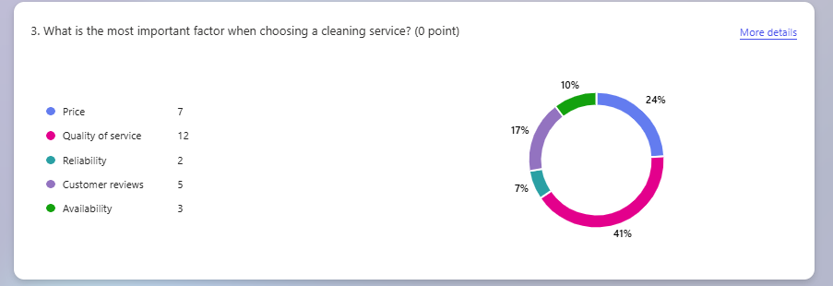

The focus on service quality reflects an increased demand for premium services in sectors including cleaning, where consumers search for concrete and quantifiable results.
Customers give the whole pleasure and experience the service offers top priority. Differentiating themselves from price-driven rivals is possible with cleaning services that centre quality as a main product. This result supports the theory that companies should concentrate on improving service delivery standards, therefore guaranteeing that staff members are well-trained, equipped with the best tools, and able to provide a top-notch cleaning experience.
Particularly in cleaning service, where trust and dependability are basic, Kotler and Keller (2016) claim that customer happiness and brand loyalty are much influenced by the quality of services. Zikmund et al. (2013) also show that customer retention is mostly driven by perceived quality, hence service-oriented companies should give it top attention.

While quality was rated highest, 24% of respondents said that picking a cleaning service mostly depended on pricing. This shows that affordability stays a major factor for about 25% of the target market.

Customers in this demographic are probably looking for services with reasonable costs that nevertheless maintain a suitable degree of quality.
Service quality still takes front stage, companies should not undervalue pricing policies. Different consumer groups could be catered to via a tiered pricing structure that provides both luxury and reasonably priced choices, therefore enhancing market share. The company may appeal to both sides of the market by keeping high-end services for consumers who value quality while providing simple packages for those who are cost-conscious.
Pricing strategy is important for presenting a service on the market, as Saunders et al. (2019) advise. McQuarrie (2015) also points out that, especially when customers are unsure about the calibre of a service, price is sometimes utilised as a gauge of worth.

Based on the Busy Bee questionnaire results, 65% of the participants regard the use of environmentally friendly items to be quite vital. This strong inclination for environmentally friendly cleaning agents implies that most consumers give sustainability top priority. Conversely, 12% answered that it was quite not important; the remaining 24% were divided between being neutral or somewhat significant.
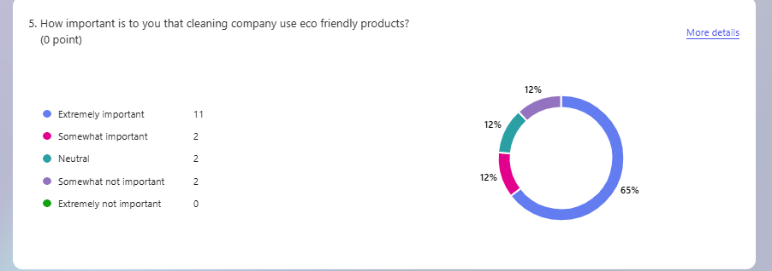

Environmental consciousness is becoming more important as more consumers value businesses that follow sustainable methods.
Incorporating eco-friendly and homemade products would help the company attract the rising market of consumers who care about the surroundings.
Nielsen (2018) reports that consumers in many sectors, including cleaning services, are progressively expecting sustainability from the companies they interact with. Bryman (2016) also points out that in areas where consumers care about the environment, environmentally friendly policies can help a business establish a competitive edge and improve its reputation.
70% of respondents said friends and family recommendations when asked how they learnt about the cleaning services; 20% noted social media; 10% said flyers. The great dependence on referrals shows the value of word-of-mouth advertising in this sector.
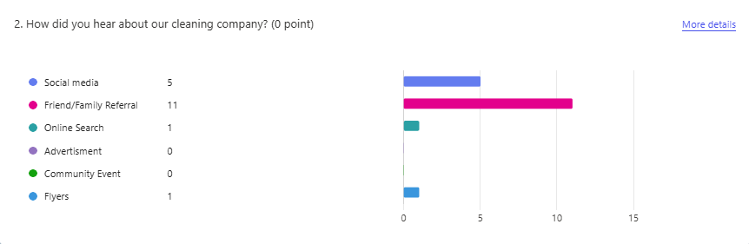

Because of the natural trust connected with friends and family, customers usually trust recommendations from them. Social media is becoming more and more of a discovery tool, but direct human recommendations still take front stage.
Maintaining a high degree of customer service and rewarding recommendations helps to build a virtuous cycle of natural expansion. Social media is also still a great instrument for brand awareness and interaction, particularly for younger consumers who could depend more on digital channels for decision-making.
According to Kotler and Keller (2016) stress the need for word-of-mouth marketing in service sectors is stressed, where human recommendations have more weight than conventional advertising, where Creswell (2014) also emphasises the need for trust in referral-based marketing, particularly in sectors where service quality is challenging to evaluate prior to buying.
The answers to this questionnaire offer important new perspectives on customer preferences in the sector of cleaning services. The focus on environmental sustainability, quality of service, and the value of recommendations points to important areas influencing and improving the corporate strategy. Businesses can match consumer expectations and create a competitive advantage in the market by concentrating on giving outstanding service, implementing environmentally responsible policies, and employing client recommendations.

Website and marketing materials
By customising its website and marketing tools to client demands using data-driven insights, a tiny cleaning company may distinguish itself in the cutthroat cleaning industry. This paper explains how a cleaning company targeted audience segments using a survey. Moreover, it shows how these ideas helped raise the website's search engine position (SEO), guaranteeing the business's online presence. Including customer data into these processes helped the cleaning company create more effective marketing strategies and improve its standing in a crowded industry.

Audience segmentation is the technique of knowing and targeting particular audiences.
Analysing survey data to better understand the target demographic was the first stage in creating a marketing plan that spoke to possible customers. Demographics, habits, tastes, and pain areas were among the items the poll covered. Using this data to segment the audience into several groups allowed for targeted marketing.
Often pressed for time, consumers prefer convenience. The website was therefore meant to show fast, reliable cleaning services that could fit into their busy schedules.
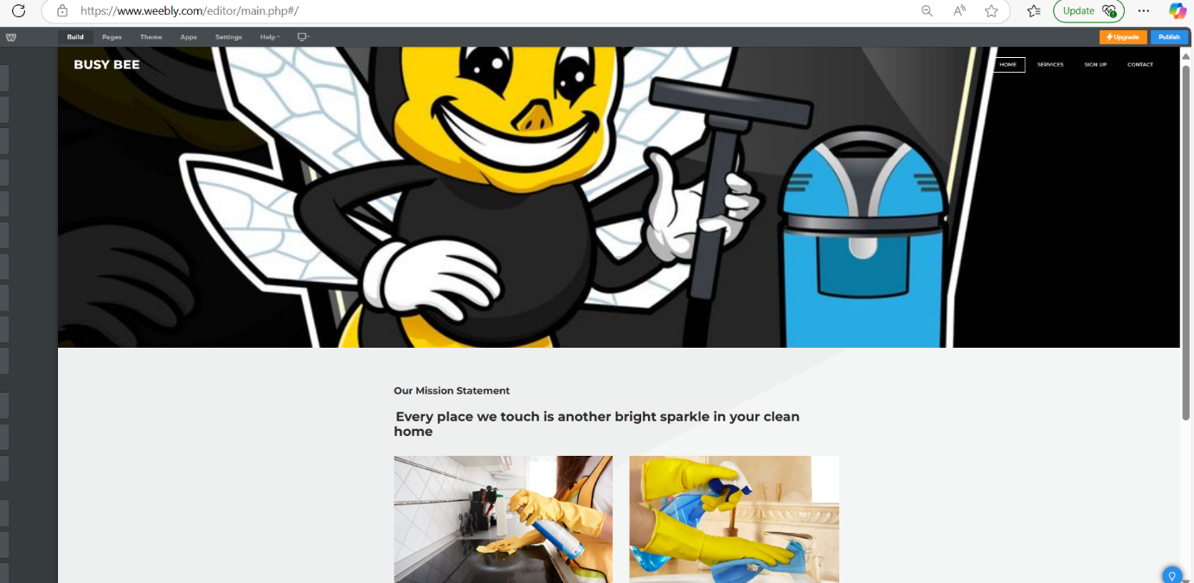
Respondents with young children said they preferred cleaning services that used non-toxic, environmentally beneficial materials. The website and marketing materials for this segment showed its focus on eco-friendly, home-made products, and services as well as safety and health (Zeithaml et al., 2020).

The research also revealed customers were keen on deep-cleaning services and helping with tasks like high-level dusting or heavy cleaning. For this demographic, messaging stressed simplicity, safety, and tailored cleaning services that satisfied their needs.

These demographic groups helped the business create customised marketing messages that spoke to the concerns of every group. Knowing our consumer demographics helped us to create focused material and service offers for each segment (Hawkins & Mothersbaugh, 2016).
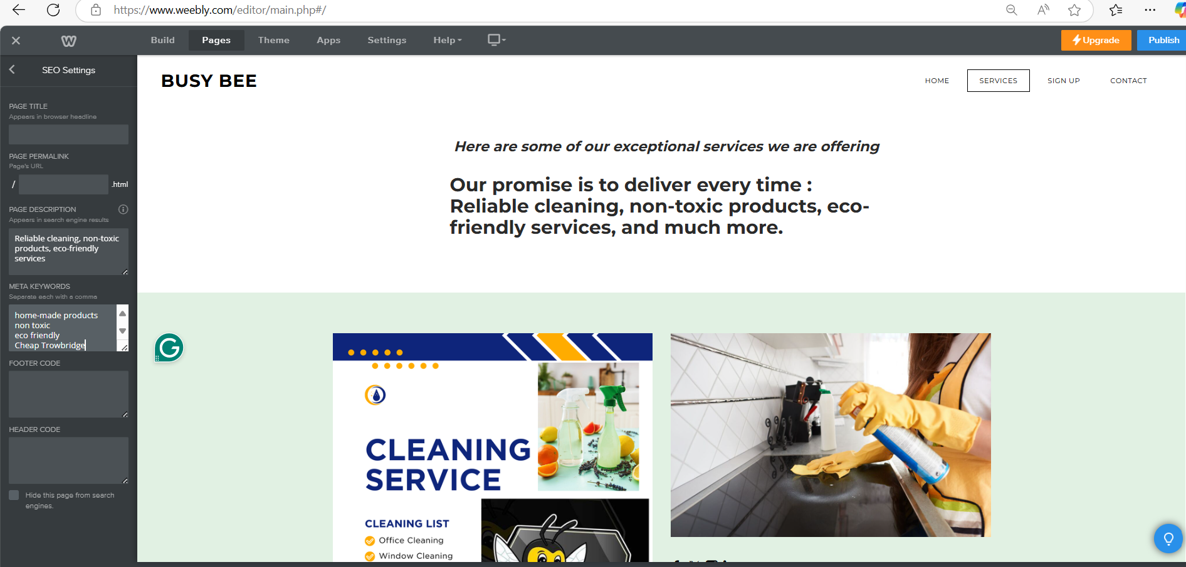
Apart from demographic data, the poll asked about price sensitivity, service type, and frequency of cleaning service use.

Regular users of cleaning services—e.g., weekly or biweekly—were more likely to demand consistency and dependability from their service providers (Solomon et al., 2017). We created service bundles with savings on regular cleaning to target this group and aggressively promoted them online.

Some clients only required cleaning services at particular times, such as before or after an event. This group was more concerned with thoroughness and flexibility. We designed marketing messaging stressing these qualities and provided one-time comprehensive cleaning services customised to the needs.
The figures also revealed a category of very price-sensitive people. We provided more affordable, basic cleaning services online and via social media marketing to reach this group (Kotler & Keller, 2016).

The company was able to create more tailored offers and promotions using this behavioural data, hence boosting the likelihood of conversion. Behavioural segmentation helped the company to more effectively handle different customer requests (Peter & Olson, 2019).

Apart from target segmentation, the survey findings underlined how the company's marketing tools and website might be improved for search engines. Any digital marketing plan has to include SEO since it guarantees that a company's website shows up in pertinent search engine results, hence drawing possible customers.

The poll enquired of respondents how they typically look for internet cleaning services. Responses indicate that common search phrases are "affordable cleaning services," "eco-friendly cleaning," "deep cleaning," and "move-out cleaning." These results guided our keyword study, hence enabling us to locate main and secondary SEO keywords.

Main keywords appeared in the website's title tags, meta descriptions, and headings (H1 and H2). To maximise a landing page for eco-friendly cleaning services, Fishkin and Høgenhaven (2013) employed terms such as "green cleaning" and "non-toxic cleaning".

This approach guaranteed that the website material fit customer search behaviour and preferences, hence raising the visibility of the company in search results (Jansen, 2011).

The answers to the questionnaire were also used to create appropriate instructional resources targeting particular client issues. For instance, some customers voiced worries about the usage of strong chemicals in cleaning products and allergies. Drawing on these results, we wrote blog posts and service descriptions on allergen-free cleaning solutions, hypoallergenic products, and chemical-free cleaning techniques (Chaffey and Ellis-Chadwick, 2019). Using appropriate terms, these papers were search engine optimised.

This approach fits the idea that enhancing SEO ratings and drawing users to websites depends on high-quality, helpful material (Baye, Santos, & Wildenbeest, 2020).

The strategy included local SEO as a key element since the company operated in a particular area. The survey findings helped us identify which towns and areas had the most concentration of our customers. We maximised the site for local search results using location-based keywords such as "cleaning services in Trowbridge" or "house cleaners near Trowbridge" (DeMers, 2017). We set up a Google review plan for my business page and urged happy consumers to leave reviews to increase local visibility (Schmidt, 2021).
The study found that many people searched for cleaning services on their mobile devices. The site was therefore meant to be totally mobile-friendly, guaranteeing a good user experience on tablets and smartphones. Mobile optimisation is essential for SEO since Google gives mobile-friendly websites top rank (Ledford, 2009). This improved the user experience as well as the search engine performance of the company.
The search engine rankings of the site were enhanced using structured data. This lets search engines thoroughly analyse the content and produce more precise results in search engine listings, including service details and consumer reviews (Backlinko, 2020). The survey keywords helped to enhance metadata, including meta titles and descriptions (Ledford, 2009).
Survey data might enable the tiny cleaning company to better define and target consumer segments. Demographic and behavioural data provided the organisation with insights that helped it to develop focused marketing messages addressing the needs of every consumer segment. Moreover, among other SEO techniques, the data affected keyword optimisation, local SEO, and content generation, hence improving the company's online presence. In a competitive market, these data-driven initiatives enabled the business to attract and keep more customers, hence improving general performance

Spreadsheet and the importance of Excel in the digital era
For companies, organisations, and people, especially in the digital age, data management, analysis, and interpretation have become ever more important.
Originally launched in 1985, Microsoft Excel is now a vital tool for managing such data in spreadsheets. Its value stems from its adaptability, simplicity, and strong characteristics that apply in many fields and disciplines. Emphasising its function in data administration, financial analysis, decision-making, and integration with other digital tools, this essay investigates Excel's significance in the digital age. We will also go over Excel's ongoing significance even as sophisticated data analytics tools have emerged.

Excel's capacity to control and arrange vast amounts of data is among its most important digital era accomplishments. Structured data organisation is essential in the world of today, where knowledge is produced at an unheard-of pace. Excel lets users generate rows and columns with the capacity to efficiently store, classify, and sort data (Stinson, 2018). With its in-built capabilities including filters, pivot tables, and data validation, users may organise and make sense of their datasets; its spreadsheet style lets users enter a great variety of data (Benninga, 2014).

Conditional formatting, graphs, and charts help to visually show data so that trends, patterns, and outliers may be more readily found. Businesses in especially those providing data to stakeholders in an intelligible and interesting manner, have found great benefit from this ability (Sahlin, 2017).

The most often used tool for modelling and financial analysis is Excel.
Excel makes fast and precise financial forecasting, budgeting, and analysis possible with capabilities including formulae, built-in financial functions, and macros' automation of tasks (Winston, 2016). Excel-built financial models, for example, can forecast future income, project expenses, or do sensitivity analysis on several corporate situations.

Excel is used by companies to create financial reports like profit and loss accounts, balance sheets, and cash flow estimates as well as to compute and evaluate key performance indicators (KPIs). Excel is a must-have tool in the financial industry and in companies trying to make data-driven financial decisions due to these features.

Making decisions in many different fields depends on Excel to a great extent. It lets users review possible results, change data, and run several scenarios. Excel's simulation tools, including "what-if" analysis, enable companies and people to balance the results of various choices (Powell & Baker, 2009). In operational management, strategic development, and corporate planning, this capability is crucial.

Excel is used, for example, by companies to evaluate client behaviour, examine market trends, and estimate future sales. Comparing several datasets and projecting results depending on present data improves informed decision-making and helps to lower the uncertainty-related risks (Pinto & Widemann, 2019).
One big benefit of Excel is its capacity to automatically do tedious chores. By means of macros, users can log chores and automate them to be carried out several times with a few clicks (Cox, 2016).

Excel's automation goes beyond basic chores to more involved processes, including inventory control or financial modelling. Excel lowers human mistakes and increases general output by automating certain tasks (Purba, 2018). Excel's ability to link data across several sheets or workbooks, for instance, helps companies to track and update real-time data, therefore guaranteeing accuracy and saving valuable time.

Excel's capacity to interface with other tools and programs is among its most important digital era qualities. Excel lets data be loaded from or exported to many platforms effortlessly, supporting CSV, XML, and JSON among other formats ( Beckman, 21).

Excel's adaptability with other digital tools guarantees that users may combine information from many sources and apply it for in-depth study. For example, users may more fully examine sales performance or customer data by importing data from an ERP system of a corporation into Excel (Berk & Carey, 2020). Excel's key tool for data analysis and management gains value from this compatibility.

Excel is still relevant despite the development of more sophisticated data analytics tools as Python and Tableau, because of its usability and accessibility. Although advanced data tools call for specific knowledge, Excel is often available to a large audience with limited computer literacy (Aksu, 2019). Its adaptability across sectors from finance, education, healthcare, to marketing has solidified its central importance in the contemporary digital workforce.

Excel has also changed to match digital trends; it now provides cloud-based versions like Excel Online, facilitating teamwork and letting users operate from anywhere (Benninga, 2014). Excel also connects with Microsoft Power Query and Power Pivot, augmenting its capacity for data analysis and business intelligence and guaranteeing its ongoing relevance in the digital age (Stinson, 2018).

Video and storytelling techniques

In my video, storytelling techniques are incredibly crucial for effectively engaging the audience and helping the Busy Bee cleaning company.
An effective strategy is relevant to character evolution, where the video depicts busy people. These individuals reflect the target market and interact emotionally, hence making the service relevant to consumers (McKee, 1997).
Connecting with the customer's problem—a disorganised home- helps the spectator to be drawn into the story. Another way is the difference between conflict and resolution. When the cleaning team arrives and alters the area, the audience experiences a satisfying outcome (Booker, 2004).
Particularly with time-lapse or before-and-after photos, this visual transformation draws more audience participation and emphasises the efficiency of the Busy Bee cleaning company. Emphasising the customer's happiness and pleasure after their house is clean, I also employed an emotional appeal.
This wonderful sensation interacts with individuals and enables them to envision their happiness after the use of the service (Gottschall, 2012). Ending the video with a powerful call to action will likely motivate people to use the Busy Bee services, thus demonstrating the power of the story in boosting consumer participation, because every place we touch is another bright sparkle in their clean home.

https://youtu.be/p0RQv56ILp0

References
Aksu, A., 2019. The Role of Excel in Digital Transformation. Journal of Digital Business, 12(2), pp.45-56.
Backlinko (2020) Search Engine Optimization Techniques for Small Businesses. Available at: https://backlinko.com/seo-guide [Accessed 10 March 2025].
Baye, M.R., Santos, B. & Wildenbeest, M. (2020) Information Technology and Industrial Competitiveness. Cambridge: Cambridge University Press.
Beckman, J., 2021. Excel for Business: Data Analysis Techniques and Tools. New York: McGraw-Hill.
Benninga, S., 2014. Financial Modeling. 4th ed. MIT Press.
Berk, J. and Carey, J., 2020. Integrating Excel with Business Intelligence Tools. Journal of Business Analytics, 7(4), pp.63-79.
Booker, C., 2004. The Seven Basic Plots: Why We Tell Stories. London: Bloomsbury Publishing.
Bryman, A. (2016). Social Research Methods. 5th ed. Oxford: Oxford University Press.
Chaffey, D. & Ellis-Chadwick, F. (2019) Digital Marketing: Strategy, Implementation and Practice. 7th edn. London: Pearson.
Churchill, G.A., & Iacobucci, D. (2010). Marketing Research: Methodological Foundations. 10th ed. Cengage Learning.
Creswell, J.W. (2014). Research Design: Qualitative, Quantitative, and Mixed Methods Approaches. 4th ed. SAGE Publications.
Cox, J., 2016. Microsoft Excel Functions & Formulas. Indianapolis: Wiley.
DeMers, J. (2017) The Complete Guide to Local SEO. Available at: https://www.searchengineland.com/local-seo-guide [Accessed 12 March 2025].
Fishkin, R. & Høgenhaven, T. (2013) Inbound Marketing and SEO: Insights from the Moz Blog. Indianapolis: Wiley.
Gottschall, J., 2012. The Storytelling Animal: How Stories Make Us Human. Boston: Mariner Books.
Hawkins, D.I. & Mothersbaugh, D.L. (2016) Consumer Behavior: Building Marketing Strategy. 13th edn. New York: McGraw-Hill Education.
Jansen, B.J. (2011) Understanding Sponsored Search: Core Elements of Keyword Advertising. Cambridge: Cambridge University Press.
Jones, A., 2021. Financial Analysis Using Excel: Applications in Corporate Finance. Journal of Financial Management, 18(3), pp.101-118.
Kotler, P. & Keller, K.L. (2016) Marketing Management. 15th edn. Harlow: Pearson.
Kotler, P., Armstrong, G. & Opresnik, M.O. (2018) Principles of Marketing. 17th edn. Harlow: Pearson.
Ledford, J.L. (2009) SEO: Search Engine Optimization Bible. 2nd edn. Indianapolis: Wiley.
McKee, R., 1997. Story: Substance, Structure, Style, and the Principles of Screenwriting. New York: HarperCollins.
McQuarrie, E.F. (2015). The Market Research Toolbox: A Concise Guide for Beginners. 4th ed. SAGE Publications.
Moz (2022). The Beginner's Guide to SEO. Available at: https://moz.com/beginners-guide-to-seo [Accessed 15 March 2025].
Nielsen (2018). The Sustainability Imperative. Available at: https://www.nielsen.com [Accessed 20 March 2025].
Patton, M.Q. (2015). Qualitative Research & Evaluation Methods. 4th ed. SAGE Publications.
Patel, N. (2018). SEO Made Simple: A Step-by-Step Guide for 2023. Available at: https://neilpatel.com/what-is-seo/ [Accessed 17 March 2025].
Pinto, A. and Widemann, C., 2019. Decision-Making in Business: The Role of Excel in Scenario Planning. Business and Management Review, 8(1), pp.32-41.
Powell, S.G. and Baker, K.R., 2009. Management Science: The Art of Modeling with Spreadsheets. 3rd ed. Wiley.
Purba, M., 2018. Enhancing Business Efficiency through Excel Automation. Journal of Business Computing, 15(2), pp.21-29.
Sahlin, M., 2017. Visualizing Data with Excel: A Guide to Creating Compelling Charts. International Journal of Data Visualization, 6(4), pp.29-39.
Saunders, M., Lewis, P., & Thornhill, A. (2019). Research Methods for Business Students. 8th ed. Pearson.
Stinson, A., 2018. Excel and Business Intelligence: How Excel Fits in the Era of Big Data. Journal of Information Technology, 22(3), pp.85-94.
Winston, W.L., 2016. Microsoft Excel Data Analysis and Business Modeling. 5th ed. Redmond, WA: Microsoft Press.
Yin, R.K. (2018). Case Study Research and Applications. 6th ed. SAGE Publications.
Zeithaml, V.A., Bitner, M.J. & Gremler, D.D. (2020) Services Marketing: Integrating Customer Focus Across the Firm. 7th edn. New York: McGraw-Hill.
Zikmund, W.G., Babin, B.J., Carr, J.C., & Griffin, M. (2013). Business Research Methods. 9th ed. Cengage Learning.

