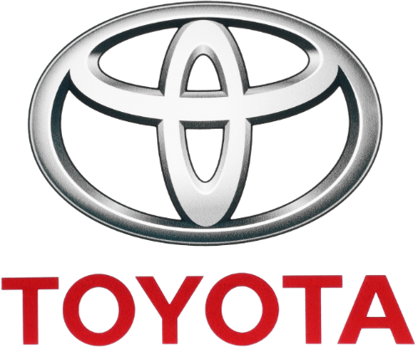

BLOGGING TO COMMUNICATE
by <Name>

Course
Professor
Institution of Learning
City/State
Date

Table of Contents
Introduction 3
Blog Post 1: The Marketing Concept 3
Blog Post 2: Situational Analysis 5
Blog Post 3: Toyota’s Marketing Mix 7
Blog Post 4: Advertising Strategy 9
Blog Post 5: Differentiation Strategy 10
Blog Post 6: Market Segmentation 11
Conclusion 12
Bibliography 13

Introduction
Toyota Motor Corporation refers to the Aichi-based automaker that started operating in 1937. Kiichiro Toyoda created the company with an objective of exploiting the rapidly expanding automotive industry of the 20th Century. Investment in innovative and high quality designs enabled the corporation to enter the global automobile industry in the 1950s. Today, Toyota locates its manufacturing plants in 27 nations, serves over 170 nations, and employs approximately 366,300 individuals (Carlier 2021). The corporation offers its global consumer population diverse products, including 2box, trucks, sedans, minivans, buses, and utility vehicles. The corporation further produces and markets car parts like engines, batteries, air-conditioning compressors, and electronic components (Osono et al. 2008). The corporation markets its diverse vehicle categories under brand names like Daihatsu, Lexus, Ranz, Toyota, and Hino. Notably, investing in effective marketing strategies has supported Toyota Motor Corporation in strengthening its brand image.

Blog Post 1: The Marketing Concept
Marketing strategy allows business organisations to convert their potential consumer population to loyal customers. Marketing supports business organizations in handling complex issues associated with the globalized market environment, including consumer taste dynamism and high competition pressure. Currently, challenges associated with the globalized market makes marketing an inevitable tactic for ensuring business survival (Fifield, 2012). Business organizations perform marketing operations with an objective of accomplishing competitiveness in the market. Managers understand that marketing strategies support brand image popularization in globalized markets.
Marketing programs represent integrated decision-making patterns that specify important choices regarding marketing resources, marketing activities, markets, and products. Marketing campaigns provide details regarding products and services that add value to customers. Marketing campaigns also define organisations’ crucial decisions regarding market penetration. The procedure describes integrated decision-making patterns that describe particular choices regarding targeted market segments. Hence, management teams understand that marketing campaigns comprise target population’s data, key brand messaging, and value proposition.
Managers should understand that the marketing mix is an important concept in the marketing process. Management teams should understand that the 4Ps marketing model enhance marketing mix components related to services and products presented in the market. Specifically, the 4Ps in the marketing mix represent promotion, place, price, and product (Yannopoulos 2011). The elements guide marketing strategies (place and product) and tactics (pricing and promotion tactics) like positioning, target market selection, and segmentation. The elements indicate that marketing strategies enable organizations to make integrated decisions regarding resources, activities, products, and distribution.
Today, business organisations combine conventional and social media marketing strategies in popularizing their products in the market. Management teams must understand that the selected marketing strategies determine their organisations’ competitiveness in the market. Selecting proper marketing tactics offer organisations an opportunity for increasing their penetration speed to new markets. Conventional advertising platforms utilised in business organizations include magazines, outdoor events, newspapers, television, radio, and cinema. Social media platforms utilised in sending crucial product and service details include YouTube, Facebook, Twitter, and Instagram (Constantinides, 2014). In general, combining digital and conventional advertising platforms enables organizations to create highly effective advertisement programs.

Blog Post 2: Situational Analysis
The situational analysis serves as the foundational element for organisations’ marketing plans. The procedure enables market research team to understand specific environmental factors affecting an organization’s operation. Business environmental factors influencing an organization’s operation are classified into external and internal factors. Notably, assessing external factors (macro and micro environmental factors) allows business organizations to establish a strong evidence-base when designing their marketing plans. In this regard, micro-environment refers to the external environment with controllable market forces like powers of buyers, new entrants threat, threat of substitutes, competitive rivalry, and power of suppliers (Baburaj & Narayanan 2016). On the other hand, the macro-environment represents the external market environment with uncontrollable market forces like ecological, social, technological, economic, political, and legal factors.
Porter’s Five Forces framework facilitates the determination of micro-environmental forces that influence marketing plans for Toyota. First, Toyota’s management team consider that the automotive industry has high buyers’ bargaining power. Toyota utilises quality maximization, aggressive marketing, and cost reduction measures in addressing the high buyers’ bargaining power (Li, 2018). Second, the management team considers that Toyota experiences low suppliers’ bargaining power, which allows it to access high quality and low cost raw materials. Third, the management understands that Toyota experiences stiff competition from automobile manufacturers like Volkswagen, Ford, Chrysler, Honda, and General Motors. Fourth, challenges competitors experiencing in creating replica motor vehicle models implies that Toyota experiences low substitution threat. Finally, the huge entry capital in the automotive industry expose Toyota to low competition from new entrants.
The PESTEL framework offers crucial details regarding macro-environmental forces for the Toyota. First, different political factors (security measures, policies, and particular requirements) creates serious challenges for the multinational corporation. Second, economical factors related to car brands’ fuelling and maintenance affects the corporation’s global operation. For instance, tough economic situations have increased the demand for cars with small and highly efficient engines (Çitilci & Akbalık 2020). Third, social factors like ideologies, cultures, and consumer wants influence Toyota’s operation. Fourth, Toyota’s management understands that producing technologically advanced cars increase automaker’s competitiveness in the industry. Fifth, the management team understands that compliance taxation, consumer protection, intellectual property, and environmental protection laws promotes smooth operations in different automobile markets. Finally, the management observes that nations require automotive companies to produce environmentally friendly automobiles.
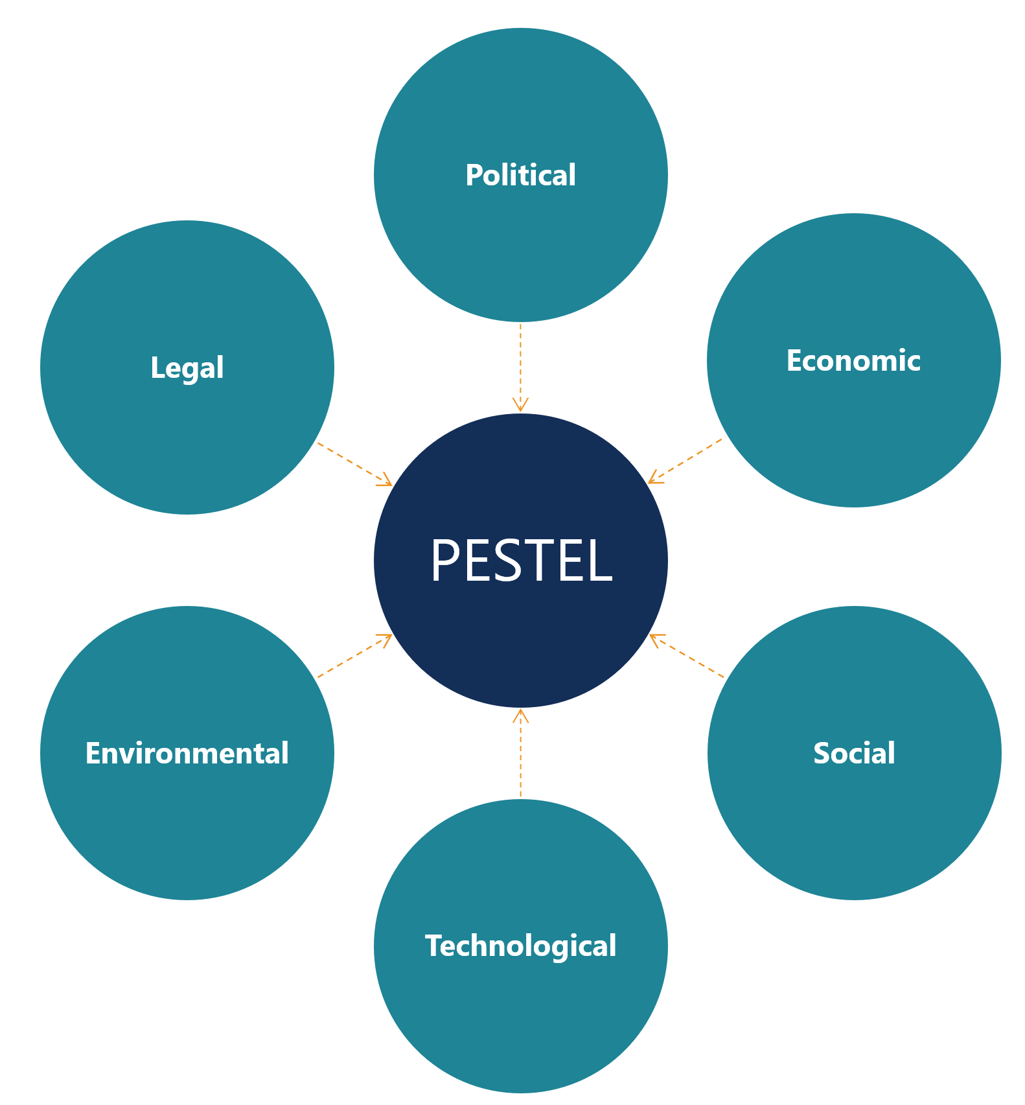
PESTEL Framework
(https://corporatefinanceinstitute.com/resources/knowledge/strategy/pestel-analysis/)
SWOT analysis presents opportunities, threats, and weaknesses that the automaker should address by capitalizing on its different strengths. Major strengths for Toyota Motor Corporation are strong supply chain, strong market position, focus on R&D, and brand recognition. Various weaknesses that the corporation should focus on eradicating are hierarchical organisational structure, organisational culture secrecy, and product recalls. Different threats that the corporation should deal with are unfavourable foreign exchange rate, natural disasters, and intense competition (Jurevicius 2013). Still, Toyota can exploit opportunities existing in the international automobile market, including partnership, technological advancement, and the automobile industry growth, in increasing its profitability and competitiveness.

Blog Post 3: Toyota’s Marketing Mix
Toyota’s success in the global automotive industry can be associated with the superiority of its marketing mix. In this regard, Toyota’s marketing strategy can be broken down into four pillars, namely promotion, pricing, place, and product. People associate Toyota’s products with values like innovation, reliability, sustainability, safety, quality, and durability. Toyota car models are categorized into passenger (Corolla, Ruckus, Tarago, Camry, Aurion, and Yaris), 4WD and SUVs (Landcruiser 200, Prado, Kluger, Rav4), commercial (Hilux, HiAce, Landcruiser, and Coaster), and hybrid cars (Prius and Camry).
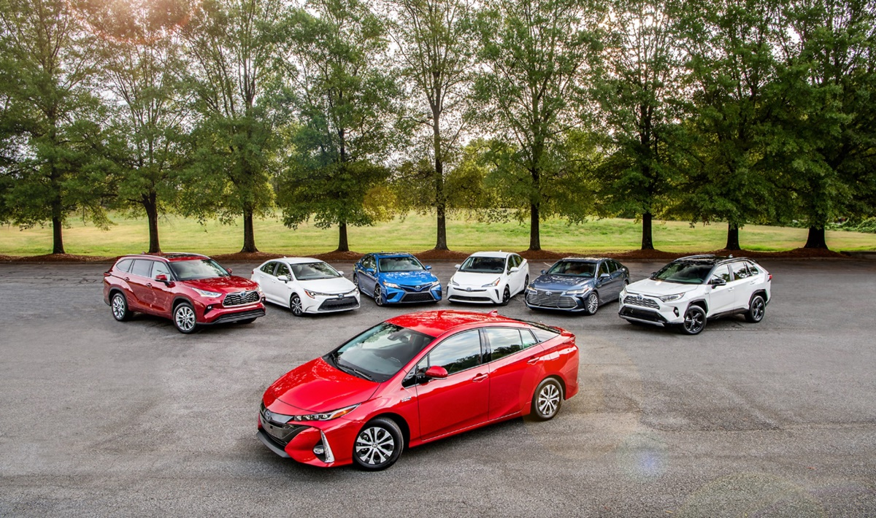
Product Strategy (Thomas, 2020)
The place strategy represent the way Toyota places its products for easy accessibility among its clients. Specifically, the corporation utilises multiple dealership outlets and retailers in distributing products to its numerous customers located in different nations globally (Thomas, 2020). The corporation has approximately 170 distributors across the globe, who ensure that the products reach consumers on time. The effective distribution system allows the corporation to supply spare parts to its clients. The corporation uses special events, exhibition centres, and showrooms in presenting its products to its buyers.
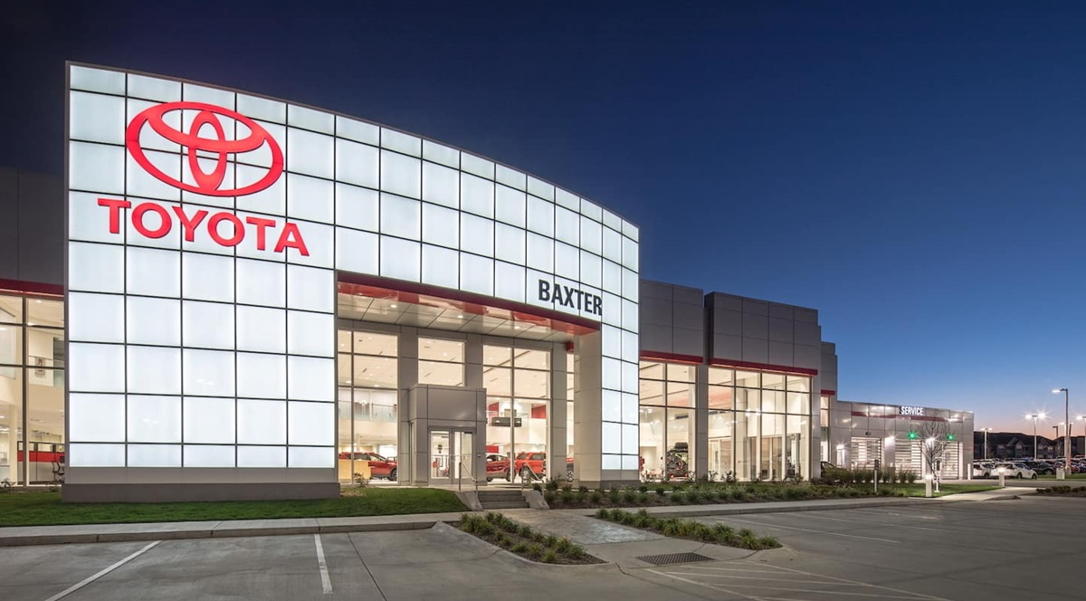
Place strategy (Thomas, 2020)
People must understand that products’ prices are determined by profit and their production cost. Toyota corporation maintains a strong brand image due to its capacity to offer affordable and high quality vehicles to its consumer population. Toyota’s pricing strategy is founded on factors like demand, geography, segment, and competition. The corporation offers its clients a flexible price list for its vehicles, which ranges from $20,000 to $100,000. The flexibility enables the prices to respond to changes in competitors’ prices and variations in market conditions. Offering affordable automobiles at relatively low prices has allowed Toyota to maintain a strong brand image in the automotive industry.
Toyota utilises different promotional tactics in increasing its revenues and profit margins. The corporation combines promotional methods like advertisement and personal selling in maintaining a strong brand image. The corporation uses the direct selling strategy in improving the experience of its corporate clients. Making the promotion strategy flexible allows the corporation to establish a comprehensive way of promoting its products and brands.

Blog Post 4: Advertising Strategy
The advertising strategy serves as a crucial promotional strategy for Toyota Motor Corporation. The corporation makes huge financial allocation to advertisement campaigns to increase popularity of its products in different markets globally. For instance, the corporation spent $2.09 billion on advertisements in 2014, whereby television advertisement received $959 million in this year. The corporation integrates catchy slogans with its advertisements to attract audience’s attention. Advertising slogans for the corporation are designed to suit specific markets around the world. For instance, Toyota used the “Let’s Go Places” slogan in its advertisement made in the US market in 2004.
Toyota Motor Corporation combines conventional and social media advertising platforms in popularising its products and brands. Conventional platforms that the corporation uses in popularising its products are television, billboards, radio, newspapers, and flyers. The fact that these platforms are costly demonstrates the corporation’s commitment to strengthening its brand image. Recently, the company has adopted social media platforms in advertising its products. Various social media platforms the corporation uses in advertising its products are YouTube, twitter, Facebook, and Instagram. The company’s management team observes that using social media platforms allows it provide detailed product information at a low cost.

Blog Post 5: Differentiation Strategy
The corporation relies on the differentiation strategy in maintaining competitiveness in the market. Today, the differentiation tactic gives Toyota Corporation a unique identity in the automobile market in regard to customer experience, technology, and product quality (Baker 2014). The corporation offer clients a diverse category of energy efficient and environmentally-friendly vehicles that meet carbon emission cap thresholds in different nations. Investing in technology enables the corporation to give its esteemed customers superior and unique driving experience (Thomas 2020). Notably, the differentiation tactic also applies to the marketing strategy for its products in different markets.
The marketing team utilises innovation in ensuring that marketing strategies selected match the selected markets. The management observes that differentiation in advertisement is important since markets have different characteristics. The marketing team observes that car markets differ with respect to people’s cultures, regional climate, ideologies, and beliefs. In this regard, the corporation uses different products in different regions and nations globally in its advertisement campaigns. Slogans that the corporation has utilized in Australia, Europe, Japan, and USA in the 21st Century are “Oh What a feeling!”, “Nothing is impossible”, “Start your impossible”, and “Let’s go places”, respectively (Thomas, 2020). The differentiation tactic has supported the corporation in increasing its market share within the global automotive industry.
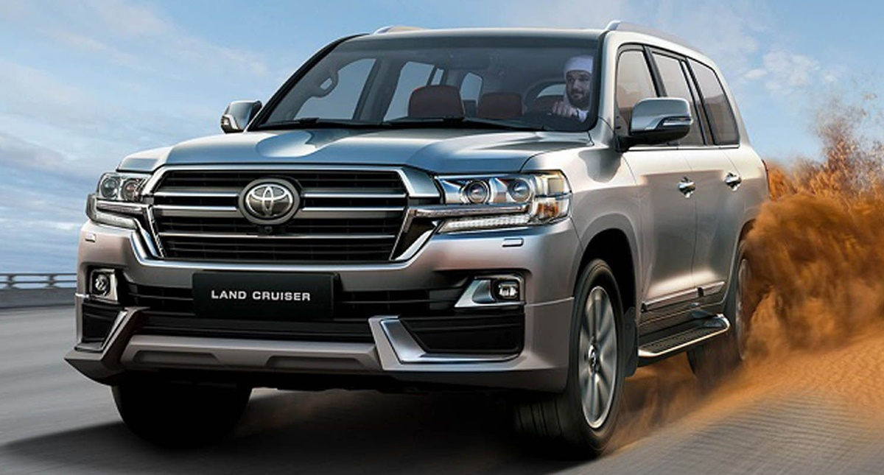
Differentiation by Region (Thomas, 2020)

Blog Post 6: Market Segmentation
The segmentation strategy represents the procedure business organizations use to identify individuals with great potential for becoming loyal customers. Markedly, most brands are designed to satisfy needs of small customer population. The right market segment identification enables marketers to communicate brand benefits effectively and efficiently. Toyota has achieved great success in market segmentation since its inception. The corporation’s segmentation tactic is based on a philosophy titled ‘right car in the right place’. The philosophy allows the corporation to utilise psychographic and demographic segmentation tactics in satisfying its consumer population. The corporation has developed focused markets in nations like Indonesia, Australia, Canada, China, and the United States.
The corporation’s market strategy matches specific populations’ choices and needs at national regional, and global levels. The differentiation tactic enables the corporation to focus its products to specific markets for excitement, kindness, and comfort. Toyota manufactures vehicles that appeal to individuals within specific age brackets, culture, and gender (Weinstein 2013). Other factors that the corporation considers when designing its segmented markets are consumers’ choices, purchasing power, economic conditions, and market conditions. For instance, the corporation focuses on developing and marketing a car for a global population aged between 18 and 25 in 2020. The Toyota Scion brain is intentionally designed to meet wants of young consumers internationally.

Conclusion
Toyota Motor Corporation has relied on strong marketing strategies in strengthening its brand images. Analysing external environmental forces using PESTEL, Porter’s Five Forces, and SWOT analysis concepts allows the corporation to create a strong evidence base for marketing decisions. The corporation’s effective marketing strategy is founded on its stable pillars, including promotion, pricing, place, and products. Toyota’s management team allocate huge financial resources to marketing campaigns to reach the global population. Combining conventional and social media marketing platforms has allowed Toyota to strengthen its brand image. Differentiation and market segmentation strategies has enabled the corporation to meet diverse needs of its global client population.

Bibliography
Baburaj, Y. and Narayanan, V.K., 2016. Five Forces Framework. The Palgrave Encyclopedia of
Strategic Management. London: Palgrave Macmillan. https://doi. org/10.1057/978-1-349-94848-2_632-1.
Baker, M.J., 2014. Marketing strategy and management. London: Macmillan International
Higher Education.
Carlier, M., 2021. Consolidated number of Toyota Motor Corporation employees from FY 2012
to FY 2021. Statista. https://www.statista.com/statistics/294192/number-of-toyota-employees/
Çitilci, T. and Akbalık, M., 2020. The Importance of PESTEL Analysis for Environmental
Scanning Process. In Handbook of Research on Decision-Making Techniques in Financial Marketing (pp. 336-357). IGI Global.
Constantinides, E., 2014. Foundations of social media marketing. Procedia-Social and
behavioral sciences, 148, pp.40-57.
Fifield, P., 2012. Marketing strategy. Abingdon: Routledge.
Li, Z., 2018. Business Network Positioning Analysis of Toyota. American Journal of Industrial
and Business Management, 8(07), p.1693.
Jurevicius, O., 2013. Toyota Motor Corporation SWOT analysis. Strategic Management Insight,
16.
Thomas, S., 2020. Toyota marketing strategy: The pride of Japanese quality? AVADA
Commerce. https://avada.io/resources/toyota-marketing-strategy.html
Osono, E., Shimizu, N. and Takeuchi, H., 2008. Extreme Toyota: Radical contradictions that
drive success at the world's best manufacturer. Hoboken: John Wiley & Sons.
Weinstein, A., 2013. Handbook of market segmentation: Strategic targeting for business and
technology firms. Abingdon: Routledge.
Yannopoulos, P., 2011. Impact of the Internet on marketing strategy formulation. International
Journal of Business and Social Science, 2(18).

