

Title of dissertation

School of Architecture, Built and Natural Environment
Course: BSc Architecture

Name: Benjamin Lloyd Howells
Student Number: 1907786
Module code: M6X01986
Word count:
Date:



Author’s Declaration
I declare that the work in this dissertation was carried out in accordance with the regulations of the University of Wales, Trinity Saint David. The work is original except where indicated by special references in the text and no part of the dissertation has been submitted for any other degree.
Any views expressed in the dissertation are those of the author and in no way represent those of the University of Wales, Trinity Saint David.
The dissertation has not been presented to any other University for examination either in the United Kingdom or overseas.
I hereby give permission for my work, if accepted, to be available for photocopying and inter-library loan, and for the title and summary to be made available to outside organisations.

Signed: | Student name Arial 11
Date: | Insert date Arial 11

Copyright statement

The copyright of this dissertation rests with the University of Wales, Trinity Saint David. No information derived from this dissertation shall be published without the prior written consent of the University.

Signed: | Student name Arial 11
Date: | Insert date Arial 11

Abstract

Urbanisation is defined as the gradual shift in residence of the human population from rural to urban areas (UN, 2018). According to United Nations data, in 2020, 56.2% of the world’s population lived in urban areas with this percentage expected to increase to 68% by 2050 (Blachier, 2021). In the UK, a study found that, on average, participants spent 95.6% of their time indoors (Ferguson et al, 2021). With scientists predicting climate change will force people to spend more time indoors, the European commission released an article raising concerns about the negative impacts that climate change could have on the quality of indoor environments (Smith, 2016). There is a need for greater emphasis from the built environment, particularly designers such as architects, on providing solutions for environments that will enhance human health and wellbeing, as opposed to causing harm.

Biophilic design has recently emerged with increased popularity based on claims that the hypothesis is the solution to creating healthier indoor environments. Psychologist Erich introduced the idea of biophilia in 1964. Edward O. Wilson popularised the concept in the 1980s by introducing the biophilia hypothesis (Equipe ArchDaily Brasil, 2021).

Many attempts to formalise biophilic design into guidance or frameworks have been made by the likes of Stephen Kellert. These frameworks intended to create a designer’s “tool kit” for professionals, such as architects, to provide guidance on the implementation of the hypothesis into real-life design. Terrapin Bright Green’s 14 Patterns of biophilic design framework is predominantly recognised within this field. The framework attempts to set out elements of biophilic design known as patterns, which have been created based on scientific biological evidence. In line with many other papers, this framework claims that the implementation of such patterns will contribute to creating internal environments that will have multiple positive impacts on occupant health and wellbeing. To address the first part of this dissertation, an examination of the key scientific case studies, which form the basis for the claims made about the relationship between biophilic design and improved health and wellbeing, was conducted. The examinations the methods used to carry out these studies, how reliable the results are, and how quantifiable the claims made are in relation to the results. These examinations reveal and highlight the precarious nature of some claims that underpin the theoretical basis for biophilic design.

The second part of the dissertation seeks to conclude whether biopilic design should be made mandatory within architectural design. A questionnaire was sent out to practicing architects in Wales and England. The findings demonstrated a division in the practice’s understanding of what biophilic design constitutes and various opinions on the effects of implementing design strategies as mandatory policies or legislation. Various responses explain the dangers of mandatory enforcement becoming a basic “tick box” standard with little success in achieving higher standards.

A case study analysis was conducted on the Spine (Liverpool). The designers of the building claim it is one of the “healthiest buildings in the world”. The building has achieved WELL Platinum accreditation. TBG’s 14 Patterns informed the basis of its design. The assessment of this case study identifies how biophilic design principles were implemented. Examples of other buildings, such as Thorncrown Chapel, were used to judge the feasibility and success of these design elements. Various positive aspects and some inconsistencies were identified. These inconsistencies, similarly to the findings of the examination of evidence used, many claims made about the Spine appear to be over-sold.

This paper concludes that biophilic design is at a premature stage and therefore inadequate for consideration to be made a mandatory design principle within architecture. However, the dissertation suggests that health and wellbeing within design should be implemented as an ethical standard within the ARB “The Architects Code: Standards of Professional Conduct and Practice”.

Acknowledgements Arial 16 Bold

Table of Contents Arial 16 Bold

PAGE TITLE Arial 11 Bold CAPITALISATION | PAGE NO
Copyright statement Arial 11
Author’s Declaration Arial 11
Acknowledgments Arial 11
Abstract Arial 11
List of Illustrations Arial 11
List of Tables Arial 11
Introduction Arial 11 Bold
Methodology Arial 11
Selection of case studies
Chapter 1: Title of chapter Arial 11 Bold
Chapter 3: Title of chapter Arial 11 Bold
Chapter 3 Title of chapter Arial 11 Bold
Last chapter: Analysis and comparison of case studies Arial 11 Bold
Conclusion Arial 11 Bold
Bibliography Arial 11 Bold
Appendix A: Title Arial 11 Bold
Appendix B: Title Arial 11 Bold
Appendix C: Title Arial 11 Bold

List of Illustrations Arial 16 Bold
Figure Table |  | Page
Figure 1 | Questionnaire results – Pie charts
Figure 2 | Kellert framework 2008- 2 categories, 6 elements & 72 attributes
Figure 3 | Spine building- External view showing the façade
Figure 4 | Spine- Split ownership per floor
Figure 5 | Japanese forest bathing environment example
Figure 6 | Thorncrown Chapel
Figure 7 | The Spine – internal landscaped space
Figure 8 | The Spine – Internal shadow patterns
Figure 9 | The Spine – Façade pattern restrictions
Figure 10 | The Spine – External views
Figure 11 | The New York Times Building Lobby Garden – External views
Figure 12 | The Bibliothèque Nationale De France
Figure 13 | The Spine – ‘Visual connection’ floor plan
Figure 14 | The Spine – Social steps
Figure 15 | Scotland Parliament Building – contemplation spaces
Figure 16 | Maggie’s Centre Cardiff – The “Cwtch”
Figure 17 | The Spine - Cast trabecular system patterns on a columns
Figure 18 | The Spine – Copper handrail
Figure 19 | The Spine- Heating & Cooling system and Ventilation system layout example (floor 10)
Figure 20 | Woha Architects – Parkroyal Collection Pickering, Singapore
Figure

List Of Tables
Figure Table |  | Page
Table 1 | Questionnaire results
Table 2 | Questionnaire results
Table 3 | Various ventilation standards - examples
Figure 4

Chapter 1

Introduction
Urbanisation is defined as the gradual shift in residence of the human population from rural to urban areas (UN, 2018). According to United Nations data, in 2020, 56.2% of the world’s population lived in urban areas with this percentage expected to increase to 68% by 2050 (Blachier, 2021). Furthermore, studies reveal that people in developed countries typically spend over 90% of their time indoors. In the UK, a study found that, on average, participants spent 95.6% of their time indoors, with 66% of their time spent in their homes (Ferguson et al. 2021). With scientists predicting climate change will force people to spend more time indoors, the European commission released an article raising concerns about the negative impacts that climate change can have on the quality of indoor environments (Smith, 2016). These concerns require professionals, such as architects, to be pro active in producing healthier indoor environments.
This paper will investigate whether biophilic design principles can provide an internal environment that will positively impact human occupants’ health and wellbeing (H&W).

Aims and Objectives
This paper aims to:
- Briefly introduce the history of biophilic design and establish attempts to formulise the concept into practical design principles and guidance.
- Identify studies that are being used as evidence to support/ promote the relationship between biophilic design and improved human H&W. The reliability and validity of the studies and evidence identified will be investigated. This research will aim to measure the legitimacy of the claims made.
- Conduct research and analysis into a case study of a building that has incorporated biophilic design principles.
- Conclude with a discussion that will tie all of the research found within the paper. The discussion will aim to evaluate whether biophilic design should be considered a mandatory design requirement within the built environment.

History and Defining Biophilic Design
"Biophilia" was defined as "love of life" in ancient Greece (Equipe ArchDaily Brasil, 2021). The Cambridge dictionary (2021) defines biophilia as “the unborn affinity human beings have for other forms of life”. The concept may seem like a relatively new trend in architecture and interior design. However, psychologist Erich introduced the idea of biophilia in 1964. Biologist Edward O. Wilson, who studied the decreased connection between nature and humans caused by urban life, further popularised the concept in the 1980s (Equipe ArchDaily Brasil, 2021). The biophilia hypothesis by Edward O. Wilson capitalises on this definition, suggesting that humans possess an innate tendency to seek connections with forms of life, in particular nature (Kellert, 2008). Biophilic design, an extension of the biophilia theory, recognises that the human species have evolved for more than 99% of its history in an adaptive response to the natural world and not to human-created or artificial forces (Kellert, 2015).

A key feature of biophilic design is its emphasis on a holistic approach, not a single or isolated occurrence of nature. This derives from the principles of nature. All organisms exist within connected and related environments as integrated wholes or ecosystems. When each habitat functions in the best interests of the organism, this creates an ecosystem that performs at a level more significant than the sum of its individual parts (Kellert, 2015). In terms of biophilic design, this ideology refers to positive impacts on the health and wellbeing.

The notion of biophilia within architecture evolved at the beginning of the 21st century. Greater emphasis was placed on the wellbeing aspect of humans' needs to interact with nature within built environments.

Biophilia was referred to as “the missing link in sustainable design” by Kellert, (Wilson, 2006). The connection between biophilic design and sustainability was acknowledged by the European Commission (2015) which launched an overriding ‘nature-based solutions’ principle (Science for Environment Policy, 2021). Within this principle, a series of actions that are “inspired by, supported by or copied from nature” are encouraged to be deployed within urban areas. Much like attempts to achieve sustainability criteria in reaction to the climate crisis, biophilic design is deemed a reactive approach to enhancing human connections with nature and the benefits that this connection deems to provide. Today, biophilic design has adopted a broader scope by adapting to utilising technology to achieve the desired standards required to maximise human H&W when real nature can not be utilised (Edge, 2022). This paper will draw upon this definition further, with examples of how technology has been used to provide healthier internal environments.

The promotion of biophilic design has recently become more apparent. Basic research in a search engine reveals many architecture practices and designers promote biophilic principle as a design for better wellbeing. Interface’s 2015 ‘Human Spaces’ report, suggests that workers in such environments are “…6% more productive, 15% more creative, and 15% improved wellbeing…” compared to those in settings deprived of natural elements (Cooper, 2014). Such health improvement claims are also advocated by reputable platforms such as BBC Future, where all publications are claimed to be factually based (Bond, 2017).

However, critics raised many questions regarding the legitimacy of the biophilic hypothesis. Such criticism is demonstrated in “Nature and I are two” (Yannick, 2015). The article concluded that biophilic design fails to establish a coherent definition. The article questions the legitimacy of the hypothesis, which is deemed to be heavily weighted in favour of the human evolution theory. Firstly, the article argues that the evolution theory is questioned by many, with various other theories believed by religions. Secondly, the evolution theory has many interpretations. The Savanna hypothesis is a core argument used in favour of biophilic design. Briefly, the Savanna hypothesis adopts the belief that humans lived for 2million years on the Savannas of East Africa. As a result of the “Environment of Evolutionary Adaptedness” theory, which suggests that human evolution inherits ancestry adaptations. Combining these theories, the biophilic hypothesis argues that humans have a general bias towards savannah-like environments or visuals. The article criticises this argument as it questions, why biophilic design is basing its entire hypothesis on the evolutionary theory when it can be argued that humans have evolved from various locations and environments. Lastly, the article questions why biophilic design is merely based on positive perceptions of environments, such as the Savannas, when negative references (fear) from hunters formed a large part of ancestry evolution.

Although it seems that biophilic design is a continually growing concept based on many claims, this paper aims to examine recent scientific research and studies to achieve the primary aims and objectives set above.

Methodology
The overriding objective of the methodology is to conduct professional, non-bias and apply a broad range of research techniques. These are set out and described below:
Literature :
As the aims of the dissertation weighs heavily on questioning the legitimacy of claims made about biophilic design, importance will be given to ensuring that the research carried out focuses on extracting information and analysing documents that are peer reviewed. Research from articles, books, journals and original documents will be given significance. Authors and background of the published documents will also be researched to eliminate any bias that may be attached.

Questionnaire:
The aims of the questionnaire was to gain an insight into: (Appendix )
• The level of understanding that professionals have about biophilic design.
• Whether the architecture profession could successfully implement biophilic design.
• Whether architects believed there is a need or demand for biophilic design. If so, what are the most efficient method that drive change.
A two-part questionnaire was developed: four primary questions and three additional questions. Some questions required a "yes" or "no" answer, and others asked for a more expansive response.
The questionnaire was sent to a vast pool of architects to increase the number of responses, providing more reliable and broader ranges of responses. A methodology weighting process, called RIM weighting, was implemented to mitigate potential problems with sample selection and response bias. This technique is used to direct research and data collection at a specific demographic (Carroll, 2019). In order to avoid complications that may have arisen due to varying mandatory construction regulations across the world, the sample range only include architects based in Wales and England. A balanced sample of 419 email addresses of architects in Wales and 419 in England was used. From the total 838 emails sent out, 36 email addresses were deemed to have ceased to exist. In order to satisfy that the sample only included architects, all email addresses were randomly obtained from the Architects Registration Board (ARB) register. Therefore, the application of the rim weighting process implies that all data extracted from the responses reflect a general consensus of the architecture practice in Wales and England.
The research questionnaire was emailed on the 13th December 2021. In order to increase the number of responses, the questionnaire was again sent out on the 27th December 2021.
Once all of the responses had been cleaned, 63 responses were received during the live period of the questionnaire (between 13/12/2021 and 10/01/22). This equates to an approximate 8% completion response rate. In comparison, Smart Survey, a UK-based provider of digital survey solutions, state a typical response rate:

“…lies anywhere in the region between the 5% to 30% range, with those surveys distributed from unknown senders tending to be at the lower end of this scale.” (Cleave, 2020)

Further, an email survey was sent out as part of an ARB “Review of architects' competence research project” in 2020 achieved a 10% response rate (Review of Architects Competences, 2020). The results of the survey were used to inform and advise professional boards on specific matters. This demonstrates that the 8% response rate to the questionnaire within this paper is adequate and the results can be used to formulate discussion.
All responses where recorded in an excel spreadsheet and then imported into visual representations, such as tables and graphs (Appendix ).
Upon reflection, a pilot questionnaire should have been sent out prior to the main questionnaire. This would have given the opportunity to analyse and mitigate any misinterpretations of questions and to narrow the scope in which the respondents answered particular questions. This would have provided more accurate results.

Case Study-
Site visit
As the success of biophilic strategies relies heavily on one’s experience of the environment, it was important that I visited the Spine. This enhanced my ability to conduct a successful and authentic case study analysis.
I identified Robert Hopkins, regional director of AHR architects, as the lead architect of the Spine. After contacting Mr Hopkins to gather information, I was invited for a tour around the key areas of the Spine on 07/12/2021. Applying an unbiased approach, I asked various questions, resulting in informative discussions. Mr Hopkins, whilst having an invested interest in the project, appeared to give a fair and balanced account of the building, remarking on both positive and negative aspects of the design. This was evident when Mr Hopkins discussed the potential negative impact that the building had on its sustainability outcomes due to the application of certain requirements of the WELL standard. The notes taken during the visit (APPENDIX…) formed a platform for further research into key aspects of the case study.
I intended to conduct a post-occupancy evaluation (POE) of the Spine. Due to the Covid-19 situation at the time of the visit, authorisation was not permitted for this questionnaire to be distributed. Mr Hopkins stated that rigorous tests and analysis of the building were continuously being conducted. Due to the pandemic, the building was yet to reach its full capacity. As a result, current statistics and analysis of how the building would perform at maximum capacity are based on anticipated calculations.

Interviews
Interviews were conducted to source information on specific areas which are not as widely covered in literature. After identifying individuals that would be key to the given research, an interview method was selected. It was concluded that semi-structured interviews was the most advantageous approach. This method provided me (the interviewer) an element of control over the direction of the interview, while also providing a balanced level of freedom for the interviewee to elaborate on new points of discussion.
Questions were prepared beforehand. Tailored questions allowed the interview to be specific to that individual's area of expertise. Each interview began with a brief introduction of the dissertation topic, followed by an outline of the aims and objectives of the interview. To conduct a proper standard of ethics, each interviewee was asked for consent for data recording and storage.
Each interview was conducted virtually. Data from the interviews were recorded using a voice recorder and later transcribed. (APPENDIX…)

Chapter
Questionnaire Results
The results stated in this section outline the findings of a two-part questionnaire. The questionnaire received an 8% response rate which equates to 63 responses from a total sample size of 802. To ensure that all participants were architects practicing in Wales and England, all email addresses were obtained from the ARB register.
Aims and objectives
The principal aim of the questionnaire was to enhance research into establishing architects positions and perception on the given topic, biophilic design. The questionnaire further aims to investigate whether the architecture profession practices in a way that facilitates requirements to implement biophilic design successfully.
The objectives for the questionnaire are to provide a conclusion on whether practicing architects have an understanding of biophilic design. Further, a conclusion should be drawn on whether professionals foresee a need for the implementation of biophilic design. If so, should this be implemented by good ethical practice or through a more enforceable route with policies and/or regulatory enforcement?

The Results
The results are formulated from 7 questions (these can be found in appendix…). For this section, the results have been divided into two categories. Category 1 will state the results from questions 1, 2 and 4. Category 2 will include results from questions 3, 5, 6 and 7. Drawing upon key results from all questions, these will be used to formulate discussions and arguments within the discussion section of this paper.
Category 1
When asked if the respondents were familiar with biophilic design, 73% stated yes. The second question asked participants to provide their interpretation of biophilic design. Of the 73% that stated yes to the first question, which equates to 46 respondents, four key themes were mentioned. The number of respondents that mentioned each theme is indicated below (Table 1):
What is your interpretation of biophilic design?
Theme mentioned | Number of times mentioned (out of 46 responses)
Health & Wellbeing | 8
Lists of design principles ( Light, ventilation and materials) | 5
Connectivity with nature | 30
Nature | 16
Table 1: Results for the various themes mentioned within the resonses whilst defining biophilic design
It is clear from these results that the responses stipulated that biophilic design includes nature or a connection with nature within designs. More so, these results suggest a potential lack of knowledge and understanding of what biophilic design fully encompasses. The few number of respondents mentioned the H&W benefits and the finer details of what design principles are usually considered or included suggest a lack of detailed knowledge or understanding of the wider principle. It is notable that none of the respondants mentioned technology in their interpretation. Through my research, it appears that technology is widely used to fulfil biophilic principles. This is demonstrated in the case study that is analysed within this dissertation.
Furthermore, of the 73% that answered yes to the first question, only 52% believed that biophilic design principles should be enforced through either planning policy requirements and/or as a standard within Building Regulations. Of this 52%, a significant majority believe that biophilic design should be encouraged within planning policy rather than enforced in regulation. Firstly, respondents stated that biophilic design would not be appropriate for all projects, for example, small residential dwellings. Therefore, implementing biophilic design standards into planning policy, rather than a mandatory regulation, would provide flexibility in its enforcement based on the project type. Secondly, many respondents raised the issue that they believed that building regulations merely enforces a minimum standard for practice to achieve. With this in mind, many respondents stated that implementing biophilic design into regulations would result in architects aiming to achieve the bare minimum standards merely to satisfy the requirements as a tick box exercise.
“…biophilia should be incorporated within projects on a holistic basis and not a ‘tick box’ basis which often is what is used for minimum standards in BREEAM and LEED schemes…”
Respondents whom stated that biophilic design should not be enforced in any way echoed these responses. Suggestions implied that architects should, where necessary, implement biophilic design as a moral, ethical and good standard of practice.
Category 2\
These questions investigated whether practicing architects had worked to particular standards and carried out maintenance plans and post-occupancy evaluations. In response to the question that asks whether the architect had worked to one of the three specified standards that was stated in the question 56% out of 100% of the responses stated that they had worked to BREEAM standards. Only 5% worked to LEED and 3% worked to WELL standards out of all respondents. 20 respondents stipulated that the main driver behind the incentive to work within BREEAM standards derived from requirements of specific government building programmes such as “Building Schools for the Future”. Further, funding was mentioned 18 times as the key driver. Of which, 14 were government-funded to achieve BREEAM standards and the remaining 4 were privately funded within projects that achieved WELL standards. Of those respondents that stated they had not worked to any of the standards and stipulated a reason for this, cost was mentioned 9 times and lack of client interest was mentioned 15 times. A small number of respondents stated that these standards were not relevant to the nature of their practice, for example, practices that merely worked with individual residential dwellings.
The following graphs demonstrated the responses that were received in regards to whether architects carried out maintenance plans and post-occupancy evaluations (figure 1):
Figure 1: Questionnaire results
In response to the question that asked, in the architects' opinion, what methods were the most effective in influencing change within the profession, 5 themes were mentioned throughout the various responses. Listed below are the 5 themes and the amount of times each theme was mentioned (Table 2): (note: each statistic is out of the 63 respondents as some respondents stated multiple themes):
In response to the question that asked, in the architects' opinion, what methods were the most effective in influencing change within the profession?
Method/ causation of changes to be made | Number of times mentioned
Legislation and Policy | 30
Good design/ ethical practice by architects | 23
Cost/ Financial incentives | 16
Sustainability/ climate | 10
Education | 6
The Grenfell fire | 4
Pandemics | 1
Table 2: Questionnaire results
Further results from the questionnaire can be found in charts and tables in appendix….

Chapter
Formalising Biophilic Design
Immediate research established that there have been various attempts to formalise biophilic design as a guide for designers, such as architects, on the practical application of biophilic principles (Clark, 2021). Authors in the book “Biophilic Design: The Theory, Science, and Practice of Bringing Buildings to Life” (Kellert et al., 2008), emphasized the need to establish a biophilic tool kit for urban designers and developers. Emerged from this were three leading attempts at clear, operable, frameworks and guidance. These are discussed below.

Kellert (2008)
Stephen R. Kellert (Kellert) Ph.D was a professor of social ecology at the Yale School of Forestry & Environmental Studies. Kellert vastly researched and authored over 150 publications about the connection between humans and the natural world (Dennehy, 2017). This played a vital role in bridging the gaps between biophilic theory and practice, resulting in Kellert pioneering a framework that attempted to outline biophilic design which identifies two fundamental dimensions:
“The first basic dimension of biophilic design is an organic or naturalistic dimension, defined as shapes and forms in the built environment that directly, indirectly, or symbolically reflect the inherent human affinity for nature. Direct experience refers to relatively unstructured contact with self-sustaining features of the natural environment such as daylight, plants, animals, natural habitats, and ecosystems. Indirect experience involves contact with nature that requires ongoing human input to survive such as a potted plant, water fountain, or aquarium. Symbolic or vicarious experience involves no actual contact with real nature, but rather the representation of the natural world through image, picture, video, metaphor, and more.
The second basic dimension of biophilic design is a place-based or vernacular dimension, defined as buildings and landscapes that connect to the culture and ecology of a locality or geographic area. This dimension includes what has been called a sense or, better, spirit of place, underscoring how buildings and landscapes of meaning to people become integral to their individual and collective identities, metaphorically transforming inanimate matter into something that feels lifelike and often sustains life.” (Kellert et al., 2008)
The first dimension emphasises the need to reflect and directly experience organic or naturalistic shapes and forms. Kellert deems that humans inevitably have an instinctive bond with this first dimension, whether direct or indirect. The examples that have been provided within the dimension description suggest that the dimension covers elements derived from nature. Further, it refers to symbolic or vicarious experience involving no actual contact with real nature, but rather the representation of the natural world through images, videos, metaphors and so on.

Kellert recognises that built environments, particularly interiors, pose a risk of disconnection between humans and nature. The place-based or vernacular, which forms the second dimension, articulates the need to recognise architecture as the combination of human and environment. Buildings become part of the individual and the collective social identity by using a mixture of social, physical and personal features to create a supportive environment (Steele, 1981). Together these two main biophilic categories complement each other and form the basis for the 6 elements of biophilic design and 72 attributes set out by Kellert (Figure 2) (Kellert et al., 2008). However the guidance was deemed, by the likes of (Browning & Ryan, 2020), to be too vague with a lack of clarity to designers how the basic two ‘dimensions’ and the subsequent categorised ‘elements’ and ‘attributes’ were linked (Kellert et al, 2008). This later resulted in Kellert synthesising the previous dimensions and elements into three ‘experiences’ (Kellert, 2018):
“(1) ‘direct experience of nature, to ‘contact with basic features and characteristics of the natural environment’;
(2) ‘indirect experience of nature, to ‘convert empirical and objective reality into symbolic and metaphorical forms through projecting thoughts, images, and feelings;
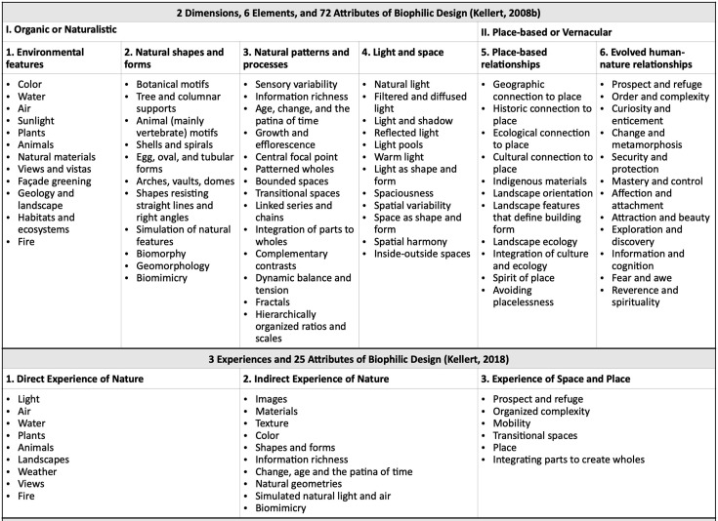
Figure 2: Kellert (2008) – 2 categories, 6 elements of and 72 attributes
(3) ‘experience of space and place’, to ‘the spatial setting’, to consider ‘how people manage and organise their environmental circumstances’.” (Kellert, 2018)

(Browning et al, 2014)
Similarly, (Browning et al, 2014) applied a combination of science, history and human intuition to develop a framework that divides various physical, metaphorical/ representational nature and the emotional reactions of nature into three categories: ‘nature in the space’, ‘natural analogues’, and ‘nature of the space’ (Söderlund, 2015). These three categories formulated the Terrapin Bright Green (TBG) “14 Patterns of Biophilic Design” framework:
“Nature in the Space
Nature in the Space addresses the direct, physical and ephemeral presence of nature in a space or place. This includes plant life, water and animals, as well as breezes, sounds, scents and other natural elements. Common examples include potted plants, flowerbeds, bird feeders, butterfly gardens, water features, fountains, aquariums, courtyard gardens and green walls or vegetated roofs. The strongest Nature in the Space experiences are achieved through the creation of meaningful, direct connections with these natural elements, particularly through diversity, movement and multi-sensory interactions.
Natural Analogues
Natural Analogues addresses organic, non-living and indirect evocations of nature. Objects, materials, colors, shapes, sequences and patterns found in nature, manifest as artwork, ornamentation, furniture, décor, and textiles in the built environment. Mimicry of shells and leaves, furniture with organic shapes, and natural materials that have been processed or extensively altered (e.g., wood planks, granite tabletops), each provide an indirect connection with nature: while they are real, they are only analogous of the items in their ‘natural’ state. The strongest Natural Analogue experiences are achieved by providing information richness in an organized and sometimes evolving manner.
Nature of the Space
Nature of the Space addresses spatial configurations in nature. This includes our innate and learned desire to be able to see beyond our immediate surroundings, our fascination with the slightly dangerous or unknown; obscured views and revelatory moments; and sometimes even phobia-inducing properties when they include a trusted element of safety. The strongest Nature of the Space experiences are achieved through the creation of deliberate and engaging spatial configurations commingled with patterns of Nature in the Space and Natural Analogues.” (Browning et al, 2014)
The overarching principle for formulating these three principles was to define and facilitate the 14 biophilic patterns that were established to provide guidance on how internal environments can be improved (figure 5). TBG’s paper states that varied and combinations of several patterns provide optimal results (Browning et al, 2014). The patterns have been formulated to be flexible to facilitate the application of the patterns for various projects and environments. An example of this is the inclusion of patterns that advocate simulations/ representations of nature.

(William Browning and Catherine O. Ryan, 2020)
More recently, biophilic strategies have been developed by the publication of “Nature Inside”, a biophilic design guide which remains to give significance to the TBG’s 14 Patterns. Drawing inspiration from existing standards such as LEED, BREEAM and WELL Building Standards, (Browning & Ryan, 2020) introduces the need for guidance on measurable performance outcomes. The guidance aims to positively influence place-making designs to holistically encompass biophilic design to achieve an overriding objective of integrating nature and human life into a harmonious ecosystem. Places based on this framework attempts to expose occupants (humans) to the long-term positive H&W benefits that are claimed to be associated with human and nature connectivity.

Much of the guidance is based on encouraging interdisciplinary working, biophilic intensity mapping and design concept peer reviews. Briefly mentioned as part of the framework is the need to measure the success of the biophilic elements on human H&W (Browning & Ryan, 2020). The framework briefly outlines that POE including: physical measurements, surveys and biometric testing, are important to gather information for future projects (Browning & Ryan, 2020). Emphasis is given to the need for sharing information and results for other designers to learn from. However, the guidance on performance measuring within this framework is vague.

The next section of this review will conduct research into the legitimacy of claims made regarding the positive impacts that biophilic design has on human H&W. The Spine (which is analysed as a case study within this dissertation) claims to be “one of the world’s healthiest buildings” (This claim can be found in the Spine’s advertisement brochure). As the TBG's 14 Patterns were used to drive the biophilic principles in the building, it is reasonable to conduct this investigation based on the evidence that TBG uses to advocate the benefits of the patterns within the framework. A limitation of words restricts the analysis of each study referred to within the document. However, a sample of six heavily emphasized studies within the document will be analysed to establish whether the research/experimental methods carried out were feasible and whether the results quantify the significance of the claims made. Two examples of these study analysis are included below and a further four can be found in (Appendix…)
Examination of studies
1. S. Ulrich –
A study conducted by Ulrich investigated whether views looking out at nature had any significant implications on human H&W. The study concluded that hospital patients with a view out to nature recovered quicker than those who had a view looking out to a brick wall. The patients with the brick wall view were deemed to have been in lower mood and more drugs were provided to aid with recovery, comfort and pain.
The experiment was conducted on patients recovering from cholecystectomy surgery 1972 and 1981. 46 patients were included in the research. 23 were placed in a room with a window looking out to nature (a garden with trees) and the other 23 were placed in a room with a window view of a brick wall.

The experiment demonstrated many variables that enhanced the reliability of the research results. Patients recovering from cholecystectomy surgery were specifically chosen, as the recovery process is particularly straightforward with limited possibilities complications arising. This limits the patients' differences in reactions and recovery, making the experiment more reliable. The two recovery rooms used mirror-imaged each other in terms of layout. The only difference was merely the window views. The results from the research were taken from the patients' medical notes and independently analysed by a medical professional that did not take part in the main body of the research. This ensured that the results were analysed based on facts, reducing biased.

However, some aspects of the experiment could have been improved for more reliable results. The experiment only consisted of 46 patients in total. A larger pool of participants may have provided a wider scope of results. Analysis of the experiment’s results further enhances this argument. The research concluded that the patients with the view out to nature recovered quicker and spent less time in hospital. While this is true, 7.96 days compared to 8.70 days per patient, this result is not as significant as the claim seems. The same applies for the claims regarding the need for less medicine for patients with the window view. Although, for days 2-5, patients in the brick wall view room required stronger doses of medicine, these medicines given were related to pain reduction. No significant differences were reported in terms of mental health (mood), and no significant differences occurred in the doses of antianxiety drugs. It further could be argued that a view out to a brick wall does not constitute much of a view. With consideration given to the growth in urbanisation, a study researching the contrast between the effects of looking out to green nature and hard urban views would be more informative.

2. “Physiological effects in humans induced by the visual stimulation of room interiors with different wood quantities” (Tsunetsugu, Miyazaki and Sato, 2006))
The TBG’ 14 Patterns document recognised that there is limited scientific evidence to support connections between human H&W and natural materials. However, the “Material connection with nature” pattern was created backed with two main bodies of evidence. Firstly, (Lichtenfeld et al., 2012) experiment which studies the presence of the colour green on participants' psychological functioning. Secondly, (Tsunetsugu, Miyazaki & Sato, 2006) study which will be examined below.

(Tsunetsugu, Miyazaki & Sato, 2006) claims to demonstrate that a difference in wood ratio and exposure to occupants in an interior space lead to a positive physiological response. It was deemed that moderate exposure to wood provided the most positive response.

The experiment, which included 15 male participants (aged 19-28), took place in 3 separate rooms. All three rooms were 13m2 and contained the same climate elements (such as, the room temperatures were all kept at 21*C). To limit any variables, such as odors, from influencing the results, each room was heavily ventilated before each participant entered. The only differences between the rooms were the wood interior coverage. Room one consisted of carpet flooring with white wallpaper and 0% wood finishing. The flooring and wall up to waist height provided 45% wood finishing in room two. Room three consisted of a wooden floor, wall and ceiling finish which equated to 90% of the room's finishes. Each participant was exposed to each room’s interiors for 90seconds in order to gather data on any physiological changes.

The study used two methods in order to monitor the participants. Pulse, blood pressure and hemoglobin readings were taken via specialist monitors that are used within the medical field. These readings aimed to establish changes within the participants' automatic nerve activity and the central nervous system to indicate how each room impacted brain activity. The second means of monitoring was a subjective questionnaire based on the following:
“The scores for the questionnaire for the sensory evaluation were obtained by converting the points the subjects had marked into scores of −6 to +6. Scores of +2 (−2), +4 (−4), and +6 (−6) were slightly comfortable/natural/restful (slightly uncomfortable/artificial/unrestful); moderately comfortable/natural/restful (moderately uncomfortable/ artificial/unrestful); and very comfortable/natural/restful (very uncomfortable/artificial/un-restful) in the questionnaire sheet, respectively.” (Tsunetsugu, Miyazaki & Sato, 2006)
Comparison of the results from all three rooms established that there were not many significant differences. This was particularly clear from the results of the subjective questionnaire. The data collected on the “Vigor” (comfort rating) and “restful” is an example of this. Although, it is worth noting that the room with the 45% wood coverage demonstrated the highest score in being “restful” and the 0% and 90% both scored low. The room with 90% wood coverage scored the lowest in the “vigor” category, deeming it the least comfortable room in this experiment.

In the 0% room, after the first 10seconds, [tHb] levels tended to increase, reaching a significant increase by the end of the 90s. Similarly, the [tHb] tended to increase, especially in the latter part of the exposure in the 45% room. In the 90% room, a significant increase in the [tHb] was observed intermittently between 42 and 81s. However, a significant result occurred after 80s, whereby the [tHb] showed a sudden drop. The results for [tHb] predominantly indicated that regional cerebral blood flow (rCBF) and cerebral activity increased regardless of the interior wood ratio. A sudden decrease in [tHb] in the 90% room was considered to show that the subjects became tired of the extensive coverage of wood in the room. These physiological responses may have a connection with the subjective questionaire results, in which the 90% room had relatively low scores in comfortable and restful feelings.

In terms of the data collected on the blood pressure activity, diastolic blood pressure significantly decreased in the 0% room, but the observed change in the autonomic nervous activity was relatively small. In the 45% room, a significant decrease in the diastolic blood pressure and a significant increase in pulse rate were observed at the later stage of the 90s exposure. The 90% room caused significant and large decreases in systolic blood pressure and diastolic blood pressure within the first half of the test.

The study concluded that the room with 0% wood coverage observed a relatively small and insignificant change in the autonomic nervous activity. The 45% room indicated a significant decrease in the diastolic blood pressure and a significant increase in pulse rate was observed. Thus, alongside the high rated results from the questionnaire, concluded that 45% wood coverage was the optimum room within this study. This further led to the study concluding that a ratio balance of natural materials provided slight improvements to human physiological responses. The 90% wood coverage results emphasised this point as the extensive coverage of wood appeared to cause a rapid decrease in brain activity.

The evaluation of these results found that, as claimed, a balanced ratio approach to including natural materials within internal environments show signs of improving occupant psychological functions. However, the reliability of the study’s data is questionable. The findings of the study are heavily dependent on the subjective questionnaire. Considering the study merely included 15 male participants from a specific age range, it could be strongly argued that the small sample of participants does not provide a reliable and conclusive set of results, especially considering the subjective nature of this aspect of the study. Lastly, examination of the results shows that key activities, in terms of blood pressure readings and [tHb] activity, tended to occur later on within the 90s that the participants were exposed to the rooms. Data on a longer exposure period may have provided a different outcome to the study. Also, thus would have provided a more realistic set of results which represent real-life situations whereby occupants in offices, for example, spend longer periods in the internal environment.

Based on the above analysis, it is questionable whether this study provides the necessary and reliable means of evidence for implementing the “material connection with nature” pattern. As the results show, there is a possibility that over-use of natural materials may negatively affect occupants' cognitive functions. For this, further research needs to be investigated with larger samples of participants, for longer periods and with various natural materials to see the true impacts.

Conclusion
In conclusion to the sample examination of the studies and evidence used by TBG’s 14 patterns, there is a strong case to be made that… (need to finish one or two other case examinations before fully concluding).

Case Study – The Spine
The Spine, located in the heart of the Knowledge Quarter, Liverpool UK, is the new home for the UK’s Royal College of Physicians [RCP]. The 160,000sq ft building provides a range of functions such as, dining, office and medical clinical space (Figure 4) shows how the building is split in ownership).
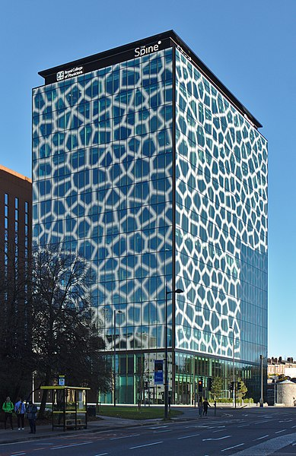
Figure 3: A view of the Spine from Brownlow Hill (Liverpool) showing the façade (Nash, 2021)

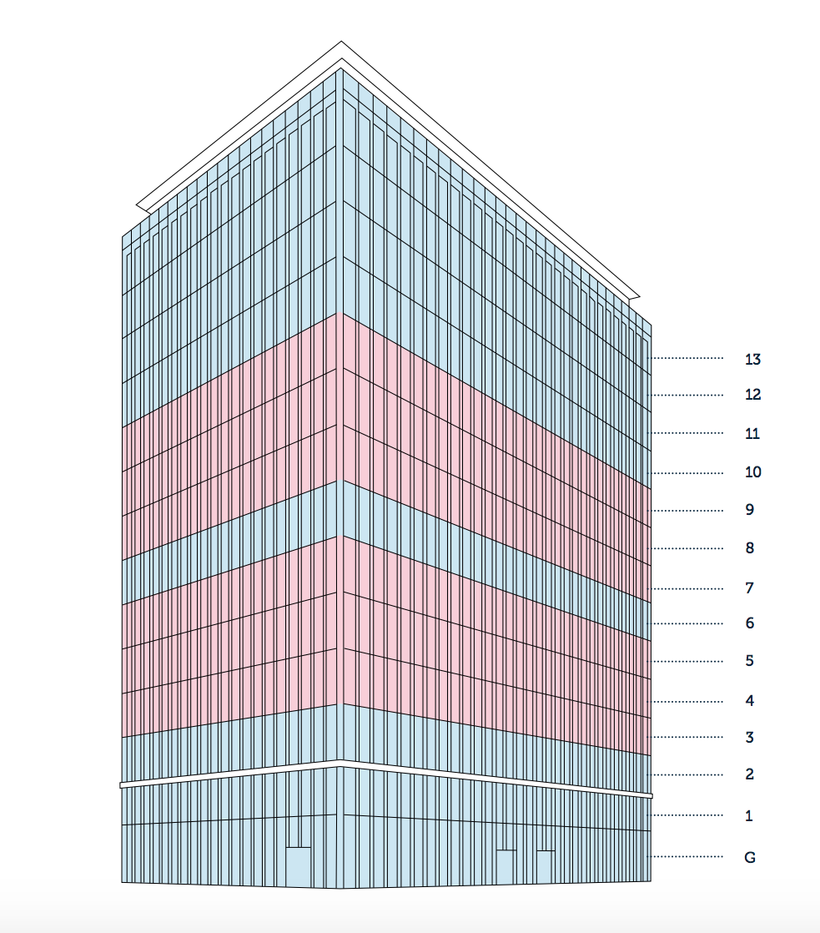
Figure 4: The Spine is split into RCP’s medical floors (Blue) and rental office spaces (Pink) and floor 6 is occupied by Clatterbridge Cancer Hospital.
Completed in early 2021, the design of the building optimistically reflects the ethos and values of the College. The client brief’s overriding objective was for the occupants “to be healthier when they walk out of the building, to when they walked in”. The majority of RCP’s scientific research helps inform health professionals and bodies such as the NHS. Further, organizations like Delos, a global wellness advisory and research leader in H&W, referenced the College’s research findings when they compiled the concepts for the International WELL Building Institutes. AHR, the architects, saw this as an opportunity to connect the College’s ethos, the WELL standard and architecture to create a reactive building to positively impact human H&W. Alongside AHR, Salvedge Sustainable Design Consultants were commissioned to provide biophilic and salutogenic design strategies.
The emerging design concept of the Spine was developed based on the narrative of the human body. This is primarily evident in the narrative of the façade. The external “skin” of the building represents an abstraction of human skin (figure 3). The application of this principle, which promotes good health from the outset, was deemed to be important in the design process of the Spine (Edge, 2022). This requires filling the environment with elements that accelerate health, opposed to pathogenic, which tries to cure poor health when it occurs.
Terrapin Bright Green’s (TBG’s) 14 Patterns of Biophilic Design were closely examined and utilised to combine biophilic and Salutogenic design methodologies. Stephen Edge, a biophilic consultant for the Spine, stated in an interview that I conducted that, while it is tempting to incorporate as many ideas as possible, it is essential to consider more thought out and detailed biophilic designs, which are more efficient than a lot of half thought out and implemented designs. In order to have the most significant impact, people need to be exposed to them for longer periods rather than just a glancing encounter (Edge, 2022) . In order to ensure that the biophilic and salutogenic interventions were achieving legitimate and positive H&W outcomes, AHR and Salvedge worked with WELL Accredited Professional (AP), who advised on the inclusion of the WELL standards (Hopkins, 2021). For a building to achieve the highest accreditation, a WELL Platinum award, a minimum of 80 credits is required (International WELL building Institute, 2019). Upon opening in 2021, out of a possible 110, the Spine scored 109 WELL credits (Hopkins, 2021). This is the highest achieving score to date by any building with WELL, anywhere in the world. For this, the Spine is being promoted as the “world's healthiest building” (Özdamar and Tandogan, 2021).

Below, I assess the performance of the Spine against the criteria embodied in the 14 patterns of biophilic design. This is done by summarising the design intent (based on interviews with the architect and the biophilic design consultant), my own experience of visiting the building and by cross-reference to other buildings that embody similar design objectives (for observations based on comparison).

1. Façade Design –
Derived from a mathematical Pythagorean triple, a form often found as fractals in trees and nature, the distinctive pattern of the building’s façade was initially organized into rational 1.5x4m sections of curtain walling (Özdamar and Tandogan, 2021). Developing this concept, a Pythagorean triple mathematical Voronoi Diagram pattern was overlayed onto the initial design. This created the façade’s patterns which represent the human body’s protective organ, the integumentary system of the skin. The distinctive façade pattern consists of 23 million unique polygons (Özdamar and Tandogan, 2021). Each polygon has been designed to varying sizes and spacing, considering the additional level of solar control required on each elevation and internal space. While conforming to the WELL Version 2 Concept – Light, the full-height glass panels with the associated biomorphic Voronoi pattern cast shadows within the internal space. These patterns are small enough to see the shadows moving slowly across the working plane throughout the day. As it is in accordance with one of the 14 patterns listed above, this design principle is deemed to positively affect the occupant’s H&W. Verified by Nobel prize-winning scientists Keffrey C Hall, Michael Rosbash and Michael W Young, light reflecting from work desks and exposure to the evolving daytime positively impacts controlling Circadian Rhythms (Heaven, 2017). Intern this can aid an efficient sleep cycle.
TBG Biophilic Patterns: Non-Rhythmic Sensory Stimuli, Dynamic + Diffuse Light, Biomorphic Forms and Patterns, Complexity + Order

A key design intention was to create a “forest canopy” of internal shading. Influenced by Japanese Forest Bathing, the biophilic patterns of dynamic and diffuse light, along with non-rhythmic sensory stimuli, are represented within the design (Hopkins, 2021). Japanese forest bathing is a traditional Japanese practice of immersing oneself in nature ((figure 5) - a forest environment) as a healing technique for physical and psychological health of the human body through a “five senses experience” (vision, smell, hearing, touch, and taste) (Wen,Y. et al. 2019). (Wen, Y. et al. 2019) examined 28 studies concluded that forest bathing has a significant role in promoting human physiology and mental health. The paper further concluded that forest bathing is a preventive method that reduces the risks of developing diseases. This echos the Spine’s aims to implement salutogenesis as a principle design ethos. While the patterned façade expressed various patterns within the 14 patterns of the biophilic design framework, the efficiency and impact that this design has on human H&W, in reality, is questionable. As is made clear within the 14 patterns of the biophilic design framework, nature should always be prioritised over the simulation of nature as there are greater benefits.
“Prioritize real nature over simulated nature; and simulated nature over no nature.” (Browning et al, 2014).
Data collected from Interdisciplinary research stresses that “five senses experience” within the forest environments have the greatest impacts on human health. However, this relies on the synergistic effect between a series of forest environmental factors (such as phytoncide, negative air ions, oxygen, and forest microclimate). These environmental factors vary significantly based on seasons, tree species/density/colour, and regions (Wen,Y. et al. 2019).

Figure 5: Japanese forest – environment where Japanese forest bathing takes place. Dense trees and dramatic shadows occupying the space. This image demonstrates a comparison to the internal space of the Spine (Stock (Photo, n.d)

Thorncrown Chapel, designed by Equine Fay Jones, demonstrates how architecture can be incorporated into the forest environment. Situated within the Ozark Mountains (USA), the natural environment, particularly patterns of light and shadows from the trees, provides a continuously changing internal atmosphere. As a result, the internal environment of the chapel is reactive to the external environment, and therefore it is never the same. Further, the large windows, roof, structural volume, and choice of natural materials, dissolve the boundaries between the external surroundings and internal space (figure 6 (Galloway, 2018).

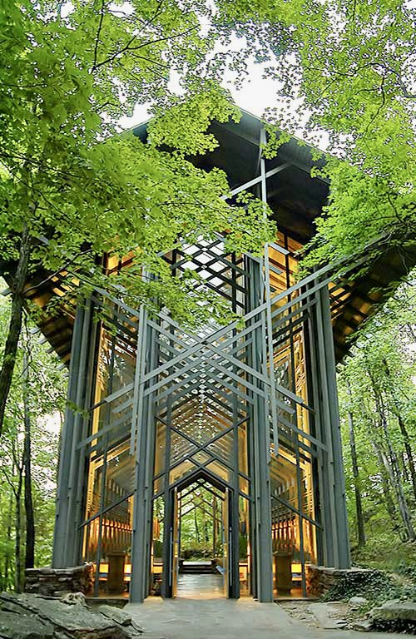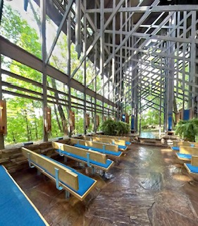

Figure 6: Thorncrown Chapel sits within Ozark Mountains (left). The boundaries between internal & external space is blurred (right)

To a degree, in direct sunlight, the shadows created from the patterns on the Spine façade evoke the intended stimulate of a shower of shadows that provide a forest canopy visual effect (figure 8). However, this is heavily dependent on sunlight to have any significant impact. Liverpool only receives on average 72.2 hours of sun per month (Climate-Data.org, 2019). This compares to the average 99.08 hours of sunshine per month counted in Ozark (Climate-Data.org, 2019). It is questionable whether the UK’s climate provides the climatic elements required for the façade to truly succeed in its design intention of emulating a simulation of Japanese forest bathing. Further, the application of the 2D patterns, which have been stuck on to the glazing, somewhat fails to satisfy the 3D/4D forms and perspective within real-life nature. It could also be argued that the patterns on the window negatively contribute to a visual disconnection out to the external landscape of the building (figure 9).
The 14 patterns of biophilic design framework stipulate that, although nature should always be prioritised, where this is not possible, simulated nature can prove to be successful too. With consideration given to the Spine being located within an urban setting, the design of the façade references the principle of simulated nature. However, when comparing this to the architectural elements of the Thorncrown Chapel, it is difficult to conclude that the intended design output of the Spine’s façade is successful. It is clear that the Thorncrown Chapel, sitting within the forest environment, can satisfy the “five senses experience” required for humans to successfully benefit from the health benefits provided by Japanese forest bathing. This is further enhanced by the chapel's architecture, which reflects and reacts to its natural surroundings authentically, providing a continuous nature immersive experience for the building’s occupier. For these points stated, it is questionable to what degree, if any, does the artificial Spine façade has on improving human H&W. A post occupancy evaluation (POE) could be carried out to determine this.

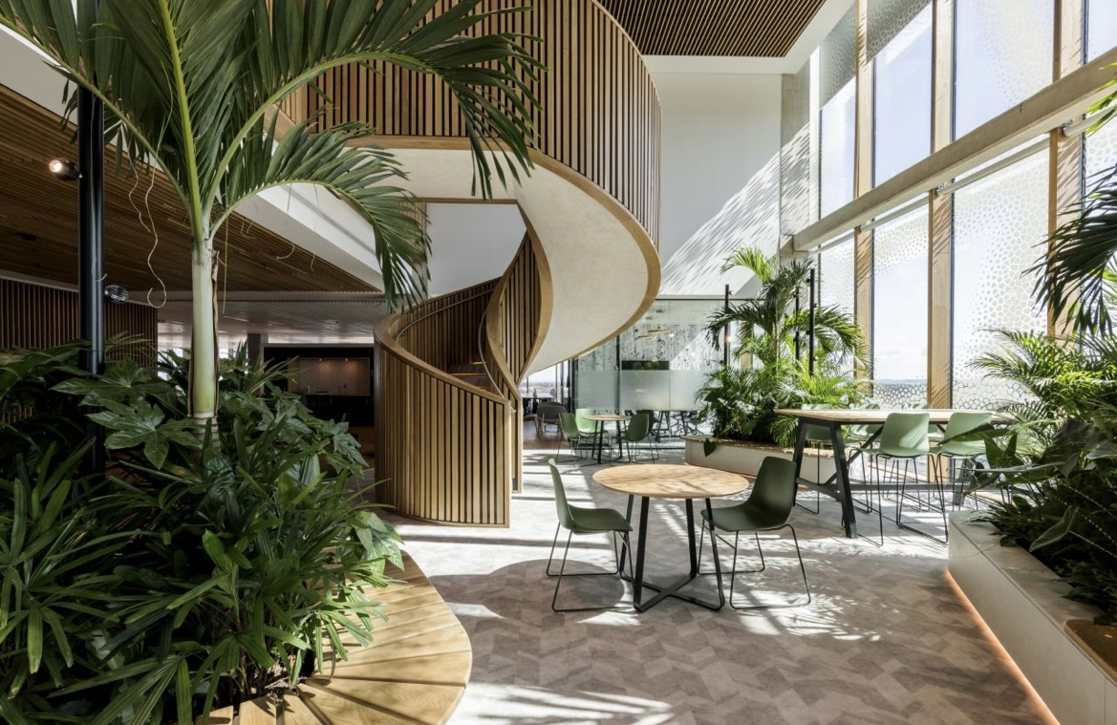

Figure 7: Example of a breakout/ circulation space which encourages occupants to connect with the plants. However, there is direct sunlight but the patterns on the façade are having little shadow effect.

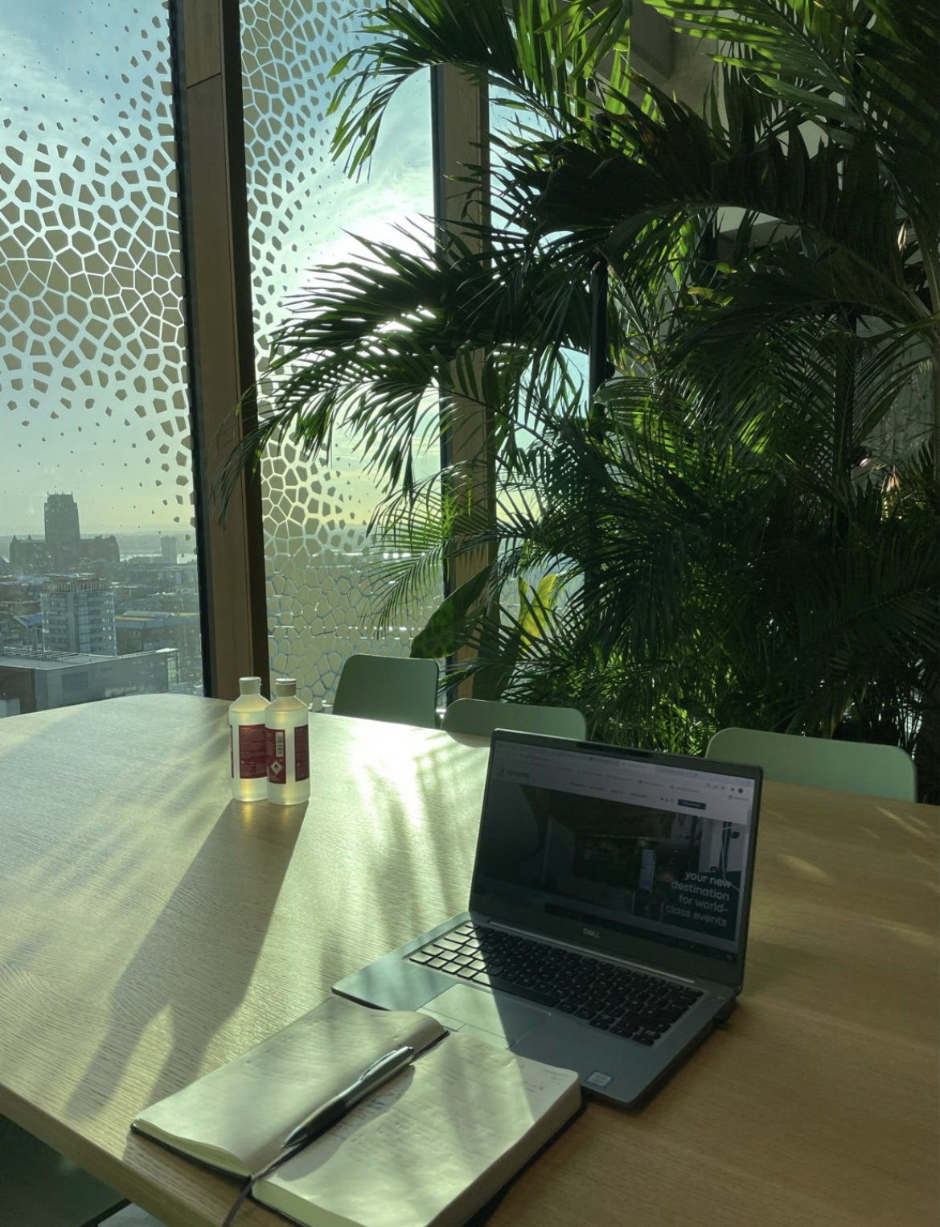 | Figure 8: Image shows the planting area being used with pattern faint shadows being casted from direct sunlight onto the surface close to the window. Planting is also in close proximity.

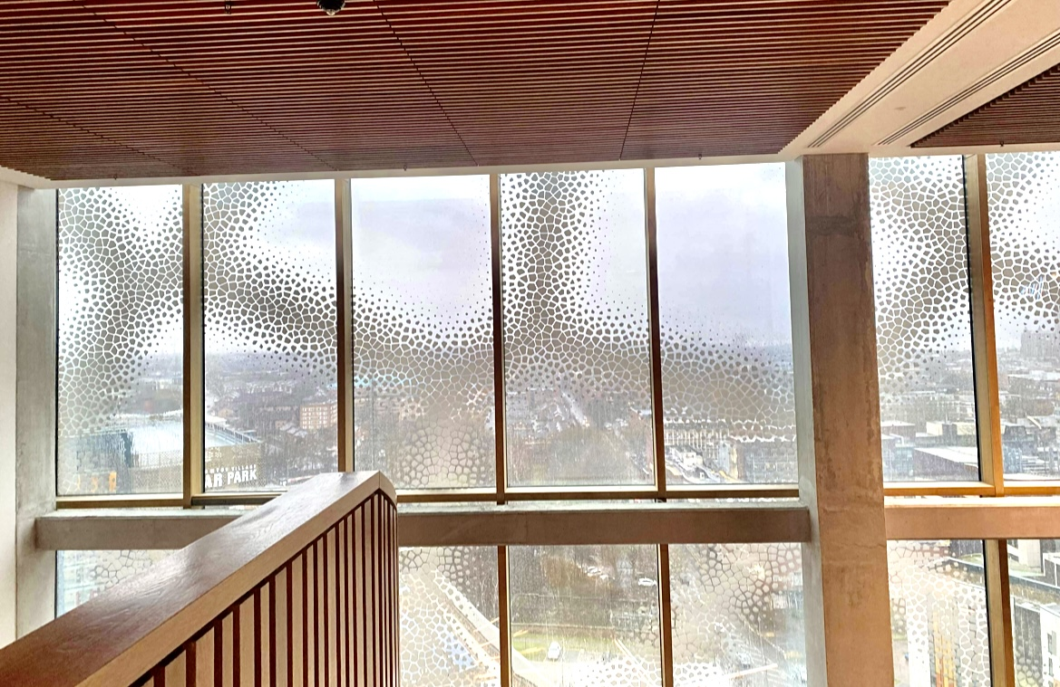 | 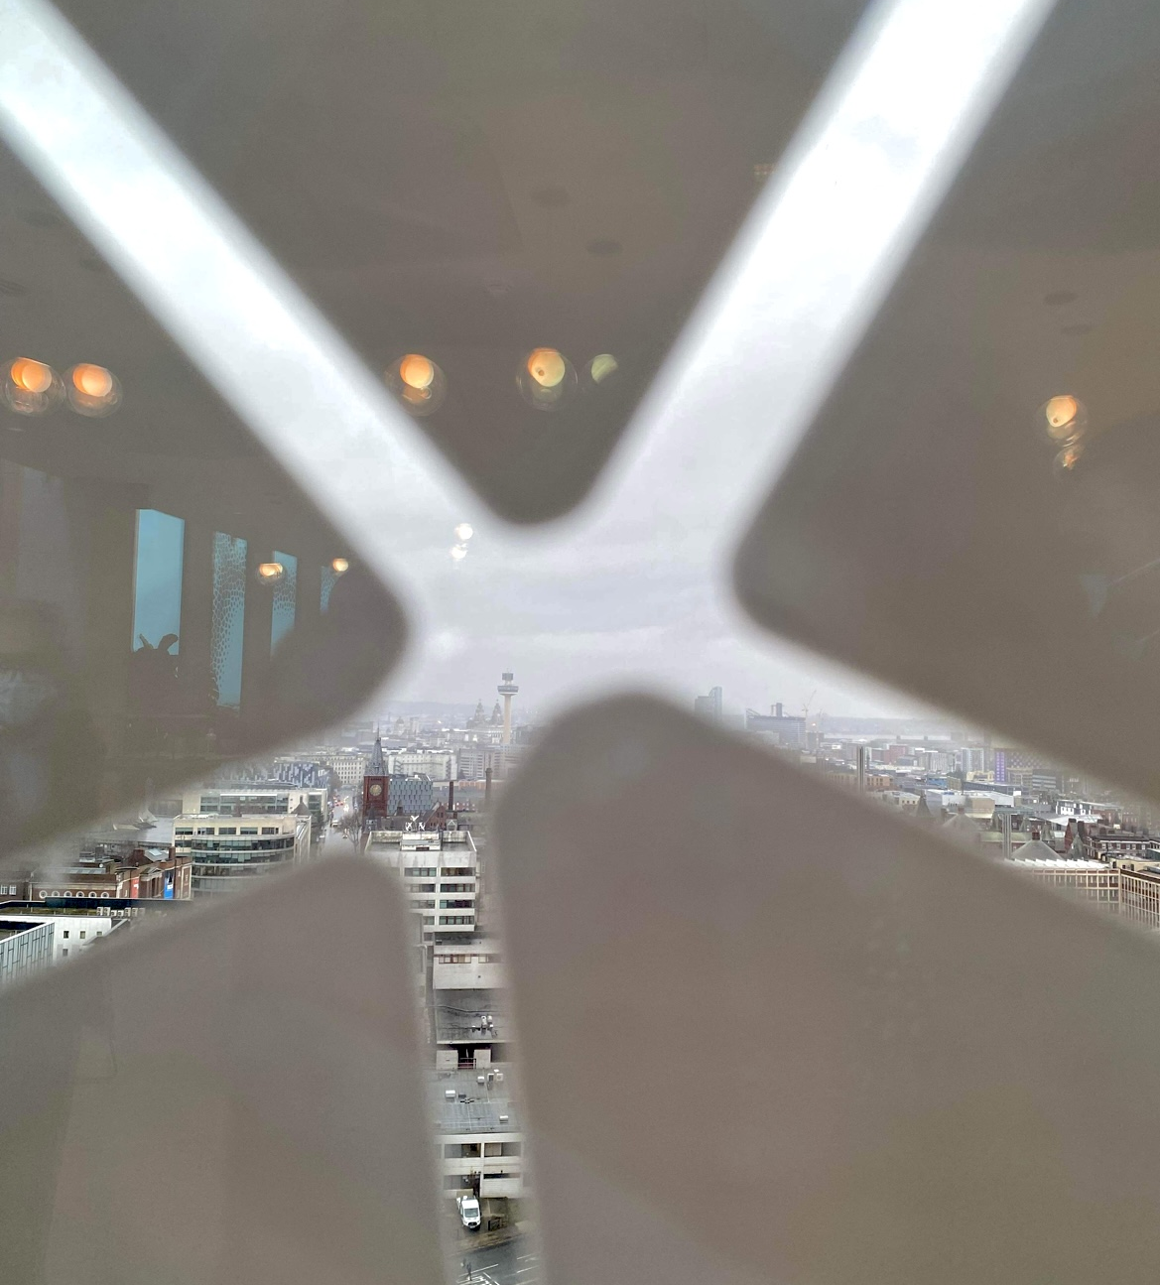
Figure 9: Image showing the view out with the patterns on the
façade. Thepatterns are small, however, at times they restrict
the view out. (Author, 2021)

2. External & Internal Views–
The Spine is located on one of the highest points in the city. Being 14 stories and 500ft above sea level, the building enjoys views in every direction (pbctoday, 2021). As seen in (figure 10), the prime view looks out to the west, whereby the dense urban city of Liverpool can be seen with the famous skyline, including the river Mersey in the background. To ensure that the “prospect” and “visual connection to nature” of TBG’s patterns are encouraged, the internal spaces of the Spine have been strictly organised. Every workstation and learning space is located within a maximum distance of 7.5m from a window (Özdamar and Tandogan, 2021). With the Spin being located within close proximity to the coast, the weather fronts can change quickly. Exposing the internal occupants to a constant visual connection to the external weather changes satisfies the requirements of the pattern “Connection with natural systems”. In turn, this intends to benefit the health of the occupants as this provides a connection with Circadian Rhythms and increase exam performances by 13% (Hopkins, 2021). Although on the face of it this seems to be successful in the Spine, it could be argued that other existing buildings are more successful in doing so.
TBG Biophilic Patterns: Prospect, Connection with natural systems, Visual Connection to Nature,

An example of this is the Birch and Moss garden within the Times Center auditorium, New York (figure 11). Described in (Archdaily, 2011), the garden comprises three primary elements: specifically selected trees, undulating topographic surface and floating walkway. The design was driven by a microclimatic computer simulation. This technology enabled the design team to make decisions based on scientifically forecasted growing conditions. The highly glazed facades encapsulates a 360-degree backdrop of the multi-layered native courtyard. This visually connects the internal occupants to the natural habitat within a close proximity, and exposes the internal occupants to the garden’s ever-changing seasonal climate. Whilst achieving these biophilic design principles, this scheme is an exemplar of how technology can be utilized within biophilic designs to maximise the efficiency and outcomes of man-made natural spaces. The garden further emphasizes the importance of including green spaces and nature within urban spaces. The National Library of France strongly emphasizes this as described in (David, 2011). Situated on the banks of the river Seine, east of the Île de la Cité in Paris, the site is dominated by four towers. These towers are Dominique Perrault’s modern interpretation of the Parisian tradition of monumental public architecture. A central courtyard forms the core of the elevated esplanade (figure 12). Situated on an old industrial site, the oasis of two hundred and fifty oaks, wild pines, and birches emerging from the site carries a powerful message: “…at the core of the project—and perhaps at the center of human knowledge is nature, not man and his urbanism” (Perrault, 1994). The four towers have been designed with a functional aspect. Built using an elaborate double facade, Perrault describes his inspiration:

"A diaphanous light will rise through the interiors of the glass towers, culminating in four top points, which will shimmer like four lighthouse beacons. This liquid light will spread over the square, while the towers will be reflected in the Seine" (Perrault, 1994)
The scheme also plays with aspects of verticality. The tall dominating towers place emphasis on how nature can be submerged into urban settings. The submergence of the core provides depth to the space, connecting the lower spaces of the building with nature. In the context of this building being vastly used as a workspaces and library, nature core space successfully satisfies the following TBG’s 14 patterns, without the need for artificial stimulation of nature: visual connections to nature, exposes occupants to natural systems, prospect, personal spaces to refuge, use of natural materials, nature-driven dynamic & diffuse light.

In comparison to these buildings, the design of the Spine is very dependent on its surroundings. The high-rise building utilizes the 360-degree views out to a wider landscape. However, the above comparisons demonstrate how urban buildings can include centralised nature driven spaces as a core of the design. The Spine fails to provide this within its high-rise form, which merely contributes more to the continuous built urbanisation of the city. It could be argued that this fails to satisfy the biophilic ethos that aims to re-connect urban spaces and nature. Further, the external views, although do successfully encapsulate a wide range of natural elements, it is questionable whether the views, which primarily capture the dense urban city-scape, diminish from the anticipated H&W benefits (figure 10). It could be argued that Spine could have included immersive external nature-driven spaces. This would have created a stronger biophilic ethos within the urban location and improved the H&W outcomes of the occupants.

Figure 10 : The Spine – External views
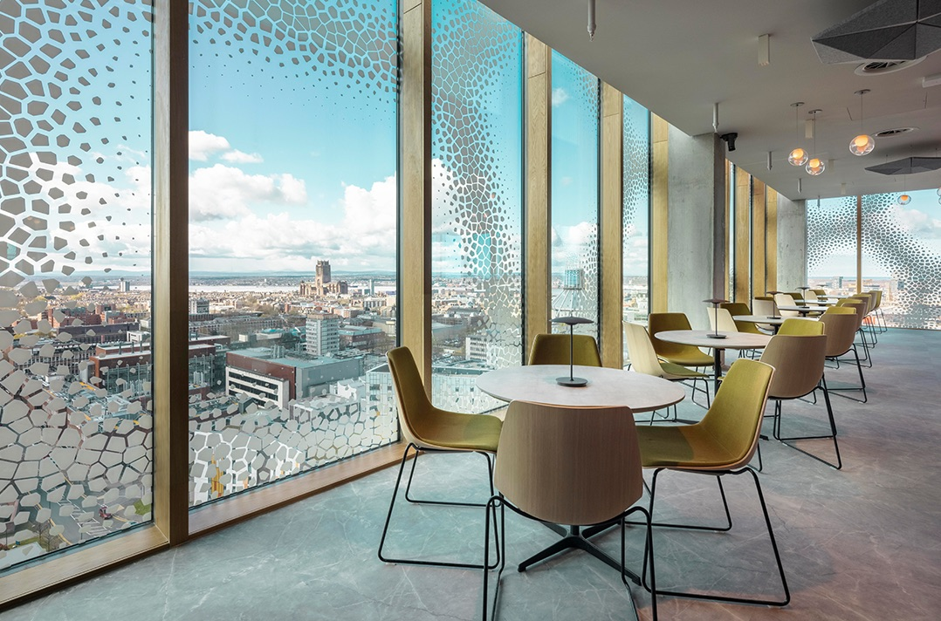 |  |  | 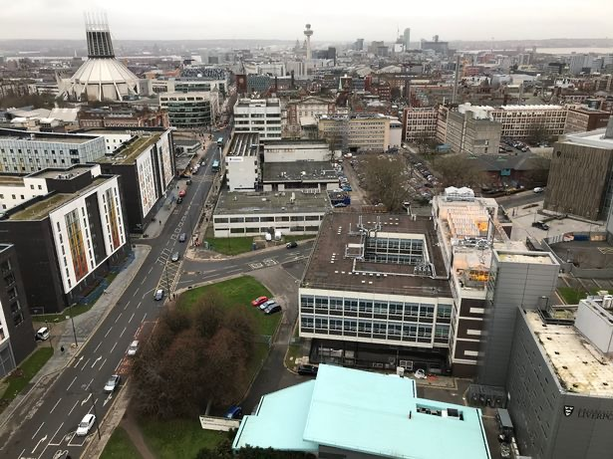
 | Views looking out to at the surrounding landscape of the Spine |  | Much of the views from the Spine  looks out at hard urban landscape.
Figure 11: The New York Times Building Lobby Garden – External views

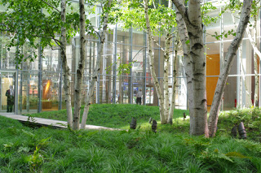 |  | 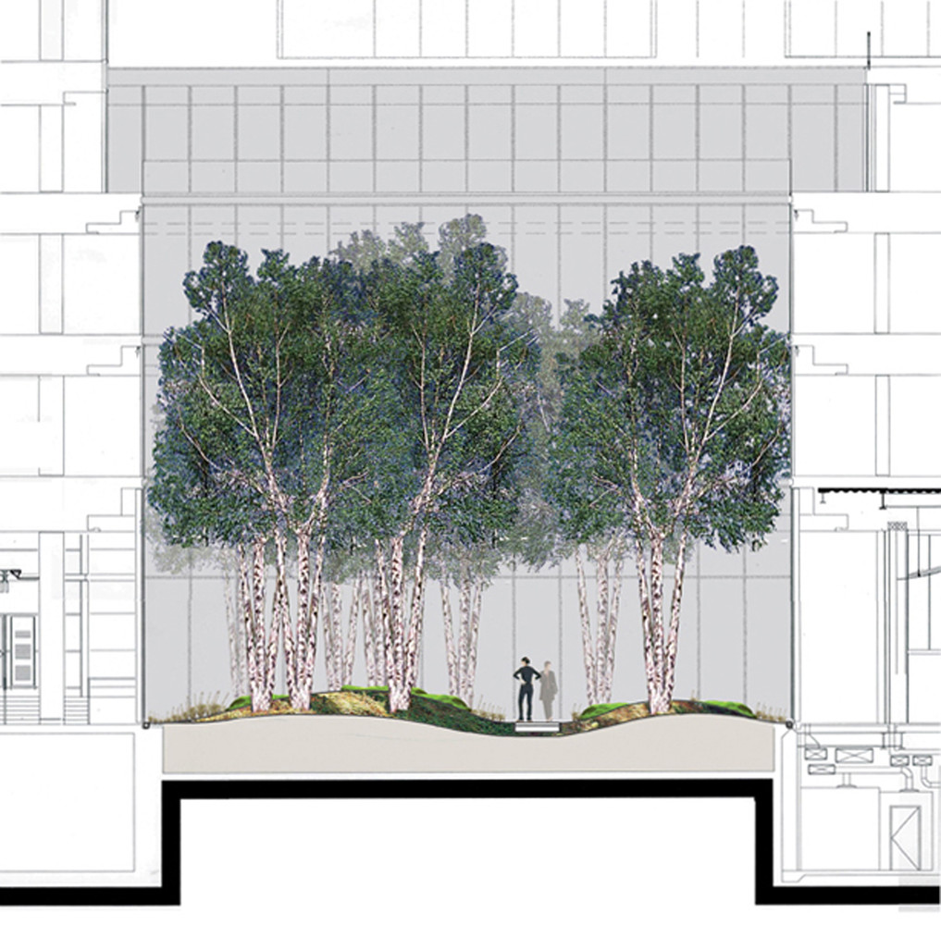 |  | 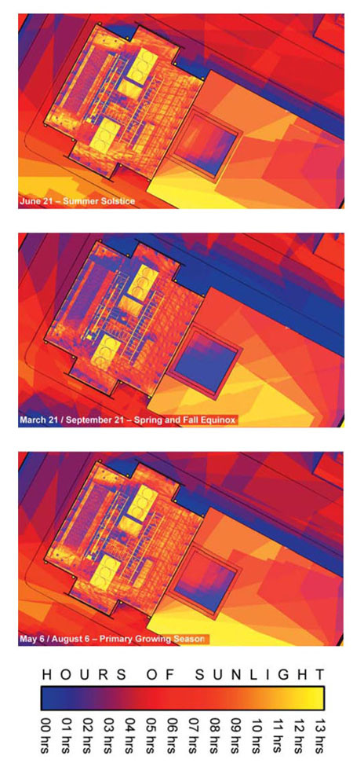
Views out to the garden space |  | Section showing the topography and close proximity of the garden and building |  | Climate analysis of the space
Figure 12: The Bibliothèque Nationale De France

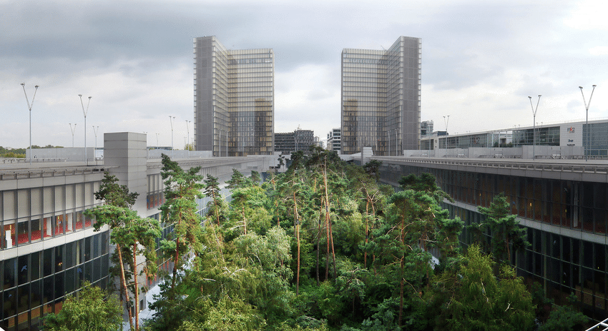 |  | 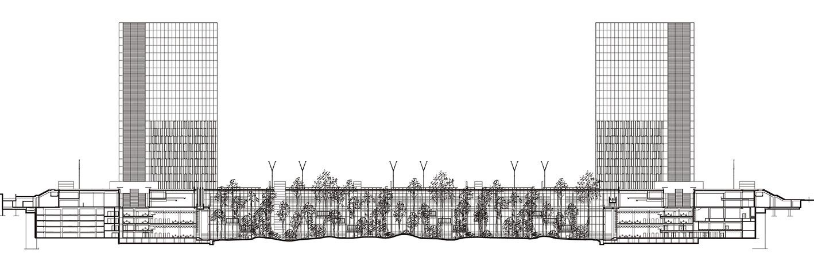 |  | 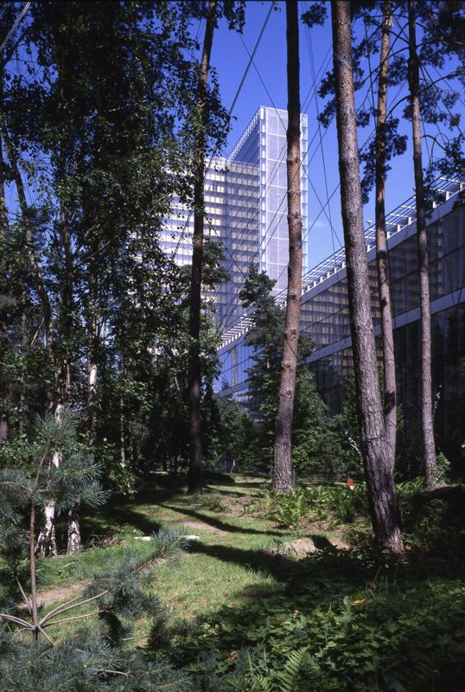
The central green spcace is submerged into the urban area |  | Section showing the relationship of the green space and the building. |  | Internal green spac connecting occupants with nature

3. Internal space
3.1 Visual Connection –

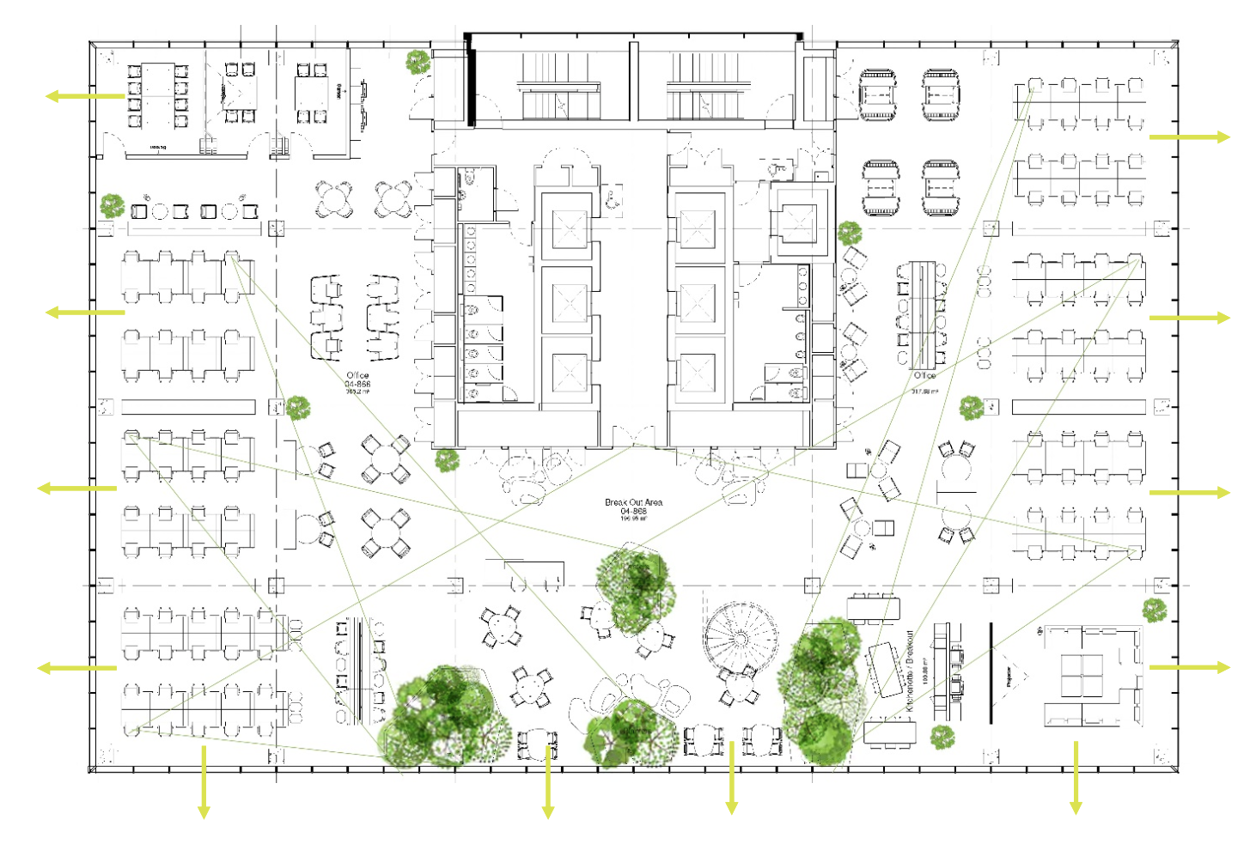
Figure 13: A floor plan of the Spine showing the strong visual connection throughout the space. The space with landscaping is placed in the centre of the plan to encourage occupant connection and interaction with the plants.
The internal space of the Spine has received awards such as Plants@work awards for the interior landscaping. Although the internal planting is discussed in detail further on in this section, it is worth recognising the inclusion of these spaces. These planted spaces, called ”vertical villages”, are placed in double-height spaces moving upwards through the building, breaking down the 14 floors (Özdamar and Tandogan, 2021). As seen in as an example in (figure 13), these vertical valleys have been carefully positioned and designed to maximise the functionality of the space and to encourage occupants to connect with biophilic and salutogenic features for longer periods. The majority of the internal spaces have a strong visual connection throughout, particularly within the office spaces. The open-plan nature of these spaces enhances visual connections to the natural materials (such as the wood finishes which are discussed further below), plating and between occupants of the spaces. This also satisfies the TBG pattern of Prospect as these spaces strike a balance between openness and surveillance with views across the space expanding from 6-30m (figure 13).
TBG Biophilic Patterns: Prospect, Visual Connection to Nature, Non-Visual Connection to Nature, Biomorphic Forms & Patterns, Material Connection with Nature.

The Spine also includes standard spaces which have been enhanced to maximise the functionality of the building, for examples the breakout spaces and the sitting steps which provide social space for occupants (figure 14). Although wood (oak) is heavily used in these spaces to expose occupants to natural materials, the dominant open-plan design of the building could be foreseen to restrict the Spine from achieving elements of the TBG 14 patterns, such as refuge spaces. In this regard, a stronger biophilic design strategy is arguably seen in examples such as the Scottish Parliament Building by Enric Miralles. Contemplation spaces with small windows have been created within the building’s elevation, providing occupants a place for mental restoration (figure 15).

The Maggie’s Centres, in particular Maggie’s Cardiff by Dow Jones provide another exemplar. The scheme aimed to celebrate surrounding landscape by using natural materials, inclusion of a central garden and within the slanted roof forms, whereby the beams of the ceiling’s underside slant towards the treeline in the external skyline. Jones describes this design philosophy as:

“…part of a narrative connecting you to the landscape, as well as continuing to make clear connections to mountains through the ceiling folds…” (Williams, 2019)

The architects further wanted to disconnect occupants experience from that of a generic health centre in order to relax and deformalise the experience. Spatially, there is a strong narrative, providing various spaces of ambiance, size and functionality (figure 16).
The scheme includes a space identified as the ‘cwtch’, a word that intrinsically evokes a sense of home. Jones describes it as ‘like a space under the stairs’, utilising the idea of ‘from space to embrace’. This small alcove provides just enough space to lie down and is shut off from other areas. Inside, the tall chimneystack structure includes a high rooflight (figure 16). This provides an experience that is compared to camping or meditation, providing an individualised relationship with the sky (Williams, 2019). The unique space satisfies many of TBG’s patterns, notably mystery, refuge. The space is described as being mentally restorative.

Figure 14: The Spine
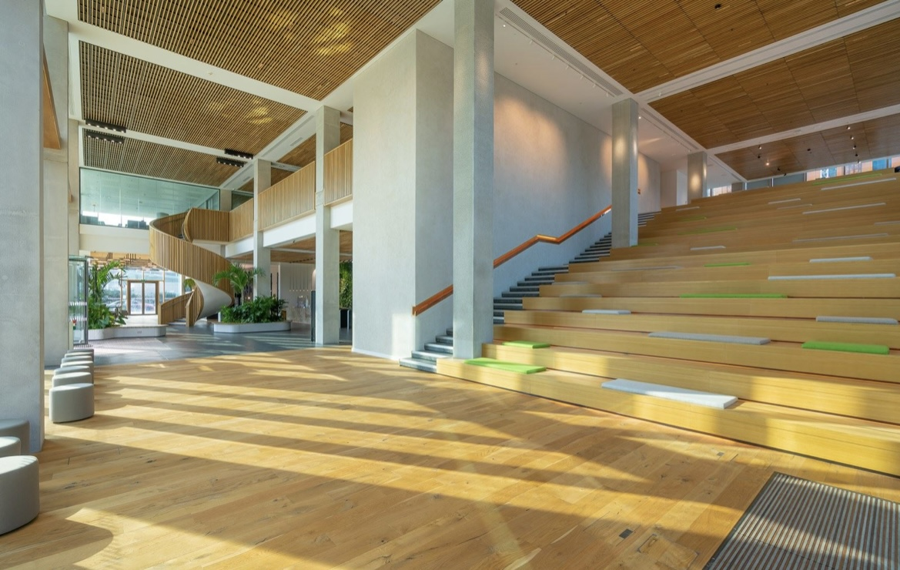
The Spine enhanced standard spaces of a building into multifunctional spaces – The sitting steps is an example of this. This space is open and encourages interaction. However, the Spine lacks spaces that fall under TBG’s “refuge” pattern.
Figure 15: Scottish Parliament Building

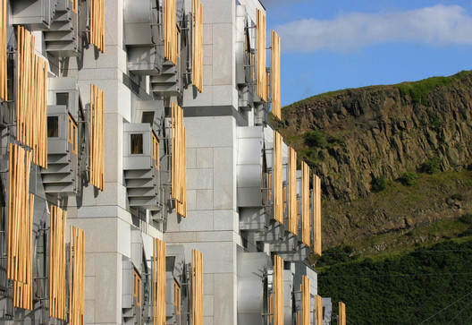 |  |  | 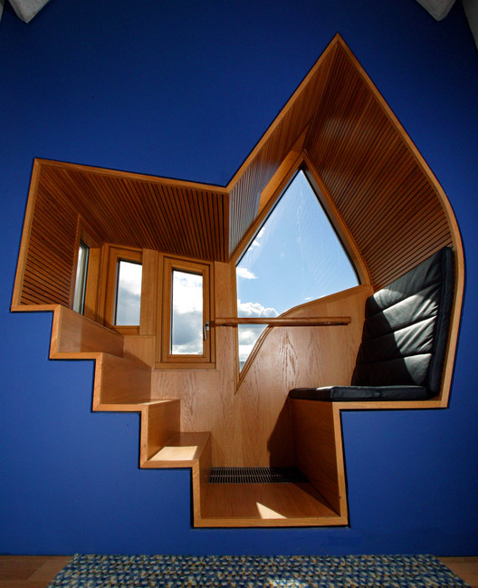
 | The contemplation spaces are expressed within the façade of the building |  | Example of the contemplation spaces which satisfies the TBG “refuge” pattern
Figure 16: Maggie’s Centre - Cardiff
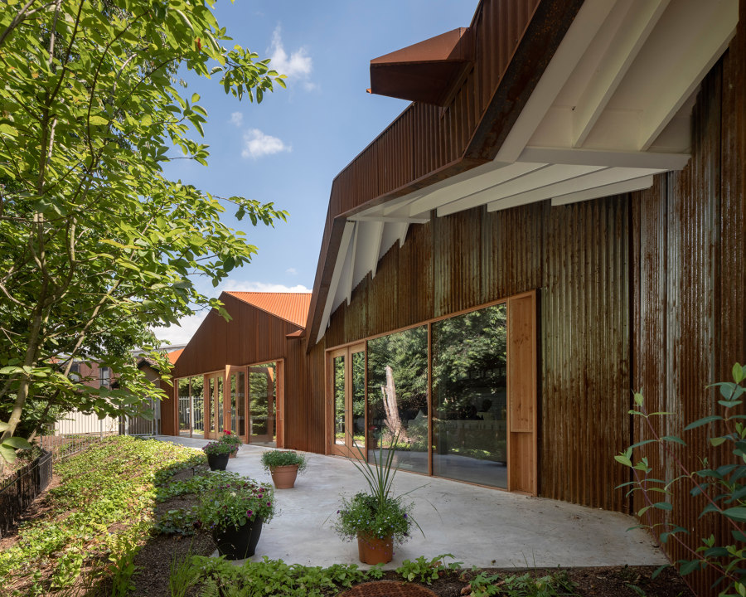 |  | 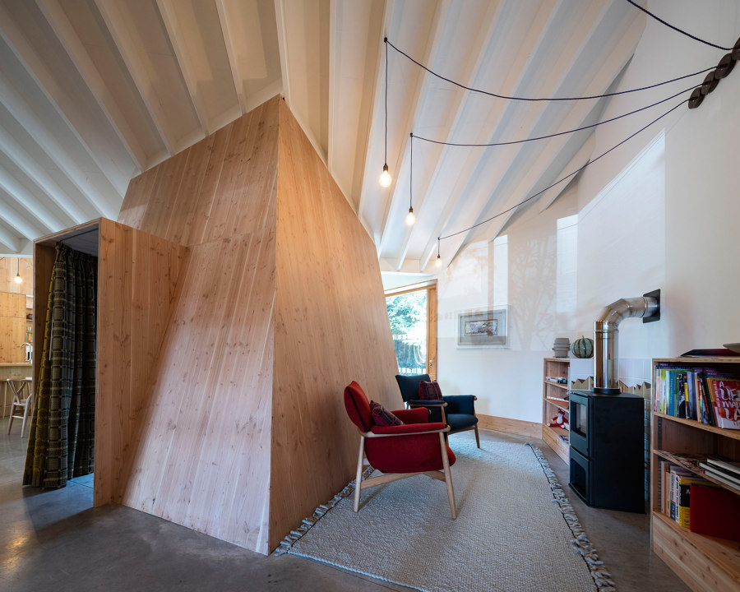 | 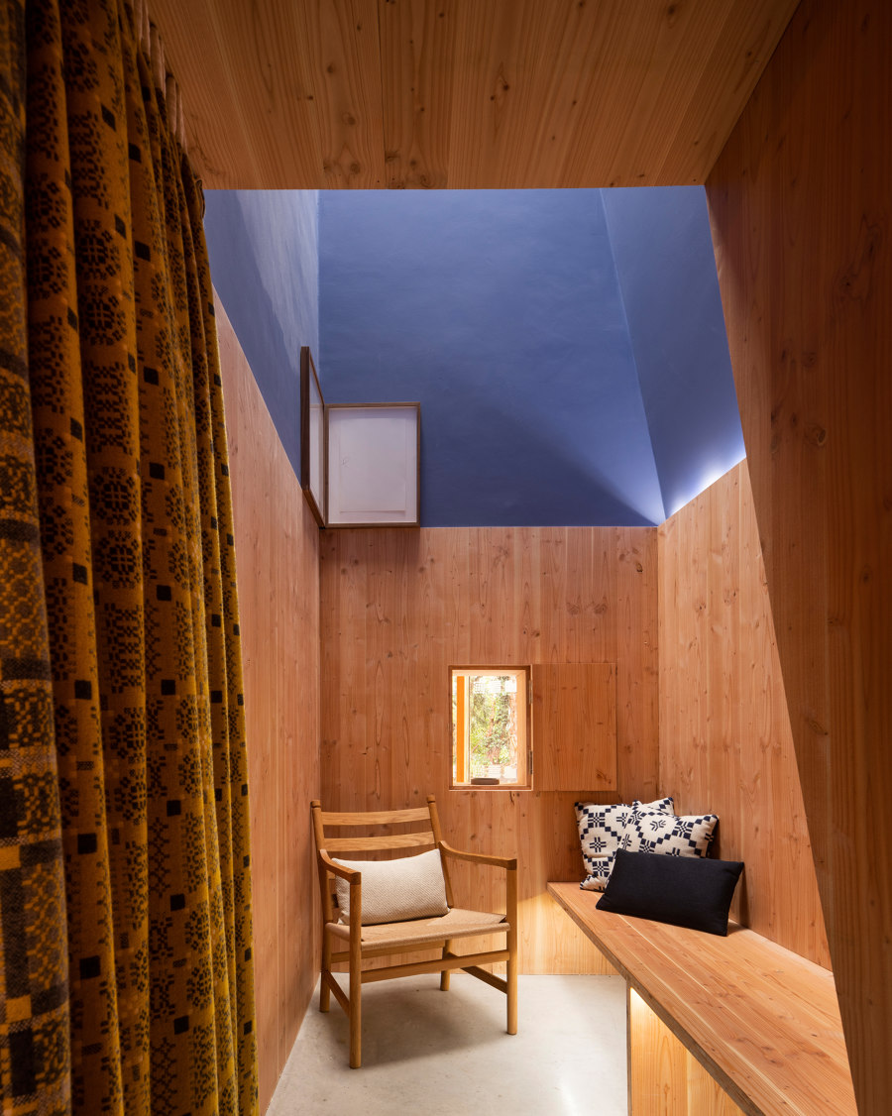 | 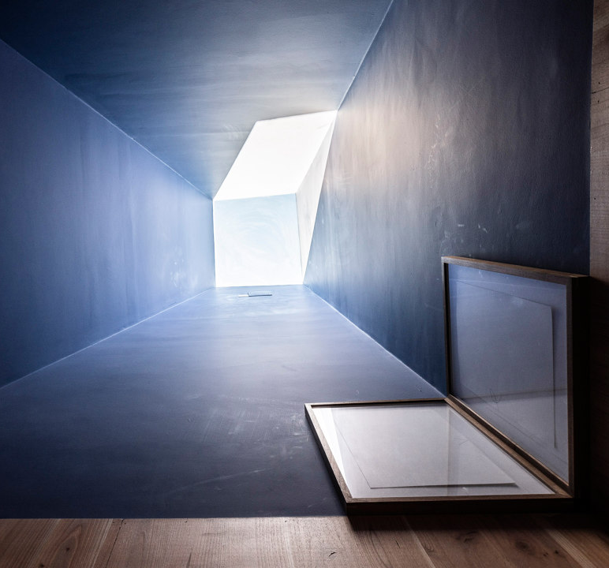
The architecture is driven by nature |  | The internal layout provides spaces of various sizes and function | The internal space of the “cwtch” which satisfies the TBG “refuge” pattern | The skylight connects the space and occupant with nature

3.2 Materiality
The materials used for the internal space demonstrate a long-term thinking policy with low maintenance also at the forefront. While designing the internal spaces, architect Robert Hopkins stated that the “if you touch it, it is real” philosophy was adopted (Hopkins, 2021).
TBG Biophilic Patterns: Visual Connection with Nature, Non-Visual Connection with Nature, Biomorphic Forms + Patterns, Material Connections with Nature

Expressed within the building is the concrete frame that forms the primary structure. Originally the concept of the structural frame was to be in timber. However, the client team changed this at the early stages of the project. As a result, the biophilic principles had to be re-thought (Özdamar and Tandogan, 2021). The solution was to cast patterns of the trabecular system into the concrete columns (figure 17). This design principle refers to the building’s human narrative concept and satisfies various elements of the 14 pattern framework such as Biomorphic Forms + Patterns.

“Each column was unique to maintain a biophilic approach and from a design perspective, these columns help to challenge the perception of what is possible with concrete construction, concerning biophilia.” (Özdamar and Tandogan, 2021)

Ensuring that natural materials and connections with nature are maximised, an extensive amount of oak has been used on the floors, ceilings, walls, surfaces, handrails, balustrades and steps (figure 14). This provides occupiers with visual and tactile contact with the natural oak throughout the building (Hopkins, 2021).
The carpets used are made predominantly made from recycled fishing nets. This Desso Airmaster system is designed to trap fine dust particles within the carpet’s structure, which are only released when cleaned (Hopkins, 2021). The product promotes recycling materials and improves indoor air quality (IAQ). Various other materials were selected to promote a healthier indoor environment. An example of this is the copper handrail used alongside the sitting steps (figure 18). A recent report investigating various scientific papers concluded that copper materials (including copper-coated materials) reduce microbial contamination such as bacteria and, subsequently, reduce health-associated infections (Arendsen, Thakar and Sultan, 2019). This example of material choice with the Spine, on a handrail whereby many occupants will come into contact with, is a strong demonstration of the level of detail that went into attempting to design a healthy indoor space. However, whilst visiting the Spine, it came to my attention that the inclusion of copper was not used on other heavy contact surfaces such as door handles and light switches. For me, this questioned the integrity of the design. Was this merely a showcase talking point? Or did other factors such as budgets not allow the design team to truly fulfil the aim?
Hopkins (2021) emphasised that the Spine adopted an approach to reduce toxins that are released from materials. Although this is discussed in more detail in the below section “Air quality”, this section identifies some of the key materials that were used to achieve this. The control of off-gassing played a key role in the material choices of the internal environment. Known as volatile organic compounds (VOCs), these gases prove to deteriorate IAQ and are harmful to human health. Biophilic consultant Stephen Edge (2021) stated that decisions on materials were based on research papers released by Building Biology Association (BBA). The BBA is an institute that provides guidance on methods such as material choices to improve IAQ. The guidance is driven by multidisciplinary research based on real-life living environments. Below is a key example of a material choices that aims to reduce VOCs in accordance with the BBA research. Further description on the choice of paint and furniture can be found in (Appendix…)
Wall finishes
The large double-height wall within the ground floor exhibition space, whereby large groups of occupants would typically spend lengthy periods at given times, has been finished in a Clayworks wall finish. Manufactured in Cornwall from abundant raw materials, the wall finish is sustainable and contains no toxic ingredients or VOCs. The clay plaster also regulates relative humidity, allowing buildings to breathe, absorb toxins, odours and enhance acoustic quality. It can further passively regulate temperature (Edge, 2022).
“This means that the FF&E specified and installed will not unduly off-gas where possible but instead will contribute directly towards helping create an overall healthy internal environment.” (Özdamar and Tandogan, 2021)
The Spine - Materials
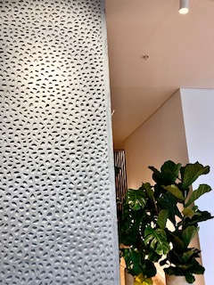 | 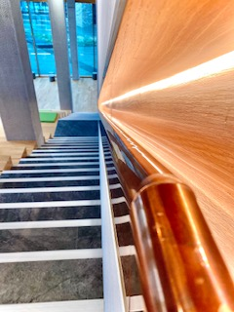
Figure 17: Cast patterns of the trabecular system on the concrete columns | Figure 18: Copper handrail in the communal area

3.3 Ventilation & Indoor Air Quality
Air quality played a pivotal role in the Spine’s ambitions to become one of the world’s healthiest buildings. This section will outline the key design principles that contribute to achieving this. Comparisons will be made with existing standards and guidance that exist in order to measure the Spine’s IAQ.
TBG Biophilic Patterns: Thermal & Airflow Variability
Air supply
A key aspect of the Spine’s air quality strategy is that the building is entirely dependent on mechanical ventilation. Other than the main door situated on the ground floor, no other source of natural ventilation is utilised (Hopkins, 2021). This is particularly interesting considering many guidance and standards such as WELL Standards, BREEAM and Health Technical Memorandum (NHS standard guidance) encourage and award buildings that utilise natural ventilation. This is primarily based on sustainability concerns related to mechanically ventilated buildings. When this was put forward to Hopkins (2021), he stated that due to the poor air quality and high pollution within Liverpool City, the Spine had to adopt a fully mechanically ventilation system that would purify the air before pumping it into the building. As a result, it is anticipated that the IAQ of the Spine is 7% cleaner than the external air quality. Tumkeen Badulla (2022), BDP’s head mechanical engineer designer for the Spine explained that, originally the system was set out by the landlord (Liverpool council controlled) and then later subcontracted out to BDP to enhance the ventilation strategy. Badulla (2022) revealed that BDP's designed team conducted a tick box approach comply with the WELL standards requirements. Many CO2 monitors were included in the design as part of a more comprehensive variable air volume (VAV) system. The VAV system is set out in various zones on each floor (Figure 19). This ensures that the system is reactive to each zone’s use and occupancy, with the VAV efficiently reacting to increasing or decreasing CO2 levels. In accordance with the WELL Platinum standard, the VAV system provides 13 litres per second (l/sec) of fresh air into the internal spaces (Özdamar and Tandogan, 2021). This equates to a CO2 level of 800ppm (Hopkins, 2021). Table (3) below gives a summary of how this compares to various guidelines and standards.
Standard / Guidance | Ari Flow - Liters per second (L/Sec) | CO2 levels (ppm)
Part F - Building regulations (2010) | 10 (L/Sec) | -
British Council of Office | 12 (L/Sec) | 1200 ppm
BREEAM Standards for education class rooms | - | 1000 ppm (max 1500 ppm with exposure for no longer than 20 minutes)
Sage Recommended levels | 10-15 (L/Sec) | Approx. 800ppm
Sage Levels of concerns | < 5 (L/Sec) | 1500 + ppm
WELL Standard | 13 (L/Sec) | 800ppm
Table 3
In comparison to the British Council of Office standard, the Spin’s lower CO2 levels (800ppm) will have a 10-20% improvement on occupants’ cognitive performance within the building (Özdamar and Tandogan, 2021).
The covid-19 pandemic evoked mass discussion and research into Air Quality and filtration systems. As previously mentioned, the design of the Spine encompassed this in the low/zero VOC materials that have been used. Hopkins (2021) explained that the air filtration system used within the Spine is a MERV 12 filtration rating system. MERV 12 air filters provide between 85% and 90% efficiency for filtering particles between 3 and 10 microns in size, such as, mold spores, dusting aids, and cement dust (Lewis, 2021). They also provide between 65% and 80% efficiency for filtering particles between 1 and 3 microns in size (such as legionella, lead dust, humidifier dust, coal dust, and nebulizer droplets). Although this filter is deemed efficient and a high standard for office spaces, recent research and recommendations papers published by ASHRAE (2018) conclude that MERV 13 air filters or above are most efficient in dealing with smaller particles such as ones from Covid-19. Further to this, the MERV 13 filtration system is stated to be the minimum requirement under the WELL Standard. It is worth noting that the Spine was designed before the pandemic and the suggested research was carried out. However, with no clear evidence to suggest any reason why the MERV 12 system was chosen for the Spine, it is questionable how the building can claim it is one of the healthiest buildings in the world. Further to this point, Badulla (2022) expressed that the open-plan nature of the Spine providing a less controlled environment, and cost limitations set out by the client, restricted the potential that BDP aimed for with the VAV system.
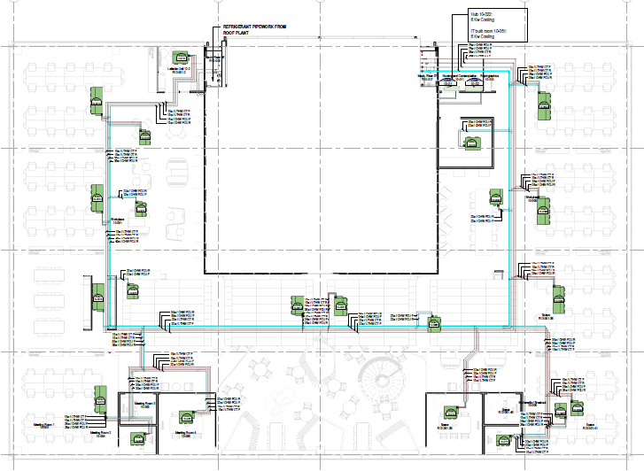 | 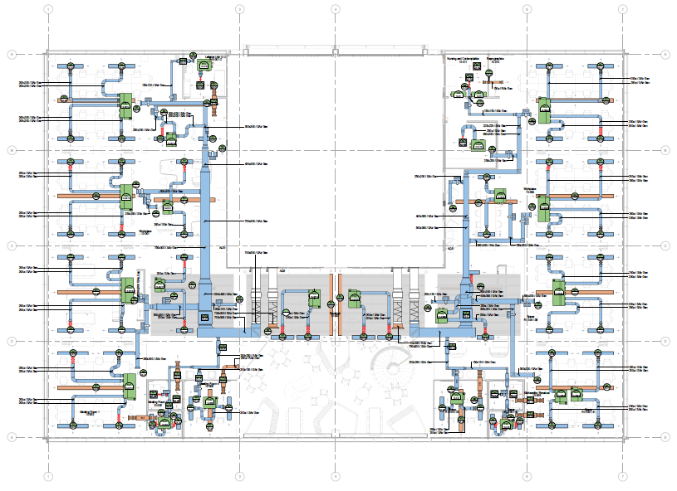
Figure 19: The Spine – example of Heating & Cooling system and the Ventilation system layout on floor 10

To conclude this case study, the ethos of the Spine and the educational conversations and messages it conveys are very successful. A prime example of this is that air quality monitors are located every 300m2 (Badulla 2022). The data collected is displayed on PC monitors to ensure awareness is raised for the occupants to see the air quality around them (Özdamar and Tandogan, 2021). The planting used is another strong example. Many deem biophilic design a process of placing as many plants into space or buildings as possible. Research into the Spine has revealed that the choice and quality of plants should be considered over quantity. The plans were carefully selected based on NASA’s “Clean Air Study” (Hopkins, 2021). The study concluded that certain plants act as natural air filters to remove organic air pollutants from their surroundings. With the plants contributing to the IAQ, they also play a vital role in satisfying elements of the TBG 14 patterns. An automated irrigation system was not designed into the planting space to encourage occupants to take responsibility and engage with the plant life. The overriding aim is to improve occupants' wellbeing and provide a closer salutogenic engagement with the natural internal environment. However, analysis of the biophilic feature within the Spine, alongside comparative examples of other buildings, establishes that the Spine lacks consistency in providing a fully successful Biophilic exemplar. This is particularly clear from the building’s rectangular block form. Correspondence from Robert Hopkins revealed that:
“The shell and core of the building needed to comply with some pretty tight metrics around budget (£1850/m2) and achieve 80% net to gross on a typical floor. Effectively making it comparable to any other commercial building.” (Robert Hopkins)
This provides an insight into why many aspects of the Spine fall short from their potential success.

Discussion and Conclusion
As established in the introduction of this dissertation, the hypothesis of biophilic design attempts to connect nature and humans to provide a positive biological improvement. As stated by Kellert (2008), principles and elements of biophilic design overlap with sustainability outcomes. An example of this is using materials that are low in volatile organic compounds.

The introduction of this paper briefly outlined how the definition of biophilic design has evolved since E.O.Wilson’s research in 1970’s. However, results from the questionnaire of practicing architects suggest that professionals have not evolved their understanding in parallel with the evolution of the hypothesis. A significant proportion of responses merely defined biophilic design as nature-driven or a connection with nature. Although correct, few responses concluded that biophilic design also encompasses a broader scope, whereby enhancement of H&W, use of technology, and simulations of nature as core principles, all of which were used in the biophilic design elements of the Spine and also referred to in attempts to formalise biophilic design in frameworks and guidances..

Although introducing real nature is the preferred and most effective means of biophilic design (TBG), simulations such as images, screens representing nature and technologies that evoke sensory reactions are encouraged within biophilic frameworks. Simulations of nature have featured in the case studies, such as (Tsunetsugu, Miyazaki & Sato, 2006), and are being used as evidence supporting the positive impacts of biophilic design on H&W. Apart from (Barton, J. & J. Pretty, 2010), which appears to have used an adequate methodology, analysis the other case study samples within this dissertation concludes that the methodologies that underpin these cases seem to be weak. With small pools of participants, for example 15 participants in (Tsunetsugu, Miyazaki & Sato, 2006) and 46 in Urich’s hospital study, the reliability of the given results is arguably questionable. More so, analysis of the Urich’s results provides clarity that some claims made, in terms of wellbeing improvements, are over-emphasised in comparison to the insignificant results produce. Due to the nature of wellbeing is subjective and will vary between individuals, the number of participants in such study would appear to be inadequate to support the findings. Furthermore, many studies were conducted in laboratory conditions for a short period. In order to gain a better understanding and more reliable results, studies need to adopt Stephen Kellert’s approach, which deems all environments to be interconnected to create an ecosystem that excels its potential. The isolated approach to case studies that have been examined within this dissertation fall short of demonstrating the impacts of the biophilic design within real-life environments, whereby various factors are to be considered.

However, it is worth noting that this dissertation is limited to the number of scientific papers that can be examined due to time constraints. Of those that were examined, there appears to be no evidence to suggest that biophilic design principles have a negative effect on human H&W. In order to further back these claims, more analysis into other studies needs to be conducted in the future.

Various attempts to create practical application frameworks/ guidance for biophilic design have been advance. Kellert”s (2018) revision of the first framework sets a precedent for the issues that have arisen. Nature as a concept is widely interpreted and encompasses a vast range of elements. Advancements in technologies and the vagueness of what constitutes a simulation of nature further add to the complications of refining a cohesive, informative framework rather than merely listing elements of design ideas. Although TBG’s 14 patterns provide a list of 14 patterns, these have been developed based on evidence that suggests that they have a positive impact on human health. This connection between the patterns and their biological effects encompasses the biophilic hypothesis's ethos. However, analysis of the Spine, which was largely influenced by TBG’s 14 patterns, revealed inconsistencies in applying the patterns. The Spine deserves recognition for its ambitions to translate biophilic principles from hypothetical theories into reality. This has evoked conversations and educational discussions on essential matters such as human H&W in the built environment. Many positive design attributes can be drawn from the Spine. In particular, the design process of the building functioned on a multidisciplinary basis. Professionals such as Stephen Edge, scientific experts who interpreted the WELL standards and client (RCP) having an informative expertise influence on the design outcomes. This reflects aspects of the guidance set out by (Browning and Catherine, 2020). Furthermore, as was seen in the questionnaire, many responses deemed biophilic design as a method of merely incorporating planting into an internal space. However, the Spine has gone a step further and included plants that would significantly impact air quality based on a NASA” “Clean Air” study. This is an example of the level of research that should be carried out to achieve the highest outcomes of biophilic design and how designers, such as architects, can lead the way in providing good design without the need to be influenced or forced by regulations.

It is arguable from the case study analysis reveals that various design elements of the Spine, much like the studies used to back up the positive effects of biophilic design, as to be oversold. The patterns on the façade are an example of this. The intent was to design the façade as a simulation to represent Japanese forest bathing with the aim to achieve the similar H&W effects. It is difficult to comprehend that these two entities of Japanese forest bathing (which is an immersive experience in nature) and a pattern on glass (representing forest bathing) have the same positive H&W effects on humans. Examples of buildings such as Thorncrown Chapel, which have not adhered to any biophilic framework, appear to achieve stronger biophilic design principles. As previously sated, various responses within my questionnaire stated that frameworks, guidance, standards, and so on, can negatively impact projects as designers adopt these as baseline “tick box” exercises. It appears that this is the case with the Spine. When asked about the why the Spine was designed in a rectangle form, opposed to the organic forms that are designed by architects such as WOHA for example (figure 20), Robert Hopkins of AHR responded with the following:

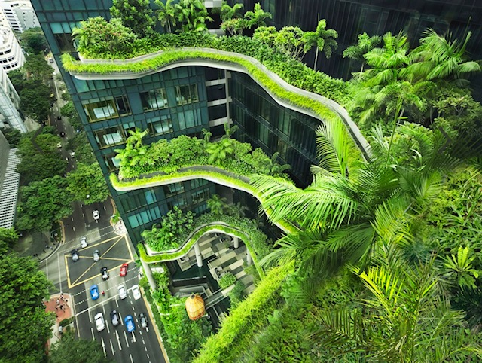
Figure 20: Woha Architects – Parkroyal Collection Pickering, Singapore
“The background behind the form of the building is that we essentially had 2 clients. Liverpool City Council commissioned the building and RCP the fit out. The shell and core of the building needed to comply with some pretty tight metrics around budget (£1850/m2) and achieve 80% net to gross on a typical floor. Effectively making it comparable to any other commercial building.”

This suggests that the Spine lacks an element of integrity within its biophilic aims and supports the argument that it is not as successful as it is claimed to be. A recent article, “The Contradictions of Green Washing in Architecture” suggests similar trends that have occurred with claims made about sustainability. Despite many examples of successful sustainability strategies, the ever-growing topic has become a marketing tool within the construction industry to increase sales and/or justify poor practices (Ghisleni, 2022). The article further expresses the need to eliminate forced marketing, which typically exaggerates or misleads on a vital and topical matter. It is unquestionable that a sufficient and rigorous means of measuring design impact success needs to be implemented to exclude such activity. This has recently been hinted at within the most recent publicised biophilic guidance (Browning and Catherine, 2020). However, guidance or references to what the success measuring strategies are, and how they ought to be implemented is very limited and vague. As previously mentioned, wellbeing effects are subjective and difficult to define as a measure of success. However, the health and physical impacts that certain elements and environments have on individuals provide a more objective means of measurement that need to be explored.

The above briefly outlines various positive and negative aspects of biophilic design regarding the hypothesis and practical application. Due to covid-19, there has not been a post-occupance evaluation done on the Spine. Therefore, many of the issues raised are based on my personal observations of the building. To fully establish the success of the building, it is recommended that a POE is conducted in the near future and thereafter at regular intervals. However, based on the collection of research gathered, this dissertation concludes that biophilic design principles are premature, and many aspects require rigorous thought and adaptations. The questionnaire results suggest a lack of understanding within the architecture profession of what biophilic design consists of. Furthermore, the responses suggest that the profession is not adequately practicing in a way that would successfully implement biophilic design. An example of this is that POE would be key in measuring the effects that the biophilic elements have on the occupants, however, only a mere 21% of respondents stated that they always or mostly carry out a POE on projects. It is also worth noting that the questionnaire revealed that 55% of the respondent stated that biophilic design should not be made mandatory in any capacity. Various respondents who stated this implied that architects should, where necessary, implement biophilic design as a moral, ethical and good standard of practice. With concerns to the negative impacts that climate change may have on indoor environments and humans spending more time indoors and in urban spaces, it could be argued that promotion of good health and wellbeing within design should be included in sub-section Standard 5 – “Consider the wider impact of your work” (2017) of the ARB “The Architects Code: Standards of Professional Conduct and Practice” as a ethical obligation for practicing architects.
However the examination of the scientific evidence highlights the precarious nature of some of the claims that underpin the theoretical basis for biophilic design. Various results deem to be unreliable, and in some cases, misleading. More adequate research must be conducted before further consideration is given to introducing biophilic design as a mandatory design requirement. Premature enforcement may lead to “tick box” exercises that achieve very little. The absence of measurable strategies opens the floodgates for biophilic design to become a false marketing tool, as is seen with greenwashing.

Bibliography: Published Works
Images
Nash, P., 2021. The new Royal Society of Physicians building seen from Brownlow Hill, Liverpool.. [image] Available at: <https://commons.wikimedia.org/wiki/File:The_Spine,_Liverpool_5.jpg> [Accessed 2 February 2022].

Stock Photo, n.d. Beautiful Japanese forest — Stock Photo from Royalty-Free Image Bank. [image] Available at: <https://br.depositphotos.com/portfolio-1719789.html?content=photo> [Accessed 23 March 2022].

BOOKS
Browning, W. and Ryan, C., 2020. Nature Inside - A biophilic design guide. RIBA Publishing.
Browning, W.D., Ryan, C.O., Clancy, J.O. (2014). 14 Patterns of Biophilic Design. New York: Terrapin Bright Green, LLC.
KELLERT, S. R., HEERWAGEN, J., & MADOR, M. 2008. Biophilic design: the theory, science, and practice of bringing buildings to life. Hoboken, N.J., Wiley.
Kellert, S., 2018. Nature By Design: The Practice of Biophilic Design Yale University Press. New Haven & London: Yale University Press.
Özdamar, E. and Tandogan, O., 2021. Emerging approaches in design and new connections with nature. Pennsylvania: IGI Global, pp.202-2244.
Steele, F., 1981. The sense of place. CBI Publishing Company.

WEBSITES
ArchDaily, 2011, "The New York Times Building Lobby Garden / HM White Site Architects + Cornelia Oberlander Architects". Available at: <https://www.archdaily.com/102398/the-new-york-times-building-lobby-garden-hm-white-site-architects-and-cornelia-oberlander-architects> ISSN 0719-8884 (Accessed 17 March 2022)
Arendsen, L., Thakar, A. and Sultan, A., 2019. The Use of Copper as an Antimicrobial Agent in Health Care, Including Obstetrics and Gynecology. [online] Clinical Microbiology Reviews. Available at: <https://journals.asm.org/doi/10.1128/CMR.00125-18> [Accessed 16 January 2022].
ASHRAE, 2018. ASHRAE Position Document on Indoor Air Quality. [online] Ashrae.org. Available at: <https://www.ashrae.org/file%20library/about/position%20documents/pd_indoor-air-quality-2020-07-01.pdf> [Accessed 18 March 2022].
Bond, M., 2017. The hidden ways that architecture affects how you feel. [online] Bbc.com. Available at: <https://www.bbc.com/future/article/20170605-the-psychology-behind-your-citys-design> [Accessed 11 February 2022].
Bored Panda. 2017. NASA Reveals A List Of The Best Air-Cleaning Plants For Your Home. [online] Available at: <https://www.boredpanda.com/best-air-filtering-houseplants-nasa/?utm_source=google&utm_medium=organic&utm_campaign=organic> [Accessed 11 January 2022].
Carroll, E., 2019. What is RIM Weighting? | The Benefits of Weighing Survey Data. [online] Driveresearch.com. Available at: <https://www.driveresearch.com/market-research-company-blog/what-is-rim-weighting/#:~:text=RIM%20weighting%20stands%20for%20Random,%2C%20geography%2C%20income%2C%20etc.> [Accessed 3 March 2022].
Clark, S., 2021. Foundation and History - Foundation of Biophilic Design. [online] biophilia.design. Available at: <https://heptagon-chicken-yj5b.squarespace.com/history> [Accessed 20 March 2022].
Cleave, P., 2020. What Is A Good Survey Response Rate? - SmartSurvey. [online] SmartSurvey. Available at: <https://www.smartsurvey.co.uk/blog/what-is-a-good-survey-response-rate> [Accessed 2 February 2022].
climate-data.org. 2019. Ozark climate: Average Temperature, weather by month, Ozark weather averages - Climate-Data.org. [online] Available at: <https://en.climate-data.org/north-america/united-states-of-america/missouri/ozark-16436/> [Accessed 17 March 2022].
Cooper, C., 2014. What Workers Want From Their Office Space. [online] Greenplantsforgreenbuildings.org. Available at: <https://greenplantsforgreenbuildings.org/wp-content/uploads/2015/08/Human-Spaces-Report-Biophilic-Global_Impact_Biophilic_Design.pdf> [Accessed 08 December 2021].
David Langdon. 2011, "AD Classics: National Library of France / Dominique Perrault Architecture". ArchDaily. Available at <https://www.archdaily.com/103592/ad-classics-national-library-of-france-dominique-perrault-2> ISSN 0719-8884 (Accessed 12 March 2022)
Dennehy, K., 2017. Remembering Stephen Kellert, Who Explored Links Between People and Nature. [online] Yale School of the Environment. Available at: <https://environment.yale.edu/news/article/remembering-stephen-kellert-longtime-professor-of-social-ecology> [Accessed 14 March 2022].
Dictionary.cambridge.org. 2021 Cambridge Dictionary. [online] Available at: <https://dictionary.cambridge.org/dictionary/english/biophilia> [Accessed 2 December 2021].
Equipe ArchDaily Brasil. "Biophilia in Architecture: Nature Indoors and Outdoors" [Biofilia na arquitetura: estratégias naturais em interiores e exteriores] 31 Jan 2021. ArchDaily. (Trans. Duduch, Tarsila) Accessed 05 Jan 2022. <https://www.archdaily.com/955940/biophilia-in-architecture-nature-indoors-and-outdoors> ISSN 0719-8884
Galloway, A., 2018. AD Classics: Thorncrown Chapel / E. Fay Jones. [online] ArchDaily. Available at: <https://www.archdaily.com/533664/ad-classics-thorncrown-chapel-e-fay-jones> [Accessed 12 March 2022].
Ghisleni, C., 2022. 50 Shades of Green: The Contradictions of Greenwashing in Architecture. [online] ArchDaily. Available at: <https://www.archdaily.com/978874/50-shades-of-green-the-contradictions-of-greenwashing-in-architecture> [Accessed 26 March 2022].
Gitlin, J., n.d. Survey data cleaning: 7 things to check before you start your analysis. [online] SurveyMonkey.com. Available at: <https://www.surveymonkey.co.uk/curiosity/survey-data-cleaning-7-things-to-check-before-you-start-your-analysis/#:~:text=Survey%20data%20cleaning%20involves%20identifying,t%20answer%20your%20questions%20thoughtfully.> [Accessed 3 March 2022].
Gray, A., 2020. What You Need to Know About Off-Gassing. [online] Architectural Digest. Available at: <https://www.architecturaldigest.com/story/what-is-off-gassing> [Accessed 14 March 2022].
Heaven, D., 2017. Medicine Nobel for scientists who unpicked our body clocks | New Scientist. [online] Newscientist.com. Available at: <https://www.newscientist.com/article/2149097-medicine-nobel-for-scientists-who-unpicked-our-body-clocks/> [Accessed 14 February 2022].
International WELL Building Institute (2019) WELL Certified. Available at: https://www.wellcertified.com/certification/v2/ (Accessed 22 November 2021)
Kellert, S., 2008. Nature By Design - The Practice of Biophilic Design. New Haven, CT: Yale University Press, pp.1-3
Kellert, S., 2015. What Is and Is Not Biophilic Design?. [online] Metropolis. Available at: <https://metropolismag.com/viewpoints/what-is-and-is-not-biophilic-design/> [Accessed 4 December 2021].
Lewis, T., 2021. Air Filter Guide: What MERV Rating Should You Use? | HVAC Training Shop. [online] HVAC Training Shop. Available at: <https://hvactrainingshop.com/what-merv-rating-should-you-use/> [Accessed 18 February 2022].
Lichtenfeld, S., Elliot, A., Maier, M. and Pekrun, R., 2012. Fertile Green: Green Facilitates Creative Performance. [online] researchgate.net. Available at: <https://www.researchgate.net/publication/221715804_Fertile_Green_Green_Facilitates_Creative_Performance#:~:text=cognition%20and%20behavior.-,Lichtenfeld%20et%20al.,the%20authors%20held.%20...> [Accessed 22 March 2022].
pbctoday. 2021. Liverpool Mayor officially opens ‘The Spine’. [online] Available at: <https://www.pbctoday.co.uk/news/planning-construction-news/the-spine-liverpool/93914/> [Accessed 15 December 2021].
Perrault, D., 1994. National Library of France – Arch Journey. [online] Archjourney.org. Available at: <https://archjourney.org/projects/national-library-of-france/> [Accessed 12 March 2022].
Review of Architects Competences, . 2020. Available at: <https://arb.org.uk/wp-content/uploads/Architects-Survey-Analysis-Paper.pdf> [Accessed 20 February 2022].
Salutogenic Approach to Wellness, 2021. Salutogenic Approach to Wellness. [online] Physiopedia. Available at: <https://www.physio-pedia.com/Salutogenic_Approach_to_Wellness> (Accessed 24 March 2022).
Schütz, M., n.d. Building Biology Course IBN – buildingbiology.com. [online] buildingbiology.com. Available at: <https://buildingbiology.com/building-biology-course/?gclid=Cj0KCQjw_4-SBhCgARIsAAlegrXatGZUoC2jrDZRcNoSG956b4uoFoI65sd2JB2S976OYbyL4jd3G4saAmoIEALw_wcB> [Accessed 14 March 2022].
Science for Environment Policy, 2021. The solution is in nature. Future Brief 24. Science for Environment Policy. Available at: <https://ec.europa.eu/environment/integration/research/newsalert/pdf/issue-24-2021-02-the-solution-is-in-nature.pdf> [Accessed 4 January 2022]
Söderlund, J., 2015. Biophilic Design: A Social Movement Journey. [online] Espace.curtin.edu.au. Available at: <https://espace.curtin.edu.au/bitstream/handle/20.500.11937/2015/240085_Soderlund%202016.pdf?sequence=2&isAllowed=y> [Accessed 20 March 2022].
Tsunetsugu, Y., Miyazaki, Y. and Sato, H., 2006. Physiological effects in humans induced by the visual stimulation of room interiors with different wood quantities. [online] Jwoodscience.springeropen.com. Available at: <https://jwoodscience.springeropen.com/track/pdf/10.1007/s10086-006-0812-5.pdf> [Accessed 21 March 2022].
Wen, Y., Yan, Q., Pan, Y. et al. 2019 Medical empirical research on forest bathing (Shinrin-yoku): a systematic review. Environ Health, Available at: https://doi.org/10.1186/s12199-019-0822-8 (Accessed 12 December 2021)
Williams, F., 2019. Maggie’s Cardiff by Dow Jones: an oasis of Douglas fir-lined solace. [online] The Architects’ Journal. Available at: <https://www.architectsjournal.co.uk/buildings/maggies-cardiff-by-dow-jones-an-oasis-of-douglas-fir-lined-solace> [Accessed 15 March 2022].
Wilson, A., 2006. Biophilia in Practice: Buildings that Connect People with Nature. [online] BuildingGreen. Available at: <https://www.buildinggreen.com/feature/biophilia-practice-buildings-connect-people-nature> [Accessed 7 December 2021].
World Health Organization. 2021, Roadmap to improve and ensure good indoor ventilation in the context of COVID-19. Geneva: Available at: https://apps.who.int/iris/rest/bitstreams/1333991/retrieve (Accessed 12 March 2022)
Yannick, J., 2015. Nature and I are two. [online] researchgate.net. Available at: <https://www.researchgate.net/publication/233564277_'Nature_and_I_are_Two'_A_Critical_Examination_of_the_Biophilia_Hypothesis> [Accessed 7 February 2022].

Barton, J. & J. Pretty (2010). What Is the Best Dose of Nature and Green Exercise for Improving Mental Health. Environmental Science & Technology
Berto. R . 2005 – “The Cognitive Benefits of Interacting With Nature”
Alvarsson, J., S. Wiens & M. Nilsson (2010). Stress Recovery during Exposure to Nature Sound and Environmental Noise. International Journal of Environmental Research and Public Health,

Bibliography: Unpublished Works
INTERVIEWS
Badulla, T., 2022. The Mechanical systems of the Spine, Liverpool, Interview by author, 28 January
Edge, S., 2022. The Role of A Biophilic Consultant - Spine, Liverpool, Interview by author, 14 January
Hopkins, R., 2021. I visited the Spine, Liverpool, Conversation between Robert Hopkins and author, 07 December

- Health & Wellbeing – 8 / 46
- Lists of design principles ( Light, ventilation and materials) – 5 / 46
- Connectivity with nature – 30 / 46
- Nature – 16 / 46

- Legislation and Policy – 30 times
- Good design/ ethical practice by architects – 23 times
- Cost/ Financial incentives – 16 times
- Sustainability/ climate – 10 times
- Education – 6 times
- The Grenfell fire – 4 times
- Pandemics – 1 time

Appendices
Appendix A: Terrapin Bright Green’s 14 Patterns of Biophilic Design

Appendix B: Additional Case Study Examinations

Case Study 3
Alvarsson. J, 2010 - Recovery during Exposure to Nature Sound and Environmental Noise
The study aimed to test whether auditory stimulation affected human functions and recovery. The study claims that nature sounds facilitate a 9-37% faster recovery rate than those of noises resembling an urban environment.
Methodology
24 women and 18 men university students with a mean age of 27 participated in the experiment. To ensure accuracy, all participants had hearing thresholds lower than 25 dB.
There were three different parts of the experiment:
“(1) One 5-min quiet baseline period, (2) five 2-min periods of testing (“stressor”), and (3) four 4-min periods of relaxation (“recovery”) during exposure to one of four experimental sounds.”
The baseline period provided baseline results that would later be used to compare with the other stages of the experiment.
The stressor was a fast mental arithmetic task known as a stress test. This consisted of the participants having three seconds a turn to identify whether a mathematical equation displayed on the screen was correct or not. Their responses were evaluated as either “correct”, “false” or “too late”.
The sounds for the experiment were chosen from a large database. It is worth noting that the selected four noises were not chosen randomly. The “nature” noise was specifically chosen to be “more pleasant than the three noises, including the ambient noise of lower sound pressure level”. This raises a question about the experiment's reliability from the outset as the nature noise was manipulated to perceive a positive noise and the urban noises represented more negative noises. It is worth noting here that noises from nature can differ significantly with various noises causing positive and negative effects and responses on people. The four sounds used in the experiment are listed below:
“ 1.Nature sound. A mixture of sounds from a fountain and tweeting birds. The average sound pressure level was set to 50 dB.
2.High noise. Road traffic noise recorded close to a densely trafficked road. The average sound pressure level was set to 80 dB .
3.Low noise. The same noise as (2), but set to a lower average sound pressure level, 50 dB.
4.Ambient noise. A recording from a quiet backyard, with a constant low level ambient noise, mainly caused by ventilation systems of the buildings surrounding the yard. The average sound pressure level was set to 40 dB.”
Measurements
The autonomic nervous system controls various human body functions: activation and mobalisation are controlled by the sympathetic branch, and the parasympathetic branch controls restoration and relaxation. Sympathetic activity can be indexed by skin conductance level (SCL), and parasympathetic activity can be indexed by frequency of heart rate variability (HRV). Therefore these two were used as measuring points for physiological stress. Physiological recovery is associated with SCL decreasing and the frequency of HRV increasing. Devices were fitted to the participants to take readings and collect data throughout the experiment.
Results
HRV: The average results from the HRV were not higher for the nature sound than any of the other three sounds, and HF HRV for the high noise was not significantly lower than any other sound. For this, neither sound had a significant effect on the participants' HRV.
SCL: Immediately after the stressor, the SCL readings were similar and then as the time period went on recovery was faster during exposure to the nature sound, the ambient and low noise was second fastest, and high noise equated to the slowest recovery.
(t-tests) comparison of the data concluded that the differences between nature, ambient and low noise conditions did not reach significance. However, the difference between nature and high noise did reach significance. It was deemed that the significant difference equated to a half-life SCL recovery of 9−37% faster during the nature sound. It is worth noting that the average slowest recovery time was 160s, which may be deemed significant in a controlled laboratory environment, however, it is not a significant period of time from a holistic real-life scenario.
In conclusion, many aspects of the above experiment, such as the data collection process and the calculations used to interpret the significance of the results, were done in accordance with scientific standard practice. However, with consideration to the significance of the use of the case study as evidence to back up the implementation of patterns within the TBG 14 patterns, It could be argued that other aspects of the experiment are questionable.
Firstly the participant pool size only included 42 participants from a mean age of 27. This pool size is arguably too small to provide reliable data and only represents a younger age group. Further, all participants were situated in the same university location. A wider pool of participants from mixed locations such
as rural areas and bustling cities may have provided a more comprehensive range of responses, and for example, a person who was born and lived in a city for all of their life may prefer and recover quicker to an urban sound.
Secondly, TBG’s 14 patterns document states that “…nature sounds, when compared to urban or office noise, accelerates physiological and psychological restoration…”. This statement suggests that multiples nature sounds were used, whereby only one sound was experimented. Further, the statement implies that the nature sound dramatically affects human physiological and psychological restoration. In reality, the experiment only concluded that only one of two recovery responses were significantly affected in one set of data (nature sound v high urban noise). This demonstrates that the experiment results were not as significant as the claims made suggest.
Lastly, as previously discussed, the four sounds used were specifically chosen so that the nature sound was a positive sound. The experiment may have provided better results by including a wider pool of sounds, with some sounds representing positive and negative natural and urban noises. It would further be interesting for future experiments to be conducted in different real-life settings, such as an office environment, for prolonged periods of time. Such experiments may identify that various sounds are preferred in different environments/ during different activities.
For the above reasons, this examination concludes that this case study does not successfully provide enough reliable and accurate array of results to use as a significant basis of evidence for the TBG 14 patterns.
(All analysis and information was obtained from the document referenced in the title above - Alvarsson. J, 2010 )

Case Study 4
Berto. R . 2005 – “The Cognitive Benefits of Interacting With Nature” - (evidence used as part of Kaplan’s Attention Restorative Theory (1995) which features numerous times throughout TBG’s 14 patterns of biophilic design)
Kaplan’s attention restorative theory (ART) is widely used in the TBG’s 14 patterns of biophilic design as a positive effect that biophilic design has on human health, wellbeing, and functionality in a space. Attention restoration theory (ART) is a cognitive framework concerning recovery from mental fatigue or directed attention fatigue (DAF).
This particular experiment evaluated what environments are best for restorative attention performance. Firstly, participants were mentally fatigued by performing a sustained attention test, then they were exposed to images of restorative or nonrestorative environments, and then performed the sustained attention test for a second time. This was carried out in a controlled laboratory environment using digital screens.
Considering that ART and other literature suggest that human capacity to direct attention can be renewed most effectively by contact with nature, the performance of participants exposed to images of natural restorative environments was expected to be better than the other group's performance.
Two experiments were conducted with identical procedures. The only difference between both experiments was the images shown. Experiment 1 used 25 images of natural environments and 25 urban images. Experiment 2 merely used images with various patterns (in biophilic design terms, these patterns represent informal shapes and patterns seen in nature). Also, the participants were different with a differing sample size (as discussed below)
Each participant was exposed to the images for 25 seconds per image.
The results of experiments 1 and 2 are limited due to a small sample size of 32 participants. They ranged of an equal amount of males and females. However, the mean participant age of 23 years old does not represent a large range of population ages.
Experiment 1 investigated the impact of restorative environments on the performance of an attention task. This experiment found that the participants exposed to restorative environments (natural scenery e.g lakes, trees etc) had a faster response time during the experiment compared to participants exposed to nonrestorative environments (man-made objects e.g cars and walls). In experiment 2, 32 different participants (again with a mean age of 23) were exposed to geometrical environments that did not include restorative or nonrestorative sceneries. The study concluded that when participants were exposed to geometrical patterns and mainly nonrestrictive environments, they did not affect the attention system and therefore did not restore participants' mental fatigue as well as the restorative group. This is particularly interesting regarding the result of experiment 2 as the TBG 14 patterns of biophilc design documents claims that: “Biomorphic Forms & Patterns… reduced stress due to induced shift in focus, and enhanced concentration”. Although this experiment does not conclude that various patterns negatively affect human cognitive and restoration functions, the experiment does conclude that the results collected do not indicate a significant improvement as a result of looking at the patterns.
In experiment 1 the participants were exposed to the task in 2 different sessions. The results of both sessions concluded that d-primes, reaction times and the number of correct responses were statistically significant in agreeing with the study’s hypothesis that nature scenes would be restorative and result in improved performance. The nonrestorative group did not yield these same significant results. However, the study did find there was a statistically significant difference in the nonrestorative group’s incorrect responses. This was deemed insignificant by the authors but it may suggest a learning curve to the experiment and it may suggest that the nonrestorative environments presented to the participants did not offer enough distraction to affect the results. When considering the results of experiments 1 and 2, the mean reaction time and correct responses were significantly worse in the restorative groups performance in session 1 compared to the results of session 2. This may also be due to a learning effect of the experiment for this group, or it may suggest the restorative environments distracted the participants more in session one and did not distract and have as much of an effect in session 2. This may negatively impact some environments, such as highly productive offices whereby the nature view may distract and relax the workers, negatively impacting productivity. However, this is just a speculative observation. This observation, however, demonstrates and emphasizes the extent of consideration needed within experiments to provide reliable and conclusive evidence.
As previously explained, the sample size of the study was small, and therefore the reliability of the results is questionable. The difference in results of reaction time and correct responses in the restorative group in sessions 1 and 2, as discussed above, may present a negative impact as it shows that restorative environments may initially negatively distract people and affect their performance. It is also difficult to comprehend the practicality of implementing results from such experiments, which are conducted in controlled environments using static 2D images as a representative of real-life situations whereby there are multiple factors to consider.

(All analysis and information was obtained from the document referenced in the title above - Berto. R . 2005)

Case Study 5
Barton & Pretty, 2010 - What is the Best Dose of Natureand Green Exercise for Improving Mental Health?

The TBG 14 Patterns of Biophilic Design states, “Positive impact on mood and self-esteem has also been shown to occur most significantly in the first five minutes of experiencing nature, such as through exercise within a green space”.
The principles aim of this study was to assess the best regime exposure to green exercise required to improve self-esteem and mood (both of which can be easily influenced in a short period of time but can have substantial long-term health effects on humans). The experiment was broken down into four key elements of research, with the following forming the basis for the research:
“… physical activities (duration and intensity), types of green places, and participant characteristics (age, sex, health status): 1. How does exercise duration affect self-esteem and mood?; 2. How does exercise intensity affect self-esteem and mood?; 3. How do different green habitats (e.g., urban green space, countryside, water-side, wilderness, woodlands) affect self-esteem and mood? 4. What are the measurable differences according to selected participant characteristics (e.g., children, adult, elderly ,female, male)”
A standardised meta-analysis method was used to assess the impact that each environment and exercise level had on self-esteem and mood.
1,252 participants self-volunteered to participate in the study. Although there are no specific breakdowns on the participant age, sex, etc, further discussion reveals that the sample mixture was reasonably diverse. Briefly, the study consisted of 6 groups that were exposed to various environments ranging from green spaces, green spaces with water, urban spaces and urban spaces with water. Each group was exposed to each environment for 5, half a day and a full day with varying low-intensity exercise activities. The participants were asked a series of questions to determine the effects on their mood and self-esteem.
Results
The results showed that acute short-term exposures (5 minutes) to facilitated green exercise improve self-esteem and mood across all categories intensity, location, gender, age, and health status. Both mood and self-esteem showed minor positive improvements from and between 10minutes, 1 hour and half-day activities, but then both increased for whole-day activities. This demonstrates that a short change in scenery or environment has a bigger impact. The study also found a significant difference in mood and esteem with low intensive activities providing the most positive results. All types of green space (either rural or urban) improved both self-esteem and mood. However, it was noted that the presence of water in both green space environments generated the most significant improvements, providing the optimal benefits to conduct activities in.
To conclude, the evidence provided in this case study appears to be based on a relitivly strong methodology. There was a relatively large participant group with a diverse range of people. Various duration of exposure to the differing environments provided an insight into the level of exposure that may be optimal to human activity. However, analysis of the study revealed that the environments that were used within the experiment were not clearly defined or described in detail. For example, the mere description used was “farmland, woodlands, urban garden, waterside habitats…”.
Although it is positive that the experiment was conducted in a real-life environment (as opposed to a control lab environment), the lack of description of these environments does not give any insight into what these “optimum” green spaces consist. This study could arguably be made stronger or further established by providing data on the long-term effects of being exposed to green environments. For example, how long does the positive effect on mood continue after leaving the green space? Moreover, does the duration spent in the green environment affect this result? Such further research would provide a stronger case for planners and architects to justify the inclusion of or better direct access to green spaces for building occupants. An example of this would be, designing an office with access to a green space courtyard allows workers to have short-term exposure to the green space and carry out light exercise activities in intervals during work time.
(All analysis and information was obtained from the document referenced in the title above - Barton & Pretty, 2010)

Appendix C: The Spine – Notes taken from the visit

Appendix D: Interview – Stephen Edge (Biophilic Consultant)

Appendix E: Interview – T B (BDP Mechanical Engineer Designer)

Appendix F: Questionnaire sent out to Architects
Primary Questions
Question 1- Are you familiar with Biophilic design? Yes/ No

Question 2- Briefly, What is your interpretation of Biophilic design?

Question 3- Have you or your practice worked to BREEAM, WELL Standard or LEED Standards? Yes / No
Q 3 (a)- If yes, could you please briefly elaborate e.g What standard? What was the project? Who was the main driver for implementing that standard, you or the client etc?
Q 3 (b)- If not, could you elaborate on why you have not worked to any of the standards e.g Cost? Lack of awareness? Lack of demand?

Question 4- With consideration to many pros and cons such as cost, ethics, safety (e.g combustible material regulations), Well-being, maintenance plans etc... Should biophilic design principles be included in planning policy requirements and/or be made mandatory as a standard within Building Regulations?

Further Optional Questions:
Question 5- Do you or your practice carry out post-occupancy evaluations?
Answer - Every Project / Majority of projects / Minority of projects / Never
(Could you briefly explain why?)

Question 6- Do you or your practice create maintenance plans as part of your design strategy/ client services?
Answer- Every Project / Majority of projects / Minority of projects / Never
(Could you briefly explain why?)

Question 7- In your opinion, what methods/ approaches drive change within the architecture and built industry?

(Any further comments or research recommendations would be much appreciated too).

Appendix G: Questionnaire Responses
(1)- Responses of Questions 1-4
Resp-onse  Num-ber | Biophilic Design - Awareness & Interpritation |  | Practice - Standards, Maintenance & Post Occupancy Evaluations |  |  | Key drivers for change - Policy, Legislation, Ethics etc
Resp-onse  Num-ber | Are you familiar with Biophlic Design? Y/N | Interpretation of Biophilic Design |  | Have you or your practice worked to BREEAM, WELL Standard or LEED Standards? |  | Should biophilic design principles be included in planning policy requirements and/or be made mandatory as a standard within Building Regulations?
Resp-onse  Num-ber | Are you familiar with Biophlic Design? Y/N |  |  | Yes | No
1 | Yes | The design of buildings and places that maximise the contact of people with the natural environment — including access to daylight and sunlight, using natural ventilation wherever possible, access to planting (both indoor and outdoor)  and specifying building materials that have minimal environmental impact.(2)(5) |  | Yes. The project was a new architecture studio building (constructed in two stages nearly ten years apart) for the University of the West of England. I was not the designer but part of the client team, as academic leader for the architecture courses. The first phase was designed by White Design and the second by Stride Treglown. The main driver for using BREEAM was the university senior management who felt it important in promotion of their green credentials, gaining planning approval and securing funding. I personally was (and am) strongly committed to building in the most environmentally responsible manner possible but also quite critical of BREEAM which (especially in the second phase of the project) required us to include some elements that had little or no real environment benefit at very significant cost — just to get the points to push us up to an ‘excellent&#39; score. I found the whole process to overly bureaucratic and intellectually flawed. BREEAM has invented a scoring system that gives a spurious sense of accuracy by giving simple numerical scores to complex, nuanced decisions —like comparing apples, oranges, ball bearings and footballs by measuring weight and diameter alone. I have no personal experience of LEED or WELL. I remain sceptical about the value of all such measures — although I recognise that they may have some positive effect in encouraging designers, clients and funders to take these matters more seriously. (1) |  | This is a difficult question. I want to answer ‘yes’ but I don’t believe that simply adding requirements to planning policy and building regulations is going to be  effective. I think both planning and building regulations are in a real mess and need fundamental reform. Planning policies refer a great deal to ‘sustainability’ but overall have little positive effect on the sustainability of what is actually built and some policies are actively negative. Planners seem to do very little actual planning —it’s all about ‘development management’. Building regulations are over-complex and weak and the privatisation of building control is a disaster.
2 | No | N/A |  |  | No. Combination of all of those reasons - Too costly, Lack of awareness, Lack of demand. (1) (2) | No Should be a recommendation backed up by informative literature not mandatory
3 | Yes | Design to maximise connection with Nature, both visually and through other senses (2) |  |  | No. I am a sole practitioner and specialise in residential properties, generally private clients, so never directly involved in BREEAM which is applied to non residential properties.  I did come across it when working on SAPs for larger projects, for example conversion  of a hospital in Bristol which planning stipulated that had to comply with BREEAM for refurbishment projects.  I would say that almost all my clients work to the minimum standard required either by  Planning or Building Regulations because of cost (1) | YES  But also need to re-think how Building regs are enforced- should not be privatised- should be national government inspectors with teeth!
4 | No | N/A
5 | Yes | Biophilic design is generally predicated on enriching the experience for the users, in this case of a given building, through its close connection to nature both internally and externally (2) |  | YES -- £3.75million new-build retail development: BREEAM Very Good was consider to be the minimum requirement re sustainability as set out in the Employer’s Requirements out of deference to the tenant’s request. Typically this is predicated on achieving a standard of sustainability that accords with the tenant’s corporate stance on environmental issues. (1) | No. In instances where a standard such as BREEAM is not requested, this is usually due to a lack of awareness on the part of inexperienced clients or that the scale of the project does not call for such rigour in its approach. For more experienced or larger clients, typically there is a presumption of a cost associated with achieving a specific BREEAM rating such that it does not often form part of the brief. (1)(2)(3) | Given the greater focus on mental health, both at home and at work (which have increasingly become the same thing), there is much to recommend biophilic design as a part of building standard for wellness within the built environment. While I think it would be beneficial to include biophilic design principles in the building regulations as part of a healthy buildings/wellness in building approved document, I would suggest that a standard of best practice for biophilic design would be more likely, occupying a similar position to Passivhaus which is held up as an exemplar and behind which Building Regulations falls short of. Yes
6 | Yes | It’s not something that has influenced or informed my career to date. For me the subject covers how the built environment can (and should) embrace nature. For me its how the internal environment compliments the internal response. There are a number of examples where this has been realised without directly referencing the subject such as: -  Woodland Crematorium, Stockholm  Burrell Collection, Glasgow  Otaniemi Chapel, Helsinki  However, the principles are only as good as the building sponsor, developer or client. (1) |  | Yes. BREEAM - It depends on the project type however I have applied this to both the Education and Healthcare sectors. Generally, refurbishment projects have required a BREEAM ‘Very Good’ rating while new build projects require BREEAM ‘Excellent’. In the most part this has been informed by Central and Local Government funding. Similarly, private developers demand BREEAM credentials as a requirement of funding streams. In other parts of the country, certainly in Wales, there is a requirement to achieve BREEAM credentials as a planning requirement. Latterly though, Net Zero Carbon has played a bigger part in building design and would achieve BREEAM ‘Excellent’ by default. Historically, I have been involved in adopting the Code for Sustainable Homes in the residential sector. (1) |  | No; how would this be regulated when there are so many competing forces. Similarly, how would this be measured or differentiated in a dense urban environment compared to that of a rural environment. There’s a lot of virtue in greening the city as a concept and the unrealised Garden Bridge design by Thomas Heatherwick was a lost opportunity.
7 | Yes | Encouraging the well-being of a  buildings occupants through the use of materials, patterns and methods which stimulate  or evoke a connection with nature (2) (4) |  |  | No. A lack of demand and the type of buildings  and clients that I work with (2) | No I think it is a worthy aim but suspect that it will lead to token measures rather than meaningful changes to design similar to the current requirement to include biodiversity enhancements at planning stage. (These are satisfied by nailing a bird-box on your project)
8 | No | N/A |  | Yes. We have designed and administered the construction of several buildings that were required to achieve BREEAM very Good or Excellent. This was a requirement of the funding. From memory we have delivered BREEAM on schemes for the former Coleg Morgannwg, Bridgend and NPT Colleges.  We are currently involved with the construction of two new large facilities within NPT that require a BREEAM score. The BREEAM rating is a condition of the sale of the land by Welsh Government.(1) |  | No Wikipedia - Biophilic design is considered young, as it has not been implemented in modern building projects for a long period of time. Because of this, there has been little research that explores the long-term challenges, negatives, and even benefits of biophilia in buildings and cities.[20] Other concerns are the initial and maintenance costs of projects that implement expensive biophilic design principles.[21] This could be due to the lack of research that was discussed above, as there is little information regarding payback periods for investors. Another issue could be the prices for the technology needed, however this should eventually lower as the concept becomes more commonplace.
9 | Yes | N/A |  |  |  | Yes
10 | Yes | Using shapes, forms or colours that are inspired by nature, or other design techniques to bring us closer to nature (1) (2) |  | Yes. BREEAM Good  Client accepted use of standard after pressure from planning department in local authority (1) |  | No
11 | No | N/A |  |  |  | No
12 | Yes | Increasing building  occupants’ connection to nature and the outdoors and creating spaces and places which  will enhance the lives of those interacting with the building and its surroundings. (2) |  | Yes -  BREEAM. A library, archive and community building. Lottery funding required BREEAM  Excellent to be achieved.(1) |  | Yes I feel that it should certainly be mentioned in Policies and  very much encouraged. I think that it might be difficult to make it mandatory.  Awareness certainly needs to be heightened. One could argue however that this is something all Architects should be integrating into their designs already.
14 | Yes | The natural world and man-made constructed world are fully integrated and act inter-dependently. (1) |  | Yes BREAM and LEED standards but not WELL standard. (1) (2)
15 | Yes | The internal and external landscape are in harmony due to the use of vegetation/greenery inside the building.(2) |  |  | No | No, I don't feel this should be part of the Building Regulations. There are already numerous costly elements that have a negative financial impact on development through the Building Regulations. This would add to the cost burden on developers.
16 | Yes | Connectivity to nature (in  buildings) (2) |  | Yes. BREEAM  Excellent as a funding requirement (1) |  | Yes - if architects are given proper training
17 | No | N/A |  |  | no - Cost, Lack of awareness, Lack of demand (1) (2) (3) | No
18 | No | N/A |  | Yes - BREEAM - (1)
19 | No | N/A |  |  | NO - cost, lack of client demand (1) (2)
20 | Yes | Bringing nature into the design, blurring the boundary between inside and out (1) (2) |  | Yes, for analysis of sustainability (1) |  | No it shouldn't. Particularly in planning where the views of the planning officer can sometimes go beyond the legislation, I think this could open up more scope for interference.
21 | Yes | Design that incorporate  the multisensory benefits of nature. (1) |  | Yes. All our school designs developed and built over the past 20 years have achieved BREEAM Excellent, in part because it was a requirement of the funding from Wales Government as part of their 21st Century school programme. (1) |  | No It would be nice but not an essential requirement. A  presumption in favour of biophilic design might be the best approach to encourage biophilic designs wherever it is appropriate.
22 | No | Never heard of it
23 | No | I have never heard of it |  | Yes. Dimentia Care Unit Who was the main driver for implementing that standard, you or the client etc? Energy assessor in order to meet Building Regulations (1) |  | No - not sure
24 | Yes | N/A
25 | Yes | Bringing nature into the building. (1) |  |  | No. Although I’ve used BREEAM on projects in larger practices, I am currently with a small practice that doesn’t apply these principles in a formal way – we do, however, consider sustainability from design inception through to realisation of a build. (4) | yes Regulations and legislation
26 | Yes | Internal nature spaces (1) |  | Yes - BREEAM - it was  mandatory and often a planning condition (1) | We don’t do it anymore because it is no  longer “required” (2) | No That is very difficult indeed. The only clients who might be  interested are owner occupiers developing their own buildings. That could be interpreted widely but won’t cover everybody. Or every project, many of which are speculative
27 | No | N/A |  | Yes. BREEAM - These are standard now and I think most  large project and smaller ones will be governed by them (1) |  | Yes It’s a good idea I think, there are plenty of new build  projects where this would be of great benefit
28 | Yes | Enabling nature in such a  way as to generate a symbiotic relationship between the natural world and human kind  in such a way as to reverse the decline in biodiversity and improve human well-being. (1) (2) (4) |  | Yes. We work to BREEAM and other similar standards extensively, including the now defunct CfSH, GLA standards and so on. We also apply the RIBA 2030 Challenge to all projects. (1) |  | Yes
29 | No | N/A |  | Yes. We work to BREEAM standards across many of our projects at varying levels from Good,  V.Good to Excellent. This is driven by a number of drivers from Local Authority / Planning  requirements or client aspirations or a mix of these factors.  We also regularly work to Happi guidance as well. (1) |  | No Probably not, as the issue would be open to too much interpretation as to how they are adopted and the approach taken. However it could potentially by another area focused on to either improve the BREEAM scoring, or as a design guidance set of measures for planning? It probably also depends on the type pf building. As a practice we deal mainly within the  Care Sector where this is important as it contributes significantly to resident’s well-being. However with Design &amp; Build Contracts the landscaping and additional elements can often get watered down due to budgetary constraints.
30 | Yes | bringing the natural environment indoors via design to promote well being (2) |  | Yes. The Dept had worked an Education scheme to BREEAM standard, reason unsure. A recent 3 storey Primary School was designed to BREEAM standard as required by the grant funding it will be built to. (1) |  | No it would be difficult to capture in legislation as not all aspects could be satisfactorily measured, benchmarked..  Some aspects were already accepted into legislation as Sustainable Drainage etc, ie promoting diverse habitats, etc
31 | Yes | An affinity with the natural world, used to indirectly or directly connect built space with the natural world (2) |  | Yes. As part of a University build as part of doctoral programme which achieved an ‘Excellent’ rating (1) |  | Yes Perhaps part of an overall sustainability address
32 | No | N/A |  | Yes. Generally, Breeam Very Good or Excellent – usually client or investor driven (1) |  | No Certainly not – biophilic design is about good architecture that exploits the opportunities that a project and its site offer. This is about our skills as designers and rules and regulations will more than likely be counterproductive. I cant see how you could legislate tor flair, imagination and creativity…..
33 | Yes | Human contact with nature within building design – trees, plants, natural light / ventilation / materials / colours / views (2) (5) |  | Yes  3a. Breeam – numerous healthcare projects over past 20 years – mandatory requirement for NHS funding (1) |  | Yes – planning policy & building regulations
34 | Yes | Connection with the environment outside – bringing the environment into the building (2) |  | Yes. Several BREEAM, very good and excellent syandards, schools, visitor centres, offices. We also work on Passivhaus projects. Have not heard of WELL or LEED. |  | No. There are enough requirements to comply with at present and it will be difficult to implement in all planning applications – a new shop front in a city centre for example or a building type for which it is totally inappropriate. I would rather see it done well on fewer projects than badly on every one!  Building regs is about health and protection. I don’t think it sits well within B. regs
35 | Yes | Creating spaces that are more in tune with nature that imitate or create a natural environment. (2) |  |  | No | Yes I think it would be the way forward to include biophilic design as a statutory requirement particularly where it would enhance a buildings carbon footprint.
36 | No | N/A |  |  | No | No, I don't think it is important or relevant to EVERY building.
37 | Yes | Biophilic design is achieved when architecture and the natural environment are fully integrated. It has to be embedded within the concept for the building.(2) |  | Yes. Most frequently BREEAM. Occasionally WELL (1) (3) |  | Yes - If it were you need to consider how it would be measured as there are many different ways of achieving Biophilic design
38 | Yes | It’s the way that a building operates and exists using core principles exhibited by  nature (1) |  | In the past, yes – LEED used on an international project in the middle east. International client was keen to use it for its international recognition. (2) |  | No – incredibly hard to make any requirements prescriptive – biophilia should be incorporated within projects on a holistic basis and not a ‘tickbox’ basis which often is what is used for minimum standards in BREEAM and LEED schemes.
39 | Yes | Incorporation of nature into design. (1) |  | Yes - Breeam – Warehouse project at Easlea Road, Bury St Edmunds, Planning requirement I think (cannot recollect). (1) |  | No Hesitate to say or understand quite how to provide a framework for these, these aspects likely present in good architecture?
40 | Yes | The incorporation of green spaces and organic life either within the liminal or communal spaces of  buildings, or incorporated into the external design aesthetic with an aim to improving human  experience, wellbeing and breathable air quality, alongside providing habitats to improve biodiversity.(4) (1) (5) |  |  | No - In professional practice as a Building Surveyor biophilic design considerations beyond the organic elements in the grounds of a development or potted plants indoors largely fall beyond the budget and scope of the leaseholders concerns and retrofitting for this design would likely be prohibitive in terms of cost in relation to the perceived benefits. (1) (2) | Yes. Including biophilic design would improve wellbeing and air quality which would lead to arguably intangible benefits – I believe it is an investment in supporting long term sustainability and combating climate change alongside improvements in overall mental and physical health in environments where pollution and stress levels are equally elevated.
41 | Yes | The use of naturally derived materials, forms, colours or sounds in built form (1) |  | Yes - practice for WELL and LEED. Numerous projects to BREEAM standard, Excellent or Very Good. Well Platinum in Manchester. Others to comment. BREEAM: Usually client-driven as it allows them to use the results for marketing/obtaining funding. Projects funded by central govt or EU have a requirement (1) (2) (3) |  | No - It should perhaps be included in BREEAM for wellbeing credits
42 | yes | Biophilic design is a concept that incorporates nature into the built environment. The aim is to connect occupants with nature in order to enhance their physical and emotional wellbeing. (4) (2) |  | Yes - WELL, Collaboration Hub on a school campus. I am the main driver. (1) |  | Yes
43 | Yes | Using the natural benefits of green/vegetation in design, to make an acutal or perceived connection to nature, for positive, healthier buildings. (2) (4) |  | Yes - BREEAM - Mainly BREEAM (excellent or outstanding (sometimes aspiration), sometime planning or funding requirement. (1) |  | No - It depends on the building, I think it should be more driven by the clients as their would be different need/approach in different buildings.
44 | Yes | From the perspective of the built environment, it is about the links and affinity that humans have with nature (or should reintroduce). It is how nature or a reconnection with nature it the broadest terms can have a positive impact on sociological, psychological, and physiological wellbeing, though this needs to be a mutual relationship with nature and its resources. At an urban level I guess that  it is about designing resilient communities that are better aligned with natural systems and where lessons from nature can be reintroduced into the lifestyles of humans in a sustainable way. Taking lessons and ideas/concepts from nature in the sense of biomimicry etc.(2) |  | Yes. I’ve worked on numerous projects where BREEAM has been implemented, but have not used the WELL and LEED standards. The projects have been in Wales and so it has always been with a view to achieving BREEAM Excellent or Outstanding, or on refurbishment projects, or projects in the historic environment, BREEAM Very Good has been the target.  · I’ve worked on a new Police Station Project that achieved Very Good (was not higher as some consultation sections could not be realised, it was in a relatively rural location and Home Office Standards at the time, also limited full implementation of sustainability principles which would now be more readily realised. Various mew schools where BREEAM Excellent have been realised. This is not always easy in rural communities/sites as the scheme is best suited for delivery in brownfield, urban  locations with good sustainable transport links and supply chains. A refurbishment  project of a school site realised a BREEAM Very Good and a new visitor building in a Castle, Scheduled Monument setting realised Very Good.  · The main driver for the approach taken was by the client and because it was a  condition of project funding for public sector building and planning policy in Wales. I would probably have proposed buildings that took more of a ‘fabric first’ approach with more emphasis given to the basics of daylighting, ventilation, thermal performance and the use of resources. The need for adherence to strict criteria sometimes necessitates the design and specification of buildings and systems that are overly complicated, and money could be better spent on the building itself. The main drivers came from the employers/clients requirements due to conditions of funding, procurement and planning policy considerations. Clients (the financial managers)  don’t always realise the implications of these Environmental/Sustainability Assessment Methods, and so the ‘stick’ is more powerful than the ‘carrot’ to improve the quality, performance and sustainability of buildings as a result of funding conditions and the associated reporting procedures. (1) |  | Yes, it could be a good idea, but would need to be embedded in policy for it to be adopted more widely for the moment. It might offer a more balanced approach to the design of buildings and communities, rather than having a single point of focus to ‘tick’ the environmental, sustainability or well-being boxes. There are aspects of  Biophilic design detail that could be assessed and approved under the Building Regulations as the derivations of the legislation that underpin Planning vs Building Regulations are historically different.
45 | No | N/A |  | Yes. Breeam Excellent standard; School extension; driven by local authority planning policy. (1) |  | No I don't think so
46 | No | N/A |  | Yes - New dwellings as well as publicly funded buildings in Wales at one time required a BREEAM rating, but was sometimes simply a means of manipulating the formulas, rather than striving for a better performance (1) |  | No If thoroughly worked through - but I’m a littel cynical - it should also go hand in hand with reducing the need to travel to work, and the whole pattern of environmental impact of travel; I presume that he principle works ,ainly fro offices, but would also work in other circumstances - schools, colleges, workshops, etc.
47 | Yes | Broad design principles which encourage / promote a connection with the environment (2) |  |  | No - Our practice's work is broadly a mixture of private residential work and larger-scale cultural projects. As far as I'm aware, it's unusual to follow these standards on private residential work. On one larger-scale cultural project we're currently working on, we have been asked to develop proposed options in line with BREEAM standards – we will be developing this next year. (2) | Yes I think in some cases encouraging the adoption of Biophilic design principles in planning policy would be another useful strand in encouraging / ensuring design quality. I'm unsure whether the broad principles that I understand Biophilic design to represent could be workably included into objective regulations like the building regs. Perhaps aspects or strands could be included?
48 | Yes | Integrate natural elements within the design of spaces (1) |  |  | No. Only worked on these on some big developments, they are not needed/used much for small ones. Cost is an issue not per se, but it depends on clients you work for. (1) (2) | Yes would be nice, although it s hard to generalise this statement. It really depends how/where/how much you do it
49 | Yes | BLURRING THE LINES BETWEEN EXTERNAL LANDSCAPE AND INTERNAL SPACES. (2) |  | Yes - BREEAM - VERY GOOD  CROWN HOUSE, BARKING  169 homes  320m2 commercial space (1) |  | YES. RECOGNISING THE SOCIETAL IMPLICATIONS OF CITIZEN WELL BEING TO POSITIVELY COMTRIBUTE TO HEALTHCARE, CRIME RATES
50 | No | n/a |  |  | No. My practice is solely residential extensions/alterations. (2) | No Now I have looked up what it is, to better answer. I don’t think it should necessarily be a mandatory minimum, but perhaps cited as an accepted method of achieving better quality. The regs need updating for ‘wellness’ and more natural physics and occupant education will go a long way for this. Biophilic design can be one solution for this it seems.
51 | Yes | The principles of how to engage people within designed spaces to build on their experiences and relationship to the natural environment. (2) |  |  | No - Cost | No I believe that there is value in finding ways to assert the benefits of biophilic design principles with designers. Whether the stick approach is right (policy and regulations), or the softer hand of education, CPD and building awareness, it is hard to say. Often regulations mean that people look only to achieve the “minimum’s to get by”; instead, this is something in which designers should be empowered to become passionate about, and driven to excel at within all aspects of their design approach.
52 | Yes | Human connection with the environment, spaces and the effects on us the users everyday (2) |  | Yes - BREEAM, CEEQUAL and Client Organisation specific project requirements (1) |  | No Personally I think it is fundamental to any design and ‘Humane Architecture’ (as I know it / have studied it - PG Dip Humane Architecture) is integral to everything that we design and experience. It should be the core / underling ethos of the design concept. The regulations do go someway towards setting minimum standards however its quite challenging to define and quantify such principles in which to be measured against across the different sectors and unique project briefs. Maybe further consideration should be placed on the client / developer as part of the planning application process depending on the size / quantity / cost of the proposed works should attribute to gold / sliver / bronze level of achievement – similar to BREEAM. Or alternatively the old Planning Section S106 contributions, This is a very good question and should also be asked across all professional serveries such as Cost Management and Project Management. Also stipulation as a project Key Performance Indicator (KPIs)?
53 | No | N/A |  | Yes - BREEAM Excellent for new build and BREEAM for reuse of buildings - various church and community building projects. Desired by client and required by some funders. (1) | No. Standards often dropped, on domestic refurb  and new build, community and church reuse, due to high capital cost. Our clients often want  simple site crafted solutions, chosen to fit with their existing buildings. Leaky old buildings  and a desire for fresh air and opening windows do not necessarily match Passivhaus for  example. (2) (1) | Building Regs are driven by health and safety so yes. If a mandatory Building Regs requirement, then measurable targets are needed, eg what percentage daylight, distance from a window, will give a measurable improvement in health and well being? I don’t know how you would measure this. A madifficulty is that if regulations become so complex, then designers (architects) will sub-contract specialist design, just as fire strategy is sub contracted. Making requirements mandatory though means that it will eventually become part of standard thinking, eg as happened for wheelchair  accessibility, a couple of decades ago. Biophilic design fits with the 2015 Well Being and Future Generations Act (Wales),  which local authorities are signed up to, so planning guidance could readily include biophilic design.
54 | yes | Biophilic design involves  making the most of natural elements, maximising the amount of daylight in a building,  exploiting views from the site and the use of natural materials to provide a connection to  nature.(2) |  |  | No Never | Yes Wellbeing and future generations (Wales) Act 2015 is  currently implemented in Wales through Local Development Plans.
55 | Yes | The symbiosis of design and nature so both can be experienced together. (2) |  |  | No. We are primarily engaged in the design of open market and social housing and the standards referred to are less relevant to our sector than standards such as Passivhaus or the now defunct Code for Sustainable homes. | Yes, if the benefits can be objectively defined and measured to an agreed standard. Subjective assessments are too open to interpretation.
56 | Yes | The Authority has and will continue to consider the use if biophilic design as part of our strategic design mapping e.g. The Education Portfolio, in developing such areas as natural lighting and ventilation and linking learning areas to the external environment to provide improved learning areas, create good habitats which satisfies the innate need to affiliate with nature and to help create more productive, interactive and creative learning opportunities.(2) |  | Yes. As part of the Welsh Government funding requirements the Authority is required  to achieve a BREEAM excellent rating in all of our school designs. The Authority  has been developing this requirement since 2009. The process of design to  incorporate the Breeam requirements is now a standard but is being  superseded, amalgamated and adapted to reflect other drivers for the Welsh  Government and Local Authority Policies such as the Wellbeing and Future  Generations act and Net Zero targets. The Breeam credits categories are broken  down into 10 different requirements. Accreditation is driven through the  successful attainment of these credits, with the final sustainability rating decided  by the percentage of available credits awarded. (1) |  | Yes Biophilic design is already by extension embedded into strategic drivers and planning policies such as Planning Policy Wales Edition 11 Feb 2021. This sets out the Welsh Government’s aim to contribute towards the delivery of  sustainable developments and improves social, economic environmental and cultural wellbeing as required by the Wellbeing and Future Generations Act. Biophilic design is interwoven into these strategic drivers but must be specifically interpreted by the designers for the end user.
57 | Yes | I have limited knowledge of it but my interpretation of it is that it’s similar to organic architecture to an extent, i.e. designs take an organic form that responds to its context (nature) thus creating a better connection with its user. (1) |  | Yes |  | yes
58 | Yes | The symbiosis of design and nature so both can be experienced together.(2) |  |  | No. We are primarily engaged in the design of open market and social housing and the standards referred to are less relevant to our sector than standards such as Passivhaus, LETI or the now defunct Code for Sustainable homes. (2) | Yes, if the benefits can be objectively defined and measured to an agreed standard. Subjective assessments are too open to interpretation.
59 | Yes | Incorporating plants and nature into building design. (1) |  |  | No. Projects I work on are too small, residential extensions and new-build houses. Lack of demand. (2) | Yes It would be great if biophilic design was part of Planning and Building Regulations, but I don’t see how it could be enforced for smaller residential projects, and would be unsure how biophilic design could be quanitified in a design.
60 | Yes | Increasing the connectivity between the users of a building and the natural environment. It should allow for direct experiences of nature and in most cases can improve health and wellbeing. (2) (4) |  | Yes. Windsor Street Supported Living Scheme, London  BREEAM - Excellent Rating  We are designing the building to BREEAM excellent rating as a result of the planning conditions associated with the planning approval of the scheme. The condition on the approved planning notice reads as the following:  BREEAM UK (Compliance) CONDITION: The development shall achieve a BREEAM [Multi-Residential Accommodation (2014)] Rating of no less than 'Excellent'. REASON: In the interest of addressing climate change and to secure sustainable development.  (1) |  | No Biophilic design should be considered and included more in design, but as we find with the majority of projects, these items are still seen by many Clients as ‘nice to haves’ and more often than not will be value engineered out throughout the design of the project. There would need to be serious thought given if it were to be made a mandatory standard as this would only add to the ever expanding list of rules that need to be adhered to in the UK. On the positive side, this would obviously force the design to include more biophilic design, the challenge then is to ensure that it has been carefully thought out and not just included to tick a regulation box. If including a requirement into every design, comes at a high cost then the overall design may be affected so that the total budget it still met. The cost will almost always be one of the driving factors that the Client has to review.
61 | Yes | How good and sustainable design can be health for the occupants and as far as possible for the site they sit in (4) |  |  | No. Projects now are all pretty small and I think it is part of the natural conversation I will have with a client during the design of their building or extension. (2) | No I just do not think that they would be able to take this on. On the scale of architecture I am involved with it should come for the architect and client working together not by regulation. On bigger projects I can understand that some enforcement would be help.
62 | Yes | The use of nature within  architecture to bring occupants and user into closer connection with nature.(1) (2) |  | Yes - BREEAM, initially on any public procured projects we undertook but now more widespread with enlightened clients on any commercial property we design. (1) | No. Generally the impression from commercial clients is that they will only design and build to  the minimum requirements because they perceive these standards as cost implications. (1) | No I think this would be difficult to standardise, measure and judge. I also believe that adopting such things into a standard would diminish the importance end effectiveness of it in my  opinion.
63 | Yes | Consideration of elements, natural light, natural ventilation, outside views, general  space and too an extent planting, water features etc., within the built environment (5) |  | Yes. BREEAM only, but next school project to achieve Welsh Governments requirements for  NZC. Usually Welsh Government requirement for funding for Excellent BREEAM rating |  | No, I think the Welsh Government tried to imposed a minimum BREAM standard for planning applications, for buildings over a certain size a few years ago, the requirement was removed after a couple of years as it was unworkable. Current planning applications already consider external landscaping, and the natural environment. New amendments to Building Regs are also looking at Carbon reducing, ventilation and possibly solar conform. SAB looks at rainwater, solutions include water features, rain gardens, reed beds etc. and as mentioned Welsh Government funding requires BREEAM and WG has ambitions of NZC, so I think there is enough legislation already.
64 | Yes | Yes I am although I would describe it as being part of environmentally responsible design and very closely connected to the building biologY movement that originated in Germany. My interpretation is that biophillic design uses structures, materials, patterns, natural light, sounds, scents, textures, planting and natural forms to mimic or replicate those found in nature in our modern built environment. There are potentially many benefits to using this method of design, including reducing the stress of building users and creating an enhanced feeling of health and wellbeing. (2) (4) (5) |  | Yes. We have extensive experience of working to BREEAM standards. Good Practice and client requirement (1) |  | No The building regulations generally define the minimum acceptable standard that is required for construction, not the best standard that can be achieved. What I would say is that it would be very difficult to enforce  biophilic design principles because it would be difficult to measure success. The sustainability standards that are currently being included in the building regulations can generally be grouped into the category of building physics e.g.  u-values, airtightness, thermal performance, acoustic performance, levels of VOC’s in air quality. These can all be measured relatively easily, which makes it simpler to define an acceptable standard. Many of the things that factor into wellbeing are difficult to measure because everyone has a different comfort level and this can change depending on a lot of other factors, not just the building environment. My research on this subject has led me to finding out about the Institute of Building Biology in Germany (https://buildingbiology.com/) who have developed 25 principles of building biology along with healthcare professionals. These are design guiding principles that all contribute to providing healthy environments in and around buildings. While not explicit building standards, their principles are a good starting point in the early design stages of a project.

(2)- Responses of Questions 5-7
Response  Number | Practice - Standards, Maintenance & Post Occupancy Evaluations |  |  |  | Key drivers for change
Response  Number | Do you or your practice create maintenance plans as part of your design strategy/ client services? |  | Do you or your practice carry out post-occupancy evaluations? |  | In your opinion, what methods/ approaches drive change within the architecture and built industry?
Response  Number | Yes | No | Yes | No
1 | N/A |  | N/A |  | In our capitalist economy dominated by neo liberal economic theory private financial interests have the biggest influence on the design of buildings and places. Change could be driven by legislation (and proper enforcement) but governments are unwilling to make the necessary radical changes in legislation that will have a real effect or raise taxes to become powerful agent of change by purchasing land for development or redevelopment and leading the design and construction processes. The promotion of good practice and dissemination of examples of innovation has some influence but sadly not enough to drive real change. (3)(1)
2 |  | Minority of projects - Only produced where requested or as part of grant funding conditions due to lack of time lack of funds to cover the additional cost |  | Minority of projectsLack of time, cost, lack of interest by clients | Increased discourse amongst the profession, legislation, costs, awareness of climate change (1) (3) (4) (5)
3 |  | Never |  | Never - Clients never want to pay for it | Legislation - The stick not the carrot (1)
4 | N/A |  | N/A |  | Architects influence change not regulation (2)
5 | Majority of project; as a standard, operation & maintenance packages are provided to the client where there is the requirement for specialises services or equipment to maintain elements of the building. In cases where the O&M is simple and considered to be common sense, this task is often omitted. |  |  | Minority of projects; in an ideal situation, we would carry out the post-occupancy evaluation for every project, however a combination of factors this is not the case:  high project turn-over of live projects diminishing the ability to carry out this stage of work  there is often not fee associated with it, so it presents a low value proposition  the vast majority of projects are of a scale where the merits for success are in no way onerous | There are a few drivers that are interconnected:  Innovation from designers who are cognizant of the role the built environment plays is wider society; environment, wellbeing, productivity, etc. typically drive a change in culture. This typically can be said to increase the quality of the built environment  These factors, such as sustainability, point to larger global trends which are enshrined in legislation i.e. 2050 net-zero carbon goals. Without this, there is only a moral incentive to improve the built environment, by making it a legal requirement, professionals in this space are held to a greater minimum standard  Without a legal mandate commercial considerations, I would argue that there would be a negative change in quality driven by the perceived need for profitability in these enterprises wherein develops will push the boundaries of how little can be provided to maximum financial gain. (2)(1)(3)
6 | Every Project |  | Majority of projects - To ensure buildings perform as designed whether technically or intellectually |  | Funding (3)
7 | Yes Every, as part of the health and safety pack |  |  | Never - Not formally. It is something that I can see the value of but time pressures tend to preclude it | Education and money. When measures save money as some of the sustainable measures can do then people get interested (5) (3)
8 | N/A |  | N/A |  | Funding (3)
9 | N/A |  | N/A |  | Regulations (1)
10 | Yes Majority, mainly for health and safety reasons. |  |  | Never – we would like to, but have not managed to persuade a client to fund the additional service this would involve. | Market forces and legislation. (1)
11 | N/A |  | N/A
12 |  | Minority of projects – primarily due to them not being requested by Clients. We do however consider the maintenance requirements of  materials and finishes as part of the design process with a view to minimizing the maintenance burden on our Clients and ensuring that required maintenance can be undertaken safely. |  | Minority of projects – primarily down to time constraints. | Legislation is certainly one. Clients’ aspirations and vision is another. It may be that Architects need to be more assertive in persuading Clients to think beyond the minimum requirements. Tragedies such as the Grenfell fire and crises such as Global Warming are other drivers for. Unfortunately we seem to be generally reactive rather than pro-active. (1)(2)
14 |  | That is too imprecise as a question. You have to define “Maintenance Plans”. N/A |  | Never - I would expect answers to this to be 95% NO despite this task being part of the RIBA code of practice and RIBA stages of any project. As an architectural journalist I have written about this lack of POE endlessly for thirty years but very few clients are prepared to pay for it and too many architects think this means just visiting the building for a few hours after 6 months.
15 | N/A |  | N/A |  | More Building Regulations changes are based on climatic factors such as energy costs and conservation. Insulation values have increased dramatically over the last few years and there is far more emphasis on reducing energy costs and consumption. The use of green energy such as wind and solar are now high on the agenda. In addition, fire resistance issues following Grenfell have been raised in their level of importance. Full access to building for all users is also a very high profile issue - morse so today, then ever.
16 |  | Minority of projects |  | Minority of projects - in high end hotels | There are very few clients who voluntarily improve  building.
17 |  | Minority of projects - when required by clients |  | Never | Legislation, finance, fashion, available materials. (1)(3)
18 | majority of the time - WE have to compile a handover document which will include such things as ‘as-built’ drawings / maintenance details etc. |  |  | Never - Reason: Clients will not pay additional fees to cover the time involved | Cost for Client (3)
19 |  | Never |  | Never | Media and fashion at the moment seem to have the biggest impact on my workload
20 | Every Project |  | Every Project |  | Raising the awareness of the client. As architects it is our responsibility to share our knowledge with clients so that they can make informed decisions. I find most clients are not well informed but when you start to discuss the benefits of working in certain ways, they can become the greatest force for change. After all it is their money that is creating the architecture that we design. Secondly, education in the building industry; that is of both architects and building contractors. I also believe there should be a greater connection between these two (2) (5)
21 | Yes. Every project has a maintenance strategy as part of the Stage 2 and 3 design development. It informs the Stage 4 details designing, ready for contractor to allow for in any tendering  procedures. |  |  | I regret to say that this is only on a minority of projects. I am currently researching how we might improve the engage met with POE and to align it with the sustainable engineering feedback that is more easily collated (quantitively). My view is that we need to set out the aims and objectives as part of the brief and for those aims tio be evaluated post completion. It is too late and meaningless to try and ask these sorts of questions post completion. | Peer reviews. (2)
22 | N/A |  | N/A
23 |  | Never - 90% of our projects are domestic extensions |  | Minority of projects | Building Regulations (1)
24 | N/A |  | N/A
25 |  | Minority. Our DRA’s go into the final maintenance manual, however we primarily work on D&B contracts where the contractor is responsible for providing maintenance information to the client at the end of a build. |  | Never - Not formally, our projects aren’t of a scale that requires this. Informally, yes – we’re often in touch with past clients to see how they’re enjoying their project. | Trial and error, to some degree – ie if something doesn’t work, we figure out a better way to do it. Wholescale changes need to come from legislation, updating of standards and regulations etc, which are largely driven by bad results (ie Grenfell!)/political climate. So we have a vote! (1) (2)
26 | Every - we always provide a maintenance strategy – part of CDM design principles |  |  | Minority of projects - only when our client is the end occupier | Legislation (1)
27 | Every - I work for Mace our facilities teams would create maintenance plans as part of the handover scope, to maintain the facility and keep it in  effective working order |  | Majority - Most medium size practices will I believe. |  | Modern Methods of construction, prefabrication, Construction to  production, digital delivery, BIM and virtual construction assembly etc (2) (4)
28 | Majority |  | Majority |  | Set targets, sign up to challenging frameworks, undertake research, seek out sympathetic clients. (2)
29 | Majority It varies by project. There is always a Maintenance Assessment undertaken as a  written document accompanying drawings where required. |  |  | Minority - Clients aren’t often interested or willing to pay. They are always willing to  feedback however on anything that doesn’t work as expected! | Client and user aspirations change and therefore drive change as to what is deemed acceptable or required in terms of design. TV programming has helped increase the publics awareness of architecture generally along with social media (Instagram / Pinterest etc) RIBA and other membership bodies also.
30 | Every Project - CDM 2015 requires us to prepare O+M files and maintenance issues arise from those but there is a distinct promotion of maintenance/planned works going forward to try to preserve our portfolio better than it has been of late. |  | Majority - We would do more but sheer pressure of work prevents  same |  | (In order of comment) Law suits, legislation change, pandemics now revolutionizing type of demand in both well being and physical form (1)
31 |  | Minority of projects - Rarely requested by clients | Majority of projects - Quality assurance and client feedback purposes, to allow us to develop as professionals adopting a reflective process |  | From research experience: education, policy and individual values (5) (1) (2)
32 |  | Minority of projects - when required | Majority - We look at what has worked and what we might get ‘better right’ next time. We don’t want to repeat mistakes |  | Difficult question, its depressing but with many of our new buildings we seem to be seeing a ‘race to the bottom’ – poor, low quality, cheap design. Boringly safe. The architects’ position in the design team has, over time, been eroded by planners, value engineers, cost consultants and design and build procurement. Also, I think architectural education doesn’t equip designers to lead construction /delivery teams. To much time is spent on visionary projects and images for the ‘end of year’ show and not enough time is spent real world on how you put buildings together. After 5 yrs. of full-time education, it’s tragic that architectural graduates are so ill equipped to function and contribute to the building team (2)
33 | Yes – every project for CDM, health & safety, maintenance & O&M manuals |  |  | Minority of projects - for lessons learned, repeat clients & design development | Human necessity, evidence based design, new technology & response to climate change (4) (2)
34 |  | Never - Not a maintenance plan as such but details for carrying out maintenance re included in the Operation and Maintenance Manuals |  | Minority of projects - I don’t think you need a questionnaire to know if all is ok and if a client is happy. If there is an issue we expect client to raise it. Our work load is not so repetitive for it to be very useful in respect of project type. Not all our projects are ‘occupied’.  Cost, hassle for clients. Not everyone likes questionnaire which can be reason enough to get a bad response! | Climate change, fire matters, PI insurance requirements, legislation, budgets (4) (1) (3)
35 |  | Never - Most of our clients wouldn’t want to or could not afford that level of service despite there being an argument that it could save them money in the long term. |  | Minority of projects - In an ideal world we would evaluate all projects post occupancy but time and cost often dictate otherwise. | New technology in terms of materials and energy generation. Technological advances in 3D scanning, virtual reality software will change the way design is communicated to clients and even contractors. The industry will also move more and more into prefabrication and modular construction. (4)
36 |  | Never we always meant to but in practice never did ! Projects always seem to over-run and staff were deployed onto the next project before that task was completed. I guess it was not considered important enough and clients didn't chase up on it. |  | Never | Like everything, profit. (3)
37 | Every Project |  |  | Minority of projects - We’d like to do more but cost, time and client barriers often get in the way | Perhaps a mandatory approach at least to external landscaping and species uplift in regulation. I think it is hard to mandate an approach internally as it has effects on conditioning of internal space and maintenance burden which are not always appropriate. (1)
38 |  | Minority of projects - Brief ones, however unfortunately this often comes down to the client’s wishes / fee  available for this work |  | Minority of projects - for some projects, however only when clients were the driver behind this. | Government mandates, i.e. a large number of people will only do something if it’s mandated by law (1)
39 |  | Minority of projects |  | Minority of projects | Good Architecture (2)
40 | Every Project - We are involved in the delivery of cyclical planned maintenance surveying services to address areas for improvement and act as Contract Administrator on planned  works. |  |  | Never | The building industry is constrained by financial realities as much as it is by an understandable reluctance to explore new ideas and technologies owing to the fact that some designs can seem modern at the time of inception, design and construction, but when buildings are in use or are 10-20- 30 years old, the lifecycle financial costs and realities of new ideas are unknowable. This leads to slow adoption of such technologies and slow change, which at a glance gives an impression of clinging to older tried and tested methods of construction and design, and arguably with good reason. Asbestos was once heralded as a good idea.  Biophilic design may present future challenges such as water and moisture management which are pressing concerns in a temperate climate. I suggest that the challenge is how we would approach the ongoing management of biophilic design, and the diagnosis and repair of structural or cosmetic building elements in instances of neglect or poor design leading to costly interventions through a building’s lifecycle. Careful and considered design with a view to balancing the potential costs of these issues with the benefits of potential improvements is therefore vital. (3) (2)
41 | Every Project - All projects have cleaning and maintenance strategies from a health & safety point of view, some more detailed than others. For the most part maintenance costs relate to M&E equipment so these are produced by others |  | Every Project - It is a requirement from the RIBA that PoE is carried out on all projects to a degree, dependant on the project size |  | Awards, progressive practices and clients, government policy, public opinion (1) (2)
42 |  | Never |  | Never - Not formally, too time consuming | Concepts linked to community engagement, cultural projects that  accommodate various kinds of activity and housing (2)
43 | Every project – access and maintenance strategy |  |  | Minority of Projects - We have done a few in the past, but we have signed up the architectures declare act https://www.architectsdeclare.com/ so should be doing it where possible on future projects. We have done it on key projects in the past, but the key is to learn from them not just to do them for the sake of it. Also depends on the client, and if they are the end user. | Cost and changes in guidance. (3)
44 | Majority of project - Yes – For projects which are e.g. funded by the National Heritage Lottery Fund or other grant awarding organisations relating to the Historic Environment. The answer is otherwise No, for everything else that excludes Operation and Maintenance Manuals (O&amp;M) as part of the handover process on projects unless there are specific ‘Soft Landings’ approaches that are adopted by Clients. Actual Management and Maintenance Plans (MMP’s) are mostly encountered on Building Conservation Projects in my experience to date. |  |  | Never - I am now a sole practitioner and my projects are modest in scale and  content, though this should happen and I’ve been involved in projects where post-occupancy evaluations have taken place. | Individuals and industry can’t often fund the research and change that is necessary, the application of change in a consistent way is difficult to realise unless it is applied democratically to everyone via policy and legislation. Change will otherwise occur much  more slowly, if at all and would represent more of a ‘nice to have’, ‘wish list’ item, rather than being embedded in the culture and consciousness of the ‘mainstream’. (1)
45 |  | Never - Never has been a part of any brief or client instruction. |  | Never | Architectural fashion, economic swings, regulation and legislation. (3) (1)
46 |  | Minority of projects - we used to gather information (subjective) and feedback (objective), but not necessarily in a structured way (tremendous variation in building size, scale and uses |  | Minority of projects - we used to gather information (subjective) and feedback (objective), but not necessarily in a structured way (tremendous variation in building size, scale and uses | better brief development incorporating knowledge of technical development (services) and techniques (construction); development of a more intelligent ‘loose fit' strategy (2)
47 | Majority of project - We consider maintenance routinely on our projects, but may only produce a formal maintenance plan for larger projects. |  |  | Minority of projects due to lack of client demand. | The construction industry is notoriously conservative, so:  There is a huge economic driver in the adoption of new methods / approaches – for example, in a previous practice we did a lot of work on the time (and thus cost) -saving offered by CLT against traditional concrete frame buildings which was helpful in persuading clients / contractors of the benefits of this.  Other architects leading by example, proving (to other architects and clients) that new approaches can be followed.  Legislation drives change (eg new Part L regulations). (1) (3) (2)
48 |  | Minority of projects |  | Never | Cost (3)
49 | Majority of project - YES. FOR HOUSING DEVELOPMENTS AS REQUIRED BY EMPLOYERS REQUIREMENTS. |  |  | never | THE MOST IMPORTANT THING IS TRYING TO BUILD THE RIGHT SPACES IN THE RIGHT PLACES - CONVINCE THE CLIENT TO TRUST YOU, AND IN TURN, CONVINCE THEM THAT YOUR RIGHT ARE THE IDEAS  I THINK ONE OF THE BIGGEST DRIVERS FOR CHANGE RECENTLY HAS BEEN:  - THE GRENFELL DISASTER AND  - THE YOUNG ACTIVISTS BRINING CLIMATE CONCERNS TO THE PUBLIC EYE.  UNFORTUNATELY CHANGES TO BUILDING STANDARDS ARE REACTIONARY RATHER THEN PREEMPTIVE ACTION. THIS WILL MOST LIKELY ALLOW FURTHER DISASTERS. (2) (4)
50 |  | never - maintenance activities would be covered in the O&M manual for safety and consideration, but no planning as such. |  | Minority of projects - About 25-50% of projects I do not carry out detailed design. I return to photograph and discuss success of the project (or its failures). | Clients goals/desires (which comes from education and abilities) and regulations (5) (1)
51 | Majority of project - |  |  | Minority of projects - Clients need to be involved in this, and many simply do not want anything more than  checks on construction quality, and little more. Taking time to discover more about  occupant’s feedback on the space that you have designed and built can be hard to obtain. | Good architects and designers are driven by gut instinct. Hand them a set of regulations that they don’t feel committed to, leaves them slavish in their response. It is not to say that all designers are mavericks, but it is important to recognise that empowerment of  creative and artistic individuals is almost always the best means of achieving real and lasting change and benefit. There are now many tools to aid this, and as an increasingly connected industry and society, how we lead change, in micro and macro methods, can all  involve inspiring people, and the use of social media, promotion and more direct methods of triggering interest and resolve in architects, is I believe the most effective way of driving change. (2)
52 | Every. Yes always. Under CDM the designers and Project team are required to develop the design in accordance with CDM obligations to ensure the design is fit fir purpose, can be accesses, maintained and replaced safely as when required. |  | Every - Yes always. As part of Soft Landings requirements which are developed through the RIBA Stages with the design, the requirements, responsibly and actions are developed / defined and undertaken as when required. |  | Polices and Bills are the key mechanism for implementing enhancements / changes within the industry. This can be supported at grass roots too via RIBA / ARB reginal support and members (1)
53 | Majority of project - We work on historic buildings, with many of our clients, over several years and projects.We expect our buildings and repairs to often  last at least 50 years. |  | Majority - We work on historic buildings, with many of our clients,  over several years and projects. |  | Sometimes, off site composite building systems have BREEAM accreditation whereas more traditional site based building fabrication, is not accredited construction. Reuse of historic  buildings is becoming a specialist niche. Good architecture has always made good connections with nature and uses building materials which have been carefully specified. We do not work in the mainstream, on historic buildings, and are lucky to be able to learn from the past and use site based craft skills. Building Regs and planning policy drive change. Building Regs should be studied as part of architects’training. (1) (5)
54 |  | Minority of projects |  | Minority of projects | Legislation, public pressure etc (1)
55 |  | Never - Due to the predominance of the design and build procurement process in our sector, this is provided to clients by the main contractor. |  | never - However, this is about to change following publication of the updated Welsh Development Quality Requirements 2021. | Politics and regulation are the only means by which wholesale change is delivered outside of niche sectors and innovators because the generally reactionary construction industry is inherently resistant to change. (1)
56 | Every - Yes -The Authority provides dedicated maintenance strategies for all new and  existing stock. For new schemes the Authority prepares whole life costing analysis. This provides a cyclical planned maintenance approach to the Authority’s stock to help reduce costly reactive maintenance. |  | Every - Yes all completed developments - There is a requirement to provide the funding bodies with post occupancy surveys with regards to benchmarking in Educational attainments levels but also on a design “lessons learnt” feedback to  better understand the built environment. |  | What significantly changes architecture and the built environment is a team approach to a development whereby the funder, client, designers and contractor buy into the vision, goals, aspirations and deliverables for each scheme. (2)
57 |  | Minority of projects |  | Minority of projects | Sustainability. During RIBA Stages 01-02 we work with the client in going over our Environmental Sustainability Design Checklist to encourage them to utilise renewable energy sources and materials to improve the quality of our environment, and reduce the carbon footprint of the projects and impact on climate change. We do this through environmentally sensitive design, choice of renewable and long lasting materials, good long term decision making, and avoiding unnecessary work ( which can also reduce project costs). In recognition of our environmental approach and management systems, we are ISO 14001 accredited (4)
58 |  | Never - Lack of demand from clients. However, this is about to change following publication of the updated Welsh Development Quality Requirements 2021 |  | Never - Lack of demand from clients. However, this is about to change following publication of the updated Welsh Development Quality Requirements 2021. | Politics and regulation are the only means by which wholesale change is delivered outside of niche sectors and innovators because the generally reactionary construction industry is inherently resistant to change. (1)
59 |  | Never. Projects are too small and there is no demand for it. |  | Never. There is generally no budget for post occupancy valuations. It would be nice to do them though. | Progressive architects pushing clients to make the right decisions. Building Regulations forcing clients and developers to make better decisions. Progressive clients looking beyond profit and wanting better designs/specifications. (1) (2)
60 |  | Minority of projects - We would typically prepare initial maintenance and access plans to help the Client understand how the design works. These plans will then either be agreed with the Client or developed further by specialists depending on the project and complexity of the scheme. We would typically encourage the Client to appoint a specialist for the maintenance of whatever the item/ equipment is. |  | Minority of projects - This will depend on the Clients requirements. The majority of our Clients are Developers so they would typically carry these evaluations out unless we have been requested to do so. | We have known for a while now and currently seeing more requests from Clients for the implementation of BIM. The embedding of BIM into the culture and processes of many practices is reducing project costs and improving certainty for clients. I believe the more projects that are designed in a BIM environment, the quality of the architecture will improve as there is less chance of user error and more time to focus on quality design.  The drive to improve productivity is key to improving architecture. If productivity is improved and time is saved, that means that money is saved on the Client side. It is still the Architects job to persuade the Client to proceed with great design and if the design team can demonstrate the improved efficiency from what the Client initially thought then perhaps this where less items can be value engineered out and improvements can be added i.e biophilic design, better quality materials etc (2)
61 | Majority of project - Yes, will try and help but it does vary with different clients and wish some would look after there buildings better after they have been completed. |  | Majority - Again part of the natural discussion on a project leads on to this and I keep in contact with most clients. |  | This really is big and I have been thinking about it but do not know what the answer is. There is such waste of opportunity and materials in construction. (4)
62 | Every Project - As part of any CDM assessment for almost all but the smaller domestic projects. |  |  | Minority of projects - Some, but not enough. Difficult to get clients to appreciate the value of this process and  subsequently to generate a fee. | Generally leading by example. Whilst legislation and standards can set the framework for design most architects strive to deliver projects that exceed these levels. (2) (1)
63 | Every Project |  | Majority Sometimes as part of BREEAM requirements but as Net Zero Carbon comes it, it will  be more of a requirement for those projects. |  | Technology, cost, legislation (in no particular order). (1) (3)
64 | Every Project-. For all projects we have to contribute to the project Health and Safety File at the completion of the project. This contains drawings, including fire strategy drawings, and maintenance risk assessment forms. We also contribute to Operations and Maintenance Manuals, which are usually compiled by the main contractor at handover. These contain more information about particular specification and equipment items that require regular maintenance. Mostly it covers M&amp;E equipment but we also include information from product suppliers about their maintenance and cleaning requirements. In recent years we have also occasionally provided a regular maintenance guide for some of our conservation projects. This identifies how frequently some building elements should be checked e.g. roofs, masonry, window seals. We’ve been using it as  a place to record what types of masonry, mortar, paint, etc. that were used in maintenance and refurbishment work so that can match it if subsequent repairs are required. |  |  | Minority of projects - We have only carried out POE on the minority of projects. This is due to the cost that we incur in this process, something that very few clients are willing to pay us to do. | The one thing that has the biggest impact is changes to regulations. The Building Safety Bill, once it has passed, will generate a significant change in how architects work, probably the most significant change since the CDM Regulations were first introduced over 25 years ago. If climate change mitigation requirements are introduced into the building regulations that will  also have a substantial impact. (1)(4)
Appendix H: Questionnaire Full Results

“Once all of the responses had been cleaned” refers to the process of removing responses whom stated that they could not/ did not wish to complete the questionnaire (Gitlin, n.d)
Formulas and functions within excel, such as “SUM”, were used to carry out analysis on the data.
A short questionnaire was prepared. This questionnaire aimed to establish whether occupants of the building felt that the building performed in line with the claims that have been made, with a particular emphasis aiming towards physical, emotional and psychological H&W.
I conducted a process of weighing up the advantages and disadvantages of the three primary interview methods (structured, semi-structured and unstructured) for each interview.
Salutogenic principles are recoginised in the medical field and by the World Health Organisation Ottawa Charter (Salutogenic Approach to Wellness, 2021).
“Cwtch” is a Welsh term for a ‘cuddle’ or ‘hug’, a word that is associated with being endearing and provides comfort.
As a result of substantial evidence, copper is the only hard surface material that has been approved for its antibacterial qualities by the U.S. Environmental Protection Agency (EPA).
Off-gassing is a process whereby organic chemicals (in liquid or solid materials) which are trapped within a material during manufacturing are eventually released overtime (Gray, 2020)
The BBA is an institute, started in 1970’s, that consists of multidisciplinary research (for example architects, engineers, scientists and doctors) (Schütz, n.d.). Drawing inferences from experienced professionals and scientific evidence, the institution claims it differs from scientific evaluation. This claim is made because, unlike scientific experiments that are predominantly conducted, the BBA conducts experiments and research in real-life living environments. Based on the continued evolution of research results, the BBA provides “Evolution Guidelines” for professionals to follow. The standard places great emphasis on improvements that are required within IAQ with the overriding aim to improve human H&W.
In a recent report, the WHO outlined the importance of measuring CO2 levels to provide a proxy measurement of IAQ (World Health Organization, 2021). However, the report emphasises the need for more focus on measuring and excluding VOC’s such as Formaldehyde to reduce H&W risks that these cause.

