Author: 2005385
University of Wales Trinity Saint David
17th May 2021
Word Count: 3,600

Designing, Delivering and Evaluating Learning and Development
BMHR7001
Learning need at South Wales Police

Executive Summary
The following report outlines the importance of developing a learning for Disability inclusion within South Wales Police.
The business case, looks through and identifies suitable learning styles and techniques to adapt to the workings of South Wales Police. It highlights the need for a stimulating course to allow for interactions and the learning of best practice, which the Force can incorporate into their learning and development practices along with additional learning for individuals to keep their knowledge and skills updated.
The recommendations have been made from the research that has been collected and from learning that has been developed from other organisations and historical cases. They have been set as ways for the organisation to begin educating and assisting line managers and employees in the knowledge and skills to assist with disability inclusion.
.

Contents
Table of Figures 3
Introduction 4
The learning need: 5
The aim: 5
Literature Review 6
PESTLE and SWOT 6
Learning techniques and styles 9
Individual and Collective Learning 10
The delivery 10
Push and pull 10
Gamification 11
The how 13
Evaluation 14
Conclusion 15
Recommendations 16
Appendix 18
References 19

Table of Figures
Figure 1: Number of disabled people in employment aged 16 to 64 years, UK, 2013 to 2019 5
Figure 2: The decision framework can help to determine when and how to use VR in learning 10
Figure 3: Kirkpatrick's four levels 13

Introduction

This report is to highlight the importance of disability inclusion in an organisation whose reputational foundation is based on Equality, Diversity and Inclusion. It is intended for a cross section of stakeholders due to the difference in departments and functions which will assist in the communications and encouragement for the want of learning by line managers (CIPD, 2020c).
South Wales Police (SWP) has a people strategy of making sure that the right people, do the right things in the right way to keep it in fitting of the organisation's overall strategy. Being the best at understanding and responding to the needs of its communities, in representation and inclusivity. However, grievance statistics show that there are failings for those who suffer from a disability, it is the third highest disgruntlement within the Force, with management style as the top issue.
Disability discrimination was incorporated into law under the Equality Act 2010 Section 6, it defines it as ‘a physical or mental impairment which has a substantial and long-term adverse effect on his ability to carry out normal day-to-day activities’ (Royal College of Nursing, 2021). There are several forms of discrimination that can happen within the workplace, direct and indirect discrimination, discrimination arising from a disability, associative and perceptive discrimination, victimisation and harassment, each of which result in an individual(s), being treated differently whether they are covered by a protected characteristic or not (Equality and Human Rights Commission, 2020).
South Wales Police have in 2011, had an Employment Tribunal uphold a claim against them relating to disability discrimination, Horler v Chief Constable of South Wales Police [2011]. This case cost the organisation £230,215 and was awarded for injury to feelings and loss of earnings, as well as interest on the sum (Redmans Solicitors, 2014). An understanding of the reasonable adjustments and the legal obligations could have potentially resulted in a different outcome. Not only did this result in a cost to the organisation but also to the reputation as the Employment Tribunal publish the details and decisions of their cases (Government, 2021). Revealing the need for line managers to understand what is required for individuals (Murray-Hinde, 2018).
Geggs and Hawkes (2020), highlight the importance for employers to create an open and supportive working environment, with the need for diversity training for all staff. The case of Carreras v United First Partners Research [2016], is a case that highlighted the importance for employers to make reasonable adjustments (CIPD 2021c).
As highlighted in Griffiths and Inman’s “is it time to take learning design to task?” (2017), adult learning is beyond just the content of the learning, it is about the understanding of the principles that govern it, whether this is self-directed or not. This is where the relevance of the learning from the Horler v Chief Constable of South Wales Police [2011], and the grievances will play a vital role in the development of the learning.
The objective of this report is to assist South Wales Police in developing the awareness and learning too line managers and others across the force in how to accommodate and talk about disabilities in the workplace, the legalities, as well as the processes.
The learning need:
An understanding of what constitutes disability discrimination

The aim:
- Developing the knowledge to identifying disabilities and disability discrimination
- How to have the conversations, when appropriate
- Why it is important to know and understand
- The best way to get a rounded understanding and the same outcome

Literature Review

The Office for National Statistics recorded that employment rates increased in 2019 by 1.3 million compared to 2013 (Figure 1) (ONS 2019). Which means that employers need to be aware of their duty of care (Health and Safety Executive, 2021) to their employees to be able to treat them equally and give them the best chance to show their abilities and getting the most out of their performance.
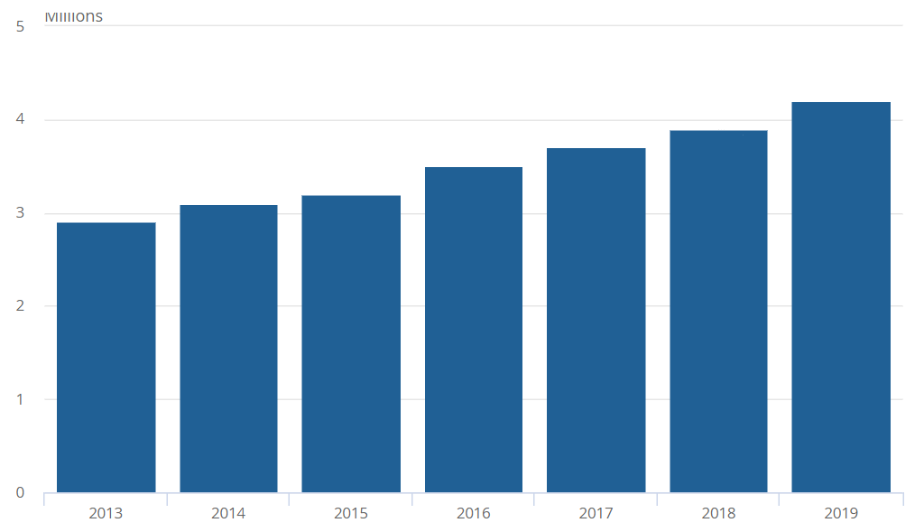
Figure 1: Number of disabled people in employment aged 16 to 64 years, UK, 2013 to 2019
(Source: Office for National Statistics – Labour market A08 dataset, Labour Force Survey)
Although the Leonard Cheshire report (2020) stated 71% of disabled individuals in employment, were affected by the Coronavirus pandemic, through redundancies, furloughs and loss of income. The Unison survey, said that 73% of those that have remained in work, have had more flexibility and able to work from home have allowed for an increase in productivity and health (CIPDb, 2021).

PESTLE and SWOT

To understand the impact on learning and design in awareness for disability discrimination a PESTLE and SWOT analysis will account for what impacts on changes both internally and externally.
The PESTLE will assist in the examination of the external factors (CIPD, 2020a) and the SWOT the impacts of the internal (CIPD, 2020b).
 | External factors | Factors affected within my organisation | Importance to organisation
Political | Government Policy and legislation  Local elections (including the Police Crime Commissioner)  BREXIT | Policies and processes within the organisation are affected. Line managers and Senior Management will always need to be kept up to date with the changes and how this affects their teams. The training programme will therefore need to be easily updated. | High  High  Low  Medium
Economical | Funding  COVID  Budgets  Training costs  Consumer confidence | Training and financial costs impact on the consumer confidence. Without the right training and/or budget this can impact on the development and performance for both the individuals and line managers. | High
Social | Demographics and attitudes  Gender race  Working trends | Demographics alter and with an ageing workforce and millennials coming through attitudes and an understanding of diverse ways of working could impact on this. | Medium
Technology | Increase in technology and artificial intelligence. | Keeping up to date with the latest technology will increase what can be offered. Artificial intelligence can assist individuals and reasonable adjustments that are offered. | Medium
Legal | Laws for disability discrimination  Lack of awareness  BREXIT | Changes in law can impact on the decisions and conversations that could take place. There is a lack of awareness surrounding the laws for disability and BREXIT changes may also impact on these. All of which could impact on grievances and the reputation for departments and the Force. | High  Medium  Low
Environmental | COVID | Impacting on organisational conduct, policy and its environments | Medium

SWOT
Strengths | Weaknesses
Equality  Reputation  Increase in resources.  Happier workforce  Disability compliant  Better recruitment | Additional training costs on an already tightly monitored and highly scrutinized budget.  Attitudes  Poor reputation for departments as well as the force  Poor recruitment
Opportunities | Threats
Growth  Leaders of change  Changing attitudes be at the forefront  Cost savings from settlements that will allow for the money to be used in other productive manners. | Poor reviews  Higher turnover  Increase in grievances.  Increase in public scrutiny.  Increase in employment tribunals and settlements which all impact on cost.

Learning techniques and styles

Lachman (1997) created a definition of learning as “the process by which a relatively stable modification in stimulus-response relations is developed as a consequence of functional environmental interaction via the senses”.
Kolb’s experiential cycle (1984) and Honey and Mumford (1982) each highlight different learning techniques and styles, Honey and Mumford (1982) defined them as:
- Activists: learning through a practical element, the act of doing
- Reflectors: observe, collect and then conclude
- Theorists: understanding what is behind the learning, theoretical and analytical
- Pragmatists: how they can apply it to the real world
SWP’s learning culture at present has a didactic approach (Stewart and Cureton 2014), based on the trainer ‘content dumping’ (Shackleton-Jones, 2019) with the hope that the information remains. Nick Shackleton-Jones in his book “How People Learn” (2019) shows that there is a link between the story and the learning, a story preserves the significance and allows it to be reconstructed into reality (p.120). Each individual therefore allowing for considerations to each learning strategy. As Stuart Crabbe mentioned in his interview with Robert Jeffrey, that there is importance in connecting those that have something valuable to learn and those that who are looking and ready to learn (People Management, ANON).
With these learning styles in mind, it must be looked at how SWP would be able to accommodate for each of them, would this be best via individual or collective learning?

Individual and Collective Learning

Individual learning incorporates traditional theories such as, behaviourism which is based on conditioning for example Pavlov experiment where he used a bell and food to trigger salivation in a dog (Bichler et al, 2013); cognitive approaches, which investigate the working of the mind; and social learning theory which concentrates on experience and examples (Stewart and Cureton, 2014). Whereas the more contemporary theories look at multiple disciplines, for example adult learning (also known as andragogy), experiential learning and learning styles, which have been highlighted above (Stewart and Cureton, 2014).
Sadler-Smith (2006) highlights that collective learning is above that of the individual learner. Hynchak and Batty (2012) combined individual learning style with team-based learning (TBL), it reflected the benefit of practical learning and an engagement with peers to allow for critical thinking and an evaluation of each other’s methods. This was based on the healthcare profession which can be linked to the practical workings and learnings of that within the Police Force.

The delivery

Push and pull
To understand the best way of teaching and learning about disability discrimination, there needs to be a clear path of what is required, a course or a resource?
Learning design has a foundation of push and pull, the pull element being that of a resource, something quick and easy that the individual cares about and is trying to do, for example a YouTube video (Shackleton-Jones, 2019). The push, this is the one that teaches individuals something that there needs to be a concern for. It needs to be more than e-learning or a YouTube video, it needs to provide an affective significance, or as Nick Shackleton-Jones states it should be “an experience, such as a challenge, experience or story” (p.70, 2019).
With that in mind and understanding the value of SWP where they look to support, engage and enable employees to realise their full potential, reducing the issues around disability discrimination is therefore more than an e-learning and not one that falls under self-learning. Which is why this applies more to the “push” element but does also apply to the “pull”. For example, an engaging course, like the one that Aldi created for customer service representation (People Management, 2021a), which allowed teams to come together and work outside of the standard environment, would provide a foundation collective aims and values. But a resource (pull) could be implemented for when the individual is in that situation and requires a checklist to make sure that they remember each step especially when implementing reasonable adjustments.
The British Association of Social Workers (BASW) and the Social Care Institute for Excellence (SCIE), created several resources that could be used to expand the knowledge and understanding for autistic adults and people with learning disabilities, social workers, social work employers and educators. The resources have been put together from those that have experienced discrimination, the families, social workers and employers and is set to challenge them in their thinking and course of action (Harvey, 2020).

Gamification
Gamification is fast becoming a method that organisations are choosing to use for developing their individuals (Rathore, 2020). It can be used for more learning styles, allows for better learning environments, and is beginning to see results supporting high behavioural changes (Pandey 2021). This style of learning has a potential demographic issue, it aligns itself more with the millennials, the technological savvy (Bannon et al, 2011) with 50% of SWP being within the 18-40 age range this allows for a good balance of demographics to assist one another through the learning, if this was a deciding factor.
There are difference elements to this, there are game play, game mechanics and VR (plus many more) (Raftopoulos, 2018). Virtual reality allows for more training repetition, faster training, safer and at less cost but is better for learning that is more complex (Deloitte Insights, 2018). See Figure 2 below, which shows that VR is better for those that require complex training in a safer environment, which would apply to Hynchak and Batty’s (2012) study above.
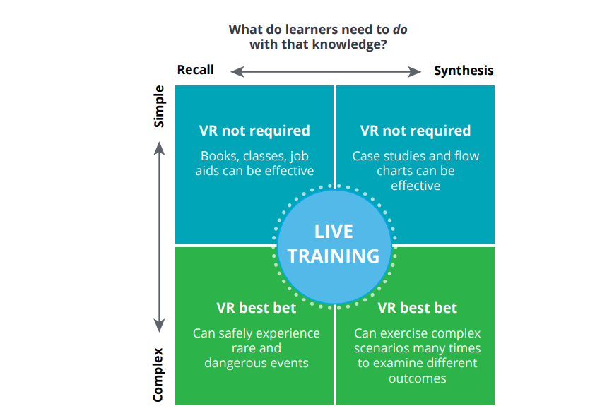
Figure 2: The decision framework can help to determine when and how to use VR in learning
(Source: Deloitte Insights, 2018 Real learning in a virtual world, how VR can improve learning and training programmes)
ACAS with their mediation use a blended method of teaching theory and applying the learning in a role play scenario which costs up to £2000 per individual (ACAS, 2021a). However, using a similar technique as the medication would be too difficult for SWP to maintain on a regular basis, not just because of the cost but also because it takes individuals out of the workplace for 5 full days.
To bring this to the forefront of technology, be more cost effective and time friendly, the company SAP, used Road Warrior, this is where individuals are trained through simulations on how to speak and answer customers, with rewards being received when the best course of action and conversation has taken place (Dupey, 2016). The difference between RoadWarrior and VR is that a simulation applies to more than just complex cases whilst still learning from their mistakes, is more cost effective as the organisations can continue to reuse the same system and will cost less time which is more encouraging to staff and officers who then do not have to struggle to find time to fit a course in whilst worrying about their work commitments. Within the Neuro Leadership Journal, it highlights that the brain will be able to function better when learning is being built and it does require maintenance, so any learning had will need to be complimented and updated throughout their time (Davachi et al, 2010).
Using simulations, such as the Road Warrior, managers will be able to understand and learn the techniques that will assist in the conversations that will take place, it will look to break through linguistic barriers as well as increasing the confidence of the line managers and the relationships that form from there (Christiansen and Chandan, 2017).

The how

Disability inclusion is crucial for all members of an organisation to understand, whether it is being looked at as a line manager, a colleague or as the individual themselves, this can be completed through formal training, policies and induction sessions (Charles, 2018).
Within the 21st century there has been an evolution of technology with Artificial intelligence increasingly on the rise. 2019 saw 35% of organisations investing in this technology (CIPD, 2019) and can impact on how Learning and Development can influence on organisations.
Nick Dam (2012) highlighted four areas to approach learning within organisations:
- Online – a specific learning for example resources. Although this element will be useful as a “how to use the reasonable adjustments form” it is not suitable to understand and work through the best practice of looking after the individuals.
- Collaborative or social learning – this is for up to two or more individuals learning through activities such as live interactions and shadowing other colleagues. Shadowing an experienced line manager in the discussions is a good form of learning however it would have to be assured that best practice was utilised.
- E-courses – support specific learnings. Regarding learning about disability discrimination, e-courses will be able to assist in areas such as the law and quizzing individuals for this but learning the physical elements of having the conversations and understanding best practice then e-courses may not be able to supply the best learning.
- Physical classroom learning – an important aspect for individuals to take them out of the working environment to concentrate on the learning requirement and to work with other individuals across the organisation to share knowledge, best practice and develop new relationships. For a workforce that is under demand, physically attending courses can on occasions be a hindrance and limit attendance. But this environment will allow individuals to run through simulations, best practice, provide feedback to one another and potentially hear first-hand experience.
ACAS offer a free e-learning course for disability discrimination and reasonable adjustments (2021c). ACAS also deliver a course for Equality, Diversity and Inclusion that costs £110 per person or can be discounted if a group course is required (ACAS 2021b), this is currently being run online.

Evaluation

Although Giangreco (2010) stated the Kilkpatrick’s evaluation model is based on an industrial society that is too time consuming and costly for organisations to complete, Kirkpatrick’s four levels of evaluation are still a popular method that organisations consider. These four levels can be found in figure 3 below:
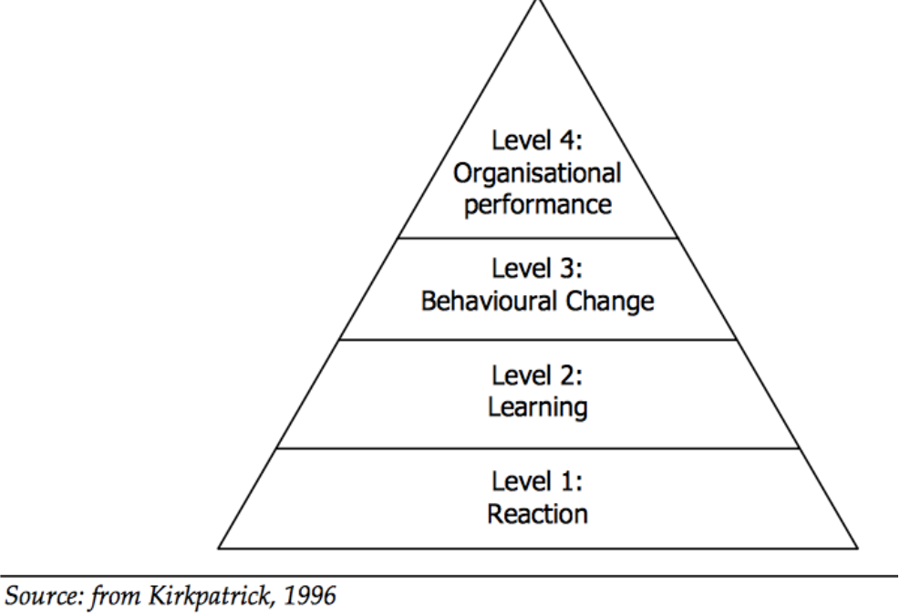
Figure 3: Kirkpatrick's four levels
(Source: Kurt, 2018)
These four levels can and should be used from the implementation of the learning need all the way through to the completion (Kurt, 2018). At present South Wales Police request feedback through a survey at the end of the lesson but with the use of Kirkpatrick’s model there is an element of further understanding how individuals can implement this into their workplace surroundings.

Conclusion

As has been mentioned, through the Horler V Chief Constable of South Wales Police [2011], disability discrimination can be a heavy cost to an organisation. The cost is not only of a monetary value but also through the reputation, there are departments within the organisation that already have a reputation for not fulfilling the family, diverse and inclusive values that South Wales Police holds itself too.
With having its own Learning and Development department, South Wales Police are in an advantageous position to encourage the creation and engagement of a course that will allow for the practice of disability inclusion. Disability discrimination has several elements to it, the law, the conversation, the reasonable adjustments and the putting it into practice, each one requires an understanding. Each organisation has employees that learn differently, and it is important that the learning and development department take this into account to make sure that they provide the best learning experience.
As the learning need was found through grievance statistics, it allows for the opportunity for Nick Shackleton-Jones’ “story” to be utilised to create an impacting learning experience. This “story” can be found through the experiences that individuals have gone through whether they are anonymously recited, or the individuals want to talk of their story in person very much like the BASW experience.
With a simulation, individuals can learn through practice of how to discuss an individual’s disability and what it is that they require to be treated as equals to their colleagues. This will allow for feedback from the participants and to appreciate the ways of best practice which will give them the confidence to approach this subject in the real world.
However, there are requirements for reasonable adjustments to be recorded. This learning is one that is required at the time, a resource, for example a “how to” video on where to find it and how to complete it. This is a valuable and easy to use resource that hits the need for the “pull” requirement and will allow the course to concentrate on the organisational values of creating an inclusive and diverse workforce.
Learning is a continuous factor, and this is where Kirkpatrick’s four levels of evaluation come into play. Rather than completing a survey at the end of the course, the organisation needs to invest in a more robust evaluation scheme, that will allow for the course requirements to amend and change and for a better understanding on what is required.
Having this course and the surrounding subject matter, will not completely resolve disability discrimination but there is the ability to raise awareness, allow the right conversations to take place and to promote equality within their teams. Employment Tribunals will therefore see that the organisation has taken the right steps and best practice is being used, saving money, having a good reputation and a happier workforce.

Recommendations

Recommendation 1
South Wales Police has its own Law department, making use of this, it would be beneficial for the department to work alongside the learning and development team to create a simulation that will allow for good practice.
Cost of using our own department rather than an outside solicitors company. Financial cost unknown however time and ease of altering the course when required will allow for a saving in cost and time.
Legal solicitor salary per month = £2722.75
Legal assistant per month = £1984.75
Recommendation 2
Create a full package to assist individuals throughout their time in the workplace. This should include a resource for the reasonable adjustments and what to do and a full course including a simulation for the group to participate in. By utilising the ACAS course at either a £110 per person or if possible a group course then this will allow for a good understanding of what is required and how to implement as well as the feedback.
Recommendation 3
Request assistance in the creation of the programme from those that have put the grievances in or have a condition that is classed as a disability. This will allow for the course to have a personal and practical element that those attending the course will be able to learn from and be able to put into practice within their working environment.
Recommendation 4
Creating a resource that will allow for line managers to have quick and easy step by step guides when they go through the discussions that will take place.
HR helpdesk one month to complete and one individual this could be the cost of £1761.25.

Appendix
This is a table reflecting the action for the recommendations highlighted above
Who | Legal this will consist of one caseworker assistant and caseworker  Learning and development team, including a training co-ordinator and a trainer who will work with legal to create the course.  HR Business Partner who will assist in the discussions surrounding the content and the information that it contains.  HR Helpdesk to assist in the creation of the resource check list that will also come out of the course
Where | This can be based in different locations throughout the force to assist with individuals travel (including those with childcare considerations) and those on shift. This also allows for change in the individuals that attend and the networking that they do.
When | As this is a demand and growing gap in the Force, this does need to look to be implemented on a sooner rather than later basis. Allowing for a decrease in grievances and a happier workforce.
How | The project will need to work together to look through the companies that will be able to assist in the creation of the courses, such as ACAS who already deliver a well-rounded role play based course. At this time there does not need to be an inclusion of AI but in order to gain a full understanding and to have the participants invested it may need to be considered as part of the evaluation process once some courses have taken place.
Cost | The cost of putting and delivering this course will have a potential impact on the amount of grievances received which will assist in decreasing the time that Business Partners, Chief Inspectors, Superintendents and Professional Standards (plus many others) will spend on investigating and meetings. Allowing for the time saved to be spent on other areas of work and a more proactive approach to the force and community’s needs.  It will also save any further settlements that may take place and the potential costs if the employment tribunal progress the case, the savings would be on the outcomes, the reputation and the legal costs.

References

ACAS, (2021a) CIWM Certificate in internal workplace mediation Available at: Acas - Training - CIWM Certificate in internal workplace mediation (Accessed on: 17th May 2021)
ACAS (2021b) Training – Equality, diversity and inclusion: the essentials. Available at: Acas - Training - Equality, diversity and inclusion: the essentials (England & Wales) - digital event (Accessed on: 17th May 2021)
ACAS (2021c) Course: Disability Discrimination and reasonable adjustments. Available at: Course: Disability Discrimination and Reasonable Adjustments (acas.org.uk) (Accessed on: 17th May 2021)
Bannon, S., Ford, K., Meltzer,L (2011) Understanding Millenials in the workplace THE CPA Journal; New York. Vol 81 issue 11 page 61.65
Bichler,O. Zhao.W. Alibart, F. Pleutin,S. Lenfant, S. Vuillaume, D. Gamrat, C. (2013) ‘Pavlov’s Dog Associative Learning Demonstrated on Synaptic-Like Organic Transistors’ Neural Computation. 25 (2) pp549–566.https://doi.org/10.1162/NECO_a_00377
Charles, K. (2018) People Management. ‘The pitfalls of perceived disability discrimination’ Available at: The pitfalls of perceived disability discrimination (peoplemanagement.co.uk) (Accessed on: 17th May 2021)
CIPD (2021a) Disability at work. Available at: Disability at work | CIPD Viewpoint. (Accessed on 17th May 2021)
CIPD (2021b) Disability and Employment. Available at: Disability & Employment | Factsheets | CIPD (Accessed on 17th May 2021)
CIPD (2021c) Carreras v United First Partners Research. Available at: Disability Discrimination Cases | CIPD (Accessed on: 17th May 2021)
CIPD (2020a) ‘PESTLE analysis Available at: PESTLE Analysis | Factsheets | CIPD (Accessed 7th January 2021)
CIPD (2020b) SWOT analysis. Available at: SWOT Analysis | Factsheets | CIPD (Accessed: 7th January 2021)
CIPD (2020c) Learning and Development Strategy and Policy. Available at: Learning & Development Strategy and Policy | Factsheets | CIPD (Accessed on: 17th May 2021)
CIPD (2019) People and Machines: from hype to reality. Available at: people-and-machines-exec-summary_tcm18-56971.pdf (cipd.co.uk) (Accessed on: 17th May 2021)
Dam, N. (2012) TD Magazine ‘Designing Learning for a 21st Century Workforce’. Available at: Designing Learning for a 21st Century Workforce (td.org) (Accessed on: 17th May 2021)
Davachi, L. Kiefer, T. Rock, D. and Rock, L. (2010) ‘Learning that lasts through ages’ Neuro Leadership Journal, Issue 3
Demarinis, T. Calligaro, L. Harr, C and Mariani, J. (2018) Deloitte Insights: Real learning in a virtual world, how VR can improve learning and training programmes. Available at: How VR training can improve corporate learning outcomes | Deloitte Insights. (Accessed on: 17th May 2021)
Dubey, A, D., (2016) Top 10 examples of Gamification. Available at: Top 10 Examples of Gamification - Learn about the organizations that have implemented Gamification (linkedin.com) (Accessed on: 17th May 2021)
Equality and Human Rights Commission (2020) Disability Discrimination. Available at: Disability discrimination | Equality and Human Rights Commission (equalityhumanrights.com) (Accessed on 17th May 2021)
Equality Act 2010 section 6. Available at: Equality Act 2010 (legislation.gov.uk) (Accessed on: 17th May 2021)
Gegg, B. and Hawkes, A. (2020) People Management. Promoting disability inclusion in the workplace. Available at: Promoting disability inclusion in the workplace (peoplemanagement.co.uk) (Accessed on: 17th May 2021)
Gelder, E. (2016) Discrimination arising from disability: five examples from case law. Available at: Discrimination arising from disability: five examples from case law - Personnel Today (Accessed on: 17th May 2021)
Giangreco, A., Carugati, A. and Sebastiano, A. (2010), "Are we doing the right thing? Food for thought on training evaluation and its context", Personnel Review, Vol. 39 No. 2, pp. 162-177. https://doi.org/10.1108/00483481011017390

Government UK (2021) Employment Tribunal Decisions. Available at: Employment tribunal decisions - GOV.UK (www.gov.uk) (Accessed on: 17th May 2021)
Griffiths, D and Inman, M (2017) ‘Is it time to take learning design to task’. Journal of Adult and Continuing Learning. 23(2) pp226-249. https://doi-org.ezproxy.uwtsd.ac.uk/10.1177/1477971417733270
Harvey, M. (2020) ‘Learning Disability Week: our role in ending discrimination.’ Social work with adults [blog]. Available at: Learning Disability Week: our role in ending discrimination - Social work with adults (blog.gov.uk) (Accessed on: 17th May 2021)
Health and Safety Executive (2021) Employer’s responsibilities: Workers’ health and safety. Available at: Employer's responsibilities: Workers' health and safety (hse.gov.uk) (Accessed on: 17th May 2021)
Honey, P. & Mumford, A. (1982) Manual of Learning Styles London: P Honey
Horler v Chief Constable of South Wales Police ET/1600591/2012 Available at: Employment tribunals: 10 large tribunal payouts in 2014 | Law reports | Tools | XpertHR.co.uk (Accessed on: 17th May 2021)
Hrynchak, P and Batty, H. (2012) ‘The educational theory basis of team-based learning’ Medical Teacher. 34(10), pp796-801. DOI: 10.3109/0142159X.2012.687120
Jeffrey, R. (ANON) People management. ‘We’ve already got all the skills that we need’
Kirkpatrick Partners (2021) Kirkpatrick Foundational Principles. Available at: Kirkpatrick Foundational Principles (kirkpatrickpartners.com) (Accessed on: 17th May 2021)
Kolb, D. (1984) Experiential Learning: Experience as the source of learning and development. Prentice Hall: New Jersey
Kurt, S. (2018) Kirkpatrick Model: Four levels of learning evaluation. Available at: Kirkpatrick Model: Four Levels of Learning Evaluation - Educational Technology (Accessed on: 17th May 2021)
Lachman, S.J. (1997) ‘Learning is a process: Toward an improved definition of learning’ The Journal of Psychology. 131(5)pp. 477-480. DOI:10.1080/00223989709603535
Leonard Cheshire (2020) Disabled people plunged into crisis by COVID employment landscape. Available at: Disabled people plunged into crisis by COVID employment landscape | Leonard Cheshire (Accessed on: 17th May 2021)
Murray-Hinde, S (2018) People Management. ‘Avoiding disability discrimination in the workplace’ Available at: Avoiding disability discrimination in the workplace (peoplemanagement.co.uk) (Accessed on: 17th May 2021)
Office for National Statistics (2019) Disability and Employment, UK: 2019. Available at: Disability and employment, UK - Office for National Statistics (ons.gov.uk) (Accessed on 17th May 2021)
Pandey,A. (2021) How gamification is reshaping corporate training. Available at: 6. EI-Design-How-Gamification-Is-Reshaping-Corporate-Training (3).pdf (Accessed on: 17th May 2021)
People management (2021) Aldi. February 2021, p.25
Raftopoulos , M (2018) How to use a gamification taxonomy to guide design decisions. Available at: How to use a gamification taxonomy to guide design decisions (linkedin.com) (Accessed on: 17th May 2021)
Rathore, V. (2020) Elemens. 8 Surprising Gamification Statistics in 2020. Available at: 8 Surprising Gamification Statistics in 2020 (elmens.com) (Accessed on: 17th May 2021)
Redmans Employment Team (2014) Police officers wins over £200,000 in Employment Tribunal disability discrimination claim. Available at: Police officers wins over £200,000 in Employment Tribunal disability discrimination claim | Redmans Solicitors (Accessed on: 17th May 2021)
Royal College of Nursing (2021) Disability discrimination and the Equality Act 2010. Available at: Disability discrimination and the Equality Act 2010 | Advice guides | Royal College of Nursing (rcn.org.uk) (Accessed on 17th May 2021)
Sadler-Smith, E. (2006) Learning and development for managers: perspectives from research and practice. London: Blackwell Publishing
Shackleton-Jones, N. (2019) How People Learn: Designing education and training that works to improve performance. London: Kogan Page
Solow, M. and Wakefield, N, (2016) Deloitte Insights. Design Thinking: Crafting the employee experience. Available at: Design thinking for employee experience management | Deloitte Insights (Accessed on: 17th May 2021)
Stewart, J. & Cureton, P. (2014) Designing, Delivering and Evaluating L&D: Essentials for Practice. Glasgow: Bell and Bain

