Lowri Jones
1801539
Applied Computing
Enterprise and Innovation Group Project
Individual Report
03/03/2020

Table of Contents

Introduction. 3
Trading name. 3
Start-Up description – 3
Team Members. 3
Mission Statement. 4
Objectives- 5
Development 5
Conclusion. 9
Appendix 9
Reflection. 9
Networking. 10
Team-Working. 11
Week 1 – Progress meeting. 11
Week 2 – Progress meeting. 12
Week 3 – Progress meeting. 13
Week 4 – Progress Meeting. 14
Week 5 – Progress meeting. 15
Week 6 – Progress meeting. 16
Week 7 – Progress meeting. 17
Week 8 – Progress meeting. 18
Week 9 – Progress meeting, 19
References 19

Introduction.

Trading name.
The trading name is J & J Fitness. The team members feel like this name fits the project accurately. The team members have also come up with a motivating slogan for the project which is shown below;
‘changing the way we see fitness’.
A slogan is important as it is what sets you apart from the other competitors you may have [1], it is vital to make your slogan eye catching and interesting for the chosen target audience. The slogan has been chosen to keep the users intrigued and it should suggest that the application is different to the other competitor apps.

Start-Up description –
The 6 team members of J & J Fitness came up with the idea of creating a web application that will contain unique features that aren’t currently included in other similar fitness applications. The unique selling proposition of J & J Fitness is it’s live competing feature which allows users to compete against others to gain points and gain a spot on the leader board. This feature will allow for friendly competition hopefully motivating the users to work towards their set goals. [2]
Other features of the app will include a recipes section where users are able to be inspired to cook and try new things to help them maintain their fitness and a challenges section containing a list of set challenges that are the same for all users to help them gain points for the leader board.

Team Members.
Lowri Jones – Mobile Developer
A mobile developer creates mobile apps, along with writing all of the necessary code and testing it. [3] Lowri Jones is developing her knowledge and learning more about coding web applications in completing this assignment..
Scott Jones – Project Manager
A project manager has the lead role in a project, they are in charge of the entire project along with the resources and team members. A project manager must ensure that the whole team is on track for success the entire time. [4]
Lloyd Johnson – Business Developer
A business developer assists their company to gain new customers and sell more of their products and services to both new and existing ones. [5]
Rosiey Aktar – Marketing Manager
A marketing managers job is to develop marketing strategies that work well with the company’s project and come up with different ways to advertise the business such as social media sites. The marketing manager is responsible for looking at the market trends finding out what works and what doesn’t for the project. [6]

Shaun Holborrow – Business and Usability Analyst
The job of a business and usability analyst drives both the design of websites and applications making it more intuitive. They will also spend time looking for improvements for the users. [7]
Habib Muin – Website Developer
A website developer is a team member who takes a given website design and is able to create an actual website from it. A website developer is someone who is familiar with different coding languages and is able to write lines and lines of complicated code to create a fully functioning and successful website. [8]
Throughout completing the group project, Lowri has been responsible for the Mobile side alongside Scott and Shaun.
Lowri has done the database which will then be linked up with the application. Whilst Scott has coded the application, all of them initially designed it together.
Lloyd, Rosiey and Habib have been responsible for both designing and implementing the website side of the project. As a group, it was decided that it would be beneficial to have a website as well as an application so that users are able to have help and support on there and it also adds another platform to download it.

Mission Statement.
J & J Fitness aims to provide all it’s users with a reliable and effective Fitness experience which is both enjoyable and motivating. The 6 team members want to encourage users of all different ages and abilities to use the well-equipped app and overall improve their wellbeing and get fit. It is certain that all tips and general information that has been included on the application is all professional and honest. All team members are motivated to grow their own set of skills in order to provide a better experience for their users. The application users needs are always put first by the team members making their wellbeing the main priority.

Objectives-
- As a group, the team members would like to encourage as many people as possible to use their application. To do this, the marketing manager will need to look at different ways to advertise the app to the correct target audience.
- A second objective will be to make the app simple and easy to understand for all users. To do this, it is important that the team members take the users needs into consideration.

Development
Lowri was initially in charge of designing the JJFitness app alongside group member Scott. Between them they fully designed a professional looking app, which Scott then worked on developing. Lowri was able to help Scott research about different Software he would be able to use and different ways to code it. Below is the evidence of Lowri’s research;
Option 1 – Appery.
Appery was one of the options found, it runs in the cloud so there is no need to install or even download anything. It is an easy platform to use and it also includes a visual editor to help and build the User Interface. However, prices start at £60 a month which made this an unsuitable option as this couldn’t be sustained in the budget. [9]
Option 2 – Android Studio.
Android Studio was the second option that was considered, it offers Graphical User Interface which allows the developer to use the function ‘drag-and-drop’ to create their UI. Android Studio also has lesser bugs than other alternative platforms which allows for a safer and more stable performance. [10]
Lowri and Scott decided to go with option 2 – Android Studio.

Lowri Jones was in charge of the database that will be used to hold all important customer and business information. Whenever a user logs in or creates an account on the app or website, all of their information will be held on the database.
To create the database, Lowri used Microsoft SQL Server Management Studio. The main reasoning behind writing in Structured Query Language (SQL) was because it is the computers language, from this you can easily progress towards coding with other languages. Whilst learning SQL you are able to develop your abilities helping you towards specializing as a programmer or a developer. Lowri thought that by developing her knowledge in this language, it would help her be able to make both the app and website more advanced at a later stage. [11]

From the screenshot below, we can see that Lowri has firstly created the table for the customers. When anyone creates a new account on either the website or the app all of their details will be saved into this ‘Customer Details’ table so that they are able to log in again on any device.
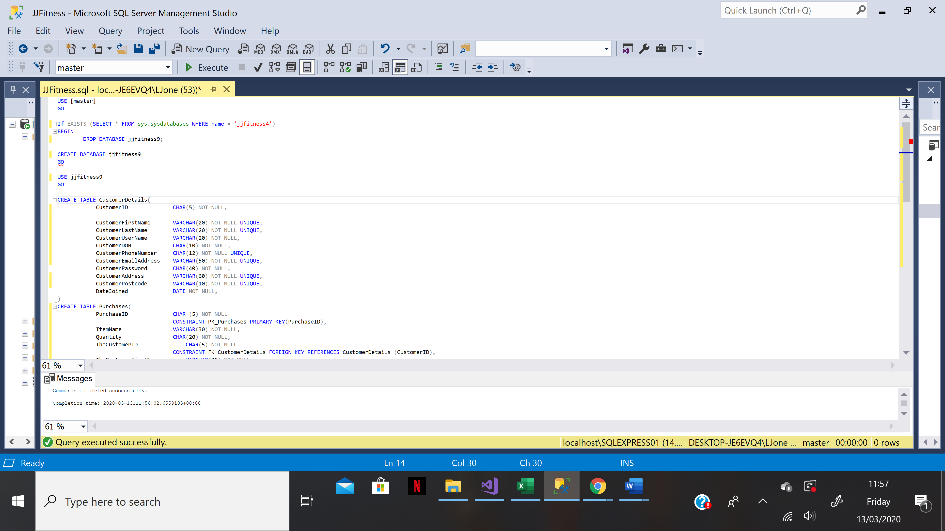
The second table created was the purchases table which directly links with the customer table. When a user chooses to purchase something through the app, their purchase will be saved into this table to ensure there is a direct tracking of what has been done through the app. The users will also be able to view all of their previous orders due to having this table.
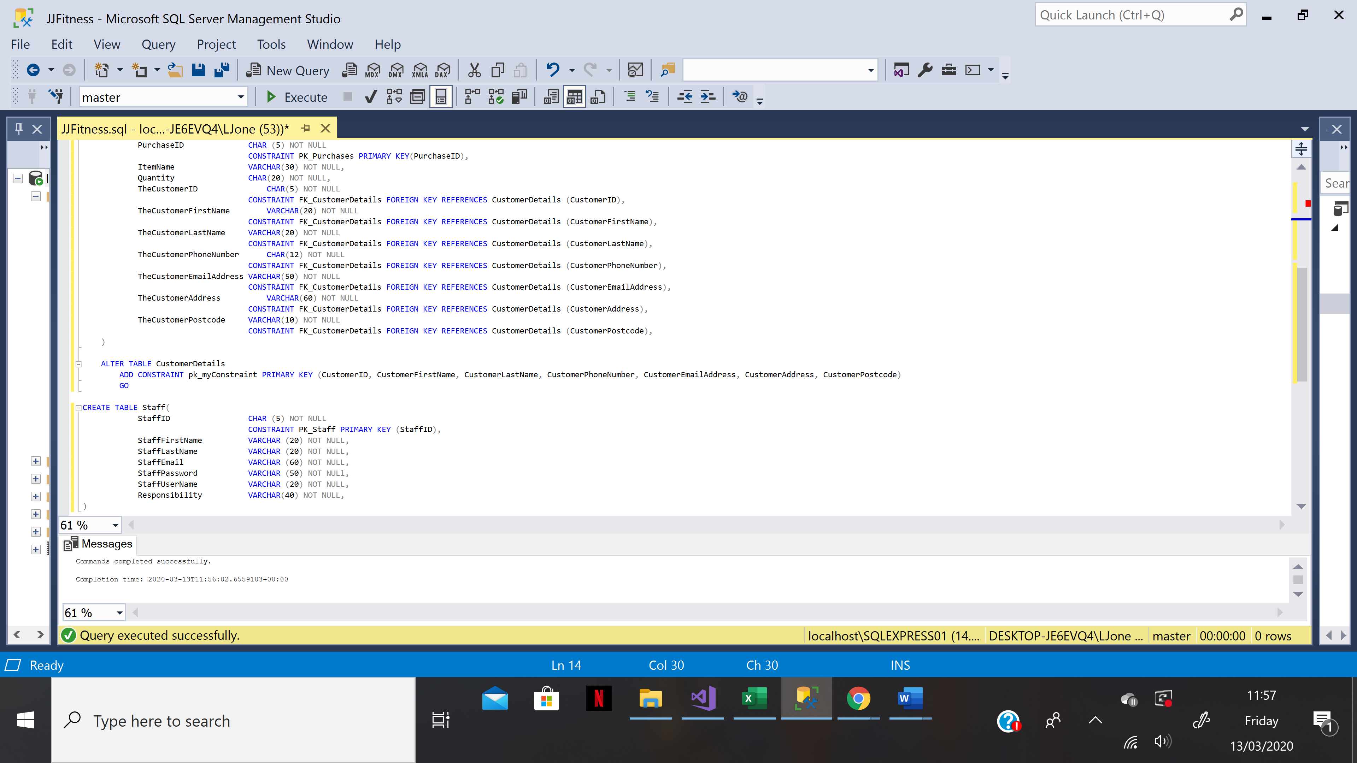
After this second table was created, the Customers table was altered to make sure that there were both Primary and Composite keys included in order to be able to successfully link with the Purchases table. The third and final table that was included into the database was the Staff table where all of the Staff data is collected and saved such as their personal log in information.
As you can see from the Messages box at the bottom of the screen, all commands were completed successfully meaning all of the database code is working correctly.
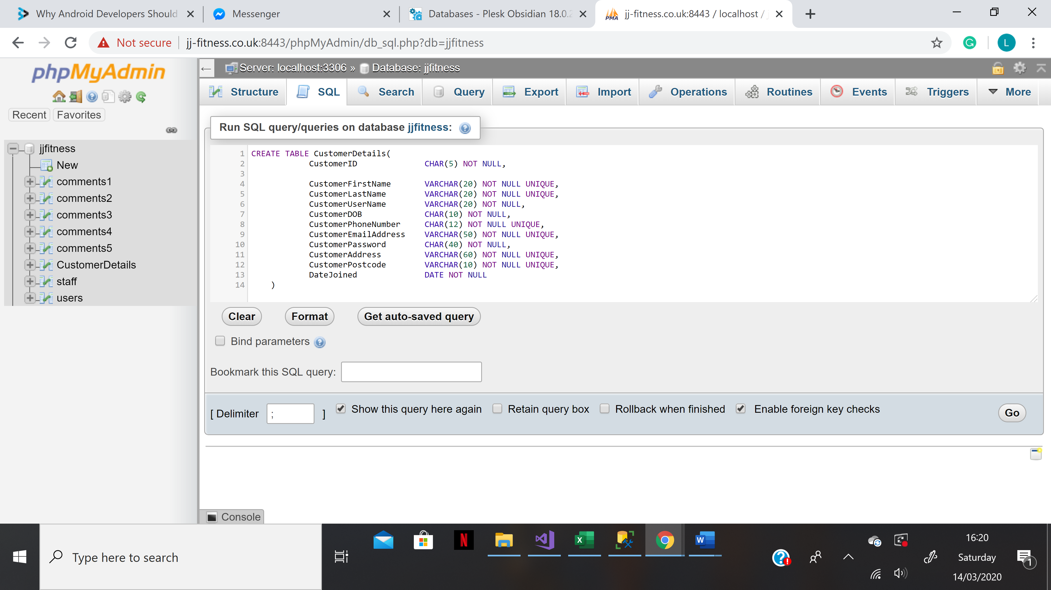
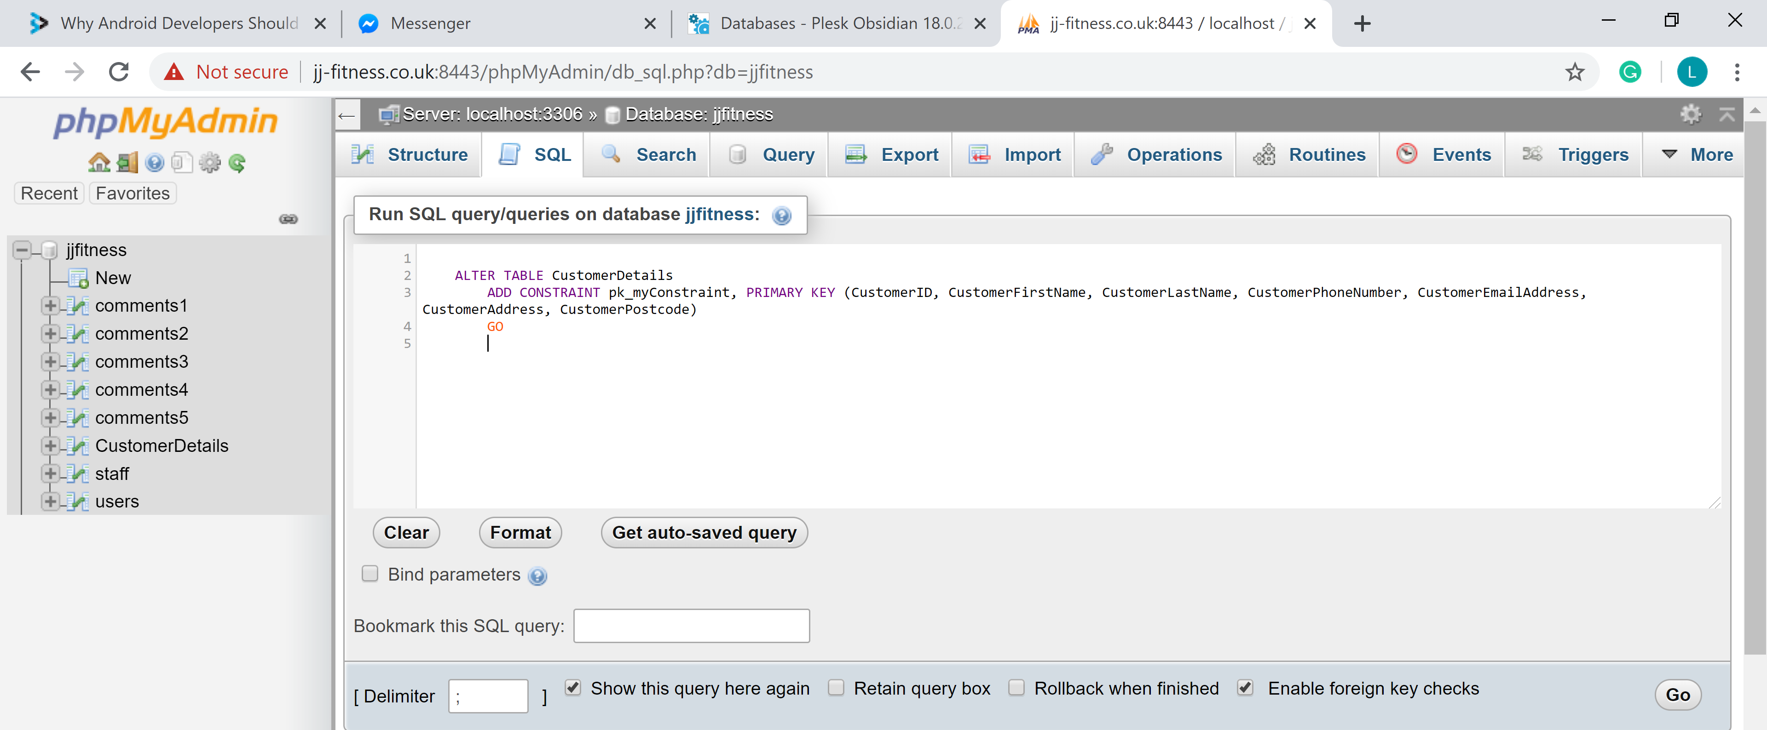
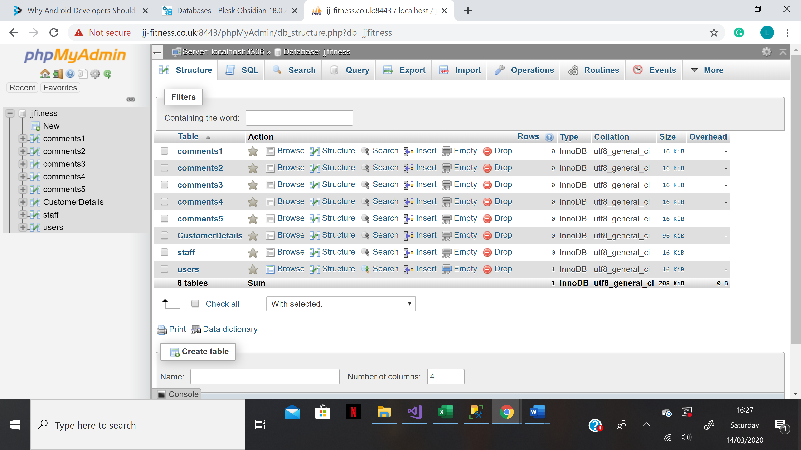
As you can see from the screenshots above, all of the tables have been implemented into the JJFitness overall database using phpMyAdmin.
Code.
USE [master]
GO

If EXISTS (SELECT * FROM sys.sysdatabases WHERE name = 'jjfitness4')
BEGIN
DROP DATABASE jjfitness9;

CREATE DATABASE jjfitness9
GO

USE jjfitness9
GO

CREATE TABLE CustomerDetails(
CustomerID CHAR(5) NOT NULL,

CustomerFirstName VARCHAR(20) NOT NULL UNIQUE,
CustomerLastName VARCHAR(20) NOT NULL UNIQUE,
CustomerUserName VARCHAR(20) NOT NULL,
CustomerDOB CHAR(10) NOT NULL,
CustomerPhoneNumber CHAR(12) NOT NULL UNIQUE,
CustomerEmailAddress VARCHAR(50) NOT NULL UNIQUE,
CustomerPassword CHAR(40) NOT NULL,
CustomerAddress VARCHAR(60) NOT NULL UNIQUE,
CustomerPostcode VARCHAR(10) NOT NULL UNIQUE,
DateJoined DATE NOT NULL,
)
CREATE TABLE Purchases(
PurchaseID CHAR (5) NOT NULL
CONSTRAINT PK_Purchases PRIMARY KEY(PurchaseID),
ItemName VARCHAR(30) NOT NULL,
Quantity CHAR(20) NOT NULL,
TheCustomerID CHAR(5) NOT NULL
CONSTRAINT FK_CustomerDetails FOREIGN KEY REFERENCES CustomerDetails (CustomerID),
TheCustomerFirstName VARCHAR(20) NOT NULL
CONSTRAINT FK_CustomerDetails FOREIGN KEY REFERENCES CustomerDetails (CustomerFirstName),
TheCustomerLastName VARCHAR(20) NOT NULL
CONSTRAINT FK_CustomerDetails FOREIGN KEY REFERENCES CustomerDetails (CustomerLastName),
TheCustomerPhoneNumber CHAR(12) NOT NULL
CONSTRAINT FK_CustomerDetails FOREIGN KEY REFERENCES CustomerDetails (CustomerPhoneNumber),
TheCustomerEmailAddress VARCHAR(50) NOT NULL
CONSTRAINT FK_CustomerDetails FOREIGN KEY REFERENCES CustomerDetails (CustomerEmailAddress),
TheCustomerAddress VARCHAR(60) NOT NULL
CONSTRAINT FK_CustomerDetails FOREIGN KEY REFERENCES CustomerDetails (CustomerAddress),
TheCustomerPostcode VARCHAR(10) NOT NULL
CONSTRAINT FK_CustomerDetails FOREIGN KEY REFERENCES CustomerDetails (CustomerPostcode),
)

ALTER TABLE CustomerDetails
ADD CONSTRAINT pk_myConstraint PRIMARY KEY (CustomerID, CustomerFirstName, CustomerLastName, CustomerPhoneNumber, CustomerEmailAddress, CustomerAddress, CustomerPostcode)
GO

CREATE TABLE Staff(
StaffID CHAR (5) NOT NULL
CONSTRAINT PK_Staff PRIMARY KEY (StaffID),
StaffFirstName VARCHAR (20) NOT NULL,
StaffLastName VARCHAR (20) NOT NULL,
StaffEmail VARCHAR (60) NOT NULL,
StaffPassword VARCHAR (50) NOT NULl,
StaffUserName VARCHAR (20) NOT NULL,
Responsibility VARCHAR(40) NOT NULL,
)

Conclusion.
JJFitness is a fitness app which helps all different types of users stay fit and healthy, it also helps the users to remain motivated through its different tasks aimed at everyone. The apps Unique Selling Point is its live friendly competition feature. Throughout the development process, I feel like I have learnt necessary SQL skills to help me later on with programming tasks and apps. I am now much more confident in learning new coding and database languages.

Appendix

Reflection.
Before developing the database, I researched ‘SQL’ and ‘Microsoft SQL Server Management Studio’ to make sure I would be able to make the relevant tables to the best standard. I feel like I have greatly developed my research skills to the extent that I would feel comfortable to research different topics in the future.
Whilst researching SQL, I was able to learn more about different SQL features and different ways to code the tables to make it as successful as possible. I have been able to develop my technical skills which will help me in the future when I am needing to create company databases. I am able to include different security features into tables which helps for a more secure database.
I feel like this group project has helped me develop necessary skills that will help me in future jobs working on my own and also as part of a team. Research and understanding many different coding languages are key skills for working in ICT. I feel I have benefitted greatly from the tasks I have completed.

Networking.
Lowri, Scott, Lloyd, Rosiey and Shaun all attended the industry networking event in Swansea. The networking event that we chose to attend was ‘an introduction to Marketing’. We felt like this was relevant to our project idea as it is such a large aspect of starting a business. We were able to take away key skills that we would need to develop our ideas into a business. We learnt about the importance of advertising and the multiple routes of market such as through social media, coming to events to talk about our ideas and through signs or billboards. The most effective way in my opinion of advertising is through social media site as social media has a big audience. By advertising our project over social media we would be able to reach a large audience, persuading them to download our app.
Another important feature that was discussed during this workshop was the importance of having a stand out logo. The logo that has been created for JJFitness is both relevant and eye-catching. It was designed having a weight included with the project name in the middle. Having the weight in the centre of the logo will help to show the users exactly what the application and website is based on.
I feel like this Workshop really helped me understand more about the key features that need to be taken into consideration when looking into starting a new business. It made me aware of the different aspects to a good and successful business. Below is a picture and screenshot of Workshop we attended;
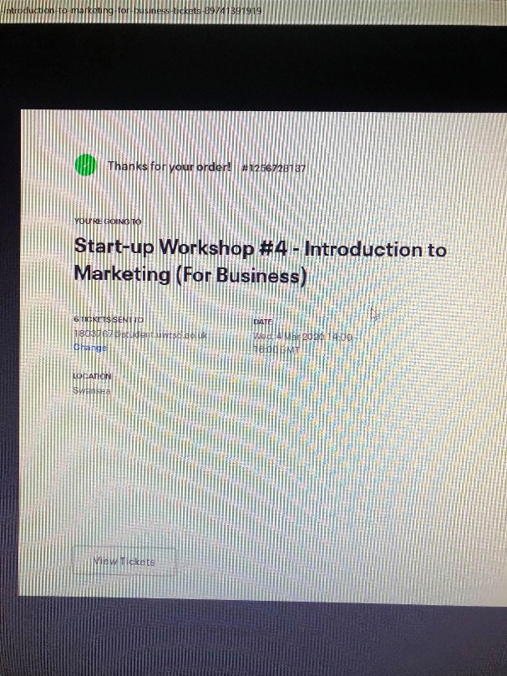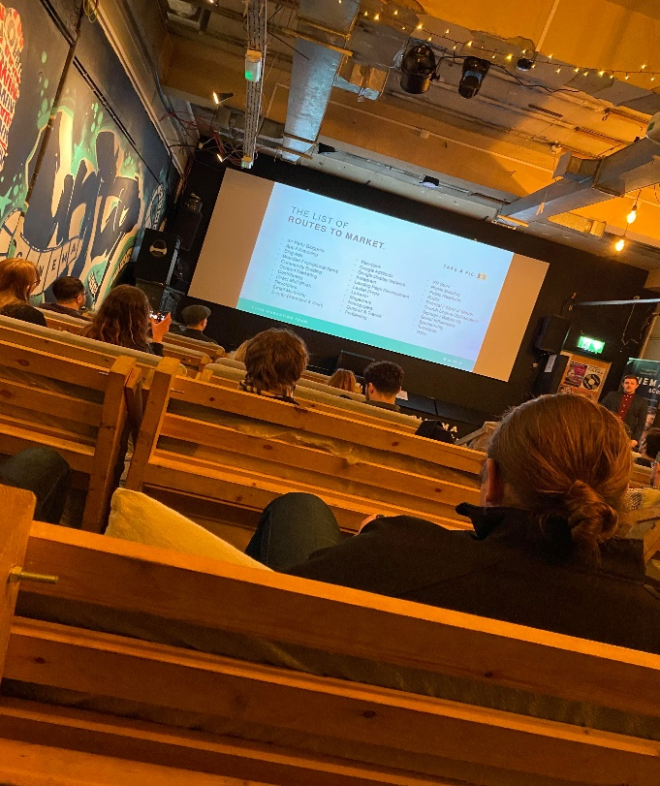

Team-Working.

Week 1 – Progress meeting.
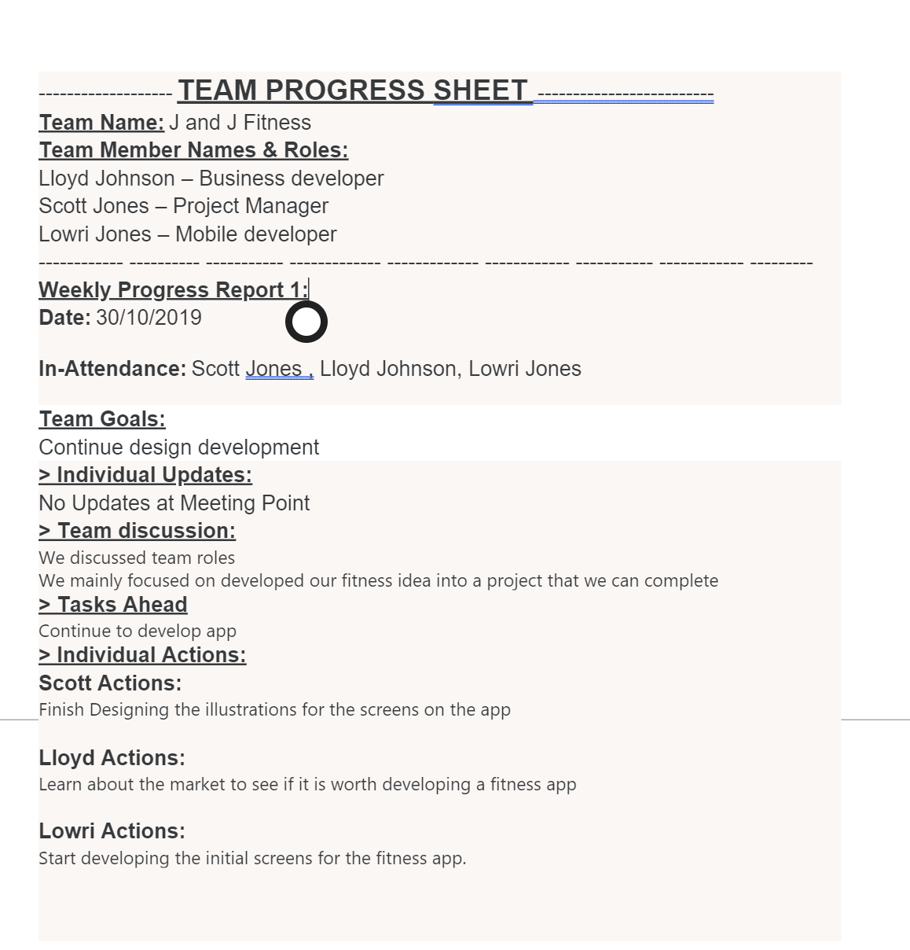

Week 2 – Progress meeting.
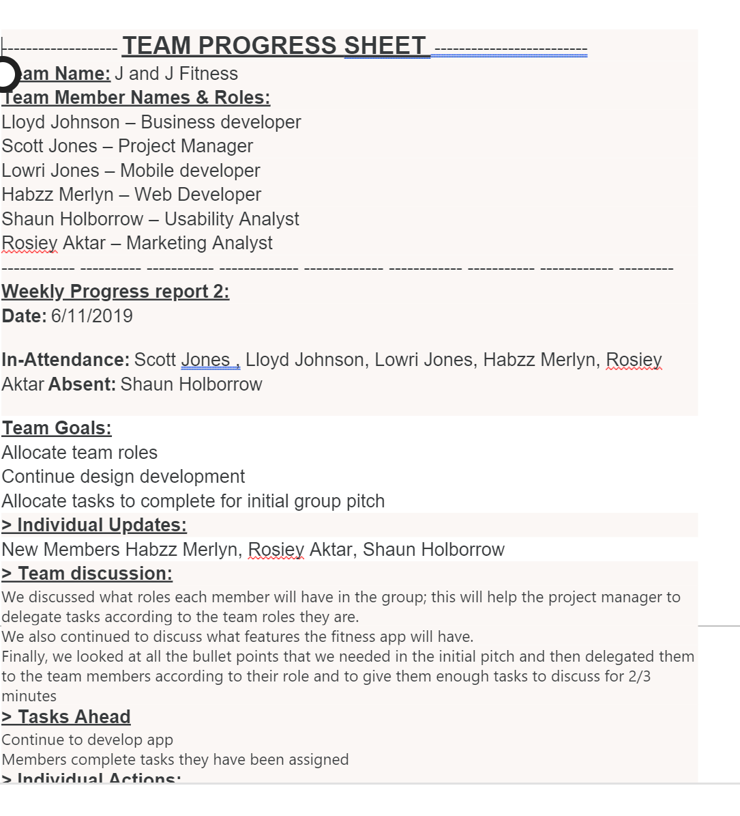
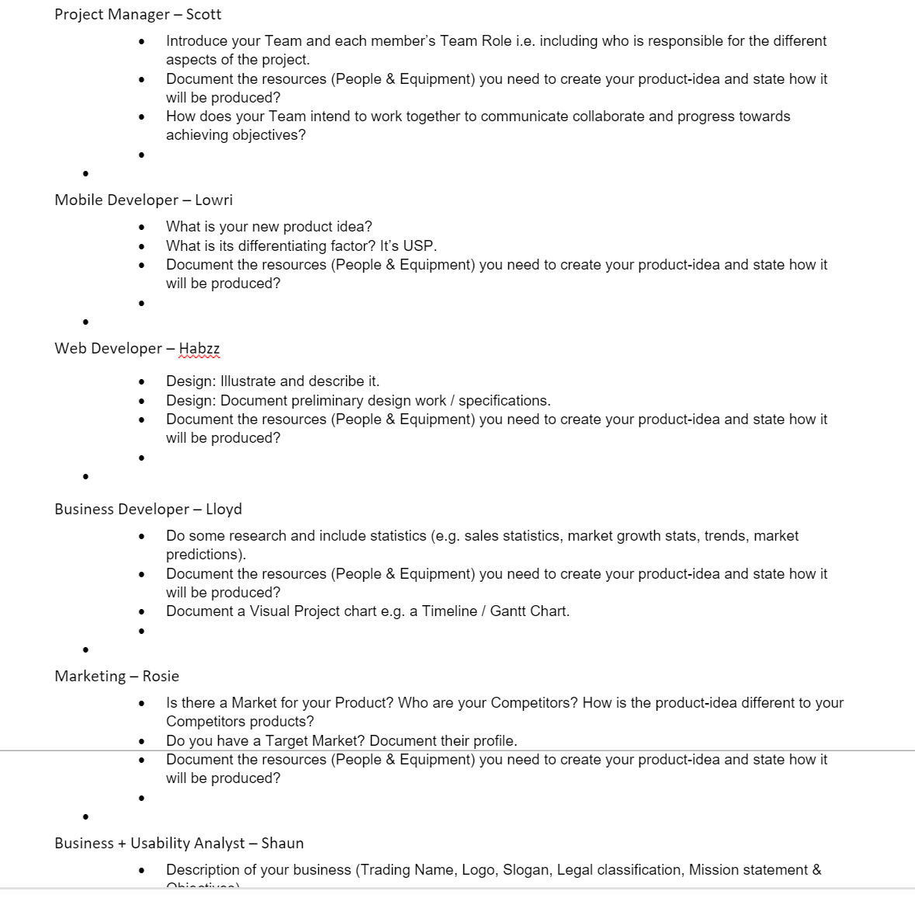

Week 3 – Progress meeting.
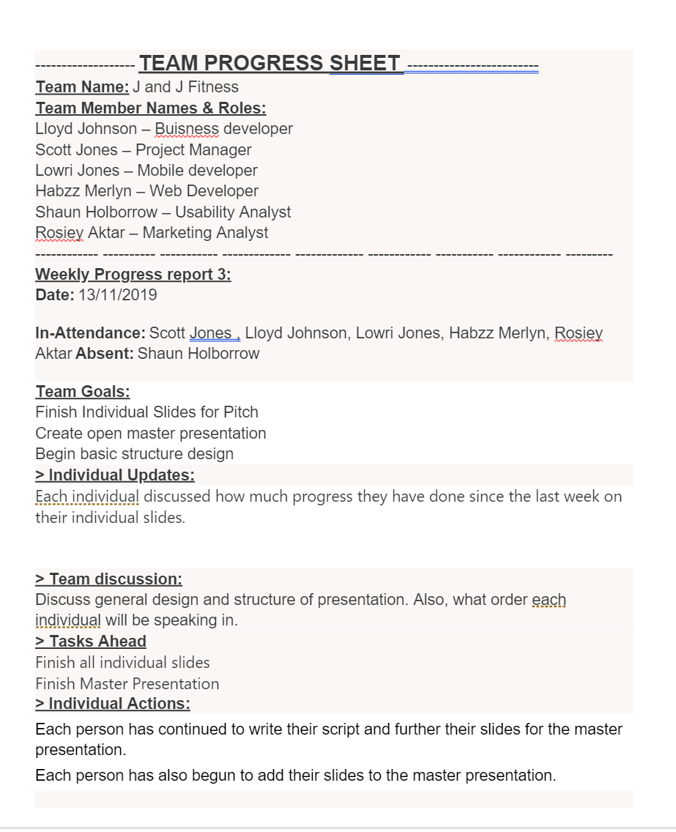

Week 4 – Progress Meeting.
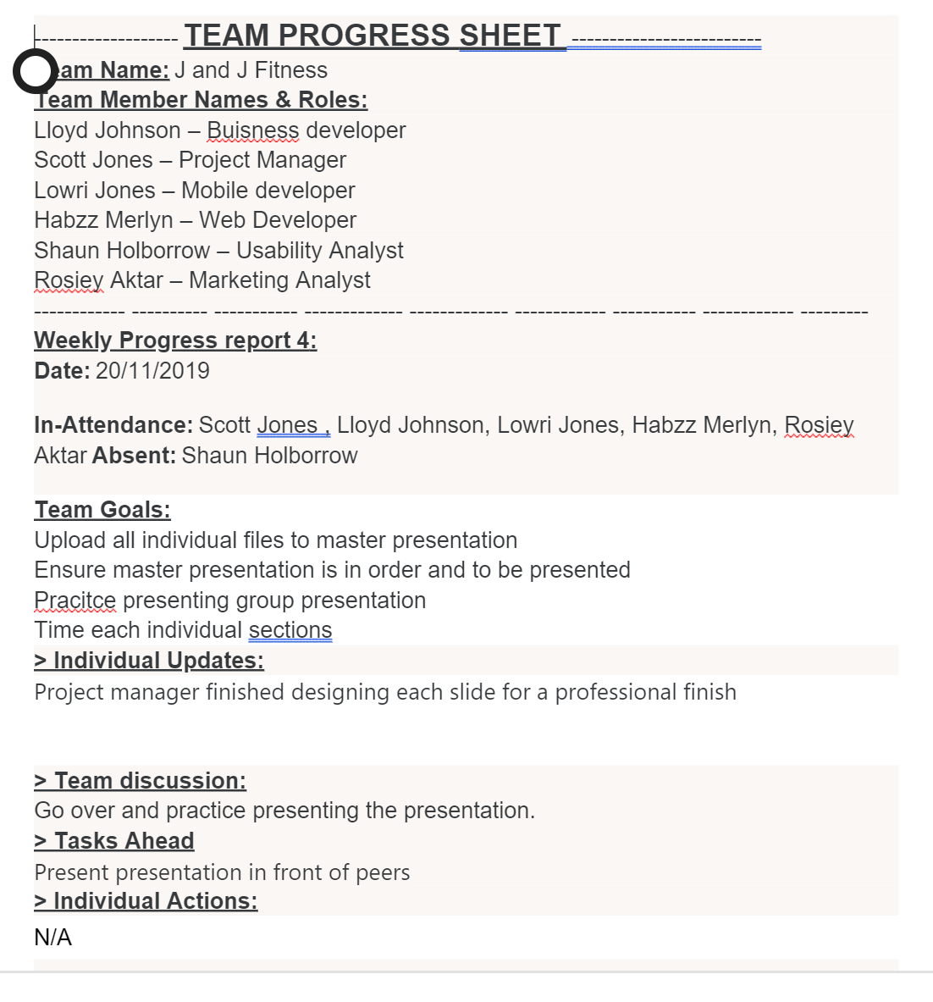

Week 5 – Progress meeting.
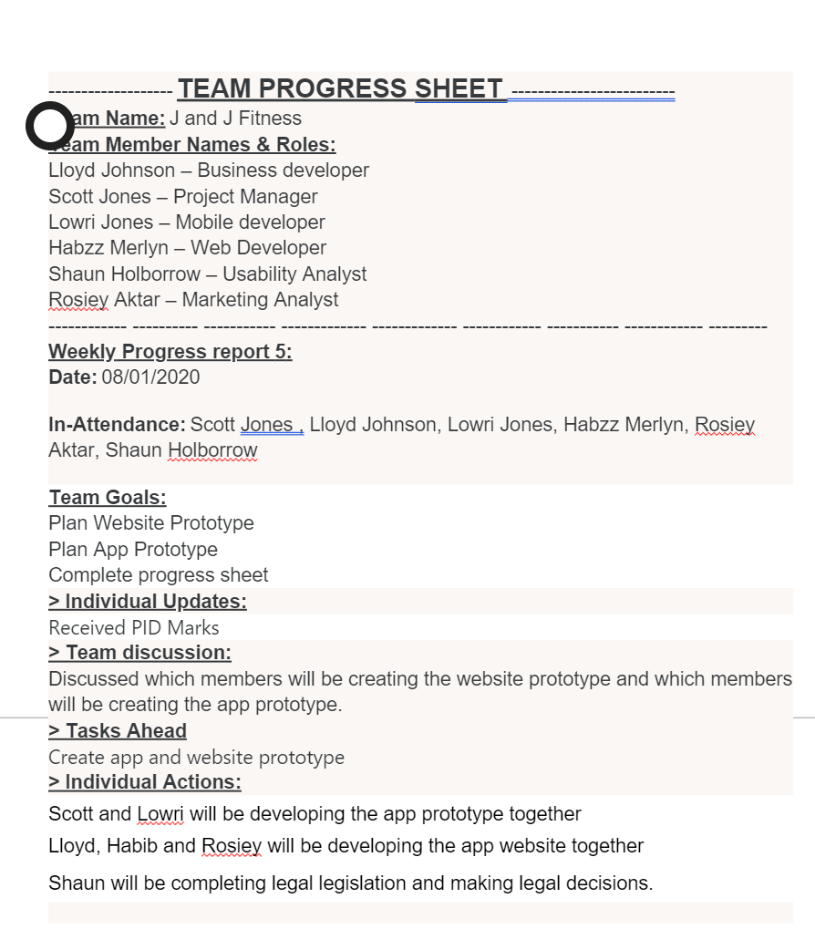

Week 6 – Progress meeting.
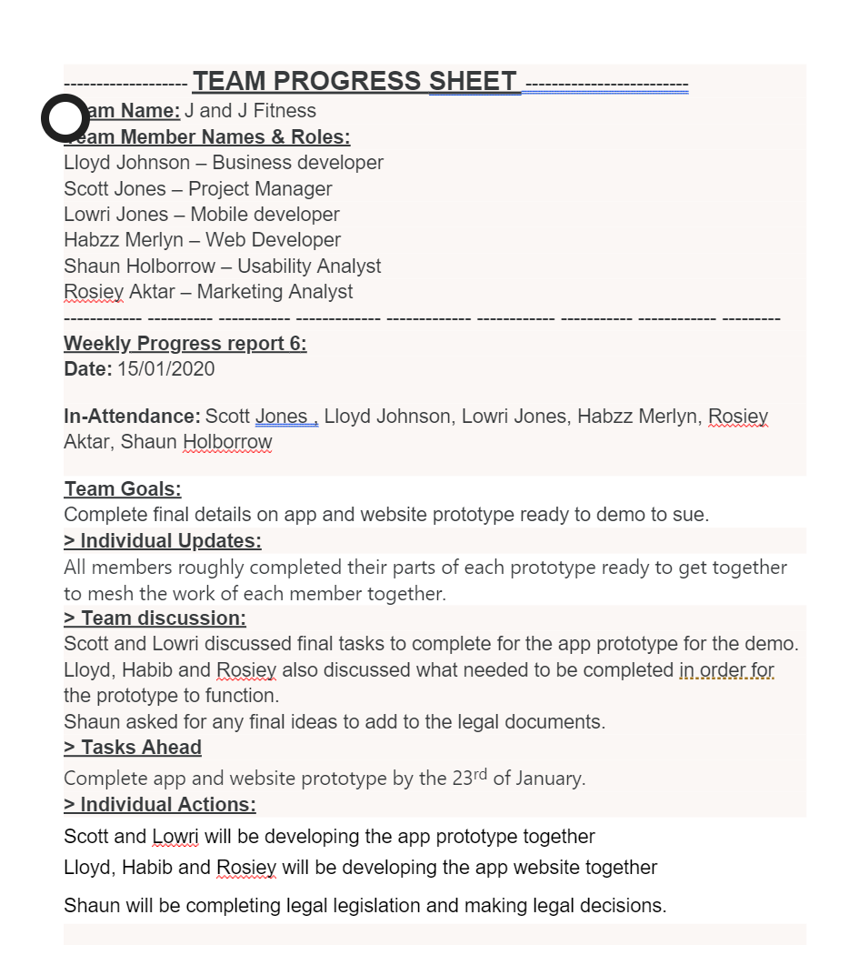

Week 7 – Progress meeting.
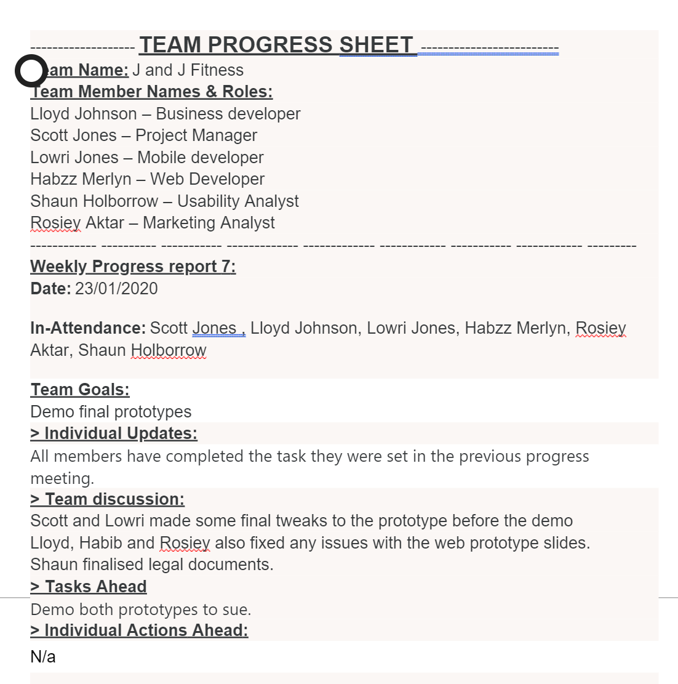

Week 8 – Progress meeting.
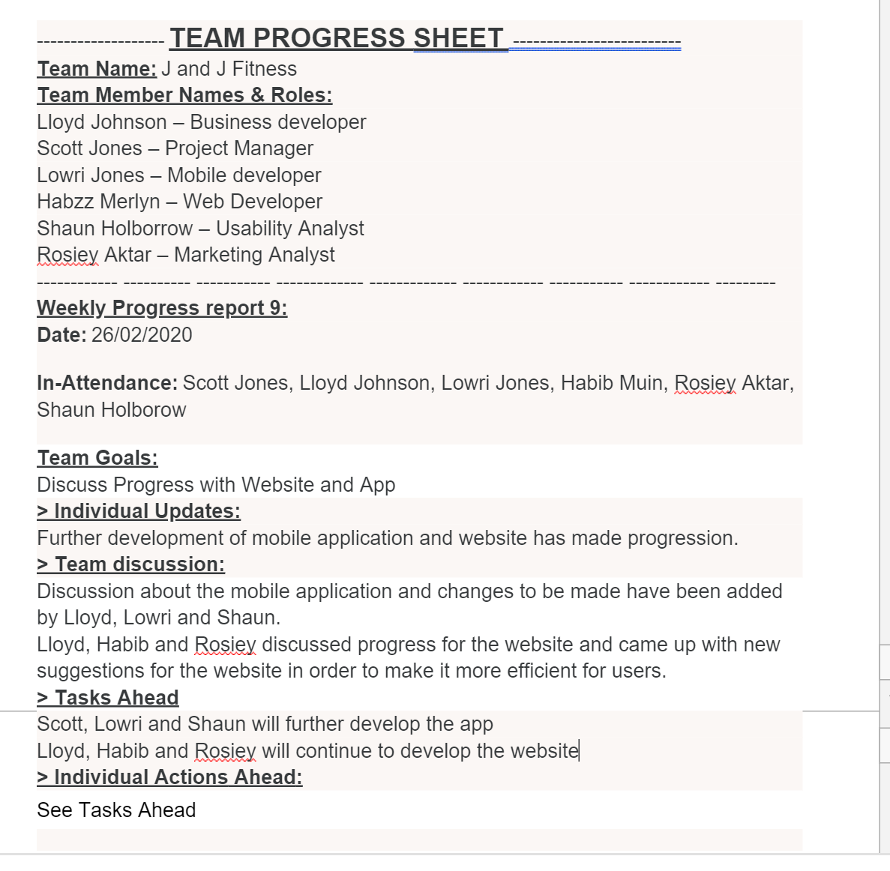

Week 9 – Progress meeting,

References

[1] | T. Berger, "The Importance of a Great Slogan and Taglines – With Examples.," Social Seeder, 21 September 2018. [Online]. Available: https://www.socialseeder.com/blog-marketing/the-importance-of-a-great-slogan-and-taglines-with-examples/.
[2] | A. L. Novak, "Benefits of Friendly Competition," SocialMediaToday, 12 August 2012. [Online]. Available: https://www.socialmediatoday.com/content/benefits-friendly-competition.
[3] | J. Wiggins, "What Does a Mobile Developer Do and How Do You Become One?," glassdoor, 29 September 2016. [Online]. Available: https://www.glassdoor.co.uk/blog/what-does-a-mobile-developer-do/.
[4] | M. Alexander, "What is a project manager? The lead role for project success," CIO, 26 May 2019. [Online]. Available: https://www.cio.com/article/3224865/what-is-a-project-manager-the-lead-role-for-project-success.html.
[5] | "Business Development Executive Job Description," 24 July 2015. [Online]. Available: https://jobs.telegraph.co.uk/article/business-development-executive-job-description/.
[6] | M. Patel, "Job description: Marketing manager," CampaignLive, 2 April 2019. [Online]. Available: https://www.campaignlive.co.uk/article/job-description-marketing-manager/1373868.
[7] | L. Hamilton, "Job Description for a Usability Analyst," Career Trend, 5 July 2017. [Online]. Available: https://careertrend.com/about-6722788-job-description-usability-analyst.html.
[8] | BitDegree, "What Is A Web Developer: Understanding What Is Web Development," BitDegree Tutorials, 10 January 2020. [Online]. Available: https://www.bitdegree.org/tutorials/what-is-a-web-developer/.
[9] | J. Krol, "10 excellent platforms for building mobile apps," Mashable UK, 17 August 2018. [Online]. Available: https://mashable.com/article/build-mobile-apps/?europe=true.
[10] | "Why Android Developers Should Prefer Android Studio Over Eclipse?," Brainvire, 13 October 2016. [Online]. Available: https://www.brainvire.com/android-developers-prefer-android-studio-eclipse/.
[11] | A. Babu, "Importance of learning SQL," coding Sight, 30 July 2018. [Online]. Available: https://codingsight.com/structured-query-language-importance-of-learning-sql/.

