Data Mining

South German Credit

Shane Clement
ID: 134351

Table of Contents

Data Mining for Business Endeavours 3
Dataset Descriptions 4
Pre-Processing 7
ARFF File 7
Data Cleansing 8
Post-Processing 10
Linear Regression 10
Random Tree 11
M5P 13
K-Means Clustering 14
Nearest Neighbour (KNN) 16
Business Recommendations 18
Reflective Commentary 19
Was it a success? 19
Linear Regression 19
Random Trees 19
M5P 19
K-Nearest Neighbor (lazy IBK) 19
K-Means Clustering 19
Advantages and Disadvantages 20
Future Improvements 20
References 21

Data Mining for Business Endeavours

Data Mining (DM) is an organisational process that transforms unstructured data into relevant insights. For instance, banks can utilise DM to retrieve intel about their customers and internal operations. Important datasets can be collected to empower comparisons between historical data, quantifying enhanced decision-making and strategy (1). A variety of techniques are included in DM, like feature selection, regression, classification, and clustering. Regression and classification techniques are implemented using both supervised and unsupervised learning approaches. With classification predicting the class labels, it can be used to categorise various datasets (2 p.18). To find groups of objects (clusters), that are similar to one another than to other objects, clustering techniques are applied (3). This method can be viewed as a preprocessing phase or as an exploration task. Information retrieval, pattern recognition, and pattern classification are examples of DM activities where clustering becomes beneficial (4 p.3). By eliminating unnecessary and duplicated data, feature selection offers a practical solution. This can accelerate computation, increase learning accuracy, and enable the learning model or data to be comprehended effectively (5).
Bank executives are better at predicting the reactions of their consumers to changes in interest rates. For example, DM can help banks determine whether clients are more likely to accept offers for new products and to miss loan payments. Subsequently, banks can forecast if it is worth increasing the profitability of customer connections by using DM to analyse patterns and trends (6 p.740). Lending money to customers is one of the main functions of banks. However, banks provide these loans to borrowers who can afford to repay them to remain in business, reducing the chance of loan default. Determining which clients are dependable in repaying these loans is a developing problem. Before extending credit to a consumer, banks must be able to predict the credit risk of that customer based on a variety of factors, including employment, age, marital status, equity amount, and credit history (7 p.967, 8).

Dataset Descriptions

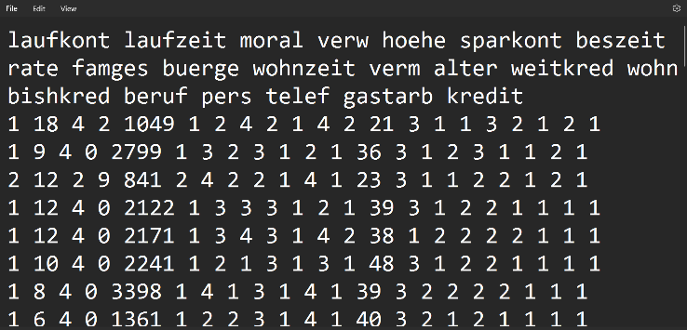
The original data was retrieved from the UCI Machine Learning Repository which consists of numerical data and corresponding attributes that may be utilised to determine the credit risk of each customer. Initially, the column headings were written in German language which needed to be translated into English language.

A text file containing metadata was also generated that provides further information about the data such as identifying the possible attributes with their datatypes. For instance, the datatypes for ‘Status’ will be 1 of 4 results: “no checking account”, “< 0”, “< 200”, “>= 200” and for ‘Credit Risk’, 1 of 2 results: “Bad”, “Good”.
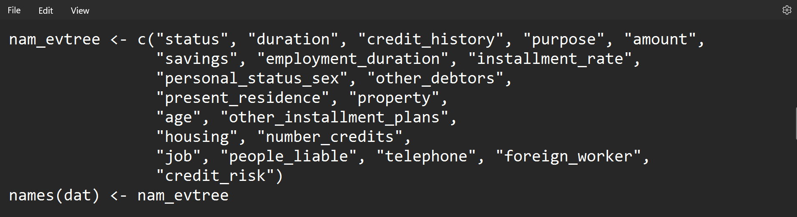
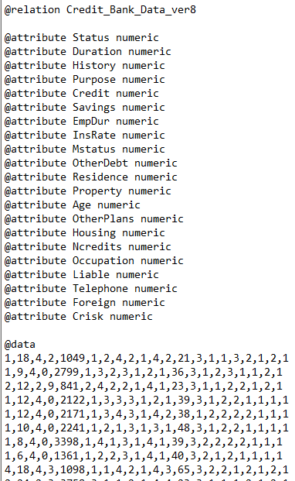

There are a total of 21 attributes of numerical and nominal datatypes which matched the context to each of the 1000 instances. The data needed to be converted into an ARFF file readable to WEKA (Waikato Environment for Knowledge Analysis). Each attribute was declared as numeric to match the given data.

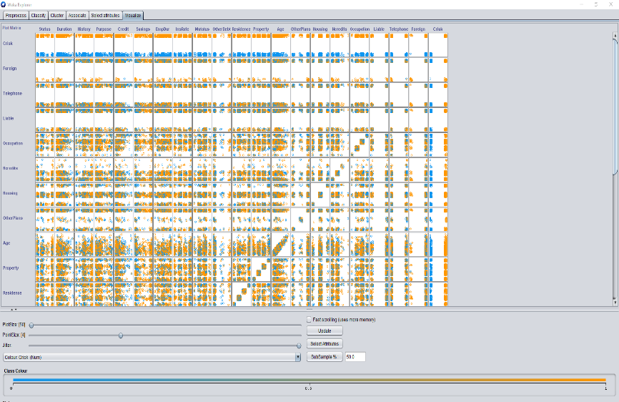
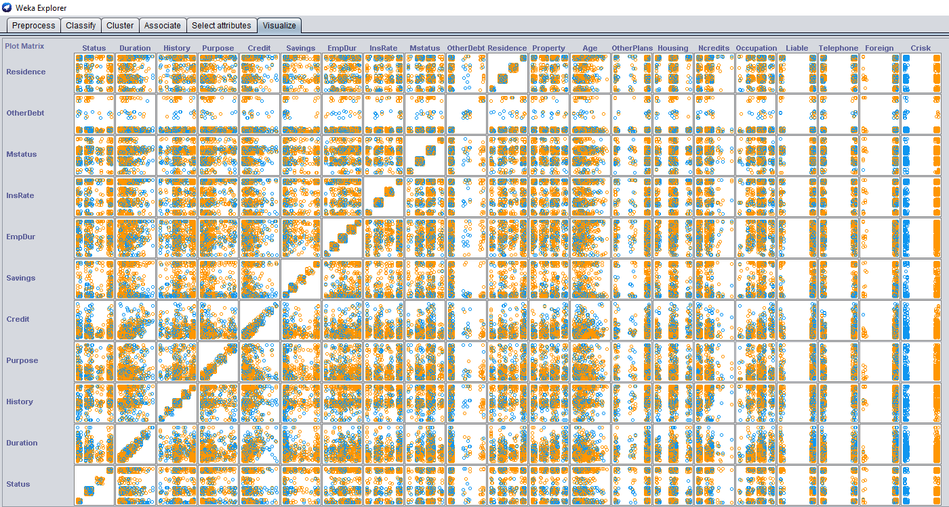
WEKA was able to interpret the file which allowed for visualisations to be produced for a comparison analysis. Patterns, anomalies, and trends may be established from this by utilising the jitter filter. For example, ‘Crisk’ at the X-axis (horizontal) conveys the same pattern from ‘Occupation’ to ‘Status’ at the Y-axis (vertical). However, it is challenging to comprehend the meaning of this analysis without providing the attributes (headings) with context to the results.

A deeper analysis was applied by selecting attributes of ‘Age’ and ‘Credit’ to compare influences on credit risk. To determine the credit risk, blue instances are represented as 0 and orange instances as 1, respectively, for "Bad" and "Good."
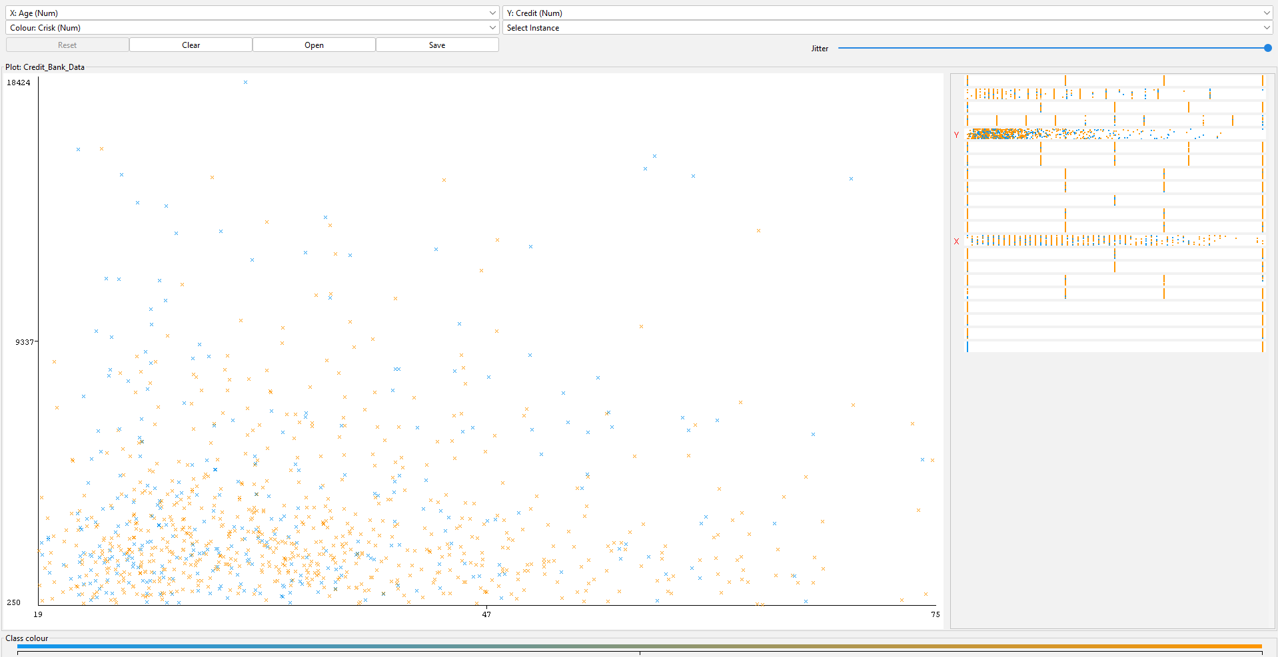

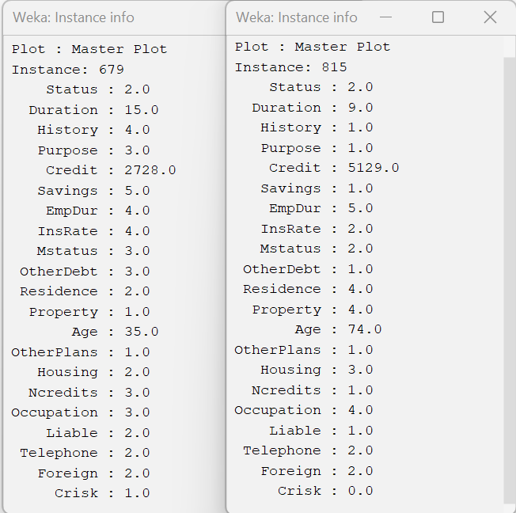
We determine that instance 679 is a good credit risk while instance 815 is bad. Instance 679 is requesting a lower credit amount with a history of 4, indicating that all prior credits have been correctly repaid. In contrast, instance 815 is requesting a higher credit amount, and their paying-off history of 1 indicates that they have additional credits from other banks. Instance 679 has savings of more than 1000 Deutsche Marks, while instance 815 has a higher age and lacks a savings account.

Pre-Processing

One of the most important steps in DM is data pre-processing, which includes several processes to get data ready and transformed for effective mining techniques. This entails managing operations like data reduction, which comprises choosing and extracting features and examples from a database, integrating multiple data sources, transforming data into formats appropriate for data mining tasks or aggregation operations, and eradicating noise and inconsistent data. Reducing the quantity of the data, discovering relationships within it, removing outliers, and extracting features from the dataset are the primary goals. Data pre-processing involves several approaches, such as data reduction, integration, transformation, and cleansing (9 p. 2, 10 p.4102).

ARFF File
An ARFF (Attribute-Relation File Format) file was constructed to meet WEKA’s compatibility to interpret the provided dataset. The first section of the ARFF is the header information which contains lines of ‘%’ for comments to add context that WEKA ignores, relation declarations that are identified as ‘@relation’ to specify the name or identifier of the dataset, and attribute declarations as @attribute which define the name and data type to each unique attribute. These attributes are declared in vertical formation to indicate the column position of each set of data.
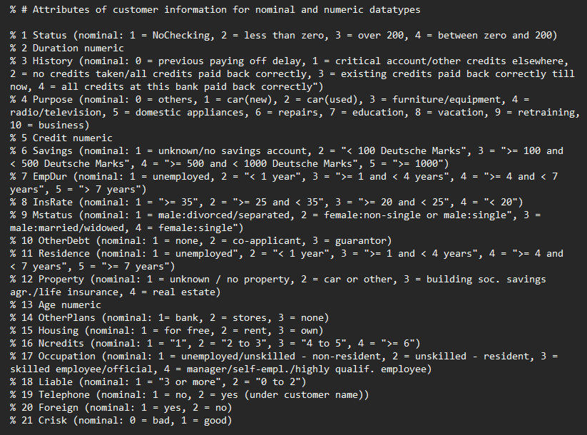
Here is an example of comments being applied consisting of metadata to explain the context of each attribute. The original attributes and their context were retrieved from the South German Credit’s banking repository. However, the context needed to be altered for the analyst to simplistically comprehend its meaning by adding these comments.

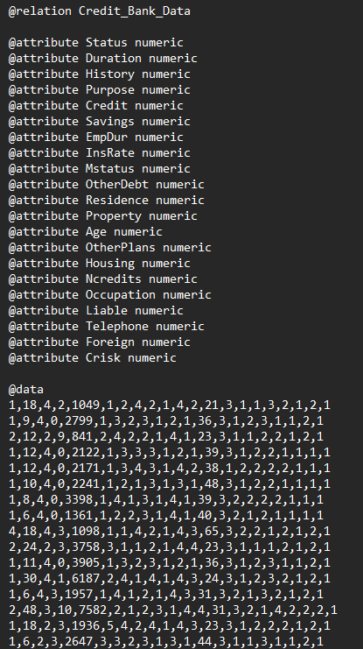

The attributes in this ARFF file were declared as numeric to match the data. Each attribute was declared by the additional information from the repository. The data consisted of 21 columns that matched the total number of attributes.

Data Cleansing
Although it was stated that the data did not contain any missing values, this was corroborated by importing the data into a spreadsheet formation using Microsoft Excel. However, the initial data was numeric, so it was challenging to identify any missing or incorrect values. This was resolved by transforming the numerical data into nominal data by applying VLOOKUP functions that search for specific values in each row.
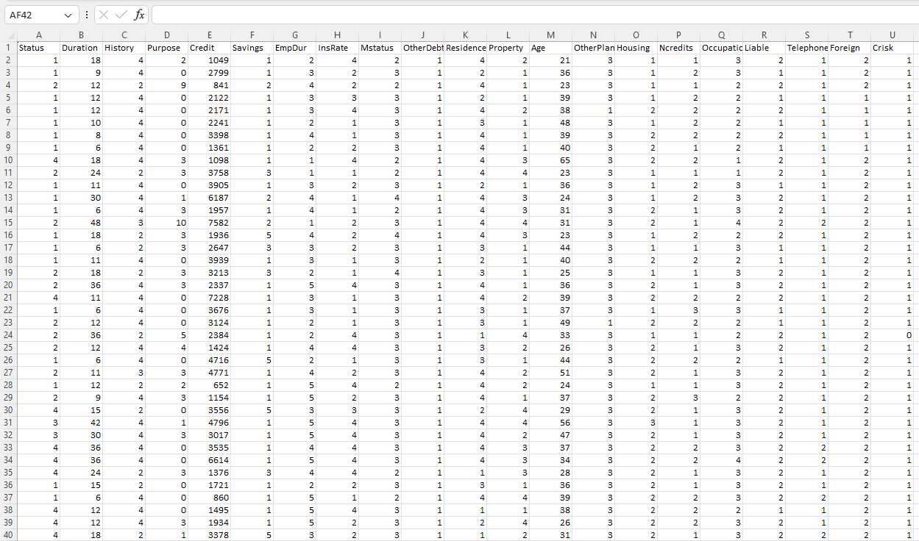

The highlighted cells were used in the VLOOKUP function to attach each nominal result that corresponds to each numeric datatype.
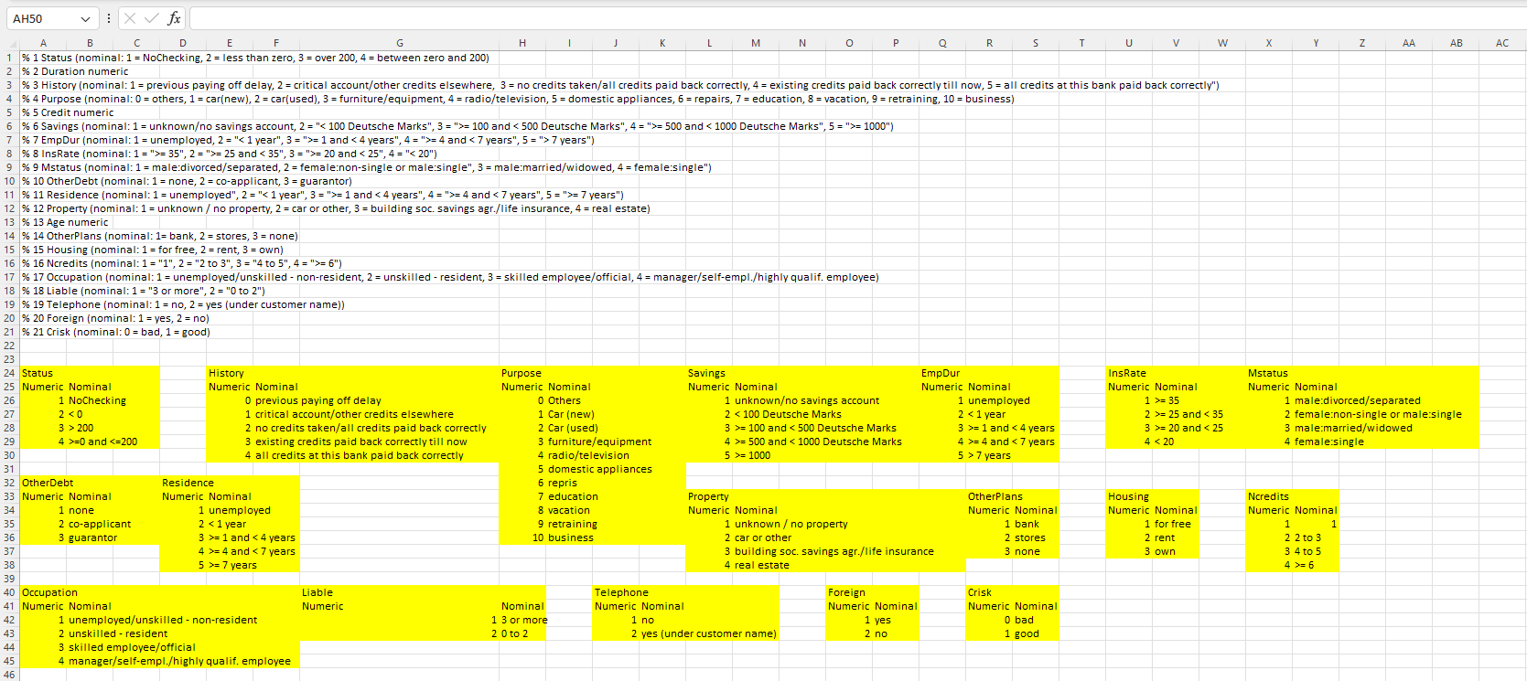

Having each row in nominal data assisted with the cleaning process which enabled all rows to obtain correct and efficient data for analysis. This nominal data was later inputted into an ARFF file where each attribute had to change from numeric to nominal except for ‘Duration’, ‘Credit’ and ‘Age’ which were solely numeric.
Example of the VLOOKUP function for ‘History’: =VLOOKUP(Original_Data!$C2,'Credit_Bank_Data - with vlookup'!$E$26:$F$30,2,TRUE)
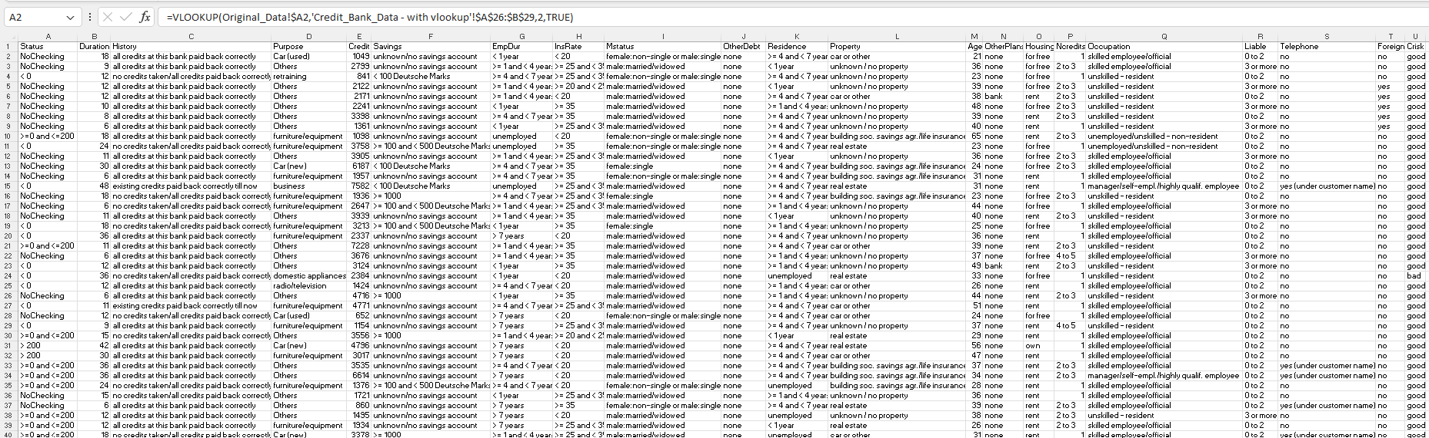

Post-Processing

Post-processing techniques are applied in DM for the analyst to attain knowledge from the noisy data and make comprehensions, in this case, determining if an instance is a credit risk to receive a loan or is likely to repay the loan correctly. For this stage, the data will be explored through statistics and visualisations produced by WEKA to gain insights and identify patterns and anomalies. This entails taking descriptive statistics, such as central tendency, dispersion, and feature correlation, and utilising them to summarise the data. It also comprises visualising data point distributions and applying clustering or classification algorithms to put comparable data points in one group (11). For erroneous, inaccurate, or unintuitive knowledge obtained using an inductive method, each of these post-processing techniques offers a type of symbolic filter (12).
A series of classification techniques have been utilised.

Linear Regression
The data mining industry frequently uses linear regression to ascertain the quantitative relationship between two or more variables. One independent variable and one dependent variable make up linear regression, and the relationship between the two can be roughly represented by a straight line (13 p.66).
Two sets of analysis were carried out for linear regression on the target variable ‘Crisk’, including an analysis using a 66% split and another using a training set. The correlation coefficient, which measures the two variables’ relationship strength, for the test split evaluation is 0.4546 and the training set evaluation is 0.4854 which indicates similarities and identifies the relationship between the predicted and actual values. The Mean Absolute Error represents the average differences between predicted and actual values. These results provided inaccuracies of 0.3505 for the test split and 0.3339 for the training set which signifies the latter as slightly better prediction performance. To analyse the error relative to the mean of the target variable (Crisk), the Relative Absolute Error can be evaluated. The test split has 81.40% while the training set has 79.48%, resulting in the latter being more accurate. However, these differences are very minimal and with the Crisk variable being binary (Good or Bad), it shows that linear regression may not be an accurate technique for this dataset.
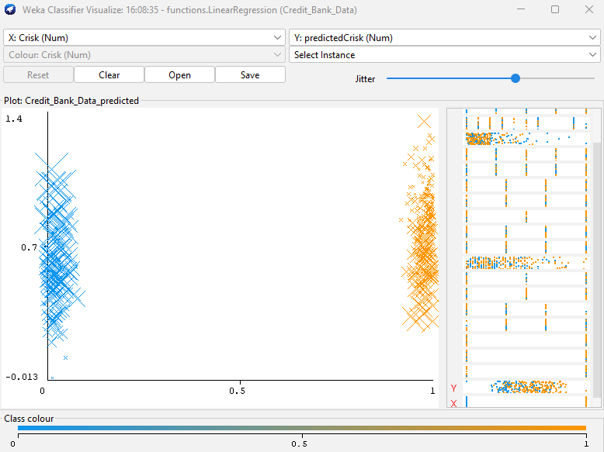

66% Test Spilt Training Set
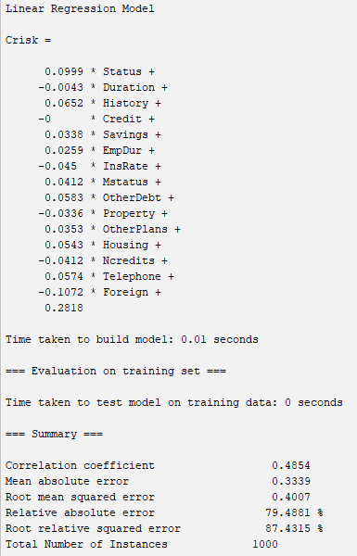
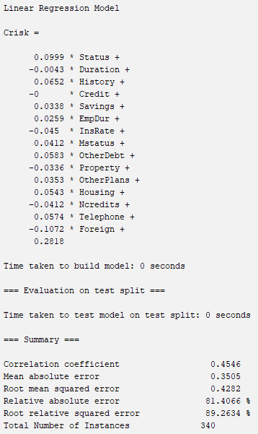

Random Tree
Random Trees operate as supervised classifiers in an algorithmic process to produce unique learners. This method generates a random collection of data for building a decision tree by using the bagging approach. The technique can handle issues involving both regression and classification. A random tree is one of the tree predictors that make up a forest. After classifying the input feature vector with each tree in the forest, the random trees classifier returns the class label that gained the majority of scores (14 p.441).
For this analysis, the same sets were utilised of the 66% split set and the training set. The tree on both consisted of 563 nodes which indicates the complexity of the model. The Correlation Coefficient was 0.158 for the split set which resembled a weak positive correlation between the direction and strength of the linear relationship. The training set resulted in 1, meaning a perfect relationship. Other split test results included MAE = 0.3618, RMSE = 0.6015, RAE = 84.02% and RRSE = 125.36% which can be translated to a weak result, compared to the training set which had zero errors for all predictions.
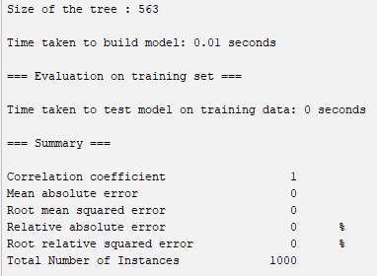
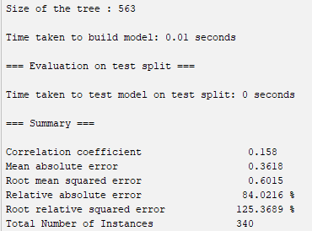
66% Test Spilt Training Set

Here is the tree visual on the training set data. It would be practical to alter and remove any parameters that have no relation to the model. This will significantly lower the number of nodes and help to eradicate any complexities as this representation is challenging to comprehend.

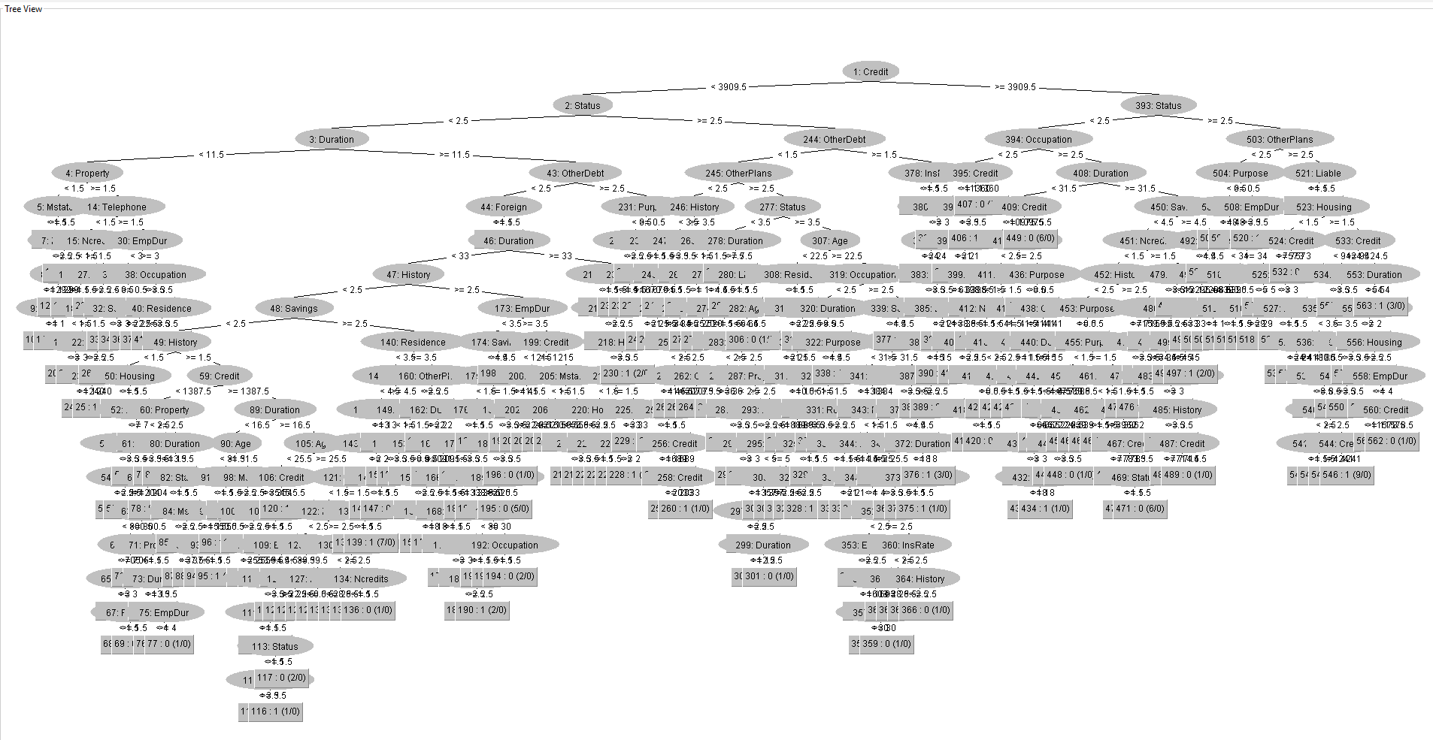

M5P
To minimise the number of nodes, pruning can be applied that removes unnecessary attributes which is represented below by using an M5P (M5 Pruned model tree). The tree structure is defined by conditions on each feature, which involve calculated formulas called Linear Models (LM) to predict ‘Crisk’ as the target variable for the disparate subsets of instances. The tree has only 2 branches where LMs are applied through rules: if ‘Status’ is <= 2.5, it predicts using LM1, if ‘Status’ is > 2.5 and ‘EmpDur’ is <= 3.5, it uses LM2, and if ‘Status’ is > 2.5 and ‘EmpDur’ is > 3.5, use LM3.
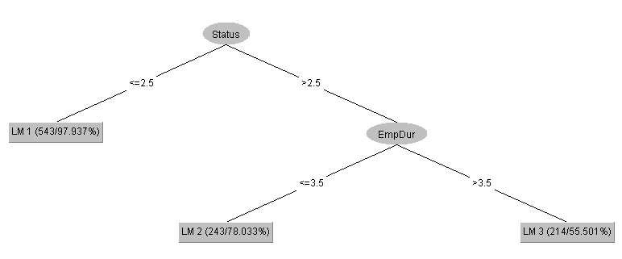

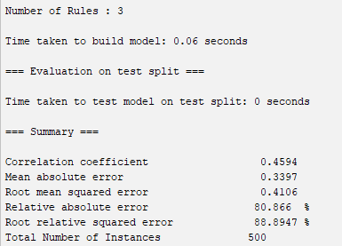
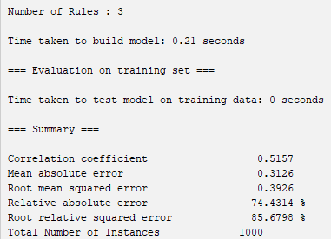
50% Test Spilt Training Set

K-Means Clustering
Clustering can be utilised in DM to represent similarities of relations throughout the dataset. In WEKA, K-means clustering was selected as an effective partitional clustering approach. First, K representative points are selected to serve as the initial centres. The nearest centre for each point is then determined by selecting a certain distance metric. The centroids of each cluster are updated when they have formed. Until the centroids remain unchanged or until another alternative condition is satisfied, the algorithm iteratively repeats these two phases (15 p.89).
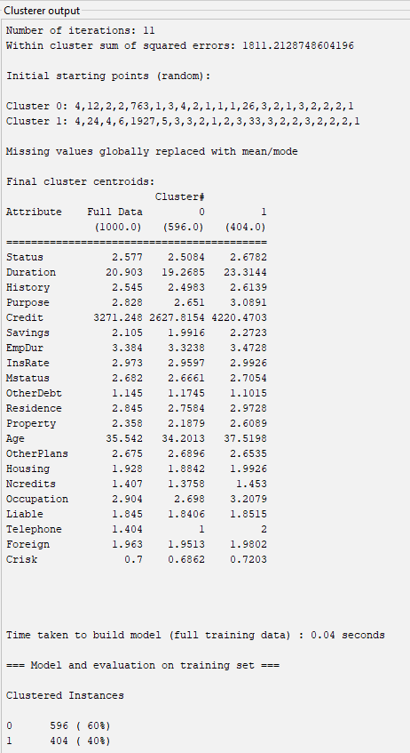
The results present the analysis of the Full Data (1000.0 instances), Cluster 0 (596 instances of 60%) and Cluster 1 (404 instances of 40%). This model shows similarities within ‘Crisk’ of 0.7, 0.6862 and 0.7203 respectively and also similarities with ‘Age’. However, with the data being numeric without any labels, it is challenging to interpret whether K-means clustering is accurate.

Similarities can be identified when visualising the data that represent ‘Crisk’ with other attributes such as ‘Credit’, ‘Duration’ and ‘Age’.
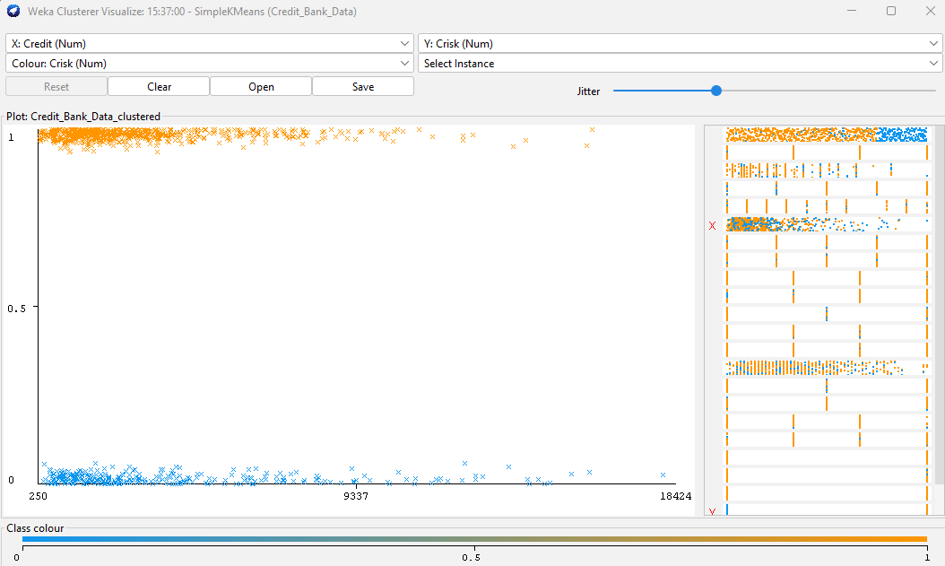

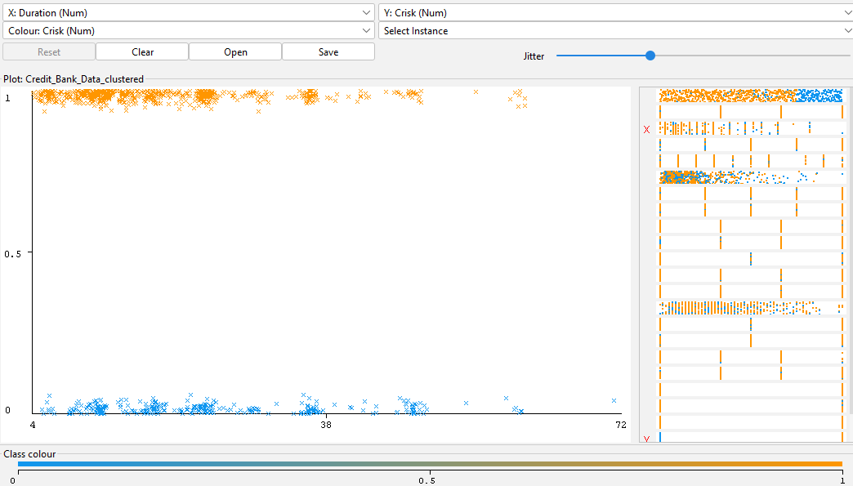

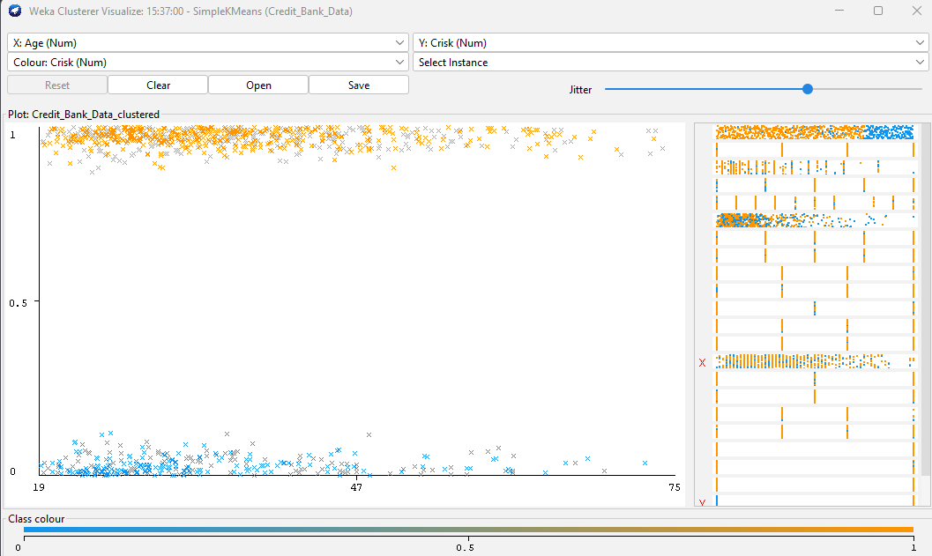

Nearest Neighbour (KNN)
A practical and well-known technique for supervised learning is KNN. This model is based on predicting a target output (Crisk) that a sample or object being queried ought to have based on the similarity principle by computing its k nearest neighbours. The k-NN technique uses the outcome of multiple nearby objects in the feature space of a training set, or the result of the nearest samples, to derive the target output of new items. One of the most straightforward machine learning algorithms is the k-NN algorithm, a technique that can handle both regression and classification issues (16 p.5).

In WEKA, the lazy IBK was executed which is a lazy learner that does not build a model during the training phase, unlike eager learners such as decision trees or linear classifiers. The IBK produces a comparison of the instances to the stored instances by formalising predictions during runtime from the stored training dataset.

The first analysis was run with the value of K set to 1 and a cross-validation test option of 10 folds with an example showing the first 20 results and the overall summary of the 1000 instances. The correlation coefficient is low which resembles weak predictions to the actual values, a high error rate of predictions is identified with the MAE and RMSE, and the relative errors are also high. This establishes that the lazy IBK 10 folds provide a mixed performance of accurate and inaccurate predictions.

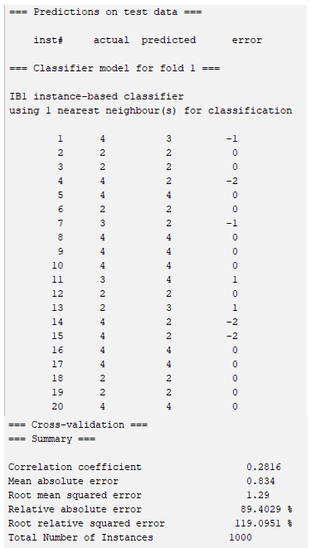

To further analyse, modifications were applied by altering the K value to 3 and using the training set test. The results were improved from the previous prediction model. The correlation coefficient is higher which establishes a stronger relationship between actual and predicted values, both MAE and RMSE were improved by decreasing in value, and the errors are reduced within the relative errors result. Overall, applying these modifications proved to be beneficial for predictions to some extent.
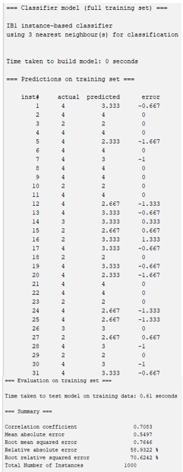

Business Recommendations

Businesses, such as South German Credit can utilise data mining techniques to harness predictions in obtaining accurate insights regarding their customers. In the banking sector, it is essential not only to improve customer retention but also to ensure that each customer is an asset to the organisation, for example, determining if they are a credit risk or if they are susceptible to repaying loans correctly.
On the sample runs executed, it was indicated that the classification models M5P and K-Nearest Neighbor (lazy IBK) showed relatively better performance for determining credit risk. M5P showed a moderate to good performance with a correlation coefficient of 0.5157 and provided lower errors compared to linear regression and random trees. However, M5P may be difficult to interpret predictions due to its decision tree structure, whereas KNN provides a straightforward understanding of how predictions are made. Changing the K value to 3, KNN increased its performance and accuracy with a good correlation coefficient of 0.7083 and empowered efficiencies for predicting the credit risk of each instance.
In summary, since identifying a loan default is not a straightforward linear trend, M5P's decision tree structure may be more effective at capturing numerous segments for varying ranges of a customer's credit history. The linear regression leaf formation allows M5P to perform precise approximation by comparing and evaluating multiple ranges of credit history with the target variable (credit risk). However, lazy IBK proves to be more efficient for predicting when dealing with large datasets such as banking data. The IBK model is robust to noisy data and obtains effectiveness through its regression techniques when using a set of independent variables (‘Status’, ‘History’, ‘Credit’) to predict the result of the dependent variable (‘Crisk’) (17 p.607). From this, IBK’s Nearest Neighbor may be the most practical method due to its predictive accuracies and simple interpretation framework.

Reflective Commentary

Was it a success?

The majority of models applied to the South German Credit dataset were classification algorithms by predicted the target class through analysing the dataset. These algorithms are regarded as the most commonly used DM techniques (18 p.150).

Linear Regression
The model predicted moderate accuracies and efficiencies and edged a slightly improved performance rate utilising the training set data. There were minimal differences between the MAE and RAE results of the test split and training set. Due to the target variable (Crisk) being binary (Bad or Good), linear regression resulted in an inaccurate approach.

Random Trees
Adopting this technique obtained complexities with a total of 563 nodes in the tree structure, which could be minimised by eradicating irrelevant parameters. A weak correlation resulted from the split set of 66% compared to a perfect correlation within the training set. The Random Tree model can assist in decomposing complex relationships but only if strategic modifications are applied through performance evaluation.

M5P
Applying pruning, M5P was able to provide accurate predicting formulas on specified conditions concerning the target variable (Crisk). The training set proved to be accurate and was easier to interpret its tree structure due to removing irrelevant nodes, compared to the Random Tree model.

K-Nearest Neighbor (lazy IBK)
Selected as the most appropriate model for the given dataset, lazy IBK resulted in the most accuracy out of each model. Executing a 10-Fold Cross-Validation with a K value of 1 proved to be inefficient, indicating weak predictions with high error rates. After making modifications to increase the K value to 3 and selecting the training set test, a correlation was strengthened in the relationship between predicted and actual values and errors were decreased – improving accuracy and efficiency.

K-Means Clustering
The clustering model proved to be ineffective for forecasting each instance as a credit risk or determining if loans will be paid correctly. However, clustering can be utilised to form similarities in the data which resulted in patterns between the target variable (Crisk) and independent variables of ‘Age’, ‘Duration’ and ‘Credit’. Interpretation challenges existed due to not declaring any nominal attributes, which would have provided explicit labels for analysis.

Advantages and Disadvantages

Classification Model | Advantages | Disadvantages
Linear Regression | Easy to interpret and provides good performance when the connections between the target and predictors are linear. | Fails to perform effectively with non-linear relationships.
Random Tree | Performs well with complex and non-linear interactions. | May become very complex if pruning modifications are not applied for node reduction.
M5P | Handles both numeric and nominal attributes efficiently and captures relationships between the target variable and multiple features. | Failure to modify pruning can result in interpretability issues.
K-Means Clustering | Great for identifying data patterns, clusters and hidden structures. | Selecting incorrect cluster centroids may prove to be sensitive.
Nearest Neighbour (KNN) | Obtains good performance for predictability and is simplistic to comprehend its results. | Performance may be affected by using the incorrect number of K values.

Future Improvements
To improve the data mining mechanisms, it would have been efficient to incorporate nominal attributes to harness a comprehensive predictive analysis. Due to each attribute being numeric, it was challenging during the evaluation phase and caused WEKA to not provide accuracy percentages in the statistics. The analyst declared nominal attributes and transformed the data into nominal results by using Microsoft Excel, but due to lack of technical skill was unable to make the ARFF file compatible with WEKA. This resulted in the analyst relating to the context section of the ARFF to determine each result, which impeded time and formed complexities.
A classification model, J48 Decision Tree, may have provided a more accurate and efficient analysis for the South German Credit dataset but due to all attributes being numeric, it failed to be implemented in WEKA. The J48 would improve performance by applying pruning techniques to summarise the relevant attributes and eradicate complexities in the decision tree, unlike the Random Tree model which consisted of interpretation discrepancies through excessive nodes.

References

- Dery D. Data Mining in Business Analytics. Western Governors University. 2020 [Accessed on 13.01.2024]. Available from: https://www.wgu.edu/blog/data-mining-business-analytics2005.html
- Verma K, Bhardwaj S, Arya R, Salim Ul Islam M, Bhushan M, Kumar A, Samant P. Latest Tools for Data Mining and Machine Learning. International Journal of Innovative Technology and Exploring Engineering. 2019 Aug 23;8(9S). DOI: 10.35940/ijitee.I1003.0789S19
- Rodriguez MZ, Comin CH, Casanova D, Bruno OM, Amancio DR, Costa L da F, et al. Clustering algorithms: A comparative approach. PLOS ONE. 2019;14(1). Available from: https://journals.plos.org/plosone/article?id=10.1371/journal.pone.0210236
- Alelyani S, Tang J, Liu H. Feature Selection for Clustering: A Review. Data Clustering. 2018. DOI:10.1201/9781315373515-2
- Cai J, Luo J, Wang S, Yang S. Feature selection in machine learning: A new perspective. Neurocomputing [Internet]. 2018 Jul;300. DOI: https://doi.org/10.1016/j.neucom.2017.11.077
- ‌Moin K I, Dr. Ahmed Q B. Use of Data Mining in Banking. International Journal of Engineering Research and Applications. 2012;2(2)
- Kumar V S, Rokade A, MS S. Bank Loan Approval Prediction Using Data Science Technique. International Research Journal of Modernization in Engineering Technology and Science. 2020;2(2). Available from: https://www.irjmets.com/uploadedfiles/paper/volume2/issue_5_may_2020/1222/1628083027.pdf
- Moradi S, Mokhatab Rafiei F. A dynamic credit risk assessment model with data mining techniques: evidence from Iranian banks. Financial Innovation. 2019;5(15). https://doi.org/10.1186/s40854-019-0121-9
- GarcíaS, Julián Luengo, Herrera F. Data Preprocessing in Data Mining. Intelligent Systems Reference Library 72. Springer International Publishing; 2015.
- Alasadi S S, Bhaya W S. Review of Data Preprocessing Techniques in Data Mining. Journal of Engineering and Applied Sciences. 2017;12(16). Available from: https://www.researchgate.net/publication/319990923_Review_of_Data_Preprocessing_Techniques_in_Data_Mining
- ‌Rivera S, Hammond T. What is data mining and what are the best techniques to follow? 2023 [Accessed on 28.01.2024]. Available from: https://www.thoughtspot.com/data-trends/data-science/data-mining
- Bruha I. Pre- and Post-processing in Machine Learning and Data Mining. Machine Learning and Its Applications. 2001;2049. DOI: https://doi.org/10.1007/3-540-44673-7_13
- Yang J, Li Y, Liu Q, Li L, Feng A, Wang T, et al. Brief introduction of medical database and data mining technology in big data era. Journal of Evidence-Based Medicine. 2020;13(1). Available from: https://www.ncbi.nlm.nih.gov/pmc/articles/PMC7065247/
- Kalmegh S. Analysis of WEKA Data Mining Algorithm REPTree, Simple Cart and RandomTree for Classification of Indian News. International Journal of Innovative Science, Engineering & Technology. 2015;2(2). Available from: https://ijiset.com/vol2/v2s2/IJISET_V2_I2_63.pdf
- Reddy C K, Vinzamuri B. Data Clustering: Algorithms and Applications. CRC Press. 2018.
- Triguero I, García-Gil D, Maillo J, Luengo J, García S, Herrera F. Transforming big data into smart data: An insight on the use of the k-nearest neighbors algorithm to obtain quality data. Wiley Interdisciplinary Reviews: Data Mining and Knowledge Discovery. 2018;9(2). DOI: 10.1002/widm.1289
- Imandoust, S.B., Bolandraftar, M. Application of K-Nearest Neighbor (KNN) Approach for Predicting Economic Events: Theoretical Background. International Journal of Engineering Research and Applications. 2013;3(5). Available from: https://www.ijera.com/papers/Vol3_issue5/DI35605610.pdf
- Keles M K. Breast Cancer Prediction and Detection Using Data Mining Classification Algorithms: A Comparative Study. Tehnicki vjesnik - Technical Gazette. 2019;26(1). DOI: https://doi.org/10.17559/TV-20180417102943
‌

