UNIVERSITY OF WALES TRINITY ST. DAVID

DIGITAL SKILLS AND RESEARCH METHODS (BMSW4003_LON)

A REPORT EVALUATING THE USE OF TECHNOLOGY, DIGITAL TOOLS AND TECHNIQUES TO IMPROVE EFFICIENCY IN HEALTHCARE.

STUDENT NAME: NEH NATACH CHE

STUDENT NUMBER: 2018139

WORD COUNT: 1544

LECTURER: DR. TOYIN ADISA
TABLE OF CONTENT
1. Introduction …………………………………………………………………………………….3
1.1 Executive Summary …………………………………………………………………………3
2. Main Body ……………………………………………………………………………………..3
2.1 Contemporary Technology in healthcare …………………………………………………3
2.2 The use of technology during COVID-19 ………………………………………….……...7
2.3 The use of digital communication, collaboration, and participation ……………….……7
2.4 The use of digital literacy to professional career development ………….……….…….7
2.5 The relevance of technical proficiency for information, data handling …………………7
3. Reference List …………………………………………………………………….……….….8
- INTRODUCTION
1.1 EXECUTIVE SUMMARY
The appreciation attached to the state of healthcare has seen a huge leap with considerable credit to technology and its digital transformation from just fax machine, postal courier and scientific knowledge application to present-day detection, diagnostics, treatment, and aftercare use of specifically identified instruments. The Telegraph (2017) supports that healthcare technology currently sits at an unprecedented position where smaller processing chipsets, longer battery life, and cheaper storage converge to deliver a unique service to humanity, an era similar to the mobile smartphone revolution. The author further stems the significant contribution of artificial intelligence (AI), 5G and robotics in future scans and disease detection with improved proven data control measures.
The technological capability has anchored best practices in the healthcare quest for optimisation, either clinical or economical when combined with analytics (Ross, 2018). Although employing technology and its digital aids accelerate relatively improved and ultra-fast treatment in healthcare, other scholars (Skinner, 2017) argue about affordability in the future as the advancement soars.
The document highlights a brief history of technology in healthcare over the past two decades and the revolution through disease and sickness detection, treatment, and support of patients to a better livelihood. This presentation seeks the relevance of digital literacy in healthcare through administration, training, self-development, aftercare and concludes with its impacts on societal values. The paper also talks about using technology during the global pandemic (COVID-19), the importance to professionals, career development and its daily healthcare effects.
The document concludes with the extent of the technological impacts on society and proficiency for information and data handling.
2. MAIN BODY
2.1 CONTEMPORARY TECHNOLOGY IN HEALTHCARE
The global society is undergoing a tremendous phase where early disease detection, ultra-tailored diagnostics for treatment, improved data analysis and storage and greater awareness of medical attention is the new norm, a massive credit to advance in technology. Through technology, scientists have significantly improved on extensive data analysis to better aid livelihood despite the considerably growing population. Arguably, there are few occurrences of death related to acute and chronic diseases with late detections.
However, diabetic type 1 cases have significantly reduced within the last two decades due to technological improvement (Diabetes.co.uk, 2015). Marr (2015) supports that technological courtesy appears to improve life expectancy over a century relative to earlier years. Technical aid spans from blood pressure gadgets and mobile apps, smart inhalers for asthmatic patients and robotic surgery to intervene in complex projects, to mention a few. Technologies in modern healthcare intervention include:
- Artificial Intelligence (AI) - Described by Mace (2020) as one of the greatest inventions in the last decade, although younger, AI appears to contribute immensely to the study of societal data based on pattern recognition (Espingardeiro, 2020). Szolovitz (2018, p3) adds that AI bridges the limitations of medical knowledge and extends an already studied medicine hypothesis despite practitioners undergoing recertification and constant training to find solutions to diseases. The author further stresses that AI serves as a bolster to present-day healthcare.

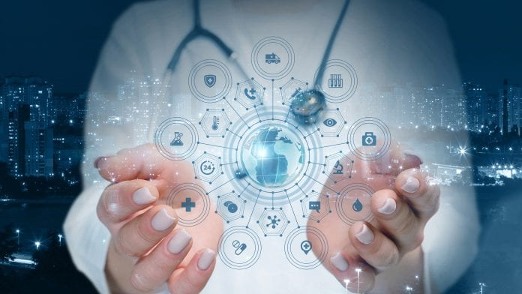
Fig. 1. ARTIFICIAL INTELLIGENCE (AI)
- Internet of Things (IoT) - Described as the interconnection of sensor systems with a comprehensive standard function, IoT draws a massive boost to society and, to a greater extent, healthcare. It brings quality to data analysis with accuracy (Karthick et al., 2019, pXXI). Shahrestani (2017, p2) supports that IoT simplifies treatment and enables quality attention through first-class records by relatively cheap sensors recording and transmitting patients' data to doctors.
- Virtual Reality – It identifies a virtual representation of an exact copy of a building facility without physical presence, ideal for patients with white coat syndrome. In this technology, patients can freely access the medical facilities and surgeons, or consultants can examine the mobility and vice versa remotely.

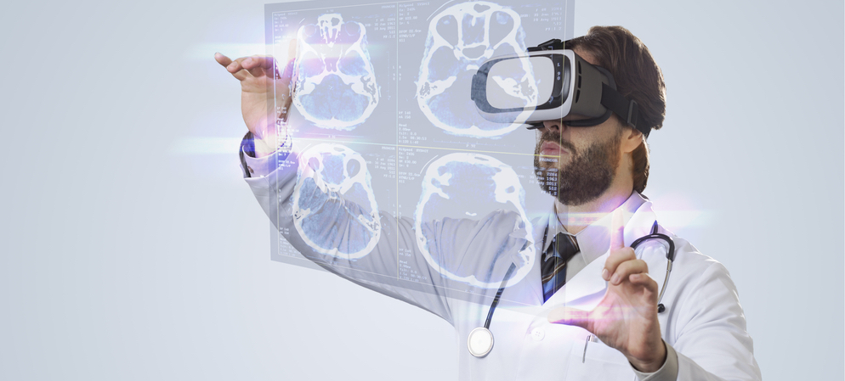
Fig. 2. VIRTUAL REALITY (VR)
- Telehealth – This technology is currently rated as the new norm where patients can attend their appointments via a link, either as a text message or email, without a physical medical centre or hospital presence. Health experts deem telehealth as a cost-effective way of hospital appointments.
- 3-D Printing – The technology behind enables medical professionals to track the levels of proposed glands under examination, which has been helpful compared to the previous analysis model.
- Blood Pressure Monitor – The technology behind the monitor aims to transmit high and low blood pulse signals to consultants for immediate attention at each recording. Purposely for pregnant women prone to pre-eclampsia and chronic hypertension individuals.
- Diabetes Monitor - The technology assists diabetic patients in recording and advising them on blood glucose levels without having to go to the hospital on regular appointments until alarming.
- Robotic Surgery – Robotics involve complex engineering to assist surgeons and consultants in performing complex surgeries. Health experts have described it as a lifesaver in contemporary medical practice.
- Health wearables – Surfaced in recent years to track steps and activities to improve life span, wearables like watches and similar gadgets have enabled the healthcare system to sync applications to monitor patients. It helps track progress in mobility-related recoveries, especially from a stroke, hip replacement related, and spinal cord correction.
- Personalised mobile apps - By way of technology through mobile apps, individuals can track their fitness progress and navigate their lifestyle. Although, it can be argued that most applications lean towards the internet for operation rendering the app useless when out of internet coverage zones.

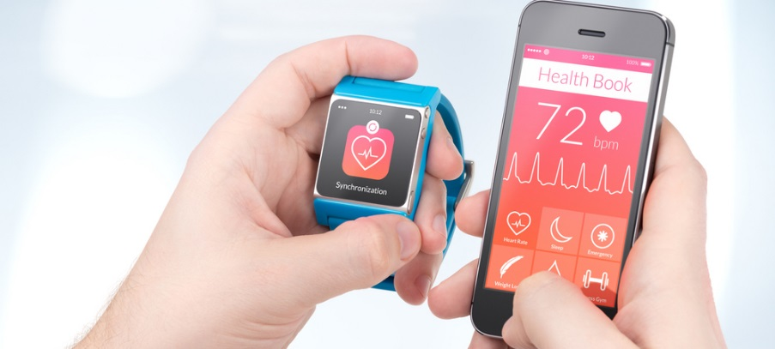
Fig. 3. PERSONALISED MOBILE APPS AND WEARABLES
2.2 THE USE OF TECHNOLOGY DURING COVID-19
Based on several assessments and data analysis across the world with sporadic spreading, the World Health Organisation (WHO), on 11 March 2020, declared the outbreak of the COVID-19 pandemic (WHO, 2020). Originated from Wuhan, a province in China and currently across the phase of the planet (Illmer et al., 2021), the pandemic has claimed over three million lives (WHO, 2021). Today, the healthcare systems worldwide experience tonnes of COVID-19 cases with overwhelming attention within ambulance operations (Connolly, 2020).
As a result, the pandemic has put a tremendous surge in healthcare professionals, pharmaceutical firms, and technical engineers to reform immediate response through intense but quick scientific research to initially minimise the spread and subsequently mitigate the deadly disease. World Health Organisation (2020) primarily responded with social distancing health policies backed by wearing face masks and coverings. However, with the help of telehealth and telemedicine, numbers have drastically been reduced relative to the former.
Although surgeries and other major procedures are suspended, doctors and consultants have pursued their usual consultancy remotely through virtual appointments, i.e., Microsoft teams, zoom meeting links, skype, and voice chatterboxes to engage and prescribe appropriate medications. Jansen et al. (2021) support that technology has significantly reduced the intense pressure from the healthcare system, restoring hope to society. Argued by some scholars on its accuracy, track and tracing system has strived on a positive note courtesy of technology. Bluetooth and the Internet of Things (IoT) have helped track and transmitted all scannable codes to identify exposures of people to infection at all visited areas. By way of technology, test samples have been conveyed from inaccessible areas to laboratories within the shortest time possible for examination.
Similarly, drones have successfully carried out medications to the right places avoiding real-time traffic and delivery problems.
2.3 THE USE OF DIGITAL COMMUNICATION, COLLABORATION AND PARTICIPATION
The brainpower behind blogs, mobile chats, website reviews, marketing advertisements on an online channel employs a carefully worked out algorithm to forecast future pathways for the advantage of companies. The same fundamental principle works out to gather records of employees, save data and key productivity indices of departmental performance for the growth of companies. In the medical and healthcare centres, the administration gathers data from all recordings of each sample and analyse the acquired data to raise advice on a patient or detect new patterns.
It is essential to understand the communication behind the technology. Duarte (2019) outlines that data is vague when there is no understanding of its analysis. Edelmann (2019) posits that communication behind digital transmission is the critical requirement for the future of healthcare.
2.4 THE USE OF DIGITAL LITERACY TO PROFESSIONAL CAREER DEVELOPMENT
Digital communication is the means of electronically transmitting information either by sending or receiving data. Today, there are many digital transmission modes or communication over various tools, including computers, mobile phones, tablets, watches, television, or radio. The means of communication over the tools include electronic mails, websites, mobile phone applications, social media, web conferencing, instant messages and cloud services.
Technology is currently evolving faster with fresh innovation across the phase of the earth each day. Digital literacy has significantly contributed to precise weather forecasting, sea level warnings, climate change awareness, deforestation, lost aeroplane searches, to name the major. On a personal level, digital literacy contributes immensely to professional career development in e-learning and teaching, where constant research over publications and articles are inevitable. Classic importance of digital use is its cost-efficiency, making decisions faster at a relatively reduced cost and time.

2.5 THE RELEVANCE OF TECHNICAL PROFICIENCY FOR INFORMATION, DATA HANDLING
Data handling is significant to every organisation. Stored data can be in the form of personal details of customers and health centres, patients, which, when compromised, could lead to severe sanctions, compensation, and eventually public backlash. It is, however, imperative to handle data with the strictest of safety and current training to handle the technicalities should there be any difficulty.

3. REFERENCE LIST
Connolly, M. (2020) Covid-19: Ambulance queues 'at all NI emergency departments'. Available from https://www.bbc.co.uk/news/uk-northern-ireland-55316063 [accessed 28 April 2021].

Duarte, N., 2019. 3 Ways to Help People Understand What Your Data Means. [online] Harvard Business Review. Available at: <https://hbr.org/2019/08/3-ways-to-help-people-understand-what-your-data-means> [Accessed 29 April 2021].

Edelmann, S., 2019. 7 ways digitization will shape the future of healthcare. [online] Healthcaretransformers.com. Available at: <https://healthcaretransformers.com/healthcare-business/digitization-future-of-healthcare/> [Accessed 29 April 2021].
Espingardeiro, A. (2020) How technology is addressing modern healthcare challenges. Available from https://www.healtheuropa.eu/how-technology-is-addressing-modern-healthcare-challenges/99553/ [accessed 27 April 2021].

Illmer, A., Wang, Y. and Wang, T. (2021) Wuhan lockdown: A year of China's fight against the Covid pandemic. Available from https://www.bbc.co.uk/news/world-asia-china-55628488 [accessed 28 April 2021].

Jansen, L., Faustenthal, L. and Cohen, D. (2020) Industry innovation: How has COVID-19 changed global healthcare?. Available from https://www.weforum.org/agenda/2020/11/healthcare-innovation-covid-coronavirus-pandemic-response-health [accessed 28 April 2021].

Mace, A. (2020) 9 health technologies every executive should be excited about in 2021. Available from https://healthcareweekly.com/health-technologies/ [accessed 27 April 2021].

Marr, B. (2015) Will These Tech Innovations Help Us Live Forever?. Available from https://www.forbes.com/sites/bernardmarr/2017/03/31/will-these-tech-innovations-help-us-live-forever/?sh=3ea984184d0c [accessed 27 April 2021].

Pankajavalli, P. and Karthick, G. (2019) Incorporating the internet of things in healthcare applications and wearable devices, 1st edition. Pennsylvania: IGI Publishers.

Ross, M., 2018. Why is Technology Important in Healthcare?. [online] Blog.cureatr.com. Available at: <https://blog.cureatr.com/why-is-technology-important-in-healthcare> [Accessed 5 April 2021].

Shahrestani, S. (2017) Internet of Things and Smart Environments, 1st edition. Cham: Springer International Publishing.

Skinner, N., 2017. Technology’s Vital Role in Healthcare and Society. [online] HIMSS. Available at: <https://www.himss.org/resources/technologys-vital-role-healthcare-and-society#:~:text=Our%20ability%20to%20store%2C%20share,saving%20the%20lives%20of%20others.> [Accessed 5 April 2021].

Technological advances have increased the life expectancy of people with type 1 diabetes, study finds - Diabetes (2021). Available from https://www.diabetes.co.uk/news/2015/oct/technological-advances-have-increased-the-life-expectancy-of-people-with-type-1-diabetes,-study-finds-99504624.html [accessed 27 April 2021].

The Telegraph. 2017. The new technologies transforming healthcare. [online] Available at: <https://www.telegraph.co.uk/business/open-economy/new-technologies-transforming-healthcare/> [Accessed 5 April 2021].

WHO Coronavirus (COVID-19) Dashboard (2021). Available from https://covid19.who.int/ [accessed 28 April 2021].

WHO Director-General's opening remarks at the media briefing on COVID-19 - 11 March 2020 (2020). Available from https://www.who.int/director-general/speeches/detail/who-director-general-s-opening-remarks-at-the-media-briefing-on-covid-19---11-march-2020 [accessed 28 April 2021].

