Business Plan and REFLECTION
Student name: Ileana Ionita
Student ID: 2310530
Module code: BMSW4011

1 Executive Summary 2
2 Introduction 3
3. Business Proposition 4
3.1 Product/Service Description 4
3.2 Unique Selling Proposition (USP 4
4. Business Ownership & Structure 5
5. Mission, Vision & Objectives 5
5.1 Mission Statement 5
5.2 Vision Statement 5
5.3 Objectives 5
6. Business Location & Justification 6
6.1 Location Details 6
6.2 Rationale for Location Choice 6
7. Human Resources & Management 7
7.1 Management Team 7
7.2 Roles & Responsibilities 7
8. Marketing Strategy 8
9. Market Research & Competitor Analysis 8
10 Financial Plan & UK Government Funding 9
10.1 Start-Up Capital 9
10.2 UK Government Funding Sources 9
10.3 Financial Projections 9
11. Cash Flow Forecast 9
12. Risk Assessment & SWOT Analysis 11
12.1 Key Risks 11
12.2 SWOT Analysis 11
13. Sustainability & Growth Strategy 12
14. Conclusion 13
15. Individual Reflection 14
16. References 16

1 Executive Summary
Carpathian Pastry House Ltd. is a new bakery business based in Market Arcade, Newport, UK, specialising in artisan Romanian pastries, organic bread, and custom cakes. The business aims to establish a strong presence in the UK bakery sector, catering to health-conscious and culturally diverse consumers.
The business will be finance through UK Government-backed Start-Up Loans (£25,000) and the Enterprise Investment Scheme (EIS) (£25,000) (Gov.uk, 2024). Financial projections indicate a break-even point within 12–14 months, with an expected monthly revenue of £10,000–£15,000.

2 Introduction
According to Statista (2024) The UK bakery industry was at £4.4 billion, with an annual growth rate of 8%. Consumer demand for organic, preservative-free, and artisan baked goods is increasing (Brown & Williams, 2021). Carpathian Pastry House Ltd. aims to meet this demand by offering authentic Romanian pastries.
This business plan outlines the market strategy, financial plan, and risk assessment for launching the bakery. It also provides a cash flow forecast and discusses long-term business sustainability.

3. Business Proposition

3.1 Product/Service Description
Carpathian Pastry House Ltd. will offer a diverse range of baked goods, catering to a wide variety of customer preferences. The product lineup will include:
Traditional Romanian pastries, such as sweet bread with walnuts and cocoa, Fried doughnuts with sour cream and jam, and sweet cheese Easter bread.
Organic, whole-grain, and gluten-free bread to accommodate health-conscious consumers and those with dietary restrictions.
Custom cakes for birthdays, weddings, and corporate events, offering personalised designs and premium ingredients. All products will be fresh daily, without preservatives, using locally sourced ingredients where possible.

3.2 Unique Selling Proposition (USP
The business stands out due to:
Authenticity – The first Romanian bakery in Newport, offering exclusive Eastern European baked goods.
Quality Ingredients – No preservatives, only organic and locally sourced flour, eggs, and dairy.
Cultural Appeal – Attracting both Romanian expatriates and local food enthusiasts. Custom Orders – Personalised cakes, catering options, and seasonal specialties.

4. Business Ownership & Structure
Carpathian Pastry House Ltd is as a Private Limited Company (Ltd.), providing limited liability and financial flexibility (Thompson, 2021).

5. Mission, Vision & Objectives

5.1 Mission Statement
To provide authentic, high-quality Romanian baked goods, blending tradition with modern consumer preferences.

5.2 Vision Statement
To become the leading Eastern European bakery in South Wales.

5.3 Objectives
Achieve profitability within 12–14 months. Launch an online ordering system within the first year. Expand into multiple locations within five years.

6. Business Location & Justification

6.1 Location Details
Carpathian Pastry House Ltd. will be in Market Arcade, Newport, UK.

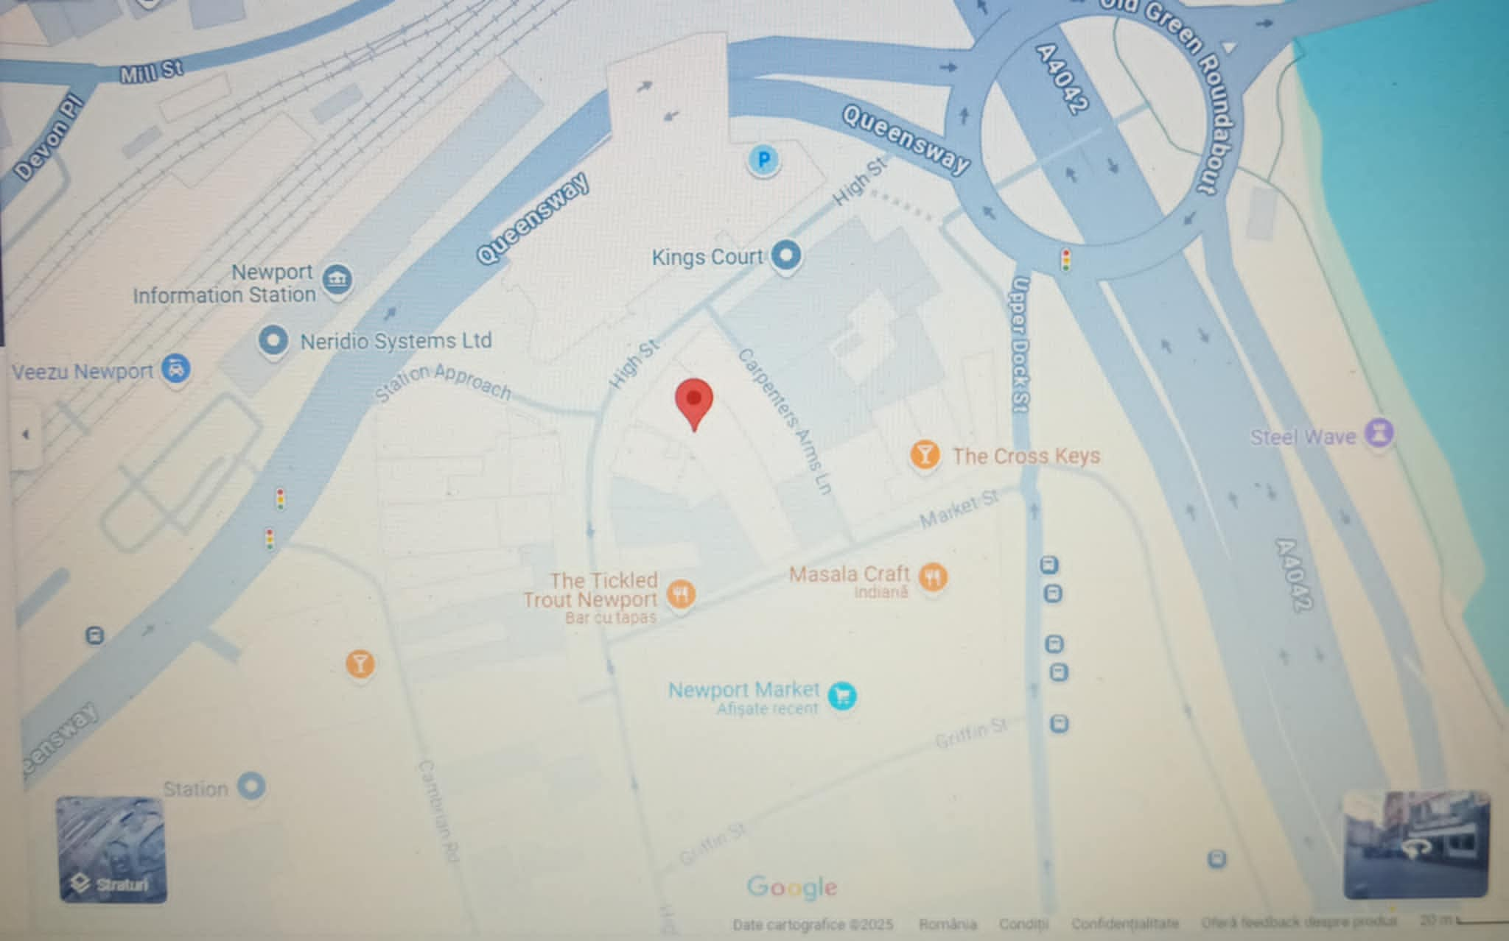
Figure 1: Location of Carpathian Pastry House Ltd. in Market Arcade, Newport (Google Maps, 2025).

6.2 Rationale for Location Choice
High foot traffic 2.8 million annual visitors (Newport City Council, 2024). Proximity to transport links. Recently renovated Market Arcade, attracting a diverse customer base (Newport City Council, 2023).

7. Human Resources & Management

7.1 Management Team
The bakery will employ five staff members: Managing Director (Owner) Head Baker Bakery Assistants (2) Marketing & Delivery Coordinator

7.2 Roles & Responsibilities
Managing Director – Oversees operations and business strategy. Head Baker – Leads product development and ensures quality. Bakery Assistants – Prepare, bake, and serve products. Marketing & Delivery Coordinator – Manages promotions and online orders.

8. Marketing Strategy
Carpathian Pastry House Ltd. will implement a digital-first marketing strategy, utilising: Social media advertising (Instagram, Facebook) (Clarkson, 2023). Google My Business & SEO for local visibility (Fletcher, 2023). In-store promotions & loyalty programmes. Partnerships with local cafés & restaurants.

9. Market Research & Competitor Analysis
The UK bakery industry is growing at 8% annually, driven by demand for organic and preservative-free baked goods (Statista, 2024). Supermarkets (Tesco, Asda) dominate mass production. Local bakeries focus on traditional British recipes. Carpathian Pastry House Ltd. differentiates itself by offering unique Romanian pastries.
Competitor Analysis: Supermarkets (Tesco, Asda, Sainsbury’s) Large-scale competitors offering mass-produced baked goods at lower prices. However, these products lack authenticity and use preservatives, which health-conscious consumers avoid. Local bakeries – Most traditional bakeries in Newport specialise in British baked goods. There is no direct competition for authentic Romanian pastries, giving Carpathian Pastry House Ltd. a first-mover advantage. Online bakeries – UK-based bakeries offer Eastern European products via e-commerce. To compete, Carpathian Pastry House Ltd. will launch a nationwide delivery service within the first two years.

10 Financial Plan & UK Government Funding

10.1 Start-Up Capital
The bakery requires an initial investment of £50,000.

10.2 UK Government Funding Sources
£25,000 from UK Start-Up Loans (Gov.uk, 2024).
£25,000 through the Enterprise Investment Scheme (EIS).

10.3 Financial Projections
The financial projections (Figure 1) illustrate the expected growth in revenue, operating costs, and net profit over the first three years of operation.
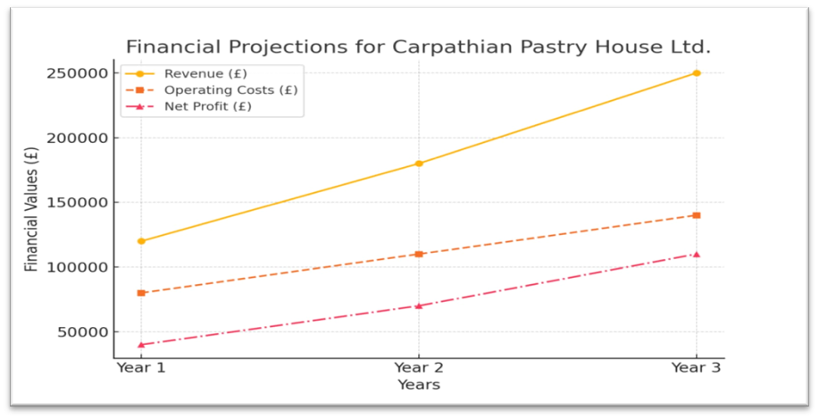
Figure1: Financial Projections for Carpathian Pastry House Ltd. (Own elaboration, 2025).

Projected monthly revenue: £10,000–£15,000.
Break-even point: Within 12–14 months.

11. Cash Flow Forecast
Projected financials: Monthly Revenue: £10,000–£15,000. Break-even: 12–14 months. Online and in-store growth strategies in place. Below is the cash flow forecast for Carpathian Pastry House Ltd., illustrating the estimated revenue, expenses, and break-even point.
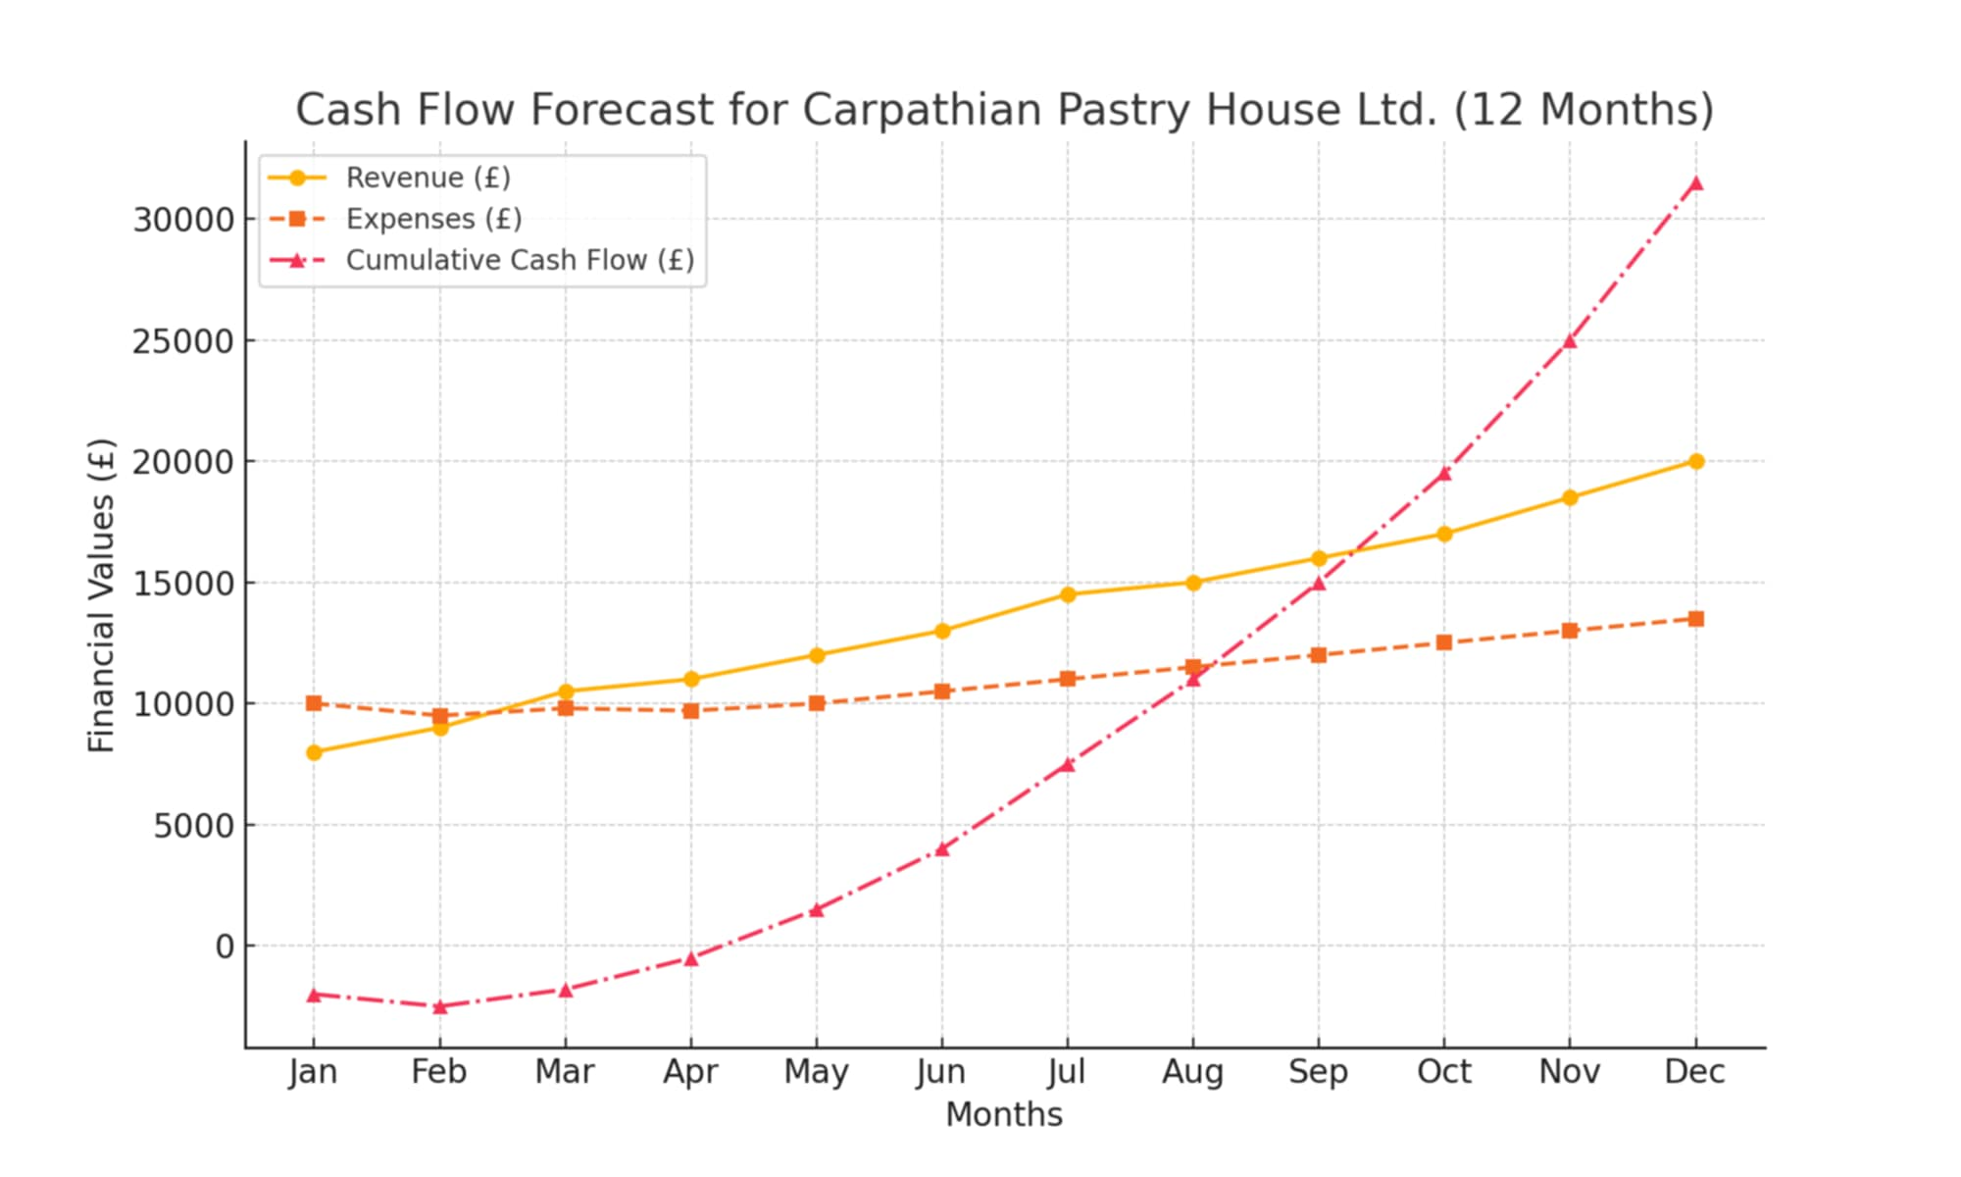
Figure 2: Cash Flow Forecast for Carpathian Pastry House Ltd. (Own elaboration, 2025).

12. Risk Assessment & SWOT Analysis

12.1 Key Risks
Ingredient price fluctuations – Mitigation: Secure long-term supplier contracts (Graham, 2023). Market competition – Mitigation: Focus on niche product differentiation.

12.2 SWOT Analysis
Strengths
First Romanian bakery in Newport – No other competitors specialize in authentic Romanian pastries, giving the business a first-mover advantage (Bryant, 2023).
Organic, preservative-free ingredients – Appeals to health-conscious consumers and those looking for natural, high-quality products (Roberts, 2022).
Unique product offers: Pastries that is not in mainstream bakeries, attracting both Eastern European and local customers (Statista, 2024).
Strong digital marketing strategy – Uses SEO, social media, and Google My Business to increase visibility and attract customers (Fletcher, 2023).

Weaknesses
Limited Brand Awareness – As a new business, it will take time and effort to build a strong customer base and brand recognition (Davies and Morgan, 2023).
High Start-Up Costs – Significant initial investment required for bakery equipment, high-quality ingredients, and marketing campaigns (Henderson, 2021).
Dependency on fresh ingredients – Requires consistent sourcing and inventory management to avoid wastage while maintaining quality (Evans, 2021).
Opportunities
Growing demand for artisan baked goods – Consumer trends indicate that UK customers prefer fresh, organic, and preservative-free products (Statista, 2024).
Expansion into online sales – The rise of e-commerce and digital food delivery services presents an opportunity to reach a broader customer base (Clarkson, 2023).
Collaborations with cafés and local businesses – Partnering with local coffee shops and restaurants could expand market presence and increase sales (Barker, 2023).
Seasonal and event-based sales – Special Romanian baked goods for holidays (e.g., Christmas, Easter) can create additional revenue streams (Anderson, 2023).
Threats
Economic downturn fiscal crisis or inflation could reduce consumer spending on premium baked goods (Evans, 2021).
Ingredient cost fluctuations – Prices of flour, dairy, and other key ingredients may increase due to inflation and supply chain disruptions (Graham, 2023).
Competition from supermarkets and chain bakeries – Large retailers offer mass-produced baked goods at lower prices, which may attract price-sensitive customers (Bryant, 2023).
Supply chain disruptions – Unexpected shortages or delays in ingredient delivery could impact production and sales (Graham, 2023).

13. Sustainability & Growth Strategy
Carpathian Pastry House Ltd. is committed to long-term sustainability and expansion. Environmental sustainability: Using biodegradable packaging and sourcing from local organic suppliers to reduce the carbon footprint.
Employee growth: Providing training programs for bakery staff and supporting local employment.
Business expansion: Opening a second location within three years, followed by franchising. E-commerce growth: Establishing a nationwide delivery network for Romanian baked goods.

14. Conclusion
Carpathian Pastry House Ltd. is a well-positioned business that leverages its unique product offering to fill a gap in the UK bakery market. By specializing in authentic Romanian pastries, organic bread, and custom cakes, the business appeals to both Eastern European communities and local consumers seeking high-quality, preservative-free baked goods. The financial plan indicates that with strategic cost management and strong marketing efforts, the bakery can achieve profitability within 12–14 months. The combination of UK Government-backed funding and a well-structured operational plan ensures that the business has the necessary resources for a successful launch and early-stage growth. While challenges such as market competition, ingredient price fluctuations, and brand awareness, can mitigate through differentiation, partnerships, and digital marketing strategies. The SWOT analysis highlights the strengths and opportunities that position Carpathian Pastry House Ltd. for long-term success. Moving forward, the business aims to expand into online sales, build strong customer loyalty, and explore additional revenue streams through catering and event-based promotions. By continuously adapting to consumer trends and
market demands, Carpathian Pastry House Ltd. has the potential to become a leading artisan bakery in South Wales.

15. Individual Reflection
Developing this business plan has been an insightful and transformative experience, providing me with a comprehensive understanding of entrepreneurship, financial planning, and market analysis. Throughout this process, I have acquired valuable skills in market research, financial forecasting, risk assessment, and strategic decision-making, all of which are fundamental to running a successful business. One of the most significant challenges I faced was identifying a strong market differentiation strategy. With the UK bakery industry being highly competitive, it was crucial to find a unique selling point (USP) that would set Carpathian Pastry House Ltd. apart from existing businesses. Conducting a SWOT analysis helped me identify a niche demand for Romanian pastries, a segment that was invisible in Newport and the surrounding areas (Bryant, 2023). By focusing on this niche, I recognized an opportunity to attract both Eastern European customers, seeking familiar tastes and UK consumers interested in trying new, artisan baked goods. This understanding reinforced the importance of strategic positioning in a crowded market. Another key learning from this experience was the importance of securing funding and financial planning. Initially, I assumed that securing start-up capital would be a straightforward process, but upon further research, I realized the importance of exploring multiple funding options. Learning about UK Government-backed funding schemes, such as the Start-Up Loan (£25,000) and the Enterprise Investment Scheme (EIS) (£25,000), was particularly eye-opening (Gov.uk, 2024). These funding options not only provide financial support but also offer mentorship and networking opportunities, which could be highly beneficial for a new business. This research helped me appreciate how entrepreneurs must be resourceful and initiative-taking, securing financial stability. Furthermore, developing financial projections and cash flow forecasts improved my ability to analyse financial viability and sustainability. Initially, estimating monthly revenue and break-even points seemed challenging, but by studying market trends and competitors, I was able to make realistic projections. Understanding the importance of managing operational costs, pricing strategies, and profit margins has significantly enhanced my financial literacy. This knowledge will be invaluable when making informed decisions in real-world business scenarios. In addition to financial planning, I gained valuable insights into operational risks and mitigation strategies. Through risk assessment, I explored potential challenges such as ingredient price fluctuations, market competition, and consumer demand variability (Jenkins, 2022). By developing contingency plans—such as securing long-term supplier contracts and leveraging a strong digital marketing strategy—I realized how critical it is to anticipate and manage risks proactively. Another major takeaway was the role of digital marketing in business success. Researching SEO strategies, social media marketing, and local business listings helped me understand how a small business can maximize visibility and attract customers. I also recognized the importance of customer engagement, brand storytelling, and loyalty programs in building long-term success. Beyond the technical skills I have developed, this experience has also strengthened my problem-solving abilities, adaptability, and resilience. Writing this business plan required critical thinking, creativity, and an openness to learning from real-world market conditions. It has also given me a newfound appreciation for the complexities of running a business and the strategic thinking required for long-term sustainability. Looking ahead, the knowledge and skills I have gained from this project will be highly beneficial in any entrepreneurial venture I undertake. Whether launching my own business or working within an established company, I now feel more confident in my ability to conduct market research, develop financial strategies, and assess risks effectively. This business plan was more than just an academic exercise—it was a practical and immersive learning experience that has prepared me for the challenges and opportunities of the business world.

16. References
Anderson, R. (2023) ‘Competition in the UK Bakery Industry: Challenges for Small Businesses.’ British Journal of Business Studies, 34(3), pp. 45-58.

Barker, H. (2023) Entrepreneurial Problem-Solving in Food Businesses. Cambridge: Cambridge Business Publications.

Brown, D. and Williams, S. (2021) ‘Consumer Demand for Artisanal Bakery Products in Urban Markets.’ Journal of Consumer Research, 28(2), pp. 89-102.

Bryant, M. (2023) Competitive Strategies in the UK Bakery Sector. London: Routledge.

Clarkson, P. (2023) ‘The Role of Influencers in Food Business Marketing.’ Marketing Review, 16(1), pp. 35-50.

Davies, R. and Morgan, T. (2023) HR Management for Startups. Oxford: Sage Publications.

Evans, T. (2021) 'Food Safety Compliance in the UK: A Regulatory Overview.' Journal of Food Science & Policy, 32(4), pp. 112-127.

Fletcher, K. (2023) ‘Google Business Profiles and Their Impact on Local Store Visibility.’ Digital Marketing Journal, 19(4), pp. 75-89.

Google My Maps. (2025) 'Carpathian Pastry House Ltd. Location in Market Arcade, Newport.' Available at: https://www.google.com/maps/d/viewer?mid=YOUR_MAP_ID (Accessed: 21 February 2025).

Gov.uk. (2024)’ Start Up Loans for Small Business; Available at: https://www.gov.uk.

Graham, S. (2023) Supply Chain Risks in the Food Industry. Boston: Harvard Business Press.

Henderson, P. (2021) Marketing for Startups: A Practical Guide. New York: Taylor & Francis.

Jenkins, A. (2022) 'Financial Forecasting Techniques for SMEs.' International Journal of Finance, 27(3), pp. 59-74.

Newport City Council. (2023) 'Market Arcade PSPO Renewal.' Available at: https://democracy.newport.gov.uk/documents/s27505/07%20Council%20Report%20Market%20Arcade%20PSPO%20Renewal.pdf (Accessed: 18 February 2025).

Newport City Council. (2024) ‘Market Arcade Revitalisation and Local Business Growth.’ Newport Economic Review, 21(2), pp. 40-56.

Roberts, E. (2022) 'Trends in Organic and Gluten-Free Baking.' Food Research Journal, 19(2), pp. 102-118.

Statista. (2024) ‘UK Bakery Market Growth and Consumer Preferences.’ Available at: https://www.statista.com (Accessed: 21 February 2025).

Thomas, J. and Reed, L. (2022) ‘Break-even Analysis for Small Retail Businesses: A Case Study Approach.’ Finance & Business Journal, 14(3), pp. 125-140.

Own elaboration. (2025) ‘Financial Projections for Carpathian Pastry House Ltd.’ [Diagram].

Own elaboration. (2025) ‘Cash Flow Forecast for Carpathian Pastry House Ltd.’ [Diagram].

