Digital skills and Research Methods (BMSW4003) Lecturer: Joy Botu
Student: Anisoara Sevescu (1921539)

Disc herniation … back pain
And magnetic resonance imaging technology

London (2021)

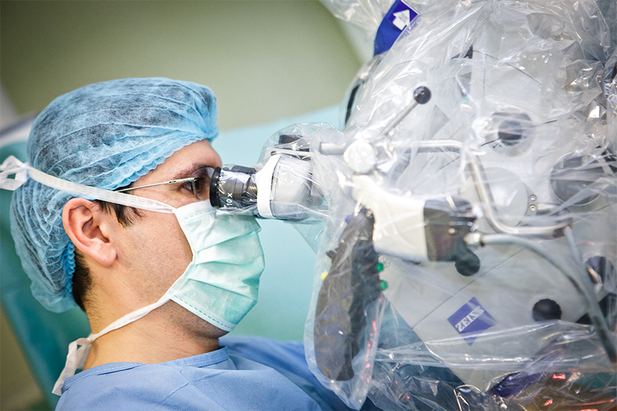
Introduction
The herniated disc is caused and provoked by several causes. It can be the cause of an accident or simply a common injury with the fall of the person. It can also be the cause of a ruptured vertebral disc or its injury. With the passage of years and age the cartilage the vertebrae begin to have the same elasticity, deteriorating. The pain begins to persist with inflammation of the joints and the formation of beaks, pressing on the nerve endings. This type of pain is tripled in intensity due to the state of too many hours standing, the person accusing a sharp back pain. They usually appear as pains that influence muscle mass such as muscle spasms called cramps. Pain and their frequency vary depending on the problems caused and the already existing ailments of the affected person.
Often the pain felt can lead to the limitation of normal movements. This type of pain and the type of intensity that the person faces can be the cause of various problems for example: the cause of a trauma as mentioned in the description above as an accident or caused. Pregnancy can cause an overload of ligaments and muscles in this area. The presence of a tumour but in much rarer cases the pain having a very large-scale intensity from 1-10 being even starting from 8 rising very quickly to 10. Other factors that manage the intensity and causes of pain can also be obesity, menopause, kidney disease even gynaecological and body posture that we use incorrectly in the state of the office chair or even driving, so the causes and factors are multiple.
In many cases when the pain goes down on the leg it should not be neglected but you should go to the emergency room because it is a much more severe condition with a compromise of the nerve and its crushing. In this case the injuries are very difficult to recover in case of paresis with nerve pain. sciatic.
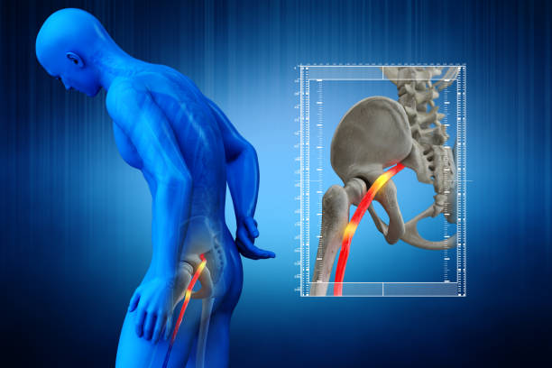
Body
The visit to the doctor consists in examining, evaluating, the frequency of the pain, finding the problem, solving it by performing and recommending the patient a nuclear magnetic resonance (NMR), to finalize and give a correct and conclusive diagnosis to the patient. Foot pain is referred to several treatments that can relieve the pain often even disappearing depending on the individual patient.
If the pain does not disappear but on the contrary worsens then the patients in question are sent to do a nuclear magnetic resonance this being specifically indicated in examining the spinal cord and nerves examining the nerve element to see the cause and make a correct diagnosis.
In the case of pain, they oscillate from patient to patient, differentiating each person's metabolism and the threshold of pain borne in different cases. Usually, the pain affects only one part of the body.
In the case of disc herniation, patients may have pain of varying intensity depending on the severity of the situation and how the patient endures the pain he has. I present in this material the diseases of the lumbar disc herniation due to the experiments had in the family, and as a transmitted genetic inheritance, from generation to generation.
The spine is made up of vertebrae and cartilage. These cartilages have the shape of small pillows with a high-water content in them that with age and aging begin to consume becoming thinner due to their dehydration with advancing age but not only because of this but also of the various factors that contribute to their deterioration. An example would be smoking (which can lead to low oxygen consumption on the disc, so the risk of decomposing faster is much faster). Again, it is the main factor in this inheritance of the family tree.
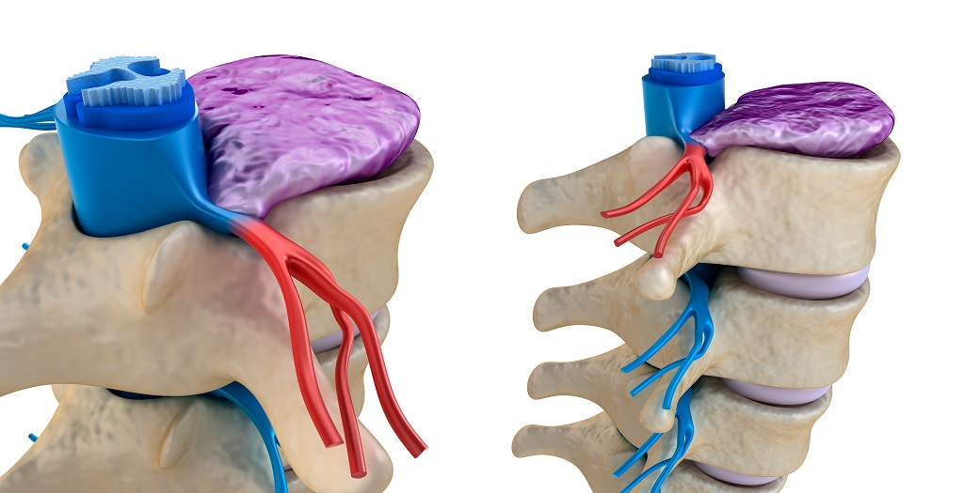
That is why when we are young, we have a few extra centimetres at our height, which decreases over the years precisely for this reason.
The vertebral canal has the function, the passage of the spinal cord having two nerves on each side. When the disc is affected, it can cause injuries or even break it for various reasons such as: overworked weight or even sedentary life can affect the same measure this lumbar problem. Once broken or fused it presses on the nerves or the marrow inside. If the pain is localized then the intensity of the pain is lower, however if the disc is broken then the pain goes down the leg with the risk of crushing nerve and foot paralysis.
The cases are classified, in emergency and the recoveries are examined according to the patient's condition. If the patient has only pain that does not accuse the pain left on the leg, then they are assigned or sent to the recovery centres through treatments in the patient's recovery.
Unlike patients who have already suffered a paresis and do not move a leg, they are sent urgently to have an MRI to examine the exact cause and to enter the operation urgently.
In general, the treatment lasts on average 6 weeks recommended by the doctor, of course only if the patients are irrecoverable at the recovery centres and the acute pain is examined and directed to the operating room according to the problems of each one.
In many cases, the prevention and correction of a correct posture, exercises in nature, body weight and quitting smoking can obviously improve the patient's condition if he does not have leg pain.
Surgery is recommended only if the patient risks paresis on the leg, otherwise it is recommended that recovery medical therapy be applied before surgery if the patient as I said does not have pain that is left on the leg and cause the risk of the technology used in the case of the operated ones. First a correct diagnosis is given after which the area that causes the patient's problem is identified. After the cause has been identified and the area that can be injured such as L4 and L5 lumbar vertebrae the patient is sent to the ward operation.
Once on the operating table, he is given total anaesthesia, and begins the intervention procedure for which he entered the operating room.

Conclusion
Once in the newer operating room, the technology technique is used by approaching through a tiny 2.5 cm length incision made with an operating microscope. Its name is also the minimum-invasive method with an operating microscope.
Through this tiny incision, a surgical instrument is introduced with the aim of creating a tunnel through the muscles, thus offering a clear view in the operation of the operating field under that small incision. The technique reduces blood loss and limits muscle injury.
The use of the operating microscope is done to see, control and limit the damage of healthy tissue so as not to destroy it. The advantages of such an intervention are in the rapid and efficient recovery of the patient by shortening the hospitalization period, reduced pain intensity.
The notions of computer technology and high-performance technology bring a professional and experimental growth in the health system to create unparalleled performance and qualification opportunities by training staff by offering special training in the career path. Helping both qualified staff to develop their skills and in support of patients.
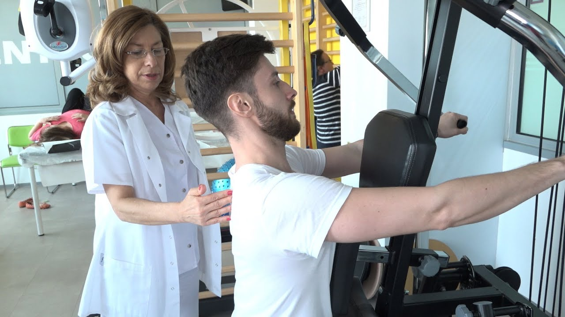
Dr. Ruxandra Iliescu, (2020), Lumbar diseases that require surgery, Doctor's Advice. ro (20/07/2021), Bucharest Emergency Clinical Hospital.

