Name: Isla Pinches
Student number: 2500455
Course title: BA design Crafts: Glass, Ceramics and Jewellery.
Tutor: Menna Buss

Tasks in the order I received them.
Task 1- manifesto writing- 467 words.
Task 2- Observational writing- 385 words.
Task 3- practice based writing- 408 words.

8 manifestos
- We embrace imperfections
- to make use of art as a tool for healing
- we raise awareness through art change through story Talent
- breathe new life into forgotten materials
- we push the boundaries of art in the digital age
- consider everything to be an experiment
- to engage with nature celebrating its beauty
- focus on the process rather than end goal

- We embrace imperfections
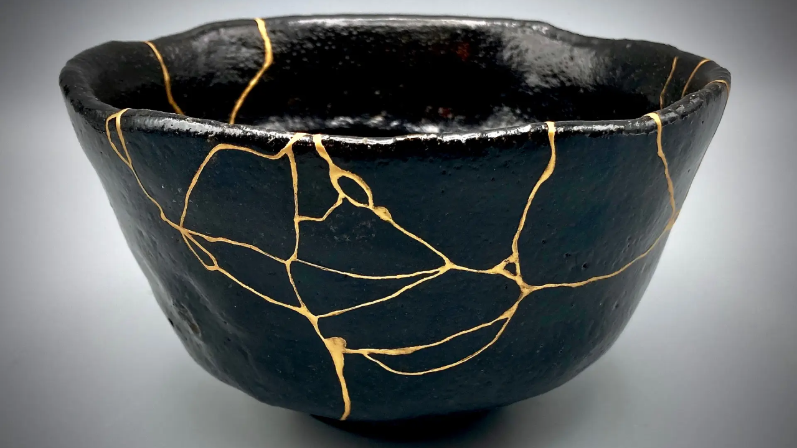
Fig 1: kintsugi.
This manifesto stems from being in a world that often demands flawlessness. I'd like to celebrate the beauty of imperfections and create a less demanding environment allowing freedom of expression. The ability to accept and honor our flaws can create more unique products that provide character and charm that are a testament to our experiences, struggles and our growth. We should reject the idea of mistakes being failures, instead we should see them as valuable lessons and opportunities for learning. We should embrace the unpredictable nature of the creative process allowing ourselves to flow with our intuition and spontaneity. Welcoming the imperfections in our work we free ourselves from the constraints of perfectionism and open ourselves to new possibilities; this creates a space to recognize ourselves and create authentic, vulnerable and genuine connections with our work. This can help create more meaningful and impactful art.

- “To use art as a tool for healing”
- 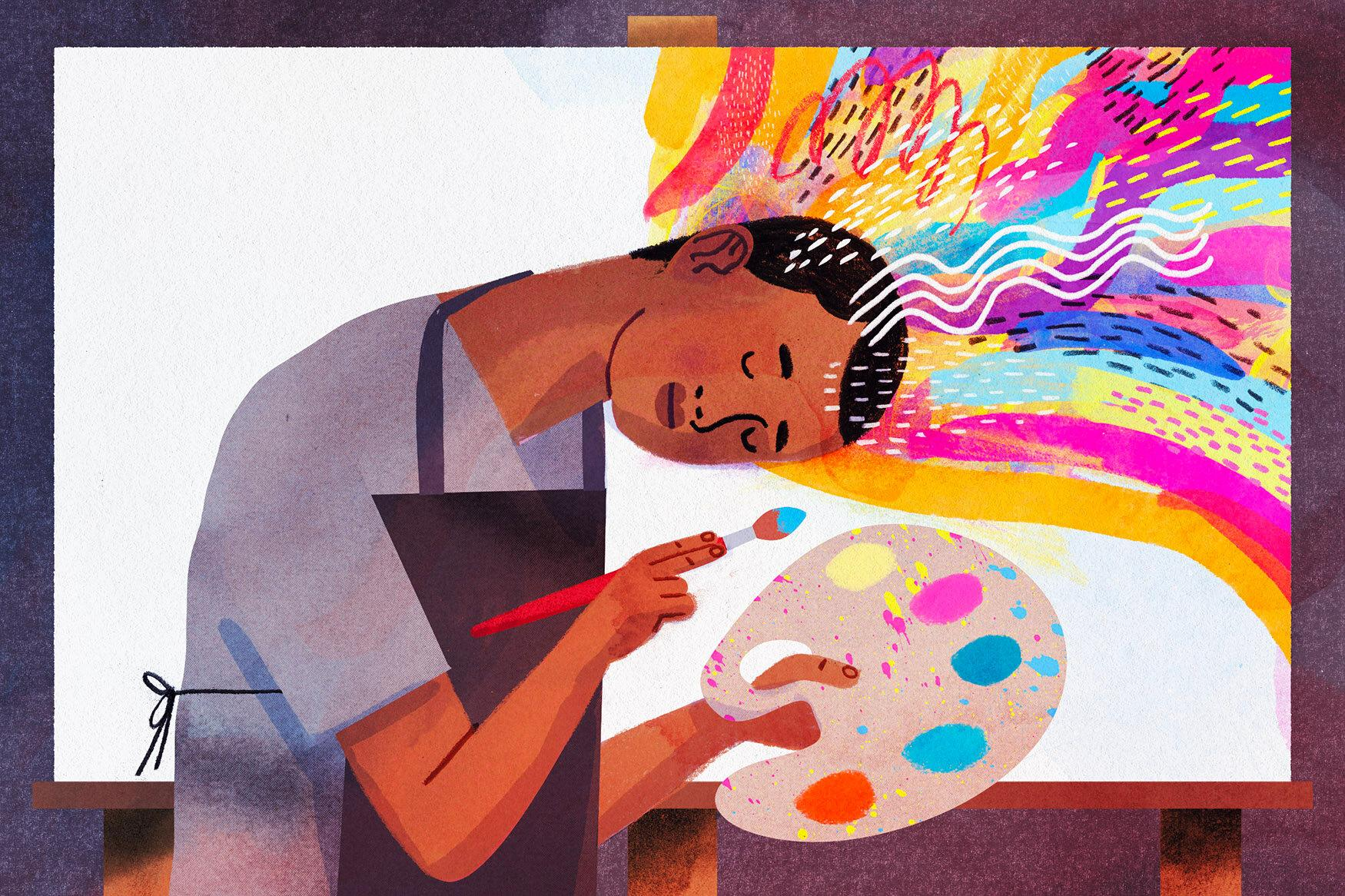
Fig 2: Keith Negley

This manifesto stems from my idea of art aiding my ADHD. I personally feel that art creates a calm environment for me and is a way for me to express my emotions in a healthy and more positive way. Art has previously been shown to have therapeutic effects often helping us cope through vulnerable times, using art can help us transform pain into beauty or chaos into order. Art can be seen as a raw and unfiltered expression of the human experience that can be shown in materials, techniques and colors. Using art as a way to express pain can free ourselves from the constraints of judgment, creating a space for authentic vulnerability in our work. Not only can this help ourselves but by sharing art created during painful experiences can help others as they may relate or understand work more clearly.

- “breathe the new life into forgotten materials”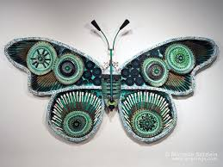
Fig 3: Michelle Stitzlein, timely emerald hackberry moth.

This manifesto is an idea to focus on the value of all materials, even some that may be discarded or overlooked. Encouraging creativity and innovation in items that may be considered waste. This manifesto is about sustainability and creating less waste in such a wasteful world. It also promotes resourcefulness and challenges the mindset of disposability, inspiring people to see the potential in unwanted items and transforming it into art that can be seen as useful or beautiful. You can see a lot of pollution in the world at the moment and a lot of artists are already pushing to create art with found materials. An example is sea glass, sea glass is heavily used in the industry however it is a form of waste from people discarding glass by beaches which when it enters the ocean could cause problems for marine life. However by collecting this sea glass it has been naturally worn down into smooth organic shapes perfect for jewellery pieces. This helps breathe new life into a piece of glass that was discarded and deemed as waste.

Observational writing

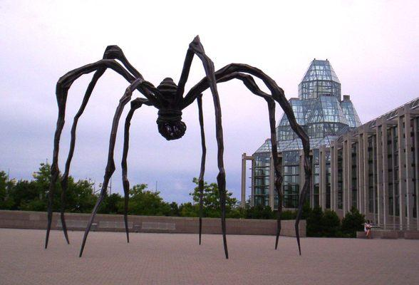
Fig 4: Louise Bourgeois, Maman, 1996

This 30 feet tall sculpture was created in 1996 by an french-american artist, The work is called maman which is french for mummy, her inspiration for this piece was from her late mother as she reminded her of spiders, Bourgeois states that her mother was “deliberate, clever, patient, soothing, reasonable, dainty, subtle, indispensable, neat and as useful as a spider” upon reading this description of her mother you can see how she can portray her mother in this way, as well as her past trauma from her fathers affair you can see where she may have got the idea to embody her mother into quite a known fearful creature however the more you know about the work the more is revealed on how it's not to be feared it is to be cherished. The main spider is made of bronze however the body holds marble like eggs. Again creating this motherly protective role, Bourgeois also states how “the spider is a repairer. If you bash into the web of a spider, she doesn't get mad, she weaves and repairs it” This quote is also a reflection on how she feels for her mother as Louise Bourgeois owned a tapestry weaving business which her mother had taught her how to sew and weave which she then went to be in charge of the tapestry weaving workshop. I believe that with this sculpture Bourgeois wanted to flip the perspective and stereotype spiders have, people usually fear them whereas she's created a protective role for them. My initial opinion of maman was fear, I first thought it was a sinister piece maybe linked to some form of trauma. I believe in this idea for the large scale of the piece as well as the form of long spindly legs, creating a horror-like character. You can see there is a large amount of textures and details almost making the piece look realistic, I believe this also plays a role in the fearful impact it has. However upon researching the meaning i have now gained a sense of love and protection from the piece and can now see past the fearful aspect. I also feel a sense of guilt almost for listening to the stereotype of spiders being scary creatures and now have a new found appreciation for the work.

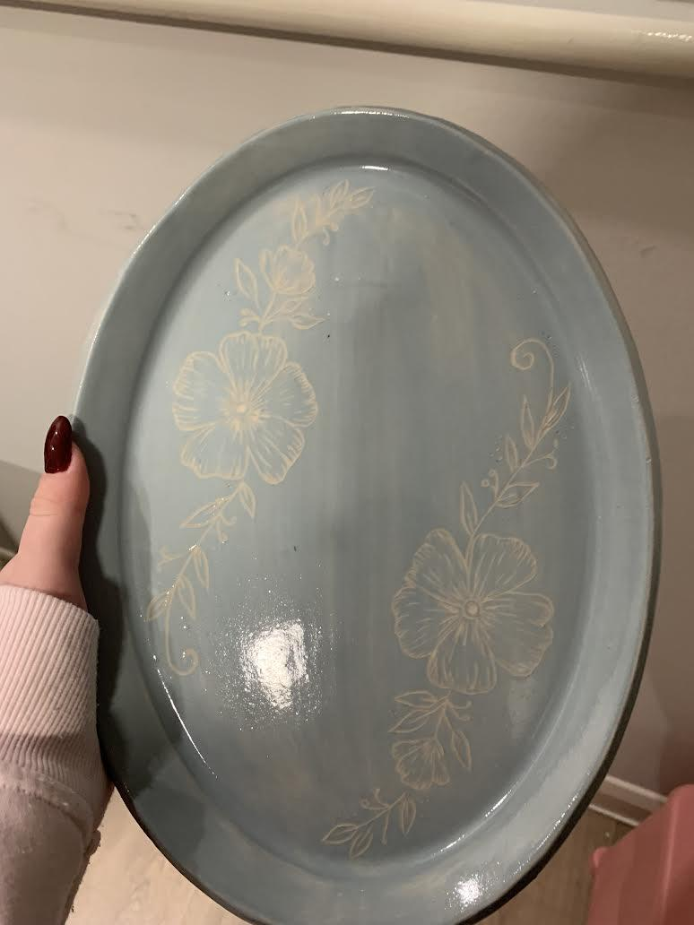
Fig 5: Isla pinches, Ceramic nature plate.

A piece I created during university in semester 1 is a ceramic plate. I created this plate using a plate former and a large sponge technique simply pressing the cut clay into the sponge so the edges rise to create the form of a plate. I then added a simple pale blue glaze as I thought it accompanied the natural organic colour of the clay. This was so I could scratch into the clay using a sgraffito technique to add detailed decoration onto my plate. I loved the oval shape of my plate which is why I created a design that went alongside the form of the plate. I believe it captured the shape of the plate as well as adding details to the previously simple form. Using the sgraffito technique allows a slight 3d tactile feel to the plate while not being too deep that it will affect the function on the plate. The design I created was a nature inspired design with detailed flowers and leaves, surrounded with whimsical swirls. I believed this accompanied the pale blue glaze quite well as its a soft delicate tone similar to the delicacy in my design. I also believe this creates a calmness to the piece, the light blue tone is known to have traits of tranquility, peace as well as flowers providing a sense of happiness and serenity. One aspect however I wish to improve is the finish of the glaze, due to the unpredictability of the glaze it ended up quite transparent causing my brush strokes to stand out. This does just give me insight into how the glaze works with clay which is that it's just a very thin glaze and needs a few extra coats to be opaque. The whole process of creating the plate took about a week between firing processes and glazing, however the process is quite simple and I believe is a much better outcome than using a mould. If I was to use a mould its not as personal to me as usually moulds are from products previously made, it also can have weak points that you may not see such as air bubbles, this can cause more problems such as breaking in the kiln. Overall I believe both techniques are suitable to use however with the technique I used it adds more personal touches to your piece as well as being able to control a lot more of the process.

References
- Google.com. (2025). Louise Bourgeois, Maman, 1996 - Google Search. [online] Available at: https://www.google.com/search?q=Louise+Bourgeois%2C+Maman%2C+1996&rlz=1CAXJLZ_enGB1176GB1176&oq=Louise+Bourgeois%2C+Maman%2C+1996&gs_lcrp=EgZjaHJvbWUyBggAEEUYOTIHCAEQABjvBTIHCAIQABjvBTIKCAMQABiABBiiBDIKCAQQABiABBiiBNIBCDM4MDZqMGo5qAIGsAIB8QU2ITIv5H1rnA&sourceid=chrome&ie=UTF-8 [Accessed 3 Jan. 2026].
- National Gallery of Art. (2025). Spider by Louise Bourgeois. [online] Available at: https://www.nga.gov/artworks/105617-spider.
- ‌Tate (2010). ‘Maman’, Louise Bourgeois, 1999 | Tate. [online] Tate. Available at: https://www.tate.org.uk/art/artworks/bourgeois-maman-t12625.
- Sarkar, A. (2025). Life, like pottery, is fragile. We all experience moments of breaking—failures, heartbreaks, setbacks—but what if instead of hiding our cracks, we embraced them? The Japanese art of Kintsugi offers a profound metaphor for life: it teaches us to mend broken pottery with gold, transforming fractures i. [online] Linkedin.com. Available at: https://www.linkedin.com/pulse/kintsugi-art-embracing-imperfections-celebrating-growth-anupam-sarkar-okxbc [Accessed 5 Jan. 2026].
- ‌lilasartclasses (2013). Found Object Art. [online] Lila’s Art Classes. Available at: https://lilasartclasses.wordpress.com/2013/04/08/found-object-art/.
- ‌Caron, C. (2023). How the Arts Can Benefit Your Mental Health (No Talent Required). The New York Times. [online] 22 May. Available at: https://www.nytimes.com/2023/05/22/well/mind/art-mental-health.html.
- ‌

- ‌

