Kian Harper-Evans (2204995)
2204995@student.uwtsd.ac.uk
Word Count: 1775 Words
(Titles Not Included)

Database analysis and design
Lecturer: Divya Chidambaram
Assignment 1
Course Title – Computer Networks and Cybersecurity

Contents
1.0 Introduction 2
2.0 Research / Initial Findings from Brief 3
3.0 ERD Document / Visio Database Plan 4
4.0 Relationships / Tables (Microsoft Access) 5
5.0 Queries Within Database 6
6.0 Report Screenshots 9
7.0 Forms Examples 10
8.0 Additional Screenshots / Resources 12
References 14

Introduction

Hello, within this document I will be analysing the key requirements and features required for the database management system requested by the company mentioned in the sample brief. The content of this document will first be made up of my research into the brief I have been given to make dure I can identify and highlight all the key details and requirements mentioned by the company representative in the brief. the second half of the content in this document will be made up of screenshots and evidence of the content I have made following the specifications of the brief. these will include and an entity relationship diagram created in Microsoft Visio, screenshots of the created relation database. These screenshots will include evidence that tables in the relation database are linked, when necessary, evidence that appropriate tables have been made, with appropriate foreign keys, and data and finally that the database follows the rules of third normal form.
For this task I will creating the relational database itself in Microsoft Access and the entity relationship diagram will be created with Visio and all screenshots will be added to this word document accompanied by descriptions of the content present in each screenshot.
All secondary research used in for this task will be cited appropriately and recorded in the references table found at the end of this document.

[1]
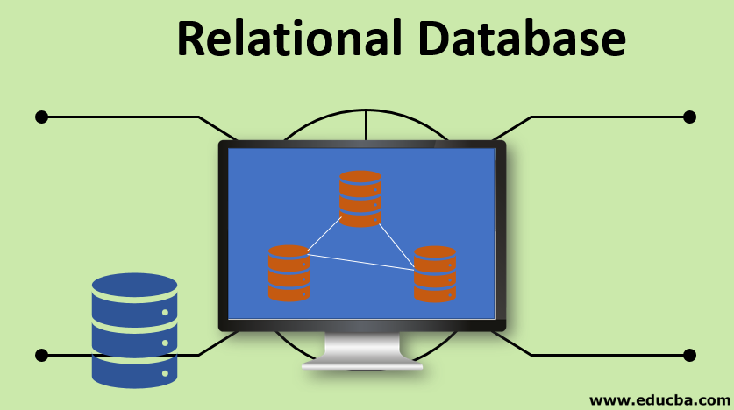

2.0 Research / Initial Findings from Brief

What has the client requested?
The brief for the task we have been given gives a description of what our client has requested from us. This being the creation of a computerised system that makes use of database management systems to replace the company’s manual administration system. For this we are required to design and create an example relational database.

Firstly, what is a relational database?
a relational database is a database that makes use of relational database management systems. Simply a relation database is a type of database that stores information and provides access to information in a database based on the relationships between the data stored on different tables within the database. According to, [2] , a relation database can be defined as, “A relational database is a type of database that stores and provides access to data points that are related to one another. Relational databases are based on the relational model, an intuitive, straightforward way of representing data in tables. In a relational database, each row in the table is a record with a unique ID called the key. The columns of the table hold attributes of the data, and each record usually has a value for each attribute, making it easy to establish the relationships among data points.”.

Identify different users that will make use of our system.
in the brief we were told that the system we are designing is going to be used by the company Northern Lights PVT LTD. This is a company that specialising in event planning. We are given a description of how the company structure operates. The brief tells us that the company is based in Swansea, however they have two additional branches in Carmarthen and Neath. Each separate branch has a supervising manager that is responsible for managing a team of people who responsibilities include the setting up of audio and visual equipment, the selling of tickets, cleaning, maintaining and administrating events. Other than the main branch manager there are also specific department supervisors. These will be responsible for supervising the work that goes on in the separate teams for activities that were mentioned previously.
Our system will be accessed by user such as:
- Company owner / CEO
- Branch supervising manager / managers
- Branch department supervisors (audio, visual, ticket sales, cleaning, maintaining, and administrating)
- Department employees (audio, visual, ticket sales, cleaning, maintaining, and administrating)

What is the different type of departments each branch may require?
In the brief we are given the information that there are multiple departments for each of the branches. These departments include the setting up of audio equipment, the setting up of visual equipment, the department that handles the sales of events, cleaning the event venue, event maintenance and finally event administration departments for each company branch. This means each branch will require seven departments at least judging from what we can find in the brief.
So, when creating our relational database, we can conclude that we will require there to be seven departments included for each branches data set. These departments will all be listed within their own separate table. My plan for this database is to have a database that will tell a person what branch what departments and what employees has work at said branches. These will be created in Microsoft Access and plan will be made using Visio.

3.0 ERD Document / Visio Database Plan

In this section I will be displaying screenshots of an ERD/table plan created in Visio. This document I will displaying in this section will display what tables I have decided to create and implement into this database. It will display what tables I have made, what data is present within these tables and the relationships between the tables and the data within them. including information on the type of relationships present between the data, the use of primary keys and the use of foreign keys and why I believe my use of them appropriate to the requirements set in the brief.

Visio Diagram Screenshot
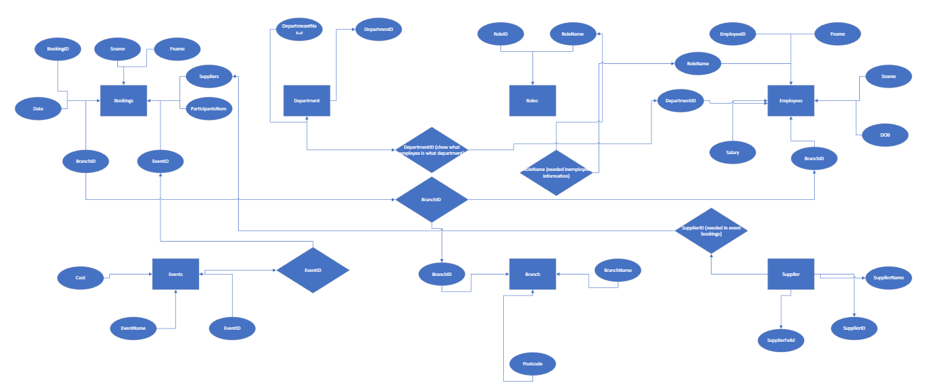

Above is an image of a copy of my ERD (Entity Relationship Diagram). The diagram is composed of three main shapes. The rectangular boxes represent entities present in the database, the circular shapes represent the attributes within the entities and the diamond shapes are there to represent relationships between entities. Entities refer to the tables within the database and the attributes refer to the types of data found in the database.
For example, as shown in the diagram the bookings entity meant to represent the future bookings table in the database is surrounded by attributes such as, Fname (first name), Sname (Surname), BookingID, Date, BranchID, EventID, NumofParticipants and suppliers. These attributes will all appear in the bookings table. Some of these attributes do not originate from the bookings table. These are the foreign keys that will appear in the database tables and are what create relationships between different entities, shown by them being present around multiple entities and they are also connect to each other through the relationship icon (the diamond).

4.0 Relationships / Tables (Microsoft Access)

In this section I will show images of screenshots taken from Microsoft access that show the tables and the relationships between said tables that are used to make up the database designed for our client.
Relationships screenshot:
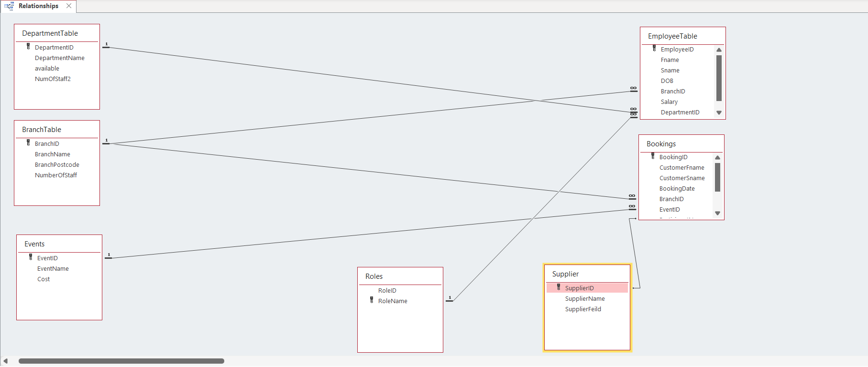

Shown above is a screenshot of the Microsoft access relationships screen. This is showing the relationships between the tables that I have created for the client’s database. For this I created seven tables. These include a Department Table, Branch Table, Events table, roles table, suppliers table, bookings table and an employee table. I believe these are appropriate tables to have because they all relate to important information that will be required when booking events but also for employees and customers of the company to check information on all aspects of an events preparation. For example the department table is important as it shows what departments will be used in the planning of an event, the branch table shows information for which branch is organising a certain event, the events table contains what type of events the company can organise (important for classifying what type event is being planned), the employee table shows information on the companies employees, what branch they belong to and what they specialise to make it easier to assign them to certain jobs. The bookings table contains on the information required for making an event booking, such as customers first name, last name, the booking date, BranchID (from Branch Table), the eventide (From the event table), Number of Participants and the supplier names for knowing what is being supplied for the event by who. All this information is integral for planning event. I believe these are appropriate because they contain all the information that may be useful to someone looking for company and event information.

5.0 Queries Within Database

In this section I will be displaying the use of some queries within my database. What is a query? According to, [3], “A query can either be a request for data results from your database or for action on the data, or for both. A query can give you an answer to a simple question, perform calculations, combine data from different tables, add, change, or delete data from a database.”.
In this case a query is a method of filtering information in a database to find a more accurate result to a question you’re trying to answer, or a request being made.

Below are two screenshots of a query being made and then the results of said query.
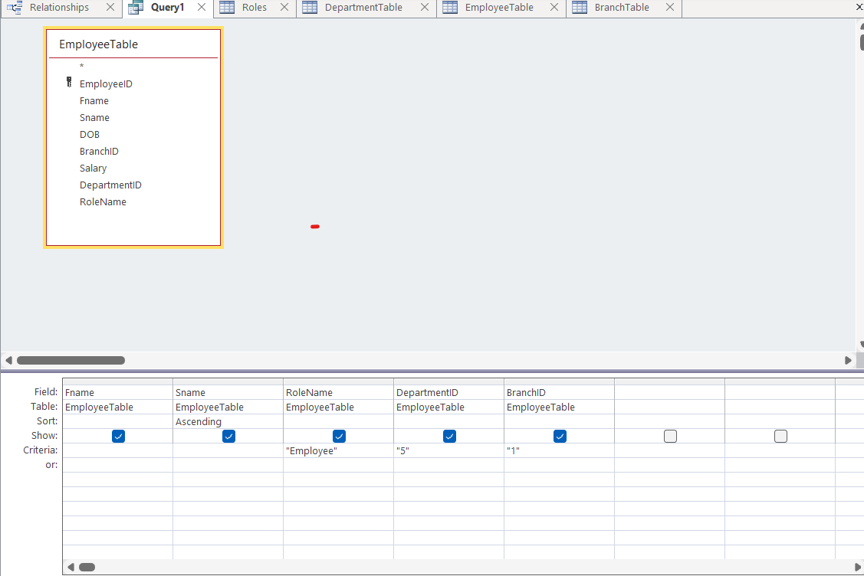

Seen above in the screenshot is me making query to search for specific information within the employee table. Specifically searching for workers who work in the Swansea branch (“1”), who work in the ticket sales department (“5”) and are specifically just employees, not managers or supervisors.

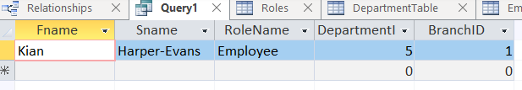
This then outputs a specific employee from the table the only one in the database that meets the criteria set within this query.
Note: any data used in the database not specifically stated within the brief is sample data created by me to demonstrate the databases functionality.

Below I will display a second query made in access for this database also making use of the Employee table to search for specific results.

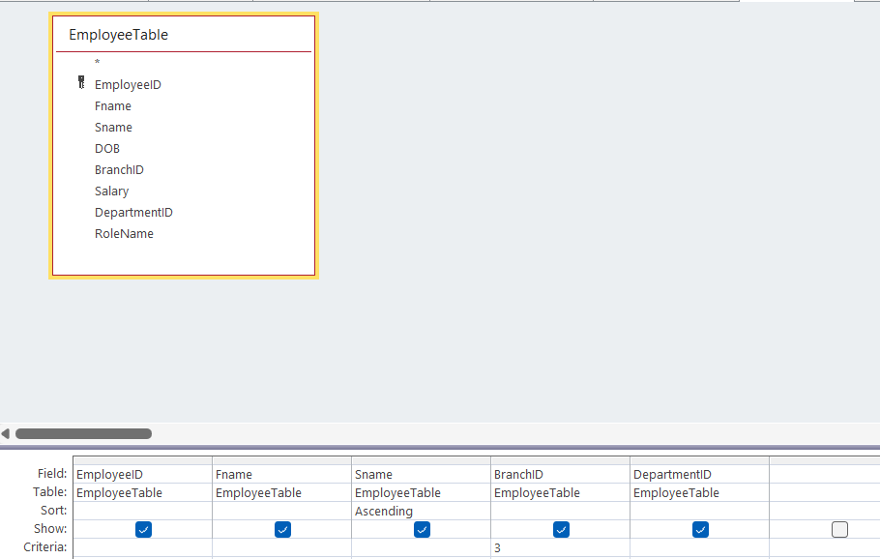

Seen above are the specifications were entered to find the results for the second query I am going to display. The specifications for this search of the database is that we are searching for an employee, that specifically works within the Neath branch of the company (“3”). This search will return the employees ID number, their first name, last name, the branch they work at and the department they work for within the branch.
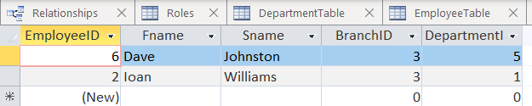

As seen in the screenshot above after running a search query with these parameters, we receive two results out of the employee list which contains five possible employees.
The query search can be used for more than searching for employee information. More specifically can be used to search for event information.
In the next query I will search for specific event types and their costs.

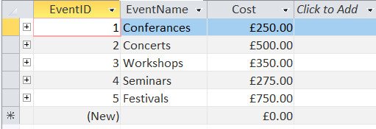

As seen above there are multiple types of events with a variety of different costs. However I am going to search the database to only show results for events that £750.
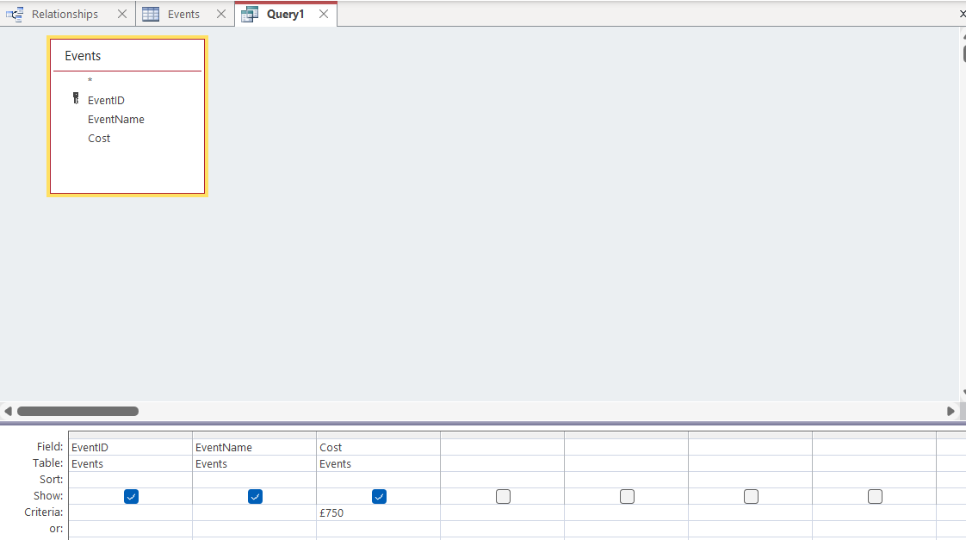

After entering the specifications above we are returned with the results shown below.
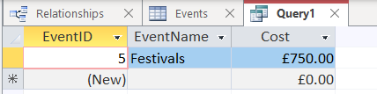
The search will turn up the only result that matches the specifications we have set.

6.0 Report Screenshots

In this section I will be displaying screenshots of reports created using Access on each of the tables present within the database.

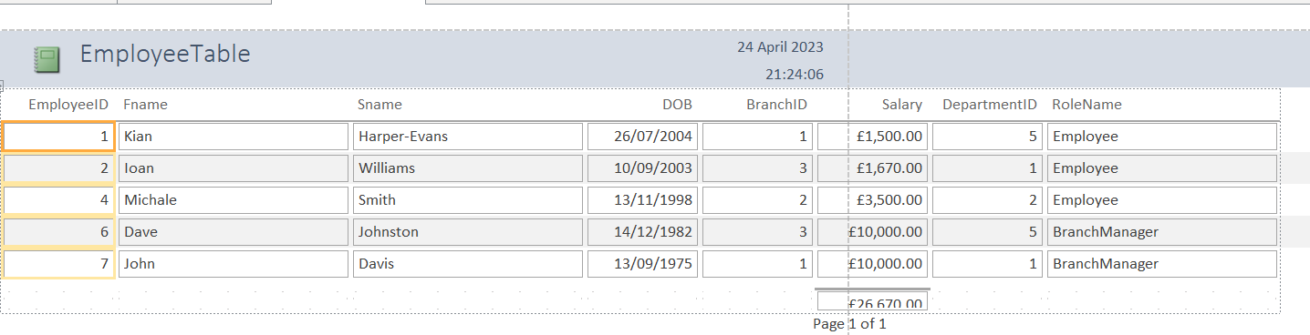

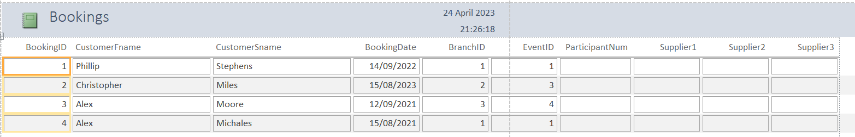

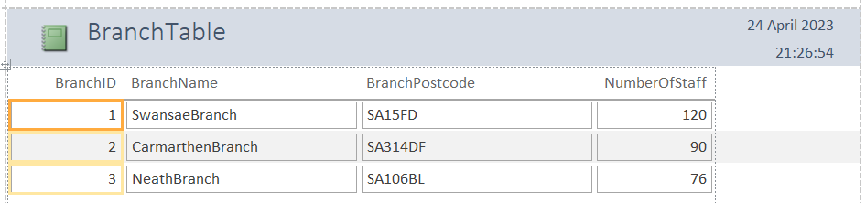

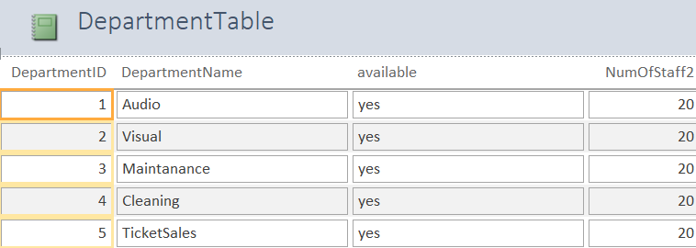

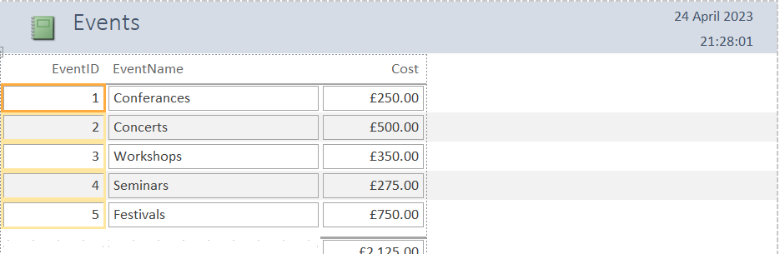

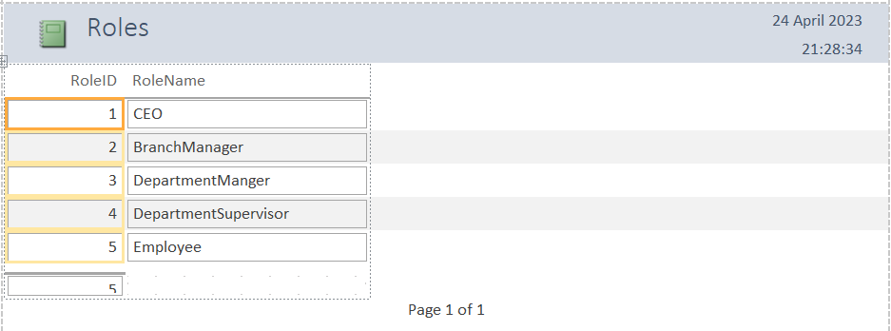
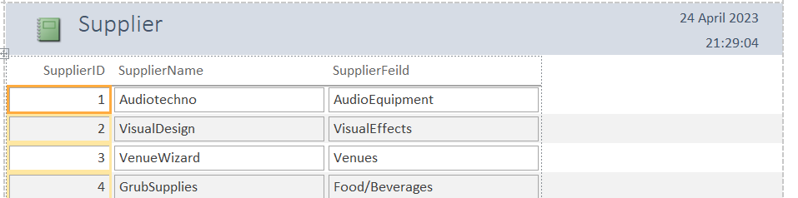

7.0 Forms Examples

In this section I will be displaying forms I have created that have functions within the database. For example, below is an example displaying the form which has the purpose of adding new records to the employee table.

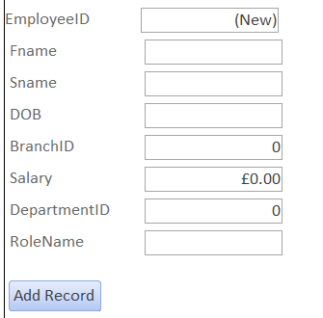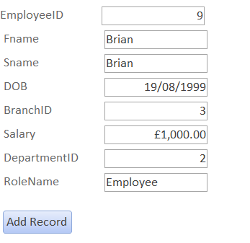

After filling out all the sections with data that is allowed to enter certain fields, the database will be updated and will add this employee into the database as shown below.
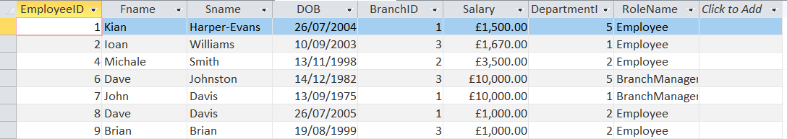

If a user tries to enter data that doesn’t match the specifications set in the databases rules, then an error message will be displayed. As seen below.
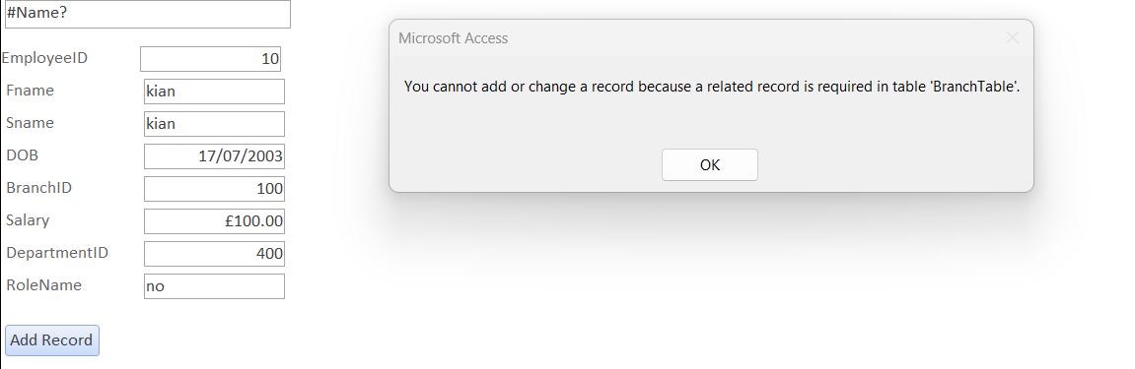

8.0 Additional Screenshots / Resources

Screenshot of Side panel of Access database, displaying a list of all tables, forms, queries, and reports designed and made.

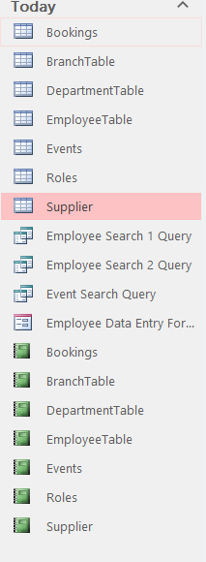
Screenshots from Tables:
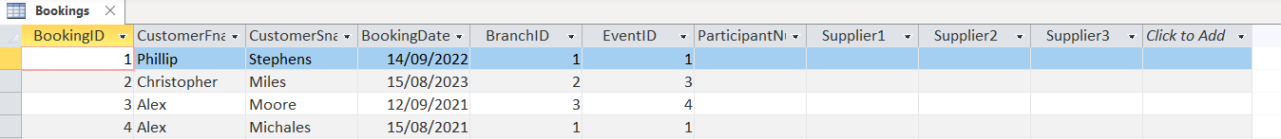
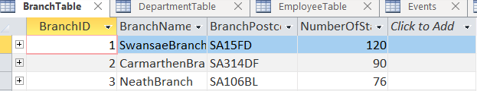
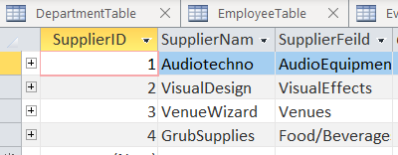

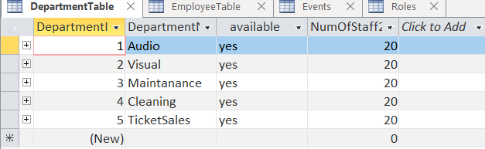

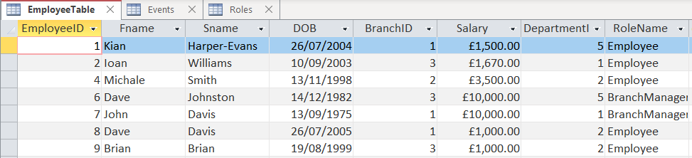
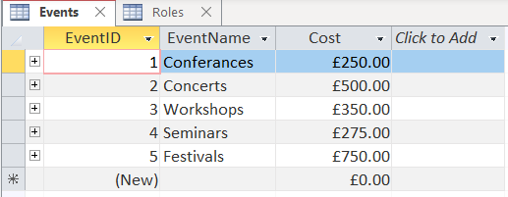
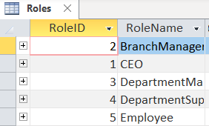

References

[1] | P. Pedamkar, “Relational Database,” EDUCBA, N/A N/A N/A. [Online]. Available: https://www.educba.com/relational-database/. [Accessed 18 April 2023].
[2] | OCI, “What is a Relational Database (RDBMS)?,” OCI, N/A N/A N/A. [Online]. Available: https://www.oracle.com/database/what-is-a-relational-database/#:~:text=A%20relational%20database%20is%20a,of%20representing%20data%20in%20tables.. [Accessed 18 April 2023].
[3] | Microsoft, “Introduction to queries,” Microsoft , N/A N/A N/A. [Online]. Available: https://support.microsoft.com/en-us/office/introduction-to-queries-a9739a09-d3ff-4f36-8ac3-5760249fb65c#:~:text=A%20query%20can%20either%20be,delete%20data%20from%20a%20database.. [Accessed 22 April 2023].

