

Effective Team Working and Communication

Name: Marius Scorcea
Student ID: 1921886

Lecturer: Dr Saqib Shamim

Contents
1.INTRODUCTION 3
1.1. Communication 3
1.2 Importance of communication in the workplace 3
1.3 Barriers to communication 5
1.4 Consequences of poor communication 6
2. MODELS OF COMMUNICATION 6
2.1 Shannon-Weaver Model (1948) 6
2.2 Osgood-Schramm Model (1954) 8
2.3 Berlo’s S-M-C-R Model (1960) 10
3. COMMUNICATION SKILLS 12
3.1 Verbal Communication 13
3.2 Non-Verbal Communication 13
4. CONCLUSION 14
5. REFERENCES 14
6. APPENDIX 15

1.INTRODUCTION

1.1. Communication
According to SKILLS YOU NEED team, communication is an art and it is essential in our lives. It is the way in which the information is transferred from one person to another. In order to communicate you need a sender, a message and a receiver. There are multiple factors that can alter the message in his way from sender to receiver, like: feelings, cultural differences, race, distance.
That is why, nowadays, as the world is becoming one big family, communication skills are very important and highly appreciated by employers.

1.2 Importance of communication in the workplace
Communication is important in every aspects of our life, personal or professional, it can make the difference. A lovely family life or a successful career are the result of our capacity to express ourselves (Zambas, 2019).
Nat Turner said: ‘Good communication is the bridge between confusion and clarity’.
Effective communication at the workplace it is the key to a successful business and the path toward goals achievement. Here are some benefits of effective communication at the workplace:
- Brings harmony between team members
Build a strong tram where every opinion matter and trust and transparency is a common practice.
- The business is developed
The success of the business is ensured when the teams works in harmony and communicates.
- People are inspired and creative
Managers need to motivate and inspire their team members to bring forward any new ideas, feels appreciated and strive for a progress in their career.
- Boosting the productivity
In a work place where team members communicate effectively, managers delegate the wright people in the wright places. This is increasing the productivity.
- Efficiency growth
If the communication is clear, everybody knows their duties, the work is effective, with no doubts upon quality.
- People are more devoted
A good communication between managers and workers brings a feeling of appreciation and trust, like this you make sure the employees become loyal.
- It reduces conflicts
Communication skills means being able to understand different cultures and personalities. Like this you avoid problems and conflicts.
- Employees become engaged
If a team communicates effectively, the unity between member is powerful, the company’s goals will be clear, and the motivation to fulfil their targets will be strong.
- Easier to solve problems
When you find a find a common language for everybody is easy to sort out any issue may arise.
- It enhances skills
Best way to know your employees is to communicate with them. Find out their interest and skills to be able to invest and make them valuable for your organisation.

1.3 Barriers to communication
Sometimes, the message between sender and recipient is not clearly transmitted and there are lots of reasons for this. Even when we possess communication skills there are still barriers that prevent this complex process (SKILLSYOUNEED, n.d).
Barriers in communication:
- The jargon - technical language or certain expressions are difficult to understand.
- Emotional barriers - difficulty to express your feeling or subject that are sensible it is better to avoid.
- Lack of interest, close mind or prejudice. Sometimes you get distracted very easy or you don’t have a good opinion about your interlocutor.
- Different opinions and approaches.
- Disabilities like bad hearing or difficulties in speaking.
- Non-verbal communication barriers. The body language, gestures and face expression speak a lot about your partners.
- Difficult accents or different languages are real issues in communication.
- Prejudice, expectations and labelling people. You stop listening when you start judging a person according to other’s people opinions.
- Different cultures. For some of us it is normal to shake hands, or to touch each other in a non-offensive way. There are cultures in which this kind of gestures are not allowed.

1.4 Consequences of poor communication
Effective communication should become a priority for any organization as the outcome of good communication strategy it is translated through growing productivity, employee’s loyalty, goals achievement. (Vdovin, 2017).
Which are the consequences of poor communication?
- Create confusion
- The wrong allocation of the resources
- Lack of collaboration and poor teamwork
- Spreading rumours and gossip
- Failure to communicate the deadlines and work instructions
- Poor confidence and respect for others

MODELS OF COMMUNICATION

2.1 Shannon-Weaver Model (1948)
Shannon-Weaver model was created in 1948 by Elmwood Shannon (mathematician) and Warren Weaver (engineer). They wrote an article in Bell System Technical Journal:,,A Mathematical Theory of Communication’’. (Businesstopia, 2018),
There are 6 parts involved in the communication process according to Shannon-Weaver:
- Information Source (sender) is the one who creates the message, choose the appropriate channel and transmit the message.
- Transmitter (encoder) what machine is used to send the message (or way).
- Channel is the way you transmit the message.
- Decoder the machine that convert the data in intelligible information.
- Receiver is the person who receive the message and gives the feedback after.
- Noise – the disruption may occur due to environment, people.

How it is working?
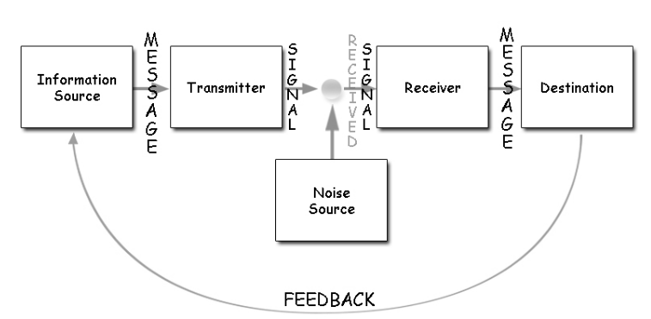

An employee text the manager to let him know that due to an emergency he will arrive at work at 12 p.m. The manager answer is: ok, see you tomorrow. Due to a faulty network he didn’t receive the 12 p.m.
We have the sender, employee, that encodes the text by the help of the phone, the channel is the mobile network, the noise is the faulty network, the decoder is the mobile phone and the receiver is the manager. The error here is due to the noise and the feedback allows the employee to see that the manager didn’t get his message completely.
Pros of Shannon Weaver Model
- It is first model that talk about the noise, allows us to identify the problems and avoid them.
- Can be measured, you can monitories the communication step by step.
- Even though originally was created to understand better communication through technology, you can apply this model in many circumstances.
Cons of Shannon Weaver Model
- As it is a linear model the feedback component sometimes is missing. Maybe because at the begging, Shannon Weaver model did not include the feedback.
- It is not ideal when we have one sender and more receivers. It is difficult to analyse the problems that may occur.

2.2 Osgood-Schramm Model (1954)
This model appeared as a reply to Shannon-Weaver model, which is a linear model of communication.
The Osgood-Schramm it is a circular model of communication, it is seen as a two-ways communication and is based on four main concepts and (Drew, 2020):
  - Communication is circular;
  - The communication process it is a balanced one;
  - There is a better understanding when the messages are interpreted;
  - Communicating needs: encoding, decoding and interpreting.

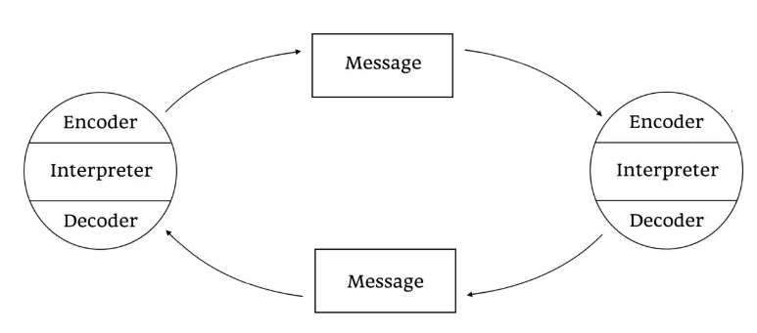
How it is working?
In this model, the communication takes part between two people, it is circular and all the involved parties are sender or receiver at the time. Communication needs Encoding, Decoding and Interpreting
- Encoding: the message that is sent has to be clear, well-structured in order to be properly received.
- Decoding: We can use reading and listening skills in order to decode a message, to make sure that we get the correct meaning.
- Interpreting: The message may be interpreted in different ways, by different people. Depends on their knowledge and their skills. It is very important to understand the medium of communication.
Advantages of the Osgood-Schramm Model
- Shows feedback importance: Unlike linear models, in this case you can get a feedback regarding the way you communicate, so you can avoid mistakes and improve the relationships.
- Communication is a complex process: Mistakes are possible, but trough all the encoding, decoding and interpreting process it is easier to spot and avoid them.
- All the parts are active: Being sender and receiver as well, all the people involved in the process have to interpret the message they receive.
Disadvantages of the Osgood-Schramm Model
- A weak understanding on how the power can influence the communication.
- Not appropriate for mass communications as it was created as a one-to-one circular type.

2.3 Berlo’s S-M-C-R Model (1960)
This Models was created by David Berlo in 1960. He started from Shanon-Weaver model, Berlo but inspired himself from Aristotle, too.
Sender-Message-Channel-Receiver (SMCR) model it is more complex and it is describing actually the whole communication activity. (Rathinaswamy, 2017).

Berlo’s Model of Communication characteristics

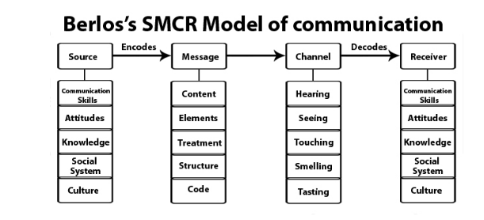

S -Sender
Sender is the source of information. The person that transmits the information to receiver should have:
- Communication Skills
- Proper attitude
- Knowledge
- Social Systems.
- Culture

M-Message
It is actually the information that is send to the receiver. Can be a oral, written, audio, or media message. The important characteristics are:
- The Content
- Elements – usually non-verbal features.
- Treatment – how the message is send to the receiver.
- Structure
- Code – how you transmit the message: oral, text, video etc/Code is the form in which the message is sent. It might be in the form of language, text, video, etc.

C-Channel
Channel is the way you choose to transmit the message. Depending on the communication level, we can use internet, telephone. Simple communication between two people uses as a channel the five senses.
- Hearing
- Seeing
- Touching
- Smelling
- Tasting
R- Receiver
Receiver is person that gets the message. But he needs to be connected with the sender, skills wise, in order to decode the message that he received. So, he needs also:
- Communication skills
- Attitudes
- Knowledge
- Social Systems
- Culture
- Lack of feedback, you can’t measure the effectiveness of the message.
- Noise is missing from this theory.
- It is a one way model of communication.
- For the communication to be effective both participants need to have the same skills.

COMMUNICATION SKILLS
Communication with the others comes naturally, we learn how to speak since early age, but the process itself it is more complex than it seems. It takes skills like listening, verbal communication, non-verbal communicates to build a good business relationship, or create a strong working team. (Doyle, 2019).
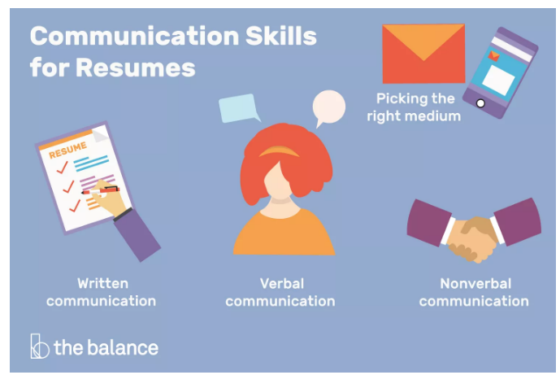

3.1 Verbal Communication
It is the oral communication and very important for people who need to talk over the phone, and essential for those that need to speak face-to-face to their colleagues or business partners. The communication needs to be clear and concise. For oral communication you need skills like: negotiation, persuasion, presentation, public speaking, telephone manner, language etc.

3.2 Non-Verbal Communication
As the name is saying it is more about the tone, the body language, face expression, posture. Adopting the right body language or face expression during a negotiation, can make a big difference. Nonverbal communication skills are considered the confidence you inspire, active listening, empathy, open-mildness, ability to foresee, emotional intelligence.

CONCLUSION
Communication is not only speaking words to other people. It is a complex and complicated process that takes skills in order to be effective and to bring personal and professional satisfaction. Over the time the preoccupation for this topic was quite important, multiple personalities, scientist tried to postulate theories, trying to understand and to make communication more efficient.

REFERENCES
Businesstopia (2018), Shannon and Weaver Model of Communication, Available at: https://www.businesstopia.net/communication/shannon-and-weaver-model-communication. (Accessed: 18 August 2020).
Doyle, A. (2019) Communication Skills for workplace success. Available at: https://www.thebalancecareers.com/communication-skills-list-2063779 (Accessed: 18 August 2020).
Drew, C. (2020) Osgood-Schramm Model of Communication | Pros & Cons (2020). Available at: https://helpfulprofessor.com/osgood-schramm/ (Accessed: 18 August 2020).
Rathinaswamy, J. (2017) David Berlo’s Model of Communication’, JAYASEELAN RATHINASWAMY [blog]. 20 July. Available at: http://jayaseelansr.blogspot.com/2017/07/david-berlos-model-of-communication.html
(Accessed: 18 August 2020).
SKILLSYOUNEED (n.d.) Barriers to effective communication? Available at: https://www.skillsyouneed.com/ips/what-is-communication.html (Accessed: 15 August 2020).
SKILLSYOUNEED (n.d.) What is communication? Available at: https://www.skillsyouneed.com/ips/what-is-communication.html (Accessed: 15 August 2020).
Vdovin, A. (2017) ‘Effects of Ineffective Workplace Communication’, DESKALERTS Internal Communications Solutions [blog]. 21 September. Available at: https://www.alert-software.com/blog/effects-of-ineffective-workplace-communication (Accessed: 15 August 2020)
Zambas, J. (2019) The Importance of Effective Communication in the Workplace. Available at: https://www.careeraddict.com/the-importance-of-effective-communication-in-the-workplace (Accessed: 15 August 2020).

APPENDIX
I am working as a manager in a big warehouse. One of our workers complain to me about another manager that had a bad attitude towards him, always demanding things on a very inappropriate tone, always saying that his race is good for nothing, things that were really demotivating and created a really bad working environment.
From my understanding this was a problem of communication, my colleague didn’t have the necessary skills to handle the situation.
He was using an unappropriated tone of voice, his attitude was bad, he didn’t have the ability to work with people from different cultures and environments.
In order to solve this situation I had to ask the operational manager to have an one-to-one meeting to my colleague and explain him what the company needs from him and also to try to motivate the worker, as he was a skilled one, in order to keep his loyalty and commitment towards company.

