Assignment Title : Individual Academic Poster

Module : Introduction to Physiology

Module Code : BMHP5003

Lecturer Name : Mumtaz Galoom

Student Name : Fizza Chohan

Student Number : 1807415
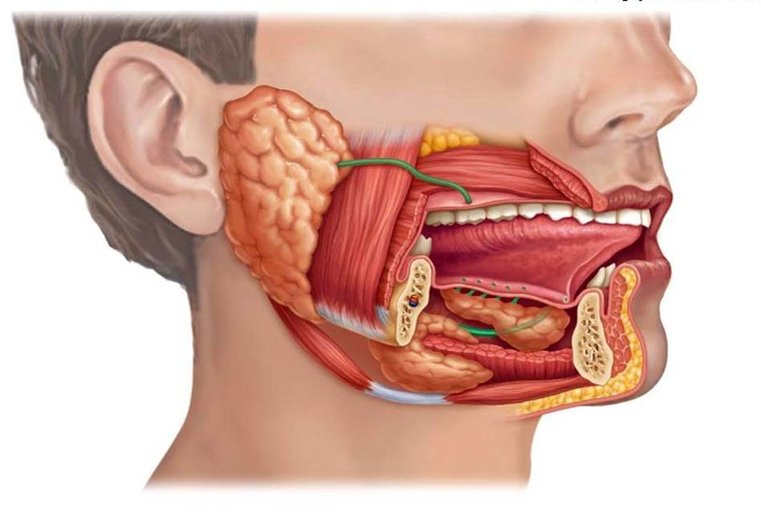
(Slide serve, 2013)
Mayo Clinic, 2020).
Oesophagus

Is primarily a transport tube that helps direct the movement of food from the mouth to the stomach. (ScienceDirect, 2020)
Liver
Gallbladder

The Stomach takes in food from the oesophagus, breaks it down into smaller particles and then pushes it down in to the small intestine( Nih.gov 2016).
Anus

Food you consume goes through an extraordinary journey through your body starting from your mouth and ending with your anus.
Mouth
THE DIGESTIVE SYSYTEM
The mouth and salivary Glands
The function of the mouth is to help chew your food. The mouth is at the start of the digestive system. As soon as you smell food this triggers the salivary glands indie your mouth to create saliva.
Sublingual Gland
Parotid Gland
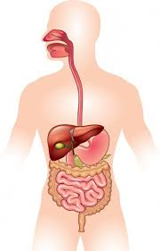
Stomach
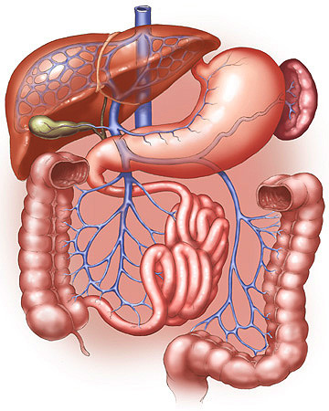
Spleen
Mucosa (Innermost layer)
Stomach wall
Pancreas
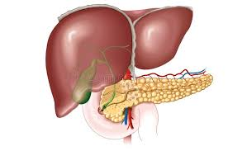

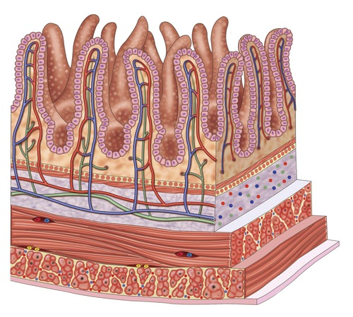
Submucosa
Muscle layer
The liver works by digesting food by generating bile which breaks down fats removes toxins. The pancreas then generates enzymes which help break down carbohydrates, proteins, and fats. The bile that is produced by the liver is stored in the gall bladder. (sickkids2013)
Serosa (outermost layer )

(Sciencephoto.com, 2020)

Large intestine
The large intestine (colon) purpose is to soak up and absorb any salts or water from the material that has not been digested as food, and to then dispose of any waste that is left ( Ros and Wilson, 2014).
Small intestine

The small intestine is where much of the chemical digestion takes place. The main function is to absorb all the minerals and nutrients from the food (WebMD, 2020).
(Waugh and Grant, 2014).
Rectum
The appendix is part of your Gastrointestinal tract. It is a thin long tube that sits just under the lower right section of your abdomen. (Castro, 2018). The function is unknown , but if appendix become inflamed it can cause serve pain.

Appendix
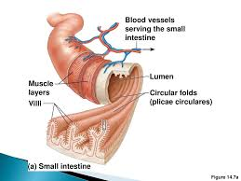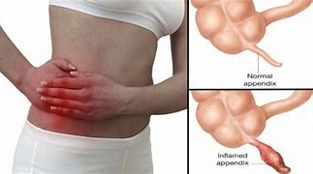
The rectum role in the digestive system is to receive waste from the large intestine, and to store the waste, until its ready to be eliminated through the Anus (Healthline, 2018)
(Doctorbabu, 2017).
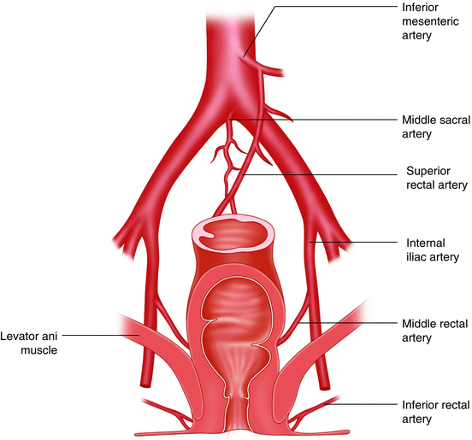
The Anus is the last part of the digestive system. The Anus is made of different muscles, which include pelvic floor muscles, anal sphincters which are internal and external. A human will rely on the external sphincter to keep the waste from coming out until you’re ready to go and use the toilet. (Healthline , 2018)
Anus
(Waugh and Grant, 2014).

(Healthline, 2018)

The digestive system is a made up of body parts, which work simultaneously to turn liquids and food into the fuel and building blocks which the body needs. There are 5 main stages to digestion which are:
- Ingestion – this stage is where you take food into the body
- Digestion- this is known as the process of breaking down the food
- Absorption- this stage is where food gets moved into cells
- Assimilation- digested food particles are turned into fluids
- Elimination- this is the process of undigested food leaving your body as faeces /waste ( Health Direct, 2019).
The process starts from the mouth. Salvia in the mouth helps breaks the food and transforms it into chemicals which are knows as enzymes. After the chewing and salvia has broken down the food it then moves through the esopgaus. The food is then stored in the stomach and is further broken down by enzymes and acid present in the stomach. After this process, the food then moves down into the small intestine, once again the food is broken down into smaller particles by enzymes which are released from the pancreas and also bile which is stored in the liver (WebMD, 2020). Nutrients are mainly absorbed from the small intestine. Any food or particles left over then proceed into the large intestine. The large intestine also known as the colon is a large tube which connects the small intestine to the rectum. It can take up to 36 hours for stool or waste to get around the colon and then to exit the rectum through the Anus. (Cleveland Clinic, 2017).
Irritable bowel syndrome also known as (IBS) is a very common condition in people of all ages and it affects a person digestive system. Symptoms will vary from person to person, but usually involve serve stomach cramps, bloating of the stomach and a feeling of fullness, constipation, and diarrhoea. Symptoms like this will come and go over time, which can last for few days or even weeks at a time. IBS is mainly a lifelong problem, which can be very uncomfortable and frustrating to live with. (Mayo clinic, 2020). This can result in having a major impact on the way you live your everyday life. Although there is no known cure for this disease changes can be made to help live a more comfortable life. Diet changes can be made to help control certain symptoms and certain n medication can be taken to also relive symptoms. (NHS, 2020). Although the exact cause of IBS is unknown there are still many factors that can play a role which are :
- Muscle contraction inside the intestine
- A serve infection inside the intestine
- Stress
- Changes inside your Gut (NHS, 2020).

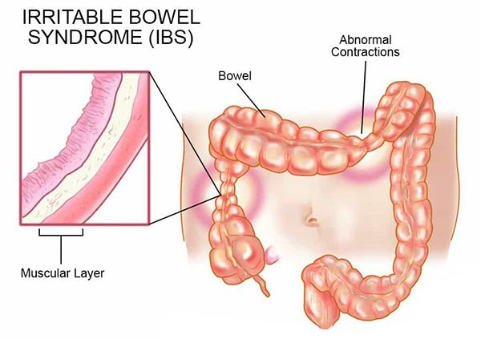
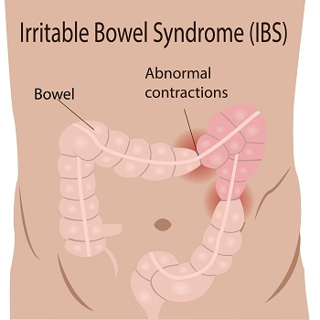
As you can see from the images below a person suffering with IBS , there colon muscles start to tighten and move without any control. This is also known as a spasm. The colons job is to absorb nutrients and water digest food. Muscles in the colon work to eliminate any waste products in the body. If the muscles do not work in synchronization or at the right speed digestion is then interrupted in the rectum. The contents that are left in the coon can then not move along to the rectum smoothly. Hence, these problems then cause an individual to having symptoms of IBS such as cramps and bloating. (Kids Health, 2019).
(Wickenburg Community Hospital , 2019).
(DHA Endoscopy, 2018).

Reference list

Castro, J (2018) Everyday Health. Available at : https://www.everydayhealth.com/appendicitis/guide/appendix/ (Accessed on 30th October 2020).
Cleveland Clinic (2017) .Available at : https://my.clevelandclinic.org/health/articles/7041-the-structure-and-function-of-the-digestive-system (Accessed on 29th October 2020)
DHA Endoscopy , Symptoms of IBS . Available at : https://www.dhaendoscopy.com/blog/post/symptoms-and-treatment-of-irritable-bowel-syndrome.html ( Accessed on 30th October 2020).
Doctorbabu (2017).Available at : http://www.doctorbabu.com/wp-content/uploads/2017/12/appendix-e1513941374697.jpg ( Accessed on 29th October 2020).
Health Direct (2019) . Available at : https://www.healthdirect.gov.au/digestive-system (Accessed on 1st November 2020).
Healthline (2018). Available at : https://www.healthline.com/human-body-maps/rectum#1 (Accessed on 29th October 2020)
How does the stomach work (2016) Available at : https://www.ncbi.nlm.nih.gov/books/NBK279304/ (Accessed on 1st November 20202)
Kids Heath (2020) Irritable Bowel Syndrome .Available at : https://kidshealth.org/en/teens/ib s.html (Accessed on 28th October 2020)
Mayo clinic (2020) What is IBS. Available at : https://www.mayoclinic.org/diseases-conditions/irritable-bowel-syndrome/symptoms-causes/syc-20360016 ( Accessed on 30th October 2020).
NHS (2020) IBS. Available at :https://www.nhs.uk/conditions/irritable-bowel-syndrome-ibs/symptoms/ ( Accessed on 30th October 2020)
Science Direct (2020 )The digestive System. Available at:https://www.sciencedirect.com/science/article/pii/B9780128040096000079 ( Accessed on 29th October 2020)
Sick kids (2013) Liver and Gall Bladder. Available at : https://www.aboutkidshealth.ca/Article?contentid=1468&language=English (Accessed on 27th October 2020)
SlideShare (2013). Available at : https://www.slideserve.com/hachi/anatomy-of-the-digestive-system (Accessed on 28th October 2020)
Waugh, A. Grant, A (2014) Ross and Wilson. Anatomy and Physiology in Health and Illness (12), pp.285-289.
WebMD (2020) The Digestive System. Available at : https://www.webmd.com/heartburn-gerd/your-digestive-system (Accessed on 1st November 2020).
Wickenburg Community Hospital (2019) . Irritable Bowel Syndrome .Available at :https://www.wickhosp.com/blog/irritable-bowel-syndrome/ ( Accessed on 28th October 2020)

