UNIVERSITY OF WALES TRINITY SAINT DAVID
Certificate of Higher Education Skills for the Workplace (Health and Social Care)
Personal Development Portfolio

Student Name: Ruqia Bashir
Student ID: 2435749
Module Code: LCHS4009
Module Title: Professional Development within Health and Social Care
Assignment Title: Personal Development Portfolio
Lecturer: Dr Walter Rodney Nagumo
Submission Date: 24 July 2026

Chosen Job Advertisement
Job Title: Teaching and Learning Assistant
Employer: Eden Boys' School, Birmingham
Location: Birmingham, West Midlands
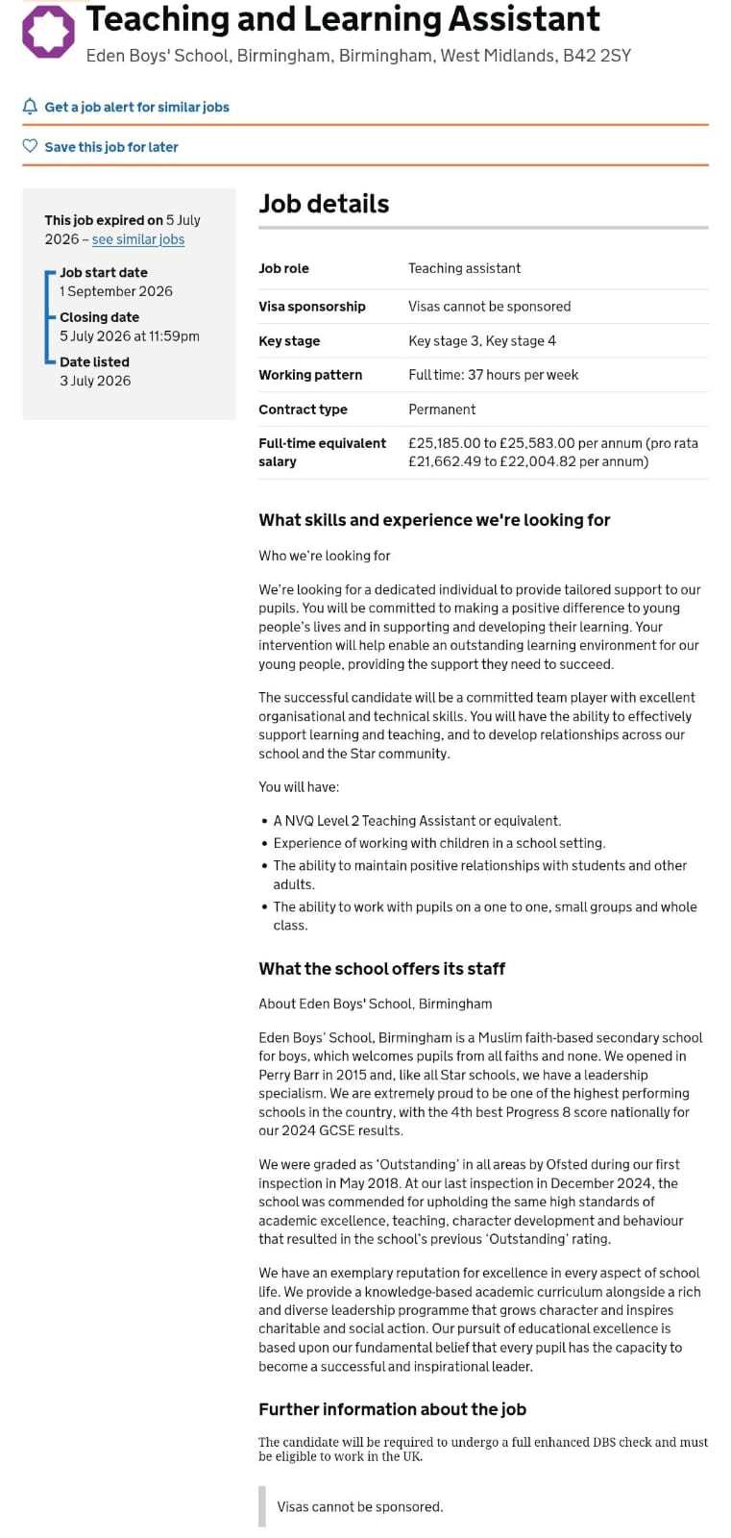
Source: GOV.UK Teaching Vacancies

RUQIA BASHIR
Teaching Assistant | Learning Support Assistant
PROFESSIONAL PROFILE
I enjoy working with children and supporting them in their learning. During my voluntary placements at Perry Beeches School and Al-Burhan Grammar School, I helped teachers with classroom activities and supported pupils when they needed extra help. These experiences gave me more confidence and improved my communication and teamwork skills. I am a patient, reliable and hardworking person, and I would like the opportunity to continue developing my experience as a Teaching Assistant.
KEY SKILLS
- Good communication and listening skills
- Able to build positive relationships with children
- Patient, caring and supportive
- Understanding of safeguarding and child welfare
- Able to work well as part of a team
- Good organisational skills
- Reliable and responsible
- Fluent in English, Urdu and Mirpuri
RELEVANT EXPERIENCE
Volunteer Teaching Assistant – Perry Beeches School, Birmingham (September 2017 – August 2018)
- Supported pupils during lessons and classroom activities.
- Helped children complete classwork and learning tasks.
- Prepared classroom resources and learning materials.
- Encouraged pupils to participate and build confidence.
- Helped maintain a safe and welcoming learning environment.
Volunteer Learning Support – Al-Burhan Grammar School (September 2018 – October 2019)
- Worked with teachers to support pupils during lessons.
- Assisted children individually and in small groups when needed.
- Helped prepare classroom resources before lessons.
- Encouraged pupils to stay involved in learning activities.
- Supported pupils' wellbeing throughout the school day.
EDUCATION & TRAINING
University College Birmingham
- Level 3 Award in Teaching and Supporting Learning (September 2016 – June 2017)
- Level 2 Award in Teaching and Supporting Learning (September 2015 – June 2016)
Succeed Training
- Skills Update Course (May 2018)

ACHIEVEMENTS
- Successfully completed voluntary placements in two schools.
- Gained practical classroom experience working with pupils and teachers.
- Completed Level 2 and Level 3 qualifications in Teaching and Supporting Learning.
PERSONAL STRENGTHS
- Friendly and approachable
- Calm and Patient
- Honest and dependable
- Positive attitude
- Good team player
- Willing to learn
INTERESTS
- Supporting children's learning
- Reading
- Community involvement
- Learning new skills
REFERENCES
Available upon request.

Task 2 – Personal Statement
I am applying for the Teaching and Learning Assistant position because I enjoy working with children and helping them with their learning. I like seeing children become more confident and make progress in school. I understand that every child learns in a different way, and I believe it is important to give them support, encouragement and patience. After reading the job advertisement, I feel that this role matches my experience and the skills I have developed during my education and voluntary placements.
I completed Level 2 and Level 3 Awards in Teaching and Supporting Learning at University College Birmingham. During these courses, I learned about child development, safeguarding, behaviour management and the responsibilities of a Teaching Assistant. I also completed a Skills Update Course, which helped me improve my knowledge and prepare for working in a school environment. These qualifications gave me a good understanding of how Teaching Assistants work with teachers to support pupils and help create a safe and positive classroom.
As part of my training, I completed voluntary placements at Perry Beeches School and Al-Burhan Grammar School. During my placements, I helped teachers prepare classroom activities, supported pupils during lessons and worked with children who needed extra help. I also encouraged pupils to join in with classroom activities and supported them when they found tasks difficult. These experiences helped me become more confident when working with children and improved my communication and teamwork skills. They also showed me how important it is to be patient, understanding and supportive.
I believe one of my strengths is that I am calm and friendly when working with children. I understand that some children need more time and encouragement than others, and I always try to support them in a positive way. I am also reliable, organised and willing to learn from experienced teachers. I enjoy working as part of a team because I know that good communication between staff helps create a better learning environment for pupils.
After reading the job advertisement, I feel that I have many of the qualities the school is looking for. My qualifications and voluntary experience have helped me develop the skills needed to support pupils, work with teachers and build positive relationships with children. I understand the importance of safeguarding, respecting confidentiality and treating every child fairly and with respect.
My career goal is to continue working in education and gain more experience as a Teaching and Learning Assistant. I would also like to attend more training courses in the future so that I can improve my skills and continue supporting children in the best way I can. I am looking forward to learning from experienced staff, developing professionally and making a positive contribution to the school community.
Task 3(a) – SWOT Analysis
Strengths
- I have completed Level 2 and Level 3 Awards in Teaching and Supporting Learning.
- I have gained experience through my voluntary placements at Perry Beeches School and Al-Burhan Grammar School.
- I enjoy working with children and helping them with their learning.
- I am patient, caring and easy to work with.
- I can communicate well with teachers, pupils and other staff.
- I can speak English, Urdu and Mirpuri, which helps me communicate with people from different backgrounds.
Weaknesses
- I have voluntary experience but I have not worked in a paid Teaching Assistant role yet.
- Sometimes I feel nervous when I start something new.
- I would like to learn more about supporting children with special educational needs (SEND).
- I need more experience using classroom technology and different teaching resources.
Opportunities
- This job will help me gain more experience working in a school. I can attend training courses to improve my skills.
- I can learn from experienced teachers and Teaching Assistants.
- I can build my confidence by working with different children every day.
- In the future, I can continue my studies and develop my career in education.
Threats
- There are many people applying for Teaching Assistant jobs.
- School policies and teaching methods can change, so I need to keep learning.
- Some children may need extra support, so I will need to continue improving my skills.
- If I do not keep developing my knowledge, it may be harder to progress in my career.
Task 3(b) – Personal Development Plan (PDP)
Goal | How I will achieve it | Time Scale | How I will check my progress
Gain experience as a Teaching and Learning Assistant. | I will apply for Teaching Assistant jobs and continue learning from experienced teachers. I will take part in school activities and try to improve my classroom skills every day. | August 2026 – August 2027 | I will ask for feedback from teachers and reflect on the skills I have developed.
Improve my knowledge of supporting children with SEND. | I will attend SEND training courses, read guidance from the Department for Education and learn from experienced staff in school. | August 2026 – February 2028 | I will review what I have learned after each course and use these skills when supporting pupils.
Develop my communication and behaviour management skills. | I will observe experienced teachers, attend professional development sessions and practise positive communication with pupils, parents and staff, in line with guidance for effective Teaching Assistant practice (Department for Education, 2021). | August 2026 – August 2028 | I will ask for regular feedback from my manager and monitor my confidence when working with children.

Summary
This Personal Development Plan will help me improve my skills and prepare for a career as a Teaching and Learning Assistant. I will continue learning through training, feedback and practical experience. By reviewing my progress regularly, I hope to become more confident and provide better support to children and teachers (Department for Education, 2024).
Task 4 – Gibbs Reflective Cycle
Description
For my Component 1 presentation, I presented the topic "Communication Skills in Health and Social Care." In my presentation, I explained the different types of communication, why communication is important in health and social care, the SBAR communication model (NHS England, 2023), and a practical example showing how good communication can improve patient care. I also used information from reliable sources and included references throughout my presentation.
Feelings
Before I started my presentation, I felt a little nervous because I wanted to do well. I think this is normal when speaking in front of other people. However, after speaking for a short time, I became more confident because I had prepared my slides and knew my topic well. As I continued presenting, I felt more relaxed and was able to explain my points clearly. At the end of the presentation, I felt happy because I had completed it successfully.
Evaluation
Overall, I think my presentation went well. My lecturer said that my slides were well organised and that I had used good sources of reference to support my presentation. After I finished presenting, the lecturer asked me some questions about my topic. I was able to answer the questions confidently, which made me feel proud because it showed that I understood my presentation. The lecturer also appreciated my work and said it was good overall. However, I was told that the design of my slides could have been better. I agreed with this feedback because although my slides contained useful information, I think they could have been more attractive and easier for the audience to follow.
Analysis
This presentation helped me understand that good preparation is very important. Because I practised before presenting, I was able to become more confident after the first few minutes. I also realised that using reliable sources is important because it makes the information more accurate and trustworthy. The lecturer's comments about my references showed that I had chosen appropriate sources for my work. Effective communication is an important skill in health and social care because professionals need to share information clearly to provide safe and high-quality care (Arnold and Boggs, 2020; Skills for Care, 2024).
Reflecting on my presentation has also helped me understand that visual presentation is important because clear and attractive slides can help the audience stay interested and understand the information more easily. This experience showed me that preparing well before a presentation can reduce nervousness and improve confidence. I also realised that communication is not only about speaking but also about listening and presenting information in a way that other people can easily understand. During my preparation, I spent time reading different sources and practising my presentation several times. This helped me answer the lecturer's questions with confidence. I also realised that every presentation is a learning experience. The feedback I received encouraged me to continue improving my presentation skills, especially by making my slides more attractive and easier to follow. I believe these improvements will help me become more confident in future presentations and will also be useful when working in education.
Conclusion
Looking back, I am pleased with my presentation because I was able to explain my topic clearly and answer the lecturer's questions with confidence. The positive feedback about my organisation and references encouraged me and increased my confidence. At the same time, I accepted the suggestion to improve my slide design because I know there is always room to develop my presentation skills. This experience has helped me become more confident when speaking in front of others.
Action Plan
In the future, I will spend more time improving the design and layout of my presentation slides so they look clearer and more engaging. I will continue practising before every presentation because practice helped me feel more confident. I also plan to keep using reliable academic and professional sources in my work because they improve the quality of my presentations. Finally, I will continue improving my communication and presentation skills by practising regularly and asking my lecturers for feedback after future presentations so I can keep learning and improving (Gibbs, 1988).

References

Arnold, E.C. and Boggs, K.U. (2020) Interpersonal Relationships: Professional Communication Skills for Nurses. 8th edn. St. Louis, MO: Elsevier.
Department for Education (2021) Teaching Assistant Deployment Guidance. London: Department for Education. Available at: https://www.gov.uk/government/publications/deployment-of-teaching-assistants (Accessed: 10 July 2026).
Department for Education (2024) Keeping Children Safe in Education. London: Department for Education. Available at: https://www.gov.uk/government/publications/keeping-children-safe-in-education--2 (Accessed: 10 July 2026).
Gibbs, G. (1988) Learning by Doing: A Guide to Teaching and Learning Methods. Oxford: Oxford Polytechnic.
GOV.UK (2026) Teaching and Learning Assistant Vacancy – Eden Boys' School, Birmingham. Available at: https://teaching-vacancies.service.gov.uk/ (Accessed: 10 July 2026).
NHS England (2023) SBAR communication tool. Available at: https://www.england.nhs.uk (Accessed: 10 July 2026).
Skills for Care (2024) Communication Skills. Available at: https://www.skillsforcare.org.uk/ (Accessed: 10 July 2026).

