Name: | Eulalio Alesino Fernandes
Student Id: | 2441942
Module: | Introduction to Web and Database Concepts (ACCA4023)
Lecturer: | Fahad Ahmed

Contents
Introduction: 3
Scenario Analysis : 3
ER Diagram : 4
Data Structure Design : 4
NORMALISATION : 5
SAMPLE DATA: 6
FIRST NORMAL FORM (1NF) 6
SECOND NORMAL FORM (2NF): 6
THIRD NORMAL FORM (3NF) : 7
QUERIES : 8
FORMS & REPORTS : 9
Validation and Testing section : 9
CONCLUSION : 10
References : 10

Introduction:
This project centers on the design and implementation of a relational database system for Medi Link Pharmacy. The existing system is manual, resulting in potential errors and inefficiencies in the management of medications, prescriptions, and sales. This database aims to automate operations, enhance data accuracy, and generate valuable reports for inventory management and sales oversight.

Scenario Analysis :
The primary entities in this system are Customer, Supplier, Medicine, Prescription, Sales, Sale Details, and Prescription Details.
Customers may possess numerous prescriptions and transactions. Pharmaceuticals are provided by vendors. Each prescription and sale may encompass many medications, which are administered through detail tables. This framework facilitates proper data organization and minimizes redundancy.

ER Diagram :
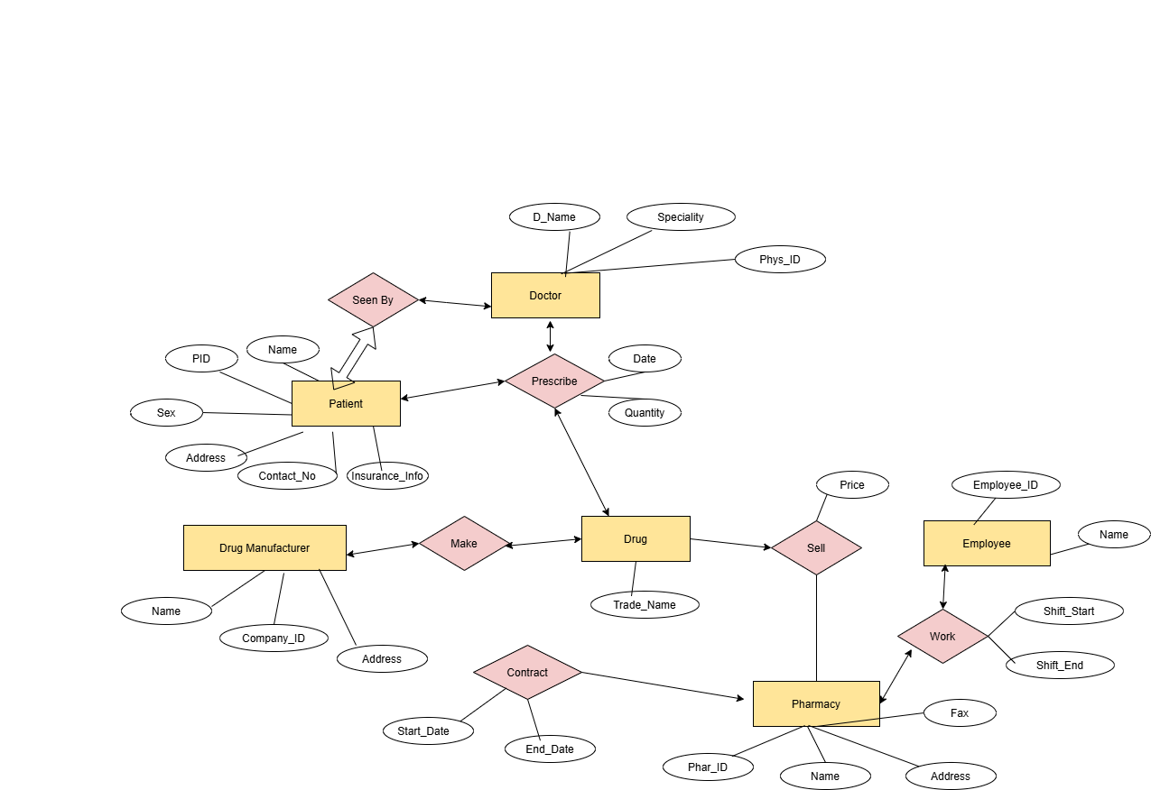

The ER diagram shows entities, attributes, and relationships using primary and foreign keys.
For example, one customer can have many sales, and one supplier can supply many medicines.

Data Structure Design :
The database consists of the following tables:
Customer Table:
Customer ID | (Primary Key)
Name
Phone
Address

Supplier Table:
Supplier ID | (Primary Key)
Name
Contact

Medicine Table:
Medicine ID | (Primary Key)
Name
Price
Stock Quantity
Supplier ID | (Foreign Key)
Prescription Table:
Prescription ID | (Primary Key)
Customer ID | (Foreign Key)
Date Issued

Prescription Details Table:
Prescription Detail ID | (Primary Key)
Prescription ID | (Foreign Key)
Medicine ID | (Foreign Key)
Quantity

Sales Table:
Sale ID | (Primary Key)
Customer ID | (Foreign Key)
Date
Total Amount

Sale Details Table:
Sale Detail ID | (Primary Key)
Sale ID | (Foreign Key)
Medicine ID | (Foreign Key)
Quantity

Relationships between tables are created using foreign keys to ensure data integrity.

NORMALISATION :
Normalisation (Up to 3NF)

- The database has been normalized to Third Normal Form (3NF).
- In First Normal Form (1NF), repetitive groupings were eliminated by establishing distinct tables for various data.
- In Second Normal Form (2NF), all non-key qualities are fully dependent on the primary key.
- In Third Normal Form (3NF), transitive connections are eliminated by partitioning relevant data into distinct tables.
- This guarantees database efficiency, minimizes redundancy, and upholds data integrity.
The data was normalized into three normal forms.

SAMPLE DATA:
Customer ID | Name | Phone
 | John | 9876543210
 | Alex | 9123456780
 | Sam | 9988776655
 | Mia | 9090909090
 | Raj | 8765432109

The table above shows sample data used to test the database system.

FIRST NORMAL FORM (1NF)
Sale ID | Customer ID | Medicine Name | Quantity | Sale Date | Sale ID
1 | 101 | Paracetamol | 2 | Jan | 1
1 | 101 | Ibuprofen | 1 | Jan | 1
2 | 102 | Aspirin | 3 | Feb | 2

In 1NF, repeating values such as multiple visit dates were removed by creating separate rows.

SECOND NORMAL FORM (2NF):
Sales Table
Sale ID | Customer ID | Sale Date
1 | 101 | Jan
2 | 102 | Feb
3 | 246 | April

Sale Details Table
Sale Detail ID | Sale ID | Medicine Name | Quantity
1 | 1 | Paracetamol | 2
2 | 1 | Ibuprofen | 1
3 | 2 | Aspirin | 3

In 2NF, the data was divided into separate tables to remove partial dependency, such as separating pet and visit information.

THIRD NORMAL FORM (3NF) :
Sales :
Sale ID | Customer ID | Sale Date | Sale ID | Customer ID
1 | 101 | Jan | 1 | 101

Medicine
Medicine ID | Medicine Name
1 | Paracetamol
2 | Ibuprofen
3 | Aspirin

Sale Details
Sale Detail ID | Sale ID | Medicine ID | Quantity
1 | 1 | 1 | 2
2 | 1 | 2 | 1
3 | 2 | 3 | 3

In 3NF, transitive dependencies were removed by creating a separate Owner table, ensuring all attributes depend only on the primary key.

The database was normalized into 1NF, 2NF, and 3NF using pharmacy-related data. This ensures consistency with the system design and reduces redundancy.

QUERIES :
The following queries were created to test the system:
1.Display all medicines available in stock
2. Find medicines with low stock quantity
3. Show all sales made by a customer
4. Display prescription details
5. Calculate total sales amount
These queries help in managing the pharmacy system effectively and support decision-making.

SELECT * FROM Customer;

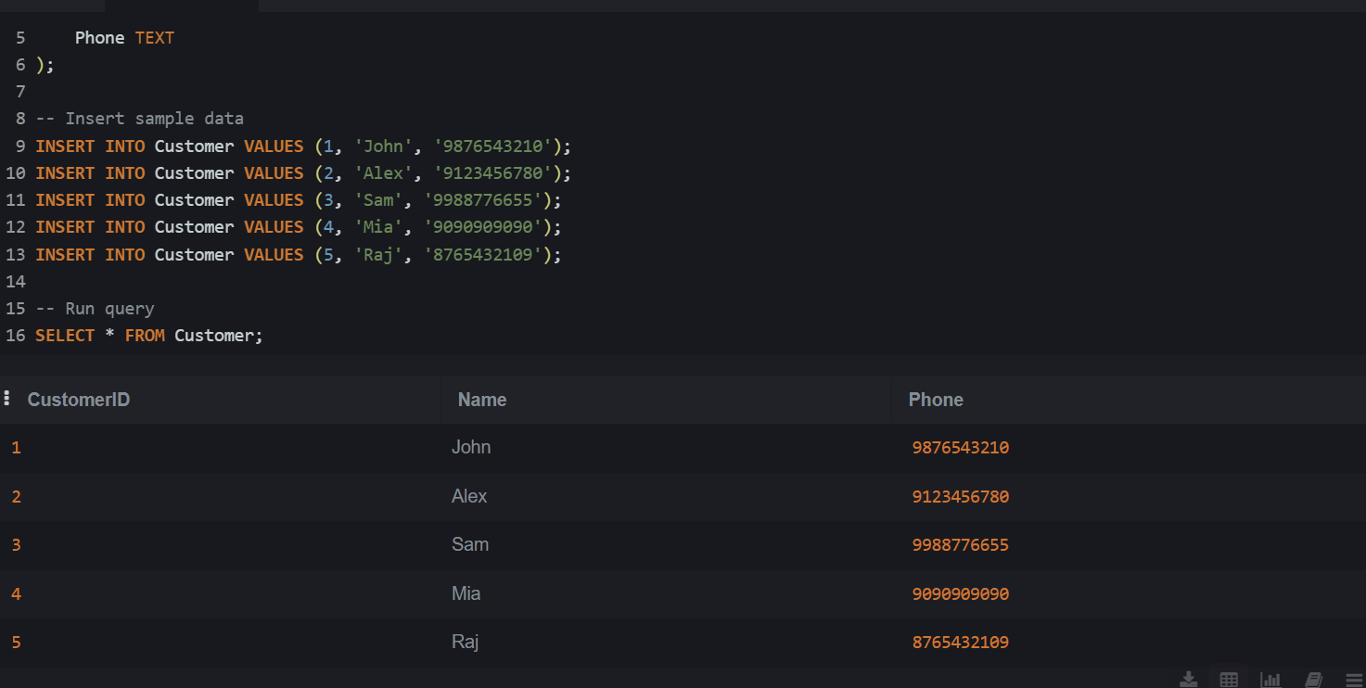
Figure 1: Query result showing customer data.

FORMS & REPORTS :
Forms were created to allow easy input of customer and sales data into the system. Reports were generated to display important information such as sales records and stock levels.
These features improve usability and help management make better decisions.

Validation and Testing section :
The database system was tested by entering sample data into different tables and running queries. The relationships between tables worked correctly, and accurate results were produced.
No major errors were found during testing, and the system performed as expected.

CONCLUSION :
In conclusion, the Medi Link Pharmacy database system effectively administers client, medication, prescription, and sales information. It enhances efficiency, minimizes errors, and facilitates superior decision-making.

References :

[1] Silberschatz, A., Korth, H. F., and Sudarshan, S., Database System Concepts.
[2] Microsoft, "Microsoft Access Documentation", available online.
[3] Draw.io, “Diagram Software and Flowchart Maker,” www.drawio.com, 2024. https://www.drawio.com/
‌

