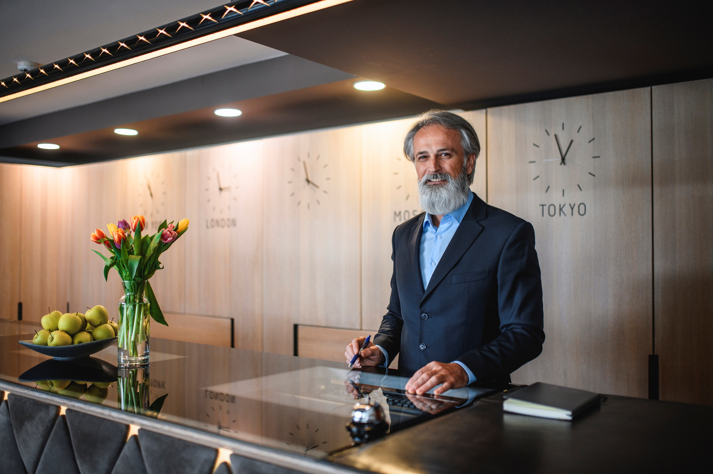  Student lEARNING lOG:  Reception/Front Office | Student Name: Anat Dranciuc Georgescu  Student Number: 2125394  Module: Managing Hotel Administration  Module code: BMIH6004  Lecturer: Lisa Bassler  Word Count: 1251

I acknowledge the use of Grammarly (https://www.grammarly.com/) on 10 February
2024 to check my work using the prompt(s):
1. Please check the following text for readability, grammar and syntax.
I confirm that I have not presented any AI-generated text as my own work. I confirm I
have copies of my drafts, notes, and other resources I used before, and after the use of
AI tools which I may be asked to provide in evidence.

Contents
Introduction 1
Concrete experience 1
Reflective observation 1
Abstract conceptualization 1
Active experimentation 1
Reference List: 1

Introduction
In this learning log, I will be presenting my short but full-experience journey with the Reception Team of Hilton Garden Inn located in Doncaster. The team should have been composed of two managers, two supervisors and at least three receptionists but currently, the team has one manager and three receptionists during the day shift, I haven’t been able to check the night teams due to personal circumstances.
Before I add any more details, this learning log will be analysed with a different reflective cycle than the rest of my work just because I believe it is more suitable for this situation.
University of Cambridge (2025) points out that, Kolb's Experiential Learning Cycle outlines how people develop understanding through experiences, and it consists of four stages: Concrete experience, reflective observation, abstract conceptualization and active experimentation. This cycle demonstrates learning through experiences and reflections, like how children learn basic concepts like hot and cold by touching and reacting to stimuli.

Concrete experience
While working within the Food and Beverage departments when it was not too busy, I had the opportunity to jump in with the reception team/front office and have a chat, take a pick at what they were doing and learn a lot about the team's activity during the day.
The current reception team at Hilton Garden Inn (2025) are covering checking in and out of customers, room key makings, Hilton’s Garden Inn inside shop, reports that help the F and B team to know how many customers will come for breakfast, dinner, lunch, reports and confirmations for the housekeeping team as to what customers will be checking in or checking out and even the rooms that need refreshing with guests still staying.
I had only one day so far in reception and what I did was to make keys ready for future customers that would arrive on that day later in the afternoon and data entry for future corporate customers that would arrive in a few days.
I had a one-on-one conversation with the reception manager as well and he explained to me that besides his office work, he currently is responsible for the reception desk some days as well, the fire alarm system, if there is no duty manager on the shift, he will be the one to take lead, and he also has training in first aid, he also explained to me that since the hotel is part of the Hilton franchise, they need to follow the rules and procedures put in place by Hilton (2025), targets that need to be achieved such as how many new customers have enrolled in the Hilton for the stay program (Hilton – Owners Portal and Hilton Honors, 2025).

Reflective observation
While I haven’t yet done any checking or check-outs I noticed that my colleagues from reception were quite under pressure, they were answering phone calls from customers interested in menus from the restaurant within the hotel, customers that wanted only a lunch reservation and many types of other enquiries that would firstly go threw their phone line, besides all this they would have cash to register, giving phone calls to corporate businesses where clients haven’t made their payments for the rooms yet, keeping an eye on the staff back door to open it in case anyone rings and also keeping on the barrier of the front of the hotel if anyone calls in.

Abstract conceptualization
What I have noticed and learned is that because the whole reception team is based on the Hilton brand and standards, meaning in every single Hilton Garden Inn you will find the same kind of organization there may be time for some practical changes, Hilton (2024) presents the new check-in system threw the app phone where customers can access their rooms by double tapping on the phone as a key card instead of going threw the hole reception process and wait for a key card.
It may not be a realistic solution for the time being and would definitely need a lot of money to invest in such a system but it is an idea for the future and if this becomes a brand standard then all Hilton brands will need to follow up with this new technology and find other resources and options for the reception employees., perhaps a customer service support would be a more suitable job in the future.
Forsey, C. (2023) explains that its article on reputation management outlines how to protect and manage your brand's online reputation. Key points include:
- Reputation Management: Managing public perceptions via online messages, SEO, social media, and PR.
- Brand Reputation Management: Monitoring and improving consumer perceptions through reviews, social media, and Google.
- Building a Reputation Management Plan: Developing an effective strategy.
- Reputation Management Software: Tools to monitor and manage online reputation.
It highlights the importance of maintaining a positive reputation to inspire customer loyalty and drive revenue while learning from negative feedback to improve business processes.
A customer support position would have a much more positive impact in the front office/ reception area that would allow the employees to check customers in real time reviews as well as help them with any information that they might need on arrival or departure almost same as airports or shop’s customer support department.

Active experimentation
Rutherford et.al. (chapter 4 p.124-125, 2006) emphasize the front office manager's active role in gathering and distributing information to assist various hotel departments in organizing hospitality. Key areas of interdepartmental communication include:
- Marketing and Sales: Guest history, reservations, messages, and function info.
- Housekeeping: Room status, house count, security, and supply requests.
- Food and Beverage: Messages, voucher info, charges, and house counts.
- Banquet: Event info, payment processes, function board, and marquee.
- Controller: Financial transactions, billing data, and credit ledgers.
- Maintenance: Room status and maintenance requests.
- Security: Fire safety, emergency communication, and guest security concerns.
- Human Resources: Screening potential employees.
The FOM must proactively communicate and facilitate, ensuring departments have necessary guest information. A typical day includes reviewing reports, communicating with staff and departments, resolving billing issues, preparing budgets and forecasts, conducting meetings, assisting with check-ins/outs, and maintaining equipment.
From my short-term experience and from what I have learned so far from my previous placement as well as my learning years, a front office manager has the hardest but most rewarding of jobs, there is a lot of patients involved, a lot of hours put in place and dedication.
What I would recommend is having an assistant manager to support the work load as well as being able to do small but significant gestures to guests every now and then because as Kevin Clark (2022) points out , every small gesture counts and not every customer is a new customer at Hilton, some are well know frequent customers and they expect the best of the best in any Hilton hotel that they might land in.

Conclusions:
Hotel Guest Management (2022) emphasises the importance of taking into account that not all guests are the same and not all guests have the same status, guests can sometimes be rough and they will let you know from the start what Hilton honour rank they have if you are not quick enough to realise or maybe by accident you haven’t received that information.
That’s why it is imperative to double-check with the manager or the shift leader all the information necessary before greeting a guest at any Hilton hotel, always have a complementary gift at hand for the special guests and always great everyone with a smile and a positive attitude.

Reference List:
Denney G. Rutherford, Michael J. O'Fallon, and Denney G. Rutherford (2006). Hotel Management and Operations, ProQuest Ebook Central - Book Details. [Online] Available at: https://ebookcentral.proquest.com/lib/trinity/detail.action?pq-origsite=primo&docID=257559# (Accessed: 7 March 2025).
Forsey, C. (2023). Reputation Management: How to Protect Your Brand Online in 2023. [Online] Available at: https://blog.hubspot.com/marketing/reputation-management [Accessed 07 March 2025].
Hilton (2024) Hilton. For The Stay. | Digital Check-In | Shining Gold - YouTube. [Online] Available at: https://www.youtube.com/watch?v=y_j2nhAJQtY (Accessed: 7 March 2025).
Hilton (2025). Hilton. For the Stay: Transforming Hotel Marketing One Campaign at A Time. [Online] Available at: https://jobs.hilton.com/us/en/blogarticle/hilton-for-the-stay-transforming-hotel-marketing-one-campaign-at-a-time (Accessed: 7 March 2025).
Hilton Honors (2025) Earn Points, Hotel Rewards, and More. [Online] Available at: https://www.hilton.com/en/hilton-honors/ (Accessed: 7 March 2025).
Hilton Garden Inn (2025) Hilton Garden Inn Doncaster Racecourse. [Online] Available at: https://www.hilton.com/en/hotels/dsadrgi-hilton-garden-inn-doncaster-racecourse/?SEO_id=GMB-EMEA-GI-DSADRGI (Accessed: 6 March 2025).
Hilton – Owners Portal (2025). Hilton Honors Member Benefits (2025). [Online] Available at: https://hilton.my.site.com/s/article/Hilton-Honors-Member-Benefits (Accessed: 7 March 2025).
Hotel Guest Management (2022) Hotel Front Desk Agents You Shouldn't Hire | Front Desk Agent - YouTube. [Online] Available at: https://www.youtube.com/watch?v=CI0Gy1L1oxs (Accessed: 7 March 2025).
Kevin Clark (2022). Hilton Honors Training – YouTube. [Online]Available at: https://www.youtube.com/watch?v=Ac10ji3InPo (Accessed: 7 March 2025).
University of Cambridge (2025). Study skills - Models of reflection - Reflective Practice Toolkit. [Online] Available at: https://libguides.cam.ac.uk/reflectivepracticetoolkit/models (Accessed: 7 March 2025).

