Strategic Management Case Analysis: Sony PlayStation

Module Code :- LCMB 7003
Lecturer :- Charles Oham
Submission Date :- 13/01/2023
Student Name And Student ID :- Vijaypal Godara (2130310)

Executive Summary
PlayStation is one of the most successful and popular offerings by Sony. The brand is synonymous for gaming consoles and has a critical brand loyalty and niche in the segment. The case study talked about the rise of PlayStation along with the failure of other brands to catchup the buzz generated by Sony. This assessment takes account of internal and external analysis of the company and PS brand by making use of most popular strategic management tools such as VRIO, Financial Ratio Analysis, PESTLE, SWOT and Five Forces Analysis.

Table of Contents
Executive Summary 2
Table of Contents 3
Introduction to PlayStation Case Study 3
Industry Analysis: Video Gaming Sector 4
Trends in Video Gaming Market 4
Expected Growth in the Sector 4
Reasons for Growth in the Sector 5
Key Success Factors for Sony 6
Internal Analysis: Sony 6
Financial and Business Analysis 6
Value Chain Analysis: Sony 8
Resource and Competence Analysis 9
External Analysis: Sony 10
Five Forces Analysis 10
PESTLE Analysis 12
SWOT Analysis 13
Strategies for Sustaining Competitive Advantage 15
Recommendations and Conclusions 18
References 19

Introduction to PlayStation Case Study
This case study takes account of one of the different product likes offered by Sony Corporation. As a multinational conglomerate, the company has numerous products and services as part of its portfolio. The most popular products include TVs, Cameras, Consumer Electronics, and Gaming Consoles. The PlayStation project was originally entered with Nintendo but due to a fallout between the two companies, Sony had carried out the project individually and it has been one of the most successful offerings besides the legendary Walkman and various television alternatives.

With the fall of Atari and an overall change in perception of video game players around the world, the overall popularity of Sony’s offering has improved significantly. There are, however, other rivals within the market which constantly affect the market position of the enterprise. The case study primarily focussed on how the company can maintain its top position within the sector. Sony has not been a traditional player in the gaming industry (like Nintendo) but despite being a late entrant, the product and games offered on the PS platform have been extremely popular. As per the case study, in 2005, 8 out of top 10 video games were offered on the PS2 framework, thereby making it one of the most successful consoles ever.

However, the case study also underlines how the console wars has reignited and it is critical for a company such as Sony to be alert in regards to strategic management and strategies implementation to ensure that it continues holding its market position. The case study assessment will take account of a comprehensive external environment and internal environment assessment of Sony and evaluate how the gaming sector is expected to perform in the next few years.

Industry Analysis: Video Gaming Sector
In the first part of the case study analysis, a brief assessment of the video game industry shall be carried out. This part will take account of the current and expected trends in the market along with the reasons for growth of the industry and Sony.

Trends in Video Gaming Market
The trends in the gaming industry have undergone massive changes. The total market size (global) is expected to reach $600 billion by the end of 2030 (Eddie, 2021). However, some of the biggest trends in the market have been due to the massive inflow of technology that has changed the way the industry operates. With AR and VR in gaming, it is expected to witness cross platform gaming trends in the upcoming years. There shall be more competitiveness in multiplayer mobile gaming. With a significant increase in smartphones usage, mobile games will be accepted in emerging markets as well. There shall be more emphasis on the usage of blockchain in gaming industry. Metaverse gaming shall also be a possibility in the next few years.

Expected Growth in the Sector
It is critical to understand that the consoles industry is distinct from the entire video gaming industry. Gaming industry can include PC and smartphone-based video gaming options. However, video gaming consoles are distinct and standalone sector. The growth trends in the consoles sector have been demonstrated by the following graph:
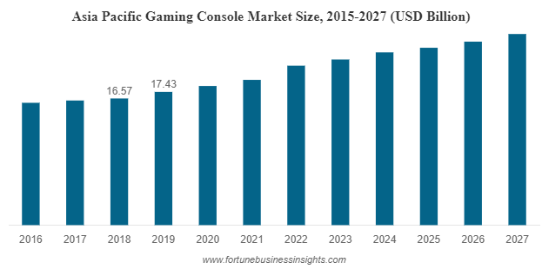
Figure 1.0: Gaming Console Market Size (Asia Pacific)

The graph above is an indicator that the market trends are largely positive. In addition to this, the CAGR of the sector shall be close to 6% in the next few years. The market drivers of the sectors can be the faster adoption of HD televisions, advanced wireless technologies, and availability of fast and cheap internet across different parts of the world. Furthermore, an overall increase in the disposable income of potential consumers even in the emerging economies could be deemed as another factor due to which the market trends are largely positive. With companies such as Sony and Microsoft planning launch of new consoles at a consistent basis (which shall be loaded with latest features), it is anticipated that the competitive rivalry and overall growth within the sector will not die down anytime soon.

Reasons for Growth in the Sector
There are different reasons due to which gaming consoles are still popular. As explained by Correa (2021), PC games are way too superior and at times economical as compared with the gaming consoles. However, the popularity of gaming consoles continues to be strong. Taylor (2015) explained that secure environment in a console is something which the gamers prefer over the PC and smartphone-based games. The accessibility of gaming consoles is also better than PC or any handheld devices. There is a significant social appeal and acceptance of consoles (Taylor, 2015). There is also a significant change in societal perspective towards video games consoles which means that they are not restricted to teenage boys and young users as there are a large number of adult gamers.

Key Success Factors for Sony
Sony Corporation as a whole has been successful in different offerings that it has provided to users in distinct sectors and products. As explained by Lee (2011), the company has been successful due to the extensive amount of money spent on research and development. Research and development in the part of image signal dispensation technologies has been the core competence of the company. The company has been technologically innovative and aimed at providing the products with highest usability. The company should be credited for a number of innovations such as the Walkman, Floppy Disks, Compact Disks, and video tape formats.

The company has a diverse and global manufacturing and distribution network which implies that the products and services offered by Sony can be accessed easily from any part of the world. The after-sales support of the enterprise is also flawless and one can see a loyal customer base.

Internal Analysis: Sony
After carrying out a brief assessment of the industry, it is now the time to move forward and evaluate how the enterprise has performed in the past few decades. The first part of the internal analysis shall include a financial and business analysis of Sony Corporation (thereby taking account of the entire group rather than PlayStation alone).

Financial and Business Analysis
In the first part of the internal analysis, a financial ratio assessment for the company is carried out. A summary of the financial rations of the company have been presented as follows:
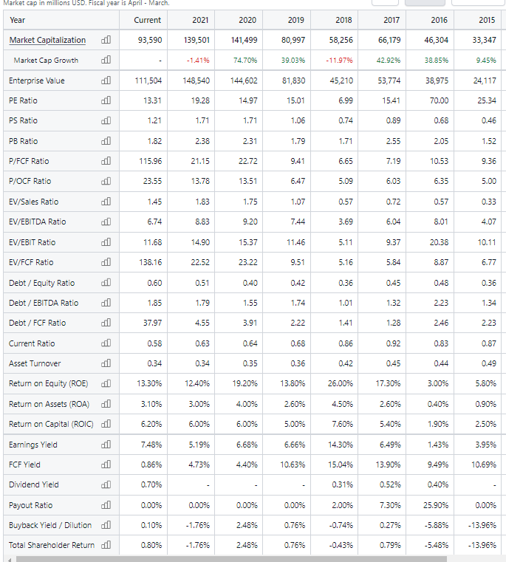
Table 1.0: Financial Ratio Analysis of Sony (Stock Analysis.com)

Starting with the ROE (Return on Equity), the company has demonstrated a consistent rate of return for the equity shareholders. In the previous year, the ROE figures were around 12.40%. However, the biggest cause for concern can be the overall volatility that the figures have shown in the past few years. In addition to this, the asset turnover has been around the 0.34 mark in the past three years. The return on capital has been around 6% in the past three years. The company should be worried about the poor state of cash management as the current ratio has never been close to the 1.00 mark which implies that the current liabilities of the company are way more than the current assets, thereby putting the company in a significant volume of risk. However, the financial performance as depicted above shows a significant consolidation as the enterprise has started to repost profits after years of volatility in the figures. As reported by Batchelor (2021), one of the reasons for the company’s stable financial performance should be attributed to the PlayStation sales. As per the report, the total year revenues affected by PlayStation were close to $82 billion, thereby becoming one of the most critical contributors to the success of the enterprise.

Value Chain Analysis: Sony
Sony has a definitive edge over the rivals because the processes and activities are related with each other in both internal and external perspective. The value chain of the company has been described as follows:
- Primary Activities
The primary activities of Sony Corporations are largely engaged in production and selling different goods to the target customers. The primary value chain activities have been further explained as follows:

2.1.1 Inbound Logistics: The production and research and development process consist of arranging raw materials such as semiconductors from different parts of the world. Most of the process of procuring raw materials and conversion of raw materials into finished goods is carried out in China.

2.1.2 Operations: Some examples of operational activities are machining, packing, assembling and testing. Equipment repair and maintenance also falls into this category. In the past couple of years, both inbound logistics and operations of the company have been affected due to the disruptions in China. As reported by Singh (2019), this is one of the reasons why critical operational centres have been moved from China to Thailand.

2.1.3 Outbound Logistics: Outbound logistics consists of supply chain, delivery networks and after-sales service of the company. The company has a significant presence in almost all parts of the world with integrated dealer networks and third-party retailers.

2.1.4 Marketing and Sales: Sony has enjoyed strong brand loyalty by a category of customers across different segments. However, the marketing processes of the company have been largely traditional without too much usage of social media.
2.1.5 Services: The after-sales support services of Sony have helped in further strengthening its brand name across different sections of customers.

2. Secondary Services
The secondary services of the company include massive firm infrastructure and presence of huge capital and cash deposits due to which making changes to the existing production and assembling processes become easier. The secondary services also include human resource management system of the company. It further takes account of technology development where the company has done some tremendous work as the innovator in different fields such as automation software, technology-supported customer service, product design research and data analytics along with various hardware.

Resource and Competence Analysis
In order to carry out a resource and competence analysis of the company, a VRIO assessment has been carried out. The summary of the VRIO analysis of Sony has been presented in the following table:
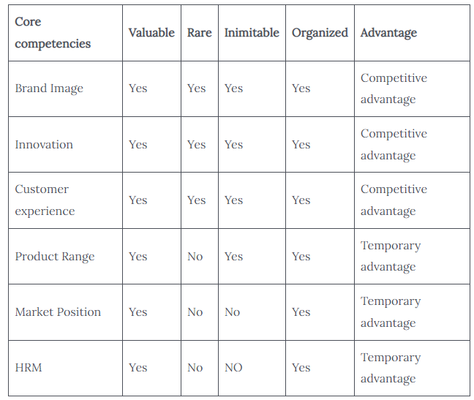
Table 2.0: VRIO Analysis Summary of Sony Corporation (Pratap, 2021)

If the brand image of the company is considered, it is a definitive competitive advantage as it takes account of all the factors as such brand value is valuable, rate and difficult to imitate. Furthermore, it is quite organized, thereby giving a definitive edge to the company over the rivals. In addition to this, the innovative capabilities if the company also satisfy all the four points, thereby providing a competitive advantage to the enterprise. As it has been mentioned at a couple of instances before, the company has released several products and technologies that were the world’s first and many first of their kind in its domestic market.

The customer experience of the company based on its integrated and strong service and supply chain also provides a definitive edge over the rivals. The company has a strong brand name that helps customers differentiate its products and offerings from the rivals. In addition to this, the product range, market position, and HRM of the company can also provide temporary advantage to the enterprise over the rivals. Overall, the company enjoys a steady and peculiar market position backed with brand loyal customers.

External Analysis: Sony
After carrying out internal analysis of the company, it is clear that the company has a unique position due to the strong internal factors such as focus on innovation and a strong external network. In this part of the assessment, an external analysis shall be carried out by taking account of three popular tools of strategic management: Michael Porter’s Five Forces Analysis, PESTLE Analysis, and SWOT Analysis.

Five Forces Analysis
The first part of the external strategic management assessment will be to carry out a Five Forces Analysis. This is discussed as follows:
- Threat of New Entrants
The kind of business model that gaming console companies need to create and follow is quite difficult to imitate. The economies of scale that PlayStation manages due to the massive size of Sony Corporation is not something that a new entrant could easily manage. The capital requirements of setting up a production and supply chain even close to Sony can be a difficult objective to achieve for new entrants. Furthermore, supplier relationships could be difficult to maintain and there are numerous licensing and government requirements which a new entrant would have to take into consideration. Hence, the overall threat of new entrants is a weak force for PlayStation and Sony Corporation.
This is a critical point in the favour of Sony Corporation. Through the cost advantage available, Sony can easily fight off any new entrant. The company can also focus on product differentiation by diversifying offerings within the PlayStation platform.

- Bargaining Power of Suppliers
There are a large number of suppliers in the industry in which PlayStation operates. Hence, suppliers are price takers and do not have any control over prices. The products supplied by partners and suppliers is fairly standard. Hence, it is rather easy for a company like Sony to switch suppliers for manufacturing software and hardware for PlayStation. The suppliers have little competition with each other and hence the bargaining power of supplier is also a weak force in the industry which works in favour of Sony. There are a number of advantages which PlayStation and Sony can have due to this weak force. Such advantages can include procuring raw materials at a lower cost, having multiple suppliers within the chain, and having close and cordial relationship with the suppliers.

- Bargaining Power of Buyers
The product differentiation within the industry is too high and hence it would be difficult for a customer to find similar products and services as offered by PlayStation. There can be games and devices protected by intellectual property rights which means that the customers will need to stick with the same company. There is also a capping on the income of the target and potential customers. There is no significant threat to the buyers to integrate backwards. This makes the bargaining threat of buyers a weaker force within the industry. Once again, this factor can be used for the advantage of PlayStation brand by Sony. There is a need for concentrating heavily on product differentiation and innovation. Since the bargaining power of buyers is a weak factor, it needs to concentrate on expanding the customer base.

- Threat of Substitutes
There are only a few companies and substitutes that can match the quality of consoles and games offered by Sony PlayStation. Microsoft Xbox and Nintendo are the closest rivals of the companies that have similar offerings as compared with the PlayStation. However, the overall dominance of the company in the gaming consoles sector is quite impressive. The threat of substitute products is therefore a moderate force as the company might need to face some level of competition from the rivals. It is advisable that PlayStation should focus on providing the best gaming experience to the customers in order to ensure that it takes advantage of the moderate threat of substitutes.
- Rivalry among Firms
There are only a few players in the console sector. As mentioned before, companies such as Microsoft and Nintendo are the biggest rivals that PlayStation needs to take account of, besides PC and Phone gaming (indirect rivals). However, due to the presence of only a few rivals within the industry, these companies take up a significant market share. Hence, the overall rivalry between the brands is quite intensive. It is critical for the company to focus on improving customer experience and expand its customer base by targeting new markets.

PESTLE Analysis
After carrying out a Porter’s Five Forces Analysis for PlayStation, it was found that despite weak and moderate threats to the company’s position, there is a need for Sony to consistently focus on differentiation, expansion, and innovation. After carrying out the Five Forces Analysis, the next step would be to carry out PESTLE Analysis for PlayStation.
- Political Analysis
Even though the presence of the company in different parts of the world is an indicator of governmental and political support enjoyed by the brand, there are a number of factors which the company might have to take into consideration in the future. First, there is an increased emphasis on security, privacy, and data protection factors by governments around the world. Since PlayStation is prone to cyberattacks and does not have a stellar security mechanism, the company should ensure that the product and services follow the highest security standards to averse any kind of external threats. Sony has created openings reliant on the political adequacy of the best markets. It is a result of Sony enterprise into the business in electronic gaming stimulation.
- Economic Analysis
Post Covid-19, the overall economic environment has not been the same as the disposable incomes have reduced. This is a consolidation phase for many focus markets of the company and hence the next few years would be quite challenging. However, with an overall improvement in supply chains and increased popularity of ecommerce sites, the presence of PlayStation and Sony shall increase in emerging and new markets.
- Social Analysis
There is a perception change as far as gaming industry is considered. As explained by Meyer (2017), gamers are not deemed to be young teenagers but is considered as a recreational sport enjoyed by people of all ages and genders. Console gaming has become a serious career option as there are a number of gamers, bloggers and vloggers who have made a name and fortune by gaining expertise in the respective fields.
- Technological Analysis
The gaming industry on an overall basis is expected to witness a massive change which Sony should be willing to embrace and introduce in the upcoming console products. One of the biggest advantages with PlayStation is the niche enjoyed by the consoles among hardcore gamers and general customers. PlayStation is a synonym for consoles.
- Legal Analysis
There are various legal factors such as intellectual property rights (patents and copyrights) and intergovernmental agreements. Furthermore, there are sustainability-related factors which the company needs to take into account for proper waste management and disposal of hazardous parts etc. Since PlayStation is shipped and available in almost all parts of the world, the company needs to take account of the local and international norms.
- Environmental Analysis
Sony has been one of the most nature-friendly companies due to the introduction of environmentally friendly equipment. In PlayStation, items causing natural effect has been decreased in various manners. All batteries and PlayStation vita screens are sans mercury. The brand has also collaborated with the United Nations in order to battle environmental damage and has done a tremendous job for protecting the environment.

SWOT Analysis
After taking account of the PESTLE Analysis which underlined different positive and negative (and challenging) aspects that can affect the long-term strategies of the company. The next part in the external analysis is to carry out a SWOT Analysis. PlayStation has enjoyed a strong position in the market and has been a market leader in the gaming consoles sector for a considerable period. This has been possible due to the wide range of strengths it has over the rivals.

Strengths:
- There are a number of exclusive games only at the PlayStation platform. Hence, hardcore gamers and enthusiasts are tempted to go ahead with this platform because of the presence of games which one might not find anywhere else.
- There are handheld variants of PlayStations such as PlayStation Vita and PSP which are extremely popular among young gamers.
- The brand is targeted by game developers as it provides an excellent opportunity to test the strengths and glitches in a game.
- The company has patented dual shock controllers which adds to the overall experience and excitement of gaming.
- PlayStation move technology helps in ensuring that gamers can play different sports-based games.
- PlayStation has integrated backwards compatibility which ensures that old games can be run on newer consoles.
- PlayStation was the first console brands to introduce 4K technology in the games, thereby enhancing the entire gaming experience.
- There are monthly plans for different gaming alternatives (Bhasin, 2019).

Weaknesses
- The price of games is too high along with the price of the console. This means that middle class buyers often think twice before purchasing a PlayStation.
- Furthermore, it needs compatible TVs which could result in additional costs that the buyer needs to pay.
- The console might need constant upgrades which could be costly for the user.
- The keyboard support is not up to the mark as complained by a number of users.

Opportunities
- There is a tremendous opportunity for the brand in the VR segment as it is dubbed as the future of the gaming industry. Virtual reality will not only help in gaming but can be a social platform too.
- There is an increase in the number of gamers in different parts of the world.
- Online gaming and the rise of disposable income in emerging markets that can result in higher sales for the company (Bhasin, 2019).
- There is a chance for the company to expand in subscription-based gaming sector.

Threats
- There is a constant decrease in the total sales of consoles and the industry has a CAGR or close to 5.5% only projected for the next five years (Gaming Console Market Size, Share, Growth | Report, 2027, 2022).
- PC gaming is a strong force in the gaming market.
- The market is maturing and the brand needs to face massive competition from rivals such as Xbox and Nintendo.
- Mobile gaming has the ability of better penetration in the emerging markets due to accessibility offered.

Strategies for Sustaining Competitive Advantage
It has been underlined in the case study and based on the assessment by secondary research on the topic that PlayStation is an undisputed market leader, as far as the gaming consoles industry is concerned. The company’s diversification strategy in the video gaming industry worked well for its advantage (Mondello, 2021). The company has a complete control on the supply chain. The success of the brand can also be attributed to the timing when it shifted to CD to DVD and Blu-ray.

As underlined by Shastri (2022), the company spends a significant amount of its total profits in the marketing and promotional activities of PlayStation. Since the brand contributes heavily to the total sales and has been described as the reasons due to which the company has regained its position in different market segments, it is imperative that the company continues spending money on marketing and expansion of the brand. Here are a few suggested strategies that PlayStation should take into account in order to sustain competitive advantage in the future as well:
- Diversification and collaboration with game developers
One of the most critical reasons for the success of PlayStation could be attributed to the ability of Sony to diversify in a sector which had little scope of it. In addition to this, there are a wide range of games exclusively on the PS platform which implies that it is the penultimate choice for gamers and even general users whilst thinking about gaming consoles. This is one strategy that has worked extremely well for the company and it must continue with it.
- Marketing and Promotional Campaigns
The promotional and marketing campaigns of PlayStation 5 across London have been dubbed as some of the most iconic advertising strategies adopted by a gaming company. The company made efforts that it reaches not only the gaming enthusiasts but people from different spheres. The company had collaborated with Travis Scott on a new pair of Cactus Jack x PlayStation Nike Dunks which was unexpected. Even though the impact of such promotional campaigns is not measured in monetary terms, it did help the enterprise in generating a lot of positive buzz among general audiences.
- Social Media Marketing
As a brand, PlayStation has a fanbase of 35 million users (Shastri, 2021). This is a massive number as a large fanbase is created after years of work and perseverance. It is critical for the company to maintain active engagement with the customers and hence there are a few innovative strategies that they need to follow. First, the focus should not be on the latest offerings but on previous consoles as well. For instance, there might be a number of active PS4 users who still follow PS social media for critical updates. It is also important that PlayStation store, the ecommerce platform of PS should be further advertised by underlining its advantages over any third-party offerings. Furthermore, because PlayStation does not segment its customers by product, customers can see what’s going on across the PlayStation system family and are aware of promotions across the board, which is a great way to increase sales.

- Enhancing SEO strategies
The SEO strategy of the company is often not discussed but there are more than 1.5 million keywords on the official PS website (Shastri, 2021) thereby proving how effectively the company has utilised SEO. There are around 50 million organic visitors to the official website. This has to be further improved by introduction of short videos and Instagram/Tiktok videos which have a massive popularity in the current scenario.

- Influencer Marketing
In the previous part, the importance of social media such as YouTube shorts, Instagram Reels and Tiktok was underlined. This gives rise to the usage of influencer marketing by PlayStation. One of the biggest advantages that PlayStation has is the fact that most of the influencer marketing it has achieved till now has been without spending too much money as the company has a massive and loyal following across the world. However, with a little bit of investment and roping in influencers from the target markets, the overall impact of influencer marketing can be increased significantly. When the company is willing to enter new markets and expand into new arenas, influencer marketing should be something which it cannot ignore.

- Focussing on casual users
PlayStation is extremely popular brand among gamers and gaming enthusiasts. However, there is a large population of casual users such as professionals, young employees, and homemakers who can be targeted by the marketing campaigns of the company. These classes of customers have the disposable income to spend on gaming and consoles. Hence, the focus should be diversified rather than on gamers only.
- Collaborating with EdTech
Another critical expansion strategy for PlayStation would be to collaborate with EdTech companies in order to design and implement game-based learning solutions. By doing this, PS can reach schools, colleges, and offices. This will mean that casual users will have access to PS consoles and games based on which the overall popularity of the brand shall increase.
In addition to the above strategies, there is a need for the company to focus on emerging markets. For instance, emerging economy such as India is expected to witness CAGR of 27% in the gaming sector which is more than any other part of the world (Rao and Karunakar, 2022). The company has a strong network in such emerging markets and it must make use of the social media and ecommerce capabilities based on which further expansion and diversification can be achieved.
PlayStation has also developed a kind of Netflix for games (in the form of subscription-based services available on PlayStation Now). here are currently more than 450 games available on PlayStation Now, according to Sony. This can be a gamechanger as far as the company’s plan to expand in new markets and existing marketplaces is concerned. None of the closest competitors of the company have been able to introduce this level of innovation in marketing and strategic management.

Recommendations and Conclusions
To conclude, the case study primarily focussed on how PlayStation emerged as the market leader in the gaming consoles sector. The study took account of the correct timing of critical decisions that the company took in order to gain a definitive edge over the rivals. Failure of a few competitors and the fallout with Nintendo led to PlayStation becoming the force to reckon in the gaming consoles sector. This expanded case study took account of internal and external assessment of Sony and PlayStation. In the internal analysis, VRIO and Financial Analysis of Sony Corporation was carried out. There were mixed outcomes of the study whereby both positive and negative aspects were covered during the assessment. However, in the external analysis, it was found (through PESTLE and Five Forces) that despite tremendous competition within the market, PlayStation enjoys a niche and this is expected to continue in the future as well.

It is further recommended that the company continues its diversification journey. It is also recommended that the company plans to expand in emerging markets by carrying out assessment of markets where the gaming sector is expected to grow in double figures. The company should also look forward to focus on casual users and concentrate on expanding its subscription program.

References
Batchelor, J. (2021) PlayStation revenues near $25bn as PS5 ships 7.8m in five months, GamesIndustry.biz. GamesIndustry.biz. Available at: https://www.gamesindustry.biz/playstation-revenues-near-usd25m-as-ps5-ships-7-8m-in-six-months (Accessed: December 29, 2022).
Bhasin, H. (2019) SWOT analysis of PlayStation, Marketing91. Available at: https://www.marketing91.com/swot-analysis-playstation/ (Accessed: December 29, 2022).
Correa, G. (2021) Is PC better than console? (yes & here's 10 reasons why), Apex Gaming PCs. Available at: https://apexgamingpcs.com/blogs/apex-support/why-pc-gaming-is-better-than-console#:~:text=Each%20platform%20offers%20a%20unique,and%20overall%20performance%20among%20others. (Accessed: December 29, 2022).
Eddie, S. (no date) Gaming trends 2023 - top 10 trends that will rule industry, EDIIIE. Available at: https://www.ediiie.com/blog/gaming-trends/ (Accessed: December 29, 2022).
Gaming console market size, share & Industry Analysis, by type (home consoles and handheld console (portable and non-portable)), by end-use (residential and commercial), by applications (gaming and non-gaming), and Region Forecast, 2020-2027 (no date) Gaming Console Market Size, Share, Growth | Report, 2027. Available at: https://www.fortunebusinessinsights.com/gaming-console-market-102420 (Accessed: December 29, 2022).
Meyer, P. (2017) Sony's Generic Strategy & Intensive Growth Strategies, Panmore Institute. Available at: https://panmore.com/sony-generic-strategy-intensive-growth-strategies#:~:text=Sony%20Corporation%20uses%20differentiation%20as,its%20products%20attractive%20and%20profitable. (Accessed: December 29, 2022).
Mondello, W. (2021) The history of PlayStation: How Sony became a leader in the Gaming World, LinkedIn. Available at: https://www.linkedin.com/pulse/history-playstation-how-sony-became-leader-gaming-world-mondello/?trk=public_profile_article_view (Accessed: December 29, 2022).
Pratap, A. (2021) Vrio analysis of Sony, Notesmatic. Available at: https://www.notesmatic.com/vrio-analysis-of-sony/ (Accessed: December 29, 2022).
Rao, A. and Karunakar, R. (2022) India is emerging as a gaming hub: Here's why, NDTV.com. NDTV Profit. Available at: https://www.ndtv.com/business/india-is-emerging-as-a-gaming-hub-heres-why-3520771 (Accessed: December 29, 2022).
Shastri, A. (2022) Complete Marketing Strategy of playstation - 2022, IIDE. Available at: https://iide.co/case-studies/marketing-strategy-of-playstation/ (Accessed: December 29, 2022).
Singh, S. (2019) Sony closing smartphone plant in China, moving production to Thailand, Gizmochina. Available at: https://www.gizmochina.com/2019/03/28/sony-closing-smartphone-plant-in-china-moving-production-to-thailand/ (Accessed: December 29, 2022).
Sony Group (Sony) financial statements: Income (no date) Stock Analysis. Available at: https://stockanalysis.com/stocks/sony/financials/ (Accessed: December 29, 2022).
Taylor, B. (2015) 4 reasons video game consoles are here to stay, Time. Time. Available at: https://time.com/3712633/video-game-consoles/ (Accessed: December 29, 2022).

