Rachid Aboulachouaq
2237654@student.uwtsd.ac.uk
Assignment 2
Learning in the Digital Era
Module Code: ACCA4025

See below a screen shot of the posted video on YouTube and the video link below it

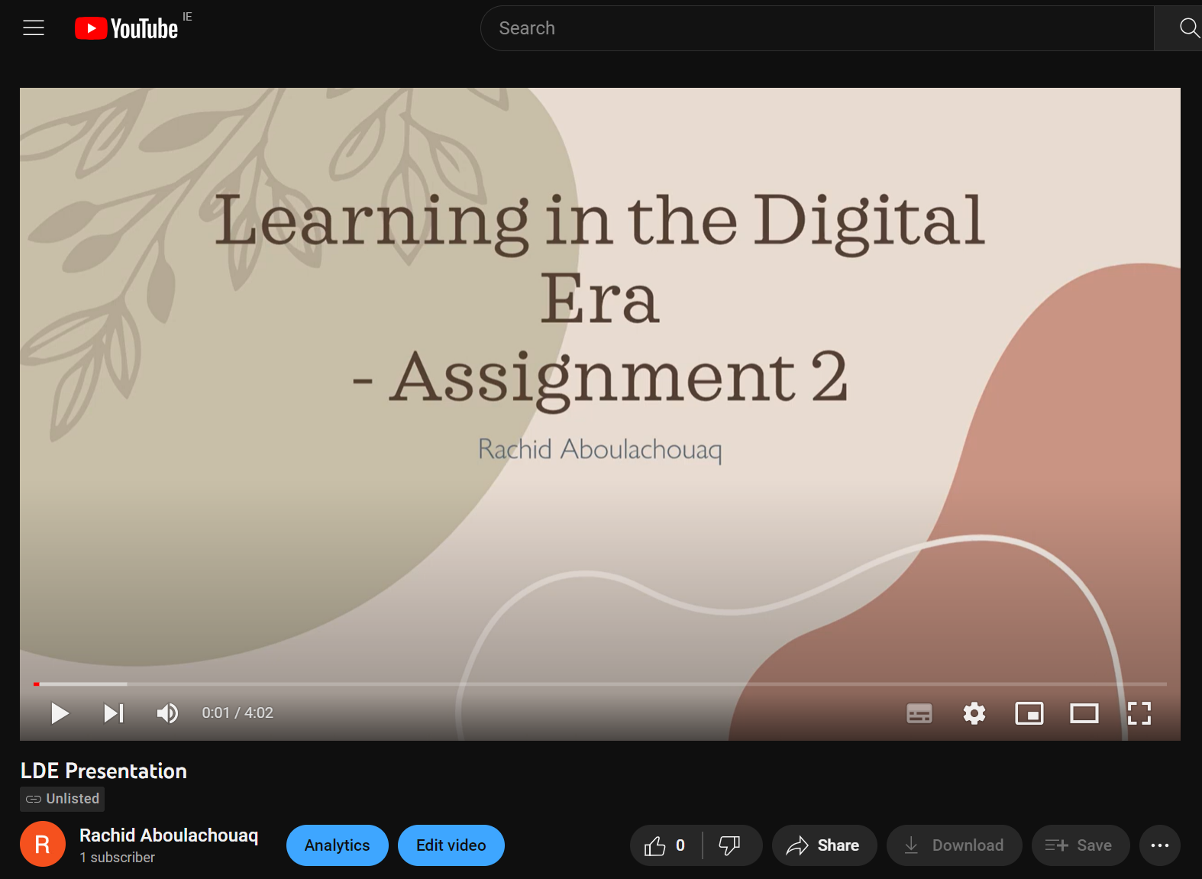

https://youtu.be/qdZjhlCwdBE

