Lab – Understanding Ethernet Cable Standards
Topology
Addressing Table
Device | Interface | IP Address | Subnet Mask | Default Gateway
PC-A | NIC | 192.168.10.1 | 255.255.255.0 | N/A
PC-B | NIC | 192.168.10.2 | 255.255.255.0 | N/A
Objectives
Part 1: Analyze Ethernet Cabling Standards and Pinouts
Part 2: Build an Ethernet Crossover Cable
Part 3: Test an Ethernet Crossover Cable
Background / Scenario
In this lab, you will build and terminate an Ethernet crossover cable and test it by connecting two PCs together and pinging between them. You will first analyze the Telecommunications Industry Association/Electronic Industries Association (TIA/EIA) 568-A and 568-B standards and how they apply to Ethernet cables. You will then construct an Ethernet crossover cable and test it. Finally, you will use the cable you just constructed to connect two PCs together and test it by pinging between them.
Note: With autosensing capabilities available on many devices, such as the Cisco 1941 Integrated Services Router (ISR) switch, you may see straight-through cables connecting like devices.
Required Resources
- One length of cable, either Category 5 or 5e. Cable length should be 0.6 to 0.9m (2 to 3 ft.)
- 2 RJ-45 connectors
- RJ-45 crimping tool
- Wire cutter
- Wire stripper
- Ethernet cable tester (optional)
- 2 PCs (Windows 7 or 8)
- Analyze Ethernet Cabling Standards and Pinouts
The TIA/EIA has specified unshielded twisted pair (UTP) cabling standards for use in LAN cabling environments. TIA/EIA 568-A and 568-B stipulates the commercial cabling standards for LAN installations; these are the standards most commonly used in LAN cabling for organizations and they determine which color wire is used on each pin.
With a crossover cable, the second and third pairs on the RJ-45 connector at one end of the cable are reversed at the other end, which reverses the send and receive pairs. The cable pinouts are the 568-A standard on one end and the 568-B standard on the other end. Crossover cables are normally used to connect hubs to hubs or switches to switches, but they can also be used to directly connect two hosts to create a simple network.

Reflection:
Write a research report (Max word count 600) on Cat 5e and 6 Ethernet cable standards.

Cat 5e and Cat6 Ethernet cable standards (600 words)

An ethernet cable is simply a network cable, used to connect devices within a Local Area Network (LAN). There are different types of ethernet cables, suited to different set-ups. These cables will vary in length and quality. Ethernet cable standards are the industry standards specific to the cable type, in this case we are looking at Cat5e and Cat6.
Cat5e or category 5 enhanced originated from the Cat 5 ethernet cable standards. Cat 5 cables use the fifth generation twisted pair cable type. The Cat 5 cables can support fast ethernet speeds of up to 100Mbps, but the category 5 enhanced (Cat5e) can support gigabit ethernet speeds of up to 1000Mbps. This is because fast ethernet communications usually only use two of the four twisted pairs available, but Cat5e uses all four pairs.
A category 6 ethernet cable uses the sixth generation twisted pair cable type. This is the standard that will take over the older, Cat 5 standard. The Cat 6 cables can ‘support gigabit ethernet data rates of one gigabit per second’ [1] Similarly, Cat 6 still uses all four twisted pairs the same as Cat5e.
These standards are published by the EIA/TIA – the electronic industries alliance and the telecommunications industry association. The EIA/TIA develops standards related to wiring and cabling, that are supported by the American National Standards Institute (ANSI). The new standards that come out of this reflect the ever-charging IT industry and how cabling needs to keep up with these changes.

Differences between Cat 5e and Cat 6
- Time – Cat5e is an older standard compared to Cat 6. This may mean the Cat 6 standard is more up-to-date with modern technologies, and therefore more applicable in the modern day.
- Price – Cat 6 cabling is more expensive than Cat5e, due to the improved functionality.
- Speed – Cat5e cables deliver a 1 Gigabit network speed, whereas Cat 6 cables deliver a 10 Gigabit network speed. This is 10 times faster.
- Length – Both cables are able to go up to 100 metres in length. However, the 10 Gigabit network speed for the Cat 6 cable is only available up to 50 meters. After the length of the wire increases over 50 meters, both cables are the same, offering 1 Gigabit network speed.
- Wiring – Cat5e and Cat 6 are both twisted pair cables, and both have four twisted pairs in use per cable.
- Twist Rate – The difference is in the twist rate. They are both using four twisted pairs in the cable, but these pairs are twisted at a different rate. Cat 6 has more twists, at 2 twists per centimetre, compared to Cat5e which has between 1.5 and 2 twists per centimetre. A higher twist rate will enable two-way communication and an overall better performance.
- Performance – Shielding on the Cat 6 twisted pairs means the wires are better protected from crosstalk and noise interference. This helps boost data transmission rates. In a figure, the performance rate of a Cat5e cable is 100MHz, compared to a Cat 6 cable with a performance rate of 250MHz.
Cat5e is more suitable for a home network, as many homes would not actually take advantage of any of the added benefits of Cat 6. It just isn’t necessary, as Cat5e will be more than capable in this environment.
For office and university environments, Cat 6 may be the preferred option. This is as long as the cables are under 50 centimetres in length, so you will actually experience the 10 Gigabit network speeds, if this is not possible then a Cat5e cable will be the better choice.

References

[1] | "Cat 6 Ethernet Cables Explained," LifeWire, [Online]. Available: https://www.lifewire.com/cat6-ethernet-cable-standard-817553.

  - Analyze diagrams and tables for the TIA/EIA 568-A standard Ethernet cable.
The following table and diagrams display the color scheme and pinouts, as well as the function of the four pairs of wires used for the 568-A standard.
Note: In LAN installations using 100Base-T (100 Mb/s), only two pairs out of the four are used.
568-A 10/100/1000Base-TX Ethernet
Pin Number | Pair Number | Wire Color | 10Base-T Signal  100Base-TX Signal | 1000Base-T Signal
1 | 2 | White/Green | Transmit | BI_DA+
2 | 2 | Green | Transmit | BI_DA-
3 | 3 | White/Orange | Receive | BI_DB+
4 | 1 | Blue | Not Used | BI_DC+
5 | 1 | White/Blue | Not Used | BI_DC-
6 | 3 | Orange | Receive | BI_DB-
7 | 4 | White/Brown | Not Used | BI_DD+
8 | 4 | Brown | Not Used | BI_DD-

The following diagrams display how the wire color and pinouts align with an RJ-45 jack for the 568-A standard.
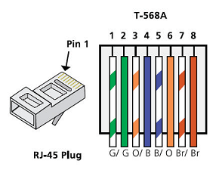
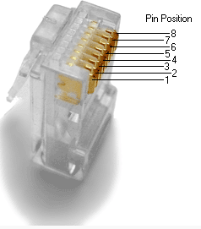
  - Analyze diagrams and tables for the TIA/EIA 568-B standard Ethernet cable.
The following table and diagram display the color scheme and pinouts for the 568-B standard.
568-B 10/100/1000-BaseTX Ethernet
Pin Number | Pair Number | Wire Color | 10Base-T Signal  100Base-TX Signal | 1000Base-T Signal
1 | 2 | White/Orange | Transmit | BI_DA+
2 | 2 | Orange | Transmit | BI_DA-
3 | 3 | White/Green | Receive | BI_DB+
4 | 1 | Blue | Not Used | BI_DC+
5 | 1 | White/Blue | Not Used | BI_DC-
6 | 3 | Green | Receive | BI_DB-
7 | 4 | White/Brown | Not Used | BI_DD+
8 | 4 | Brown | Not Used | BI_DD-
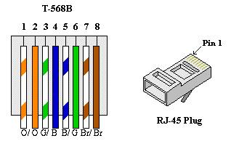

- Build an Ethernet Crossover Cable
A crossover cable has the second and third pairs on the RJ-45 connector at one end, reversed at the other end (refer to the table in Part 1, Step 2). The cable pinouts are the 568-A standard on one end and the 568-B standard on the other end. The two following diagrams illustrate this concept.
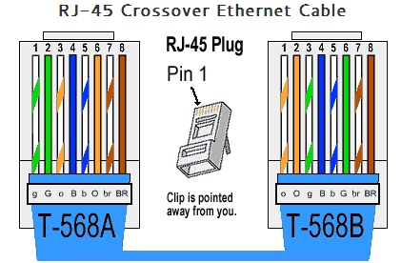
  - Build and terminate a TIA/EIA 568-A cable end.
    - Determine the cable length required. (Your instructor will let you know the cable length you should make.)
Note: If you were making a cable in a production environment, the general guideline is to add another 12 in. (30.48 cm) to the length.
    - Cut off a piece of cable to the desired length and using your wire stripper, remove 5.08 cm (2 in.) of the cable jacket from both ends.
    - Hold the four pairs of twisted cables tightly where the jacket was cut away. Reorganize the cable pairs into the order of the 568-A wiring standard. Refer to the diagrams, if necessary. Take as much care as possible to maintain the twists in the cable; this provides noise cancellation.
    - Flatten, straighten, and line up the wires using your thumb and forefinger.
    - Ensure that the cable wires are still in the correct order for the 568-A standard. Using your wire cutters, trim the four pairs in a straight line to within 1.25 to 1.9 cm (1/2 to 3/4 in.).
    - Place an RJ-45 connector on the end of your cable, with the prong on the underside pointing downward. Firmly insert the wires into the RJ-45 connector. All wires should be seen at the end of the connector in their proper positions. If the wires are not extending to the end of the connector, take the cable out, rearrange the wires as necessary, and reinsert the wires back into the RJ-45 connector.
    - If everything is correct, insert the RJ-45 connector with cable into the crimper. Crimp down hard enough to force the contacts on the RJ-45 connector through the insulation on the wires, thus completing the conducting path. See the following diagram for an example.
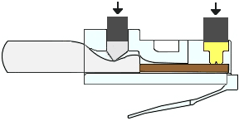
  - Build and terminate a TIA/EIA 568-B cable end.
Repeat steps 1a to 1g using the 568-B color wiring scheme for the other end.
- Test an Ethernet Crossover Cable
  - Test the cable.
Many cable testers will test for length and mapping of wires. If the cable tester has a wire map feature, it verifies which pins on one end of the cable are connected to which pins on the other end.
If your instructor has a cable tester, test the crossover cable for functionality. If it fails, check with your instructor first as to whether you should re-cable the ends and re-test.
  - Connect two PCs together via NICs using your Ethernet crossover cable.
    - Working with a lab partner, set your PC to one of the IP addresses shown in the Addressing Table (see page 1). For example, if your PC is PC-A, your IP address should be set to 192.168.10.1 with a 24-bit subnet mask. You partner’s IP address should be 192.168.10.2. The default gateway address can be left empty.
    - Using the crossover cable you made, connect the two PCs together via their NICs.
    - On the PC-A command prompt, ping the PC-B IP address.
Note: The Windows firewall may have to be temporarily disabled for pings to be successful. If the firewall is disabled, make sure you re-enable it at the conclusion of this lab.
    - Repeat the process and ping from PC-B to PC-A.
Assuming IP addressing and firewall are not issues, your pings should be successful if the cables were properly made.
Reflection
  - Which part of making cables did you find the most difficult?
It was difficult to keep the wires in the correct order when trying to put them into the correct pin positions. I learnt that stripping the cable down a bit more allowed me to move the cables more easily so they stayed in place.
  - Why do you have to learn how to make a cable if you can easily buy pre-made cables?
You may want to make your own cable so you can cut it to the exact length you require, rather than trying to buy one at the closest length.

