ACADEMIC AND EMPLOYABILITY SKILLS
Isata Mansaray
ID-1814013

Executive summary
This report sheds light on personal reflection on employability skill required by an individual to excel in future career. The report highlights three key employability skills such as presentation, reflection and time management. The importance of employability skills in promoting a better impression in competitive firm has been justified with relevant statements of author. Furthermore, this report has individually analysed time management, presentation and reflection so that their importance in their respective manner can be suggested. Implementation of certain key practices such as deep breathing techniques, making a schedule of tasks and attending seminars helps in improving the employability skill of an individual employee.

Table of Contents
Introduction 4
Explaining employability skills 4
Required skills in organization 5
Analysis on time management skill 6
Analysis on reflection skill 7
Analysis on presentation skill 8
Conclusion 8
Reference List 10
Appendix 12

Introduction
The infusion of employability skills in an employee makes them capable enough to handle organizational challenges in a profound manner. Employer of MNCs and influential organization requires candidates that can help them to deliver client satisfaction and also plays a vital role in all the major situations of the company. Possession of needed employability skills helps an employee to receive recognition and support from senior management as they get to meet every job criteria from their relevant skills.
This report requires a critical analysis of employability skills that could help an employee to meet challenges of the company. It also enlisted the importance of employability skills for being credible among employers and future career opportunities based on the perspective of an employer who is trying to recruit.

Explaining employability skills
As per my understanding, employability skills are considered to be those skills that set an employee apart from others. The fact that makes me curious about employability skill is that it empowers an individual to not only play an active role in the organization but also receive recognition from upper management. Since I consider myself as one of the employment seeker, I assume that employability skills can help me to analyse the surrounding situation and make quick decision based on my perspective. The most important thing which made me curious is that improvement in employability skills requires additional reading and accusation of higher knowledge base.
Therefore, I can say that employability skills can also improve my knowledge of my subjects and also has the possibility to act professional in my workplace. Based on the perspective of Tsitskari et al. (2017, p.6) I can analyze that employability skills allows an individual to helps in meeting the solution of critical problems. The understanding of author has made me realize that needed improvement in my analytical and interpersonal skills can help me to present and manage time in effective manner. I can also reflect through the understandings of various situations and requirement of a job project.

Required skills in organization
Employability skills play a key role for employees to pass through any challenging situation presented in front of them. In order to state my employability skills for future opportunities, I will be analysing time management, presentation and reflection skills. Inspired from the viewpoint of Lim et al. (2016, p.188) I have assessed that I need to develop my time management and presentation skills in future. Necessary improvement in my time management skill can enable me to take notice the importance of time that can be given to certain work. Since I am a slow doer, I think time management skill will help me to achieve the organizational task within a short period of time.

Figure 1: Employability skills
(Source: Influenced from views of Messum et al. 2016, p.24)
On the contrary, presentation skills empower an individual to present their needs, demands and organizational viewpoint among relevant clients of the company. It can empower my future opportunity as presentation skill will put me in secure position in the company where I can communicate with external stakeholders. However, I can ensure that I have practiced reflective thinking and understanding of situation during academic career. The probable opportunity that can come from reflection is that basic misunderstanding between employer and employee can be reduced (Messum et al. 2016, p.25). Since reflection is considered to be the personal experience of a particular situation. I can clearly understand and experience the struggles of my senior management.

Analysis on time management skill
The most basic understanding of time management skill is that it allows an individual to manage all the tasks within a scheduled pattern. My personal experience with time management can be said to be a struggling experience. Relevant improvement in my time management skill can allow me to carry out every task with sheer affection and responsibility. The opinion of Grissom et al. (2015, p.778) suggests that time management skill helps in focusing one task at a time.
I think the statement of author has relevance to my approach to task as I get lazy and shifts my focus to less important work. It can allow me to list down the priorities of my professional and personal life so that I do not lose my focus and also achieve the objectives within a deadline. I need time management skill in my life to make myself more productive and utilize maximum amount of time in important work rather than trivial necessities of mine. I think the most crucial advantage that could come from time management skill is self-awareness of my action and making a quick yet appropriate decision in less amount of time.
The fact that time management skill are an intrusive part of our lives, I also need this skill to improve my communication and planning. The basic strength that comes from time management skill is the ability to say ‘NO’ to dear ones as priority rules major factor of time management (Al Hila et al. 2017, p.142). Seeing the benefits of time management I can analyse that planning is an important part of any activity which can be less critical and more specific from acquisition of time management skill. It is being commented by Pluta and Wójcik (2015, p.252) that time management skill allows an individual to organize things and acquire efficiency. My present time management skill is limited to waking up at morning and sleeping early at night.
This is the reason why I have to improve my time management skill to manage all the activity so that I don't omit any important activities. In order to improve my time management skill, I need to list down my schedule in coming weeks and months. This can help me to prepare a ‘TO DO’ activity along with a timeline to achieve the completion of task. Another method to improve my time management skill is to prepare in advance regarding any task. This can help me to not only acquire full control over my activity as well as achieve them within a time limit.

Analysis on reflection skill
According to my opinion, reflection skill is more of experiencing or understanding the learning materials of a particular situation or activity. Let’s assume that my company holds training and development scheme for employees, reflection skill is the only employability skill that can help me to take away my learning experiences. This holds the key for successful living and also presents a positive approach to relevant tasks. Based on the understanding of Norouzi et al. (2018, p.66) I can state that reflection skill helps in experiencing the personal experiences of an instructor or employer. The most important thing that makes me curious of reflection skill is that I get to understand the needs and requirement of any task provided by my superiors.
The only ingredient that rules reflection skill is that it enables me to view the objectives from my employer’s perspective. Thus, it becomes easy to point out required materials and flaws in my work. I need reflection skill in order to listen carefully to instructions and also acquire necessary information that is viable in nature. The fact that reflection skill helps in perceiving the world from another individual’s viewpoint, it does not only tell me the expectation of individual but also meet specific requirement of the given tasks or work. One of the most important element which allowed me to consider reflection skill as one of the needed employability skill is that I can listen without interrupting the speaker.
It has been highlighted by Örnek and Ayas (2015, p.1392) that listening skills are an intrinsic part of reflection skill so that objectives can be met required elements. The necessary involvement of reflection can empower my ability to learn from any given situation. This approach has the possibility to refurbish my future career and also balance the requirements of work in favourable manner. However, I consider myself as an active learner which made me realized that I have to improve my present reflection skill to excel in professional career.
In order improve my reflection skill, I can write my experience from any serious or professional conversation. This can help me to reflect the understanding of speaker and also review my own learning experience. Another way to improve my reflection skill is to compare my experiences with thoughts occurred in me during any conversation with superiors. I think the most important element that makes a person successful is the ability to carefully examine present situation and instructions.

Analysis on presentation skill
I consider myself a novice presenter, as I used to get agitated and confused during classroom presentation during my academic years. The viewpoint of Rao (2018, p.52) suggests that presentation skill requires improved interpersonal and analytical skill of an individual. I can recall that I could not answer the questions of my audience due to weak motivation. Therefore, I think I need to motivate myself to acquire necessary courage for proper presentation of my work. I believe that I need presentation skill to make proper conversation with anyone and also present myself in a profound way. Induction of medium level presentation skill is enough to make me a better public speaker in front of large audience. I could also cite that presentation skill is important for me to have better impression on my senior management members. I could simplify the process of question and answer session between me and probable clients.
Presentation skill does not only make an individual confident enough to focus any challenge but also have a positive impact on audience. In order to improve my presentation skill, I need to rely on continuous practice of things which is going to be presented. Inspired from the viewpoint of Bond et al. (2017, p.1166) I can confirm that recurrent practice and extended knowledge on topic of presentation helps in answering the questions of viewers. It might require me to take extra time for presentation but I can be effective in the process. (Refer to Appendix)
On the contrary, I can also consider deep breathing technique before presentation. Basic reason behind such deep breathing practice is that it calms down nervous energy and also motivates one to go through presentation without any self doubt (Aryadoust, 2017, p.412). In order to compare and improve my presentation skill, I can attend seminars that signify the key practice for presentation skill and also reflect my own experience. It can help me to stay focused during presentation and also answer the queries from viewer’s perspective.

Conclusion
From the aforementioned sections, it can be concluded that employability skills empowers an individual employee to receive recognition from superiors and also participate in various demanding situation of the company. Induction of time management skill on personal level helps in carrying out every task in schedule yet professional manner. This sets the pace for meeting every objective before given deadline and also reduces procrastination of tasks. Improvement in reflection skill assists an individual to become a better listener and understanding individual. Presentation skills are important to have positive impact over audience and also increase the knowledge base on certain relevant topic.

Reference List
Al Hila, A., Al Shobaki, M., Naser, S.A. and Amuna, Y.A., (2017). The Reality of the Effectiveness of Time Management from the Perspective of the Employees of the Beauty Clinic of Dentistry. International Journal of Engineering and Information Systems (IJEAIS), 1(6), pp.137-156.
Aryadoust, V., (2017). Understanding the Role of Likeability in the Peer Assessments of University Students’ Oral Presentation Skills: A Latent Variable Approach. Language Assessment Quarterly, 14(4), pp.398-419.
Bond, R., Donohoe, K.L., Jakeman, B., Davis, H.T. and Morgan, L., (2017). Combining rhetoric and role-play to introduce and develop patient presentation skills in third year pharmacy students. Currents in Pharmacy Teaching and Learning, 9(6), pp.1164-1169.
Grissom, J.A., Loeb, S. and Mitani, H., (2015). Principal time management skills: Explaining patterns in principals’ time use, job stress, and perceived effectiveness. Journal of Educational Administration, 53(6), pp.773-793.
Lim, Y.M., Lee, T.H., Yap, C.S. and Ling, C.C., (2016). Employability skills, personal qualities, and early employment problems of entry-level auditors: Perspectives from employers, lecturers, auditors, and students. Journal of Education for Business, 91(4), pp.185-192.
Messum, D.G., Wilkes, L.M., Jackson, D. and Peters, K., (2016). Employability skills in health services management: Perceptions of recent graduates. Asia Pacific Journal of Health Management, 11(1), p.25.
Norouzi, M., Nourbakhsh, H. and Javadi, M.R., (2018). THE EFFECTIVENESS OF TIME MANAGEMENT TRAINING AND STRESS CONFLICTING METHODS ON FAMILY COHESION AND WORK LIFE QUALITY USING GROUP TECHNIQUE. TURKISH ONLINE JOURNAL OF DESIGN ART AND COMMUNICATION, 8, pp.64-70.
Örnek, A.Ş. and Ayas, S., (2015). The relationship between intellectual capital, innovative work behavior and business performance reflection. Procedia-Social and Behavioral Sciences, 195, pp.1387-1395.
Pluta, A. and Wójcik, G.P., (2015). Research on time-management skills of employees in the process of creating value for the customer. International Journal of Business Performance Management, 16(2/3), pp.246-261.
Rao, P.S., (2018). Teaching presentation skills in english classrooms: An analytical study. ACADEMICIA: An International Multidisciplinary Research Journal, 8(11), pp.49-59.
Tsitskari, E., Goudas, M., Tsalouchou, E. and Michalopoulou, M., (2017). Employers’ expectations of the employability skills needed in the sport and recreation environment. Journal of hospitality, leisure, sport & tourism education, 20, pp.1-9.

Appendix
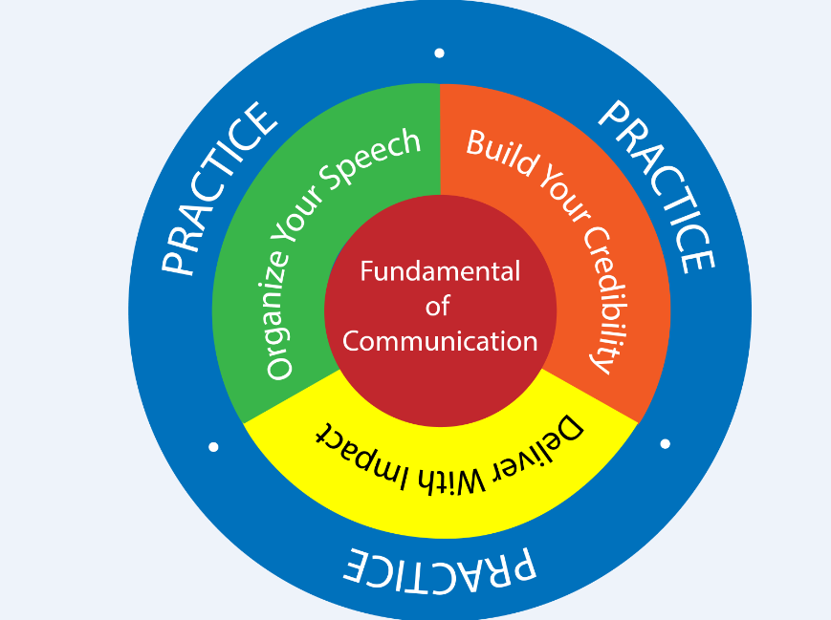
Methods to improve presentation skills
(Source: http://leap.com.my/dynamic-presentation-skills/)

