
Programme:
Certificate of Higher Education in Skills for the Workplace.
Module:
Problem Solving and Decision Making (BMSW-4004)
Student Name: Muhammad Nasir
Student No: 2127504
Lecturer Name: Dr Islam
Title:
Final Report: Problem-Solving and Decision making

Introduction:
The fourth enterprise revolution includes the
technological developments and interfacing capacities of
digital media content material fabric during various educational and social
media platforms. It is characterized with the resource of the use of a fusion of
generation that is blurring the strains maximum of the physical,
Problem-Solving
Problem-solving is the initial diploma of engaging in higher order wondering processes. Common talents related to
identifying solution techniques or strategies in problem-solving
are referred to as heuristics. George Polya (1887–1985) is a WorldClass Hungarian mathematician, professor, and creator of 5
published traditional books on problem-solving; the ones books are
committed to the practical test of heuristics in mathematics.
Decision-Making
Decision-making is a method thru which a person, group,
or enterprise identifies a choice or judgment to be made;
gathers and evaluates facts about alternatives; and
selects from some of the alternatives [14]. An information of
the approach of decision-making can provide a student with
tools and a know-how record which is vital to
growth higher-order questioning approach and, consequently,
beautify higher degree reading talents together with analysis,
synthesis, and evaluation, i.e., “The talents needed to make
sound choices can be taught” [15].

- Define the problem

Crisis of commitment and crisis of adaptability
In the classical systems view of organizational change and development, Beer (1980) suggests that
The 20th century saw the emergence of "bureaucratic" organizations as the primary means of bringing about
together and use labour, capital, and technology to achieve organizational goals. The most important of these bureaucratic organizations is the corporation. Born out of the industrial revolution,
society is hierarchical in nature, has centralized decision-making, and achieves coordination through
strict rules and controls, division of labour according to specialized functions and emphasis on standardization and
controls to achieve reliability, reasonableness and efficiency. With the market and technology stable at this stage, the company barely needs to adjust. What is needed is an organization
reliably perform a relatively simple and routine task - bureaucracy insists
standardization and control. With the rapid development of market, technology, science,
information and values, this bureaucratic organization is now under great pressure, as Toffler (1970) predicted a quarter of a century ago.
Crisis of adaptability
Everywhere we look, traditional structures are being reshaped or suddenly collapsing. Once-successful businesses find that the perfect formulas no longer work. Everyone, and even the whole
communities, seeing the world moving at their feet as traditional markets, industries and
Sources of employment are disappearing under the impact of new information technology and the restructuring of the world economy (Morgan, 1993).
It is not surprising that an organization's main strengths are predictability and reliability
find it difficult to adapt to an increasingly dynamic environment. The hierarchical structure and centralized decision-making process can prevent the organization from dealing with the huge volume of complex information that floods the organization and can impede its ability to react. Division of labor and functions
specialization makes it difficult to link functional departments and coordinate task performance, especially
when a task needs to be done quickly. Centralized rules, procedures, and other controls prevent
individuals to respond to change or manage unique problems and opportunities without taking great personal risk. When employees are not responsive, the organization cannot change appropriately (Beer, 1980).
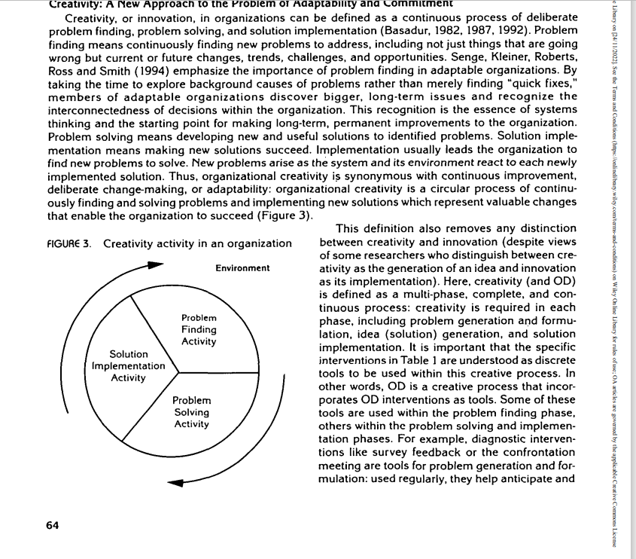

Scope and Impact
The impact of the COVID-19 pandemic on consumer behaviour and health is a reality and
Difficult questions deserve the attention of scholars and students. Our research
investigates the behaviour of different generations of customers during the pandemic,
focusing on millennials. The trend is clearly towards online shopping and retailers
need to think about how they can meet the needs of online customers [1]. The blockage caused by
COVID-19 and store closures have posed unprecedented challenges to the retail sector
industry. Customers leave, and sales fall. The impact of the COVID-19 pandemic is
can be seen in all areas of daily life and most of them have gradually been accepted
new every day, becoming the “new normal” [2]. The “new normal” represents the outcome of
the standardization process when agents systematically fit the matrix
of existing and socially shaped knowledge and practices [3]. In this model, we use "the new concept of “normal”, reflecting new habits formed during and during the pandemic
pressure on the need to shop with mobile devices at home instead of going to
shop. The explosion of wireless telecommunications has revealed incredible possibilities for
strong convergence of Internet and mobile communications in business and commerce,
where e-commerce is evolving into mobile commerce [4]
Theoretical framework and hypothesis development
The concept of behavioural intention is one of the best predictors of behaviour towards
the use of new technologies [59–62] and represents a central concept of Davis (1989)
Technology Acceptance Model (TAM) [63]. In the context of mobile commerce, behaviour
The intent is defined as the subjective likelihood that these consumers will use a mobile device
commercial [64–67]. Davis [63,68] uses two constructs as central determinants to explain
Acceptance level (attitude and/or behaviour):
useful perception and awareness
Easy to use. Focusing on the organizational context, Davis [63] defines the structure of
Perceived usefulness is "the degree to which an individual believes that using
will improve their performance in the workplace" and ease of use is considered
“The degree to which an individual believes that using a particular system will not
The physical and mental effort” [63].

Organizational and problem analysis
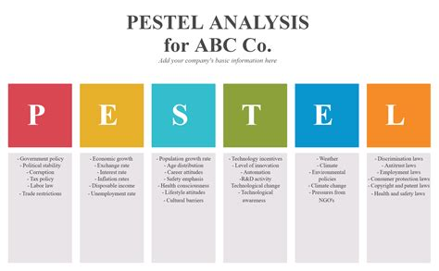
political issues
In the past, focusing on the political environment meant paying attention
politics of a country and determine who holds power
influence important decisions (Simon, 1984; Thomas, 1974).
Focus on ethnicity and national identity, providing
refers to the possibility of expropriation or confiscation of property
investments by multinational companies (MNEs) in
host country. After the process of liberalization and
Privatization policy in developing countries, leaders and analysts of many multinational companies has turned to political instability
and the factors that can lead to it. Meanwhile, African countries
strive to create a stable environment for domestic and international investors. Therefore, it is important for multinational companies to take note
The role of country of origin and host country
so that they can identify the potential of external actors
impact on business performance (Simon, 1984).

Economic factors
In 2017, East Africa's economy grew by 5.9%,
The same rate was in 2018 and will do so in 2019(African Development Bank, 2018). Increase revenue
has radically changed the consumption behaviour of city dwellers, who now eat more meat and dairy products instead of traditional foods such as cassava, cornmeal and bananas.
The growth of the middle-class EAC, estimated at
29 million people can spend $20 a day, which is a good indicator of economic vitality (The East African, 2011). From middle class tends to have fewer children
low-income people (CNN, 2011), ie
maybe they will have enough income to spend on other things
buy food. Despite the influence of middle-class sellers, modern retail is supposed to help poverty alleviation in Africa.
Social conditions
Social conditions, including culture, are important parameters in any analysis of the business environment because they
constitutes the context in which all actions between individuals and
commercial activities take place (Thomas, 1974). Candlesticks
broader social and cultural context in which retailers operate
is an important consideration (Nandonde, 2016).
The rise of modern retail in the EAC has resulted in increasing pressure from regulators, NGOs and consumers on the retail community. Social tension has arisen
between unemployed youth in the country and foreign workers
with multinational companies in the region. Many African consumers see foreign investors as representing a new form of colonialism (Nandonde, 2016), and business studies have
documented the various manifestations of this problem. Some studies
in connection with the bankruptcy of Walmart and Home Depot in
Different countries on foreign recruitment policies higher positions and eliminate local labour (Arnold & Bianchi, 2004; da Rocha & Dib, 2002; Suh, 2005).
Legal considerations
Food retailers worldwide are often faced with unpredictability of food policy in countries where
they operate and from there they source raw materials (Bianchi, 2009). In Africa, business growth has been crippled by taxes, certification requirements and other
strategy.
Meanwhile, food production in Africa remains low. This means creating favourable conditions for the movement of goods
across the continent to avoid supply shortages. In these situations, retailers face the challenge of sourcing products from different regions of the world and continents. and local development of competitive value chains. With the formation of various regional economic blocs, however, The import and export of various products may be restricted by
customs duties and other legal obstacles. For example, imported rice is
taxable at 75% in EAC (Business Daily Africa, 2010). Kenya bans chicken imports, and this policy restriction on the movement of poultry products in the area (Hinshaw, 2013)
Environment for local business
The local business environment includes policies or practices that support or hinder the growth of domestic industry.
Soil. EAC retailers inherit related problems
with the limited economic models that most countries
in the monitored area. For example, Tanzania is a
planned economy from 1967 to 1985; now this
is being converted. Kenya and Uganda are free markets
economies, but now they have introduced planned economic principles such as market protectionism. most important environmental factors to consider
Infrastructure and land management are involved in the internationalization of retail trade in the EAC.

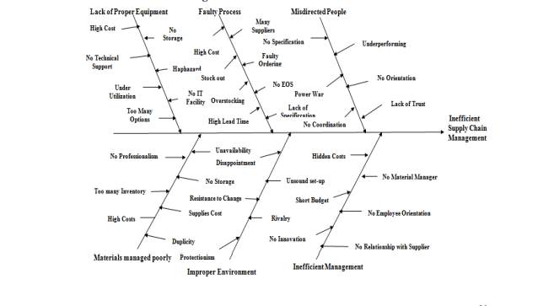
Lack of suitable equipment:
Having the most suitable equipment and using it properly is always essential for everyone.
operational maintenance as well as supply chain management (Otto, 1995). But an inside look Case studies show that one of the main causes of inefficient supply chain management is hospitals is due to the inability of the competent authority to maintain and purchase the appropriate equipment.
Some facilities have not used their full capacity, some facilities are arranged synchronously
random way. Hospital staff do not have enough IT equipment to manage
equipment in a better way and they also lack technical support. The high cost of new equipment is
Another profound reason. Due to this factor, the hospital cannot capture up-to-date information
equipment and is behind the competition (Bence, 1995).
Faulty process:
An effective business process requires an efficient supply chain and operational processes. A sound process
ensures synergy and has contributed to greater commercial success in the products and services industry
(Poli, et al., 1988). Practice at St James's Hospital shows that they are currently
implemented a very inefficient and flawed process. The reasons for this are poor inventory
management and this sometimes causes out-of-stock and overstock situations. Poor performance of
This process also stems from reasons such as high cost, lack of specifications, faulty control system.
Too many suppliers and long delivery times also exacerbate the problem (Bence, 1995).
The perverted person:
People are the foundation of any organization. If they are not motivated and well oriented,
it is very difficult for this organization to succeed (Sturges and Kilani, 1992). people of
The hospital found themselves embroiled in a power struggle and they were never ready to trust each other. There is no coordination between them and very few people are sure of their specifications. Like one As a result, they do not contribute to the organization's purpose and, therefore, to the supply chain. The management system encountered many difficulties and the hospital lost its credibility (Bence, 1995).
Mismanaged documents:
Materials management is essential to ensure a smooth and efficient supply chain
management (Sturges and Kilani, 1992). The hospital in this case study manages
unsuitable materials. No professionalism and more duplicate orders
more often than ever. The cause of material mishandling also comes from a considerable amount reasons such as high material cost, lack of proper storage capacity, not available
materials if necessary. The elimination of these problems is absolutely necessary to ensure
Good materials management and smooth supply chain management (Bence, 1995).
Unsuitable environment:
Business is conducted in an environment and that environment must be conducive to a high level of commercial success (Sturges and Kilani, 1992). But for the environment of St James's Hospital, it is inconvenient and, as a result, it aggravates business operations and supply chain management
Finally, the process. The underlying reasons are protectionism, resistance to change, poor organization, competition among employees, etc. (Bence, 1995).
5.6. ineffective management The leadership outlines the strategy and action plan for each product and service action group
Work. They are practically responsible for the management of business processes as well as procurement Chain. If they don't work, the organization will suffer heavy losses. This hospital photo Case studies reveal the same picture. Here, the supply chain is inefficient because management is inefficient. The inside story of leadership inefficiencies shows that it is hidden costs, short budget, lack of innovation, lack of direction for employees, lack of materials management, lack of relationships with suppliers, etc. As a result they cannot keep supply chain management systems are on the right track (Bence, 1995).

References
Alkhatib, O.J., (2019), March. A framework for implementing higher-order thinking skills (problem-solving, critical thinking, creative thinking, and decision-making) in engineering & humanities. In 2019 Advances in Science and Engineering Technology International Conferences (ASET) (pp. 1-8). IEEE.
Available at (https://ieeexplore.ieee.org/abstract/document/8714232?casa_token=opf4_bnEetAAAAAA:IuRICF1Ybw5WLmbBB1Rt5FfSZt-8KDgzstUmnXC-lYvMR8Rz-A7pVEylEhSyARmtUbX90rZcb7QJgw)

Basadur, M., (1997). Organizational development interventions for enhancing creativity in the workplace. The Journal of Creative Behavior, 31(1), pp.59-72.
Available at
(https://onlinelibrary.wiley.com/doi/abs/10.1002/j.2162-6057.1997.tb00781.x?casa_token=t1tNoUGIfM4AAAAA:OfLnY-zINec57n9exWZtgRF9VlvflIchIdCHeQBzqSf18MrPgdXX7a2GIJot02UvC74kZ34cffsUbYNg)

Akram, U., Fülöp, M.T., Tiron-Tudor, A., Topor, D.I. and Căpușneanu, S., (2021). Impact of digitalization on customers’ well-being in the pandemic period: challenges and opportunities for the retail industry. International Journal of Environmental Research and Public Health, 18(14), p.7533.
Available at
(https://www.mdpi.com/1660-4601/18/14/7533)

Nandonde, F.A., (2019). A PESTLE analysis of international retailing in the East African Community. Global Business and Organizational Excellence, 38(4), pp.54-61.
Available at (https://onlinelibrary.wiley.com/doi/full/10.1002/joe.21935?casa_token=2lw64uas544AAAAA%3AZo8oAN0aMV4U_KCzeJRtt7UbiW2atNo-xW3jrByxIJskzVmbDu_ZXdhSc42lqqDUkNSZHJuf_HP5CrLI)

Bose, T.K., (2012). Application of fishbone analysis for evaluating supply chain and business process-a case study on the St James Hospital. International Journal of Managing Value and Supply Chains (IJMVSC), 3(2), pp.17-24.
Available at (https://d1wqtxts1xzle7.cloudfront.net/57976184/3212ijmvsc02-with-cover-page-v2.pdf?Expires=1667081548&Signature=L1OIhzL4Yawpr-03ytiSlTkDmM4SPIJ5NbEo8klj1nIShtAPPNhpZ6GUoBuc4BVUKEHCHWdRnNNJo-4uPulcv7xKNE~WvRNyyc8W7VyaxJsNd700UhBiVyixbIPeDe0BYOmhk4lvxDzV7CgZvSMVA2dfc8tqSHjEL6g3WmQYYFD~YbG2BWy1yf9Pv1Kn-8UWtT6esQp61J~BOmjZU6hr1TtxG7jH5kjinWU0CsU~~FXzMSuc01pW6ctxZ1sxuSQMCQHuDbYTbPYLEFi3smw92u7wWSFGSJl3146fZkB3JieBgteC2q2zjcuLV~QU35cJA34O~raNQ5hzdKnT5ZrCbg__&Key-Pair-Id=APKAJLOHF5GGSLRBV4ZA)

