

MODULE CODE: Digital Skills for Personal Development and Business Growth BMSW4008

ASSESSMENT COMPONENT: 1 PORTFOLIO

STUDENT NAME: Sadia Islam

STUDENT NUMBER: 2531380

LECTURER: Manjit Biant

DATE: Monday 16th March 2026
Contents

Task 1 ……………………………………………………………………………………………………………. 3
Assessment of Digital Skills …………………………………………………………………………… 3-5
References ………………………………………………………………………………………………… 5-6
Task 2 ……………………………………………………………………………………………………………. 6
LinkedIn Learning Certificates for Office365 ……………………………………………………… 6-9
Task 3 ………………………………………………………………………………………………………….. 10
Essay on Relevance of Excel in professional and personal life ……………………………10-12
References ………………………………………………………………………………………………… 12
Task 4 ………………………………………………………………………………………………………….. 13
7 Minute Reflective Presentation ……………………………………………………………………… 13
References …………………………………………………………………………………………….. 13-14

AI Acknowledgement
I can confirm that I have not presented any AI generated materials as my own work.

Task 1 – Assessment of Digital Skills
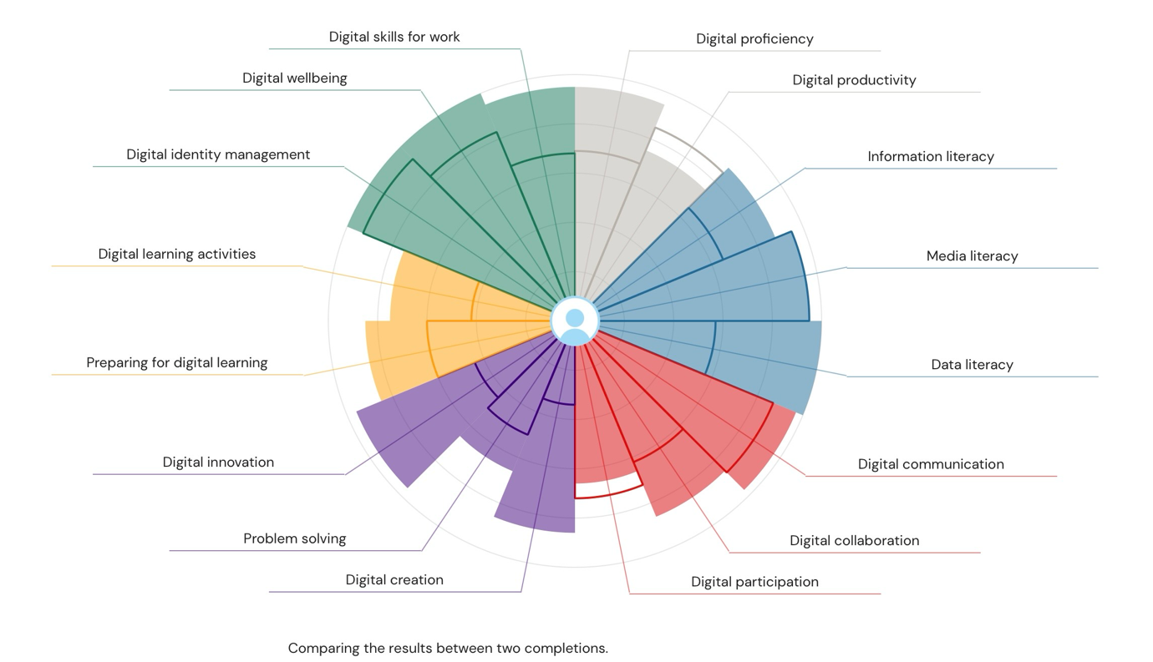
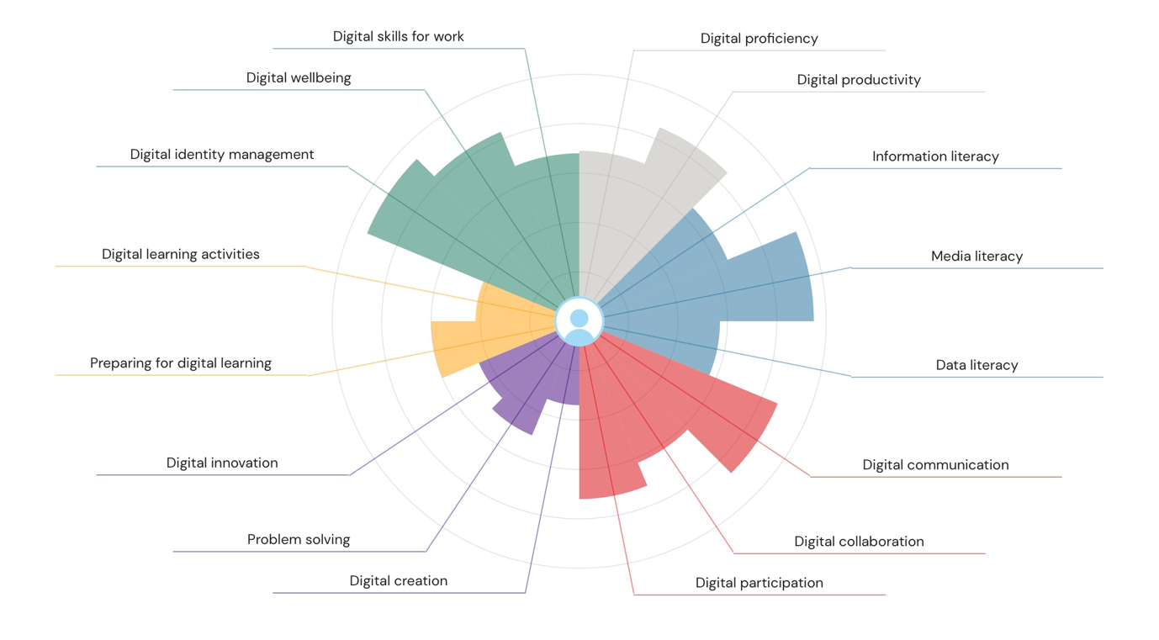

The Joint Information Systems Committee (JISC) digital capabilities test investigates 6 varied factors, “information and communications technologies (ICT) proficiency; information, data and media literacies; digital creation, problem solving and innovation; digital communication, collaboration and participation; digital learning and development; and digital identity and wellbeing” (Reedy et al, 2017). Digital capabilities are known to provide significant benefits to students, “Gaining cross-disciplinary digital skills is the lifeblood of deeper learning outcomes that lead to fruitful careers” (Reedy et al, 2017). Results from the national survey JISC Student Digital Experience Tracker conducted, shows that students “appreciate more opportunities to review and update their digital skills” (Rivers-L et al, 2020). After completing the JISC questionnaire on my digital capabilities, there is a drastic difference in the results. From the results of my first answers, I was not as confident in my digital skills as of now. Looking at the results, I was most confident in digital identity management, digital wellbeing, and digital literacy.
The ACSEL study which is an acronym for the French Digital Economy Association, have found out that “90% of internet users use three digital ID’s to access e-administration”, as well as “8% for online banking and 77% for social networks” (Laurent-Maknavicius et al, 2015). There is evidence “that the French are targets to 400,000 identity thefts per year on average” (Laurent-Maknavicius et al, 2015). This highlights how important it is to manage digital identity in our lives as well as for students to learn.
A students' journey whilst digitally online comes with demands from the institution or course leaders but also challenges that come from using online resources. This can therefore impact students' wellbeing. The definition for the term digital wellbeing can be described as “an impact of digital technologies on what it means to live a life that is good for an individual in an information-based society” (Foster et al, 2024). JISC has stated that “technologies and digital activities can impact… emotional wellbeing in both positive and negative ways” (Foster et al, 2024). This emphasises the impact of digital technologies on students' wellbeing within education and further highlights how significant it is to have good digital wellbeing.
Digital literacy is defined as “the capacity to comprehend and effectively utilise digitalised information, along with the diverse range of tools and platforms associated with it” (Malafaia Cerqueira, 2023). It is understood that this generation has a broad understanding on how to use technology however, not as effectively as we think, digital literacy is interpreted as the “skills, knowledge and understanding that enable critical, creative, discerning and safe practices with digital technologies” (Fitzgerald et al, 2015). This proves how important it is to have a deep knowledge on digital literacy as benefits students in every aspect when using online technology.
Looking at my first results, I am least confident in digital creation, as well as digital learning activities and digital innovation. Digital creation is a useful capability as this is the production of content. This can be from making websites, images, documents to technical work like coding. Creating material online can “open doors and breach boundaries” (Greaves, 2012). Digital learning activities are the several ways students can learn online with digital media. The European University Association call for “promoting active learning in higher education”. To do this “teaching and learning approaches should be student-centred” (Lohr et al, 2021). Having a good knowledge of digital learning activities allows students to find what approaches suit them and their needs whilst digitally learning. It is conceptualised that “digital innovation (is) the creation of (and consequent change in) market offerings, business processes, or models that result from the use of digital technology” (Nambisan et al, 2017). Digital innovation is important as it increases flexibility when learning and improves accessibility to students.
Furthermore, it is noticeable that from my second try at the JISC digital capability test, that I am also confident in digital skills for work, media literacy and digital communication. There is also clear improvement on the factors I struggled with at first, digital creation, and digital innovation. However, I still need to improve on digital productivity, digital participation, problem solving, and digital learning activities for a more balanced result of my knowledge on digital capabilities.

References
Fitzgerald, R. And Henderson-Martin, H., 2015. Transforming the First Year Experience (HE) With Digital Literacy via Techno-Social Engagement and Evaluation. Kidmore End: Academic Conferences International Limited.
Foster, S., Thien, T.L., Foster, A.J., Thi Hanh, T.H. And Knight, S., 2024. Digital wellbeing – a review of the JISC guidance from the UK and Vietnam. Higher Education, Skills and Work – Based Learning, 14(2), pp. 435–442.
Greaves, L. (2012) “Feed-forward for Informed Learning (FflL): learner-generated materials for personalised learning,” Enhancing learning in the social sciences, 4(3), pp. 1-7. Available at: https://doi.org/10.11120/elss.2012.04030010.
Laurent-Maknavicius, M., Bouzefrane, S. (2015) Digital identity management. Amsterdam: Elsevier.
Lohr, A., Stadler, M., Schultz-Pernice, F., Chernikova, O., Sailer, M., Fischer, F., & Sailer, M. (2021). “On powerpointers, clickeres, and digital pros: Investigating the initiation of digital learning activities by teachers in higher education,” Computers in human behaviour, 119. Available at: https://doi.org/10.1016/j.chb.2021.106715.
Malafaia Cerqueira, F., 2023. Higher Education Students and Digital Literacies: a Systematic Literature Review, The University of Western Ontario (Canada).
Nambisan, S., Lyytinen, K., Majchrzak, A., & Song, M. (2017). “Digital Innovation Management: Reinventing Innovation Management Research in a Digital World,” MIS quarterly, 41(1), pp.223-238. Available at: https://doi.org/10.25300/misq/2017/41:1.03.
Reedy, K, & Parker, J (eds) 2017, Digital Literacy Unpacked, Facet Publishing, London. Available from: ProQuest Ebook Central. [25 February 2026].
Rivers-L, Monica-J., Singer, H. And Conway, L. (2020) “Library SkillUP: Digital information skills module for students at the University of Hertfordshire,” Journal of information literacy, 14(1), p. 83. Available at: https://doi.org/10.11645/14.1.2745.

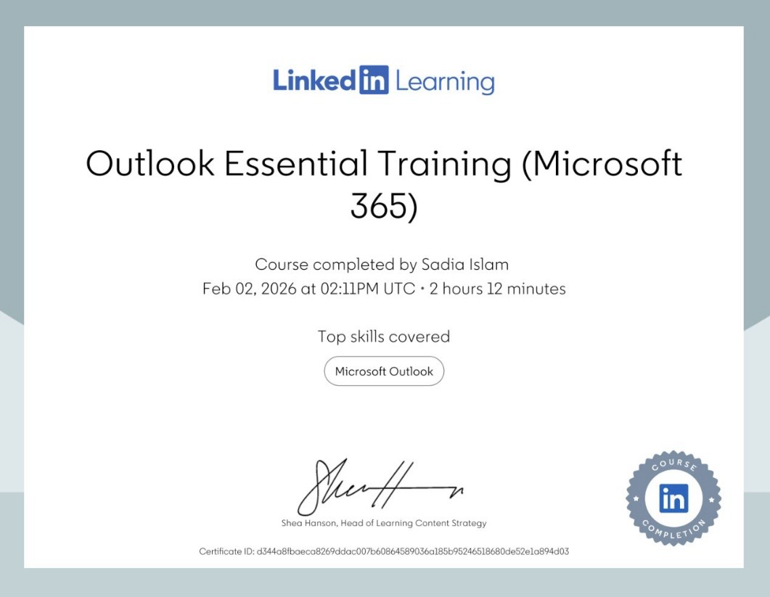
Task 2 – LinkedIn Learning Certificates for Office365

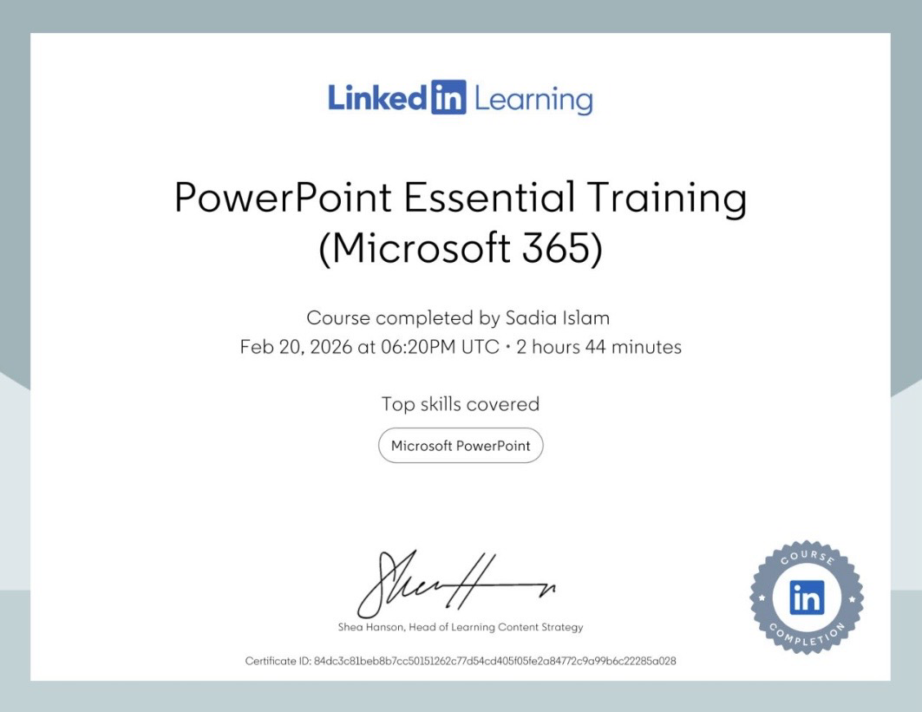
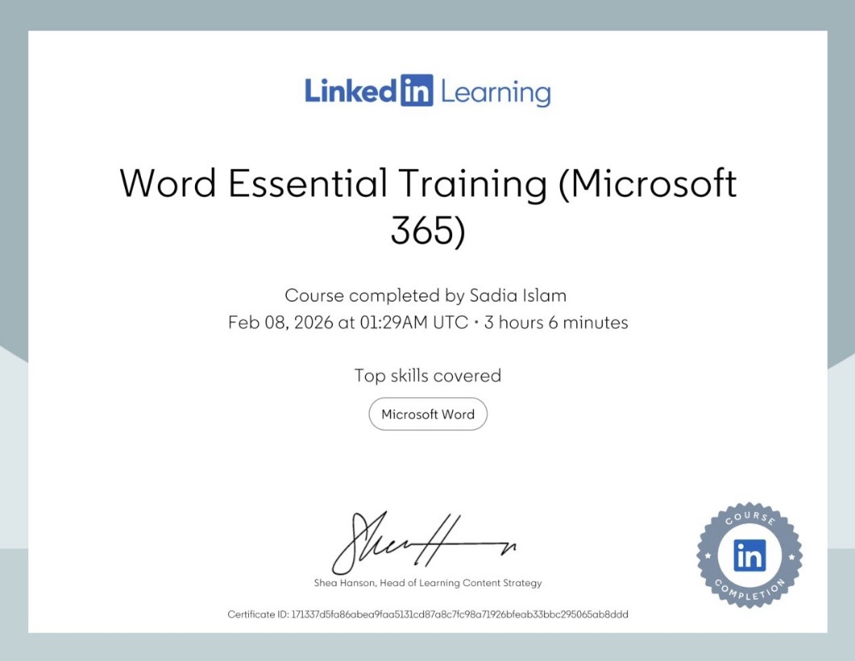

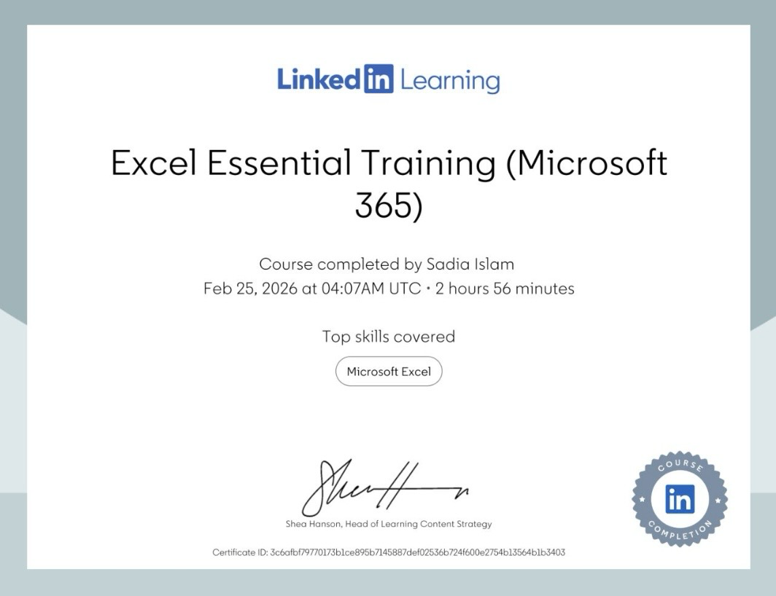
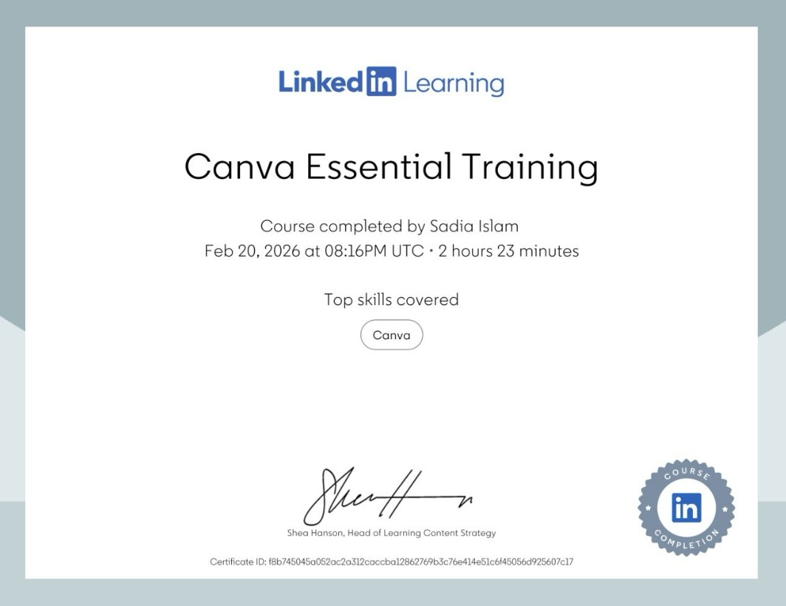

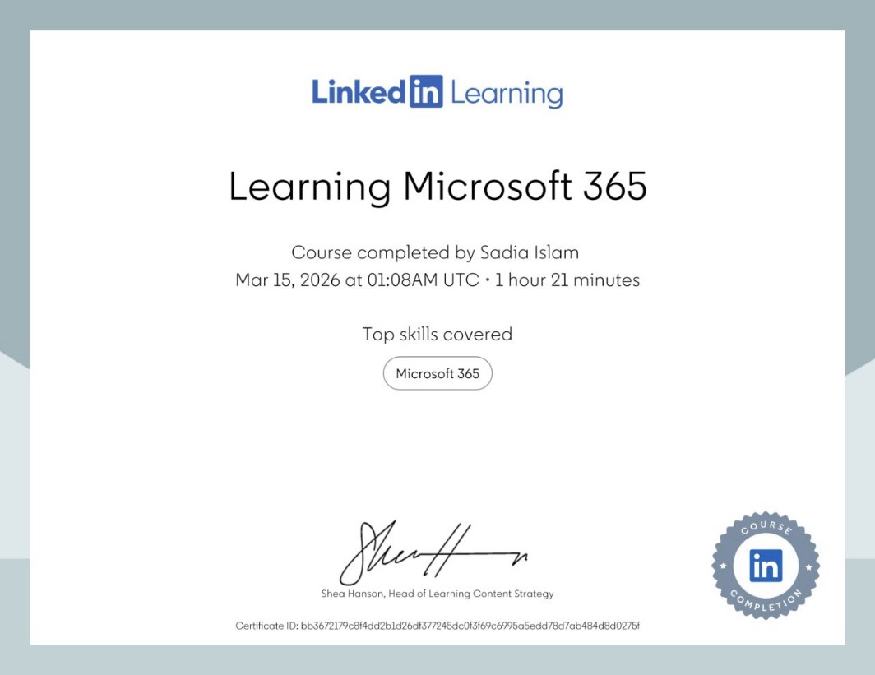
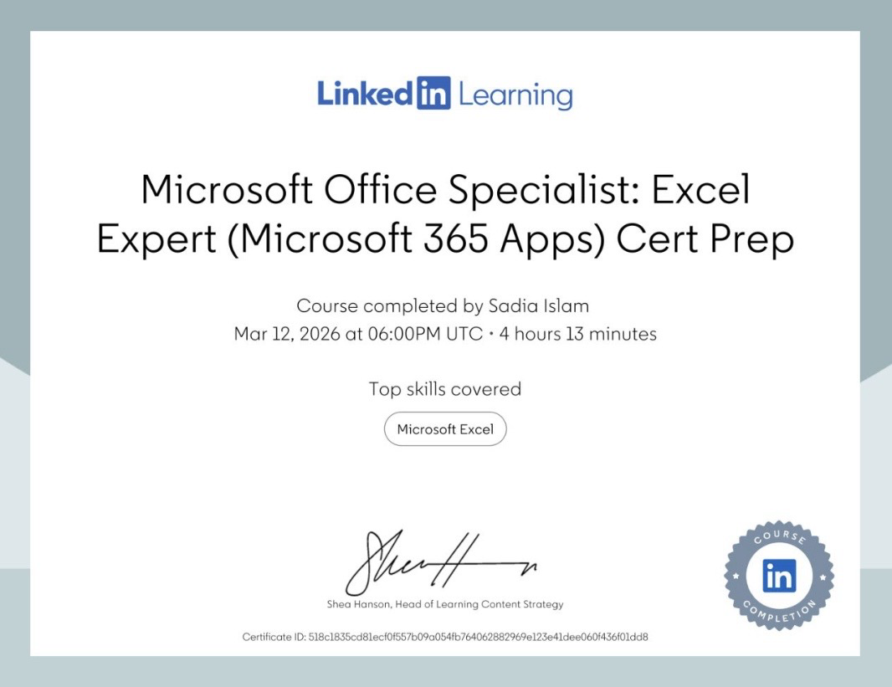

Task 3 – Essay on Relevance of Excel in professional and personal life
As we evolve through life digitally, we will always need skills to help us organise, summarise, and visualise data from. When working in a digital space, “employees will need to have basic skills to enable them to access, manipulate, organise, explore, summarise, or visualise data” (Weathers et al, 2024). Microsoft Excel is the perfect application to use to achieve all said skills, the software provides a thorough group of features including “advanced formulas, powerful charting capabilities, data analysis tools, and visualisation options” (Rosener, 2024). Launched in 1985, it has grown massively due to businesses need for “charts, graphs, statistical data computations, and formula creation” (Formby et al, 2017).
It is estimated that “80% of jobs require proficiency in Excel or similar software”, this statistic emphasises that Microsoft Excel is not something that is just restricted to jobs like finance or data analytical roles but also to a range of numerous industries, such as teaching, business, healthcare, education, engineering and many more. “There is evidence that Microsoft Excel is used widely more than any other similar spreadsheeting package (and) dominates the spreadsheet market…with an estimated 90% of market share” (Birch, 2005). Typically, Microsoft Excel is a desk-top used application, however it “offers online and mobile versions as part of the Microsoft 265 subscription service”. Excel is a familiar software used in multiple businesses around the globe, “users who are already familiar with Microsoft Office products may find Excel easy to use” (Rosener, 2024). For business use, Microsoft Excel “has a benefit in excess of extra tools in that is generally accessible and moderately easy to access” (Kumar, 2023), such as importing and exporting functions. It lets users to import data and export data to other softwares in different formats such as TXT, XML, CSV and many more. The software also supports add-ins and plug-ins by third-party or in-house teams. This emphasises Microsoft Excel’s functionality, it integrates with other softwares and provides special functions for specific tasks like project management, reporting, and data analysis. Additional features like mentioned before such as creating several types of tables, charts and formulas highlights the range Excel can offer for businesses or for those who want to use the software for personal use. As our era increasingly advances with digital technologies making its way into every aspect of life, it is obvious that “jobs requiring advanced analytical tools skills offer the strongest opportunity for middle-skill job seekers in terms of salary and growth as well as career advancement” (Formby et al, 2017). It is clear that jobs that offer high pay or more knowledge/experience into the analytics world demand people who have the top knowledge required to use such applications like Microsoft Excel, this will encourage students or job seekers to expand and gain knowledge about Excel and continue to develop their skills to get the careers they want.
Microsoft Excel is a great software for all uses, with students taking advantage of that. “Sophisticated output generated by advanced statistical packages can be confusing for students,” however, “The output generated by Excel often matches examples presented in introductory statistics recounted exercises or in classroom instruction” (Warner et al, 2001). There was a study that took part to investigate the usage of Microsoft Excel in a business school, from the results they found out that “the use of Excel together with realistic business examples and exercises can contribute greatly to students understanding of both business and statistics” (Chaamwe et al, 2016). With Excel benefitting students, teachers are also getting a helping hand from the software, a study took place to show “techniques that enable educators to design animated graphical displays in their spreadsheet constructions to enhance mathematical understanding” (Chaamwe et al, 2016). They study proved that Excel “can be used to create animated and interactive graphs of functions” (Chaamwe et al, 2016). According to an online questionnaire of 22 participants, 31.8% of students said that they use Excel several times a week as well as the same percentage who said they use the application once a month. 27.3% days there use the software everyday as the remaining 9.1% saying they rarely ever use Microsoft Excel. 54.5% of students “expressed satisfaction with Microsoft Excel’s ability to process and process data.” Whereas 18.2% of students claimed, “they were very satisfied” (Simaremare et al, 2024). 36.4% of students said Excel “were quite helpful in completing academic assignments”, as well as 27.3% of students who said the software was “very helpful in completing academic assignments” (Simaremare et al, 2024). 45.5% of students also claimed that Microsoft Excel makes it quite easy to analyse data or create data and 31.8% find it “very easy.” According to the results of this questionnaire, this proves that Microsoft Excel is quite efficient among students, however, 31.8% of students did state that found Excel to be less helpful in completing academic assignments. This was majorly down to the fact that said students just had low knowledge or understanding on the application, this emphasises how important it is to learn how to use Microsoft Excel effectively so students can use the software to its full potential.
In conclusion, it is evident that Microsoft Excel is quite relevant to all sorts of businesses, as well as those in education. It is something we should incorporate more to people to understand as well as those in education, so “students will be exposed to excel… creating, lasting learning through repetition and reinforcement” (Tientz et al, 2021). Microsoft Excel is not the only important software however, “when departments within a company exchange information, it often comes in the form of an Excel… file.” When clients give details to their auditors “most for that information is in Excel” (Tientz et al, 2021). Knowledge in Microsoft Excel is a huge advantage that employers will look for, “Early exposure to programs like Excel potentially instills a long-run benefit of general education economics courses”, they provide students “experience by providing new skills and giving them safe spaces to develop an aptitude for spreadsheet software”(Williams, 2025).

References
Birch, R. (2005). Microsoft excel: 21st Century Abacus or End-User Development Tool? Bulletin of Applied Computing and Information Technology Vol.3, Issue 1. ISSN 1176-4120. Retrieved March 3, 2026 from https://www.naccq.ac.nz/bacit/0301/2005Birch_Spreadsheets .html.
Chaamwe, N. And Shumba, L. (2016). Spreadsheets: A Tool for e-Learning – A Case of Matrices in Microsoft Excel. International Journal of Information and Education Technology. Available at: https://doi.org.10.7763/IJIET.2016.V6.753.
Formby, K.S., Medlin, D.B. And Ellington, V. (2017). Microsoft Excel: Is It An Important Job Skill for College Graduates?. Information Systems Education Journal, 15(3), pp. 55-63. Available at: https://www.isedj.org; http://iscap.info.
Kumar, D.M. (2023). A study on Importance of Microsoft Excel Data Analysis Statistical Tools in Research Works. Journal of Management & Educational Research Innovation (JOMERI), 1(3), pp. 76-83. Available at: https://doi.org/10.5281/zenodo.10449150.
Rosener, W.J. (2024) “Comparative Analysis of Google Sheets and Microsoft Excel: A Discussion Case in Spreadsheet Software,” Journal of cases on information technology, 26(1), pp. 1-21. Available at: https://doi.org/10.4018/JCIT.351672.
Simaremare, S. T., Atika, L., & Siregar, R. (2024). Effectively of the Microsoft Excel Application on Student Understanding in Statistics Courses. Indonesian Journal of Education and Social Humanities, 1(2), pp. 9-19.
Tientz, W., Cainas, J. And Miller-Nobles, T. (2021). The Common D Enominator. Strategic Finance, 103(2), pp. 34-39.
Warner, B.C. and Meehan, M.A. (2001). Microsoft Excel as a Tool for Teaching Basic Statistics. Teaching of Psychology, 28(4), pp. 295-298. Available at: https://doi.org/10.1207/S15328023TOP2804_11.
Weathers, D. And Swain, S.D. (2024) “A scaffolded learning approach to increasing student comfort with Microsoft Excel,” Journal of marketing analytics, 12(2), pp. 198-208. Available at: https://doi.org/10.1057/s41270-024-00306-1.
Williams, M.J.C. (2025). Using Microsoft Excel to Enhance a General Education Economics Course. Journal of Economics Teaching

Excel
https://uowtsd-my.sharepoint.com/:x:/r/personal/2531380_student_uwtsd_ac_uk/Documents/Finance%20spreadsheet.xlsx?d=w94a3566f1edc4cdf91cfc11db2558f13&csf=1&web=1&e=iHeqZG

Task 4 – 5 Minute Reflective Presentation
https://uowtsd-my.sharepoint.com/:p:/g/personal/2531380_student_uwtsd_ac_uk/IQBGJIAVteuGRJvX5my_4j2pAV-3CEVF4rIeZ55GOG9JuKw?email=2531380%40student.uwtsd.ac.uk&e=aVopNT

References
Amrizal, A., Rukmini, D., Hartono, R. And Mujiyanto, Y. (2024). Microsoft Word App: As Electronic Feedback in Improving Students’ Writing Skills. Proceedings of UNNES-TEFLIN National Conference.
Blake, A., 2023. Microsoft Outlook. MacFormat, (392), pp. 92-93.
Fleck, R.A.JR., Loughman, T.P. And McQueen, T.F. 2004. What the Manual didn’t tell you about PowerPoint. Allied Academics International Conference. Proceedings of the Academy of Information and Management Sciences, 8(2), pp. 17-22.
Formby, K.S., Medlin, D.B. And Ellington, V. (2017). Microsoft Excel: Is It An Important Job Skill for College Graduates?. Information Systems Education Journal, 15(3), pp. 55-63. Available at: https://www.isedj.org; http://iscap.info.
Pertiwi, W.A., Taufiq, A., Meganingtyas, D.E.W. And Meiningdias, C.Y., 2022. Student Perspectives on Using Microsoft Teams as an Alternative to the Implementation of Science Practicum. Journal of Physics: Conference Series, 2377(1), pp. 012083.

