
Module Name: Problem solving and Innovation

Module Code: BMSW4014

Student Name: Aurelia-Mirela Sterian

Student Number: 2238113

Lecturer: Jaliya De Silva

Deadline: Monday 2nd of November 2026 23.59PM
Wordcount : 1500 words

AI Acknowledgement

I acknowledge the use of ChatGPT (https://chat.openai.com) on 21th October 2026 for a Romanian explanation on how this assessment should be done, to make sure I complete all the task the lecturer is expecting.

I confirm that I have not presented any AI-generated text as my own work. I confirm that I have retained copies of drafts, notes, and resources used before and after the use of AI tools.

Executive summary

The creator economy offers substantial opportunities, but its sustainability is constrained by platform dependence, uneven income, intense competition, legal and ethnical risks. Using the DPSIR framework, this report examines how technology, audience behaviour and commercial demand drive growth while algorithmic control and unstable monetisation create pressure. STEEPLE and SWOT analyses, alongside three creator cases, show that risks differ by business model. The report recommends diversified distribution and revenue, plus clear procedures for advertising disclosure and audience trust.

Table of content
- Cover page
- AI statement
- Executive summary
- Table of content
- 1. Introduction
- 1.1 Definition of an influencer
- 1.2 Background of the Creator Economy
- 1.3 Aim and scope of the report
- 2.DPSIR Analysis
- 2.1 Divers
- 2.2 Pressures
- 2.3 State
- 2.4 Impacts
- 2.5 Responses
- 3. Future Lens
- Future trends and potential scenarios
- Risks and opportunities for the Creator Economy
- 4.Recommendations
- Recommendation 1
- Recommendation 2
- 5.Conclusion
- Full Harvard references
- Appendices
- Appendix A: STEEPLE Analysis
- Appendix B: SWOT Analysis
- Appendix C: DPSIR diagram
- Appendix D: Evidence limitations
- Appendix E: Creators reach and social blade statistics
- Appendix F: Comparison of Creator Business Model

A Critical Analysis of External Factors Influencing the Creator Economy/ Influencer industry

- Introduction
1.1Definition of an influencer: An influencer is a person who has built an audience on digital or social media and can affect that audience’s opinions, preferences or purchasing decisions through their perceived expertise, credibility, lifestyle or relationship with followers. Influencers may earn income through sponsored content, affiliate links, subscriptions or their own products. The term overlaps with “content creator”, but the two are not identical: content creators produce digital material, whereas the term influencer emphasises the potential to shape audience attitudes or behaviour. This distinction is useful for analysing the creator economy, where reach does not automatically equal influence or commercial effectiveness (Abidin, 2016; De Veirman, Cauberghe and Hudders, 2017; Vrontis et al., 2021).
1.2 Background of the Creator Economy: The creator economy includes individuals and businesses that produce digital content and generate income through advertising, sponsorships, subscriptions, affiliate marketing, merchandise and consumer products. Digital platforms have lowered barriers to publishing, allowing creators to reach international audiences without relying exclusively on traditional media organisations. However, creators also depend on platforms that control content distribution, audience data and monetisation opportunities (Cunningham and Craig, 2019; Peres et al., 2024).
1.3 Aim and scope of the report : This report critically analyses external factors influencing the creator economy through the Drivers, Pressures, State, Impacts and Responses (DPSIR) framework. The STEEPLE analysis in Appendix A categorises the external environment, while the SWOT analysis in Appendix B evaluates the industry's strategic position. Three examples illustrate different creator business models: IShowSpeed represents personality-led livestreaming, Huda Kattan illustrates the connection between beauty content and creator-led product ownership, and Steven Bartlett represents podcasting and media entrepreneurship. Their comparison in Appendix F shows why the same external changes can create different opportunities and risks for different creators.
2.DPSIR ANALYSIS
2.1 Drivers: forces driving the creator economy
The creator economy is driven by technological accessibility, changes in audience behaviour and the commercial value of digital influence. Smartphones, social platforms and accessible production tools allow individuals to publish content with relatively low initial investment. Participatory digital culture also enables audiences to comment, share and contribute to creator communities (Jenkins, 2006; OECD, 2007).
Creators can develop personal brands around a distinctive identity, expertise or lifestyle. Khamis, Ang and Welling (2017) describe self-branding and micro-celebrity as important features of social media culture. Abidin (2016) similarly shows how influencers perform visibility work to maintain audience attention and commercial relationships. These practices can make creators attractive to brands seeking to reach specific audiences.
Influencer marketing research suggests that follower numbers, perceived credibility and the value of sponsored messages can affect consumer responses (De Veirman, Cauberghe and Hudders, 2017; Lou and Yuan, 2019). Vrontis et al. (2021) identify influencer marketing as a developing research field with implications for consumer behaviour and marketing strategy. However, follower counts alone do not establish influence or commercial effectiveness; audience fit and trust also matter.
The three cases demonstrate different ways of converting attention into value. IShowSpeed's livestreaming depends on entertainment and real-time audience participation. Huda Kattan's public profile is associated with a beauty business, illustrating how a creator identity can complement products. Steven Bartlett's The Diary of a CEO demonstrates how long-form interviews can become a media product distributed through digital channels.
Nevertheless, accessible publishing does not guarantee sustainable income. Creators compete for limited attention and must continually adapt to changes in formats, algorithms and audience expectations. Peres et al. (2024) therefore describe the creator economy as a complex ecosystem involving creators, platforms, firms and consumers rather than simply a collection of independent influencers.

2.2 Pressures: risks and external constraints
A major pressure is dependence on digital platforms. Recommendation systems influence which content becomes visible, while platforms determine monetisation rules and access to audience data. Cotter (2019) describes how Instagram influencers navigate an algorithmic “visibility game”. Bucher (2018) argues more broadly that algorithms exercise power by shaping what users can see and how they experience digital systems. For creators, this means that strong performance today does not guarantee future visibility.
Platformisation also affects the relationship between creators and commercial intermediaries. Nieborg and Poell (2018) explain how cultural production becomes shaped by platform infrastructures and business models. This creates opportunities for distribution but can limit creators' control over the conditions of production. IShowSpeed's livestreaming model is exposed to platform visibility and live-content policies. Bartlett's podcast can be distributed across channels, although discovery still depends partly on third-party services. Huda Kattan's creator-led brand model can potentially build direct customer relationships, reducing—but not eliminating—dependence on social platforms.
Economic pressure compounds these risks. Advertising budgets fluctuate, sponsorship opportunities are unevenly distributed, and professional production may require spending on editing, staff and equipment. Duffy (2017) challenges the idealised image of creative independence by showing how aspirational digital work can involve insecurity and unpaid labour. Marwick (2013) also explains how online status and personal branding can become closely connected to visibility and social competition.
Legal and ethical pressures are also significant. Commercial endorsements must be recognisable as advertising, including relevant gifted products, affiliate relationships and promotions of a creator's own business (CMA, 2025a). The Advertising Standards Authority's monitoring of more than 50,000 pieces of Instagram and TikTok content found that approximately 57% of the influencer advertisements in its sample complied with disclosure rules, 9% used unclear labels and 34% had no disclosure (ASA, 2025). These findings indicate a transparency problem, although the monitored sample should not be interpreted as a census of all influencer advertising.
Ethical risks extend beyond advertising. Audiences may perceive creators as authentic or personally relatable, which can make commercial messages persuasive. Audrezet, de Kerviler and Guidry Moulard (2020) identify tensions between commercial partnerships and perceived authenticity. Evans et al. (2017) also demonstrate that disclosure language can affect advertising recognition and consumer responses. These issues are especially relevant when creators promote beauty products, financial services or other products where misleading claims may have consequences.

2.3 State: the current condition of the creator economy
The creator economy combines large potential audiences with unequal monetisation and uncertain long-term outcomes. Public attention is not distributed equally, and high reach does not necessarily translate into stable income. Ofcom's Online Nation 2025 report provides broader evidence of the scale and changing nature of online use in the UK, offering context for the digital environment in which creators operate (Ofcom, 2025).
The three cases represent distinct models of audience development. IShowSpeed uses livestreaming and personality-led entertainment; Huda Kattan connects beauty content and personal branding with a consumer-product business; and Bartlett develops a long-form podcast and media presence. Official creator and brand channels provide examples of how these models are presented to audiences (IShowSpeed, n.d.; Huda Beauty, n.d.; Bartlett, n.d.).
Social Blade’s monthly statistics for IShowSpeed also illustrate that audience growth is not necessarily linear. Monthly gains in views and subscribers fluctuate considerably across the 2024–2026 period, suggesting that creator visibility can be shaped by viral moments, content cycles and platform recommendation systems. These figures indicate reach and audience acquisition, but they are not direct measures of engagement quality, income or long-term audience loyalty; as third-party estimates, they should be interpreted cautiously (see Appendix E).
However, audience metrics must be interpreted cautiously. Subscribers, followers, cumulative views and podcast downloads measure different forms of reach and are not directly interchangeable. McCracken's (1989) work on celebrity endorsement also suggests that the meaning transferred from a public figure to a product is not captured by audience size alone. Appendix E summarises selected audience indicators and explains their limitations.
The industry's state is therefore best understood as a mixture of opportunity and fragility. Creators can build valuable communities and commercial identities, but their access to audiences, income and reputation remains vulnerable to platform changes and external events. The STEEPLE table in Appendix A summarises the factors shaping this environment.

2.4 Impacts: economic, social and environmental consequences
The creator economy can support entrepreneurship, employment, cultural participation and new routes to market. Creators can introduce niche products, provide entertainment and develop communities around shared interests. Cunningham and Craig (2019) describe social media entertainment as an evolving intersection between digital platforms and professional media production. These opportunities, however, coexist with unequal rewards and pressure to remain visible.
Social impacts are mixed. Creators can offer audiences a sense of community and access to specialist knowledge, but the boundary between personal recommendations and commercial advertising may become unclear. Sokolova and Kefi (2020) examine how credibility and parasocial interaction relate to consumers' purchase intentions, illustrating why perceived relationships with creators matter commercially. These relationships can be valuable, but they also increase the importance of transparency.
The three cases demonstrate different forms of risk. IShowSpeed's spontaneous livestreaming creates opportunities for direct interaction but can expose the creator to reputational risks arising from unpredictable live moments. Huda Kattan's association with a beauty brand makes product quality and consumer trust important to both the creator's public reputation and the brand. Bartlett's long-form interviews create opportunities for detailed discussion but also increase the importance of editorial scrutiny, especially when content addresses consequential subjects.
Authenticity is not simply a personal quality; it is also shaped by the commercial environment. Audrezet, de Kerviler and Guidry Moulard (2020) suggest that creators need to manage tensions between their perceived motivations and commercial partnerships. Similarly, Duffy and Hund (2019) discuss the pressures of maintaining visibility and authenticity in social media culture.
Environmental impacts also deserve attention. Streaming, video storage and AI-assisted production depend on digital infrastructure that consumes energy and resources. Although the environmental footprint of an individual creator's content is difficult to establish without detailed data, the industry relies on networks, devices and data centres. Environmental considerations should therefore form part of the wider STEEPLE assessment rather than being ignored because the work is digital.
The causal relationships between drivers, pressures, the industry's state, impacts and responses are shown in Appendix C. The limitations of the evidence used in this report are discussed in Appendix D.

2.5 Responses: adapting to external change
Creators can respond to external pressures by diversifying distribution, strengthening direct audience relationships and developing complementary revenue streams. Possible approaches include subscriptions, merchandise, product sales, licensing and events. Teece (2010) argues that business models are important to capturing value from innovation; this is relevant to creators seeking to convert attention into sustainable commercial activity.
However, diversification requires careful planning. A new product or platform can introduce additional costs and operational risks. A livestreaming creator may benefit from distributing selected content across several channels, while a creator-founded brand may prioritise customer relationships and product quality. A podcast business may focus on multi-platform distribution, editorial standards and a balanced revenue model.
Creators should also establish consistent procedures for advertising disclosure, sponsorship selection, product claims and corrections. The ASA's influencer guidance explains how promotional content should be clearly identifiable as advertising (ASA, 2023). The CMA (2025a) likewise states that creators must make relevant commercial relationships clear, including when they promote their own products. Brands also have responsibilities to ensure that paid-for endorsements are properly labelled (CMA, 2025b).
The SWOT analysis in Appendix B shows that direct audience access is both a strength and a potential weakness when it depends on external platforms. Responses should therefore address both business resilience and audience trust.

- FUTURE LENS:
Over the next three to five years, AI-assisted production, regulatory expectations and competition for audience attention are likely to shape the creator economy. These developments are uncertain, but existing research provides a basis for assessing their potential implications.
First, AI tools may reduce the cost of editing, captioning, translation and content adaptation. Peres et al. (2024) identify AI and platform technologies as part of the developing creator ecosystem. These tools could help creators reach audiences across language markets, but they may also increase content supply and make differentiation more difficult. Creators may need to compete through distinctive expertise, originality and trust rather than volume alone.
Second, transparency and authenticity are likely to remain important. Abidin (2018) examines the construction of internet celebrity, while Hudders, De Jans and De Veirman (2021) review how influencer marketing is strategically used by brands. As synthetic media develops, creators and platforms may face additional questions about disclosure, authenticity and intellectual property. Gillespie (2018) also demonstrates that platforms make consequential decisions about content governance, suggesting that creator opportunities will continue to be influenced by platform policies and moderation.
Third, market saturation may encourage creators to develop more resilient business models. Creator-owned products, paid communities, licensing and multi-platform media can provide alternatives to dependence on advertising, but they also create additional costs and management responsibilities. A strategy that works for one creator may not suit another. IShowSpeed's opportunities are linked to entertainment and live participation; Huda Kattan's model demonstrates the potential of connecting personal branding with products; and Bartlett's podcasting illustrates the potential of long-form media distributed across channels.
These predictions are scenarios rather than guaranteed outcomes. Their implications depend on technology, consumer behaviour, platform policy and creators' capacity to adapt. The comparison in Appendix F shows how a common external trend can have different consequences across creator business models.

- Recommendations

Recommendation 1: Develop a diversified business and distribution model. Creators should reduce dependence on a single platform and revenue source. They should select complementary distribution channels and, where appropriate, develop direct relationships with audiences through newsletters, memberships, customer databases or owned sales channels. This recommendation is consistent with Teece's (2010) emphasis on business models as a means of capturing value and with Peres et al.'s (2024) analysis of the creator economy as a wider commercial ecosystem. The practical approach should reflect the creator's business model: livestreamers can repurpose suitable content, creator-led brands can strengthen direct customer relationships, and podcasters can distribute content across audio and video services.

Recommendation 2: Establish a formal trust and compliance framework. Creators and their teams should adopt consistent procedures for sponsorship disclosure, product claims, commercial partnerships, corrections and moderation of high-risk content. The ASA (2023) and CMA (2025a) provide guidance on making advertising recognisable and transparent. These practices can reduce legal and reputational risks while supporting audience trust. Implementation should reflect the content format: livestreamers need safeguards suitable for real-time broadcasts, creator-led brands need product and marketing controls, and podcasters should maintain clear sponsorship disclosures and appropriate editorial checks.Both recommendations respond to the pressures identified in the DPSIR analysis and the weaknesses and threats presented in Appendix B.

- Conclusion

The creator economy provides opportunities for entrepreneurship, cultural participation and global communication, but its development is shaped by platform dependence, economic uncertainty, technological change and legal and ethical responsibilities. The DPSIR analysis demonstrates that the forces driving growth can also create pressures that threaten long-term sustainability.
The comparison of IShowSpeed, Huda Kattan and Steven Bartlett shows why no single strategy is appropriate for every creator. Livestreaming, creator-led product businesses and podcasting rely on different sources of value and face different external risks. Nevertheless, diversification and audience trust are relevant across all three models. Creators who adapt their business models while maintaining transparent commercial practices may be better positioned to respond to future change, although these strategies cannot eliminate the uncertainty inherent in platform-based work.

10. Full Harvard reference list :
Abidin, C. (2016) ‘Visibility labour: Engaging with influencers’ fashion brands and #OOTD advertorial campaigns on Instagram’, Media International Australia, 161(1), pp. 86–100. Available at: https://doi.org/10.1177/1329878X16665177
Abidin, C. (2018) Internet Celebrity: Understanding Fame Online. Bingley: Emerald Publishing.
Advertising Standards Authority (ASA) (2023) Influencers’ guide to making clear that ads are ads. Available at: https://www.asa.org.uk/resource/influencers-guide.html (Accessed: 18 October 2026).
Advertising Standards Authority (ASA) (2025) Influencer ad disclosure on social media: Instagram and TikTok report (2024). Available at: https://www.asa.org.uk/news/influencer-ad-disclosure-on-social-media-instagram-and-tiktok-report-2024.html (Accessed: 20 October 2026).
Audrezet, A., de Kerviler, G. and Guidry Moulard, J. (2020) ‘Authenticity under threat: When social media influencers need to go beyond self-presentation’, Journal of Business Research, 117, pp. 557–569. Available at: https://doi.org/10.1016/j.jbusres.2018.07.002
Bartlett, S. (n.d.) Steven Bartlett — official website. Available at: https://stevenbartlett.com/ (Accessed: 21 October 2026).
Bucher, T. (2018) If...Then: Algorithmic Power and Politics. Oxford: Oxford University Press.
Competition and Markets Authority (CMA) (2025a) Social media endorsements: Guidance for content creators. Available at: https://www.gov.uk/government/publications/social-media-endorsements-guidance-for-content-creators (Accessed: 17 October 2026).
Competition and Markets Authority (CMA) (2025b) Social media endorsements: Guidance for brands. Available at: https://www.gov.uk/government/publications/reviews-and-social-media-endorsements-guidance-for-businesses-and-brands/social-media-endorsements-guidance-for-brands (Accessed: 20 October 2026).
Cotter, K. (2019) ‘Playing the visibility game: How digital influencers and algorithms negotiate influence on Instagram’, New Media & Society, 21(4), pp. 895–913. Available at: https://doi.org/10.1177/1461444818815684
Cunningham, S. and Craig, D. (2019) Social Media Entertainment: The New Intersection of Hollywood and Silicon Valley. New York: New York University Press.
De Veirman, M., Cauberghe, V. and Hudders, L. (2017) ‘Marketing through Instagram influencers: The impact of number of followers and product divergence on brand attitude’, International Journal of Advertising, 36(5), pp. 798–828. Available at: https://doi.org/10.1080/02650487.2017.1348035
Duffy, B.E. (2017) (Not) Getting Paid to Do What You Love: Gender, Social Media, and Aspirational Work. New Haven, CT: Yale University Press.
Duffy, B.E. and Hund, E. (2019) ‘Gendered visibility on social media: Navigating Instagram’s authenticity bind’, International Journal of Communication, 13, pp. 4983–5002. Available at: https://ijoc.org/index.php/ijoc/article/view/11729
Evans, N.J., Phua, J., Lim, J. and Jun, H. (2017) ‘Disclosing Instagram influencer advertising: The effects of disclosure language on advertising recognition, attitudes, and behavioral intent’, Journal of Interactive Advertising, 17(2), pp. 138–149. Available at: https://doi.org/10.1080/15252019.2017.1366885
Gillespie, T. (2018) Custodians of the Internet: Platforms, Content Moderation, and the Hidden Decisions That Shape Social Media. New Haven, CT: Yale University Press.
Huda Beauty (n.d.) Official website. Available at: https://hudabeauty.com/ (Accessed: 21 October 2026).
Hudders, L., De Jans, S. and De Veirman, M. (2021) ‘The commercialization of social media stars: A literature review and conceptual framework on the strategic use of social media influencers’, International Journal of Advertising, 40(3), pp. 327–375. Available at: https://doi.org/10.1080/02650487.2020.1836925
HypeAuditor (2026) Huda (@huda) Instagram statistics and historical data. Available at: https://hypeauditor.com/instagram/huda/ (Accessed: 20 October 2026).
HypeAuditor (2026) IShowSpeed (@ishowspeed) YouTube statistics and historical data. Available at: https://hypeauditor.com/youtube/UCWsDFcIhY2DBi3GB5uykGXA/ (Accessed: 22 October 2026).
HypeAuditor (2026) The Diary of a CEO (@thediaryofaceo) YouTube statistics and historical data. Available at: https://hypeauditor.com/youtube/UCGq-a57w-aPwyi3pW7XLiHw/ (Accessed: 20 October 2026).
IShowSpeed (n.d.) Official YouTube channel. Available at: https://www.youtube.com/@IShowSpeed (Accessed: 22 October 2026).
Jenkins, H. (2006) Convergence Culture: Where Old and New Media Collide. New York: New York University Press.
Khamis, S., Ang, L. and Welling, R. (2017) ‘Self-branding, “micro-celebrity” and the rise of social media influencers’, Celebrity Studies, 8(2), pp. 191–208. Available at: https://doi.org/10.1080/19392397.2016.1218292
Lou, C. and Yuan, S. (2019) ‘Influencer marketing: How message value and credibility affect consumer trust of branded content on social media’, Journal of Interactive Advertising, 19(1), pp. 58–73. Available at: https://doi.org/10.1080/15252019.2018.1533501
Marwick, A.E. (2013) Status Update: Celebrity, Publicity, and Branding in the Social Media Age. New Haven, CT: Yale University Press.
McCracken, G. (1989) ‘Who is the celebrity endorser? Cultural foundations of the endorsement process’, Journal of Consumer Research, 16(3), pp. 310–321. Available at: https://doi.org/10.1086/209217
Nieborg, D.B. and Poell, T. (2018) ‘The platformization of cultural production: Theorizing the contingent cultural commodity’, New Media & Society, 20(11), pp. 4275–4292. Available at: https://doi.org/10.1177/1461444818769694
OECD (2007) Participative Web and User-Created Content: Web 2.0, Wikis and Social Networking. Paris: OECD Publishing. Available at: https://doi.org/10.1787/9789264037472-en
Ofcom (2025) Online Nation 2025. Available at: https://www.ofcom.org.uk/media-use-and-attitudes/online-habits/online-nation (Accessed: 19 October 2026).
Peres, R., Schreier, M., Schweidel, D.A. and Sorescu, A. (2024) ‘The creator economy: An introduction and a call for scholarly research’, International Journal of Research in Marketing, 41(3), pp. 403–410. Available at: https://doi.org/10.1016/j.ijresmar.2024.07.005
Social Blade (2026) IShowSpeed YouTube statistics. Available at: https://socialblade.com/youtube/handle/ishowspeed (Accessed: 20 October 2026).
Social Blade (2026) The Diary of a CEO YouTube statistics. Available at: https://socialblade.com/youtube/channel/UCGq-a57w-aPwyi3pW7XLiHw (Accessed: 19 October 2026).
Sokolova, K. and Kefi, H. (2020) ‘Instagram and YouTube bloggers promote it, why should I buy? How credibility and parasocial interaction influence purchase intentions’, Journal of Retailing and Consumer Services, 53, article 101742. Available at: https://doi.org/10.1016/j.jretconser.2019.01.011
Teece, D.J. (2010) ‘Business models, business strategy and innovation’, Long Range Planning, 43(2–3), pp. 172–194. Available at: https://doi.org/10.1016/j.lrp.2009.07.003
Vrontis, D., Makrides, A., Christofi, M. and Thrassou, A. (2021) ‘Social media influencer marketing: A systematic review, integrative framework and future research agenda’, International Journal of Consumer Studies, 45(4), pp. 617–644. Available at: https://doi.org/10.1111/ijcs.12647

11.Appendices
- Appendix A: STEEPLE Analysis
Factor | External change and cause | Effect of influencers / creators | Opportunities and Threats
Social | Audiences increasingly engage with personality-led, interactive and niche content. | Creators must maintain engagement and manage public reputation. | Opportunity: loyal communities. Threat: audience fatigue and reputational crises.
Technological | Algorithms, AI tools, livestreaming and distribution systems evolve rapidly. | Creators must adapt production and distribution strategies. | Opportunity: lower costs and wider reach. Threat: platform dependence and saturation.
Economic | Advertising budgets fluctuate; sponsorship competition and production costs vary. | Income can be unpredictable, especially with one revenue stream. | Opportunity: subscriptions, products and licensing. Threat: unstable earnings.
Environmental | Streaming, storage and AI processing require digital infrastructure and energy. | Creators may have limited visibility into their content footprint. | Opportunity: efficient production. Threat: growing infrastructure demand.
Political | Governments debate platform accountability, online safety and AI governance. | Policy changes can alter digital publishing conditions. | Opportunity: clearer standards. Threat: regulatory uncertainty.
Legal | Advertising disclosure, consumer protection, copyright and privacy rules affect creators. | Creators need procedures for promotions, content rights and data. | Opportunity: transparency. Threat: complaints and legal exposure.
Ethical | Concerns persist about authenticity, misinformation, hidden advertising and harmful content. | Creators must balance commercial incentives with audience welfare. | Opportunity: long-term trust. Threat: loss of credibility and audience harm.
Critical evaluation: STEEPLE factors are interconnected. AI is technological but also raises ethical questions about authenticity, legal questions about intellectual property and economic questions about production costs. Advertising regulation creates compliance responsibilities while helping audiences identify commercial content.

- Appendix B: SWOT Analysis

Strengths | Weaknesses | Opportunities | Threats
Direct communication with audiences. | Dependence on third-party platforms and algorithms. | AI-assisted production and translation. | Content saturation and intense competition.
Accessible routes into digital publishing. | Unequal income distribution and uncertain earnings. | Direct-to-consumer products and paid communities. | Algorithm changes and account restrictions.
Ability to serve specialist communities. | Pressure to publish frequently and maintain visibility. | International audiences and cross-platform distribution. | Reputational damage and undisclosed advertising.
Flexible formats, including livestreams, podcasts and products. | Smaller creators may lack legal, financial and production support. | Licensing and creator-owned intellectual property. | Copyright disputes and fluctuating advertising budgets.

Critical evaluation: Direct audience access is a strength, but it can become a weakness when controlled by external platforms. AI may reduce production costs while intensifying competition. Resilience requires audience relationships, diversified revenue, credible content and compliance.

- Appendix C: DPSIR diagram
The DPSIR sequence. Responses can influence subsequent pressures and the future state of the industry.

- Appendix D: Evidence limitations
- Audience metrics are not financial results. Followers, subscribers and views cannot establish income, profitability, customer loyalty or business valuation.
- The case studies are illustrative. Three creators cannot represent the full diversity of the creator economy.
- Regulatory monitoring has a defined sample. ASA findings describe the content monitored, not every influencer advertisement.
- Future developments are uncertain. Predictions about AI, regulation and market saturation are scenarios rather than guaranteed outcomes.
- Environmental effects are difficult to attribute. The footprint of digital content depends on devices, networks, data centres, energy sources and production practices.
- The report uses audience metrics to illustrate reach and academic or regulatory sources to analyse broader patterns. It does not infer income or profitability from audience size.

- Appendix E: Creators reach and social blade statistics
The following figures illustrate different forms of audience reach. They should not be combined into a single ranking because they measure different things.

Figure E1.IShowSpeed — monthly gained subscribers (Social Blade, 2024–2026).

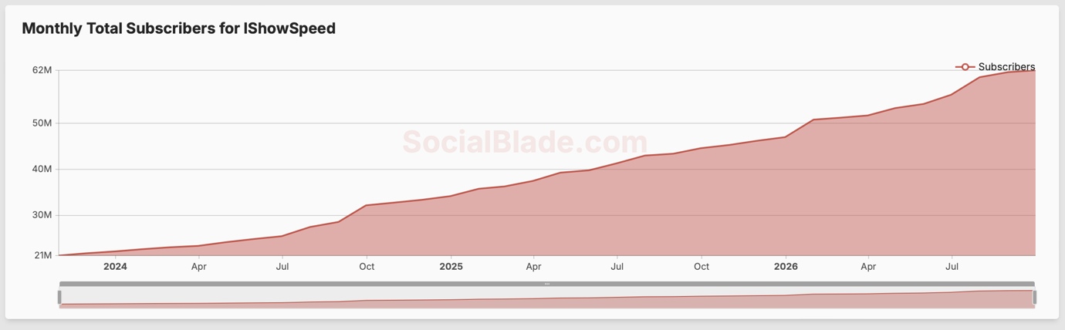
Figure E2.IShowSpeed — monthly gained subscribers (Social Blade, 2024–2026).

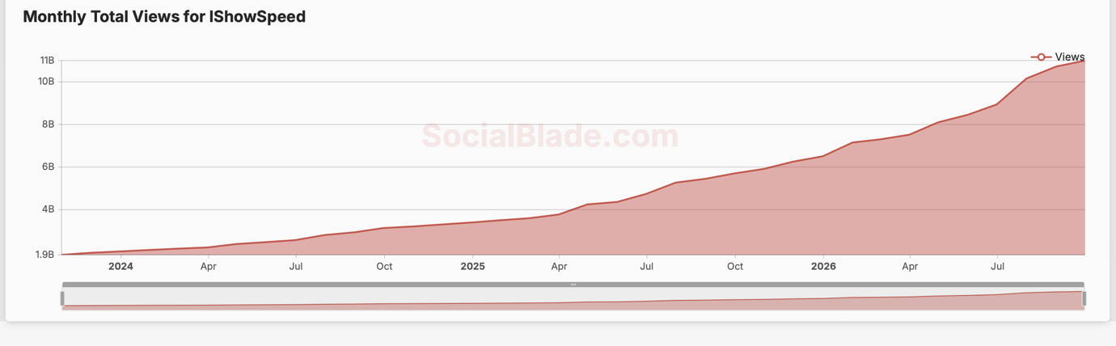

Figure E3.IShowSpeed — Daily income (Social Blade, 10.10.20026-17.10.2026).

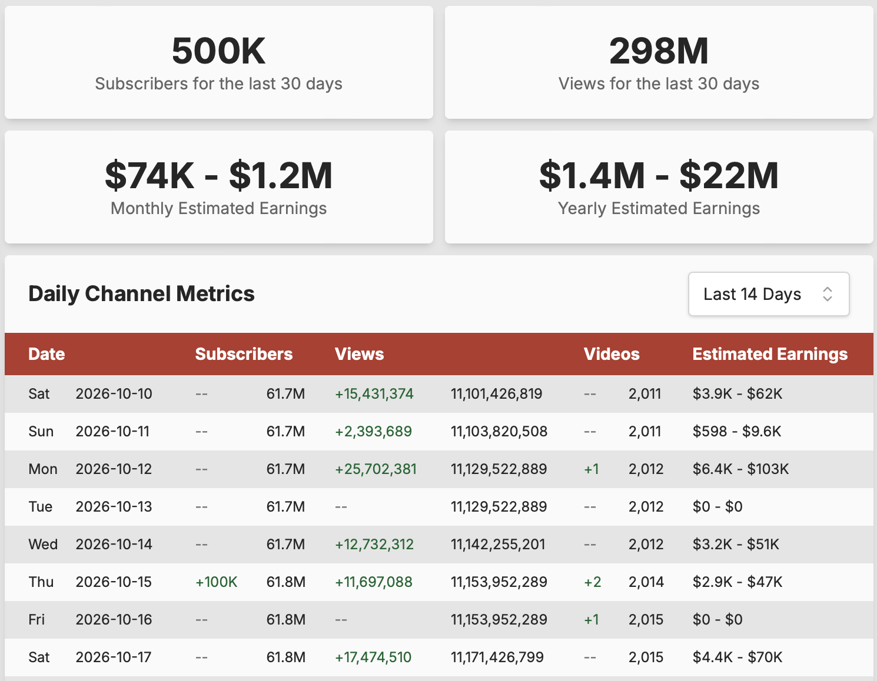

Source: Social Blade (2026), IShowSpeed YouTube statistics, monthly gained, income , views chart; screenshot supplied for this report (accessed 23 October 2026).

Figure E2. Huda Kattan — personal Instagram follower count, October 2026.

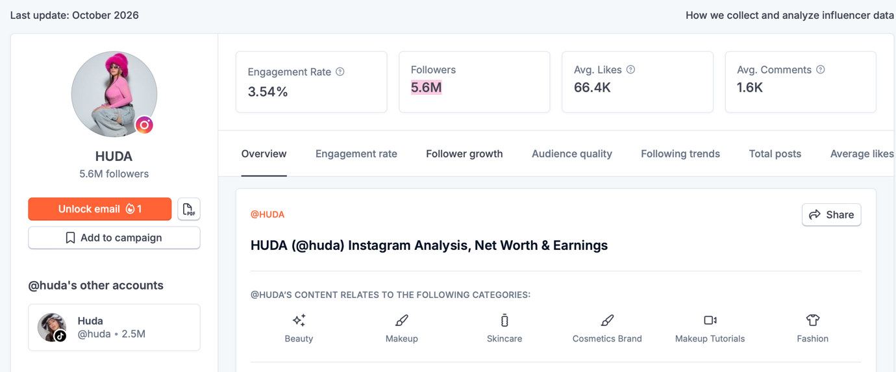

Source: HypeAuditor (2026), historical Instagram follower data for Huda (@huda), accessed 20 October 2026.

Figure E3. The Diary of a CEO .
Source: Social Blade (2026), daily YouTube channel metrics for The Diary of a CEO, accessed 21 October 2026.
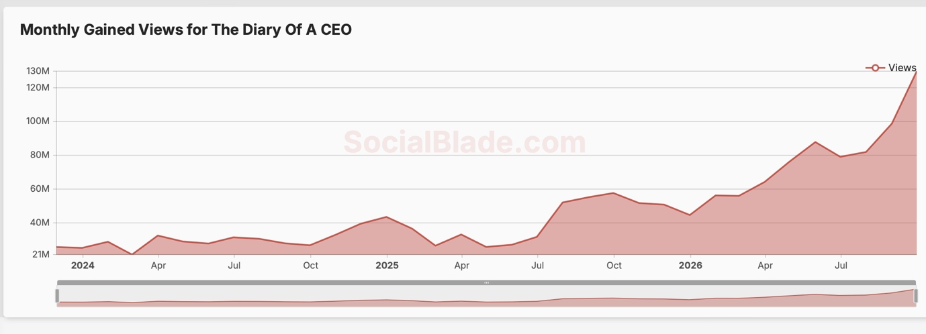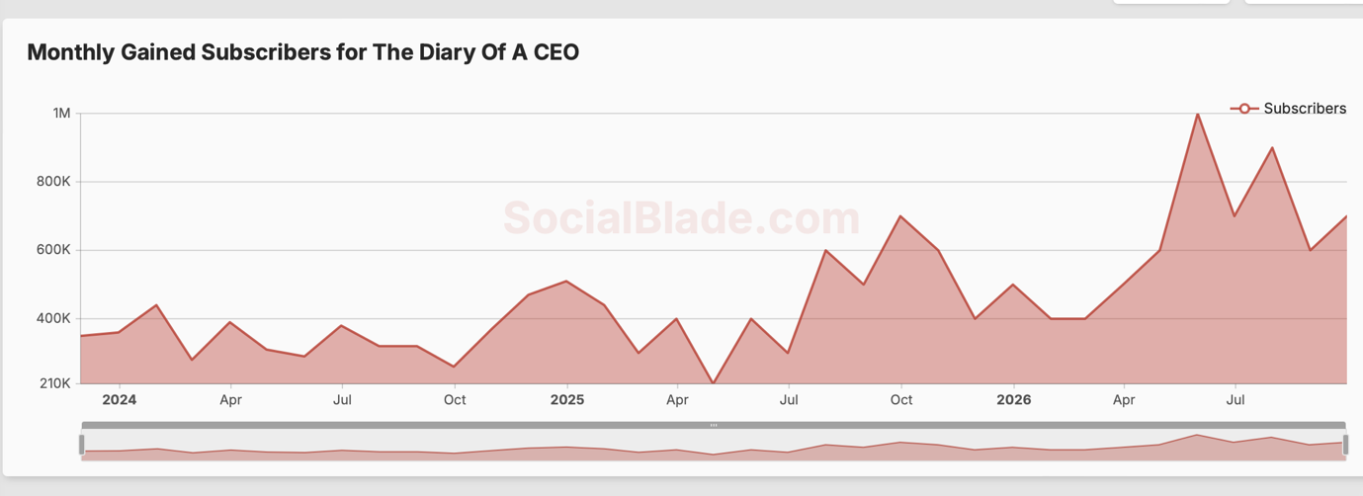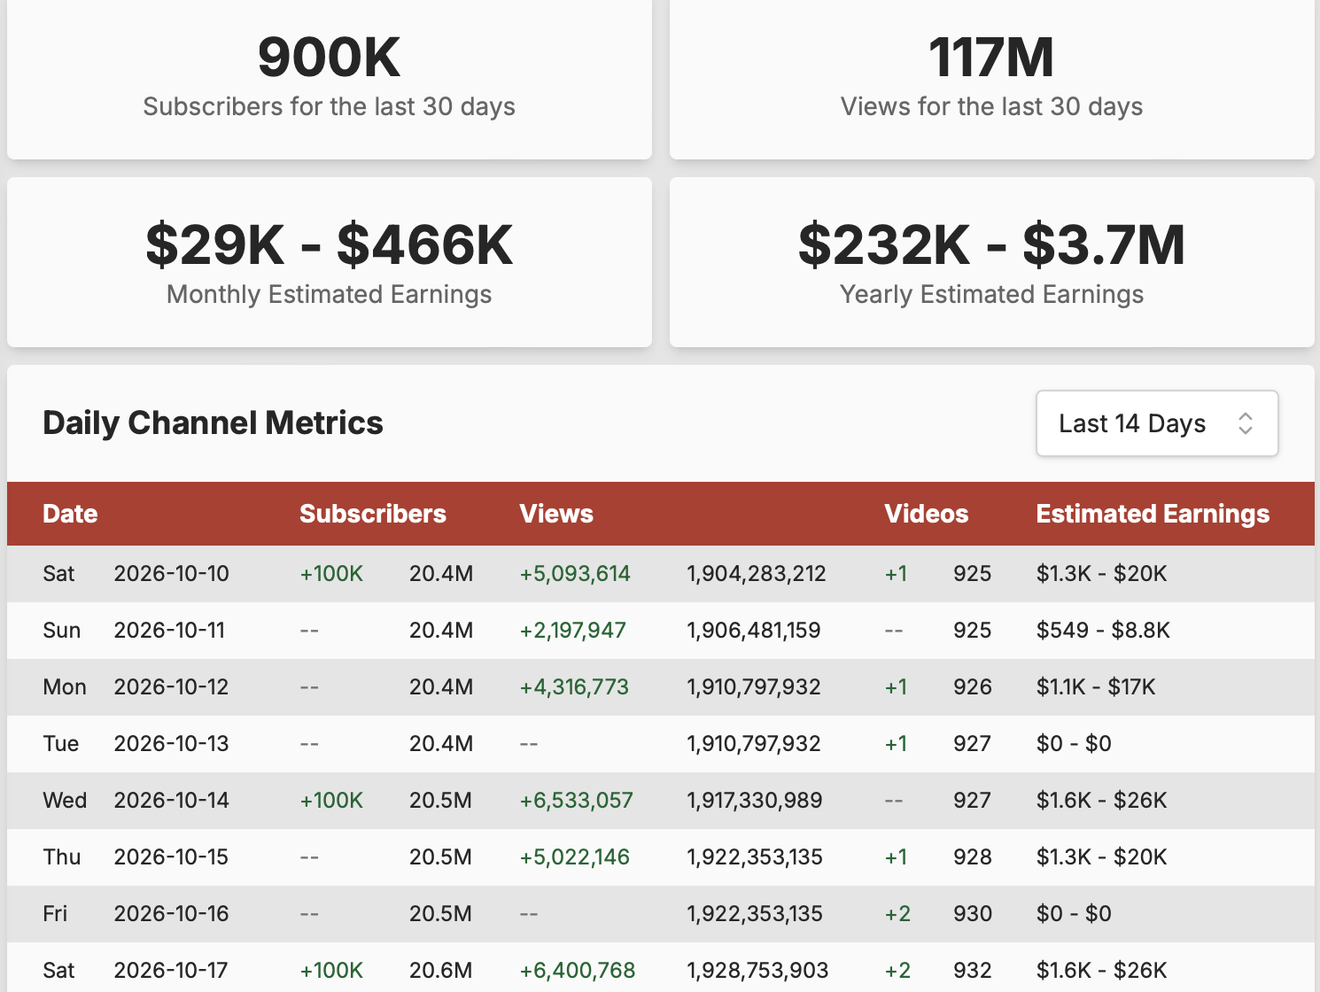
Interpretation: IShowSpeed's figures illustrate entertainment reach; Huda Kattan's personal Instagram figure illustrates the reach of a creator associated with a consumer brand; and Bartlett's YouTube milestone illustrates the scale of a long-form media property. These indicators do not establish relative income, engagement quality or profitability.

Appendix F: Comparison of creator business models

Dimension | IShowSpeeed | Huda Kattan | Steven Bartlett
Principal model | Livestreaming and personality-led entertainment | Beauty content and creator-led consumer brand | Podcasting, media and entrepreneurship
Main source of value | Live interaction, entertainment and shareable moments | Beauty expertise, personal brand and products | Long-form conversations and media distribution
Most relevant STEEPLE factors | Technological, social, ethical and legal | Economic, social, legal and ethical | Technological, economic, legal and ethical
Main vulnerability | Platform visibility and live reputational risk | Product trust, competition and consumer confidence | Platform discovery, audience retention and credibility
Recommended response | Diversify distribution and use live-content safeguards | Protect product quality and develop direct customer relationships | Diversify distribution and maintain editorial standards
Future opportunity | AI-assisted translation and cross-platform clips | Social commerce and owned product channels | Multi-format publishing and international distribution

This comparison applies the industry-wide frameworks to three different creator models. Appendix A identifies the external environment, Appendix B evaluates the industry's strategic position, and Appendix F demonstrates how the same factors can have different implications for individual creators.

