Reflective fieldwork management plan for Dinefwr Park
- Executive Summary
- Introduction
- Management Plan
- .1 Site Overview
- .2 Vision and Objectives
- Evaluation of Conceptual Frameworks
- Impact Evaluation
- Evaluation of Strategies and Practices
- Conclusion
- References

Executive summary
Dinefwr in Llandeilo, Carmarthenshire is a historic house and nature reserve owned by the National Trust where the public can use and enjoy the space. With an increase in outdoor recreation the site has a few challenges regarding the impact on nature, accessibility and development around the site. A management plan will therefore be put in place to help reduce the negative impacts on the landscapes whilst still providing a natural, historical space for the public.

Introduction
A challenge in today’s era is to sustain human wellbeing without destroying the natural environment. With a need to improve health and welling, access to natural spaces is a must. However, according to Shankar and Greenwood (2025), the environmental impacts of tourism are among the most consistently documented concerns, and when combined with growing tourism there are pressures in protected natural areas. This shows the urgent need for effective management and regulation to safeguard ecosystems, wildlife and local communities, ensuring the long-term sustainability of nature-based tourism. This is partially important in the UK because according to Davies and Dutton (2021), the nature-based tourism sector is growing by roughly 10% each year with participation in outdoor activities increasing from 1.2 billion to 1.5 billion visits between 2011 and 2016. Environmental degradation such as footpath erosion, litter, excessive traffic congestion and disturbance to wildlife are all arising issues across the UK.
Site Overview
According to National Trust (2026) Dinefwr Park National Nature Reserve is an 800 acres estate approximately a mile from the centre of Llandeilo in Carmarthenshire, with an 17th century manor house and formal fountain garden with a wild Deer Park (see figure 1). The highest point is occupied by the 12th century Dinefwr Castle enriched with Welsh history. The National Nature Reserve is a Site of Special Scientific Interest (SSSI), known for its ancient trees, rare White Park cattle, medieval deer park and wildlife habitats. The park if managed correctly will be ideal for outdoor recreation due to its expansive historic parkland, wildlife-rich habitats and accessible trails to offer space for walking, cycling, nature watching as well as having a peaceful time in a scenic natural setting. According to Carmarthenshire Council (2026) the Tywi Valley Path is an active-travel initiative creating a safe, accessible 21km walking and cycling route linking Carmarthen and Llandeilo, running through some of Wales’s most scenic countryside. This new cycle path from Carmarthen to Llandeilo will improve accessibility to the park, which may lead to increased visitor numbers. Whereby, challenges may occur as recreational use starts to conflict with conservation priorities, requiring careful management to protect the site’s natural values.
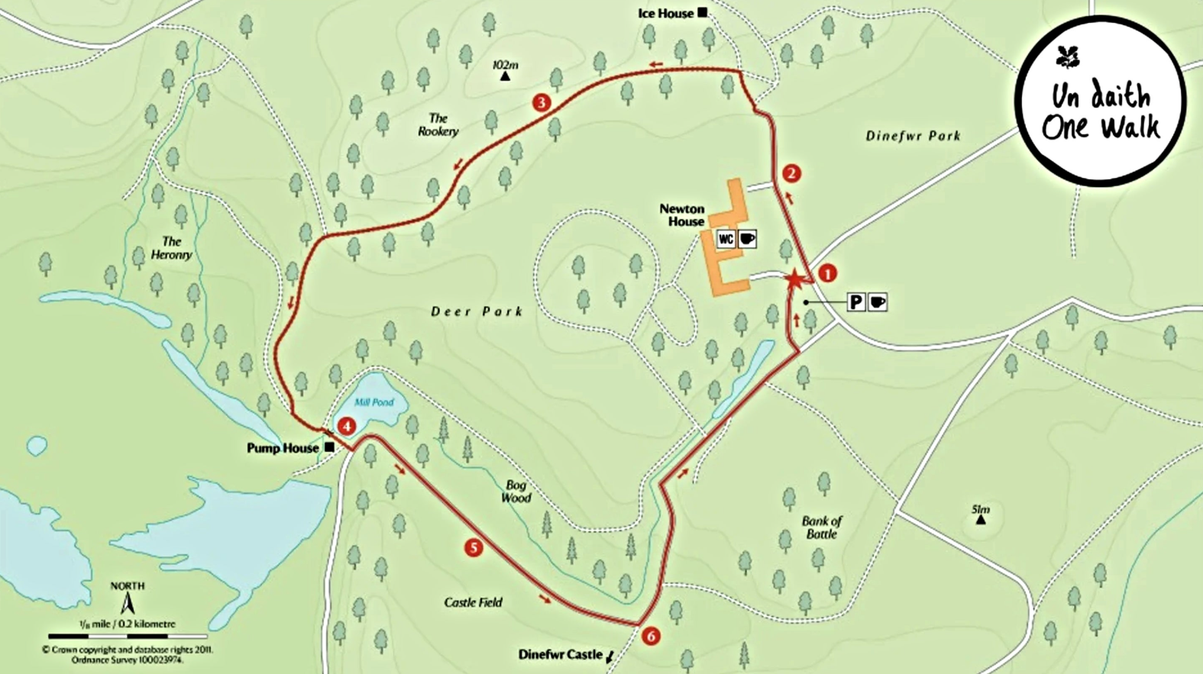
(Figure 1)
The vision and objectives for this site are to conserve Dinefwr Park’s nationally important landscapes and habitats while providing high-quality, low-impact outdoor recreation that connects people with nature. To do safe, enjoyable and clearly waymarked routes will be provided for walking, cycling, wildlife watching, and family-friendly exploration. To promote nature connection and wellbeing, guided activities and quiet restorative spaces will be integrated. Improved accessibility will be needed so that people can experience the parkland without compromising sensitive habitats. Support for sustainable tourism that benefits the local economy while protecting the site’s special qualities is important whilst preserving the unique heritage of the site.
Problems
With this vision there will be a likely increase in the number of visitors and this may come with bigger problems. One of the main issues is visitors straying from designated paths. Boardman (2022) notes that in protected and recreational landscapes, including UK National Parks, footpath erosion and trail degradation are common consequences of high visitor use and organised events. In the UK, long-distance routes frequently experience erosion that requires substantial maintenance, and studies measuring path conditions before and after major walking or running events show how concentrated human activity accelerates surface wear. When people leave marked routes, the problem intensifies, as trampling directly damages vegetation, compacts soil and contributes to wider environmental degradation. Another issue that arose from the site was the increase of litter pollution. According to Lev, Negev and Ayalon (2023) litter pollution affects ecosystems and wildlife by degrading habitat quality and potentially harming animal health, which shows the need for mitigation efforts in protected areas.
The final main challenge that arose was vehicle congestion in the park. Rhodes, et al. (2014) shows that construction and expansion of road networks in such landscapes often lead to habitat fragmentation, increased wildlife mortality, and disruption of ecological connectivity. This is particularly significant as vehicular traffic continues to grow, intensifying pressure on wildlife populations and natural habitats. Therefore 3 main problems were identified.

Visitors straying from paths / mountain bikers creating informal routes

Litter and dog waste

Car park congestion and traffic impacts
This report will look at the solutions to these problems using different management practices strategies and frameworks.

Evaluation of Conceptual Frameworks and Theories
Recreation Opportunity Spectrum (ROS)
The Recreation Opportunity Spectrum (ROS) was selected to guide zoning decisions within the management plan, ensuring that different parts of the site offer recreation experiences that are compatible with their ecological sensitivity and visitor use patterns. According to Park (2008) the Recreation Opportunity Spectrum (ROS) is a framework used to characterize recreation opportunities by categorizing land types according to setting, activity and experience attributes. It provides a continuum of recreation settings ranging from highly developed areas with easy access and basic facilities to more natural, remote and primitive zones. ROS is particularly effective for addressing issues such as visitors straying from paths and the creation of informal mountain-bike routes, as it provides a rationale for designating certain areas as low-intensity, conservation-focused zones while directing higher-intensity activities to more robust locations using infrastructure and signage. Therefore this framework underpins the spatial structure of the plan and ensures that recreation opportunities are matched to the site’s environmental capacity.
Carrying Capacity
Carrying capacity was chosen as it is a concept used to describe the maximum population size or level of activity that an environment can sustain over time without degradation. Manning, Anderson and Pettengill (2017) emphasise that carrying capacity is a fundamental concept in outdoor recreation management, helping planners understand how increasing use can intensify environmental and social impacts. Ecological carrying capacity is particularly relevant to issues such as soil erosion and vegetation loss caused by visitors straying from paths or creating informal cycling routes. Social carrying capacity supports decisions about acceptable levels of crowding, especially in relation to car-park congestion and visitor flow. Physical carrying capacity informs the maximum number of vehicles or visitors that the site’s infrastructure can accommodate.
Limits of Acceptable Change (LAC)
LAC forms the core framework for the management plan because it provides a clear, measurable process for defining objectives, selecting indicators, setting standards, and identifying management actions. This makes it the most effective tool for addressing the site’s key issues such as off-path use, litter, dog waste and car park congestion. However, LAC requires an establishment of indicators such as the number of informal paths, litter counts, dog-waste incidents, or car-park occupancy levels, alongside standards that define the maximum acceptable level of change. When these standards are exceeded, LAC then triggers management responses. “In summary the process requires deciding what kind of wilderness condition are expectable, then prescribing actions to protect or achieve those conditions” (Stankey, 1984). According to Its structured, evidence-based approach Manning, Anderson and Pettengill (2017, p. 6) illustrate the limits of acceptable change through a graph showing that as visitor use increases, environmental impacts rise correspondingly. In their model, an increase in use from X1 to X2 results in impacts escalating from Y1 to Y2.
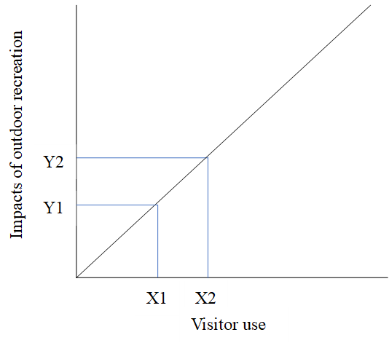
Visitor Experience and Resource Protection (VERP)
VERP was selected for its focus on balancing visitor experience with resource protection, making it particularly effective for issues involving behaviour, crowding, and visitor flow. McKinlay-Jones (2000) demonstrates how the VERP framework was developed and tested at Arches National Park, showing its effectiveness in managing visitor pressures by defining desired conditions and linking them to measurable indicators and management actions. Unlike traditional, simple numerical carrying capacity, VERP focuses on the conditions desired for the park. Therefore, VERP will complement the other frameworks used. It also informs behaviour-change interventions for litter and dog waste, as well as implementing directions to keep visitors on designated paths. This framework therefore strengthens the plan’s ability to address both environmental impacts and visitor satisfaction.

Impacts Evaluation
Resources — Habitat degradation and soil erosion caused by visitors straying from paths, informal mountain‑bike lines, and verge parking, leading to vegetation loss and increased sedimentation.
Intensive visitor use can significantly alter ecological conditions in protected landscapes. A study by Call, Barker and McKell (1981) in the Bryce Canyon National Park, show that intensive visitor use of scenic overlooks produced clear differences between high- and low-use areas, including reduced soil infiltration, and increased sediment runoff, all of which accelerate erosion and landscape recession. Similar vulnerabilities exist at Dinefwr Castle Woods. According to The Wildlife Trust of South and West Wales (N.D) the steep ancient semi-natural woodland is rich in bluebells, dog’s mercury, mosses, lichens and veteran trees which sit on nationally important Ordovician geology. With visitors straying from designated paths, these sensitive areas are at risk of the same compaction and erosion processes observed at Bryce Canyon. This highlights the need for careful path management and visitor guidance to protect Dinefwr’s woodland habitats and maintain the ecological integrity of the site.

Visitor Experience — Reduced quality of visit due to visible litter, dog waste, eroded informal routes, and congestion in the car park, which collectively diminish perceptions of naturalness, cleanliness and tranquillity.
Visitor experience at Dinefwr is shaped by a combination of environmental conditions, site management, and the quality of engagement opportunities available. Kempiak et al. (2017) states that, visitor experience is multifaceted and influenced by factors such as atmosphere, on-site interpretation, audio-visual communication and the preservation of heritage features, with many visitors motivated primarily by recreation and guided by recommendations from friends and family. At Dinefwr, issues such as litter, dog waste, informal path creation, and car park congestion directly undermine these experiential dimensions by reducing perceptions of naturalness, tranquillity and site care. In a landscape where visitors come to enjoy historic parkland and wildlife-rich habitats, these pressures disrupt the immersive qualities and sense of place that are central to a positive visitor experience. As a result, unmanaged impacts risk diminishing visitor satisfaction and weakening the site’s reputation as a high-quality recreational and heritage destination.

Facilities/Services — Increased operational pressure on staff and infrastructure, including higher maintenance needs for paths, more frequent waste management, and additional traffic/parking management during peak periods.
Increasing visitor numbers place substantial pressure on the facilities and services that support Dinefwr’s operation. Higher off-path use increase the maintenance demands on path networks, while litter and dog waste require more frequent waste management, stretching staff capacity during busy periods. Car park congestion and traffic flow issues also intensify during peak times, requiring active management to maintain safe access. As Shackley et al. (1998) highlights, in world heritage sites, effective visitor management must balance the provision of adequate facilities. At Dinefwr, infrastructure must support visitor needs without compromising the historic parkland, ancient woodland, and ecological value of the site. These pressures underscore the need for efficient infrastructure planning and targeted visitor management to maintain service quality while protecting the site’s heritage character.

Strategies and practices
Resources
6c, design facilities to concentrate use on naturally resistant or hardened soils by Manning, Anderson and Pettengill (2017), was chosen because it directly addresses the underlying causes of vegetation loss, soil compaction, and erosion by guiding visitors onto durable surfaces that can withstand high levels of use. This can be done by mowing grass into clear desire lines or reinforcing existing paths so that visitors naturally follow the most resilient routes. As well as this, number 1 Inform visitors of current conditions (i.e., soil compaction, erosion) by Manning, Anderson and Pettengill (2017), was also selected. This was because raising awareness of the site’s sensitivity, encourages responsible behaviour and reduces off-path travel. Together, these practices both shape visitor movement and influence visitor behaviour, providing a combined approach that protects Dinefwr’s vulnerable soils and ground-flora while maintaining access.
Visitor Experience
Improving visitor experience at Dinefwr requires both encouraging responsible behaviour and addressing instances where behaviour negatively affects others. Informing visitors of acceptable and unacceptable behaviour (61b) (Manning, Anderson and Pettengill, 2017) such as staying on paths, keeping dogs under control and not littering helps set clear expectations that support a clean and enjoyable environment. When visitors do not comply, managers may need to escalate to prohibiting depreciative acts (63) (Manning, Anderson and Pettengill, 2017), particularly behaviours such as littering or graffiti that directly undermine the quality of the site. In cases where problems persist, sanctioning inappropriate behaviour (64b) (Manning, Anderson and Pettengill, 2017), through warnings or fines provides a stronger deterrent and reinforces the importance of protecting both the environment and the visitor experience. Together, these practices help maintain the sense of care, cleanliness and respect.
Facilities/Services
Zoning alternative areas for higher use (89) (Manning, Anderson and Pettengill, 2017) is an effective way to relieve pressure on Dinefwr’s core heritage and ecological zones by directing visitors towards locations better suited to accommodate higher levels of activity, such as expanded or redesigned car-parking areas. Complementing this, improving attractions, facilities and services in these alternative areas (54a) (Manning, Anderson and Pettengill, 2017) will help by providing additional bins, toilets and cafés. This will draw visitors away from sensitive historic and cultural features while still meeting their needs. Together, these practices increase the site’s ability to absorb visitor numbers without compromising the integrity of its most valued resources, ensuring that operational pressures are managed while protecting Dinefwr’s heritage.

Objective | Indicator | Standard | Practice
Maintain healthy vegetation and minimise soil erosion caused by visitors straying from paths. | Percentage vegetation loss and visible soil exposure within 2 m of designated paths; number of new off-piece routes. | Bare soil exposure; no new off-piece routes forming. | Close and redirect off-piece tracks; improve path surfacing/drainage; install signage and light barriers to keep visitors on designated routes.
Ensure a high-quality visitor experience by reducing litter, dog waste and visual degradation. | Number of litter/dogs-waste incidents per week; visitor satisfaction scores relating to cleanliness and naturalness. | Litter/dog-waste incidents <5 per week; visitor satisfaction >80%. | Increase bins; run volunteer clean-ups; improve visitor signs; promote responsible dog-owner behaviour.
Maintain efficient functioning of parking and access to reduce congestion. | Car park occupancy levels; duration of congestion periods. | Car park occupancy not exceeding 90%; zero verge-parking. | Implement overflow parking attendant; redesign traffic flow; provide real-time parking information; promote alternative transport modes.

Conclusion
This management plan for Dinefwr demonstrates the need for an approach that balances conservation priorities with high-quality recreational opportunities. The assessment of current conditions shows that increasing visitor pressures are contributing to resource degradation, declining visitor experiences and growing operational demands on facilities and services. Issues such as soil erosion, vegetation loss, informal path creation, litter, dog waste and car park congestion highlight the nature of these challenges and the importance of addressing them through an evidence-based strategy. By applying established frameworks and management practices, the plan provides targeted interventions that protect Dinefwr’s heritage and ecological value while maintaining accessibility to the park. Together, these measures support a sustainable future for the site, ensuring that Dinefwr continues to offer meaningful recreational, cultural and educational experiences without compromising the integrity of its historic landscapes and ancient woodland habitats.
Word count: 2566

References
Boardman, J. (2022) ‘Footpath erosion: assessment, extent and impacts with especial reference to the UK’, Geography, 107(2), pp. 60–69. Available at: https://doi.org/10.1080/00167487.2022.2068836.
Call, C.A., Barker, J.R. and McKell, C.M. (1981) ‘Visitor impact assessment of scenic view areas at Bryce Canyon National Park’, Journal of Soil and Water Conservation, 36(1), pp. 50–53. Available at: https://doi.org/10.1080/00224561.1981.12436076.
Carmarthenshire Council (2026) Tywi Valley Path. Available at: https://www.carmarthenshire.gov.wales/business/development-and-investment/tywi-valley-path/ (Accessed: 29 April 2026).
Davies, B. and Dutton, M. (2021) Tourism and outdoor leisure accounts, natural capital, UK: 2021. Office for National Statistics. Available at: https://www.ons.gov.uk/economy/environmentalaccounts/bulletins/tourismandoutdoorleisureaccountsnaturalcapitaluk/2021#main-points (Accessed: 29 April 2026).
Kempiak, J., Hollywood, L., Bolan, P. and McMahon-Beattie, U. (2017) ‘The heritage tourist: an understanding of the visitor experience at heritage attractions’, International Journal of Heritage Studies, 23(4), pp. 375–392. Available at: https://doi.org/10.1080/13527258.2016.1277776.
Lev, N., Negev, M. and Ayalon, O. (2023) ‘Sometimes Littering Is Acceptable—Understanding and Addressing Littering Perceptions in Natural Settings’, Sustainability, 15(18), p. 13784. Available at: https://doi.org/10.3390/su151813784.
Manning, R.E., Anderson, L.E. and Pettengill, P.R. (2017) Managing Outdoor Recreation: Case Studies in the National Parks. Wallingford: CABI.
McKinlay-Jones, K.M. (2000) Cows, crowds and carrying capacities: Developing and testing the Visitor Experience and Resource Protection (VERP) process at Arches National Park. PhD thesis. ProQuest Dissertations & Theses.
National Trust (2026) Dinefwr. Available at: https://www.nationaltrust.org.uk/visit/wales/dinefwr (Accessed: 29 April 2026).
National Trust (2026) Parkland at Dinefwr. Available at: https://www.nationaltrust.org.uk/visit/wales/dinefwr/parkland-at-dinefwr (Accessed: 29 April 2026).
Park, C. (2008) ‘Recreation Opportunity Spectrum (ROS)’, in A Dictionary of Environment and Conservation. Oxford: Oxford University Press.
Rhodes, J.R., Lunney, D., Callaghan, J. and McAlpine, C.A. (2014) ‘A Few Large Roads or Many Small Ones? How to Accommodate Growth in Vehicle Numbers to Minimise Impacts on Wildlife’, PLOS ONE, 9(3), p. e91093. Available at: https://doi.org/10.1371/journal.pone.0091093.
Shankar, S. and Greenwood, S. (2025) ‘Understanding tourism’s environmental, social, and economic impacts through systematic literature mapping’, Tourism and Hospitality Research [Preprint]. Available at: https://doi.org/10.1177/14673584251356792.
Shackley, M.L., Cole, D.N., Lucas, R.C., Petersen, M.E. and Frissell, S.S. (1998) Visitor Management: Case Studies from World Heritage Sites. Oxford: Butterworth-Heinemann. Available at: https://doi.org/10.4324/9780080520681.
Stankey, G.H. (1984) The Limits of Acceptable Change (LAC) System for Wilderness Planning. USDA Forest Service, Intermountain Forest and Range Experiment Station.
The Wildlife Trust of South and West Wales (n.d.) Dinefwr/Dynefor Castle Woods, Llandeilo https://www.welshwildlife.org/nature-reserves/dinefwrdynefor-castle-woods-llandeilo (Accessed: 29 April 2026).

