Programme: BA (Hons) International Hotel Management
Module code: BMIH5006
Assignment Title: Report
Module title and code (BMIH5006: Sustainable Hospitality & Tourism Management)
Flying Towards Sustainability: Challenges and Solutions in Hospitality-Linked Aviation
Lecturer: Christopher Wilkin
Student Name: Vasile Puscuta
Student ID: 2233417
Word: 2017

Declaration:

I declare that I have not used AI tools in the creation of this assignment, and I confirm that I have not presented any AI generated materials as my own work.

Executive Summary
This report explores the environmental and social challenges posed by commercial aviation within the hospitality industry and presents potential solutions to support sustainable travel. In connecting overseas tourists with hospitality services, air travel largely contributes to international tourism, economic development, and cultural exchange. But on the flip side are the huge environmental costs it runs away with, such as emissions of carbon dioxide (CO₂) and nitrogen oxides (NOₓ) that lead to climate change, air pollution, and noise-related health problems. Although aviation accounts for about 2.5% of CO₂ emissions worldwide, with non-CO₂ impacts who`s combined are equally significant, its entire contribution to climate change ranges somewhere between 4 and 5%.
The existing obstacles that would impede the sustainability of the industry encompass notable reliance on fossil fuels, slow evolution of regulations, and high cost of green technologies. Meanwhile, newer solutions are now arising, including SAF (Sustainable Aviation Fuel), more efficient airframes (e.g., Airbus A350 and Boeing 787), and carbon offsets. All of these measures are directed toward lessening the environmental pressure caused by aviation. In a sustainable way with greener technologies, the aviation and hotel industries could seize environmental opportunities of consequence.

Table of Contents

1. Introduction 5
2. Main Findings 5
2.1 Role of Air Travel in the Hospitality Industry 5
2.2 Environmental Impact of Air Travel 6
2.3 Social and Economic Impacts 7
2.4 Challenges in Achieving Sustainability in Aviation 8
2.5 Solutions and Innovations 9
2.6 Hospitality Sector Response & Responsibility 9
3. Conclusion & Recommendations 10
Reference list 12

1. Introduction
Hospitality transport refers to the various modes of travel used by guests and tourists to reach hospitality destinations such as hotels, resorts, or event venues. It is very important for tourism around the world since it supports the movement of people from one location to another. The growth and stability of the hospitality industry depend largely on good and accessible transportation, since these systems determine how effortless it is for tourists to travel.
Air Travel (Commercial Aviation) has been chosen as the main form of transport for the hospitality industry. Many international tourists want to use commercial aviation to get from one far-off area to another quickly. It helps travellers reach their destinations quickly, which encourages people from other countries to take part in global tourism by visiting hotels and other hospitality businesses. Packages that combine air transportation with accommodation bookings are often offered nowadays in the industry. Though it is key to many lives, air travel causes a lot of concern for the environment. This document is designed to assess how commercial aviation harms the environment, mainly in relation to the hospitality industry. Next, the text will present solutions applied by companies in the industry and use examples to explain the process.

2. Main Findings

2.1 Role of Air Travel in the Hospitality Industry
The global hospitality and tourism industry relies a lot on air travel to expand and remain active. By enabling reservations, it allows many travellers to visit places around the world and tourists from every corner to reach popular destinations. Having air connections is critical for international hospitality firms in exclusive areas to invite visitors from other countries and boost their incomes (Cooper et al., 2021). Because it has made travelling across great distances safer and more comfortable, aviation helps make international hotels adjust to a global market.
The growth of global tourism has always been near to the rise in commercial aviation. According to the International Air Transport Association (IATA), from 2019’s 4.5 billion passengers to 8 billion in 2040 is the number of passengers that are projected (Rasel, 2024). The growth in air travel reflects the fact that it is now cheaper, more airlines are in the market, and the necessary facilities have improved. When incomes rise worldwide and the middle class gets bigger, especially in emerging countries, people take more trips and use air services and hotels, increasing the demand for them.
In addition, it is air travel that allows participants from different countries to take part in major events, festivals, conferences, and cultural exchanges. Travel packages that help customers save time are offered by airline and hospitality businesses as they work together to provide flight, hotel stay, and transport services (Sloan et al., 2017). Since air travel is essential, the aviation and hospitality sectors depend on each other. Still, this level of tourism brings sustainability issues, and they have to be solved to guarantee the future of the industry with as little damage to nature as possible.
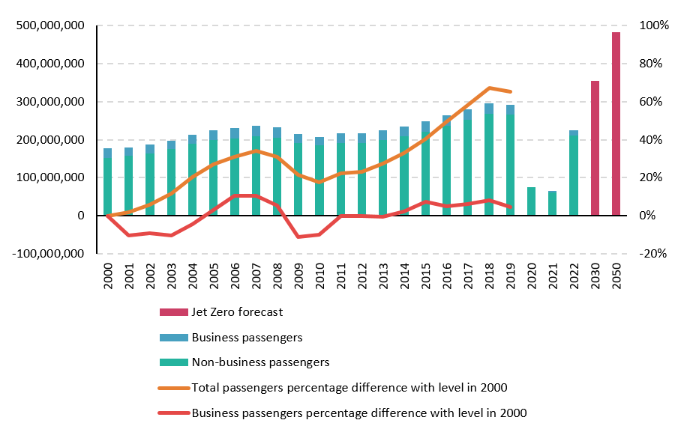
Figure 1: Air travel fails to increase UK productivity
(Source: New Economics Foundation, 2023)

2.2 Environmental Impact of Air Travel
A lot of the environmental problems worldwide come from air travel, mainly because of GHG emissions, noise pollution, and chemical changes in the air. Commercial flying was the source of 950 Mt of CO₂ emissions as estimated by the International Energy Agency (IEA, 2023), making up around 2.5% of the total CO₂ emissions from energy. Aviation’s climate effect is a lot bigger than it first seems when we include emissions other than CO₂ (Khatter, 2023). The engines in aeroplanes release nitrogen oxides (NOx) at high altitudes, which play a role in developing ozone and reducing methane, which adds to warming the atmosphere. It has been suggested by studies that aeroplane exhausts, besides CO₂, such as contrails and particles, can raise the aviation sector’s part in global warming to 4–5% (Rasel, 2024). For this reason, aviation contributes greatly to the rapid growth of climate change.
Besides polluting the air, the noise from aeroplanes flying nearby has turned into a serious issue in the areas around airports. It interrupts sleep, lowers one’s quality of life, and raises the chances of getting problems with the heart. It is expected that the number of people noticing serious aviation noise is going to increase from 24 million in 2000 to over 30 million by 2025 (Legrand et al., 2022). As aircraft have used less fuel in the past 50 years by about 70 per cent per person-kilometre, the rising demand has ensured that the total fuel used is higher than ever (Gursoy et al., 2022). In other words, commercial aviation causes a lot of environmental problems that affect the industry’s aim for sustainability.
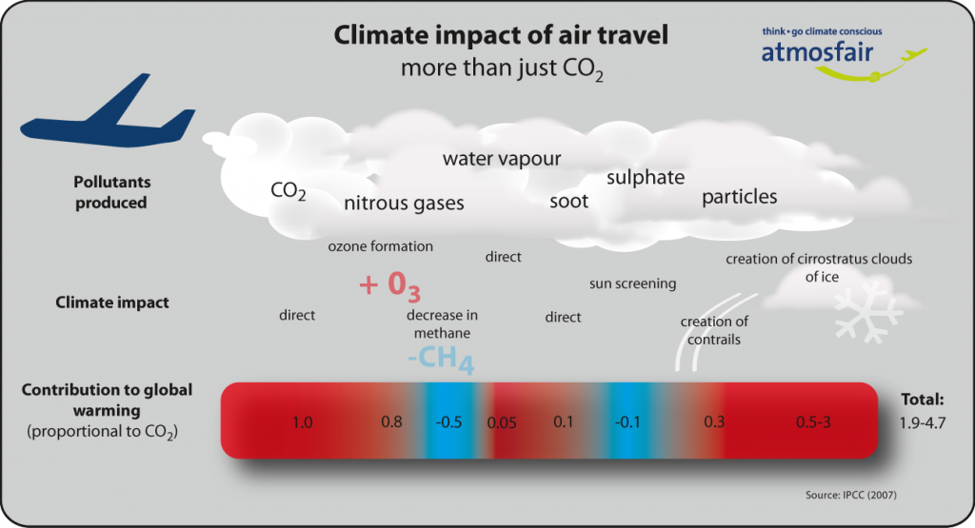
Figure 2: The impact of air travel on the climate
(Source: atmosfair, 2023)

2.3 Social and Economic Impacts
Travel by air is very important for the growth of the hospitality and tourism industry. It makes tourism possible across countries, encourages investors from abroad, and supports millions of people globally with employment. It is reported by the Air Transport Action Group (ATAG) that aviation creates over 87.7 million jobs across the world and brings in about $3.5 trillion to global GDP (Elkhwesky et al., 2024). Hospitality businesses such as hotels, resorts, and travel agencies rely on air travel to make their services available, encourage more guests, and maintain good customer flow. These benefits to the economy have generated big environmental troubles. Flying activities in the aviation industry contribute a lot to greenhouse gases, global warming, and noise problems. Even though these expenses are global, their results hurt people the most in areas that fly less (Peeters and Papp, 2024). A lot of these regions, mainly in developing countries, are already at risk from climate disasters like flooding, drought, and a reduction in biodiversity, and it is aviation that makes these challenges worse.
People do not all benefit equally from air travel (Kim et al., 2025). Most of the world’s aeroplane flights are taken by only a small share of the population. In comparison, it is often these social groups that experience the negative impacts of environmental troubles such as higher temperatures and ecological damage. Because these areas generally lack what they need to deal with new changes in the environment, the global inequality issue becomes more severe (Elkhwesky et al., 2022). Although commercial aviation contributes to the hospitality industry’s profits, it also causes more harm to the environment and social groups.

2.4 Challenges in Achieving Sustainability in Aviation
Being environmentally sustainable in aviation is not easy, as it is mainly affected by the large use of fossil fuels, slower adjustments among regulators, and the price of switching to new technologies. The use of fossil fuel in aviation is heavy, and it is hard to come up with renewable alternatives that can be used on a large scale (Meo et al., 2022). Whereas electric vehicles on the road are becoming an option, powering aeroplanes with electricity or hydrogen is still not ready for flying far enough for commercial operations. A major challenge to sustainability is that regulations are sometimes changed very slowly (El Atiek and Goutte, 2023). Aviation across the world involves various countries and, therefore, is managed by international bodies such as the International Civil Aviation Organisation (ICAO). Creating tough and effective sustainability standards takes time since there are many disagreements between politics, economics, and national interests (Das et al., 2023). This style of governance reduces the effect of policies meant to cut down on emissions or use sustainable fuels.
Adding to these problems, the cost of innovation is especially high at the moment. Sustainable Aviation Fuels are able to cut lifecycle emissions by up to 80%, however, they cost about two to four times more than the current jet fuel. To introduce electric propulsion and advanced aircraft designs, much research and money are needed, making it hard for small carriers (Abdelmoety et al., 2022). In addition, converting older fleets into green models requires a lot of downtime and costs a great deal of money
.

2.5 Solutions and Innovations
Owing to the environmental impacts borne by aviation, several measures have been undertaken with various innovative solutions designed to reduce carbon emissions and/or increase operational efficiencies of some kind. Pushed to the forefront is the acceptance of SAFs. These fuels originate from renewable sources such as waste oils or agricultural residues and reduce lifecycle emissions of carbon by approximately 80% when compared to conventional jet fuel (Vatankhah et al., 2024). Big airlines such as British Airways and KLM have started using SAF in some flights, but its usage remains limited due to cost and supply-chain drawbacks.
Offsetting presents another measure that acts practically. The program enables airlines and passengers to fund environmental projects, such as reforestation or renewable energy, in return for emissions generated during flights. Offsetting does not halt emissions at the source but acts to compensate for their impacts and also creates environmental awareness among consumers (Guden et al., 2021). Voluntary offset programs by airlines Qantas and Lufthansa have been taken up and are integrated into their booking systems.

2.6 Hospitality Sector Response & Responsibility
Influencing people to stay green makes hospitality an important ally for sustainable travel. For their part, hotels, travel operators, and Destination Management Organisations (DMOs) should help lessen aviation issues by highlighting eco-friendly travel choices and harmonious services. People should be encouraged to use sustainable ways to travel short distances. Organisations like tour operators and hotels can coordinate with railways to provide inclusive trips that are not based on short-haul flights (Leal Filho et al., 2023). Because rail systems in Europe are advanced, those who wish to protect the environment find these alternatives attractive (Ahmed et al., 2021). For instance, Deutsche Bahn works with various hotel partners to supply special train and stay prices that reduce pollution and don’t affect the level of comfort.
Hotels and travel agencies can include carbon offset programs in the services they provide. Together with trusted offset organisations, hotels and other companies in the hospitality industry give their clients the option to help the environment by supporting nature-based or energy projects. They educate tourists and encourage all to play their part in keeping tourism sustainable, and let the industry achieve its ecological goals (Salem et al., 2023). DMOs may guide regional planning of tourism by encouraging eco-friendly sites, increasing the availability of public transport, and helping with green certifications. Public campaigns that highlight eco-friendly means of transport and places to stay may lead more people to choose earth-friendly ways. Besides, informing your employees and travellers about how to support sustainability can encourage lasting change (Dasgupta and Jamader, 2024).

3. Conclusion & Recommendations
This report has examined significant environmental, social, and economic concerns surrounding commercial aviation in the domain of hospitality. Global tourism and economic growth, by extension, are made possible by air transportation, which also poses serious threats to climate change, air pollution, and inequality. The chief barriers to sustainability were, firstly, the fossil-fuel dependency of the industry; secondly, laziness on the part of regulatory bodies in imposing progressive measures; and thirdly, the enormous costs of innovation. However, newer solutions in the shape of Sustainable Aviation Fuel (SAF), carbon offsetting, and aircraft optimisations are paving the way for change. The hospitality domain can foster responsible travel behaviour and hence must actively tie up with aviation stakeholders for the cause of global sustainability.
Recommendations
- Promote Policy Advocacy: Governments should be persuaded to impose tougher emission regulations and build infrastructural support for sustainable aviation technology (Dube, 2021).
- Invest in SAF Development: Invest more in initiatives and partnerships to increase the scale of production and bring down the costs of Sustainable Aviation Fuel.
- Offer Green Travel Packages: Work jointly with rail operators and airlines to promote low-emission, sustainable travel options for short-distance travel (Tan et al., 2024).
- Enhance Consumer Education: Use marketing, staff training, and in-hotel communication to promote sustainable choices among travellers and guests.
- Implement Carbon Offset Programs: Integrate offsetting options into hotel bookings and tour packages to raise consumer awareness and reduce net emissions (Berjozkina and Karami, 2021).

Reference list
Abdelmoety, Z. H., Alamoudi, H., Alharthi, M., Sharkasi, N., and Agag, G. (2022). Ensuring a sustainable hospitality and tourism industry in the COVID-19 era: Using an open market valuation technique. Sustainability, 14(20), 13190. https://www.mdpi.com/2071-1050/14/20/13190
Ahmed, M. F., Mokhtar, M. B., Lim, C. K., Hooi, A. W. K., and Lee, K. E. (2021). Leadership roles for sustainable development: The case of a Malaysian green hotel. Sustainability, 13(18), 10260. https://www.mdpi.com/2071-1050/13/18/10260
atmosfair. (2023). The impact of air travel on our climate - atmosfair. [online] Available at: https://www.atmosfair.de/en/air_travel_and_climate/flugverkehr_und_klima/climate_impact_air_traffic/ [Accessed 10 Jun. 2025].
Berjozkina, G., and Karami, R. (2021). 3D printing in tourism: an answer to sustainability challenges?. Worldwide Hospitality and Tourism Themes, 13(6), 773-788. https://www.emerald.com/insight/content/doi/10.1108/whatt-07-2021-0100/full/html
Cooper, C. (2021) Essentials of tourism. Third edition. London: SAGE.
Das, S., Nayak, J., and Naik, B. (2023). An impact study on Covid-19 and tourism sustainability: intelligent solutions, issues and future challenges. World Review of Science, Technology and Sustainable Development, 19(1-2), 92-119. https://www.inderscienceonline.com/doi/abs/10.1504/WRSTSD.2023.127268
Dasgupta, D. S., and Jamader, A. R. (2024). Revolutionizing Tourism and Hospitality: Harnessing AI for Sustainable Transformation. Available at SSRN 4896697. https://papers.ssrn.com/sol3/papers.cfm?abstract_id=4896697
Dube, K. (2021). Sustainable development goals localisation in the hospitality sector in Botswana and Zimbabwe. Sustainability, 13(15), 8457. https://www.mdpi.com/2071-1050/13/15/8457
El Atiek, S., and Goutte, S. (2023). Impacts, sustainability, and resilience on the Egyptian tourism and hospitality industry after the Russian airplane crash in 2015. Research in International Business and Finance, 64, 101866. https://www.sciencedirect.com/science/article/pii/S0275531922002525
Elkhwesky, Z., El Manzani, Y., and Elbayoumi Salem, I. (2024). Driving hospitality and tourism to foster sustainable innovation: A systematic review of COVID-19-related studies and practical implications in the digital era. Tourism and Hospitality Research, 24(1), 115-133. https://journals.sagepub.com/doi/abs/10.1177/14673584221126792
Elkhwesky, Z., Salem, I. E., Varmus, M., and Ramkissoon, H. (2022). Sustainable practices in hospitality pre and amid COVID‐19 pandemic: Looking back for moving forward post‐COVID‐19. Sustainable Development, 30(5), 1426-1448. https://onlinelibrary.wiley.com/doi/abs/10.1002/sd.2304
Guden, N., Unal Girgen, M., Saner, T., and Yesilpinar, E. (2021). Barriers to sustainable tourism for small hotels in small island developing states and some suggested remedies. Worldwide Hospitality and Tourism Themes, 13(4), 510-521. https://www.emerald.com/insight/content/doi/10.1108/WHATT-02-2021-0032/full/html
Gursoy, D., Malodia, S., and Dhir, A. (2022). The metaverse in the hospitality and tourism industry: An overview of current trends and future research directions. Journal of Hospitality Marketing and Management, 31(5), 527-534. https://www.tandfonline.com/doi/abs/10.1080/19368623.2022.2072504
Haski-Leventhal, D. (2018) Strategic corporate social responsibility : tools & theories for responsible management. London: SAGE.
Khatter, A. (2023). Challenges and solutions for environmental sustainability in the hospitality sector. Sustainability, 15(15), 11491. https://www.mdpi.com/2071-1050/15/15/11491
Kim, H., So, K. K. F., Shin, S., and Li, J. (2025). Artificial intelligence in hospitality and tourism: Insights from industry practices, research literature, and expert opinions. Journal of Hospitality and Tourism Research, 49(2), 366-385. https://journals.sagepub.com/doi/abs/10.1177/10963480241229235
Leal Filho, W., Ng, A. W., Sharifi, A., Janová, J., Özuyar, P. G., Hemani, C., ... and Rampasso, I. (2023). Global tourism, climate change and energy sustainability: assessing carbon reduction mitigating measures from the aviation industry. Sustainability science, 18(2), 983-996. https://link.springer.com/article/10.1007/s11625-022-01207-x?mf_ct_campaign=yahoo-synd-feed
Legrand, W., Chen, J. S., and Laeis, G. C. (2022). Sustainability in the hospitality industry: Principles of sustainable operations. Routledge. https://www.taylorfrancis.com/books/mono/10.4324/9781003081128/sustainability-hospitality-industry-willy-legrand-joseph-chen-gabriel-laeis
Meo, M. S., Kanwal, S., Ali, S., Karim, M. Z. A., and Kamboh, A. Z. (2022). The future and challenges of applying innovative technologies in the tourism and hospitality industry in Asia. In Handbook of Technology Application in Tourism in Asia (pp. 1287-1298). Singapore: Springer Nature Singapore. https://link.springer.com/content/pdf/10.1007/978-981-16-2210-6_58.pdf
New Economics Foundation. (2023). Boom in air travel fails to increase UK productivity or GDP growth. [online] Available at: https://neweconomics.org/2023/07/boom-in-air-travel-fails-to-increase-uk-productivity-or-gdp-growth [Accessed 10 Jun. 2025].
Peeters, P., and Papp, B. (2024). Pathway to zero emissions in global tourism: opportunities, challenges, and implications. Journal of Sustainable Tourism, 32(9), 1784-1810. https://www.tandfonline.com/doi/abs/10.1080/09669582.2024.2367513
Rasel, M. A. B. (2024). Navigating Sustainability In the Tourism and Hospitality Industry: Transformation Under the Influence of Climatic Challenges. SocioEconomic Challenges, 8(4), 112-120. https://armgpublishing.com/journals/sec/volume-8-issue-4/article-7/
Salem, I. E., Abbas, H., Akram, H. W., and Elbaz, A. M. (2023). Contemporary sustainability themes in tourism and hospitality during and post COVID‐19: Critical review and a step strategies forward for post the pandemic. Sustainable Development, 31(5), 3946-3964. https://onlinelibrary.wiley.com/doi/abs/10.1002/sd.2636
Sloan, P., Legrand, W. and Chen, J.S. (2017) Sustainability in the hospitality industry : principles of sustainable operations. 3rd edn. London: Butterworth-Heinemann.
Sustainability Management in the Event Sector. Event
Tan, K. L., Gim, G. C., Hii, I. S., and Zhu, W. (2024). STARA fight or flight: a two-wave time-lagged study of challenge and hindrance appraisal of STARA awareness on basic psychological needs and individual competitiveness productivity among hospitality employees. Current Issues in Tourism, 27(13), 2151-2169. https://www.tandfonline.com/doi/abs/10.1080/13683500.2023.2224550
Vatankhah, S., Fejes, O. F., Karatepe, O. M., and Nosrati, S. (2024). Fly green: environmentally specific servant leadership and its impact on green performance outcomes. Current Issues in Tourism, 27(24), 4594-4609. https://www.tandfonline.com/doi/abs/10.1080/13683500.2023.2288664
Wickham, Donnelly, T., and French, L. (2021). Strategic Management Association. (2018). Sustainable Tourism. IGI Management, 25(3), 279–296.

