Student Name: Joyce Gibson Missa

Student ID 2419636

Programme: BSc Health and Social Care

Assignment Title: Component 2: Written
Assignment (Report)

Lecturer Name: Zarah Ahmed

Module: Creativity and Value Creation

Module Code: BMHP5014

Submission deadline: Sunday 19th July
2026

Word count- 2000

Task I. Poster

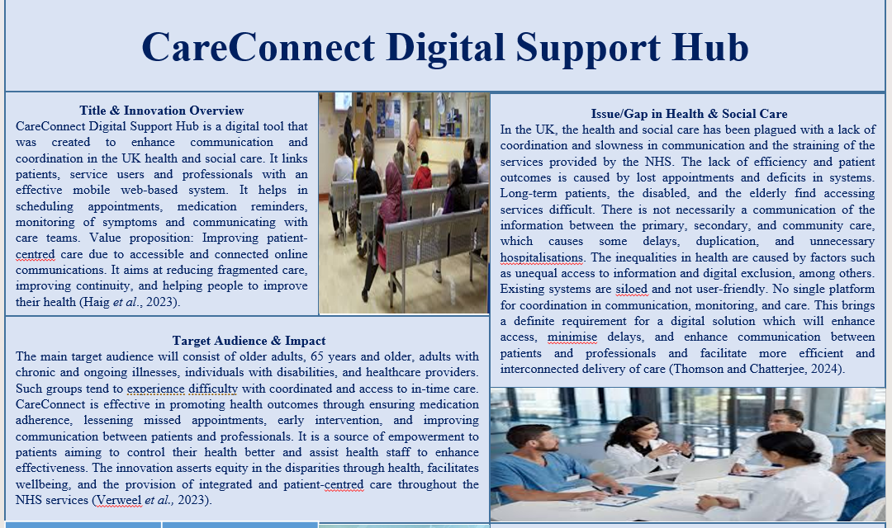
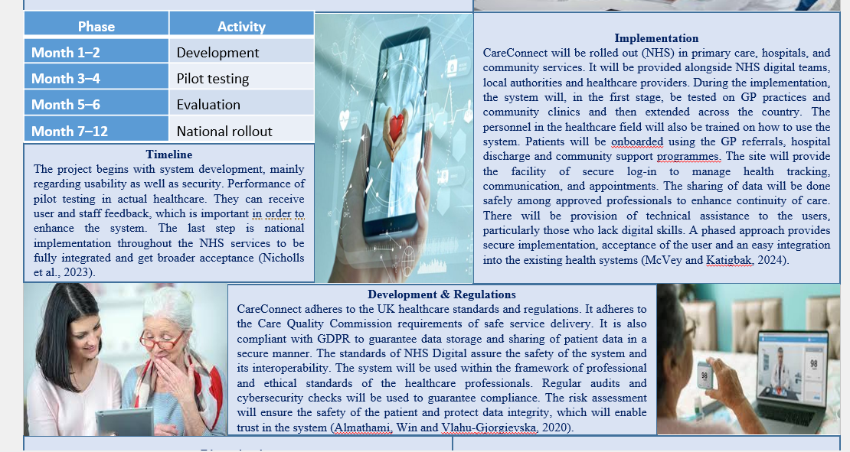
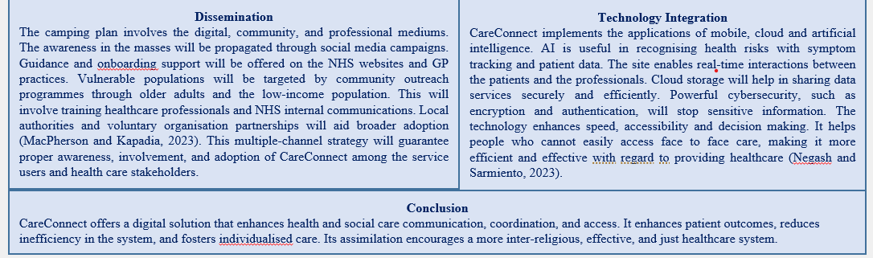

Task II. Pitch

CareConnect Digital Support Hub
My proposal is a new digital health and social care product called CareConnect Digital Support Hub that can solve a severe and continuing problem in the UK healthcare system: the lack of communication, queues, and inefficient coordination among the NHS services. This is usually accompanied by late treatment, absence of visits, and patient problems, especially patients with chronic illness, people with disabilities, and the elderly (Taylor et al., 2022). Currently, patients cannot easily tackle several fragmented services, and healthcare professionals get more and more overloaded with ineffective systems and administrative overhead (Lennox-Chhugani, 2023).
CareConnect will be a web and mobile-based application where patients, service users, and healthcare professionals interact in real-time, through a secure and integrated system. It allows booking an appointment, medication time reminders, symptom monitoring, and personal communication with care teams. It also has smart triage assistance that assists in ranking patient needs in a chronological order (urgency). Its purpose is to establish one digital ecosystem whereby the flow of information among all those concerned works efficiently to enhance the accessibility and sustenance of care (Creber et al., 2023).
I think this innovation is extremely topical at the moment, as the NHS is strained the most, as the demand for services increases, and the number of workers is limited. Late care and lack of effective communication are no longer limited problems, but systemic problems impacting patient wellbeing and safety. CareConnect is an immediate answer to these issues because it enhances efficiency, eliminates delays, and promotes proactive healthcare delivery (Gajarawala and Pelkowski, 2021).
CareConnect is easily and effectively functioning. The platform is accessed by a secure login system on the web portal or mobile app by patients. They are able to enter the symptoms, make appointments, see how they are going to have their care, and communicate with the individuals involved in healthcare. The system incorporates systematised digital channels that make information available immediately to the concerned professionals. Staff members in healthcare are able to respond, prioritise cases, and coordinate care in a more effective manner. This eliminates overlap of work, and patients get to be assisted promptly (Liu, Brandon-Jones and Vasilakis, 2024).
Implementation wise, I would advise a step-by-step program to make sure there is safety, usability, and effectiveness. Design and development will be the first step, during which a platform will be developed by cooperating with NHS digital teams and medical staff. This makes sure that in the initial stages, clinical safety standards and user requirements are instilled. The second phase will be the pilot testing phase, where CareConnect will be launched in a few GP practices and the community healthcare environment. This will enable real-world testing, gathering of user feedback and optimisation of the system (Nicholls et al., 2023). Evaluation is the third phase, whereby the level of performance is to be evaluated using patient outcomes, measures of efficiency and staff reaction. Lastly, the national rollout stage will further roll out the system to the NHS services in England, and possibly other parts of the UK.
This implementation plan is supported by a simple timeline where months 1-2 allow development, months 3-4 allow pilot testing, months 5-6 allow evaluation, and months 7-12 allow national rollout. This is a staged process, which ensures there is minimisation of risks and the possibility of continuous improvement before roll out.
These are among the main stakeholders of NHS England, the Integrated Care Boards, GP practices, hospital trusts and the community health organisation. There will also be a need to train healthcare professionals to make smooth integration with existing workflows (Thomson and Chatterjee, 2024).
When producing this innovation, it is also vital that I take into consideration the key regulations and standards. CareConnect will adhere to the guidelines of the General Data Protection Regulation (GDPR) in all respects to ensure patient information is securely stored and processed. It will be in line with the Care Quality Commission (CQC) in terms of safe and quality care delivery. Also, it will adhere to NHS Digital requirements on interoperability and clinical safety. System design will be based on ethical concerns such as patient confidentiality and informed consent.
CareConnect is valuable as it helps to enhance communication, lower the occurrence of inefficiency, and increase patient outcomes. It promotes digital transformation, integrated care, and preventative healthcare aimed at by the NHS. It also equips patients with better control of their health, which is critical to condition management in the long-term and minimises the number of hospital admissions (Senft Everson, Jensen and Vanderpool, 2024). Nonetheless, I am aware that certain implementation obstacles might exist, such as digital exclusion, resistance to change by the staff, and funding constraints (Almathami, Win and Vlahu-Gjorgievska, 2020).
One option that I would offer to solve digital exclusion is to offer user-friendly interfaces, community education, and alternative access assistance by using GP practices. To break the culture among employees, I would introduce well-organized training programmes and show the employees how the system can make work light instead of heavy. The problem of funding could be solved by introducing phased investment and collaboration with NHS transformations concerning digital matters.
The ability to scale and adapt to innovations in the future is also high. It may be considered further to increase AI-based predictive health analytics, mental health assistance systems, and connectivity to wearable health technology (Negash and Sarmiento, 2023). It can also be modified to be utilised in social care environments to aid in the monitoring of elderly care and home based care services.
CareConnect overlaps with NHS long-term objectives in relation to digital transformation, integrated care systems and patient-centred service delivery. It provides national interests in shortening waiting time, enhancing efficiency and ensuring better access to healthcare for every group in the population.
Conclusively, I am suggesting CareConnect as a viable, small and big scale solution towards some of the most significant challenges to the UK health and social care system. I am confident that this system will have a positive effect on patient outcomes, lessening the strain on healthcare services and making the care environment more connected and efficient. I am requesting NHS leaders and policymakers to endorse both the growth and pilot implementation of CareConnect, with a view to adopting it as part of the landscape alterations in digital healthcare in the UK in the future (Haig et al., 2023).

References
Almathami, H.K.Y., Win, K.T. and Vlahu-Gjorgievska, E. (2020) Barriers and facilitators that influence telemedicine-based, real-time, online consultation at patients’ homes: systematic literature review. Journal of medical Internet research, 22(2), p.e16407. https://doi.org/10.2196/16407
Creber, A., Leo, D.G., Buckley, B.J., Chowdhury, M., Harrison, S.L., Isanejad, M., Lane, D.A. and TAILOR investigators, (2023) Use of telemonitoring in patient self-management of chronic disease: a qualitative meta-synthesis. BMC cardiovascular disorders, 23(1), p.469. https://doi.org/10.1186/s12872-023-03486-3
Gajarawala, S.N. and Pelkowski, J.N. (2021) Telehealth benefits and barriers. The Journal for Nurse Practitioners, 17(2), pp.218-221. https://doi.org/10.1016/j.nurpra.2022.10.013
Haig, M., Main, C., Chávez, D. and Kanavos, P. (2023) A value framework to assess patient-facing digital health technologies that aim to improve chronic disease management: a Delphi approach. Value in Health, 26(10), pp.1474-1484. https://doi.org/10.1016/j.jval.2023.06.008
Lennox-Chhugani, N. (2023) Inter-disciplinary work in the context of integrated care–a theoretical and methodological framework. International journal of integrated care, 23(2), p.29. https://doi.org/10.5334/ijic.7544
Liu, Z., Brandon-Jones, A. and Vasilakis, C. (2024) Unpacking patient engagement in remote consultation. International Journal of Operations & Production Management, 44(13), pp.157-194. https://doi.org/10.1108/IJOPM-03-2023-0188
MacPherson, M.M. and Kapadia, S. (2023) Barriers and facilitators to patient-to-provider messaging using the COM-B model and theoretical domains framework: a rapid umbrella review. BMC Digital Health, 1(1), p.33. https://doi.org/10.1186/s44247-023-00033-0
McVey, C. and Katigbak, C. (2024) Telemedicine and teamwork among health care professionals: State of the science. Telemedicine and e-Health, 30(8), pp.2119-2133. https://doi.org/10.1089/tmj.2024.0068
Negash, Y.T. and Sarmiento, L.S.C. (2023) Smart product-service systems in the healthcare industry: Intelligent connected products and stakeholder communication drive digital health service adoption. Heliyon, 9(2). https://doi.org/10.1016/j.heliyon.2023.e13137
Nicholls, W., Lloyd, J., Shepherd, K., McArdle, P., Tellwright, H. and Devonport, T.J. (2023) Digital consultations for weight management in the NHS: A qualitative evaluation. Obesity Research & Clinical Practice, 17(2), pp.158-165. https://doi.org/10.1016/j.orcp.2023.03.003
Senft Everson, N., Jensen, R.E. and Vanderpool, R.C. (2024) Disparities in telehealth offer and use among US adults: 2022 Health Information National Trends Survey. Telemedicine and e-Health, 30(11), pp.2752-2758. https://doi.org/10.1089/tmj.2024.0014
Taylor, M.L., Thomas, E.E., Vitangcol, K., Marx, W., Campbell, K.L., Caffery, L.J., Haydon, H.M., Smith, A.C. and Kelly, J.T. (2022) Digital health experiences reported in chronic disease management: an umbrella review of qualitative studies. Journal of telemedicine and telecare, 28(10), pp.705-717. https://doi.org/10.1177/1357633X221119620
Thomson, L.J. and Chatterjee, H.J. (2024) Barriers and enablers of integrated care in the UK: a rapid evidence review of review articles and grey literature 2018–2022. Frontiers in Public Health, 11, p.1286479. https://doi.org/10.3389/fpubh.2023.1286479
Verweel, L., Newman, A., Michaelchuk, W., Packham, T., Goldstein, R. and Brooks, D. (2023) The effect of digital interventions on related health literacy and skills for individuals living with chronic diseases: a systematic review and meta-analysis. International journal of medical informatics, 177, p.105114. https://doi.org/10.1016/j.ijmedinf.2023.105114

